Figure S2
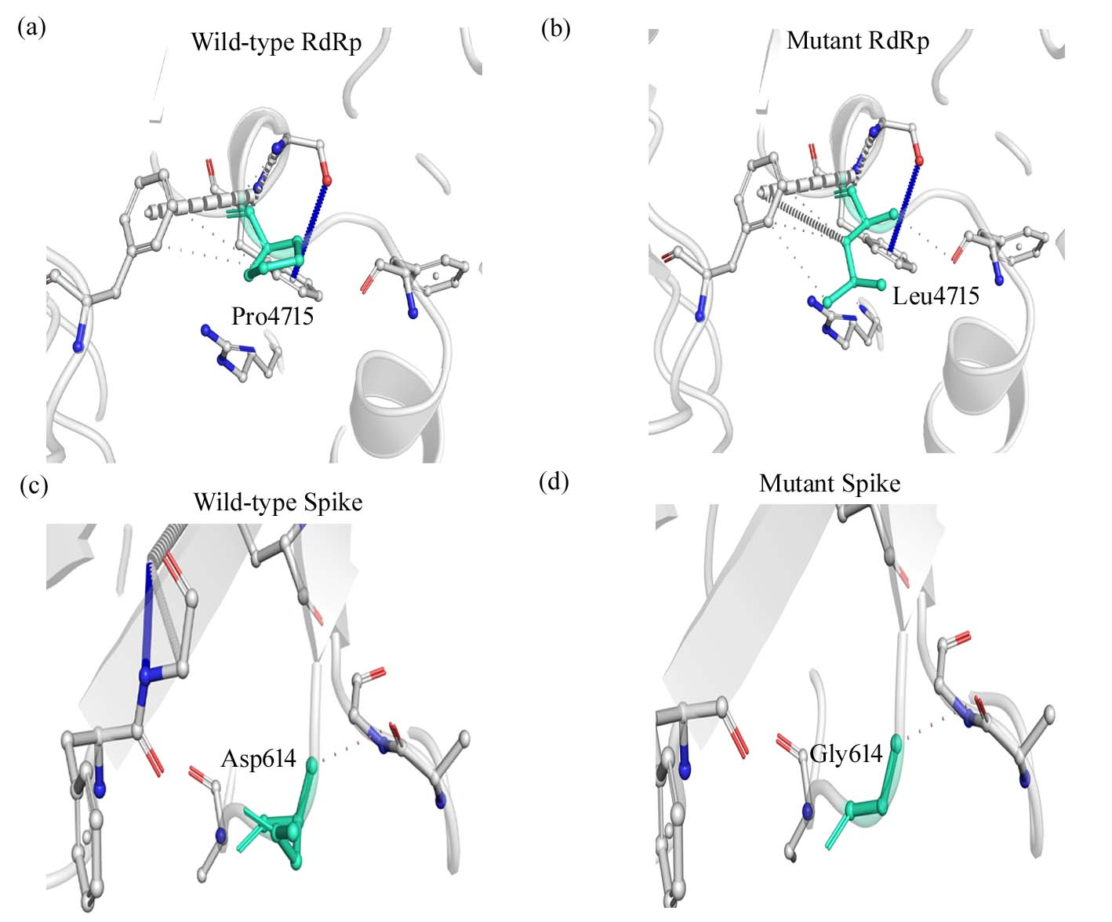
Comparison of interatomic interactions in the wild-type and mutant form. Wild-type and mutant residues are marked in green represented in stick form. (a)-(b) Structural comparison due to P4715L RdRp. (c)-(d) Structural comparison due to D614G in spike protein.

