Figure S1
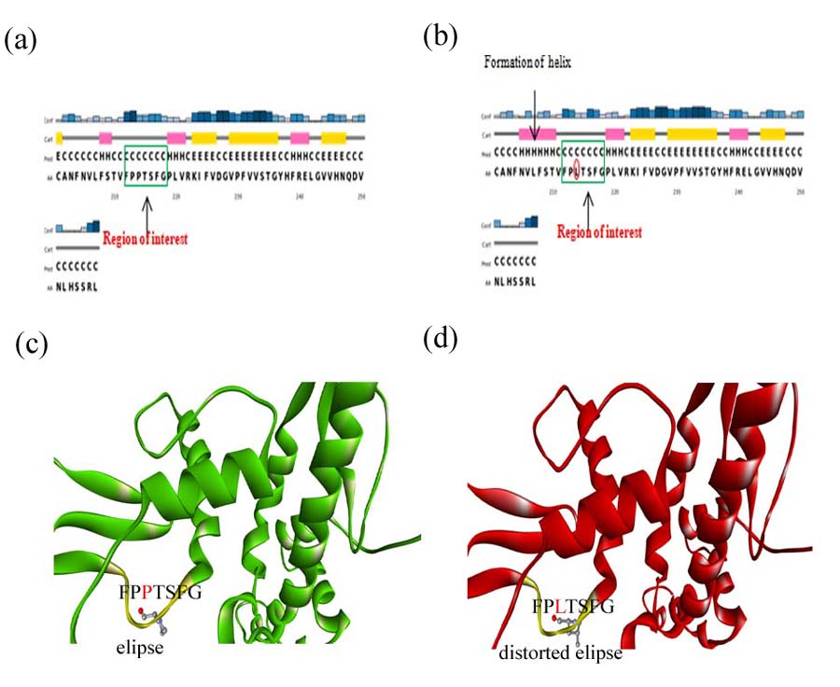
(a)-(b) Structural changes in RdRp due to P4715L. (a) Change in secondary structure due to mutation wildtype exhibit turn and (b) P4715L mutant shows helix conformation. (c) –(d) Change of shape in epitope of RdRp. (c) wildtype RdRp (green) with the elliptical loop of epitope highlighted in yellow. Pro4715 is displayed with ball and stick. (d) mutant RdRp (red) with the distorted elliptical loop of epitope highlighted in yellow. Leu4715 is displayed with ball and stick.

