Label-free human-disease characterization through circulating cell free DNA analysis using Raman Spectroscopy

Supplementary Files

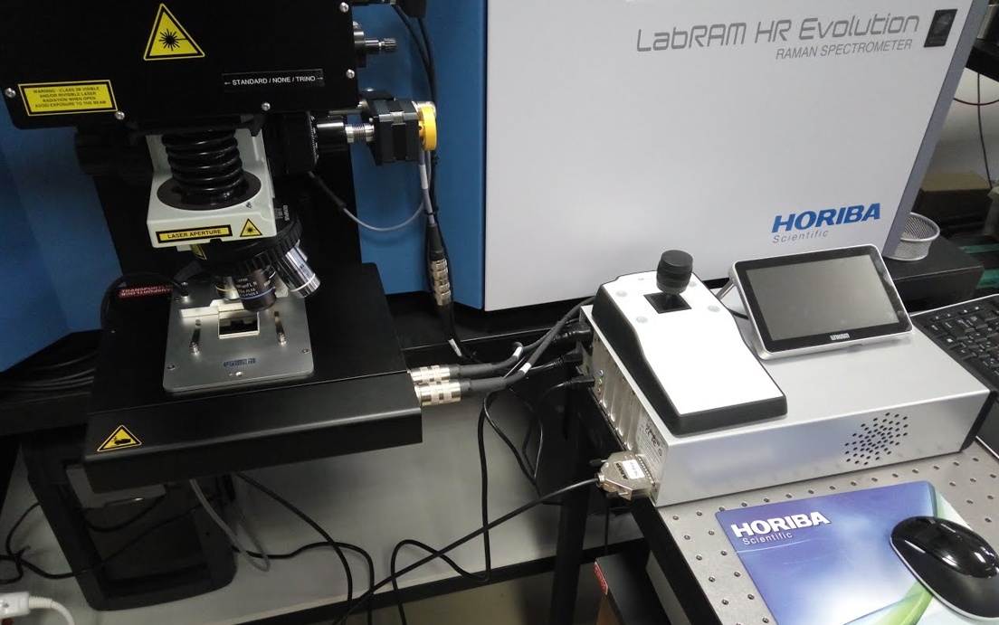
Supplementary Figure 1. The experimental setup used. The Raman microscope, the temperature control stage and the objective lens are depicted.

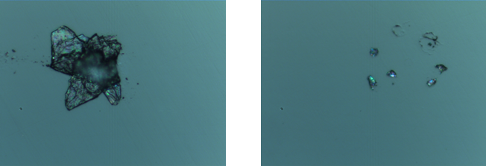

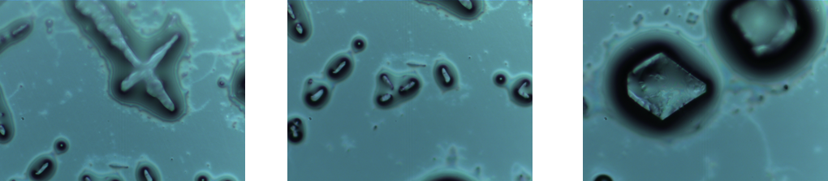
Supplementary Figure 2. Dried DNA cluster images on CaF2 substrate.

Supplementary Table 1. Table of clinical and demographic information of healthy individuals and patients included in the study.

Patient group | BMI | Sex | ccfDNA  concentration in plasma  (ng/ml) | ccfDNA  concentration after extraction (ng/μl) | Treatment
Healthy n=6  Average Age 62 yo | n/a | F | n/a | 0.34 | n/a
Healthy n=6  Average Age 62 yo | n/a | F | n/a | 0.274 | n/a
Healthy n=6  Average Age 62 yo | n/a | F | n/a | 4.44 | n/a
Healthy n=6  Average Age 62 yo | 29.32 | M | 680 | 0.144 | n/a
Healthy n=6  Average Age 62 yo | 26.12 | M | 580 | 0.23 | n/a
Healthy n=6  Average Age 62 yo | 21.34 | M | 920 | 0.434 | n/a
Metastatic Breast cancer patients  (=11)  Average age 61 yo | n/a | F | 616 | 0.202 | Taxoprol,carbo,  Retacrit,arimidex,
Metastatic Breast cancer patients  (=11)  Average age 61 yo | n/a | F | 780 | 0.204 | Abraxane, avastin, zometta
Metastatic Breast cancer patients  (=11)  Average age 61 yo | n/a | F | 475 | n/a | n/a
Metastatic Breast cancer patients  (=11)  Average age 61 yo | n/a | F | 569 | n/a | n/a
Metastatic Breast cancer patients  (=11)  Average age 61 yo | n/a | F | 3000 | n/a | n/a
Metastatic Breast cancer patients  (=11)  Average age 61 yo | n/a | F | 493 | n/a | n/a
Metastatic Breast cancer patients  (=11)  Average age 61 yo | n/a | F | 643 | n/a | n/a
Metastatic Breast cancer patients  (=11)  Average age 61 yo | 23,01 | F  1st measurement | 552 | 0.136 | n/a
Metastatic Breast cancer patients  (=11)  Average age 61 yo |  | 2nd measurement | 623 | 0.192 | n/a
Metastatic Breast cancer patients  (=11)  Average age 61 yo |  | F  1st measurement | 649 | 0.21 | n/a
Metastatic Breast cancer patients  (=11)  Average age 61 yo | 32.47 | 2nd measurement | 579 | 0.18 | n/a
Metastatic Breast cancer patients  (=11)  Average age 61 yo |  | F  1st measurement | 586 | 0.16 | n/a
Metastatic Breast cancer patients  (=11)  Average age 61 yo | 39.64 | 2nd  measurement | 431 | 0.596 | n/a
Metastatic Breast cancer patients  (=11)  Average age 61 yo |  | F  1st measurement | 527 | 0.208 | n/a
Metastatic Breast cancer patients  (=11)  Average age 61 yo | 29.76 | 2nd  measurement | 596 | 0.132 | n/a
Metastatic Breast cancer patients  (=11)  Average age 61 yo |  | F | 668 | 0.276 | n/a
Breast cancer patients taking  adjuvant therapy (=9)  Average age 57 yo | n/a | F | 1110 | 10 | n/a
 | n/a | F | 470 | n/a | n/a
 | n/a | F | 521 | n/a | n/a
 | n/a | F | 569 | n/a | n/a
 | n/a | F | 242 | n/a | n/a
 | n/a | F | 323 | n/a | n/a
 | n/a | F  1st measurement | 469 | 0.164 | n/a
 | 19 | 2nd measurement | 379 | 0.312 | n/a
 |  | F  1st measurement | 456 | 0.174 | n/a
 |  | 2nd measurement | 479 | 0.156 | n/a
 |  | F | 765 | n/a | n/a
Breast cancer patients taking  neoadjuvant therapy (=5)  Average age 44 yo | n/a | F | 253 | n/a | n/a
 | n/a | F | 932 | n/a | n/a
 | n/a | F | 803 | n/a | n/a
 | n/a | F | 673 | n/a | n/a
 | n/a | M | n/a | n/a | n/a
Prediabetic patients (=3)  Average age 40 yo | 36.46 | M | n/a | n/a | n/a
Prediabetic patients (=3)  Average age 40 yo | 28.06 | M | n/a | n/a | n/a
Prediabetic patients (=3)  Average age 40 yo | 28.03 | M | 900 | 0.448 | Glucophage
Diabetic patients (n=3)  Average age 60 yo | 30.61 | M | 740 | 1.44 | Glucophage
Diabetic patients (n=3)  Average age 60 yo | 35.7 | M | 670 | 0.156 | Glucophage
Diabetic patients (n=3)  Average age 60 yo | 26.44

