Electronic Supplementary Material (ESM) 2

Results

e-Table 1 ESM 2: Baseline characteristics of the patients by study group (median (IQR), Wilcoxon rank sum test, frequencies (percentage), Pearson´s Chi-squared test or Fischer´s exact test). BMI body mass index, ASV/PSV pressure support ventilation, BIPAP bilevel positive pressure ventilation, SIMV synchronous intermittent mandatory ventilation, MMV mandatory minute ventilation, PEEP positive end-expiratory pressure, Pmean mean airway pressure, Pplat inspiratory plateau pressure, MV minute ventilation

Parameter | Propafenone n=104 | Amiodarone n=105 | p-value
Age (years) | 70 (61, 74) | 70 (62, 78) | 0.12
Female | 42 (40.4%) | 38 (36.2%) | 0.5
BMI | 30 (26, 35) | 28 (24, 31) | 0.012
SOFA | 10 (8.0, 12.0) | 10 (9.0, 12.0) | 0.3
APACHE II | 26 (20, 30) | 25 (20, 30) | ˃0.9
Arrhythmia type |  |  | 0.8
AF | 78 (75%) | 80 (76.2%)
Flutter | 20 (19.2%) | 21 (20.0%)
SVT | 6 (5.8%) | 4 (3.8%)
El. CV prior to inclusion | 14 (13.5%) | 12 (11.4%) | 0.7
Achievement of sinus rhythm | 95 (91.3%) | 93 (88.6%) | 0.5
El. CV post inclusion | 42 (40.4%) | 34 (32.4%) | 0.2
History of paroxysmal SV arrhythmia | 23 (22.1%) | 14 (13.3%) | 0.10
Hypothyroid | 10 (9.6%) | 9 (8.6%) | 0.8
Euthyroid with medication | 11 (10.6%) | 9 (8.6%) | 0.6
Hyperthyroid | 0 (0.0%) | 1.0 (1.0%) | ˃0.9
CRRT | 20 (19.2%) | 15 (14.3%) | 0.3
IPPV | 95 (91.3%) | 102 (97.1%) | 0.07
NIV | 7 (6.7%) | 3 (2.9%) | 0.2
IPPV modality |  |  | 0.3
ASV/PSV | 44 (42.3%) | 37 (35.3%)
BIPAP | 26 (25%) | 25 (23.8%)
SIMV | 21 (20.2%) | 35 (33.3%)
MMV | 5 (4.8%) | 2 (1.9%)
PEEP (cmH₂O) | 8 (6.5, 10.0) | 8 (6.0, 10.0) | 0.6
Pmean (cmH₂O) | 14 (12, 17) | 14 (12, 17) | 0.7
Pplat (cmH₂O) | 22 (17.5, 26) | 23 (19, 26) | 0.8
MV (l/min) | 9.7 (8, 11.1) | 9 (7.7, 11.2) | 0.3
FiO₂ | 50 (40, 60) | 50 (40, 65) | 0.6

e-Table 2 ESM 2: Comparisons of drug history, concomitant potentially pro-arrhythmogenic medications and additional antiarrhythmic drugs given during the ICU stay. *The rates of a betablocker represent proportion of patients given metoprolol at the end of the study medication and on a continuing betablockade after ceasing of the study infusion. (frequencies (percentages), Pearson´s Chi-squared test or Fischer´s exact test).

Parameter | Propafenone n=104 | Amiodarone n=105 | p-value
A history of
Betablocker | 29 (27.9%) | 24 (22.9%) | 0.4
Amiodarone | 8 (7.7%) | 7 (6.7%) | 0.8
Ca channel blocker | 10 (9.6%) | 12 (11.4%) | 0.7
Digoxin | 0 (0.0%) | 2 (1.9%) | 0.5
Propafenone | 5 (4.8%) | 1 (1.0%) | 0.12
Chemotherapy in the last 3 months | 16 (15.4%) | 14 (13.3%) | 0.7
Anthracycline cytostatic | 1 (1.0%) | 2.0 (1.9%) | ˃0.9
ICU medications
Haloperidol | 8 (7.7%) | 7 (6.7%) | 0.8
Clarithromycin | 7 (6.7%) | 1 (1.0%) | 0.035
Fluoroquinolone | 20 (19.2%) | 15 (14.3%) | 0.3
Amphotericin B | 14 (13.5%) | 10 (9.5%) | 0.4
Azole antimycotic | 36 (34.6%) | 30 (28.6%) | 0.3
Anticholinergics | 1 (1.0%) | 1 (1.0%) | ˃0.9
Aminophylline | 0 (0.0%) | 1 (1.0%) | ˃0.9
Terbutaline | 1 (1.0%) | 1 (1.0%) | ˃0.9
Additional antiarrhythmic medication
Betablocker* | 30 (28.8%) | 20 (19.2%) | 0.10
Magnesium | 28 (26.9%) | 28 (26.9%) | ˃0.9
Adenosine | 1 (1%) | 0 (0%) | ˃0.9
Verapamil | 1 (1%) | 0 (0%) | ˃0.9
Lidocain | 0 (0%) | 1 (1%) | ˃0.9

e-Table 3 ESM 2: The baseline haemodynamic and laboratory data enrolled in a study (medians (IQR), Wilcoxon rank sum test, frequencies (percentage), Pearson´s Chi-squared test or Fischer´s exact test).

Parameter | Propafenone n=104 | Amiodarone n=105 | p-value
HR (b/min) | 130 (112, 149) | 130 (112, 145) | 0.8
BPs (mmHg) | 111 (105, 125) | 114 (105, 125) | ˃0.9
BPd (mmHg) | 60 (50, 63) | 56 (50, 62) | 0.5
BPmean (mmHg) | 75 (70, 82) | 75 (70, 82) | 0.5
CVP (mmHg) | 9.0 (6.0, 12.0) | 8.0 (5.0, 10.0) | 0.049
Temperature (°C) | 36.95 (36.5, 37.6) | 36.8 (36.23, 37.5) | 0.3
Norepinephrine (n=206) (µg/kg.min) | 0.30 (0.15, 0.41) | 0.28 (0.15, 0.48) | 0.9
Arginine vasopressin (n=55) (IU/h) | 2.00 (2.00, 3.75) | 2.00 (1.00, 2.40) | 0.068
Dobutamine (n=11) (µg/kg.min) | 3.00 (2.50, 3.00) | 2.75 (2.75, 4.00) | 0.6
Potassium (mmol/l) | 4.30 (4.00, 4.62) | 4.20 (4.00, 4.50) | 0.3
Calcium (mmol/l) | 1.90 (1.77, 2.02) | 1.92 (1.80, 2.08) | 0.3
Ionized calcium (mmol/l) | 1.05 (0.93, 1.12) | 1.05 (0.97, 1.12) | 0.4
Magnesium (mmol/l) | 1.27 (1.03, 1.55) | 1.22 (0.95, 1.57) | 0.6
Urea (mmol/l) | 18 (10, 24) | 16 (11, 22) | 0.7
Creatinine ($µ$mol/l) | 156 (95, 225) | 140 (88, 207) | 0.5
Bilirubine total (µmol/l) | 16 (11, 29) | 17 (11, 35) | 0.5
Bilirubine conj. (µmol/l) | 9 (6, 18) | 9 (6, 23) | 0.3
ALT (µkat/l) | 0.7 (0.4, 1.6) | 0.8 (0.5, 2.1) | 0.4
AST (µkat/l) | 1 (1, 2) | 1 (1, 2) | 0.3
GGT (µkat/l) | 1.85 (0.98, 3.65) | 1.78 (0.84, 3.50) | ˃0.9
ALP (µkat/l) | 1.69 (1.19, 2.57) | 1.73 (1.23, 2.66) | 0.9
CRP (mg/l) | 202 (116, 314) | 187 (108, 314) | 0.9
PCT (nmol/ml) | 3 (1, 16) | 4 (1, 20) | 0.2
Hb (g/l) | 100 (88, 116) | 104 (92, 121) | 0.2
WBC (10³/µl) | 18 (13, 25) | 16 (12, 23) | 0.2
pH art | 7.36 (7.31, 7.40) | 7.36 (7.29, 7.42) | 0.9
pO₂ art (kPa) | 11 (9, 14) | 11 (10, 13) | ˃0.9
pCO₂ art (kPa) | 6 (5, 8) | 7 (6, 8) | 0.2
BE art (mmol/l) | 0 (-3, 5) | 3 (-3, 6) | 0.2
HCO3- art (mmol/l) | 26 (22, 31) | 28 (23, 31) | 0.3
Lactate art (mmol/l) | 2.55 (2.18, 3.53) | 2.60 (2.20, 3.70) | 0.5

e-Figure 1 ESM 2: Proportion of arrhythmia recurrences. 51.9% (N=54) of patients in the propafenone arm had at least one episode of arrhythmia during the infusion compared to 76.2% (N=80, p˂0.001) in the amiodarone arm. 9 patients (16.7%) in the propafenone group had more than three recurrences compared to 31 patients (38.8%, p=0.006) in the amiodarone group.

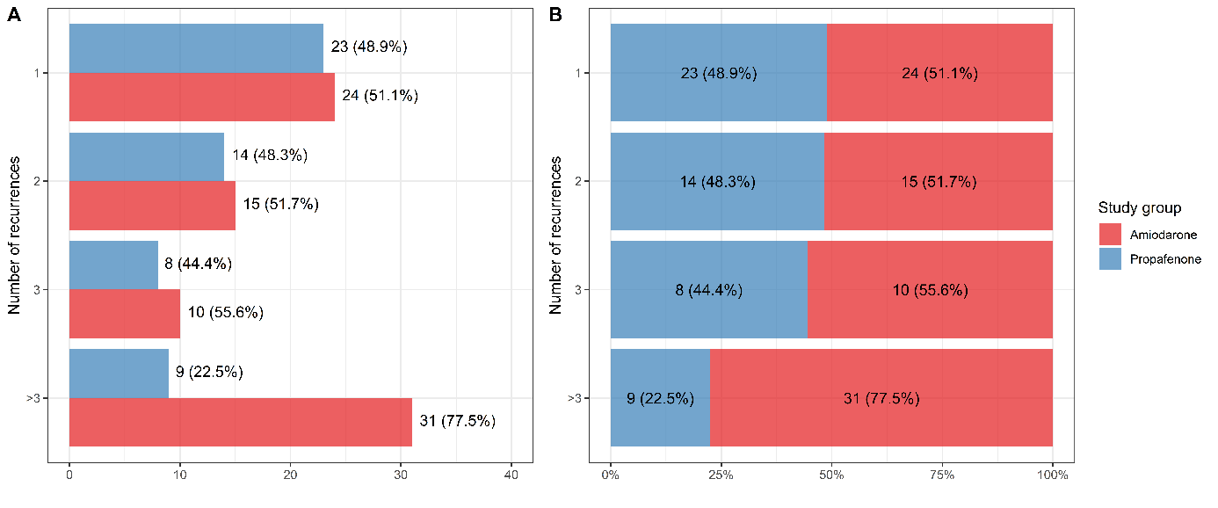

e-Figure 2 ESM 2: Comparison of the percentages of patients without cardioversion with moderate-to-severe right ventricular dysfunction (left) and normal-to-mild right ventricular dysfunction (right) between the propafenone and amiodarone arms (Kaplan-Meier log-rank test).

