Supplementary Materials for
On catching the preparatory phase of damaging earthquakes: an example from central Italy
Matteo Picozzi*, Antonio G. Iaccarino, Daniele Spallarossa, Dino Bindi
*Corresponding author. Email: matteo.picozzi@unina.it

This PDF file includes:
Figs. S1 to S5

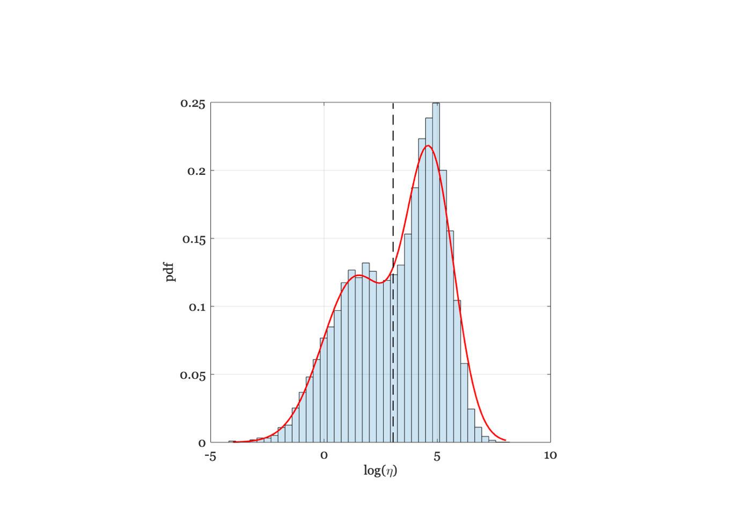
Figure S1. Histogram of the nearest-neighbor distance h, which is modeled by the sum of two log-Gaussian function (red line). Threshold h value considered for discriminating the two populations (dashed black line).

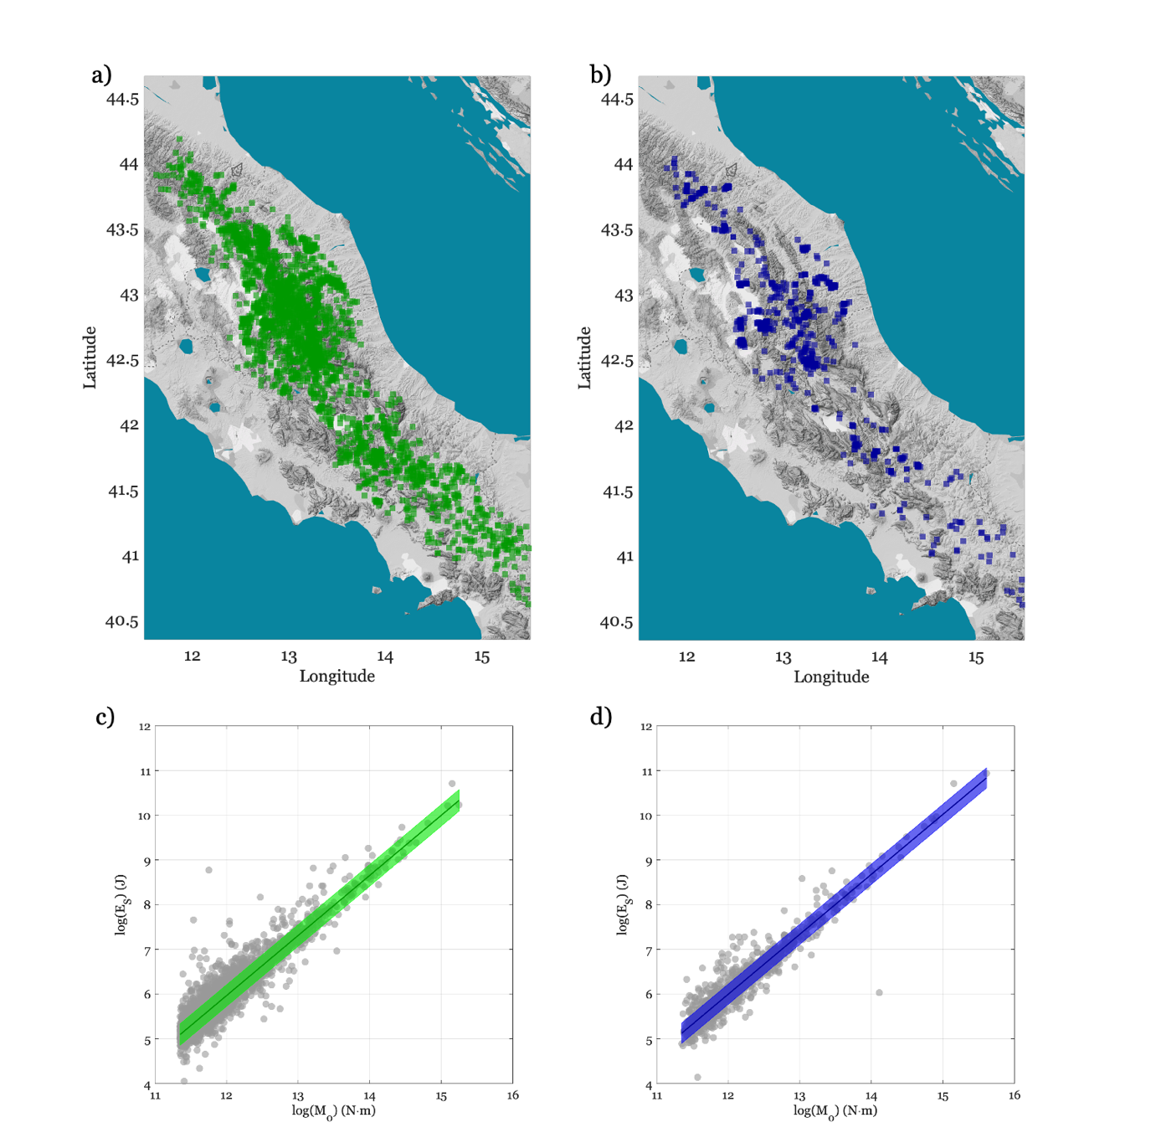

Figure S2. (A) Distribution of events belonging to background. (B) The same as (A), but for the clustered seismicity. (C) Radiated seismic energy scaling over seismic moment for background seismicity. (D) The same as (C), but for the clustered seismicity.

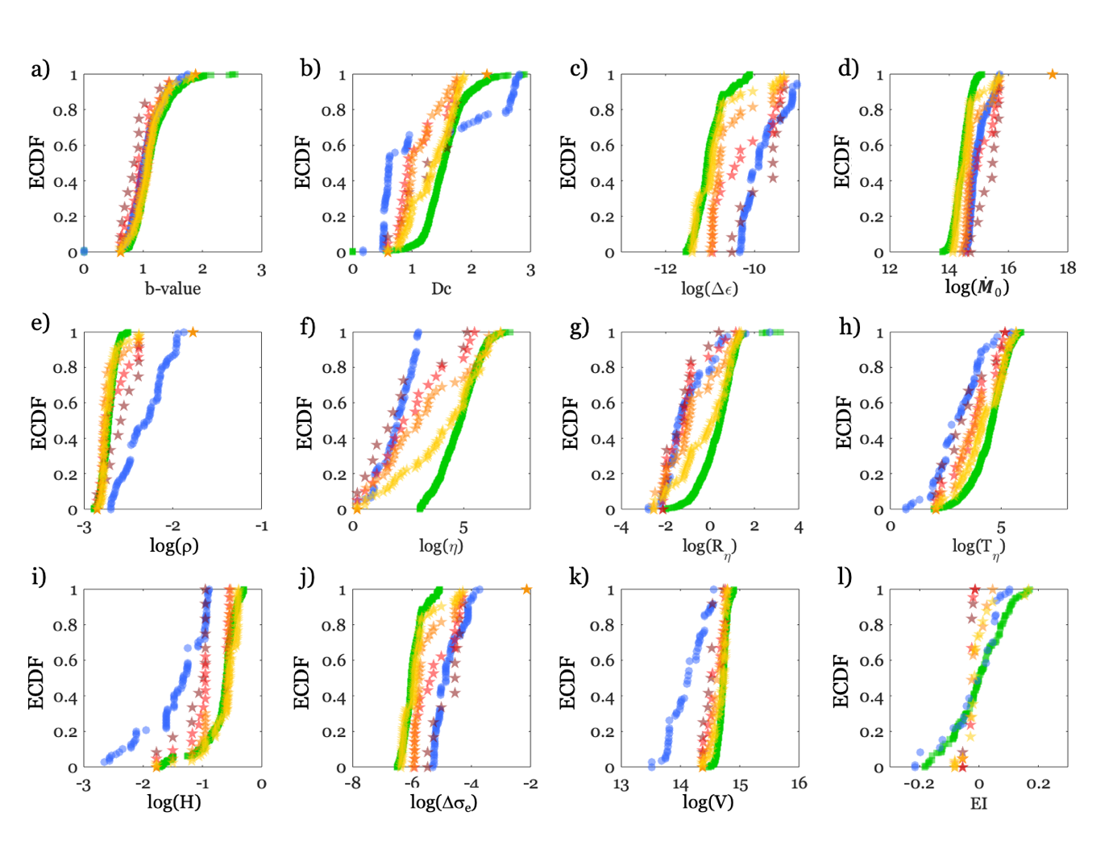
Figure S3. Empirical Cumulative Density Function (ECDF) computed for the different features and seismicity belonging to different periods. From (A) to (L) we show for each feature the ECDF for the background seismicity in green, the clustered one in blue, and those of different time periods before the Mw 6.3 L’Aquila earthquake (120 days yellow, 60 days orange, 30 days light red, 15 days dark red).

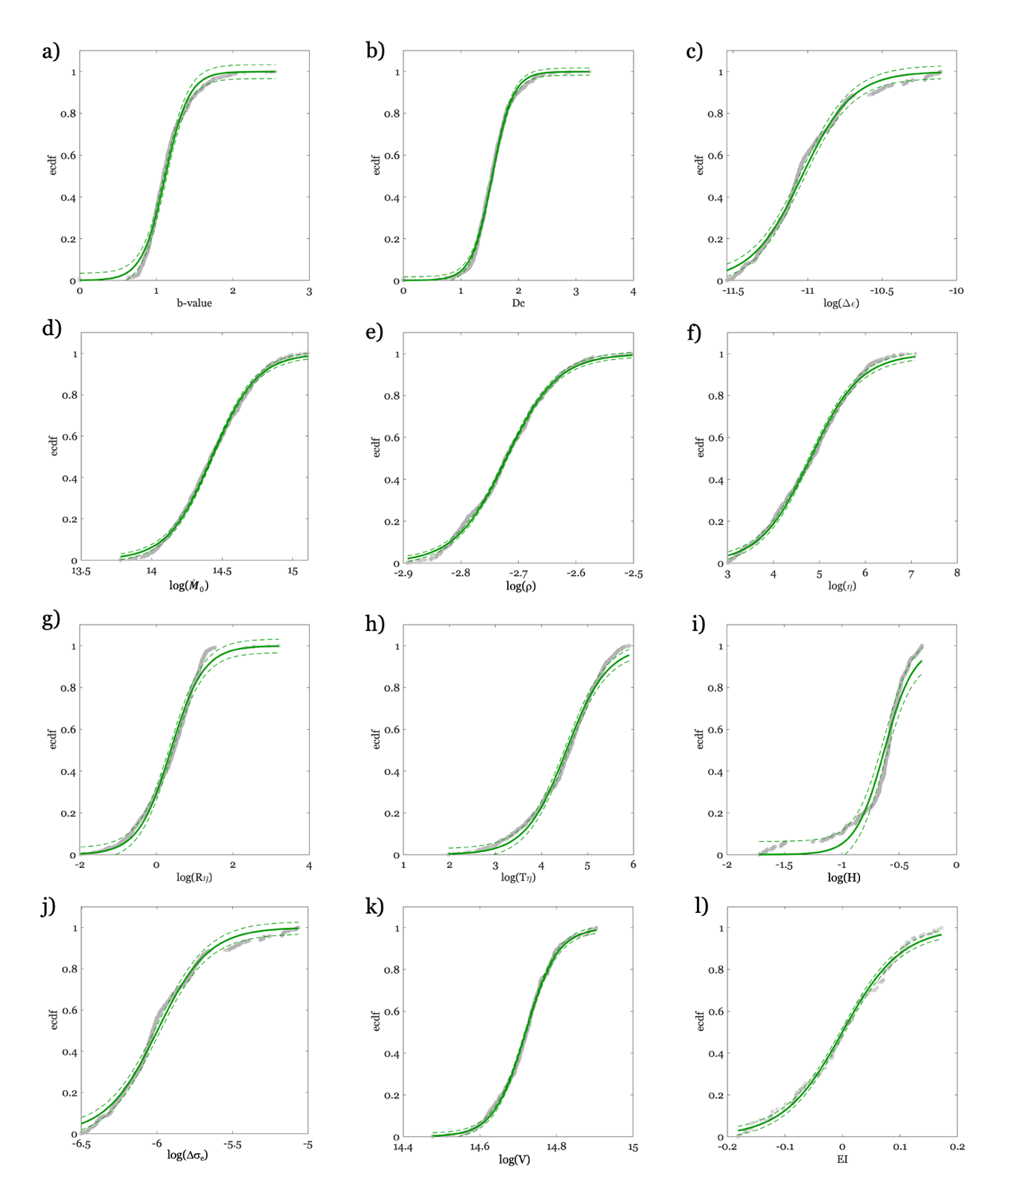
Figure S4. Fit of the ECDF for background seismicity with logistic functions. From (A) to (L), ECDF for the different features (gray dots), best-fit logistic function (green line) +/- 1 st.dev. (green dashed line).

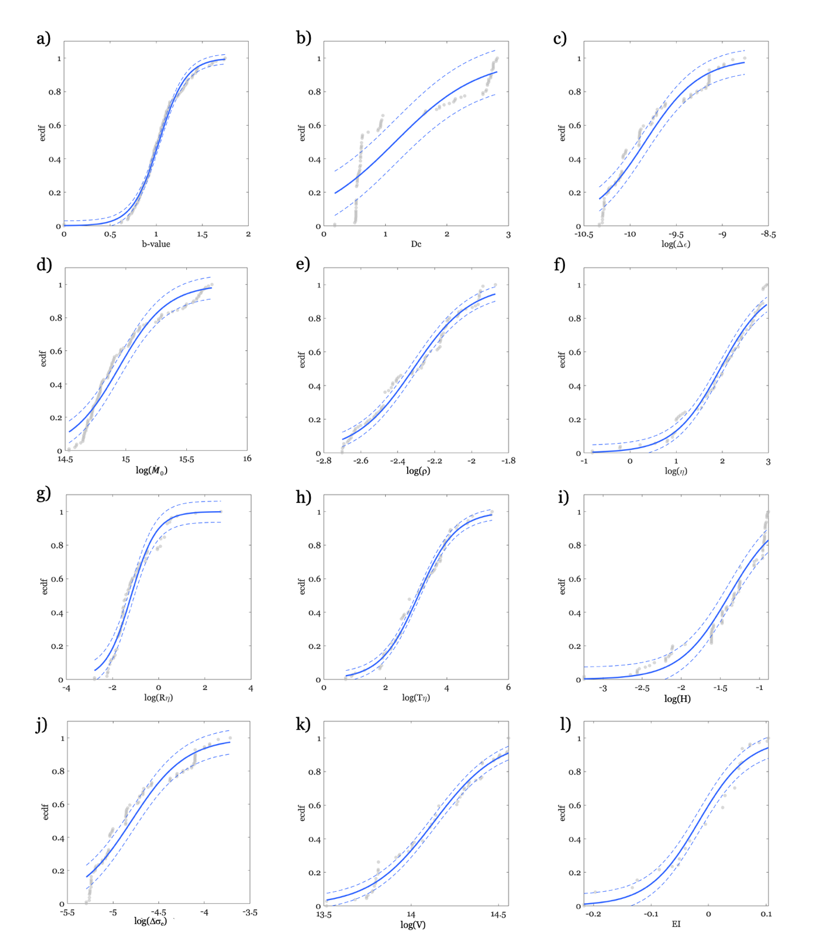
Figure S5. Fit of the ECDF for clustered seismicity with logistic functions. From (A) to (L), ECDF for the different features (gray dots), best-fit logistic function (blue line) +/- 1 st.dev. (blue dashed line).

