Supplementary figures II.
Electrophysiology

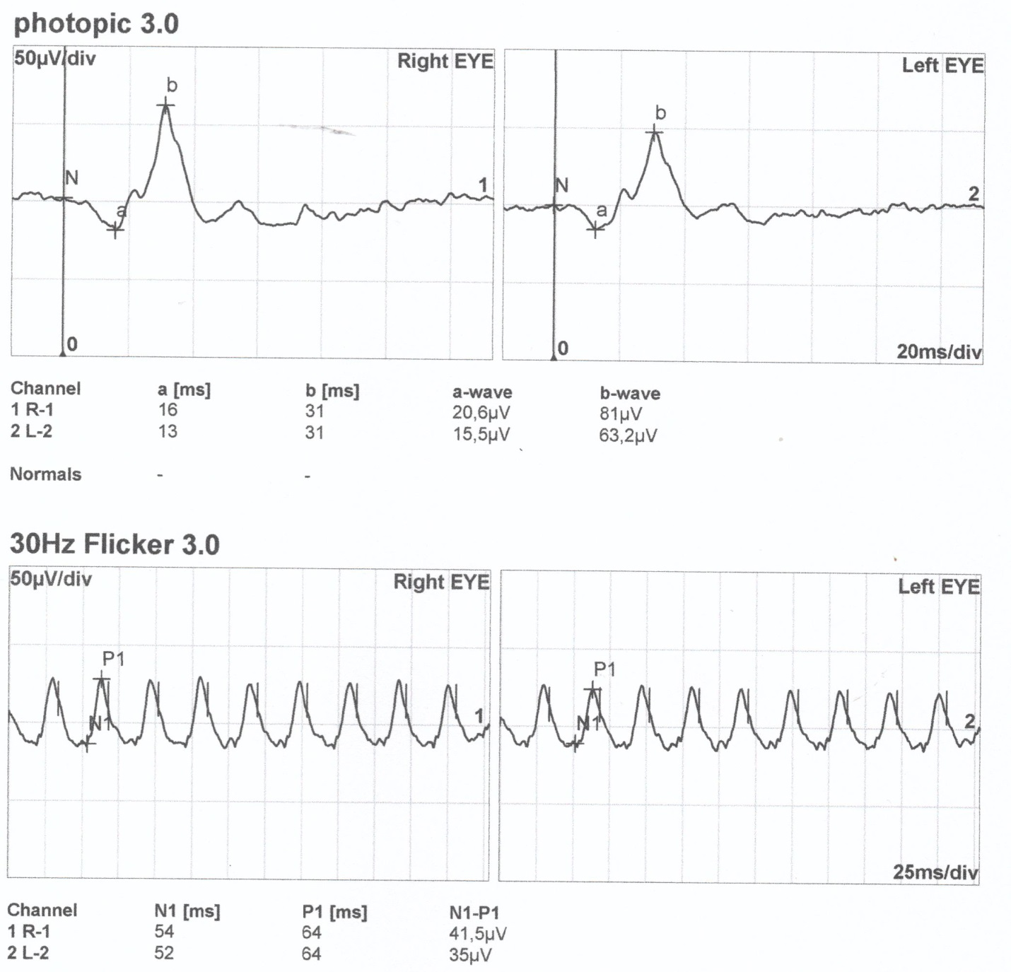
Figure S22. Standard full-field ERG recording of patient III/3.

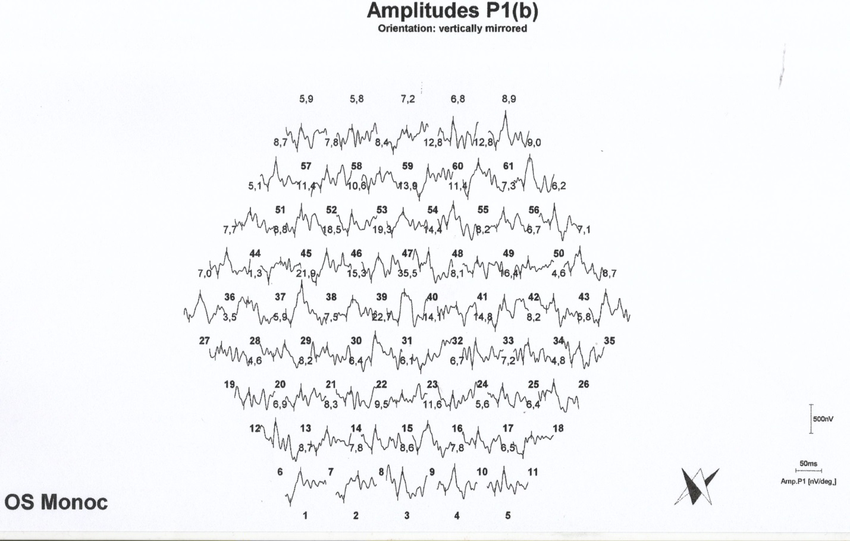
Figure S23. mfERG recording of patient III/3, OS.

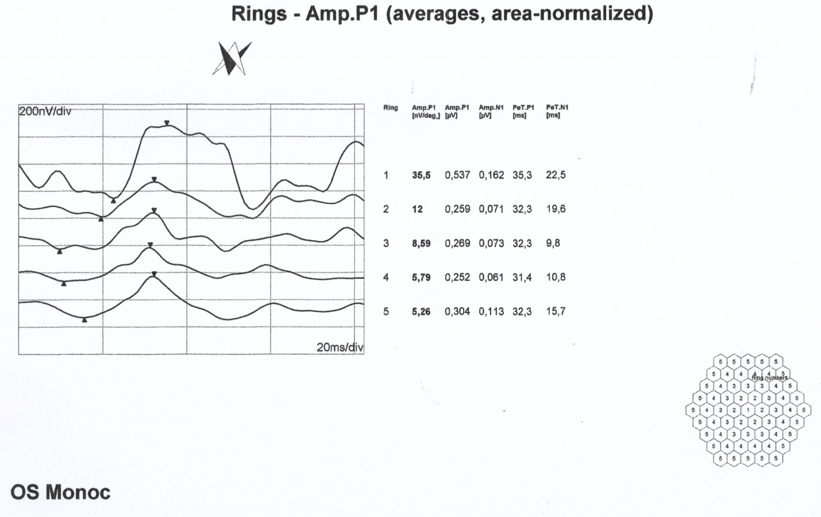
Figure S24. mfERG ring analysis of patient III/3, OS.

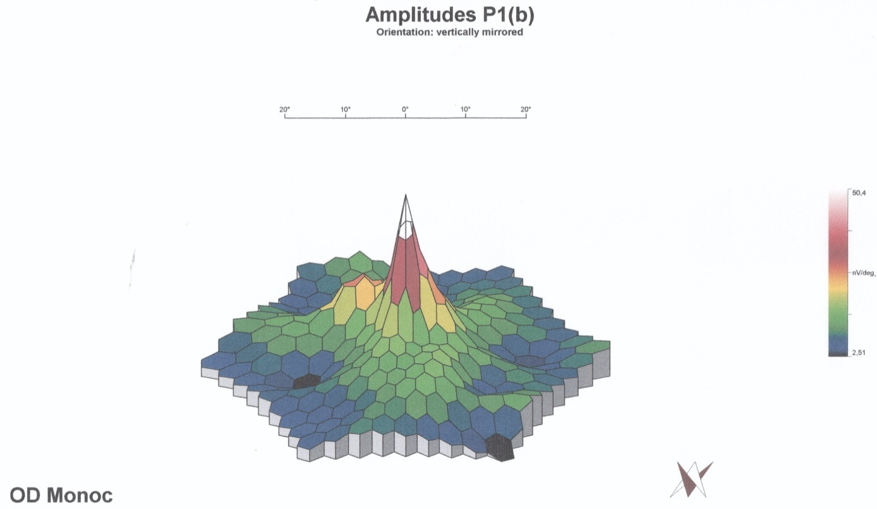
Figure S25. Multifocal ERG 3 D colour map of III/3 carrier male right eye displays overall normal central macular function with scarce subnormal responses only.

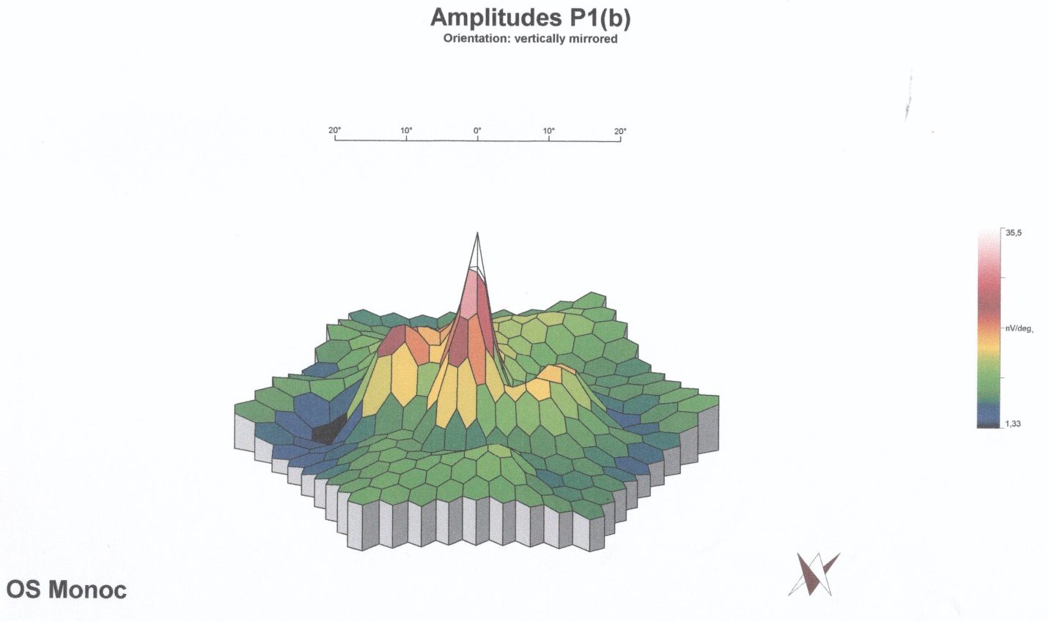
Figure S26. Multifocal ERG 3 D colour map of III/3 carrier male, left eye displays overall normal central macular function with scarce subnormal responses only.

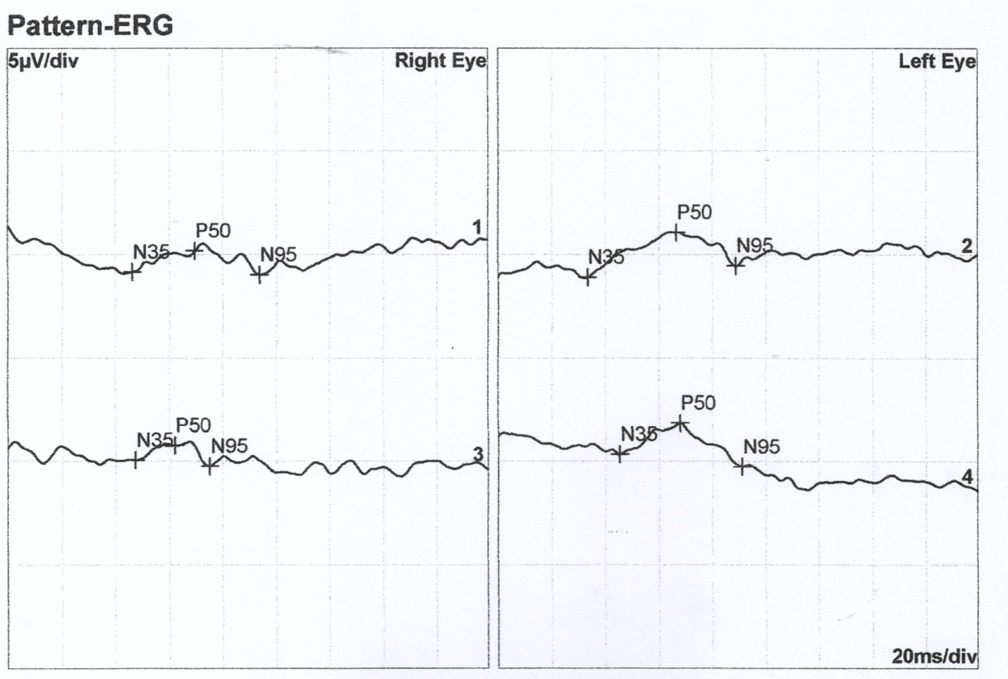
Figure S27. PERG recording of patient III/8. Lines 1 and 3 and lines 2 and 4 represent pairs of replicate measurements.

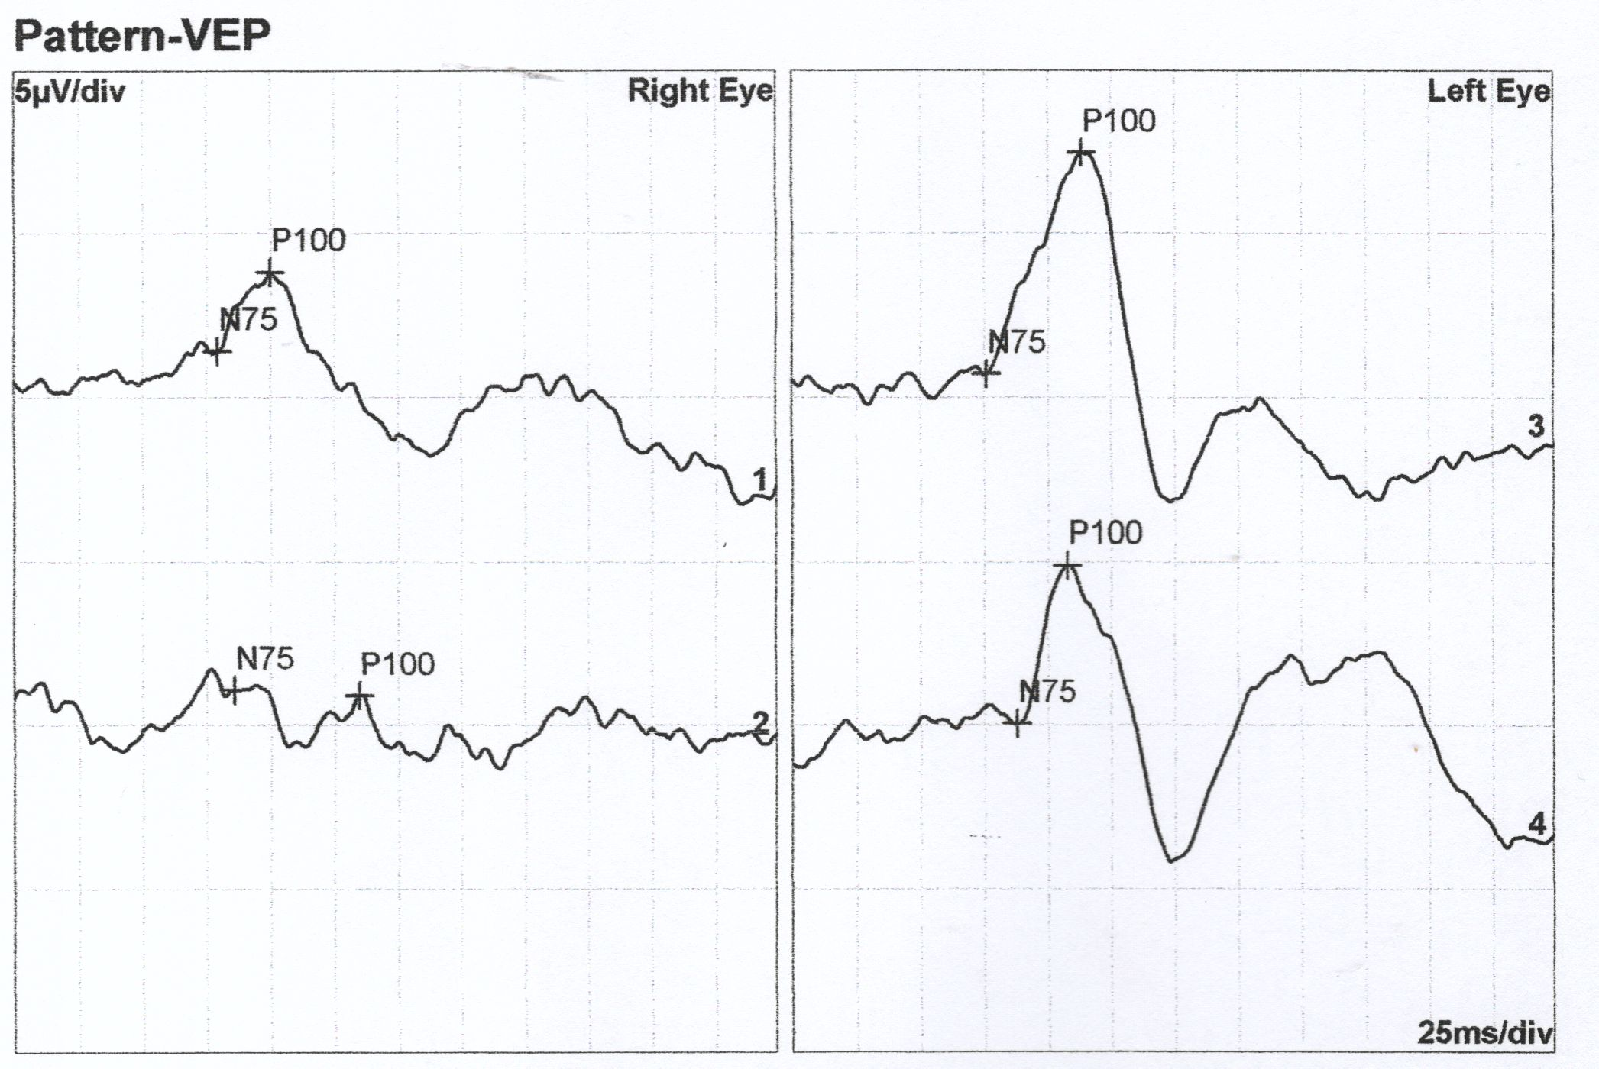
Figure S28. pVEP recording of patient III/8. Lines 1 and 3 display responses to 60' stimuli and lines 2 and 4 represent responses to 15' stimuli.

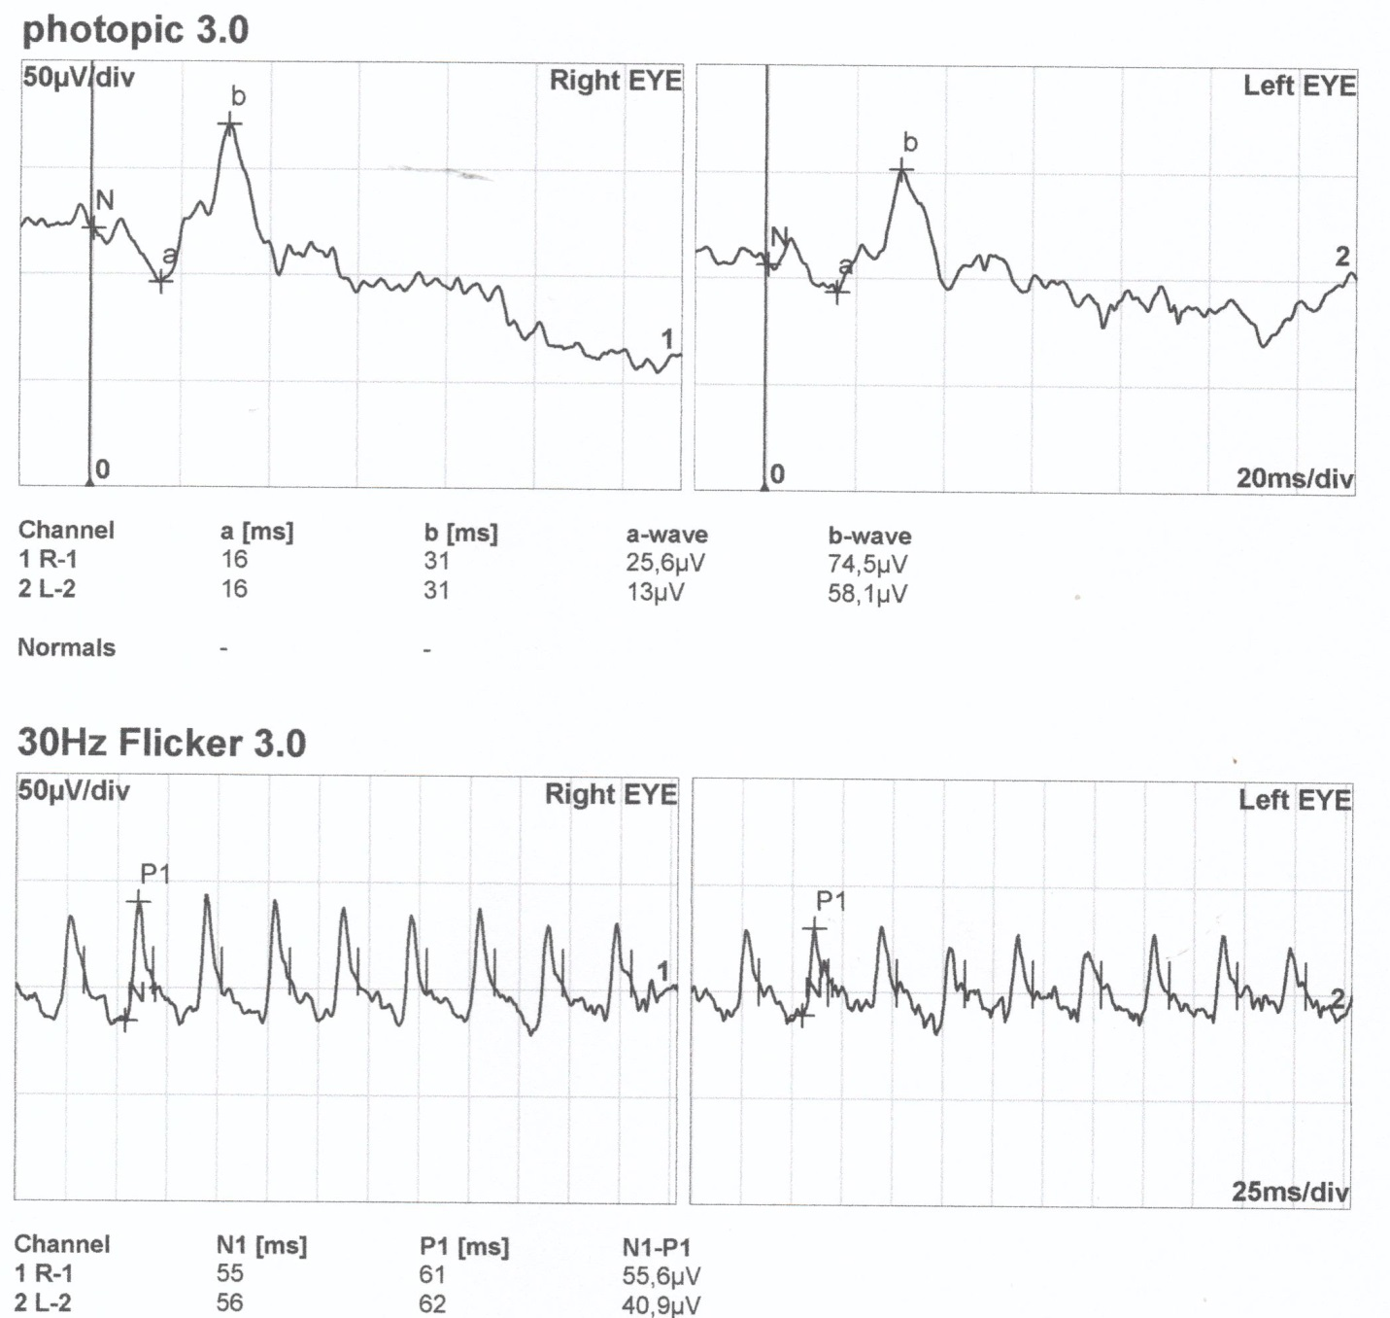
Figure S29. Standard full-field ERG recording of patient IV/1.

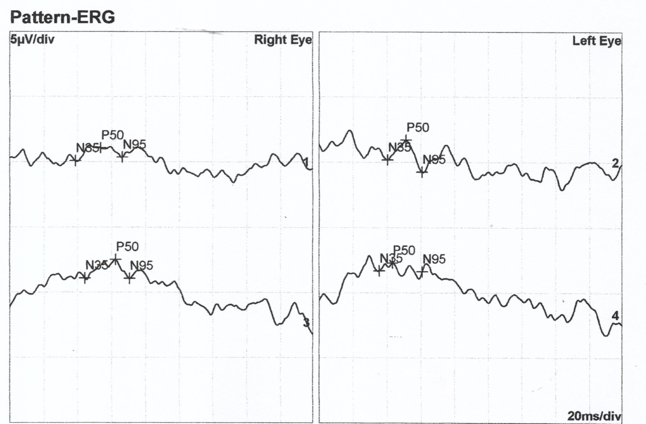
Figure S30. PERG recording of patient IV/1. Lines 1 and 3 and lines 2 and 4 represent pairs of replicate measurements.

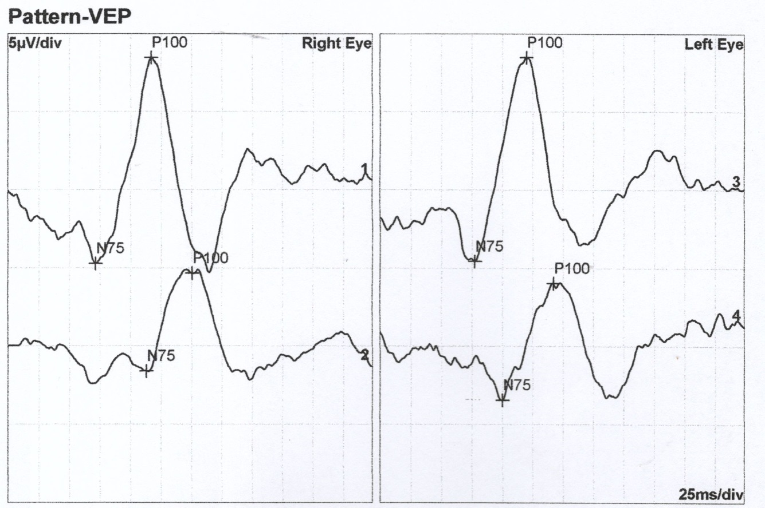
Figure S31. pVEP recording of patient IV/1. Lines 1 and 3 display responses to 60' stimuli and lines 2 and 4 represent responses to 15' stimuli.

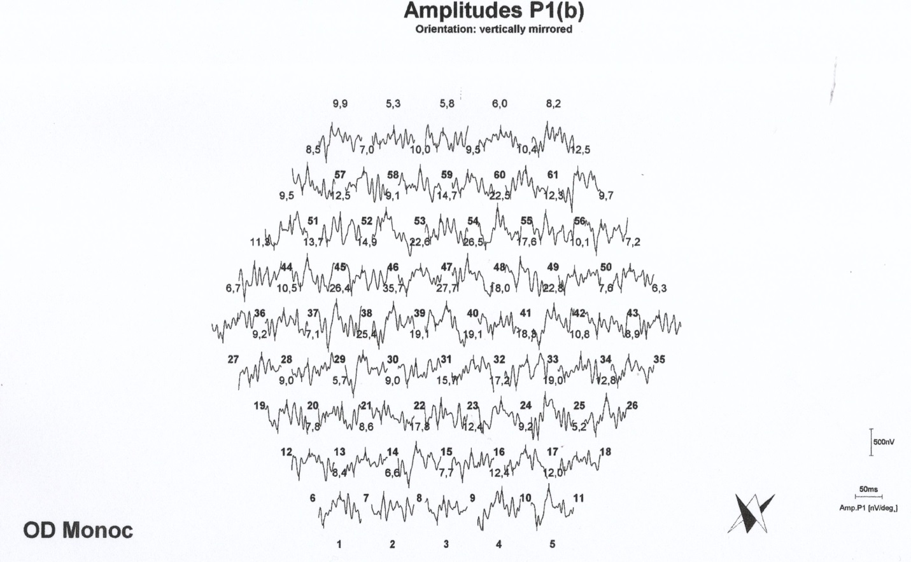
Figure S32. mfERG recording of patient IV/1, OD.

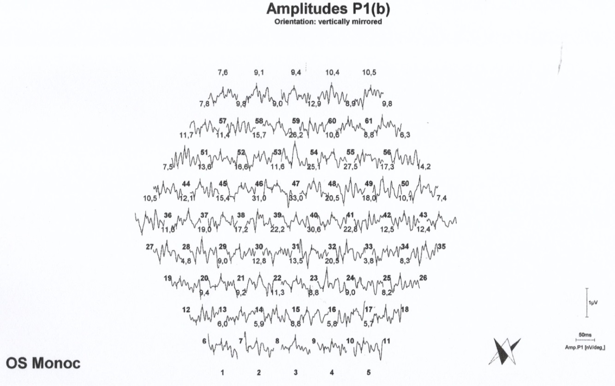

Figure S33. mfERG recording of patient IV/1,, OS.

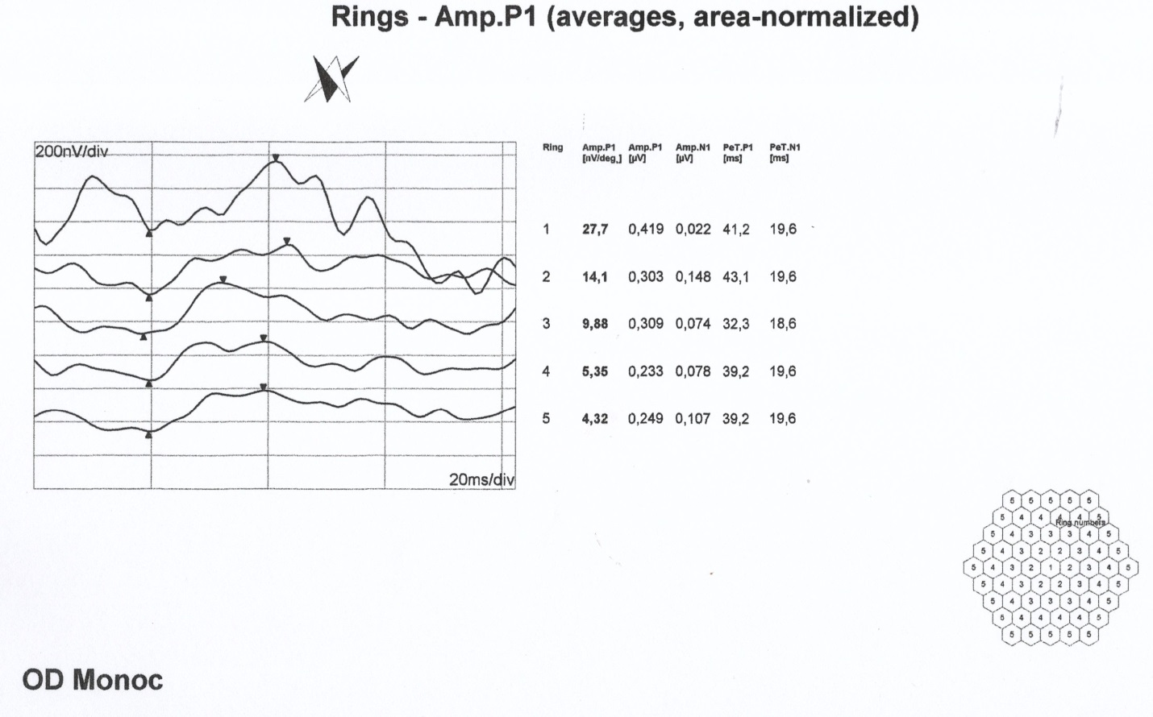
Figure S34. mfERG ring analysis of patient IV/1, OD.

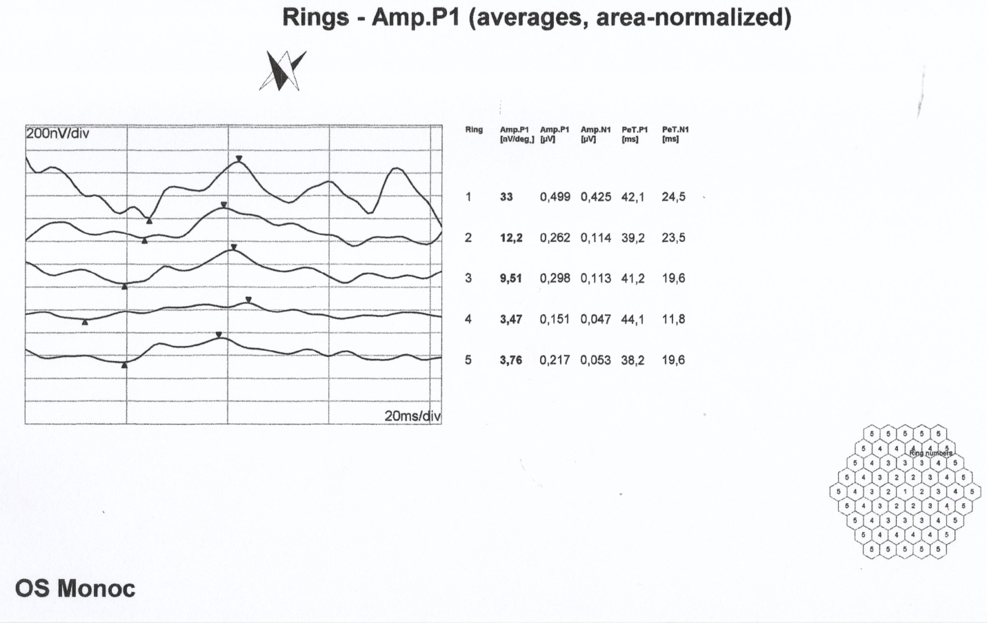
Figure S35. mfERG ring analysis of patient IV/1, OS.

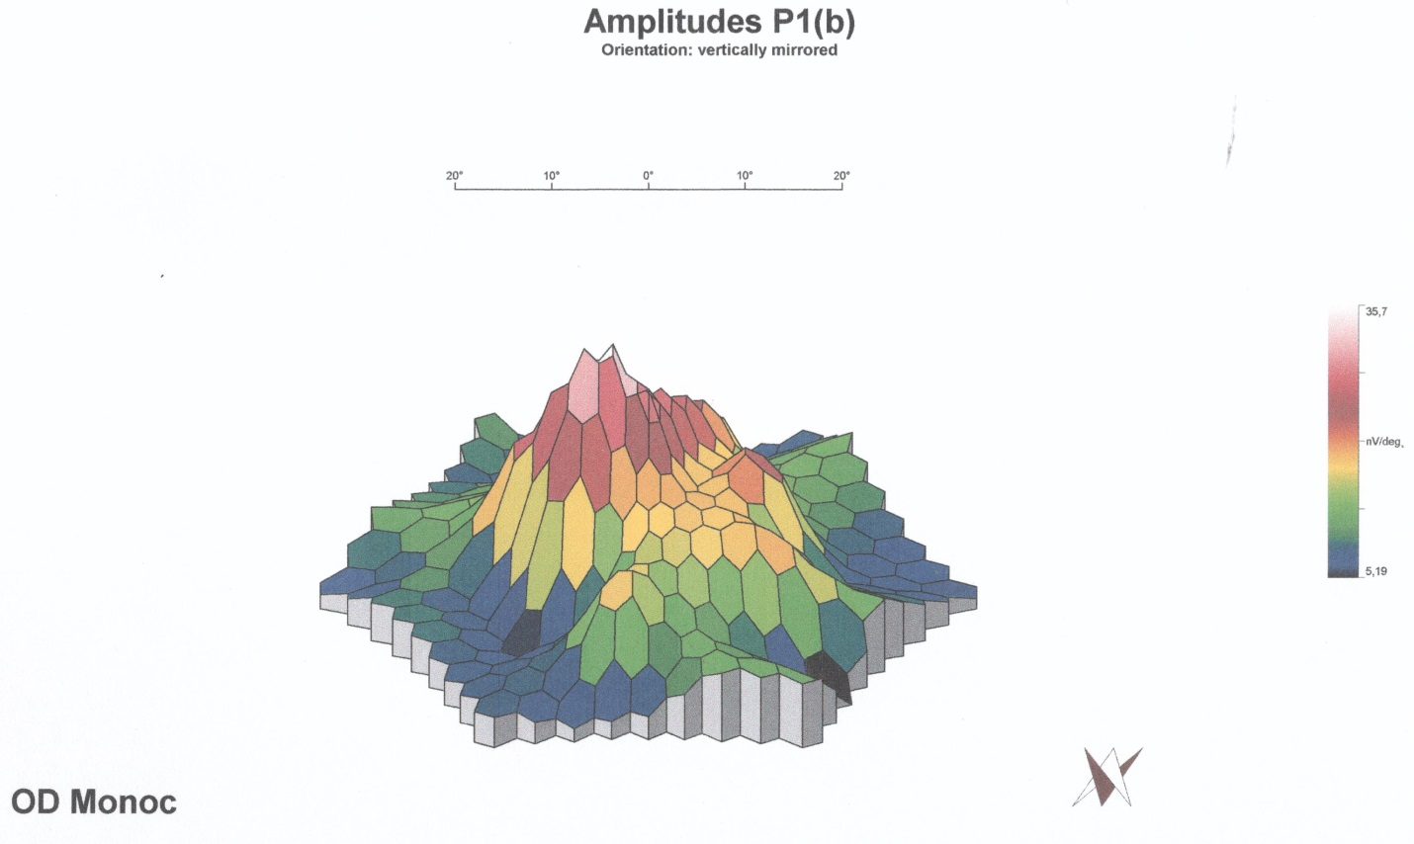
Figure S36. Multifocal ERG 3 D colour map of patient IV/1, OD

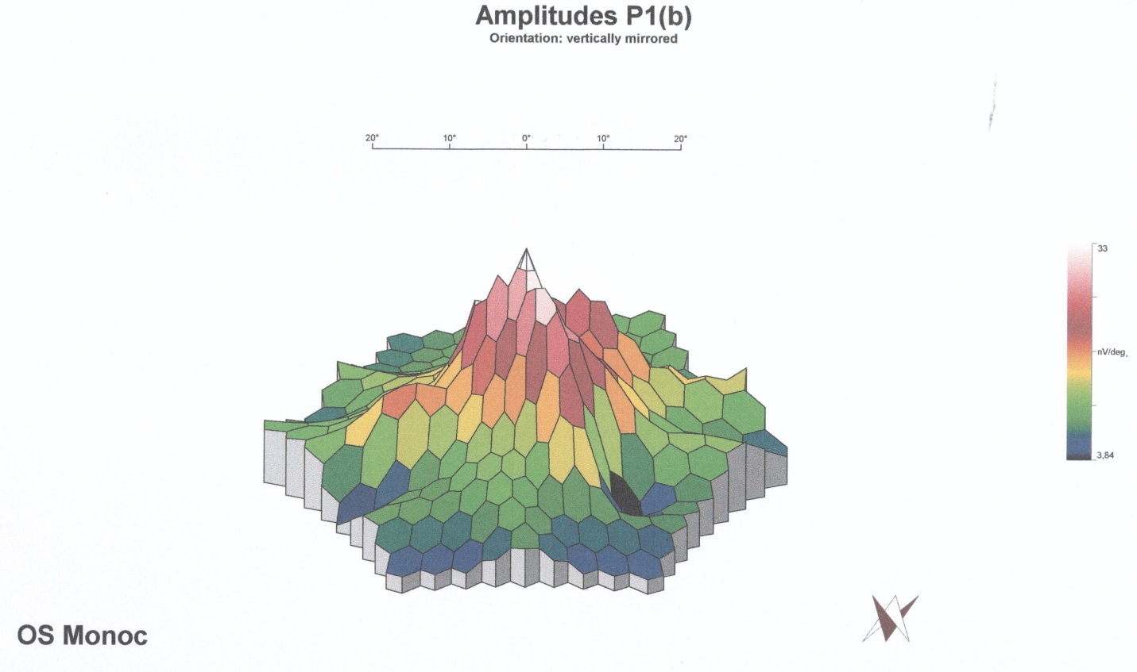
Figure S37. Multifocal ERG 3 D colour map of patient IV/1, OS
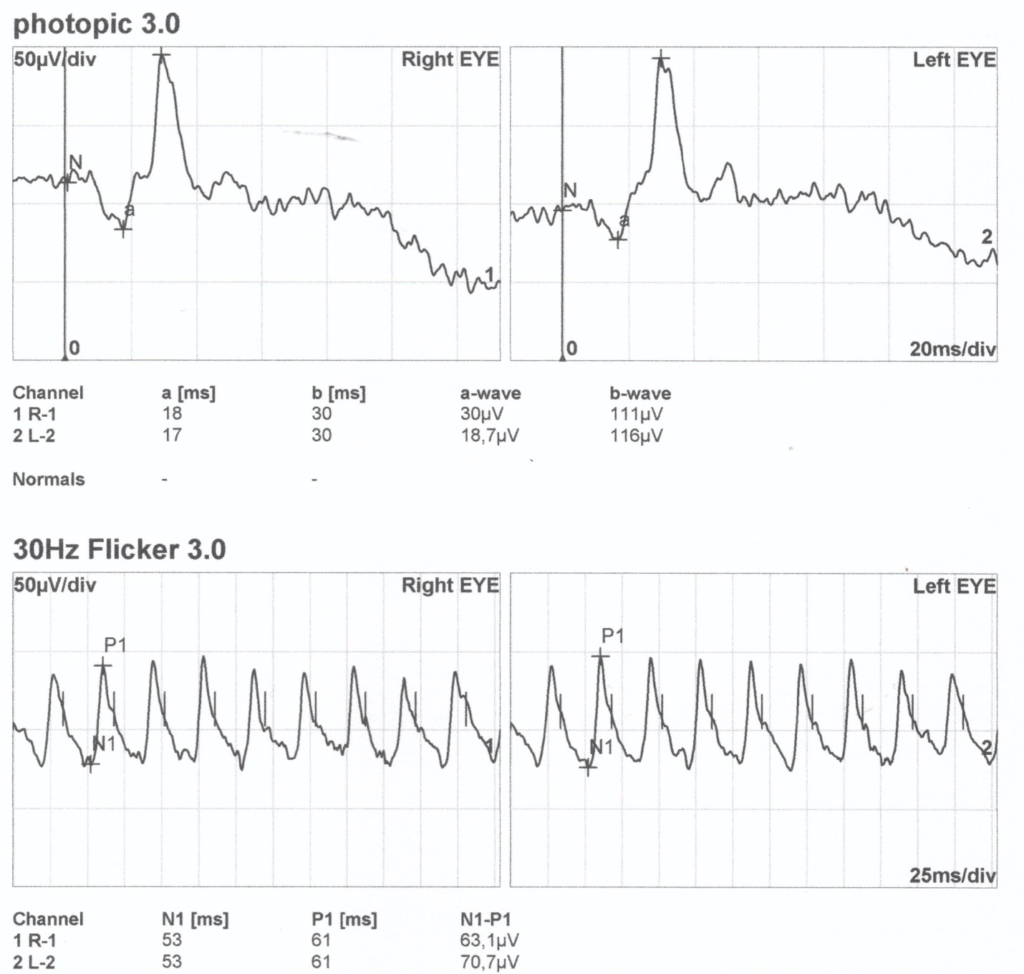
Figure S38. Standard full-field ERG recording of patient IV/2.

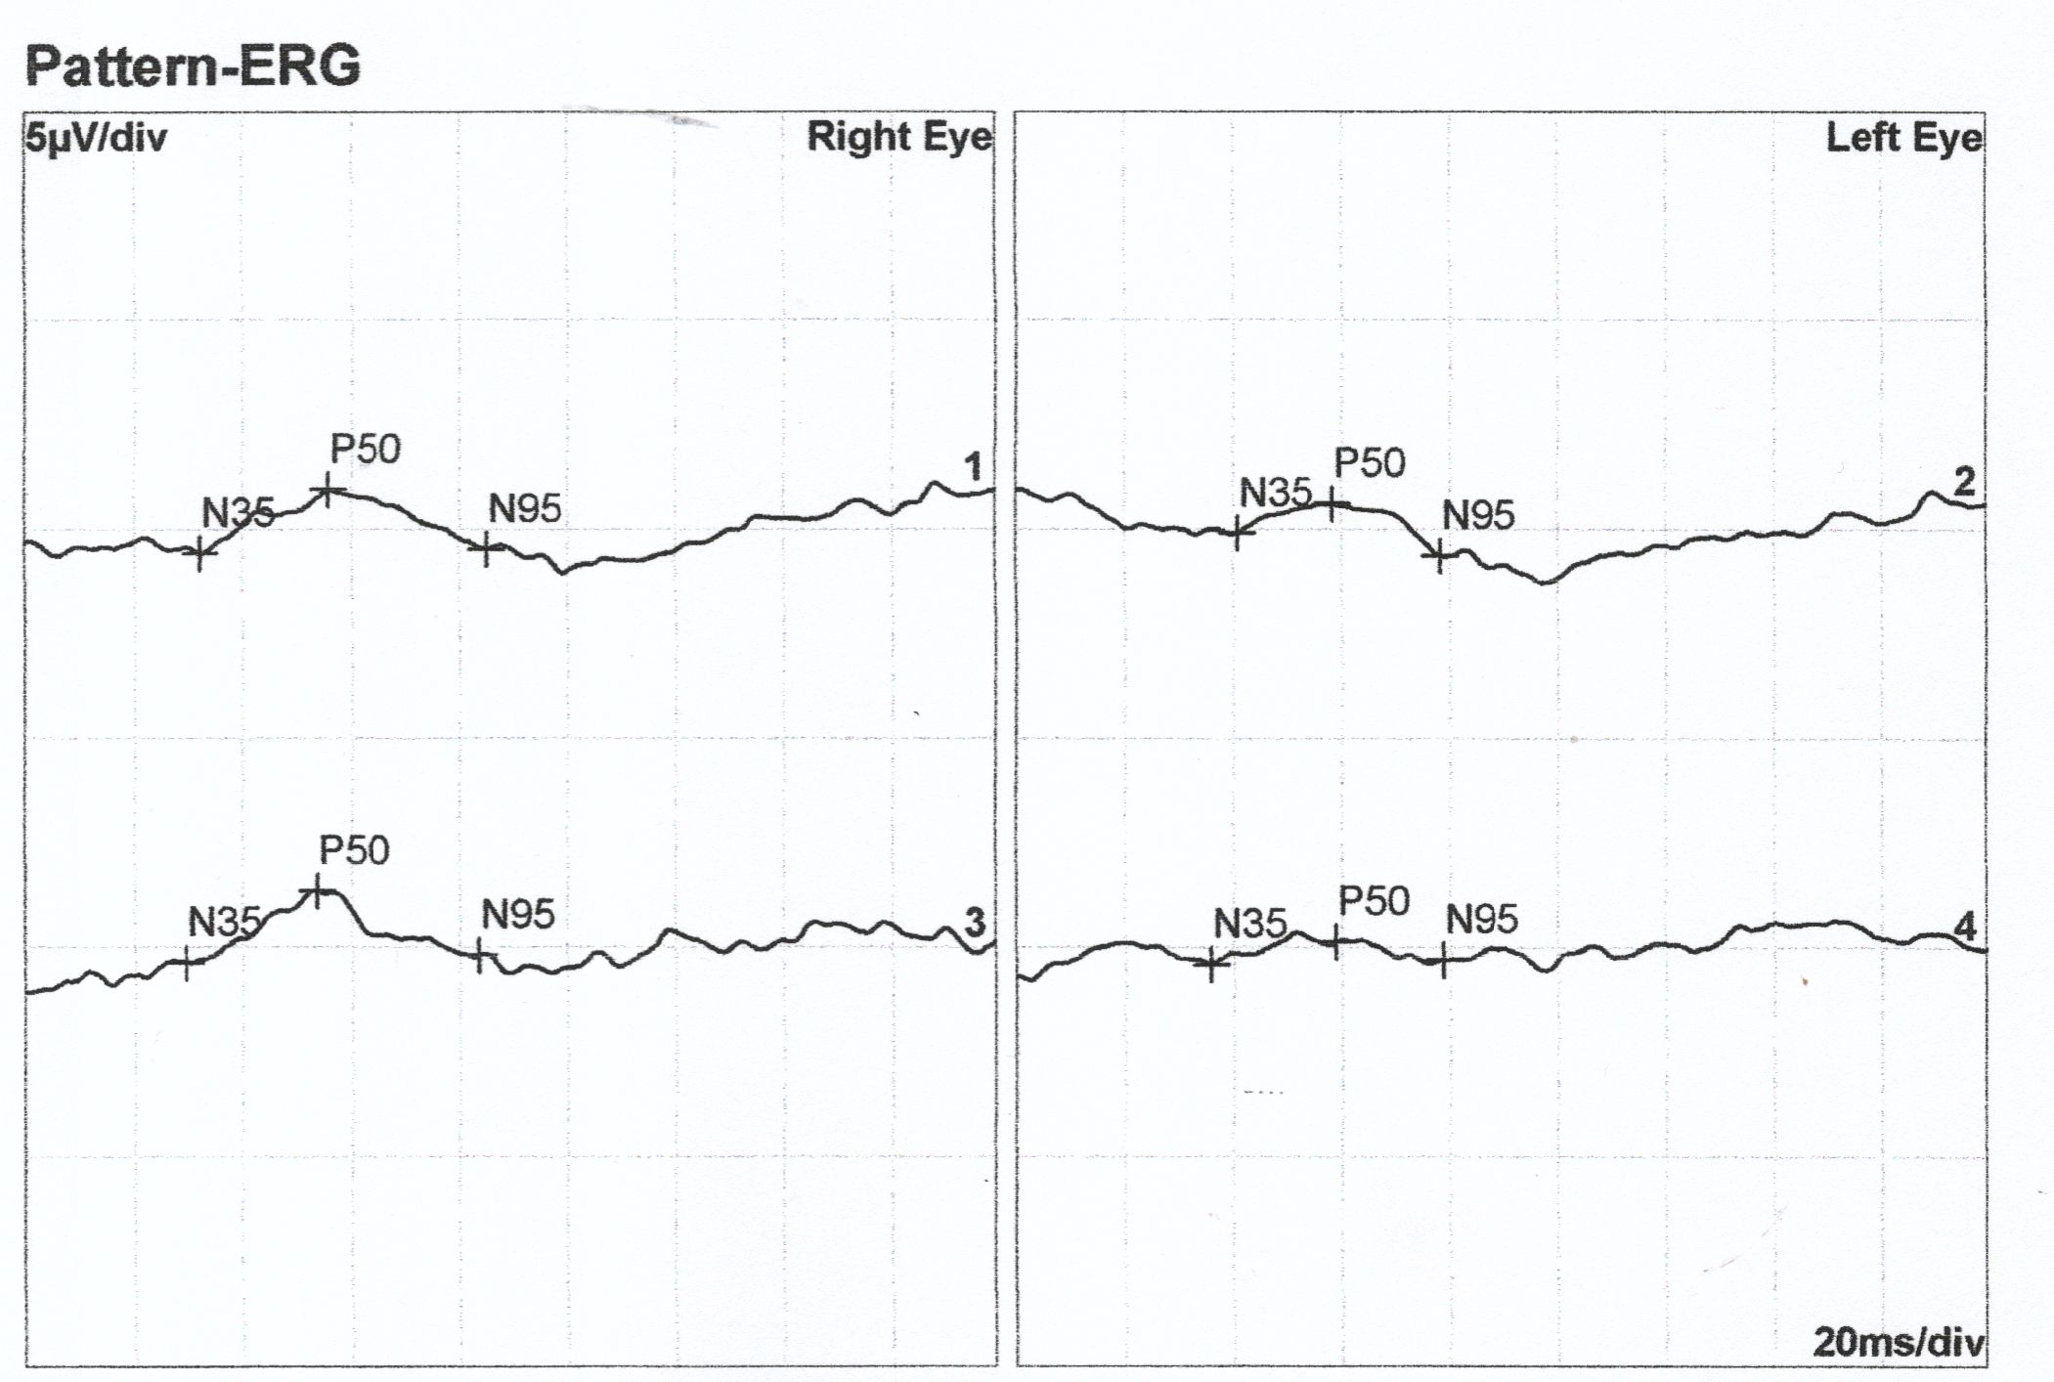
Figure S39. PERG recording of patient IV/2. Lines 1 and 3 and lines 2 and 4 represent pairs of replicate measurements.

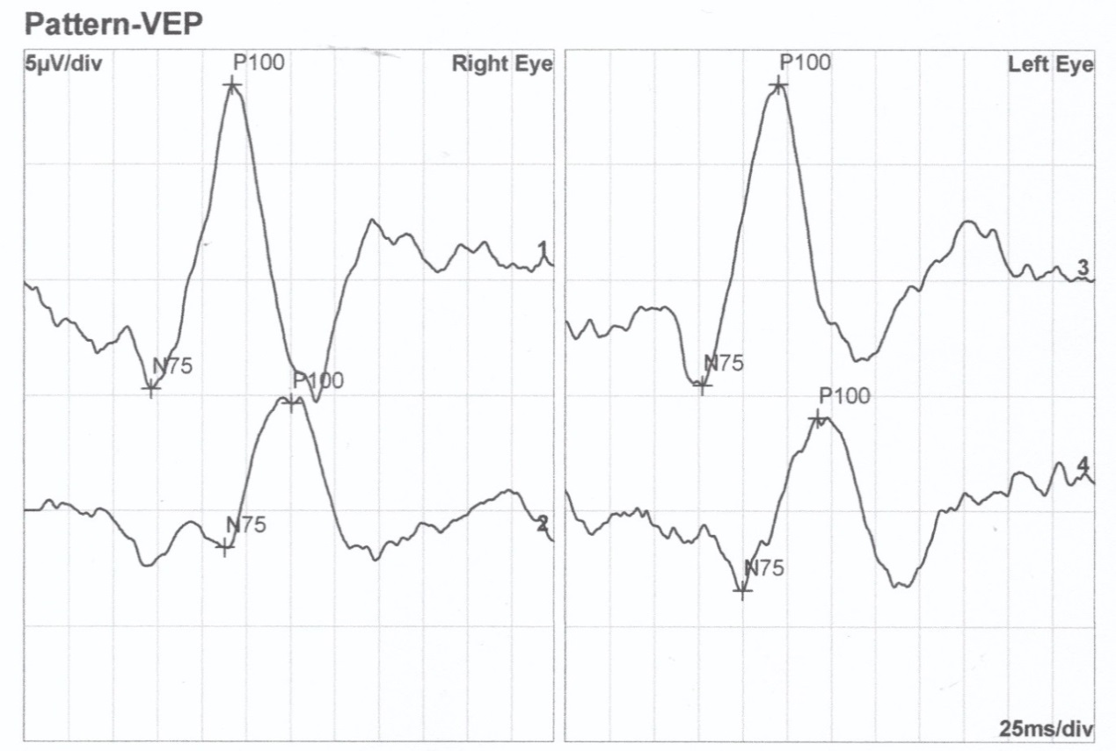
Figure S40. pVEP recording of patient IV/2. Lines 1 and 3 display responses to 60' stimuli and lines 2 and 4 represent responses to 15' stimuli.

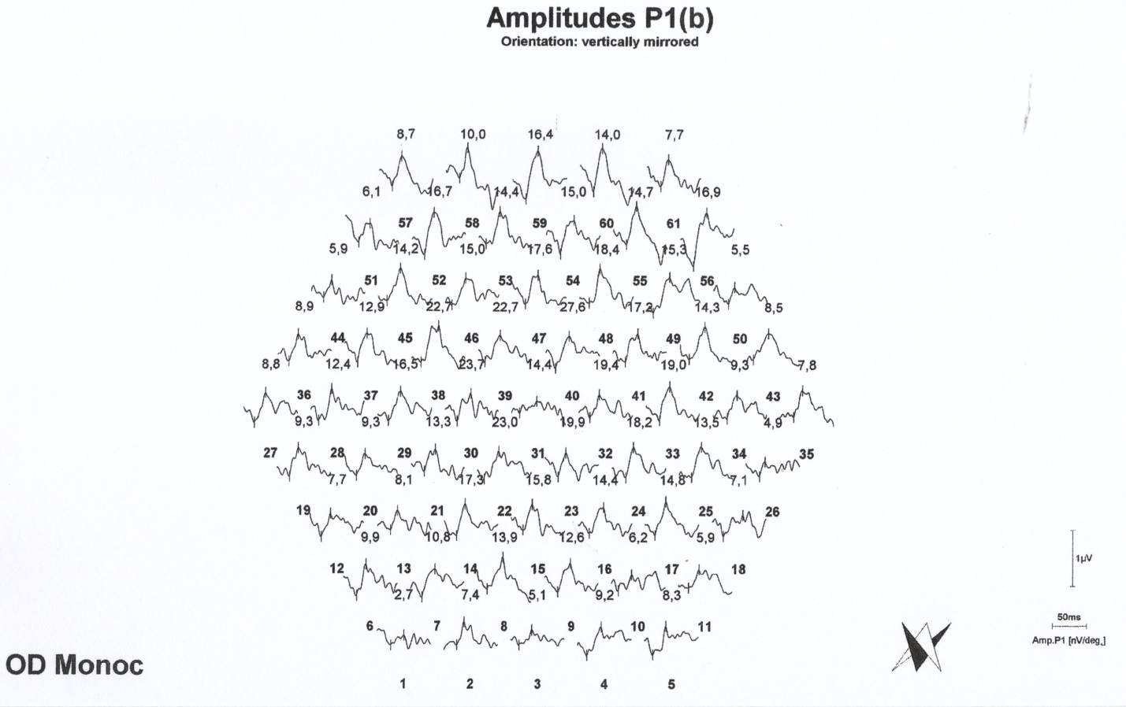
Figure S41. mfERG recording of patient IV/2, OD.

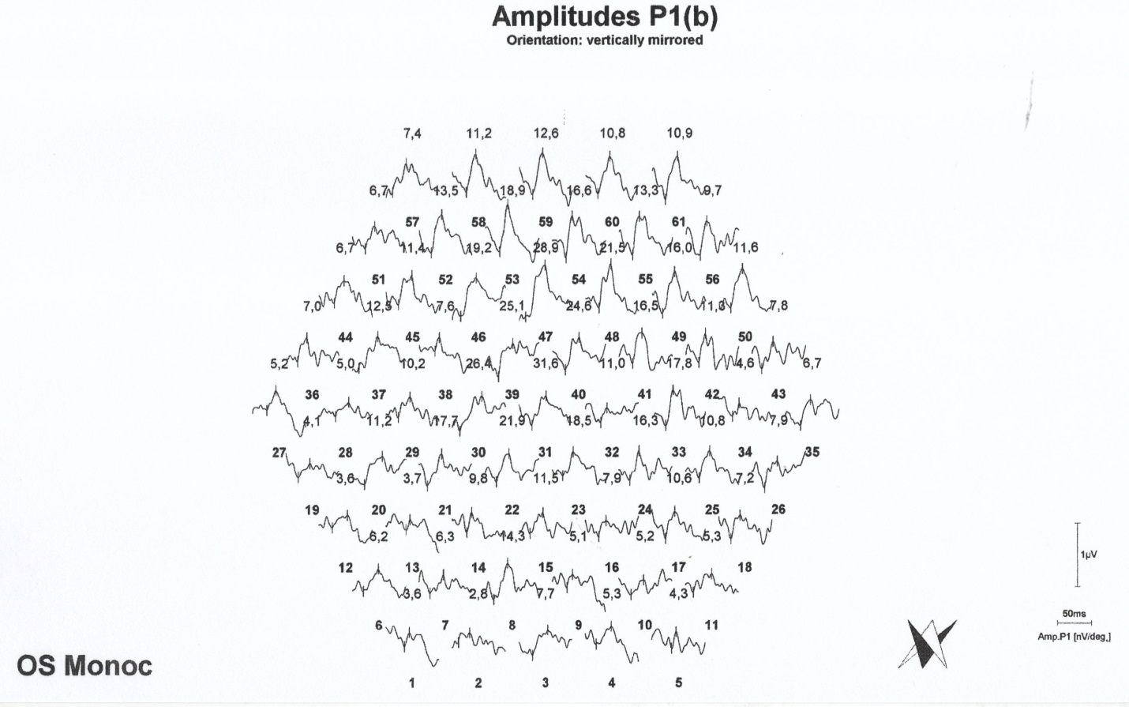
Figure S42. mfERG recording of patient IV/2,, OS.

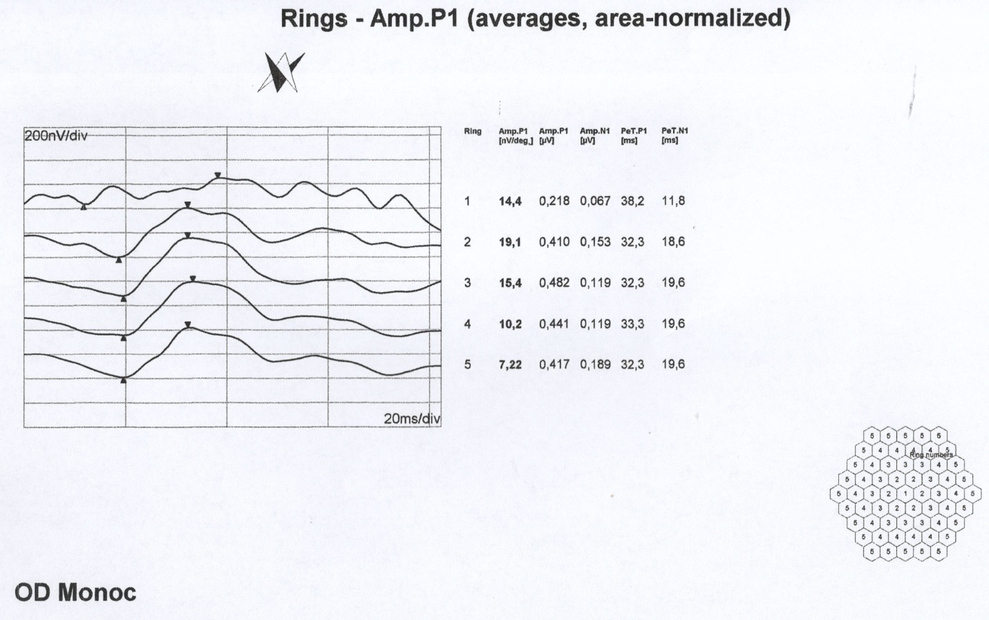
Figure S43. mfERG ring analysis of patient IV/2, OD.

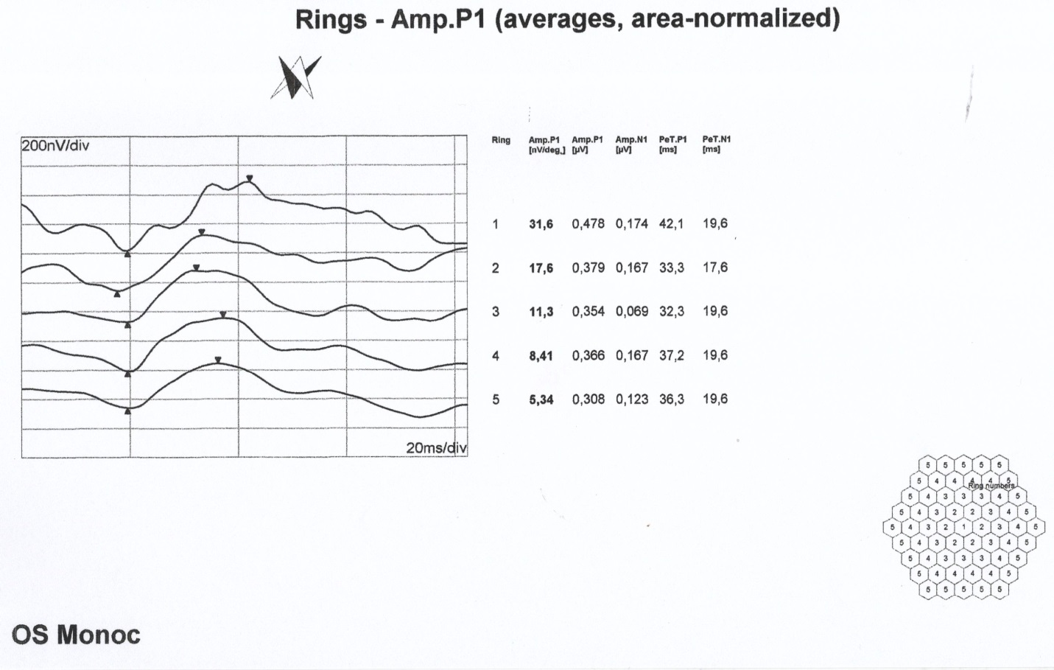
Figure S44. mfERG ring analysis of patient IV/2, OS.

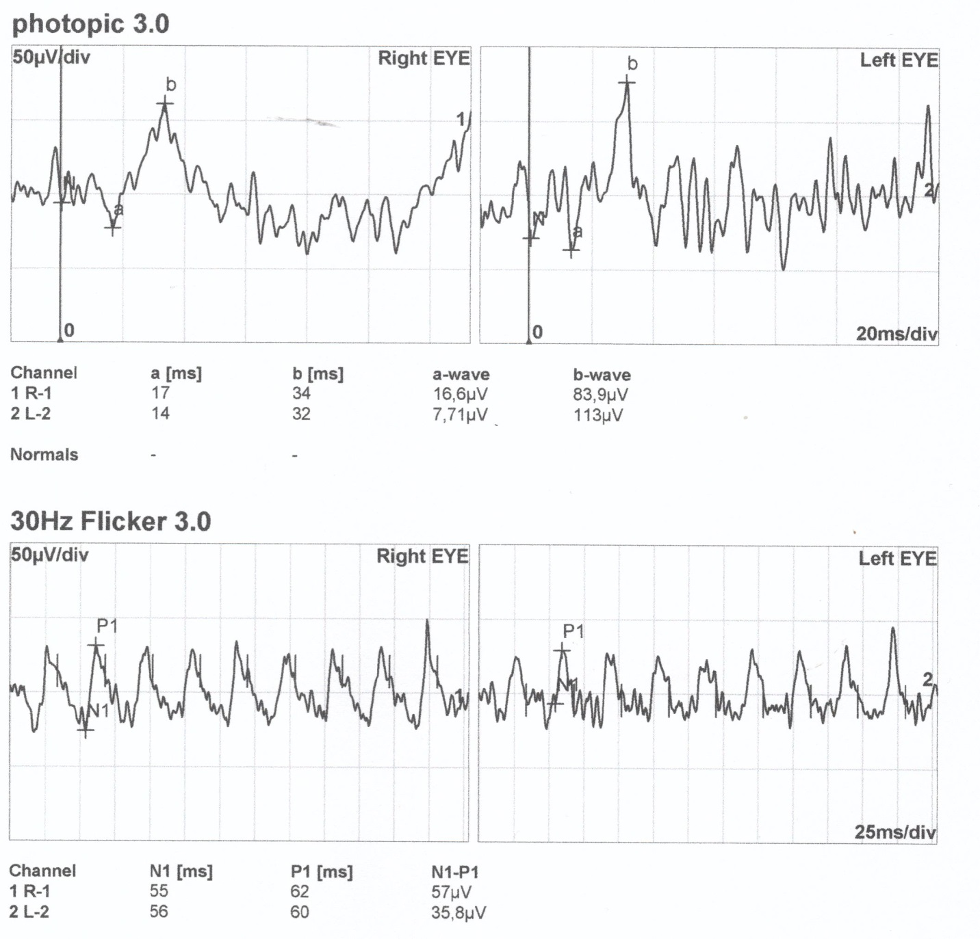
Figure S45. Standard full-field ERG recording of patient IV/6.

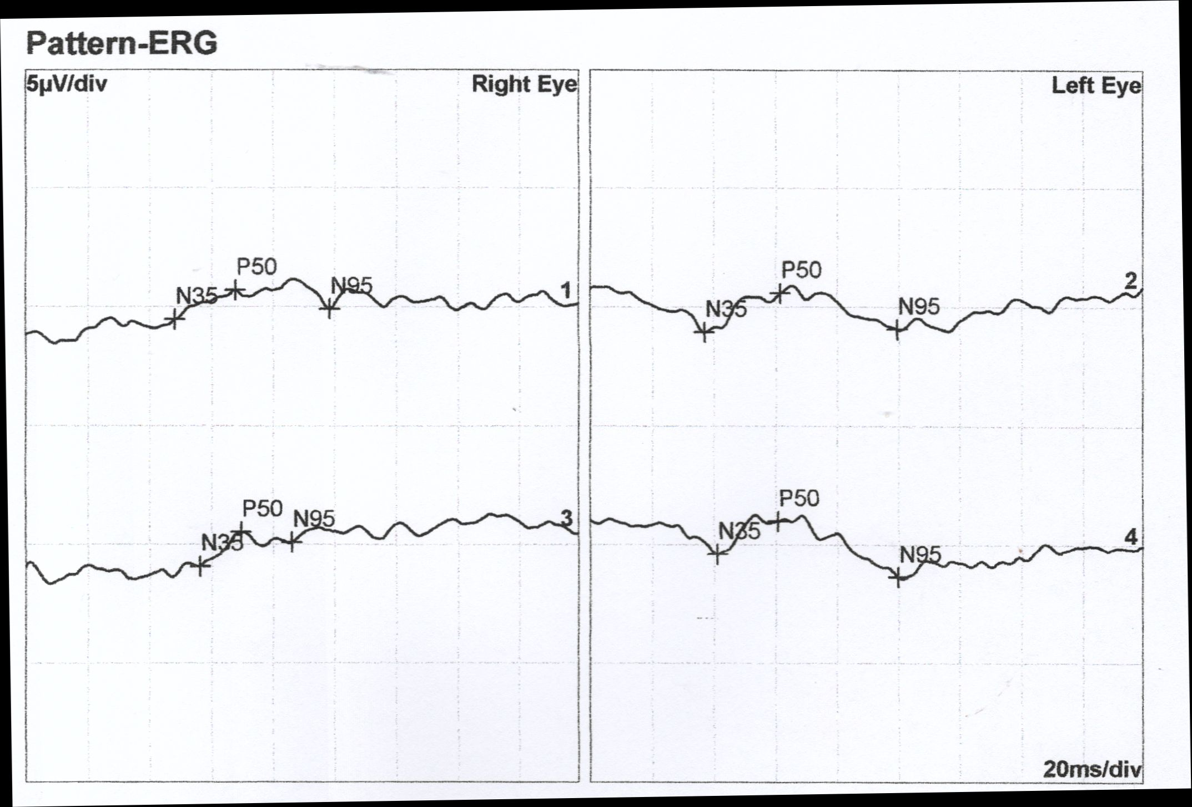
Figure S46. PERG recording of patient IV/6. Lines 1 and 3 and lines 2 and 4 represent pairs of replicate measurements.

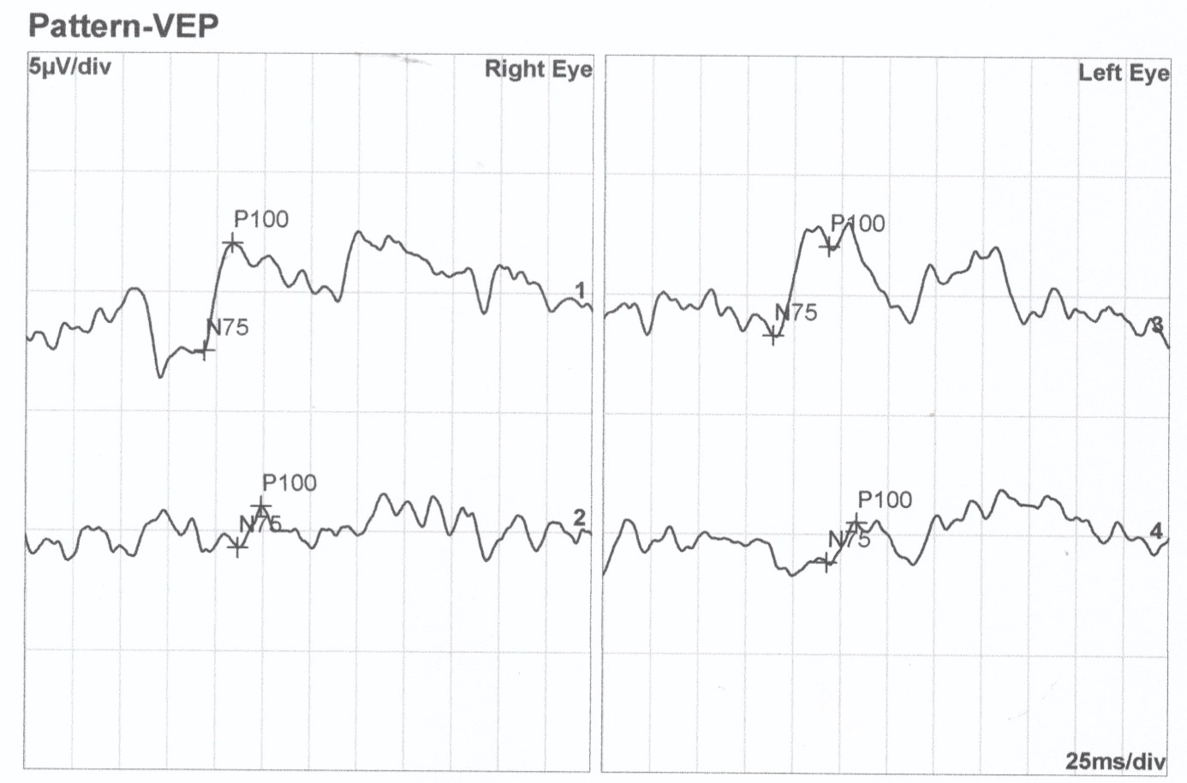
Figure S47. pVEP recording of patient IV/6. Lines 1 and 3 display responses to 60' stimuli and lines 2 and 4 represent responses to 15' stimuli.

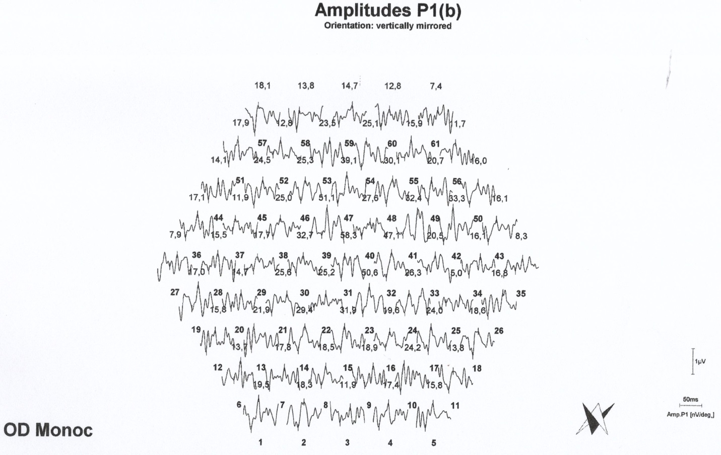
Figure S48. mfERG recording of patient IV/6, OD.

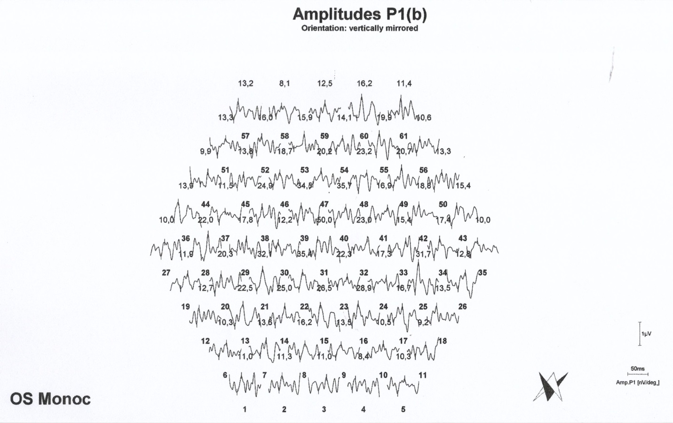
Figure S49. mfERG recording of patient IV/6, OS.

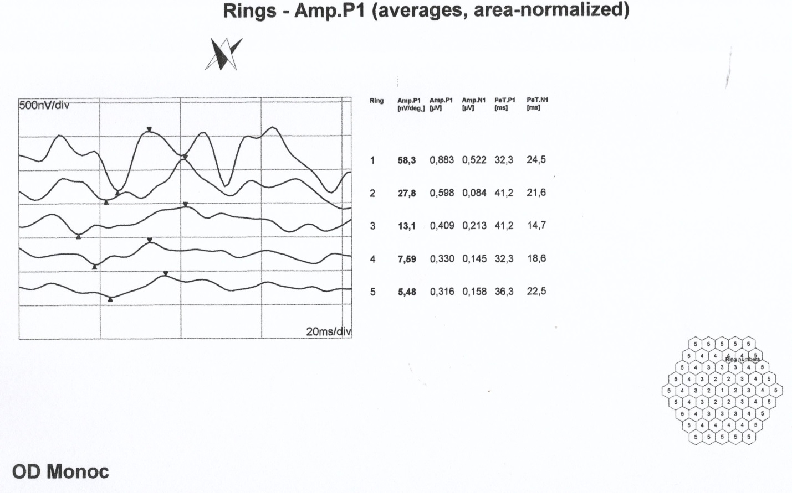
Figure S50. mfERG ring analysis of patient IV/6, OD.

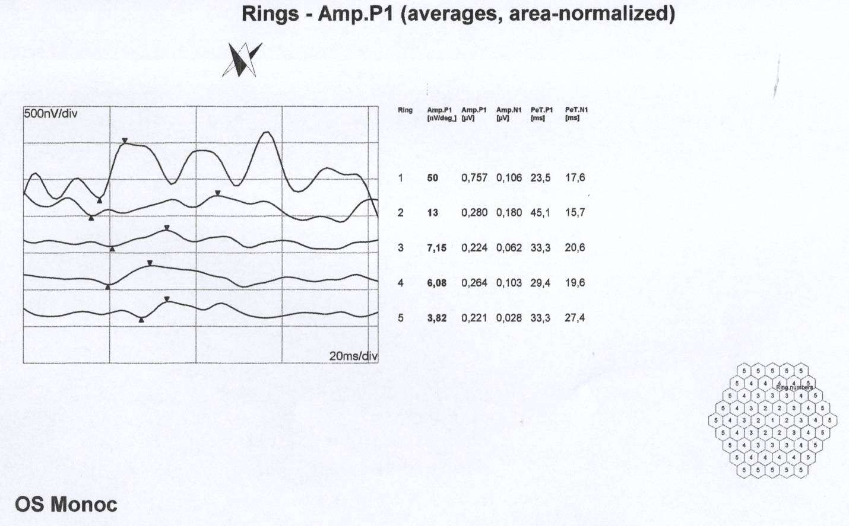
Figure S51. mfERG ring analysis of patient IV/6, OS.

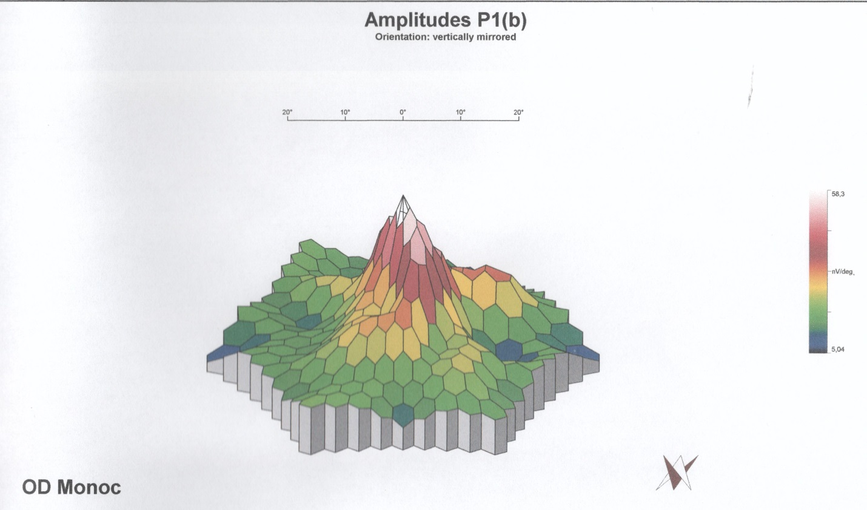
Figure S52. Multifocal ERG 3 D colour map of patient IV/6, OD

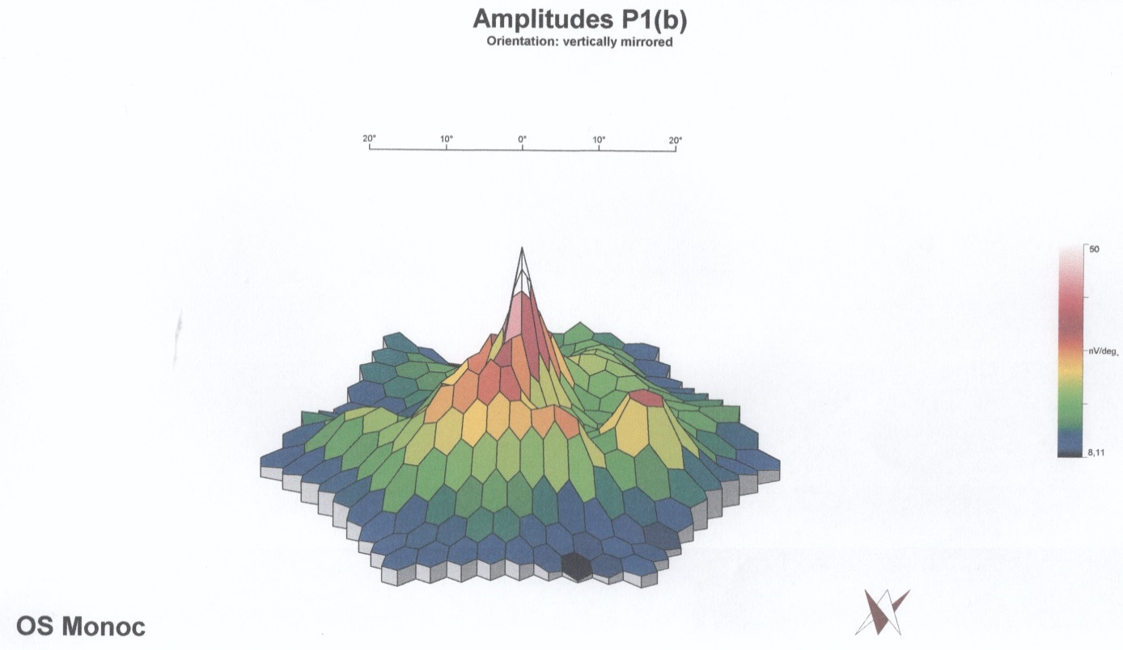
Figure S53. Multifocal ERG 3 D colour map of IV/6 severely myopic affected female left eye displays extensive subnormal responses within the whole central 30 degrees.

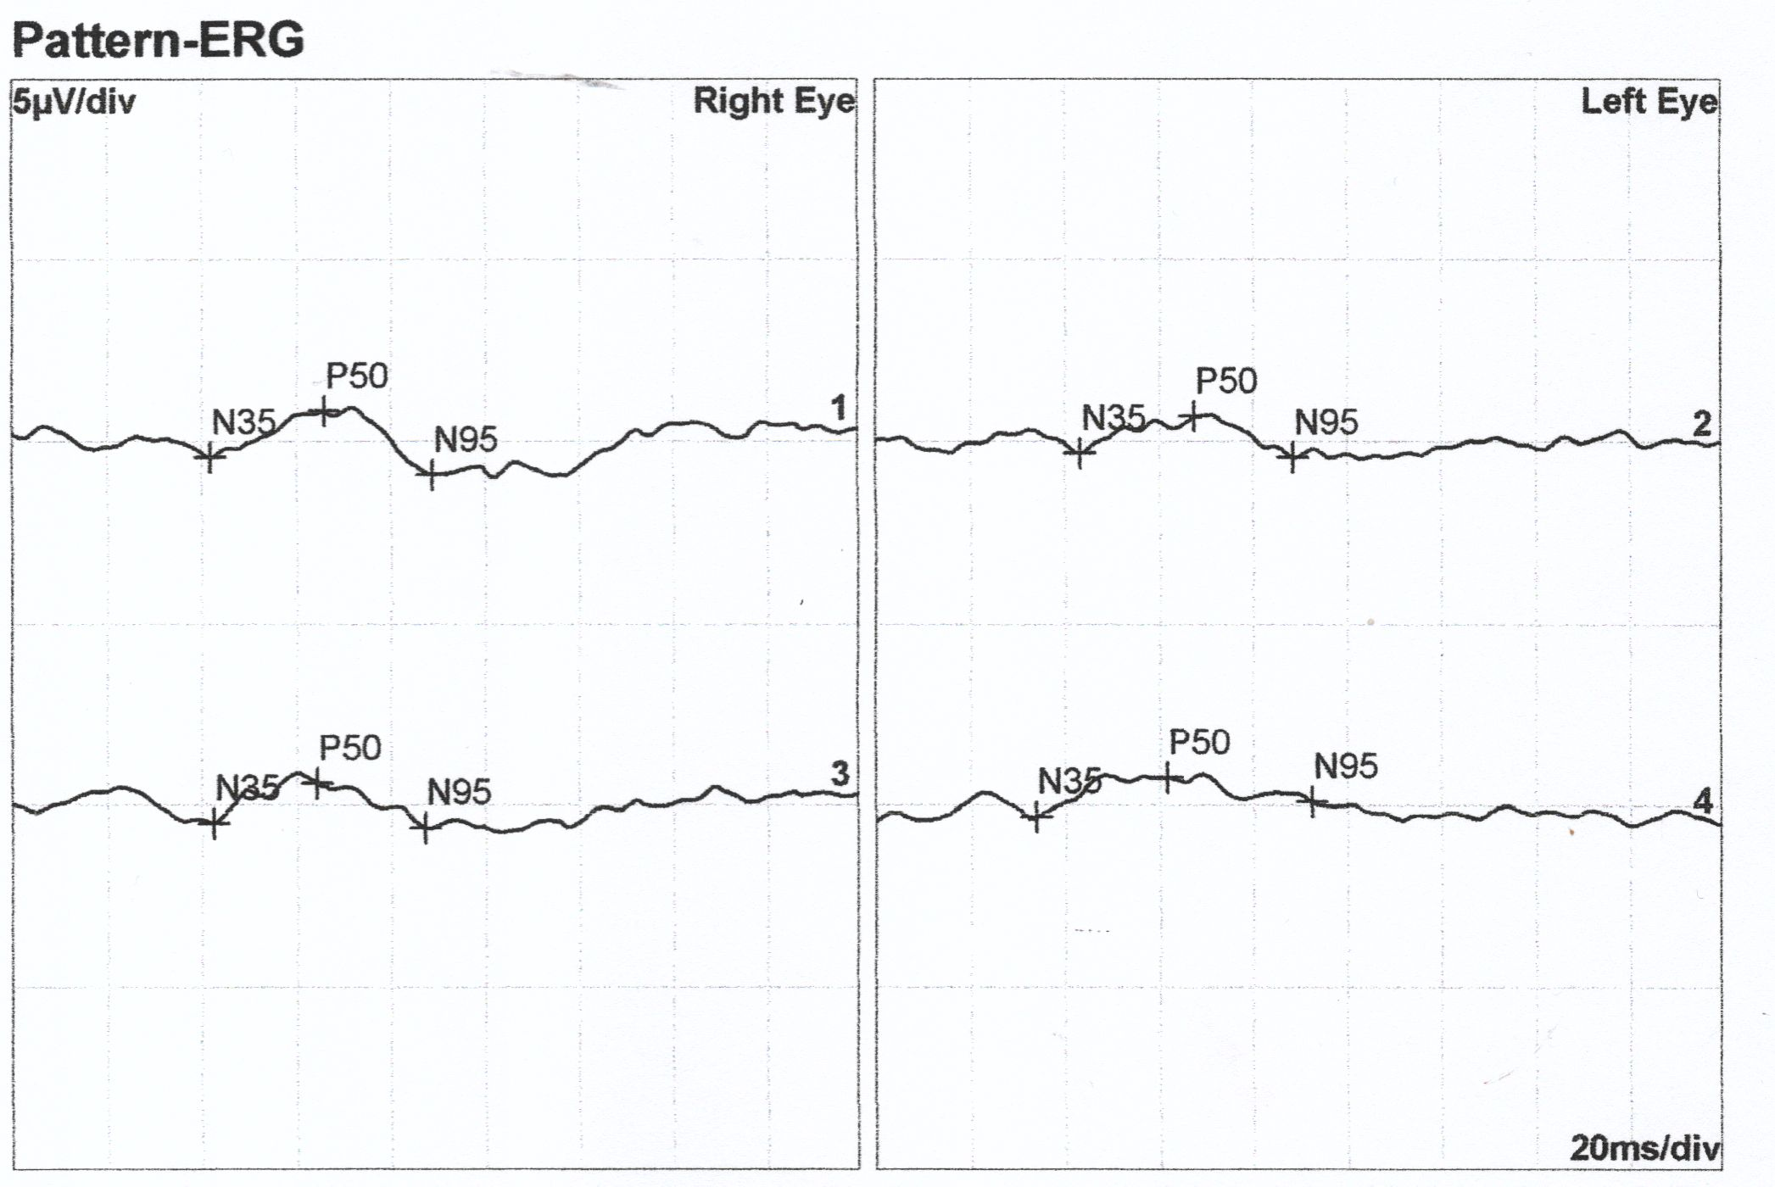
Figure S54. PERG recording of patient IV/10. Lines 1 and 3 and lines 2 and 4 represent pairs of replicate measurements.

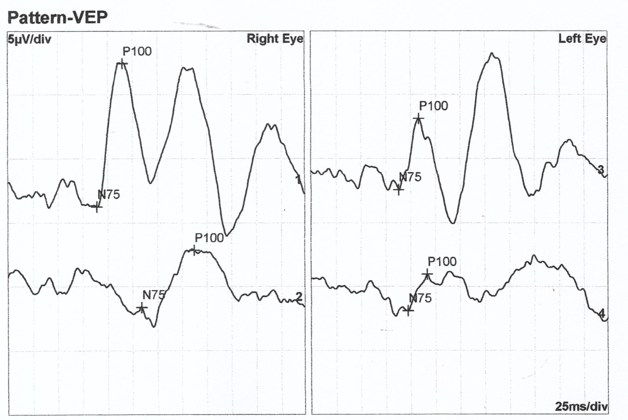
Figure S55. pVEP recording of patient IV/10. Lines 1 and 3 display responses to 60' stimuli and lines 2 and 4 represent responses to 15' stimuli.

