Additional file 1.

I. Supplementary figures
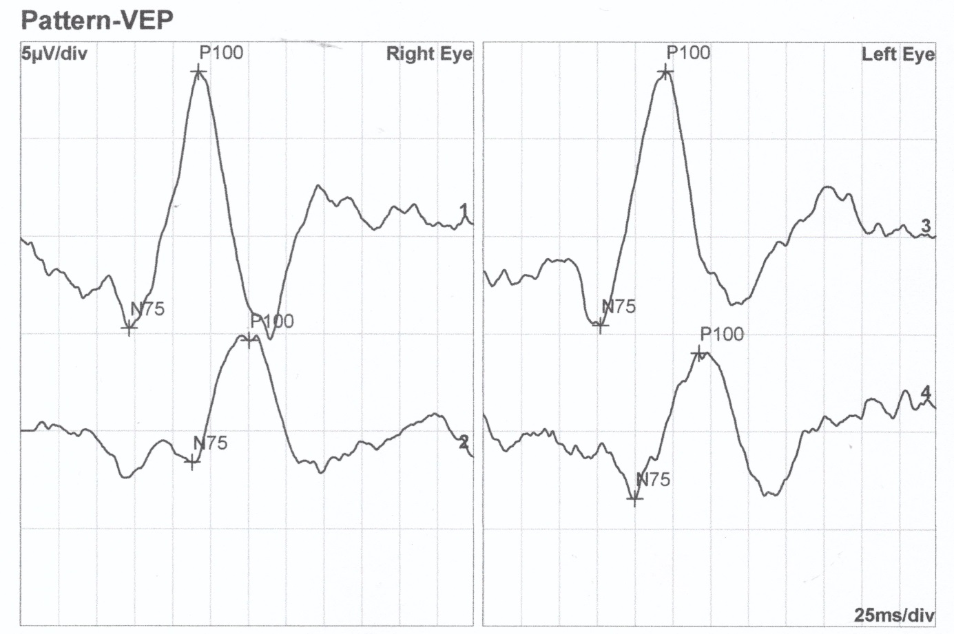
Figure S1. VEP recordings of IV/2 (moderately myopic) affected female display subnormal responses only for 15 min. stimulation (foveal region).

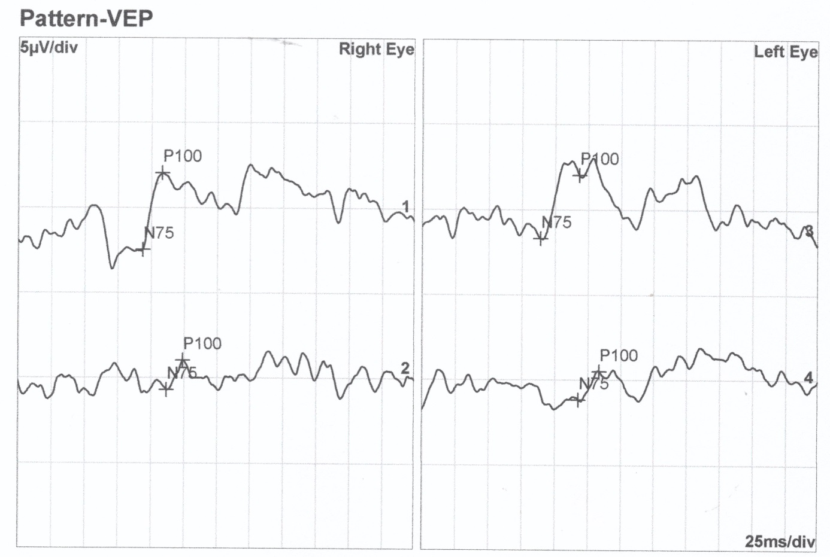
Figure S2. VEP recordings of IV/6 (severely myopic) affected female display a more extensive central dysfunction as for both 15 min. (foveal region) and 60 min. (perifoveal region) stimuli subnormal responses were detected.

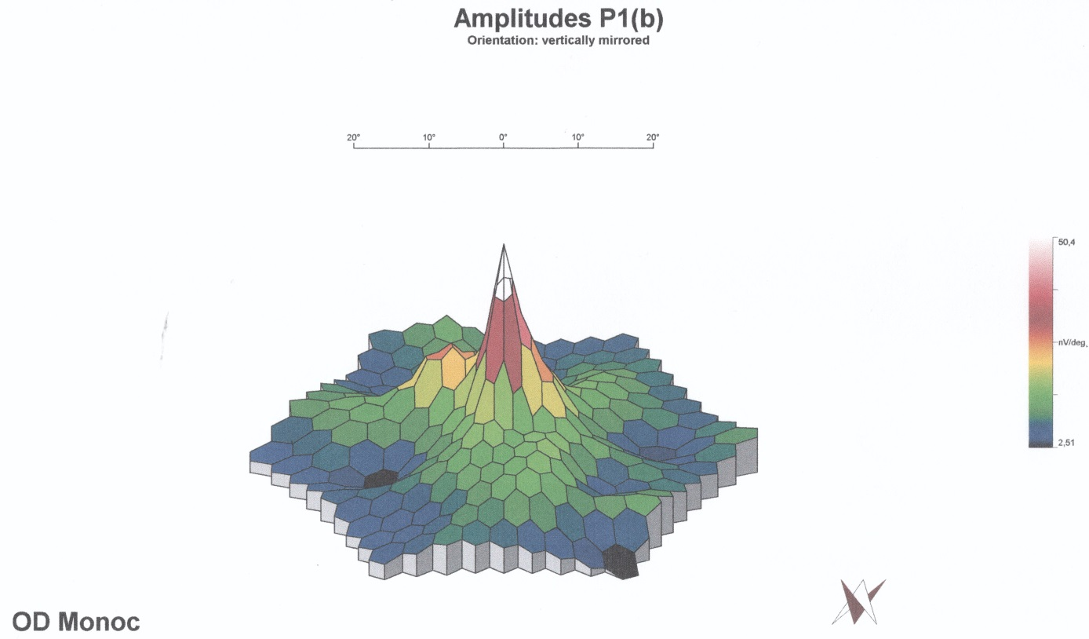
Figure S3. Multifocal ERG 3 D colour map of III/3 carrier male right eye displays overall normal central macular function with scarce subnormal responses only.

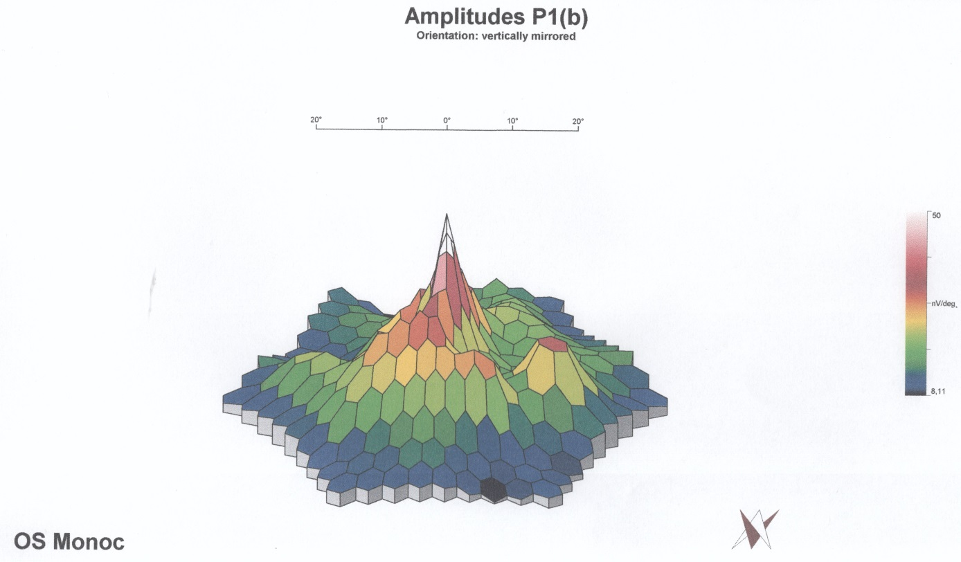
Figure S4. Multifocal ERG 3 D colour map of IV/6 severely myopic affected female left eye displays extensive subnormal responses within the whole central 30 degrees.

II. Supplementary methods
Electrophysiology methods

Standard full-field and multifocal ERGs were performed with fully dilated pupils, after half an hour dark adaptation for standard ERGs. For multifocal ERGs (mfERGs) the stimulus consisted of 61 scaled hexagons covering the central 30◦ of the visual field. DTL fiber corneal electrodes were used to detect electric signals for the ERGs (standard, multifocal and pattern). Black and white reversal checkerboard stimulus was used for pattern visual evoked potential (VEP) and pattern ERG (PERG) tests, the check size was 60ʼ and 15ʼ for VEP and 48ʼ for PERG recordings, respectively. Refractive errors were corrected for the viewing distance before mfERG, PERG and pattern VEP tests.

III. Supplementary discussion
IOP (intraocular pressure)
We only had the possibility to measure IOPs in one session, therefore- taking in consideration the known fluctuation of IOP- we cannot be sure whether these values are the lowest, highest or medium ones for the patient. At the same time, evaluation of IOPs in high myopic patients is rather questionable, because of the high rate of false negative values due to the characteristically thinner corneas of these patients. Therefore these values should be evaluated critically.
VFD (visual field defects)
As opposed to single measured IOPs, VFDs reflect a more stable condition as the consequence of a longer period of possible glaucomatous damage.
We planned to carry out automated kinetic full-field perimetry as a gross „screening” test of high myopic visual field defects in our patients. Nevertheless, we found visual field defects (VFD) not characteristic of high myopia (HM), rather of age-related POAG. We concluded this for two reasons: i) VFDs showed a significant deterioration with older age (such progression is not characteristic for HM) and ii) VFDs were most prominent nasally (characteristic of glaucomatous VFD) and not temporally as could have been expected for high myopia [1, 2].

Electrophysiology

PatternVEP
Visual cortex is activated primarily by the central visual field, VEPs are therefore the representations of the central macular region and depend on the functional integrity of central vision at any level of the visual pathway. 15 min and 60 min stimuli responses represent the foveal and the larger perifoveal regions, respectively. VEP abnormalities are not specific, however, and can occur in a wide variety of ophthalmological and neurological conditions [3].
VEP is also known to be heavily affected by refractive error, especially if uncorrected and associated with poor VA or amblyopia [4]. Our patients’ VEP recordings were in accordance with the above statements: they correlated on one hand with the degrees of myopia (SE and VA) and the corrected- uncorrected refractive error status : IV/1 and IV/2 showed the best results and IV/6, 7, 8 and 10 (higher degrees of uncorrected myopia) the worst. III/3 could have subnormal responses due to his strabismic amblyopia.
Another point of note is that for small checks (15 min) all affected patients showed a reduced amplitude or longer latency, in addition to this, individuals with higher degrees of myopia and poor VA (IV/6, 7, III/8 and IV/10) –suggesting a more extensive macular damage- showed reduced responses for larger checks (60min) as well.
Overall, VEP alterations are likely to be attributable to high myopia along with uncorrected refractive error status or strabismic amblyopia in our patients and represent a central macular deficit on a post-retinal level.

Pattern ERG
PERG is dominated by inner retinal, i.e. ganglion cell activity in the central macular area, and therefore it allows for direct assessment of ganglion cell function of the central retina. Of all electrophysiological investigations pattern ERGs were most uniformly and unequivocally affected in our patients. As opposed to VEP or multifocal ERG recordings, all patients showed similarly diminished responses to pattern ERG stimuli independent of their degree of myopia, corrected-uncorrected refractive status or affected or carrier genetic status. Along with the normal responses of the healthy unaffected individual, these findings are highly indicative of a ganglion cell involvement in all affected and carrier patients.

Standard full-field ERG
The first three ERG recordings under scotopic conditions represent the rod system, i.e. the function of a broader retinal area than the cone driven photopic recordings, which represent the central foveal area occupied exclusively by cones. Cone photoreceptor function is therefore best assessed by photopic ERG recordings to single flash and flicker stimuli.
Out of 4 affected and one carrier patients, scotopic responses were subnormal in two patients, those with higher degrees of protractedly uncorrected myopia (IV/6,7).
Photopic ERG responses, however, were overall unequivocally normal in all 5 patients, indicating an overall normally functioning cone system and not a general cone system involvement in the form of either cone dystrophy or generalized cone system dysfunction, as it was proposed in accordance with ARR3 mutation in animal models [5].

Multifocal ERGs
According to multifocal ERG recordings, the whole macular area within the central 30 degrees was severely affected only in patients IV/ 6 and IV/7, which is in concordance with severe macular involvement evidenced similarly in these two patients with 60 min VEPs. (These two patients have the highest degrees of protractedly uncorrected myopia along with most diminished visual acuity and myopic fundus alterations.) Whereas for patients IV/1 and IV/2 (with smaller degrees of myopia, good visual acuities and no retinal degenerations) mfERG alterations were less pronounced, which is again in accordance with the VEP recordings (subnormal responses only for smaller 15 min checks, but not for 60 min checks).

Colour Vision Testing

Colour vision results were inconsistent in our patients. Certain subgroups and individuals of the bigger family showed colour vision defects, while others not, irrespective of gender, age or genetic status. Carrier and healthy control male patients similarly displayed colour vision defects. These defects, at the same time, seemed to be diffuse colour discrimination errors (that is not specific for any distinct colour). We therefore could not draw a general conclusion from these test results.

1. Nitta K, Sugiyama K, Wajima R, Tachibana G. Is high myopia a risk factor for visual field progression or disk hemorrhage in primary open-angle glaucoma? Clin Ophthalmol. 2017;11:599-604.
2. Ballon BJ, Echelman DA, Shields MB, Ollie AR. Peripheral visual field testing in glaucoma by automated kinetic perimetry with the Humphrey Field Analyzer. Arch Ophthalmol. 1992;110:1730-2.
3. Odom JV, Bach M, Brigell M, Holder GE, McCulloch DL, Tormene AP, et al. ISCEV standard for clinical visual evoked potentials (2009 update). Doc Ophthalmol. 2010;120:111-9.
4. Jang J, Kyung SE. Assessing amblyopia treatment using multifocal visual evoked potentials. BMC Ophthalmol. 2018;18:196.
5. Deming JD, Pak JS, Brown BM, Kim MK, Aung MH, Eom YS, et al. Visual Cone Arrestin 4 Contributes to Visual Function and Cone Health. Invest Ophthalmol Vis Sci. 2015;56:5407-16.

