Supplementary Materials for
Transient, accelerating slow slips drive the Preparatory Process of the 2023 Mw 7.8 Türkiye Earthquake
Matteo Picozzi*, Antonio G. Iaccarino
*Corresponding author. Email: matteo.picozzi@unina.it

This file includes:
Fig. S1 and Fig. S2

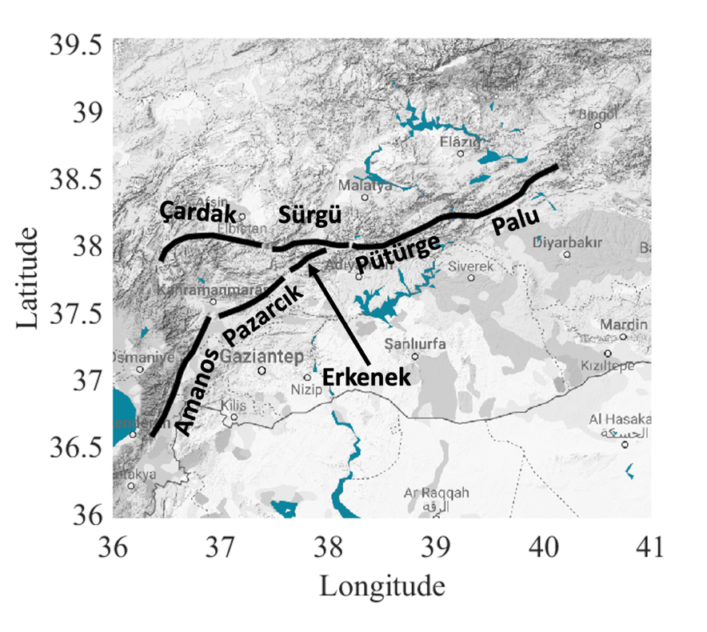
Fig. S1 Distribution of EAF’segmennts involved in the 2023 Mw 7.8 Nurdağı, the 2023 Mw 7.4 Ekinözül and the 2020 Mw 6.8 Elazığ earthquakes.

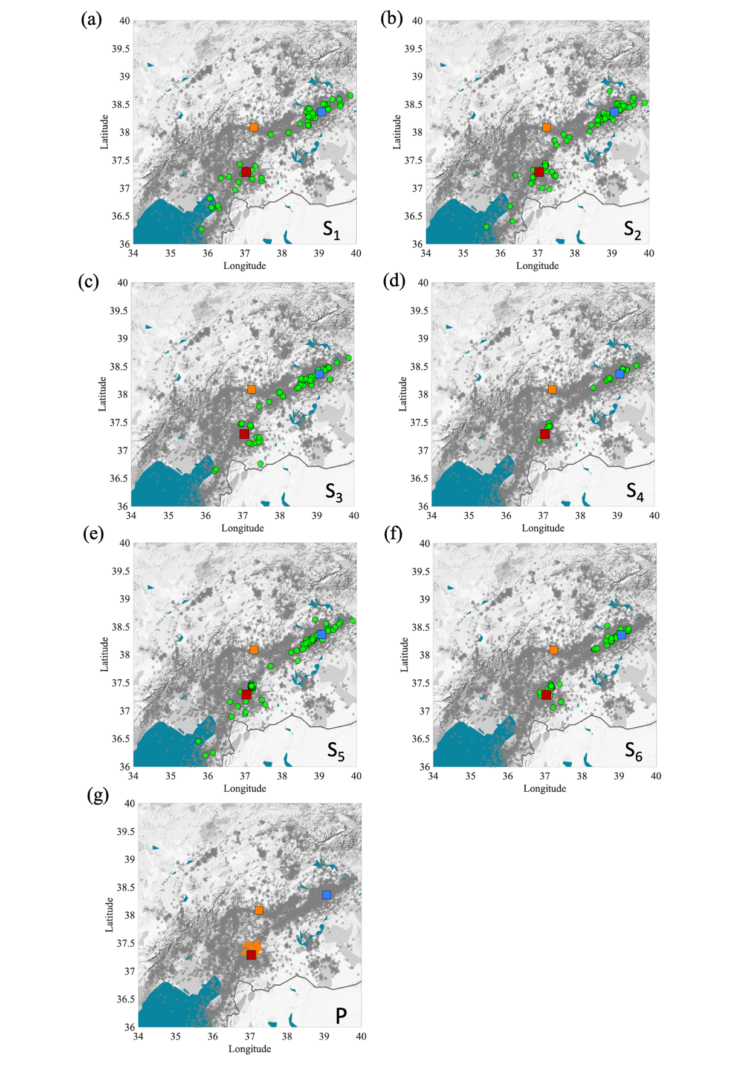
Fig. S2 Distribution of seismicity belonging to the slow slip episodes (from a to f) and preparatory phase (g). Earthquakes for each slow slip are highlighted in green with respect to the other events (gray), while events for the preparatory phase are orange. The 2023 Mw 7.8, 2023 Mw 7.5 and 2020 Mw 6.8 are highlighted as red, orange, and blue squares, respectively.

