Motives Guide

Purpose
Educating people about why they should wash their hands with soap rarely gets them to do it. That’s because there are many factors that affect the way our brains make decisions. Motives drive humans to do things that meet their short-term goals (such as putting on a coat if we are feeling cold) and their long-term goals (such as completing many years of education because we believe that knowledge can improve our status within society). Everyone has individual goals and dreams. But the motives that drive these goals and dreams are shared by all humans, irrespective of circumstances, culture, or beliefs. The reason we share these motives is because, throughout human history, we have passed on skills and behaviours that help us to live longer, more enjoyable, and more productive lives. The Motives tool will help you to identify what is driving handwashing behaviour, or preventing it, in your context. It will also identify motives that shape people’s identity and other behaviours. You will use these motives to develop a motivational story for your handwashing intervention.

Requirements

Time
20-40 minutes per focus group discussion

Format
A minimum of two focus group discussions (FGDs)

Participants
Form one focus group with approximately seven women and conduct a separate one with seven men.

Tip: Try to make sure that the people in each FGD are similar. Mixing men and women, or young people and older people can affect power dynamics and make some participants reluctant to speak.

Materials
- Motives character cards (at the end of the guide)
- Motives consent script (at the end of the guide)

Roles
- Facilitator: One person to facilitate the activity and discussion
- Scribe: One person to fill in the worksheet to capture key information from the participants
- Analysis team: Several team members to analyze and discuss the findings

Data Collection

Preparation
- The character cards should be translated into the local language in the blank space provided.
- Print and cut out each of the character cards.
- Print the Motives worksheet.
- Read the separate Tips for Effective Focus Group Facilitation guide in the Quick Tips section of the website.
- Rehearse the activity with a team member.

Consent
Ask the participants for their consent:
- Introduce yourself.
- Explain what you are doing and why.
- Briefly describe the activity.
- Tell participants how you will use their information.
- Assure them of confidentiality.
- Explain that there will be no consequences if they do not wish to participate.
- Ask participants if they are willing to participate.
(See a sample consent request script at the end of this guide.)

Activity
- Locate an appropriate space to conduct the FGD. Try to find somewhere that is private and conveniently located for the participants.
- Outline the rules for the FGD to participants, explaining there are no right or wrong answers to anything they are asked. Ask them to be respectful of all opinions and not to interrupt or talk over one another. To encourage everyone to share freely, request that they do not share what was discussed with anyone outside of the group after the session.
- Briefly introduce each of the characters on the character cards and explain what each card is showing. Then, put each card down in the middle of the focus group circle. The images on each card are designed to represent a character, but may not be obvious without explanation. It is your job to fully explain the character to the participants by reading the small print written on each card. Do not ask the participants to tell you what they think the character is, as doing so could create confusion.
- When all the cards are spread out on the table, check that the participants remember the characters. Show one card at a time and ask participants, “What is this character?” This step is particularly important for participants who cannot read or write.
- Ask the participants to rank the character cards from the person they think is most likely to always wash their hands with soap to the person who they think is least likely to practice handwashing with soap. Make sure everyone is involved in developing the ranking order.
- Once the order is finalized, go through each card and ask why they ranked each character where they did.
- Wrap up the activity by asking two additional questions:
- Which of the characters would you aspire to be like?
- Which character do they currently feel most like?

For both of these questions make note of the two most commonly mentioned characters. You may need to get people to vote for their preference.

- Thank the participants for their time.

Scribe
- Record the final ranking of the characters on the Motives worksheet. You may want to take notes on any interesting comments the group makes.
- For the last two questions, write down the two most commonly mentioned characters for each question.

Analysis
- Discuss with your colleagues any surprising opinions that emerged from the discussion.
- When you return to the office, open the project you have created in the Wash’Em software. Follow the instructions as you enter the ranking and your results from each of your focus groups into the Wash’Em software.
- The Wash’Em software will highlight key patterns emerging from your data. Read the section analysis to learn how to interpret these results and which behaviour change challenges to focus on.

Recommendations
- After entering the results from all the tools you’ve used, click on the Generate Recommendations button in the Wash’Em software.
- As a team, discuss the recommendations and how you plan to implement them.
- Discuss how you can incorporate what you learned from the Motives tool in the motivational story. For example, you may have discovered the characters most likely to wash their hands were
a someone who is respected because of their politeness,
b someone who is respected because of their education or wisdom, or
c someone who values having lots of friends.

Based on this finding you could develop a motivational story that utilizes or heightens these motives.

Sample Motivational Story
A young man is leaving the toilet and forgets to wash his hands. He sees the village leader passing by and runs over to shake her hand, because handshaking is a way of showing respect in his culture. However, the village leader laughs and recoils in disgust. The young man is confused. But then, out of the corner of his eye, he sees another man leaving the toilet. The other man washes his hands thoroughly with soap as he leaves the facility and even stops to breathe in the fresh perfumed smell of his hands. Seeing the village leader, he too walks over to greet her. This time, the village leader smiles and welcomes the man warmly. “Ahh!” thinks the young man, “How foolish of me not to wash my hands with soap. Shaking hands when your hands are dirty is disrespectful.”

Tool Limitations
This exercise relies on stereotypes of people. Real people do not have only one characteristic. Dealing with an abstract character may also be confusing for participants. To reduce confusion, make sure you clearly explain what each character card is trying to depict.

Motives Consent Script
It is important your participants are provided with appropriate details about why you are collecting information from them, what will be required of them, and how the information will be used. When using the Motives tool, you can use the following explanation:
Hi, my name is_________and I work for_________organization. We are visiting your community/camp to learn more about people’s lives and behaviours here. If you are willing to help us, we would like you to be part of a group discussion where we will ask you and six others from your community about how this emergency (for example, displacement or a cholera outbreak) has affected the lives of people around here. The discussion will involve the use of picture cards and scenarios that we would like your opinions on. During the discussion, we will take notes. People in our organization will use the information. We will not share your information more broadly. We are not here to judge you, but to learn from you. The things we learn will be used to design programs that will help people in communities/camps like yours. There are no consequences to you or your family if you choose not to participate. Do you wish to participate?

Motives Cards

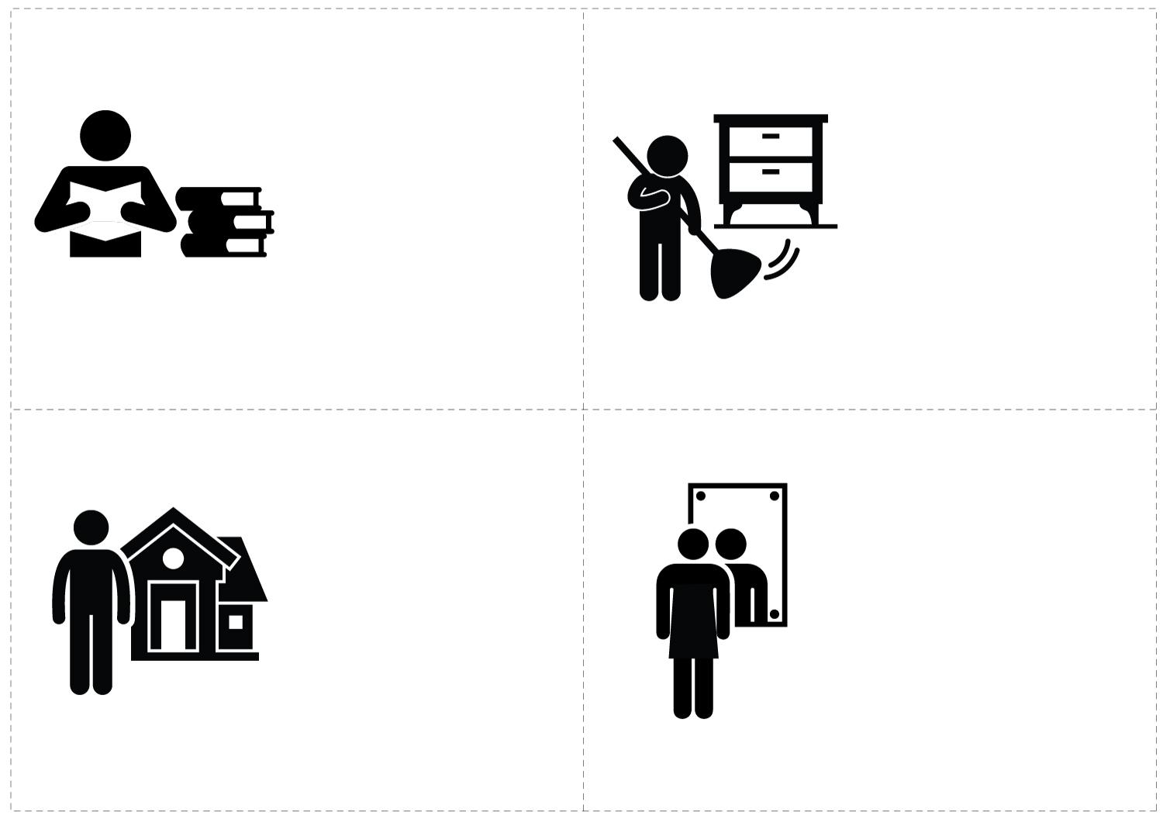
A person who is respected because of their education or wisdom

You can tell this because in the image they are reading lots of books.

A person who is neat and has their life in order

You can tell this because in the image they are busy sweeping and cleaning up their house.

A person who wants to look attractive

You can tell this because in the image they are looking at themselves in a mirror.
A person who is wealthy and has a nice house

You can tell this because in the image they are standing in front of a nice house.
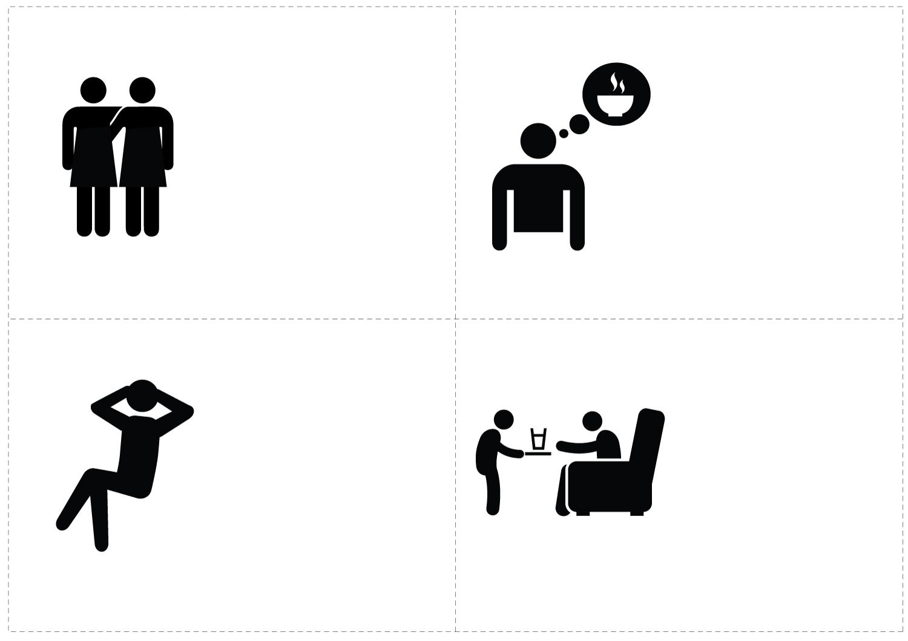
A person who wants to
be comfortable

You can tell this from the image because they are leaning back and looking comfortable.
A person who is hungry

You can tell this characteristic from the image because they are thinking about a meal.
A person who values having lots of friends

You can tell this from the image because they have their arms around each other like good friends often do.
A person who is respected because they are polite

You can tell this from the image because the person is serving a guest a glass of water.

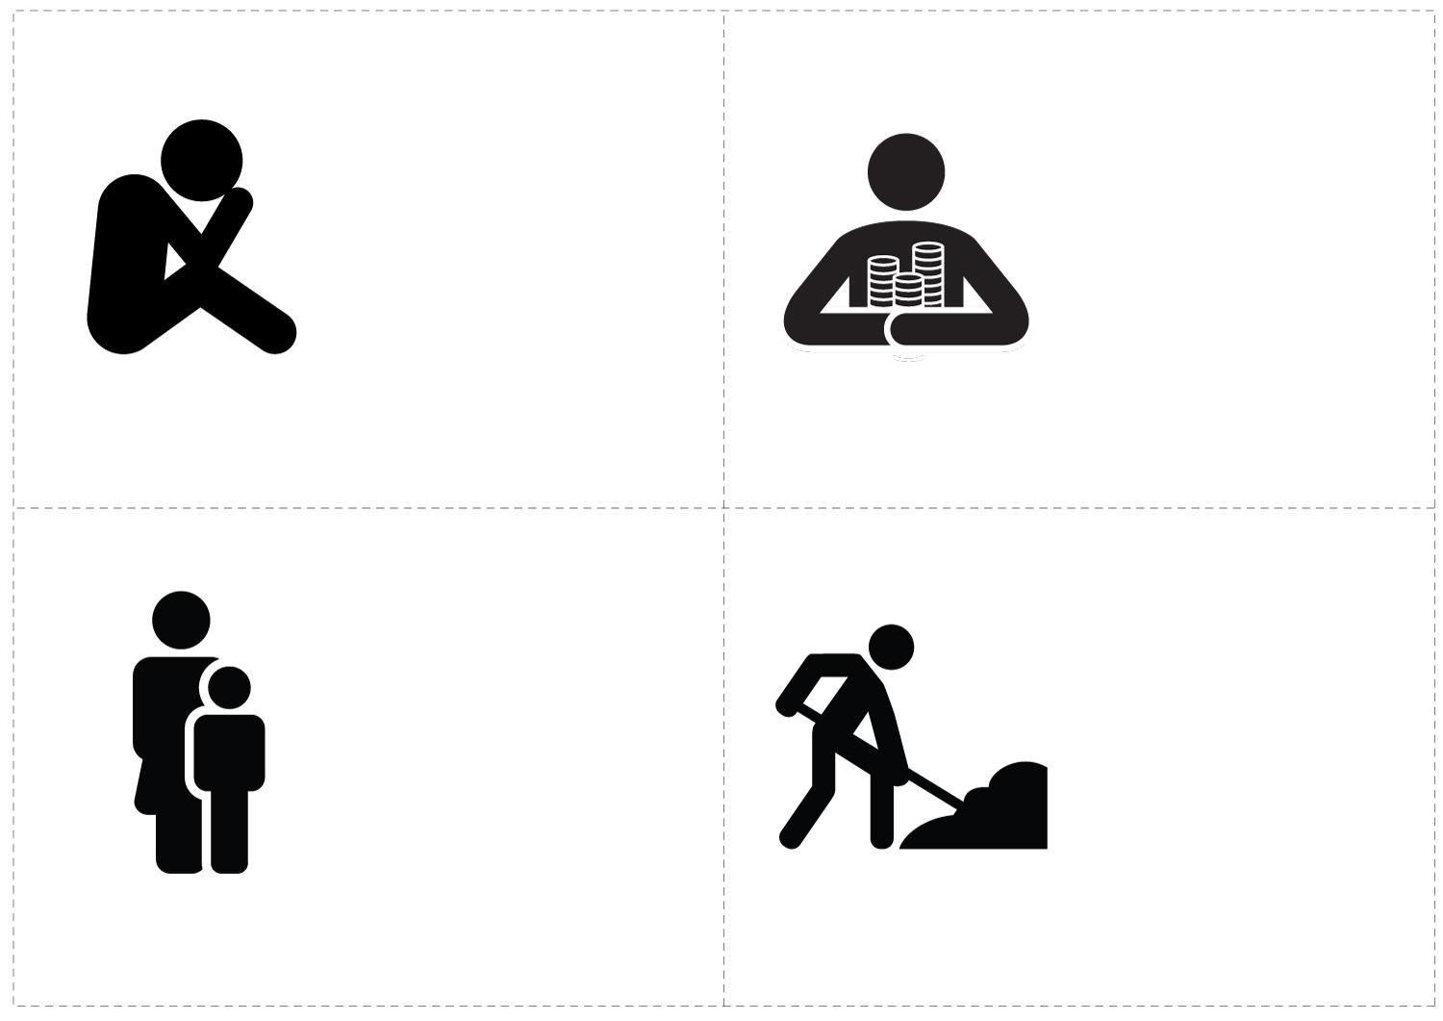
A person who is upset

You can tell this from the image because the person has their head in their hands and looks like they are crying.
A person who does not like to spend money or waste things

You can tell this from the image because they are holding on to their money.
A person who is a good parent

You can tell from the image because there is an adult and a child together.
A person who is a hard worker

You can tell this from the image because they are holding a shovel and digging in the earth.
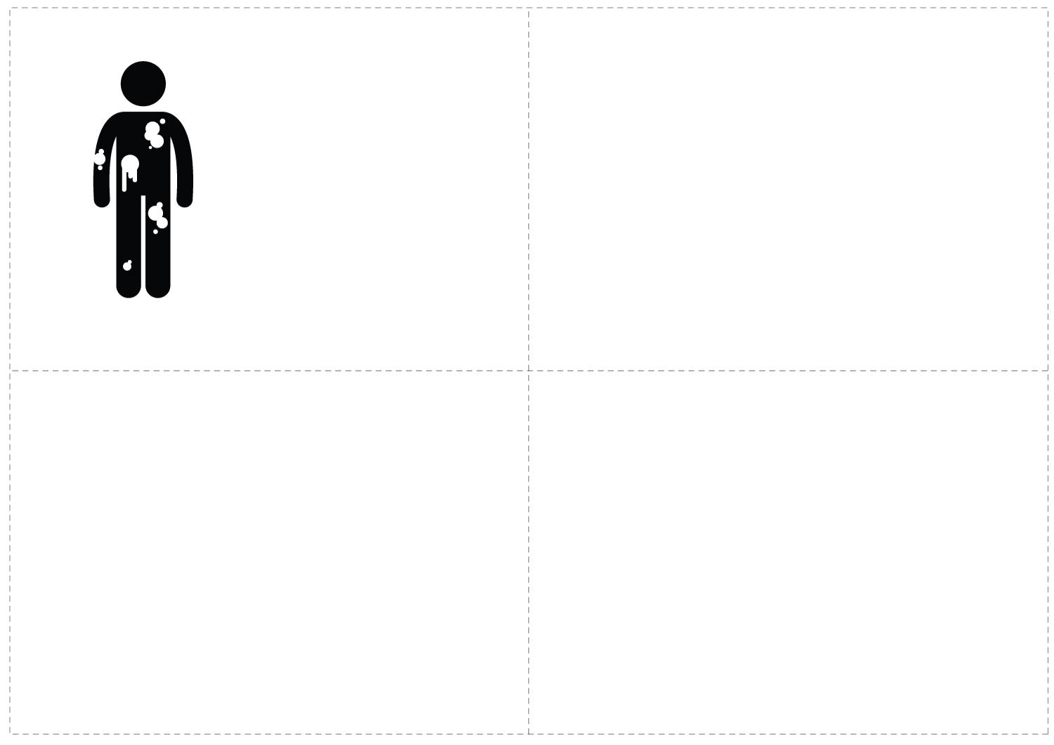
A person who feels dirty

You can tell this from the image because the person has dirt on their clothes.

Motives Worksheet

Character |  | Rank  (1 = most likely to always wash hands with soap  13 = least likely) | Which characters do you aspire to most?  (tick the 2 most commonly mentioned characters) | Which characters are you most like? (tick the 2 most commonly mentioned characters) | Notes  For example: What did people say about this character’s handwashing practices?
 | A person who is respected because of their education or wisdom
 | A person who is neat and has their life in order
 | A person who is wealthy and has a nice house
 | A person who wants to look attractive
 | A person who values having lots of friends
 | A person who  is hungry
 | A person who wants to feel comfortable
 | A person who is respected because they are polite
 | A person who is upset
 | A person who does not like to spend money or waste things
 | A person who is a good parent
 | A person who is a hard worker
 | A person who feels dirty

