Supplementary information

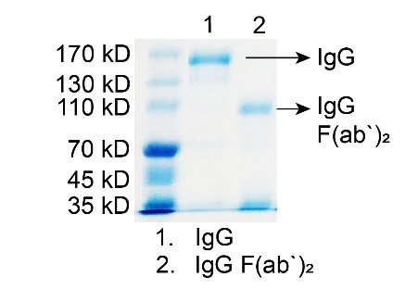
Fig. S1. SDS-PAGE gel of IgG, IgG F(ab′)₂.

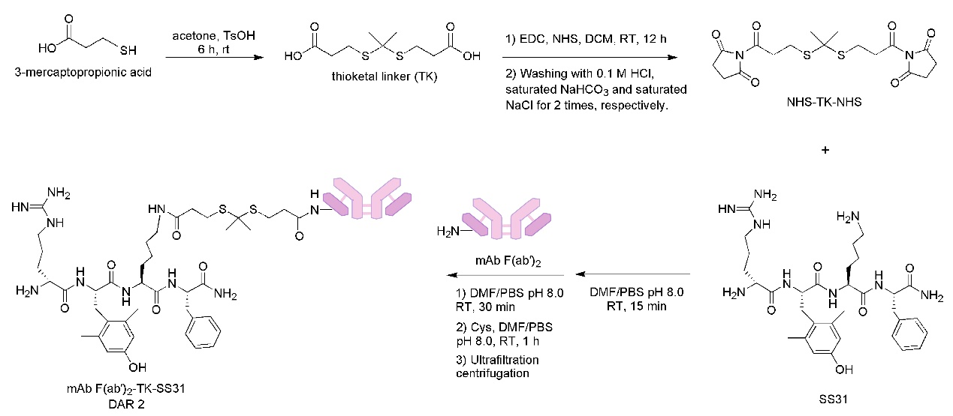
Fig. S2. Synthesis of anti-VEGFR2 F(ab′)₂-SS31.
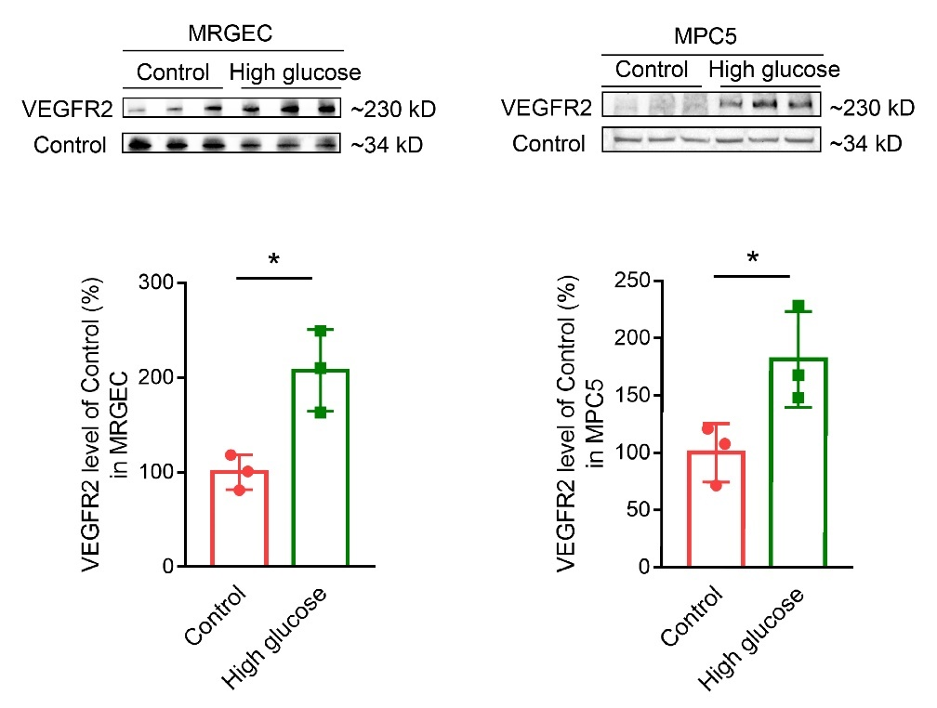
Fig. S3. Western blotting and densitometric analysis of VEGFR2 expression using lysates from normal and high glucose-treated MRGECs and MPC5 cells. All data are expressed as mean ± s.d., n = 3 in each group, * p < 0.05.

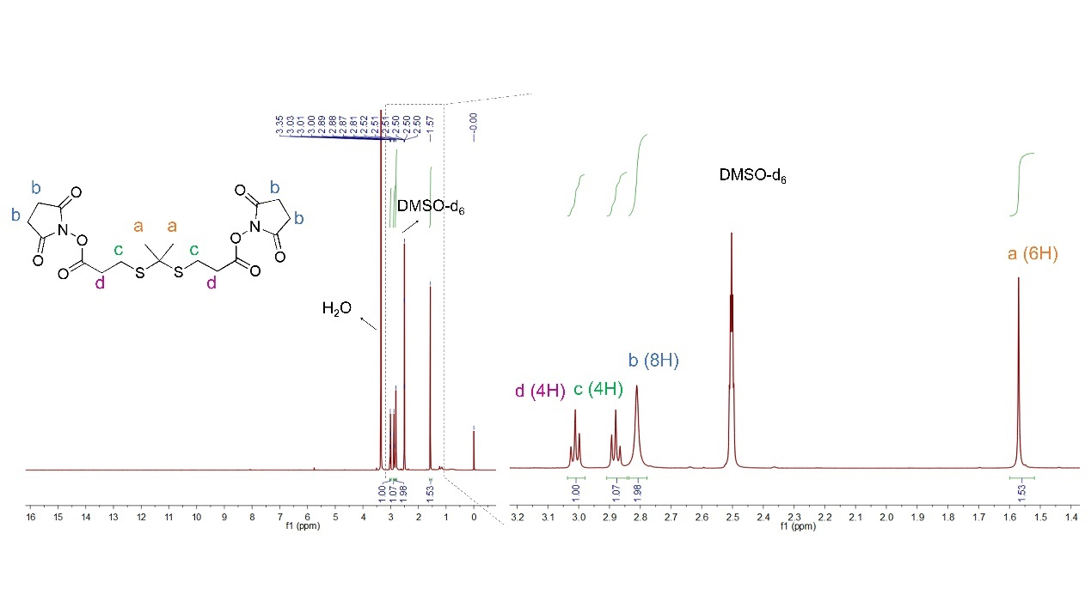
Fig. S4. ¹H-NMR spectra of NHS-TK-NHS.

Table S1. The molar concentration and fluorescent intensity of Cy5 labeled agents
Cy5 Labeled Agents | Molecular Weight (kDa) | Mass Concentration (mg/mL) | Molar Concentration (pmol/μL) | Cy5 Absorption (pmol/μL)
Isotype IgG-Cy5 | ~150 | 3.209 | 21.39 | 22.67
Isotype IgG F(ab′)₂-Cy5 | ~110 | 2.318 | 21.07 | 22.56
Anti-VEGFR2-Cy5 | ~150 | 3.169 | 21.13 | 22.18
Anti-VEGFR2 F(ab′)₂-Cy5 | ~110 | 2.378 | 21.62 | 22.76
Anti-VEGFR2 F(ab′)₂-SS31-Cy5 | ~110 | 2.283 | 20.75 | 21.73

