Greener synthesis and antimicrobial activity of some coumarin analogues

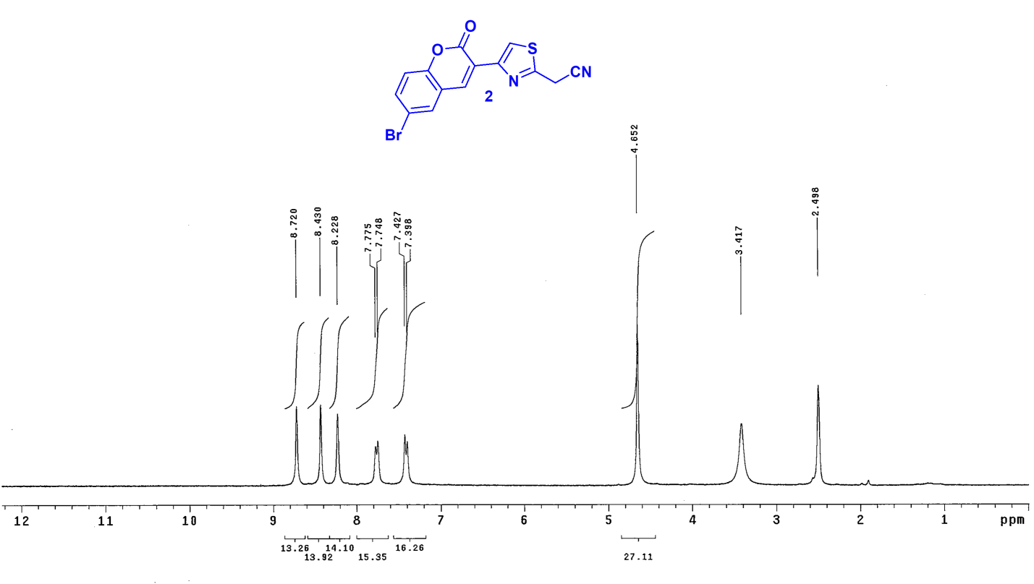
Figure s1. ¹H NMR spectrum of compound 2

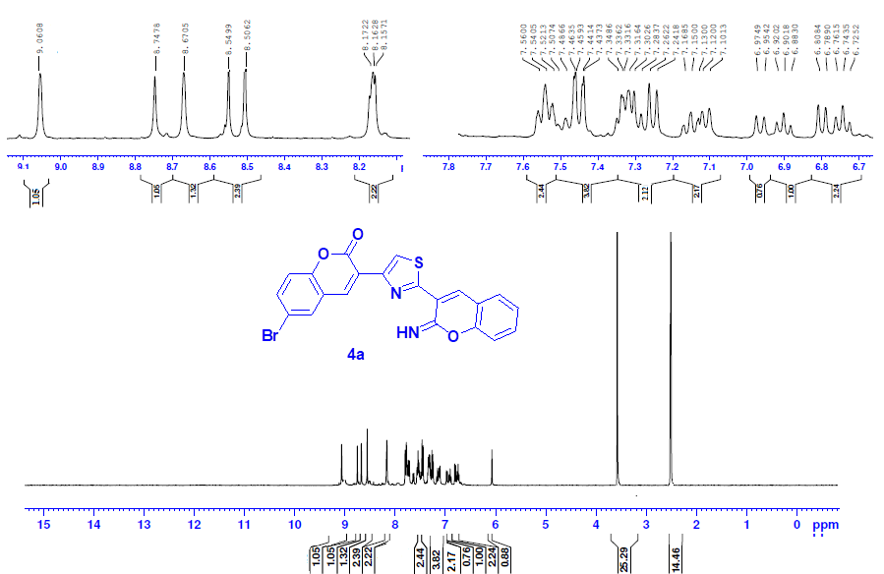
Figure s2. ¹H NMR spectrum of compound 4a

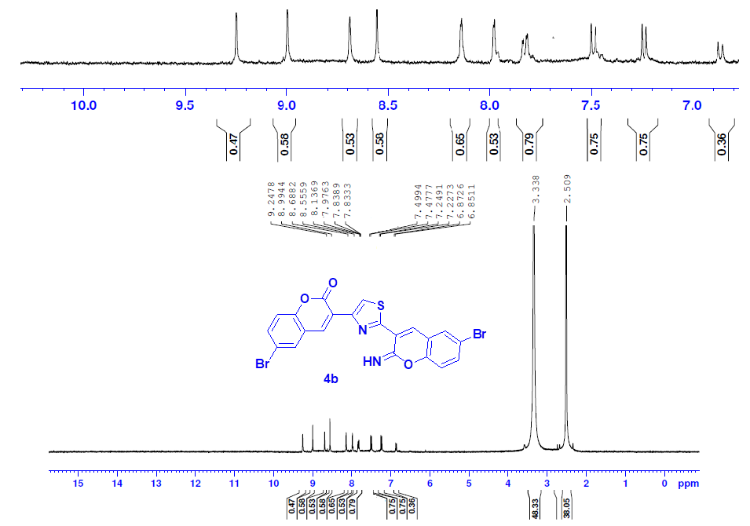

Figure s3. ¹H NMR spectrum of compound 4b

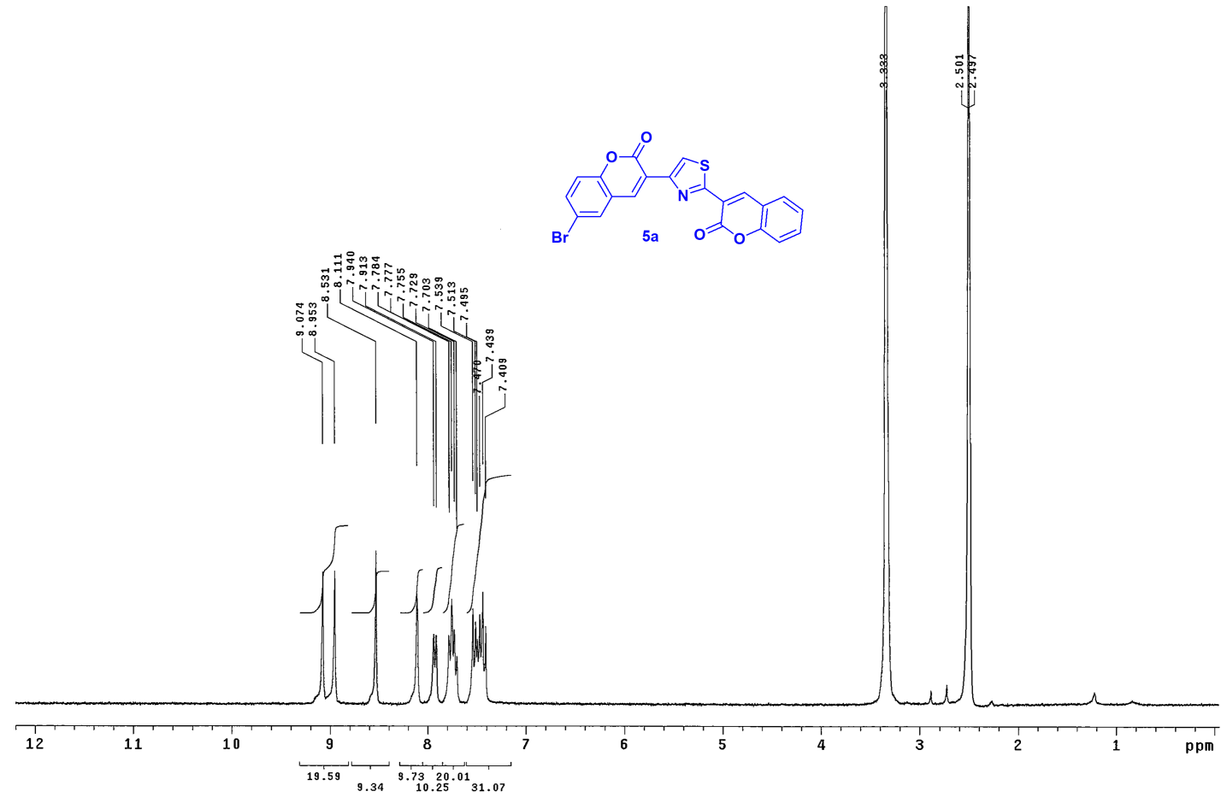
Figure s4. ¹H NMR spectrum of compound 5a

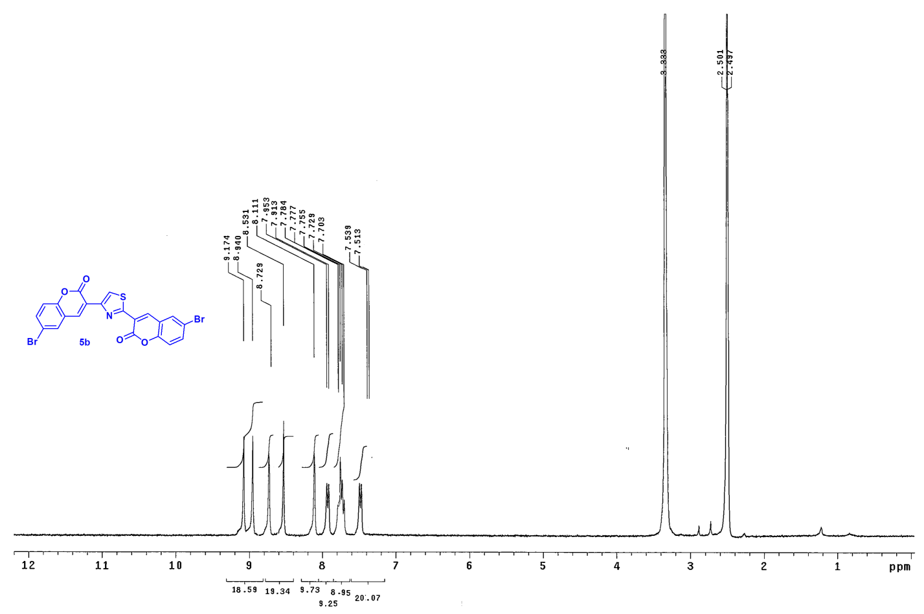
Figure s5. ¹H NMR spectrum of compound 5b

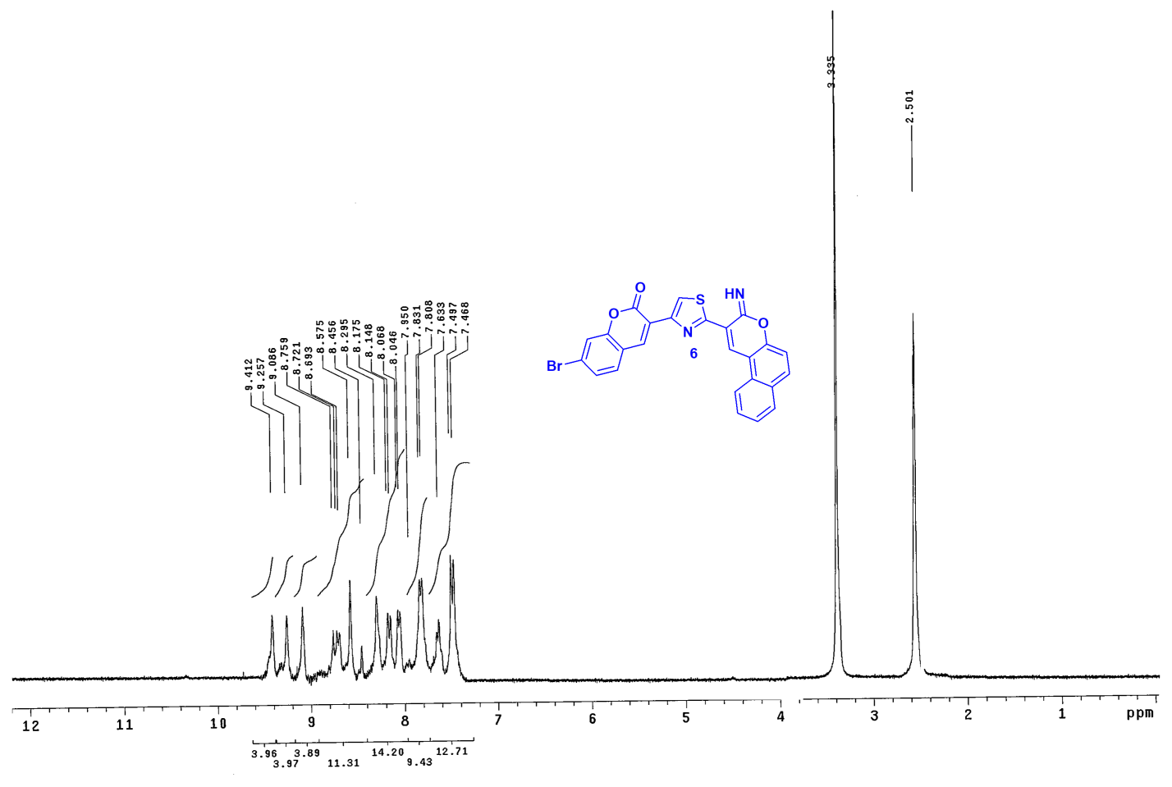

Figure s6. ¹H NMR spectrum of compound 6

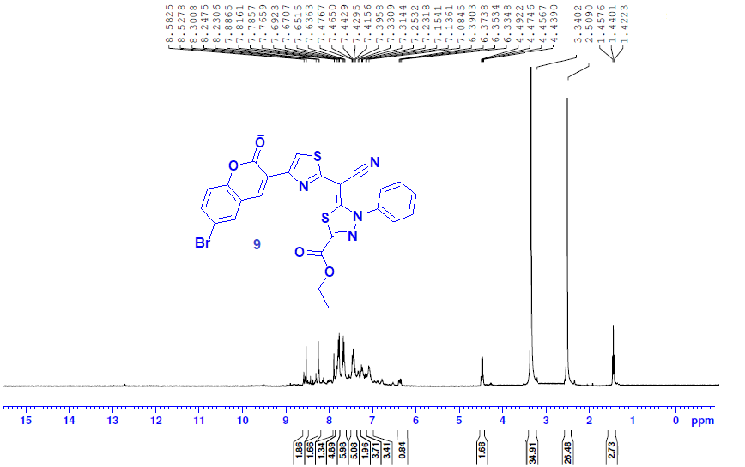

Figure s7. ¹H NMR spectrum of compound 9

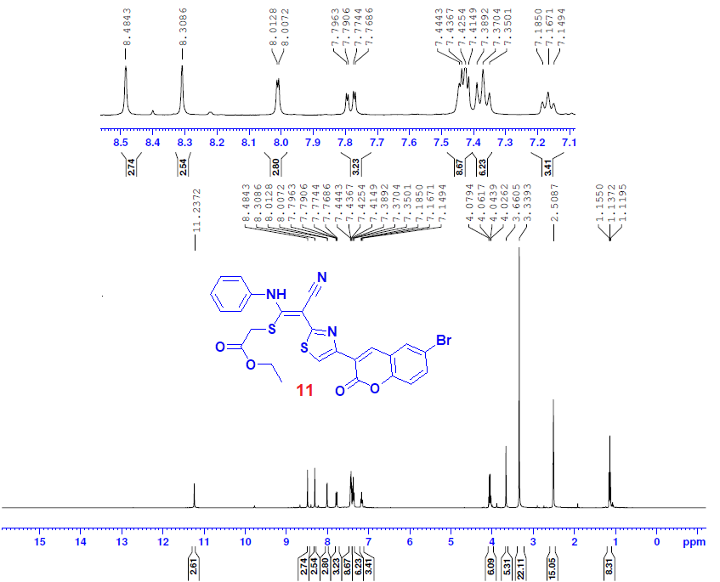

Figure s8. ¹H NMR spectrum of compound 11

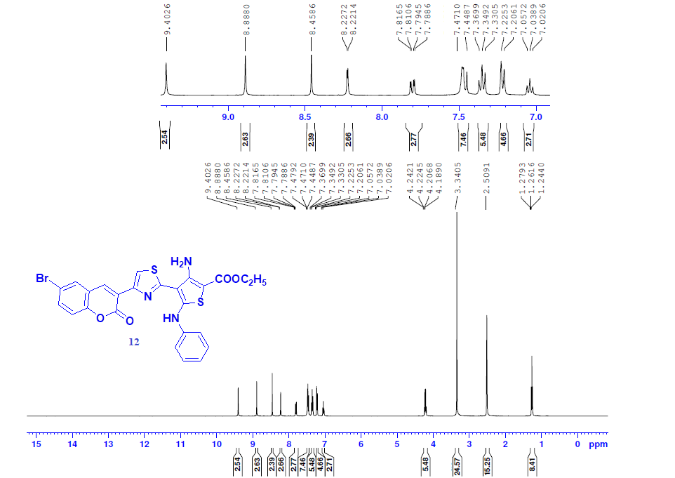

Figure s9. ¹H NMR spectrum of compound 12

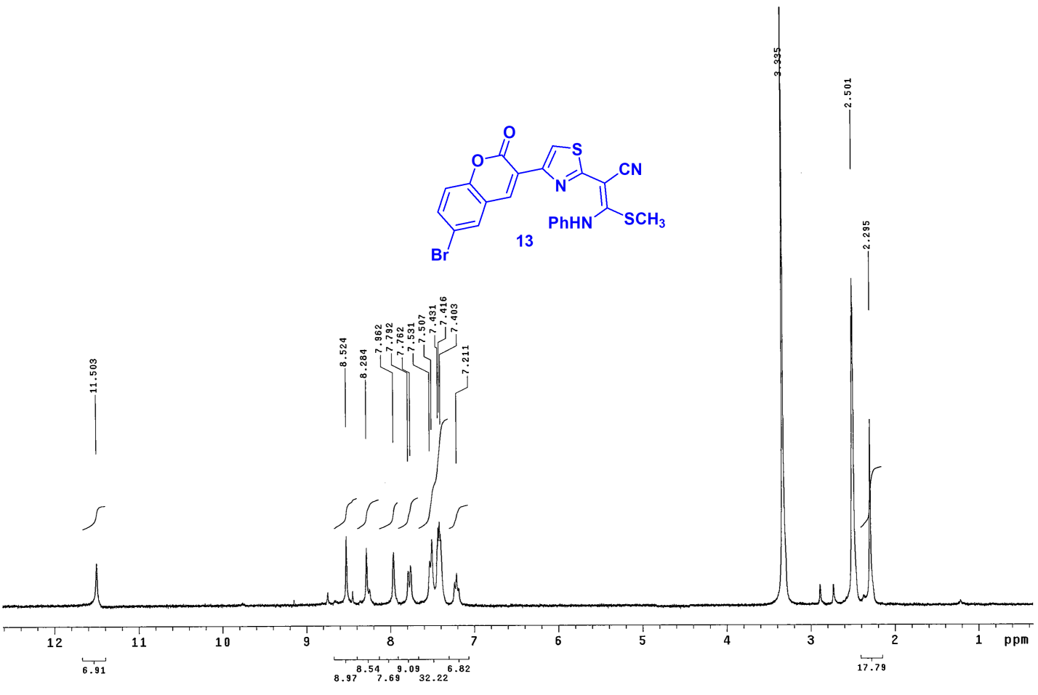
Figure s10. ¹H NMR spectrum of compound 13

