Supplementary Information
Flexible Crossbar Molecular Devices with Patterned EGaIn Top-Electrodes: Scalable Integration and All-Molecule-Circuit Implementation
Zhou Cao^{1, #}, Yu Xie^{1, #}, Jin-Liang Lin¹, Shuai Zhong², Zhenyu Yang¹, Ziming Zhou¹, Wuxian Peng¹, Shengzhe Qiu¹, and Yuan Li^{1, *}

¹Key Laboratory of Organic Optoelectronics and Molecular Engineering and Laboratory of Flexible Electronics Technology, Department of Chemistry, Tsinghua University, Beijing, 100084, China
²Guangdong Institute of Intelligence Science and Technology, Hengqin, Zhuhai, 519031, China
#These authors contributed equally to this work
*E-mail: yuanli_thu@tsinghua.edu.cn

This supplementary information includes:
Supplementary Figure 1 to 26
Supplementary Table 1 to 4
Supplementary References
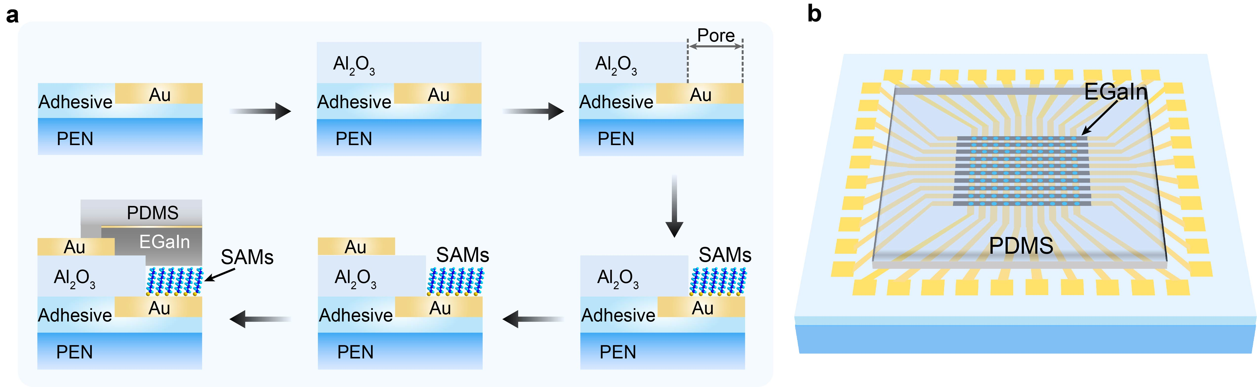
Supplementary Fig. 1 | a, Schematic presentation of the fabrication process for the molecular junction array with EGaIn top electrodes on flexible PEN substrate. b, Schematic structure of the completed device, featuring one hundred molecular junctions arranged in a 10 × 10 crossbar array configuration.

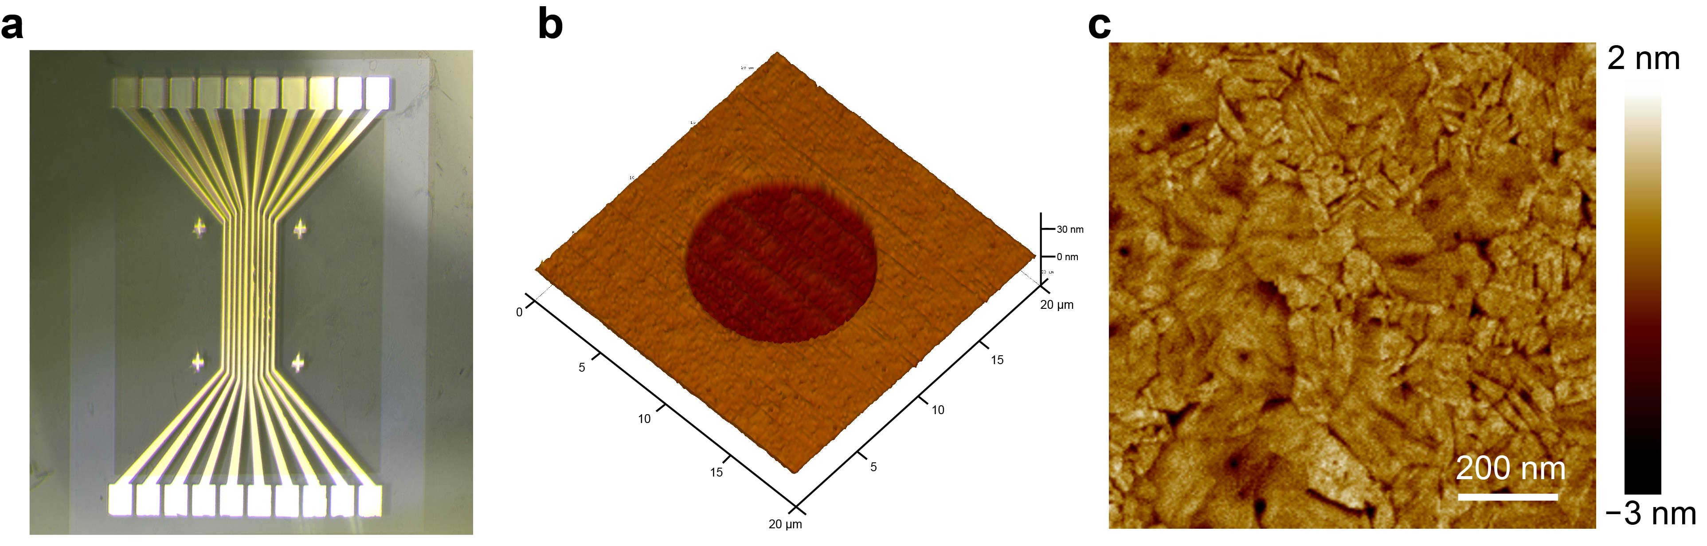
Supplementary Fig. 2 | Characterizations of bottom electrodes. a, Optical microscopy image of patterned Au bottom electrodes. b, 3D AFM image of the patterned 10 μm diameter pore surface after the etching process. c, 2D AFM image of the exposed Au inside the pore following the etching process. The root mean square (RMS) roughness of the exposed Au inside the pore is 0.43 nm.

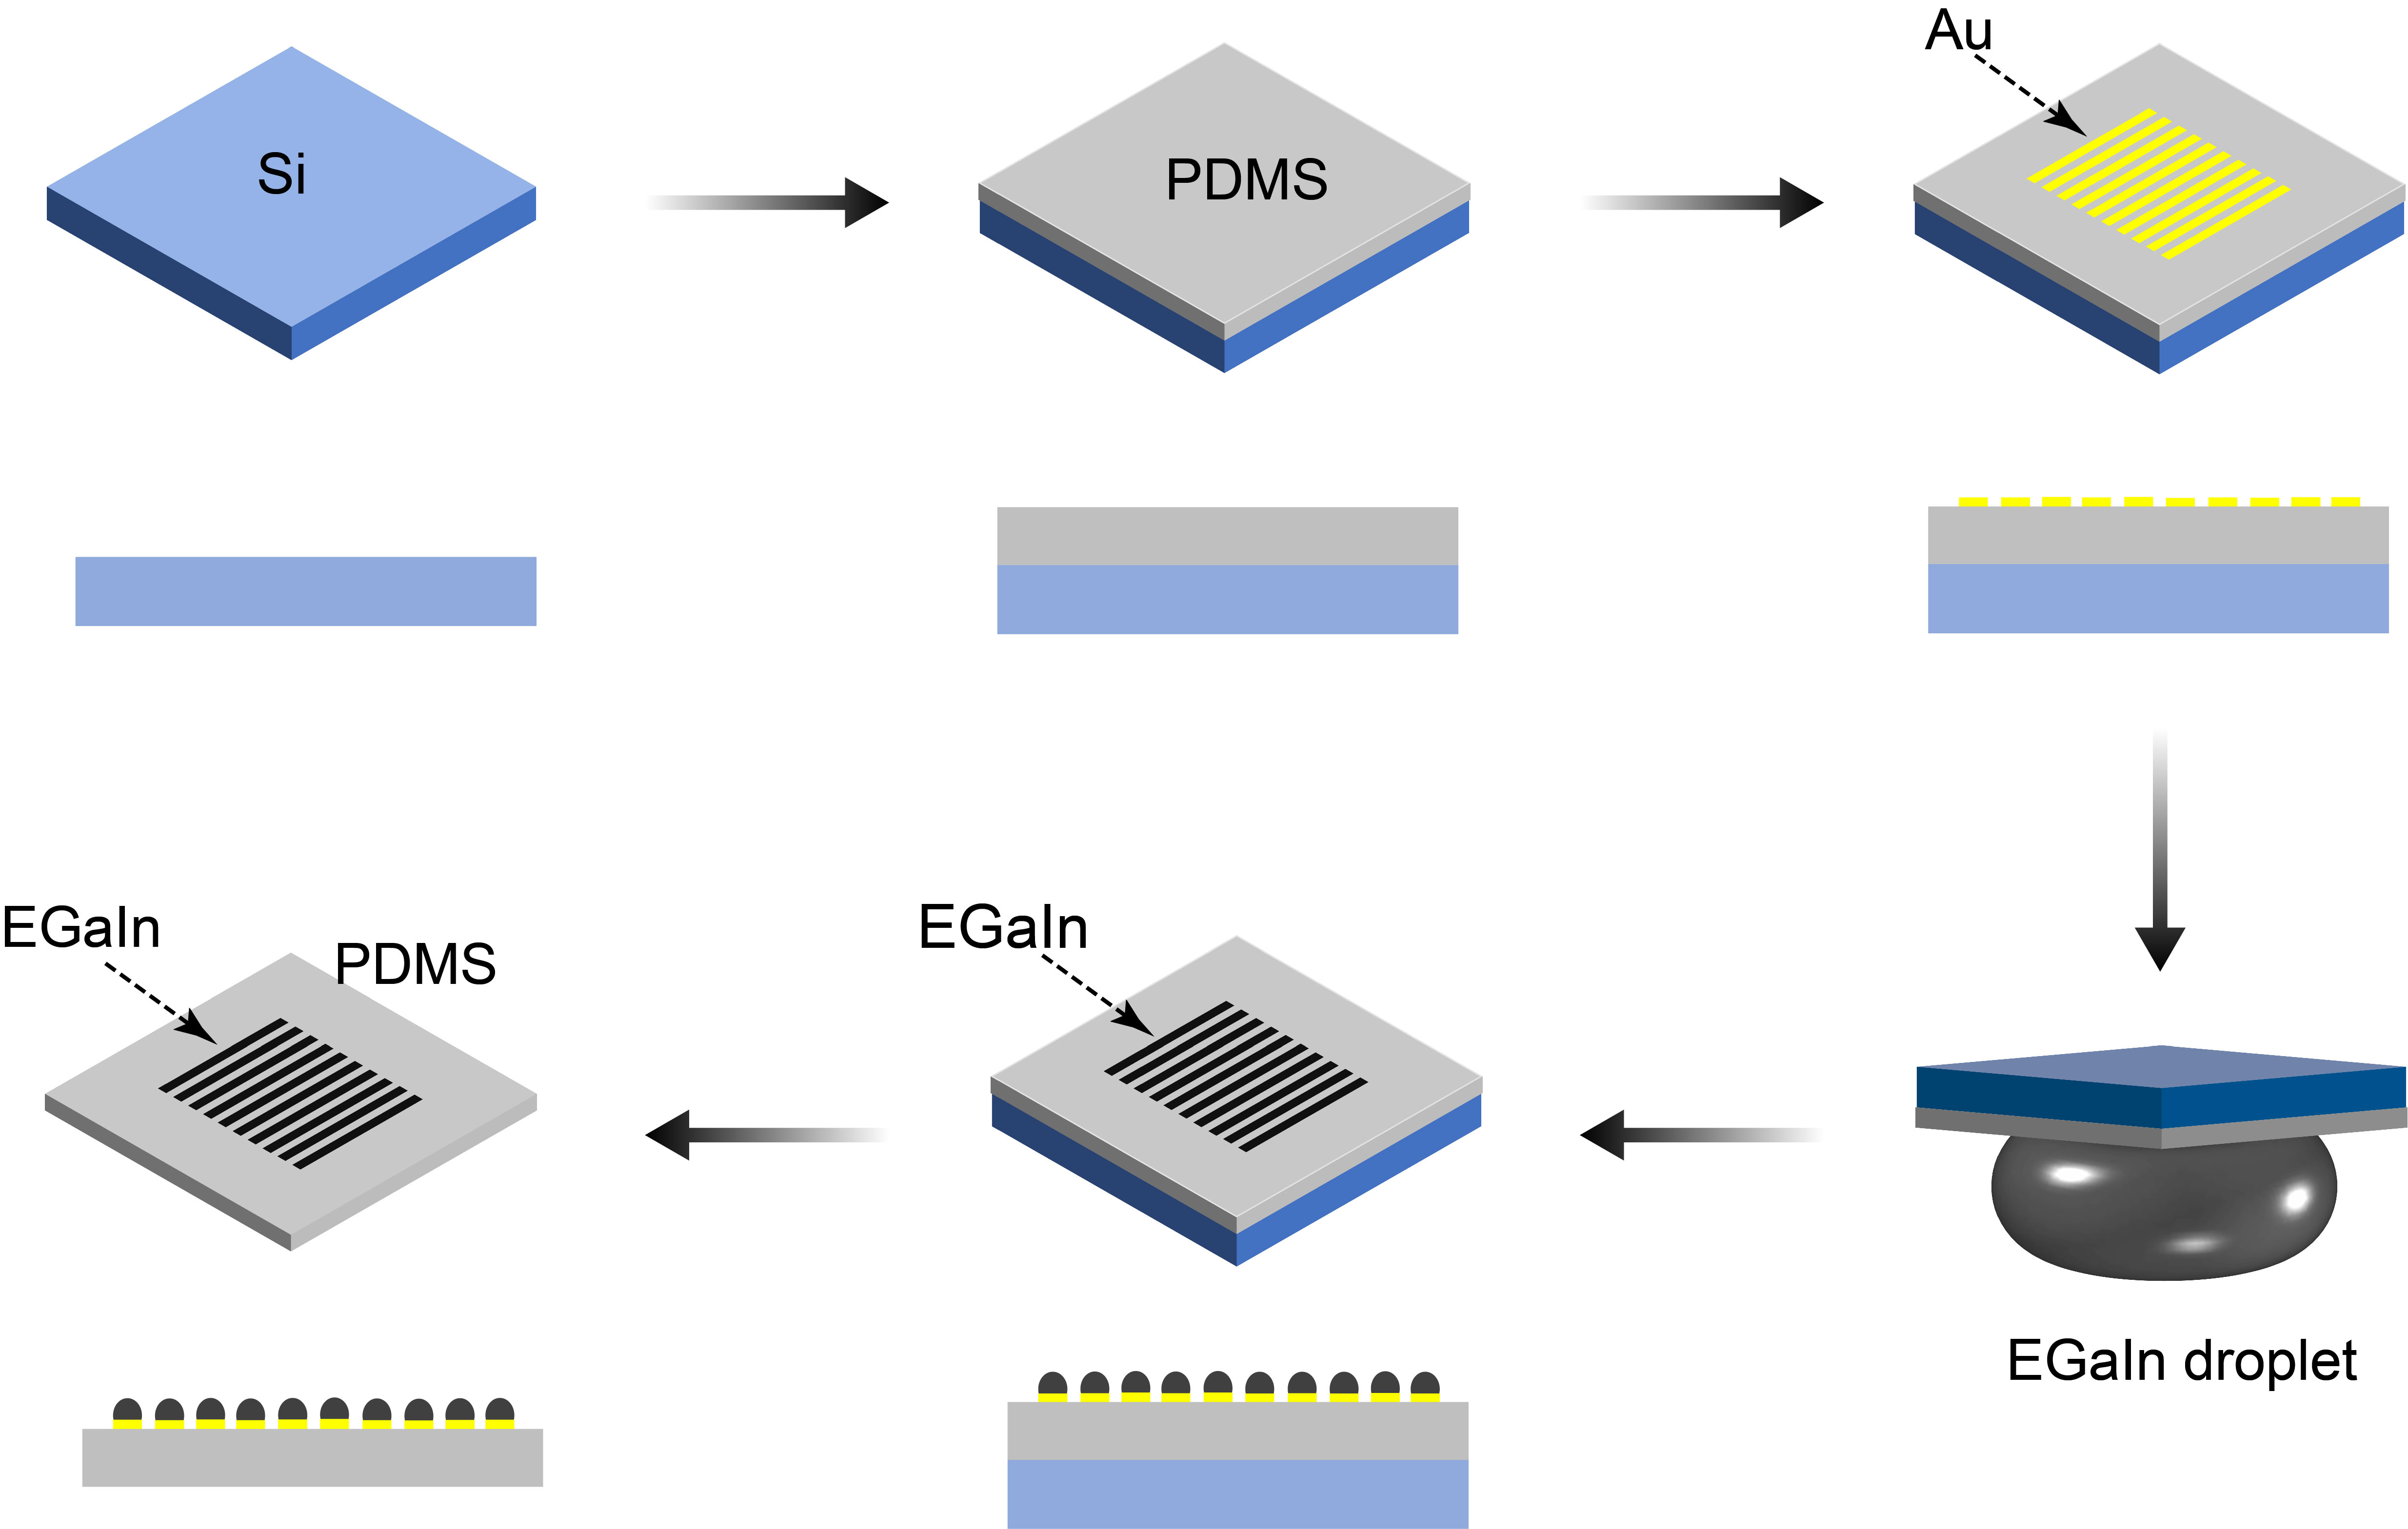
Supplementary Fig. 3 | Schematic illustration of the fabrication procedure for stamping liquid metal EGaIn-patterned electrodes on PDMS substrates.
To construct the EGaIn-based electrode top-contact junctions, a 100 μm thick PDMS layer was spin-coated on silicon substrates to support the patterned Au adhesion layer. The stamping process of liquid metal EGaIn was operated in a NaOH bath to keep the liquid metal oxide-free. During this liquid metal stamping transfer step, the liquid metal adheres only to the Au-coated pattern, even after removing the substrates from the liquid metal droplet. Next, the patterned EGaIn electrodes on the thin PDMS film were carefully peeled off from the silicon substrate. The detached EGaIn electrode was gently rinsed several times with deionized water and gently dried with a stream of N₂.
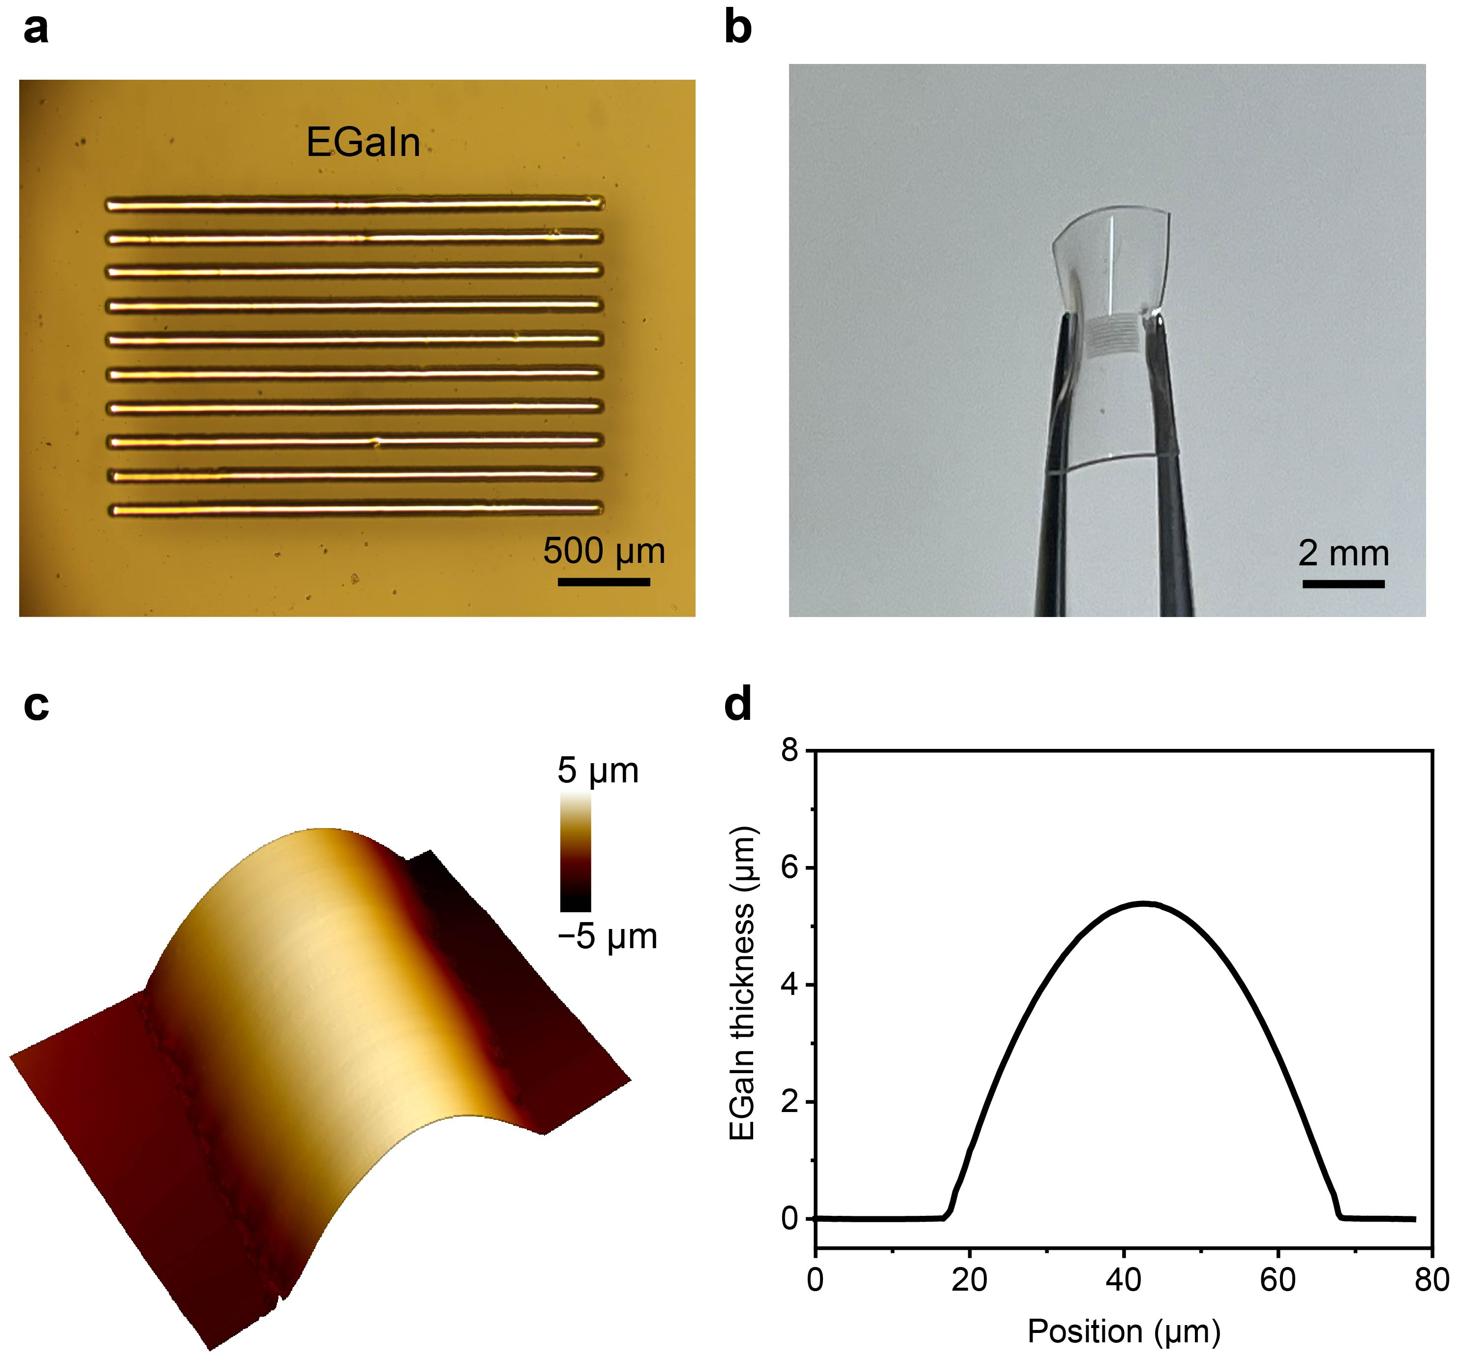
Supplementary Fig. 4 | characterizations of patterned EGaIn by stamping process. a, Optical microscopy images of patterned EGaIn. b, Optical images of patterned EGaIn on PDMS. c, 3D AFM topography of the patterned EGaIn electrode. d, Cross-sectional profile. Additionally, comparing the Au precursory patterns with the EGaIn patterns reveals that the stamping process precisely duplicates the sharp features of lines. The stamping approach can readily fabricate submicron-scale liquid metal patterns when combined with the lithography fabrication process¹⁻³. The resolution of the liquid metal patterns is mainly limited by that of the precursory Au patterns and not the liquid metal EGaIn stamping approach. Therefore, the stamping process can be used as a readily accessible approach to fabricate high-resolution and complex liquid metal EGaIn patterns on flexible substrates.
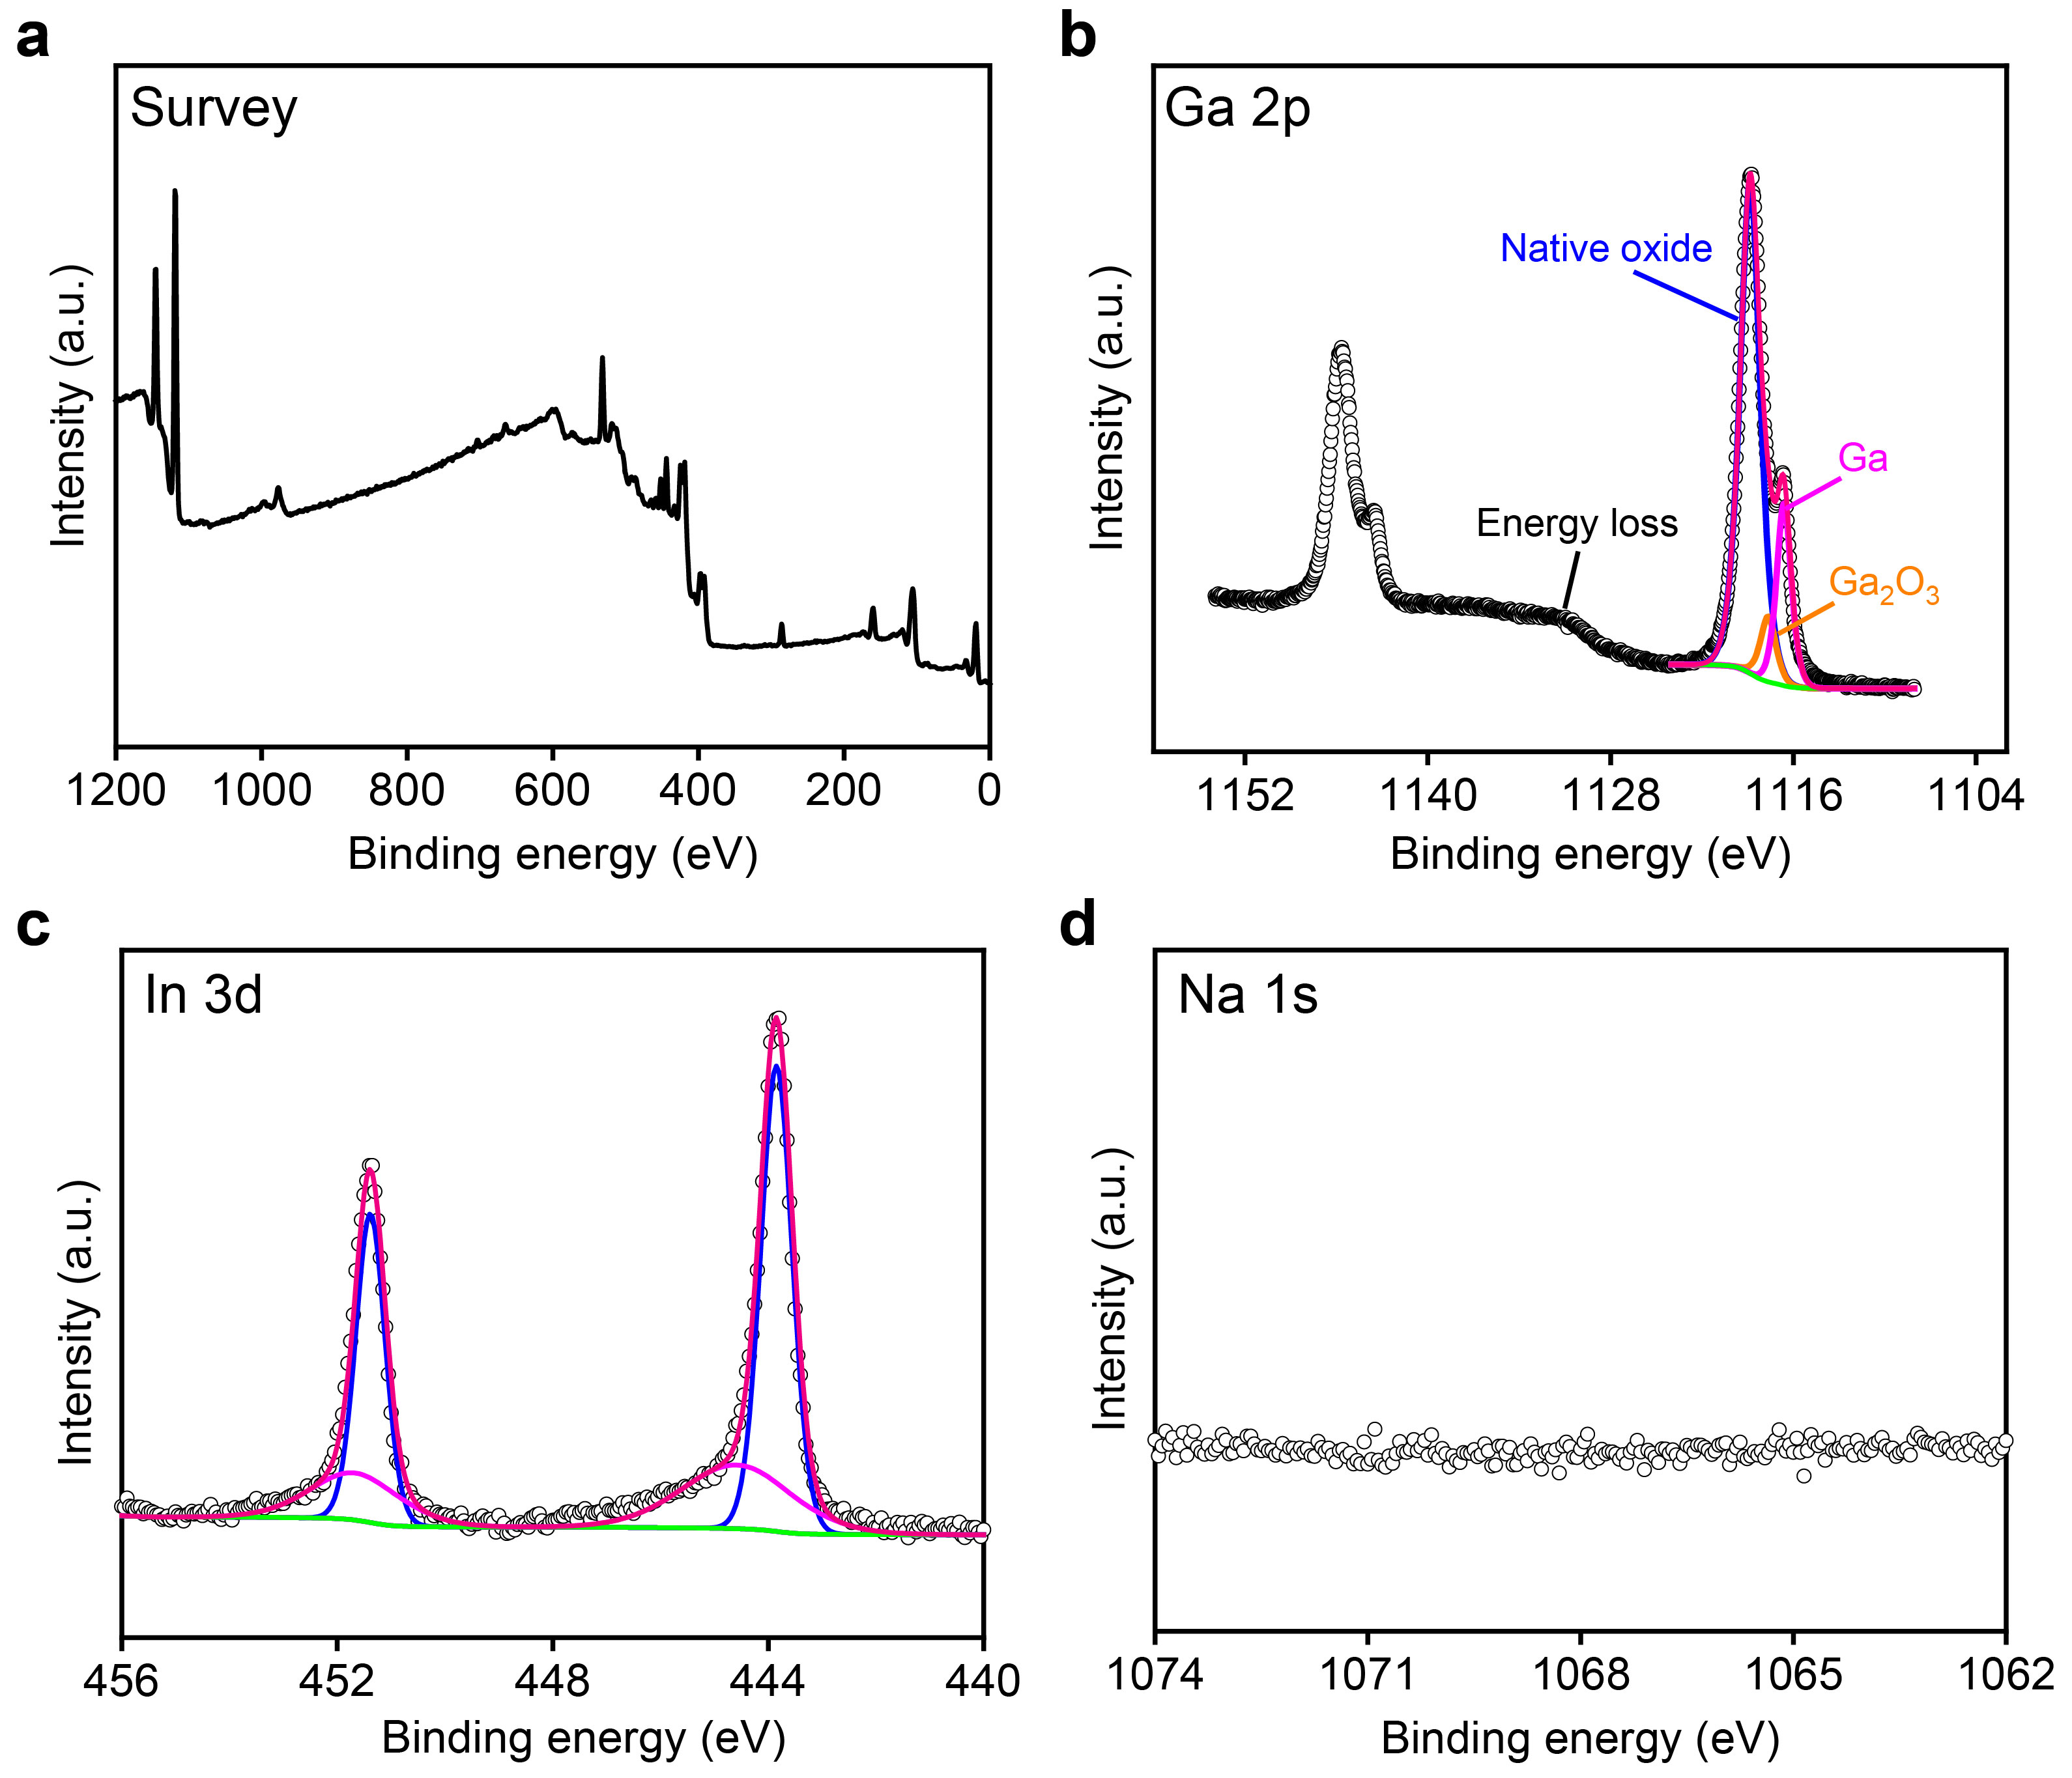
Supplementary Fig. 5 | XPS characterizations of patterned EGaIn by stamping process. a, XPS survey spectrum. b–d, High-resolution spectra of the Ga 2p region (b), In 3d region (c), and Na 1s region (d) for patterned EGaIn. Typical elements are readily detectable in patterned EGaIn using XPS, indicating that surface cleanliness and chemical purity.

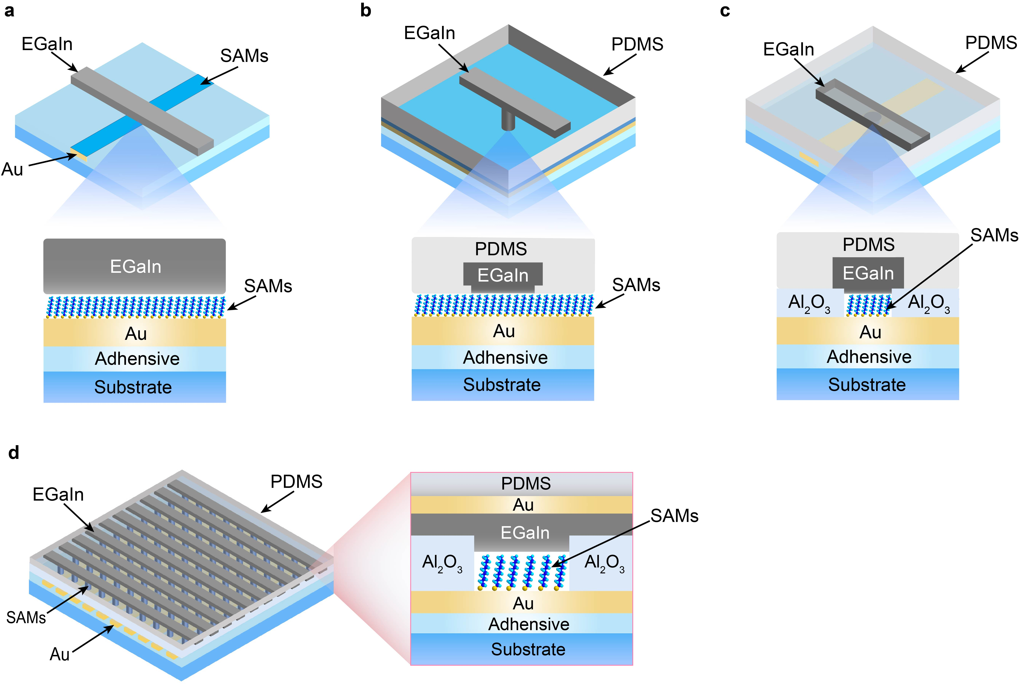
Supplementary Fig. 6 | Schematic illustrations of the top and side views of EGaIn-based molecular junctions in crossbar configuration. a, Direct printing. b, Molecular junction with the top-electrode EGaIn stabilized in the through-hole. c, Molecular junction with the top-electrode EGaIn stabilized in the microfluidic channel. d, Molecular junction arrays with the patterned EGaIn top-electrode by stamping approach.
When the size of the microfluidic channel is decreased to below 10 μm, the liquid metal EGaIn is difficult to inject into the nozzle and microchannel resulting from the high surface tension. Different from using direct print^{4,5} or injected EGaIn into the microfluidic channel by pumping method⁶⁻⁸, this approach defines a readily accessible process for rapidly and reliably evaluating molecule with crossbar structured molecular junction array on the flexible substrate.

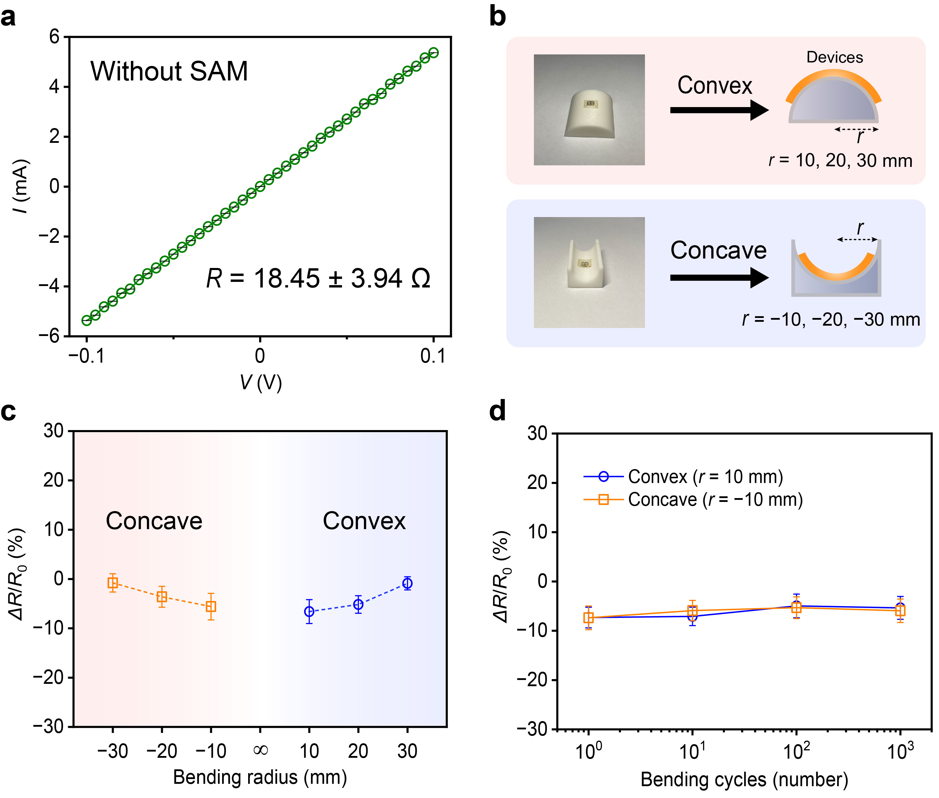
Supplementary Fig. 7 | Electrical characterization of the flexible devices without SAM. a, Representative of the I–V curve of flexible devices without SAM. b, Photograph of the conductivity testing setup, which measures the transport curves of the flexible devices. c, Resistances of the flexible devices with respect to different bending radius. d, Resistances of the flexible devices with respect to different bending cycles. Error bars represent standard deviations from multiple samples. The resistances (R) of the devices without SAM calculated from their I–V curves. The output curves show a linear behavior, indicative of good electrical contacts.
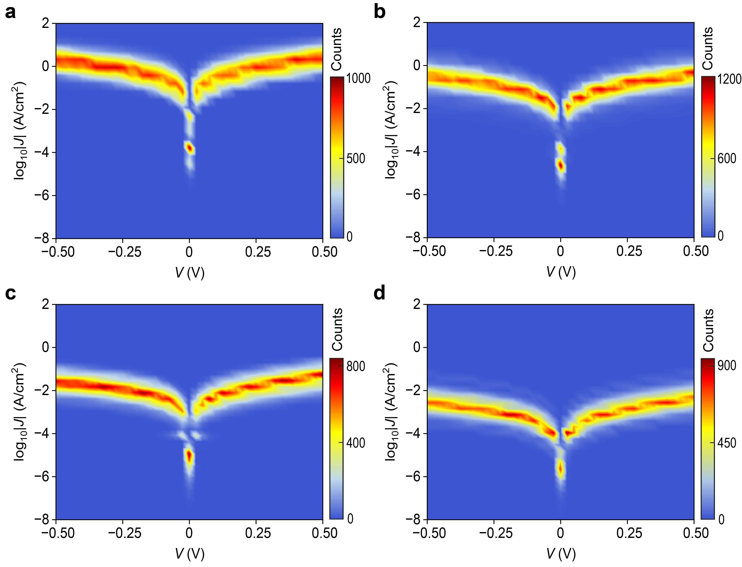
Supplementary Fig. 8 | Heatmaps of the log₁₀|J| curves for alkanethiols molecular devices. a, Electrical characteristics of the SC₆ junction. b, Electrical characteristics of the SC₈ junction. c, Electrical characteristics of the SC₁₀ junction. d, Electrical characteristics of the SC₁₂ junction.

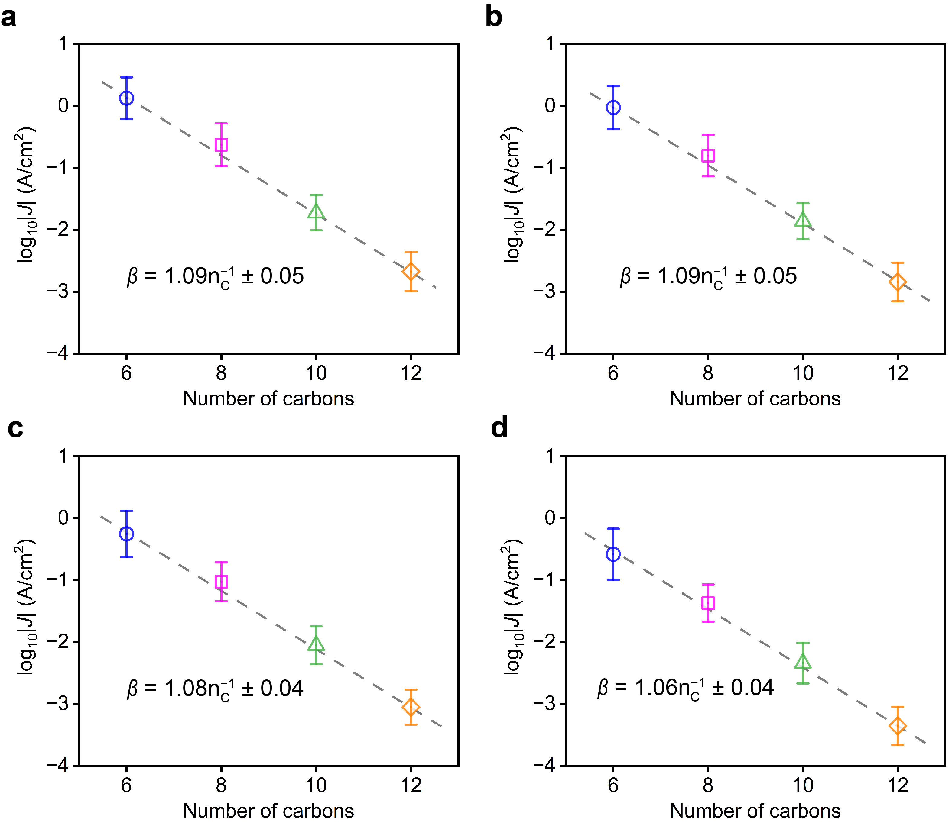
Supplementary Fig. 9 | Current density as a function of the number of carbons in the alkanethiol-SAMs molecular junctions at different biases. a–d, Current density and exponential fit of data as a function of number of carbons in the alkanethiol molecular junctions at a bias of −0.4 V (a), −0.3 V (b), −0.2 V (c), and −0.1 V (d), respectively. In a simple model, the SAM is considered a tunnel barrier with J = J₀e^{−βd}, where β is the tunnelling decay coefficient, d is the barrier width, and J₀ (A/cm²) is a constant that depends on the contacts and system. We find β values of different biases are typically ~1, which is consistent with the reported values in the literature⁹⁻¹².

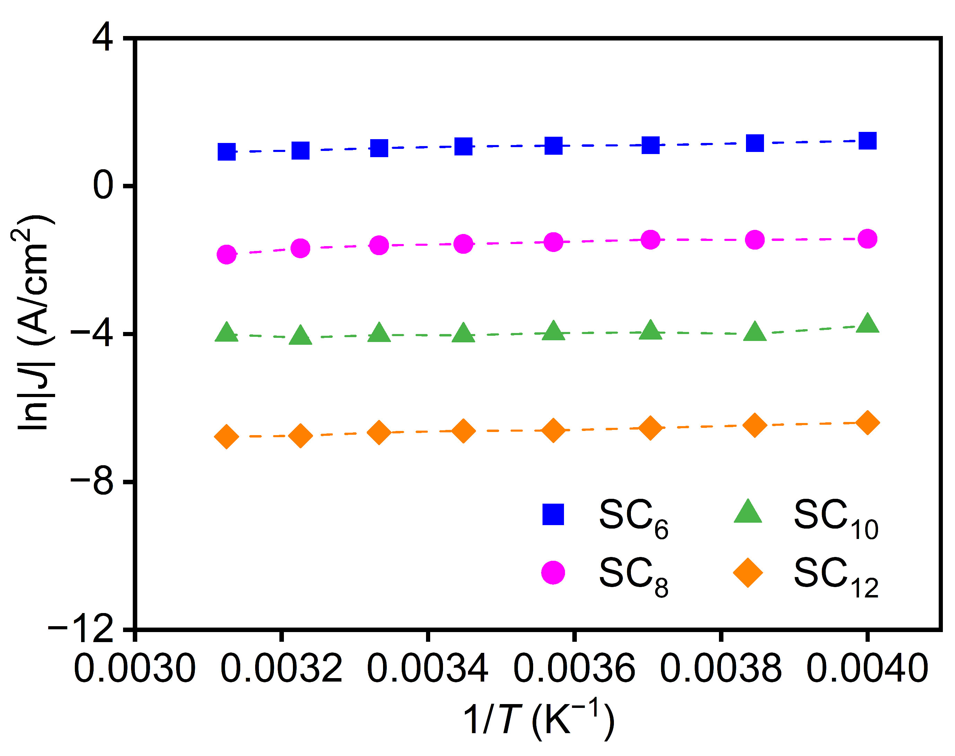
Supplementary Fig. 10 | Dependence of alkanethiol-SAMs molecular devices characteristics on temperature. Arrhenius plots of ln|J| versus 1/T for SC₆, SC₈, SC₁₀, and SC₁₂ molecular devices at −0.5 V, respectively. Arrhenius plot for alkanethiol-SAMs molecular devices (pore diameter, 10 μm), showing temperature independence.

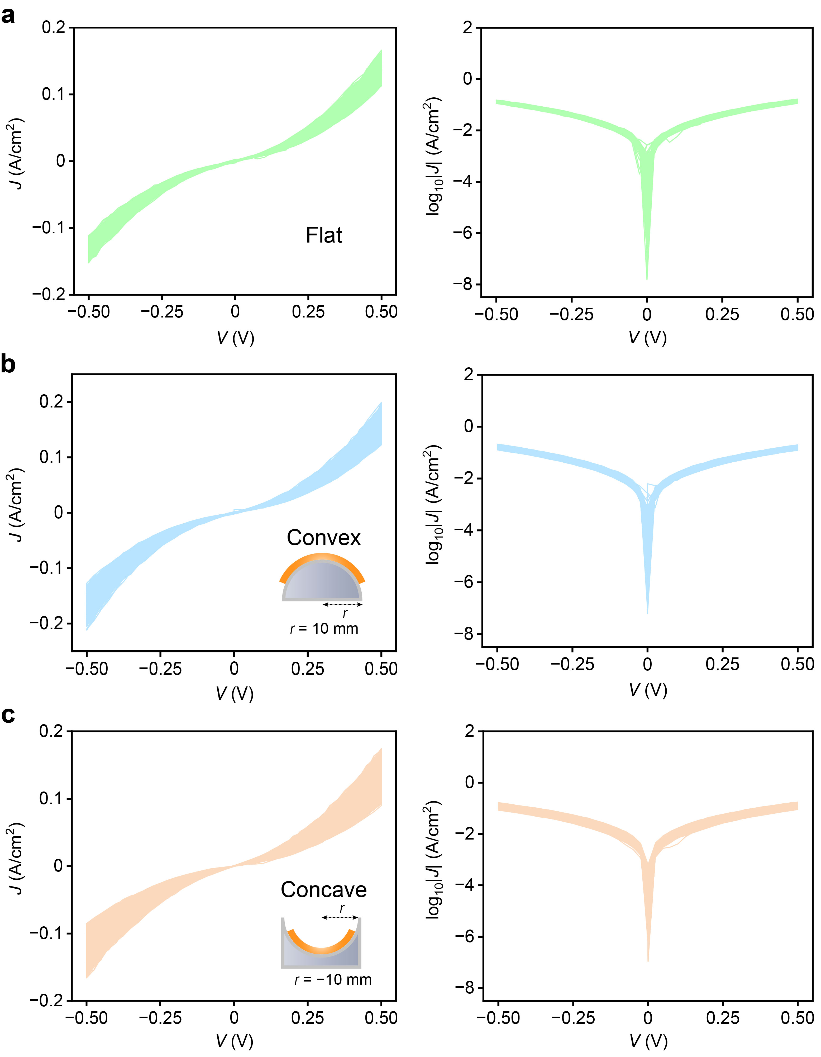
Supplementary Fig. 11 | Electrical characteristics of the SC₈ flexible molecular device for 1000 consecutive sweeps under various bending configurations. a–c, J–V plots corresponding to 1000 successive scans by continuous voltage cycling (0 V →+0.50 V → −0.50 V → 0 V) under flat r = ∞ (a), convex r = 10 mm (b), and concave r = −10 mm (c) conditions.

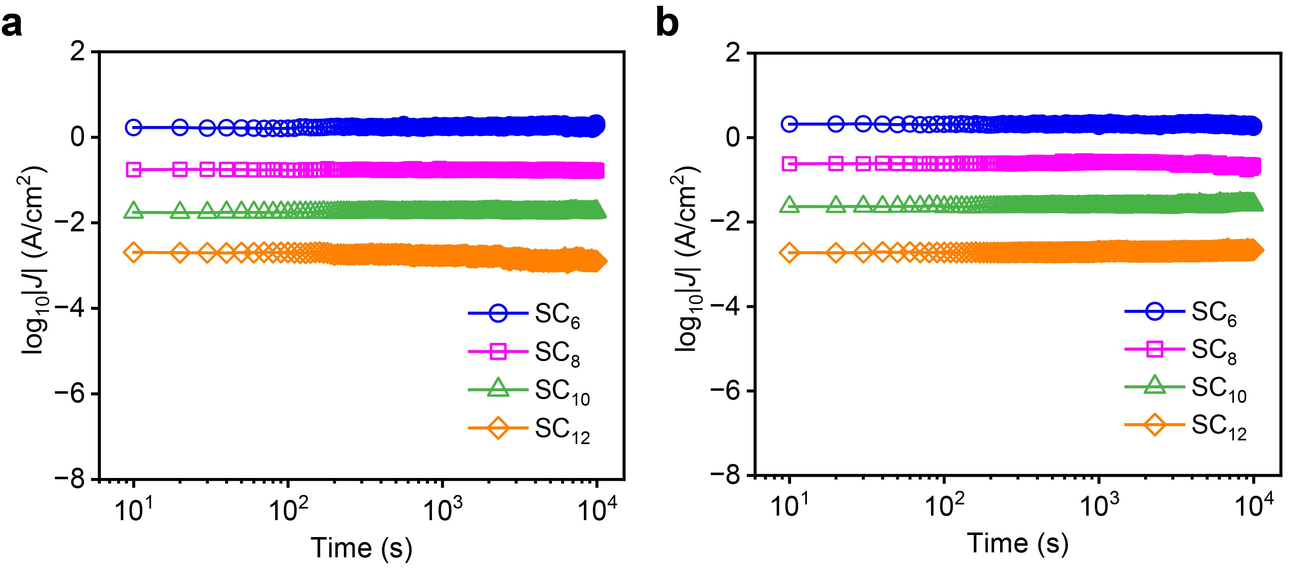
Supplementary Fig. 12 | Retention characteristics of the alkanethiol-SAMs molecular device under various bending configurations. a–b, The electrical stability of the molecular junctions at constant bias at −0.50 V for 10⁴ seconds under convex r = 10 mm (a), and concave r = −10 mm (b) conditions.

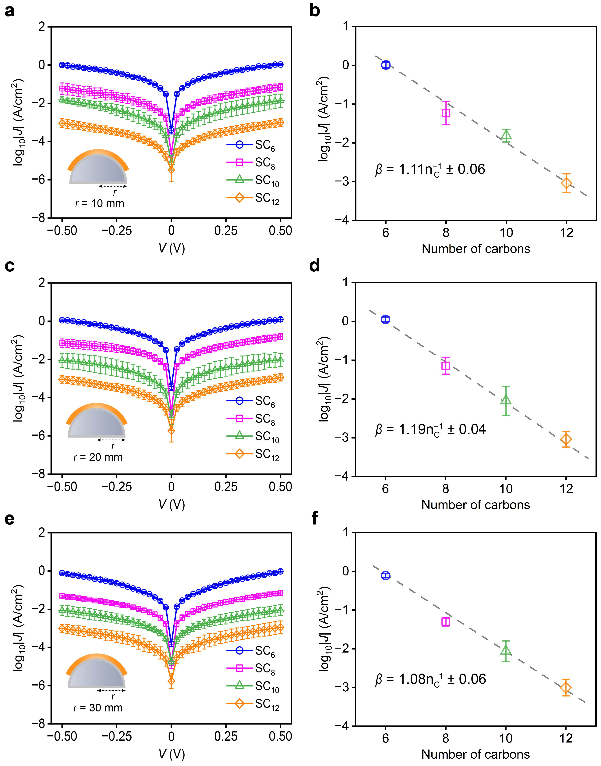
Supplementary Fig. 13 | Electrical characteristics of alkanethiol-SAMs flexible molecular devices under convex conditions. a–f, J–V characteristics of SC₆, SC₈, SC₁₀ and SC₁₂ molecular junctions and decay coefficient (β) at −0.5 V under different bending radius r = 10 mm (a, b), 20 mm (c, d), and 30 mm (e, f).

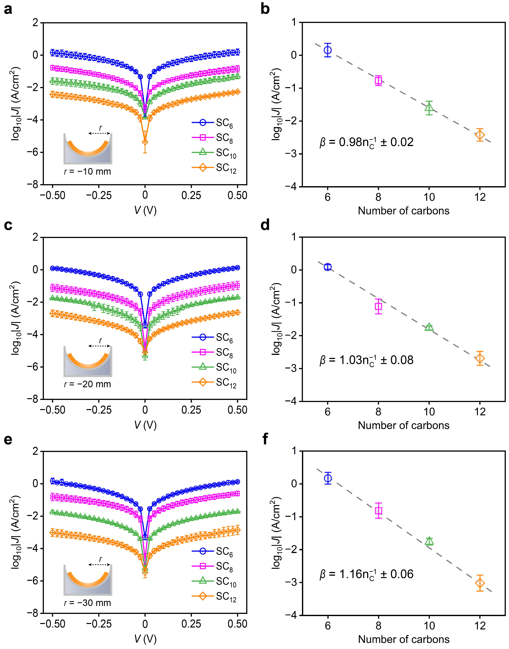
Supplementary Fig. 14 | Electrical characteristics of alkanethiol-SAMs flexible molecular devices under concave conditions. a–f, J–V characteristics of SC₆, SC₈, SC₁₀, and SC₁₂ molecular junctions and decay coefficient (β) at −0.5 V under different bending radius r = −10 mm (a, b), −20 mm (c, d), and −30 mm (e, f).

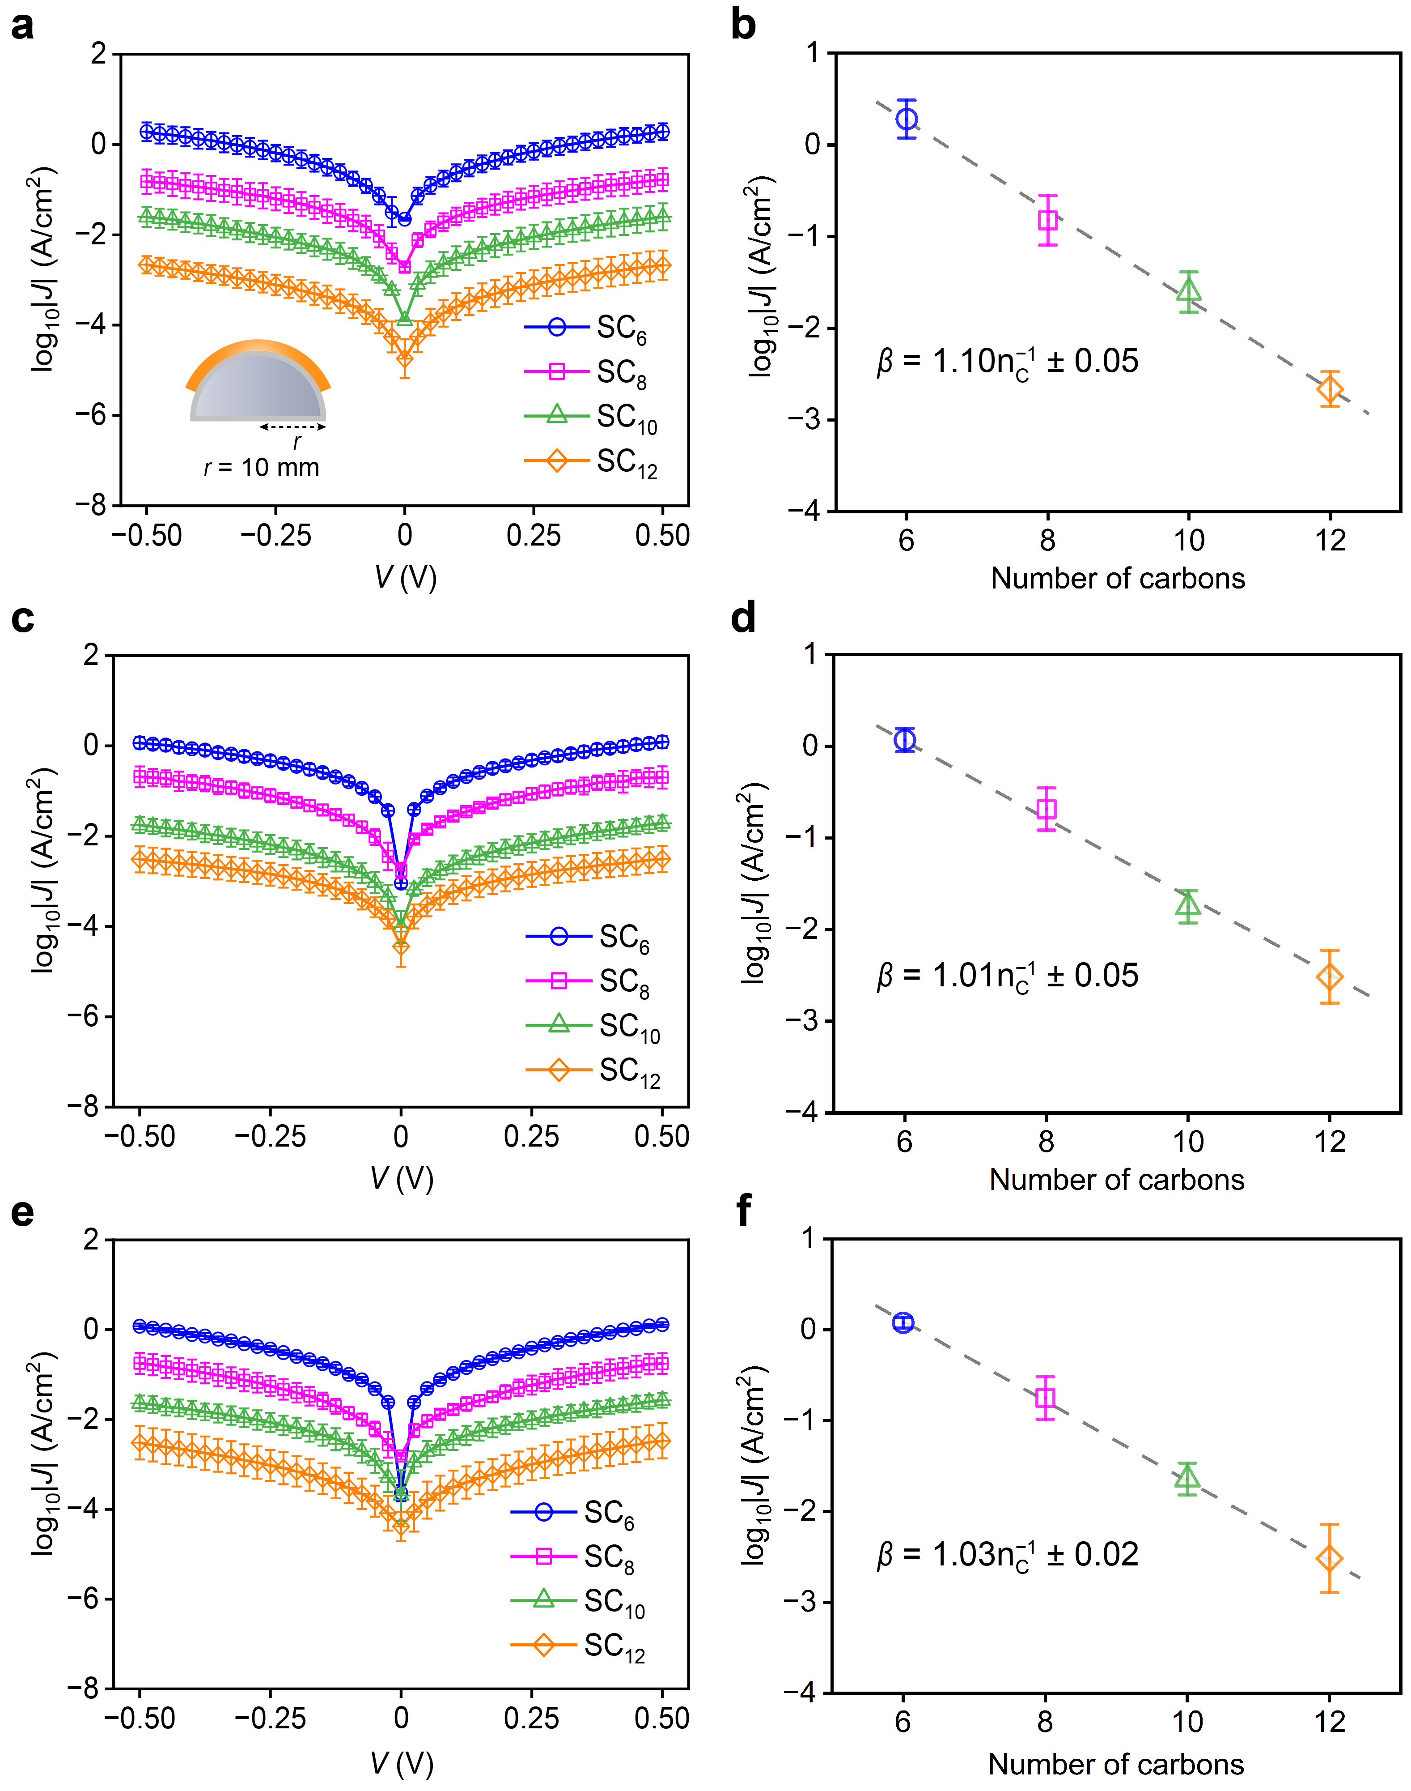
Supplementary Fig. 15 | Electrical characteristics of alkanethiol-SAMs flexible molecular devices under repeated bending cycles at convex conditions (r = 10 mm). a–f, Statistical J–V data for SC₆, SC₈, SC₁₀ and SC₁₂ flexible molecular devices and the decay coefficient (β) at −0.5 V under repeated bending cycles: 10 times (a, b), 10² times (c, d), and 10³ times (e, f).
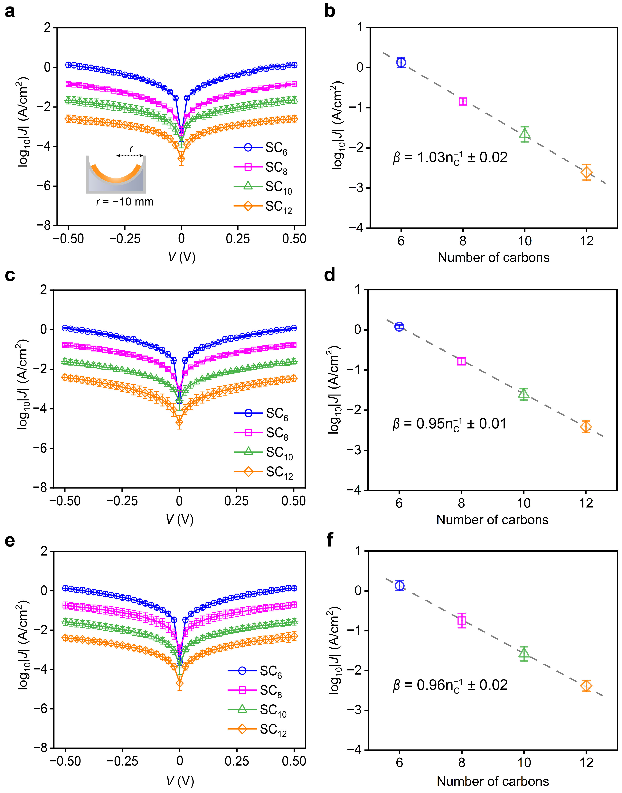
Supplementary Fig. 16 | Electrical characteristics of alkanethiol-SAMs flexible molecular devices under repeated bending cycles at concave conditions (r = −10 mm). a–f, Statistical J–V data for SC₆, SC₈, SC₁₀ and SC₁₂ flexible molecular devices and the decay coefficient (β) at −0.5 V under repeated bending cycles: 10 times (a, b), 10² times (c, d), and 10³ times (e, f).

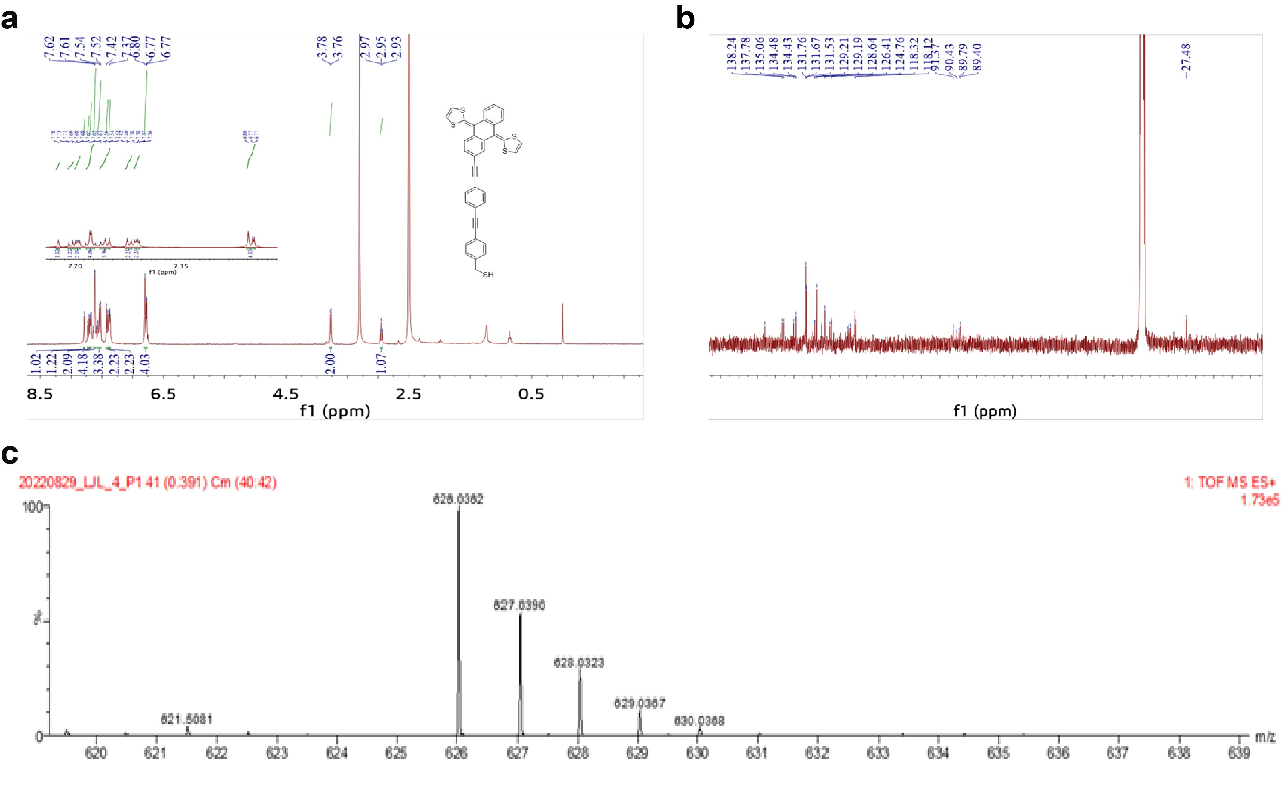
Supplementary Fig. 17 | NMR and mass spectrum of the exTTF. a, The ¹H-NMR spectrum. b, The ¹³C-NMR spectrum. c, The HRMS spectrum. The preparation of exTTF will be presented in a working manuscript^{13,14}. ¹H NMR (400 MHz, CDCl₃) δ 7.81 (br, 1H), 7.73 – 7.68 (m, 2H), 7.65 (d, J = 8.0 Hz, 1H), 7.40 (d, J = 8.0 Hz, 1H), 7.33 – 7.28 (m, 2H), 6.31 (s, 4H), 3.10 (s, 1H). ¹³C NMR (101 MHz, CDCl₃) δ 137.08, 136.91, 135.98, 135.60, 135.30, 129.73, 128.57, 126.25, 126.23, 125.11, 125.06, 125.04, 121.68, 121.20, 119.49, 117.45, 117.38, 117.31, 84.02. TOF-MS m/z calc for C₃₇H₂₂S₅ [M+H]⁺ 627.0403, found 627.0390.

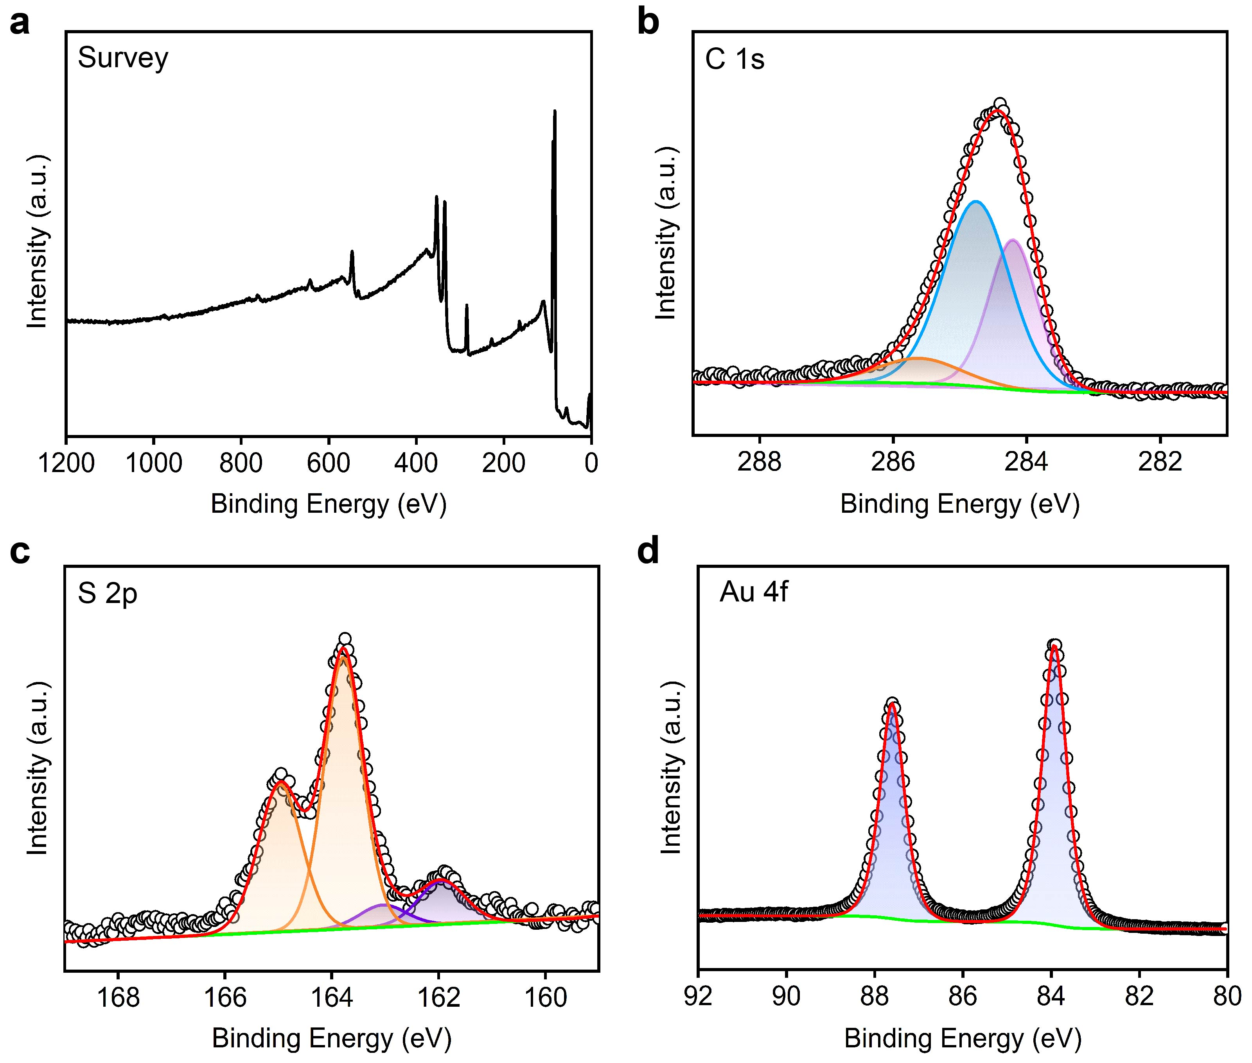
Supplementary Fig. 18 | XPS characterizations of exTTF SAMs on template-stripped Au. a, XPS survey spectrum. b–d, High-resolution spectra of the C 1s region (b), S 2p region (c), and Au 4f region (d) for the exTTF SAMs.

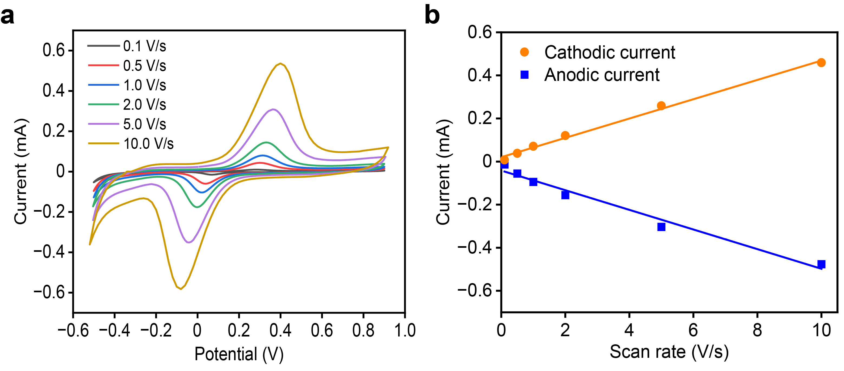
Supplementary Fig. 19 | Electrochemical characterizations of exTTF SAMs on Au performed in a cell equipped with platinum counter electrode, Ag/AgCl reference electrode and aqueous 1.0 M HClO₄ as electrolyte solution. a, Cyclic voltammograms recorded at different scan rates from 0.1 to 10 V/s. b, Plots of peak currents under different scan rates. Peak current is linear with the scan rate.

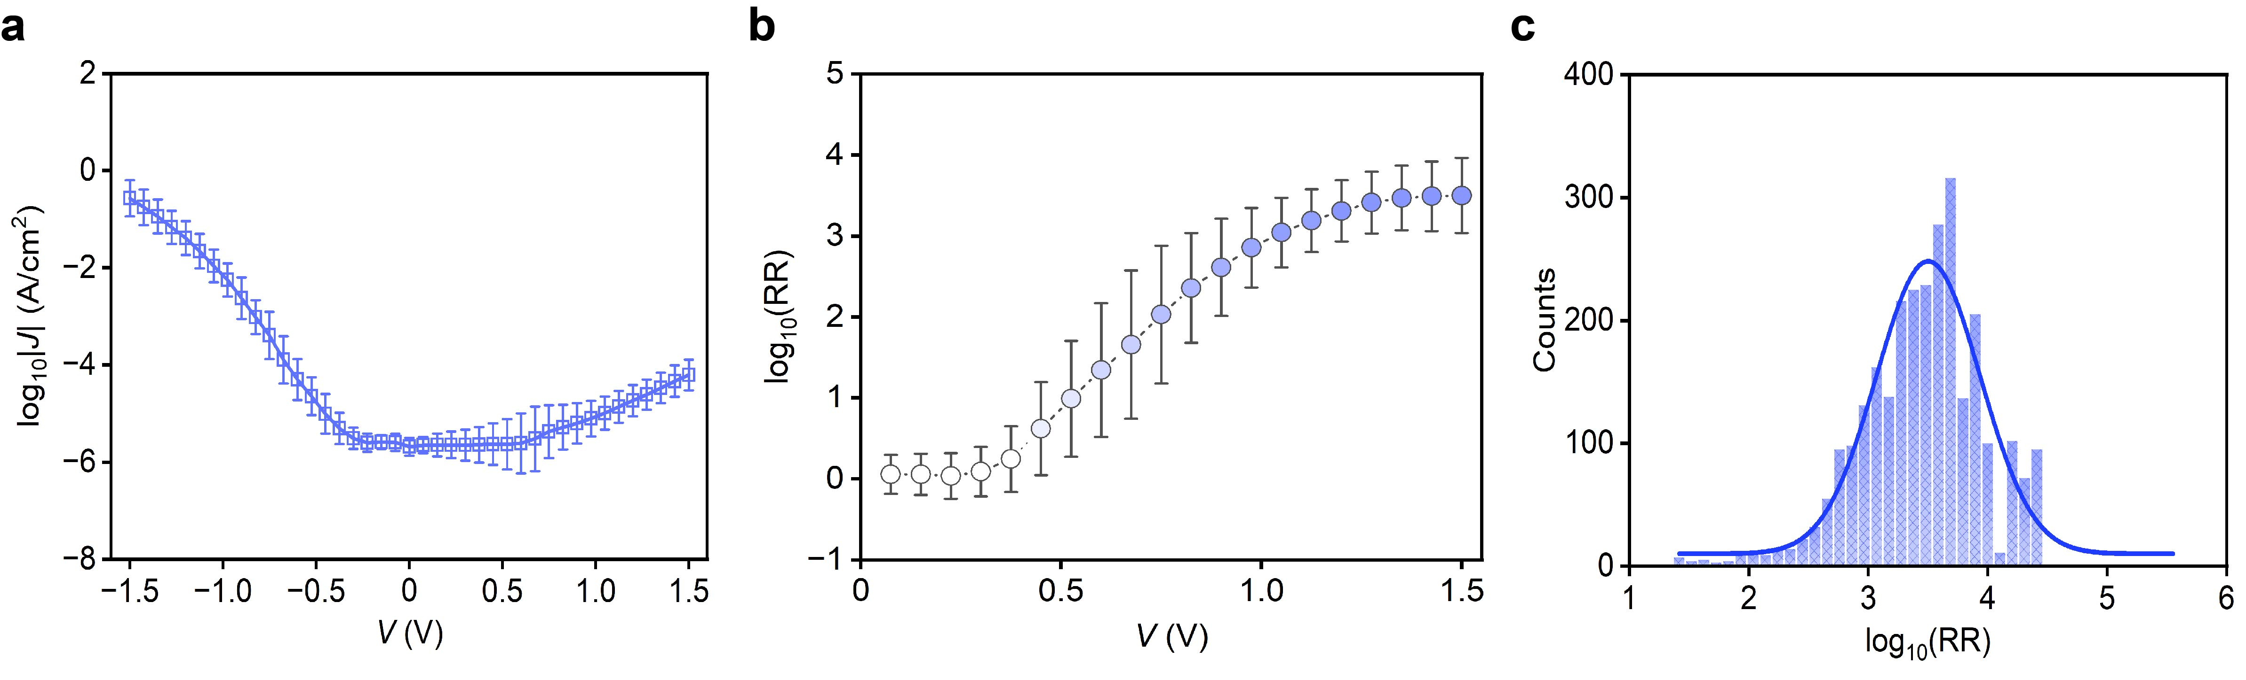
Supplementary Fig. 20 | Electrical characteristics of the exTTF SAMs molecular devices. a, Semi-log plot of the J–V characteristics with error bars determined from the standard deviation. b, Rectification ratio vs. V for EGaIn-exTTF-Au molecular junctions. c, Histograms of the rectification ratio at ±1.5 V with Gaussian fitting.

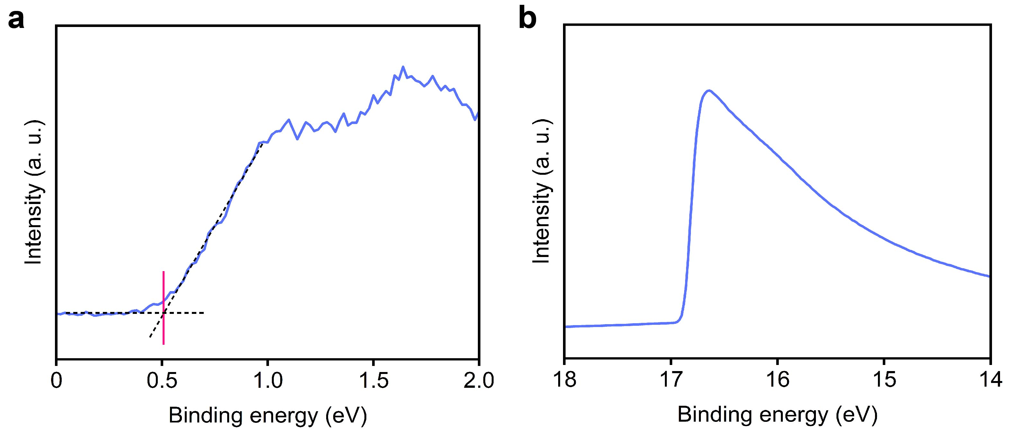
Supplementary Fig. 21 | UPS characterizations for exTTF SAMs on the template-stripping Au. a–b, HOMO peak (a) and secondary electron cut-off spectra (b) of the exTTF SAMs.
Extracted from the UPS spectra, the values of the E_{HOMO} and δE_{ME} for the exTTF SAMs are −4.84 eV and 0.51 eV, indicating that the HOMO are energetically close to the Fermi level of the electrodes. The lowest unoccupied molecular orbitals (LUMO) are not energetically accessible in the applied bias window within the HOMO-LUMO gap¹⁵⁻¹⁸. The HOMO is coupled to the top electrode: at positive bias the HOMO does not fall in the energy window defined by both Fermi-levels but at sufficient negative bias its energy lies within the energy window of both Fermi-levels. Hence, only at negative bias the HOMO participates in the mechanism of charge transport resulting in the observed rectification effects.

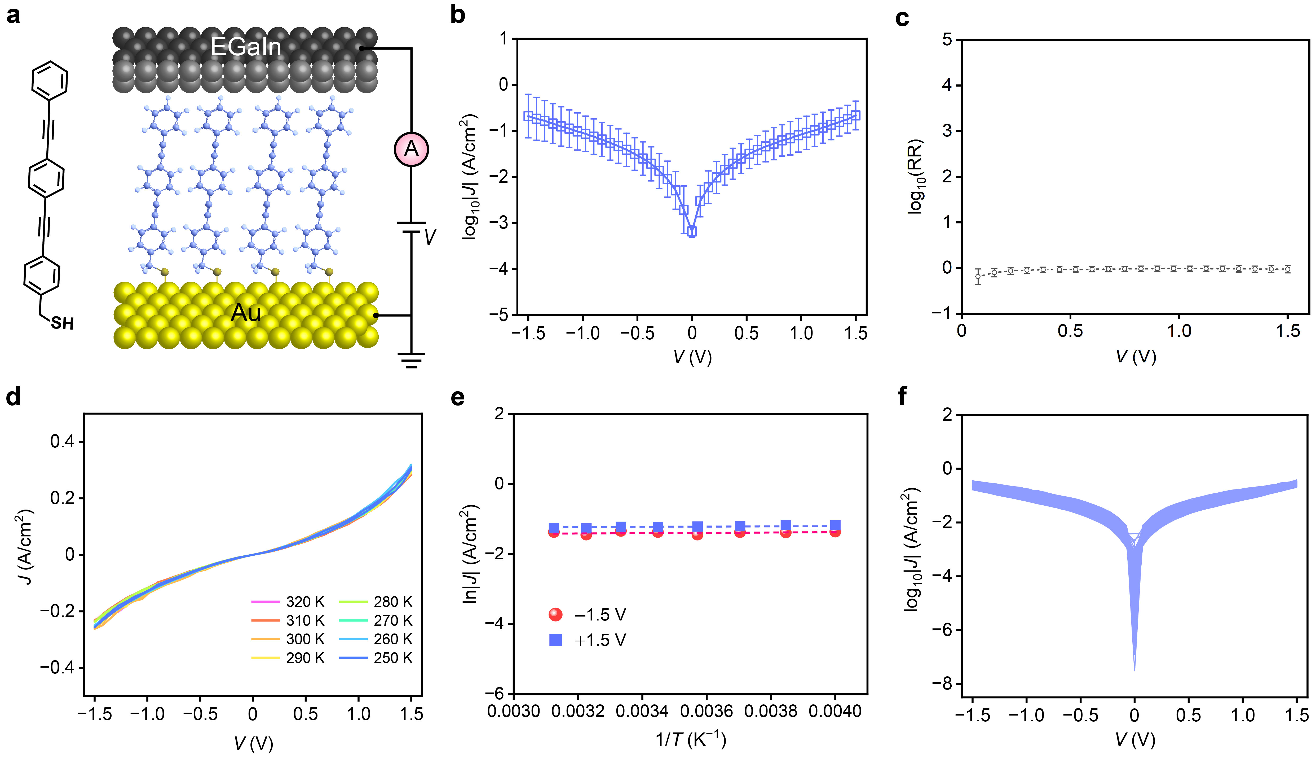
Supplementary Fig. 22 | Electrical characteristics for the 1,4-bis(((4-acetylthio)phenyl)ethynyl)benzene (OPE3) molecule devices. a, Structure of the OPE3-SH molecule and the schematic picture of the EGaIn-OPE3-Au molecular junction. b, J–V curves for OPE3 molecules statistical data of molecular devices. c, Rectification ratio vs. V for OPE3 molecular junctions. d, Temperature-dependent J–V characteristics of OPE3 molecular junctions. e, Arrhenius plots of ln|J| versus 1/T for OPE3 molecular devices at ±1.5 V, respectively. Arrhenius plot for OPE3 molecular devices, showing a very slight temperature dependence. f, J–V plots corresponding to 1000 successive scans for OPE3 molecular junction.
To ensure that the off unity asymmetric ratio is truly attributed to the exTTF moiety, we could find from the reports that the estimated RR is clearly ≈1 (Supplementary Fig. 22) when the deposited molecules are lacking the exTTF moiety but under same device configurations.
Supplementary Fig. 23 | Retention characteristics of the exTTF molecular devices under various bending configurations. a–b, J values versus time for the exTTF devices measured every 10 s at +1.5 V and −1.5 V for 10⁴ seconds under convex condition r = 10 mm (a), and concave condition r = −10 mm (b).

Supplementary Fig. 24 | Electrical characteristics of the exTTF flexible molecular devices for 1000 consecutive scans under various bending configurations. a–c, J–V plots corresponding to 1000 successive by continuous voltage cycling and rectification ratio vs. scan number under flat (a), convex r = 10 mm (b), and concave r = −10 mm (c) conditions.

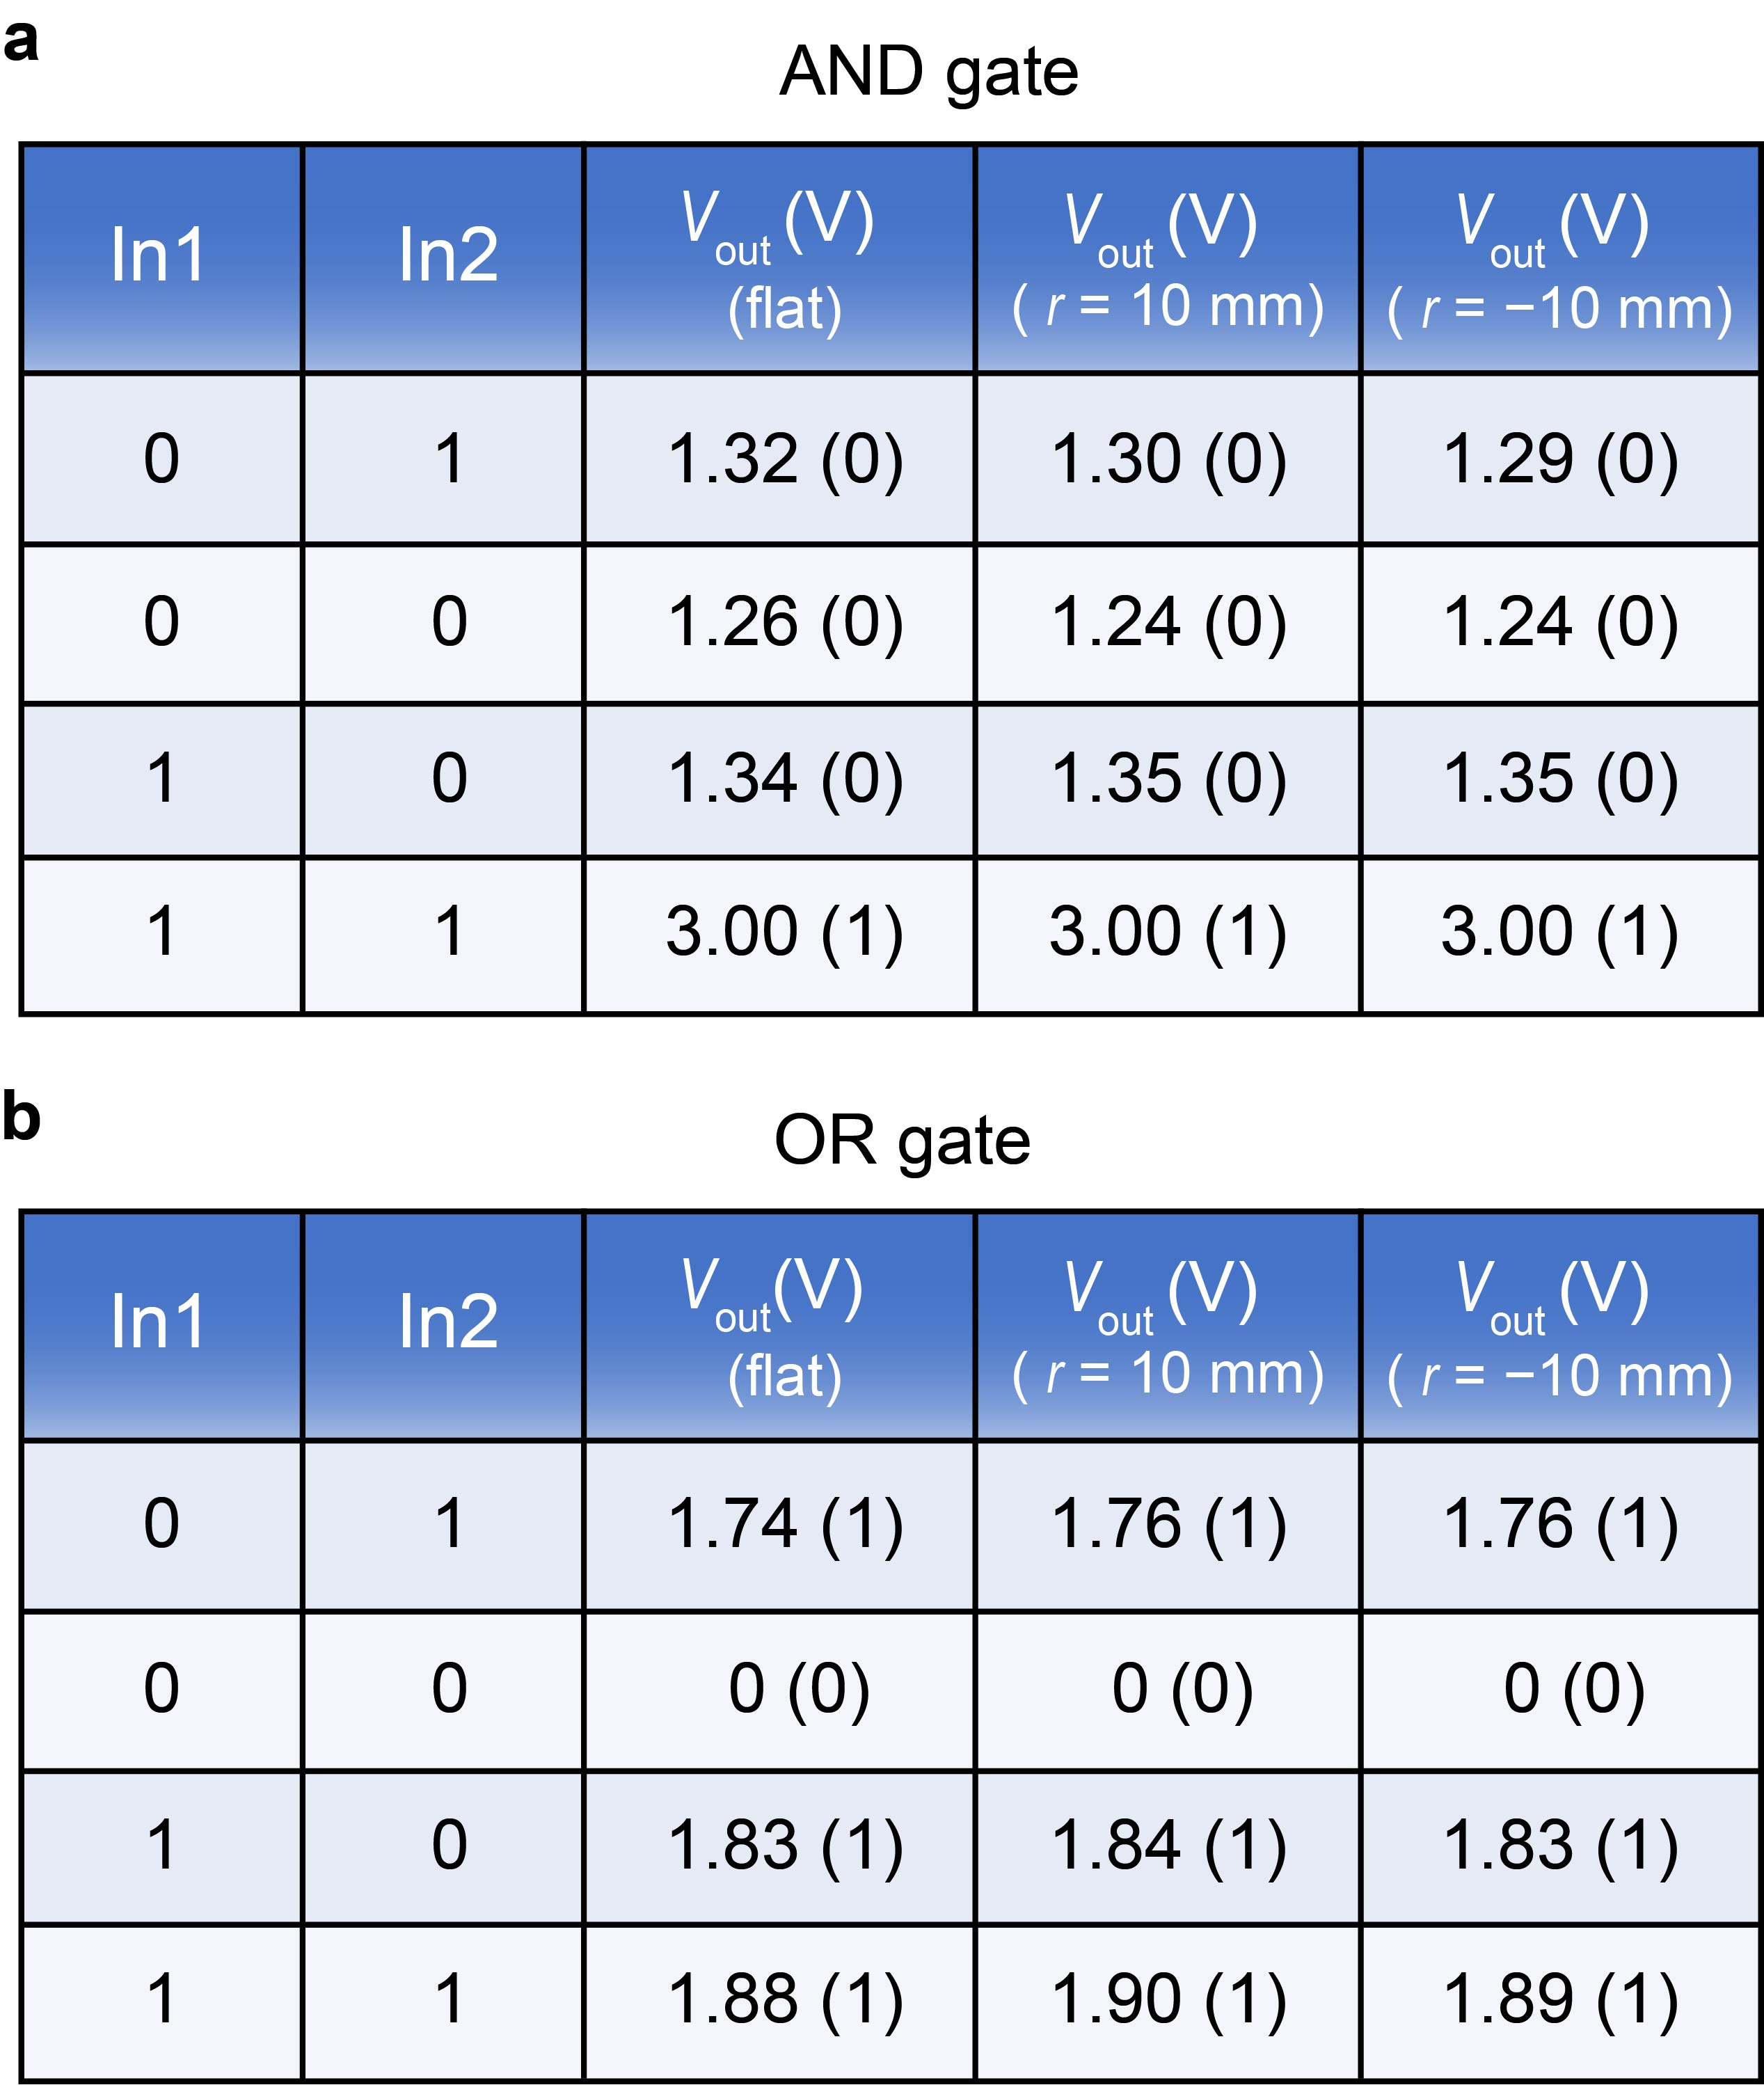
Supplementary Fig. 25 | Experimental truth tables of the flexible logic gates. a, AND gate. b, OR logic gate.

Supplementary Fig. 26 | Rectifier performance of half-wave and full-wave rectifier circuits at different frequencies. a–c, Half-wave rectifier at frequency of 10 Hz (a), 100 Hz (b), and 1000 Hz (c). d–f, Full-wave rectifier at frequency of 10 Hz (d), 100 Hz (e), and 1000 Hz (f).

Supplementary Table 1 | Statistical analysis of alkanethiol-SAMs molecular devices J–V characteristics.
SAMs | Number of junctions | Working junctions | Number of stable traces | Yield (%) | σ_{log}
SC₆ | 100 | 83 | 1162 | 83 | 2.15
SC₈ | 100 | 85 | 1190 | 85 | 2.23
SC₁₀ | 100 | 75 | 1050 | 75 | 1.87
SC₁₂ | 100 | 77 | 1078 | 77 | 2.08

Supplementary Table 2 | Statistical data of flexible molecular devices for alkanethiol-SAMs under different bending conditions.
Bending radius (mm) | Yield of working devices after bending test (%) |  |  |  | Decay coefficient (β)
Bending radius (mm) | SC₆ | SC₈ | SC₁₀ | SC₁₂ | Decay coefficient (β)
10 | 100 | 100 | 100 | 100 | 1.11±0.06
20 | 100 | 100 | 100 | 100 | 1.19±0.04
30 | 100 | 100 | 100 | 100 | 1.08±0.06
−10 | 100 | 100 | 95 | 100 | 0.98±0.02
−20 | 100 | 100 | 100 | 100 | 1.03±0.08
−30 | 100 | 100 | 100 | 100 | 1.16±0.06

Supplementary Table 3 | Statistical data of flexible molecular devices for alkanethiol-SAMs under repeated bending cycles.
Bending conditions | Bending cycles | Yield of working devices after bending test (%) |  |  |  | Decay coefficient (β)
Bending conditions | Bending cycles | SC₆ | SC₈ | SC₁₀ | SC₁₂ | Decay coefficient (β)
Convex  (r = 10 mm) | 10 | 100 | 100 | 95 | 95 | 1.10±0.05
Convex  (r = 10 mm) | 100 | 100 | 100 | 100 | 100 | 1.01±0.05
Convex  (r = 10 mm) | 1000 | 100 | 100 | 100 | 100 | 1.03±0.02
Concave  (r = −10 mm) | 10 | 100 | 100 | 95 | 100 | 1.03±0.02
Concave  (r = −10 mm) | 100 | 100 | 100 | 100 | 100 | 0.95±0.01
Concave  (r = −10 mm) | 1000 | 100 | 100 | 100 | 100 | 0.96±0.02

Supplementary Table 4 | Statistics for the exTTF-SAMs flexible molecular devices under different bending conditions.
Bending radius (mm) | Number of junctions | Working junctions | Number of stable traces | Yield (%) | log₁₀RR (σ_{log})
∞ (flat) | 100 | 93 | 1302 | 93 | 3.49±0.46
10 | 20 | 20 | 280 | 100 | 3.31±0.37
20 | 20 | 20 | 280 | 100 | 3.52±0.44
30 | 20 | 20 | 280 | 100 | 3.54±0.25
−10 | 20 | 20 | 280 | 95 | 3.61±0.37
−20 | 20 | 20 | 280 | 100 | 3.59±0.25
−30 | 20 | 20 | 280 | 100 | 3.51±0.36

Supplementary References
1. Kim, M.-g., Brown, D. K. & Brand, O. Nanofabrication for all-soft and high-density electronic devices based on liquid metal. Nat. Commun. 11, 1002 (2020).
2. Johnston, L., Yang, J., Han, J., Kalantar-Zadeh, K. & Tang, J. Intermetallic wetting enabled high resolution liquid metal patterning for 3D and flexible electronics. J. Mater. Chem. C 10, 921–931 (2022).
3. Li, G. & Lee, D.-W. An advanced selective liquid-metal plating technique for stretchable biosensor applications. Lab Chip 17, 3415–3421 (2017).
4. Byeon, S. E., Kang, H. & Yoon, H. J. Toward printed molecular electronics: direct printing of liquid metal microelectrode on self‐assembled monolayers. Adv. Electron. Mater. 7, 2000829 (2020).
5. Park, Y.-G., An, H. S., Kim, J.-Y. & Park, J.-U. High-resolution, reconfigurable printing of liquid metals with three-dimensional structures. Sci. Adv. 5, eaaw2844 (2019).
6. Wan, A., Jiang, L., Sangeeth, C. S. S. & Nijhuis, C. A. Reversible soft top-contacts to yield molecular junctions with precise and reproducible electrical characteristics. Adv. Funct. Mater. 24, 4442–4456 (2014).
7. Wan, A. et al. Arrays of high quality SAM-based junctions and their application in molecular diode based logic. Nanoscale 7, 19547–19556 (2015).
8. Karuppannan, S. K., Hongting, H., Troadec, C., Vilan, A. & Nijhuis, C. A. Ultrasmooth and photoresist‐free micropore‐based EGaIn molecular junctions: fabrication and how roughness determines voltage response. Adv. Funct. Mater. 29, 1904452 (2019).
9. Karuppannan, S. K., Neoh, E. H. L., Vilan, A. & Nijhuis, C. A. Protective layers based on carbon paint to yield high-quality large-area molecular junctions with low contact resistance. J. Am. Chem. Soc. 142, 3513–3524 (2020).
10. Yuan, L., Jiang, L., Zhang, B. & Nijhuis, C. A. Dependency of the tunneling decay coefficient in molecular tunneling junctions on the topography of the bottom electrodes. Angew. Chem., Int. Ed. 53, 3377–3381 (2014).
11. Jeong, H., Kim, D., Xiang, D. & Lee, T. High-yield functional molecular electronic devices. ACS Nano 11, 6511–6548 (2017).
12. Xie, Z., Bâldea, I., Oram, S., Smith, C. E. & Frisbie, C. D. Effect of heteroatom substitution on transport in alkanedithiol-based molecular tunnel junctions: evidence for universal behavior. ACS Nano 11, 569–578 (2017).
13. Yuan, L. et al. Transition from direct to inverted charge transport Marcus regions in molecular junctions via molecular orbital gating. Nat. Nanotechnol. 13, 322–329 (2018).
14. Lin, J.-L. et al. Molecular diodes with tunable threshold voltage based on π-extended tetrathiafulvalene. Adv. Mater. Interfaces, 2201238 (2022).
15. Martín, N. et al. Synthesis, properties, and theoretical characterization of largely π-extended tetrathiafulvalene derivatives with quinonoid structures. J. Org. Chem. 63, 1268–1279 (1998).
16. Yuan, L. et al. Chemical control over the energy-level alignment in a two-terminal junction. Nat. Commun. 7, 12066 (2016).
17. Song, P. et al. Stable molecular diodes based on π–π interactions of the molecular frontier orbitals with graphene electrodes. Adv. Mater. 30, 1706322 (2018).
18. Capozzi, B. et al. Single-molecule diodes with high rectification ratios through environmental control. Nat. Nanotechnol. 10, 522–527 (2015).

