Supplementary Documents (Appendices)

A. Descriptive Statistics
Table A1. Descriptive Statistics (entire study area)
 | Total (N = 102,195) | Unburnt (n = 84378) | Low and Moderate (n = 12925) | High (n = 4068) | Very High (n = 824)
Burn Severity
Unburnt | 84,378 (83) | 84,378 (100) | 0 (0) | 0 (0) | 0 (0)
Low and Moderate | 12,925 (13) | 0 (0) | 12,925 (100) | 0 (0) | 0 (0)
High | 4,068 (4) | 0 (0) | 0 (0) | 4,068 (100) | 0 (0)
Very High | 824 (1) | 0 (0) | 0 (0) | 0 (0) | 824 (100)
Rainforest Classification
Cool temperate rainforest | 156 (0) | 147 (0) | 8 (0) | 1 (0) | 0 (0)
Dry rainforest or vine thickets | 2,337 (2) | 2,092 (2) | 200 (2) | 33 (1) | 12 (1)
Tropical or sub-tropical rainforest | 67,768 (66) | 55,861 (66) | 8,949 (69) | 2,509 (62) | 449 (54)
Warm Temperate Rainforest | 31,934 (31) | 26,278 (31) | 3,768 (29) | 1,525 (37) | 363 (44)

Table A2. Descriptive Statistics (within burn extent - ‘cool temperate rainforest’ and ‘dry rainforest or vine thickets’ excluded)
Descriptive Statistics (within burn extent) | Total (n = 42,502) | Unburnt (n = 24939) | Low and Moderate (n = 12717) | High (n = 4034) | Very High (n = 812)
Elevation
min | -5.26897 | -5.26897 | -2.74026 | 0.01 | 6.88061
median | 641.32895 | 719.61072 | 567.9245 | 461.6851 | 413.677
max | 1562 | 1562 | 1527.97827 | 1514.609 | 1524.979
mean (sd) | 635.59 ± 280.10 | 696.73 ± 283.97 | 573.82 ± 243.90 | 489.24 ± 255.95 | 452.34 ± 242.09
TPI
min | -15.37320423 | -14.27755737 | -11.41617107 | -15.3732 | -7.424317
median | -0.64086175 | -0.662499726 | -0.691621542 | -0.445962 | -0.235607
max | 11.2898922 | 11.2898922 | 10.68348885 | 9.909675 | 11.27922
mean (sd) | -0.71 ± 2.34 | -0.75 ± 2.19 | -0.75 ± 2.55 | -0.42 ± 2.47 | -0.10 ± 2.59
Slope
min | 0.03850174 | 0.13475655 | 0.03850174 | 0.079837 | 1.072374
median | 17.66692066 | 16.04712486 | 20.27946281 | 20.30257 | 19.54151
max | 82.86851501 | 80.83131409 | 79.13515472 | 72.32076 | 82.86852
mean (sd) | 18.64 ± 9.96 | 17.25 ± 9.32 | 20.66 ± 10.46 | 20.56 ± 10.65 | 20.22 ± 10.43
Aspect
North | 15,003 (35) | 7,927 (32) | 4,816 (38) | 1,880 (47) | 380 (47)
South | 27,499 (65) | 17,012 (68) | 7,901 (62) | 2,154 (53) | 432 (53)
Burn Severity
Unburnt | 24,939 (59) | 24,939 (100) | 0 (0) | 0 (0) | 0 (0)
Low and Moderate | 12,717 (30) | 0 (0) | 12,717 (100) | 0 (0) | 0 (0)
High | 4,034 (9) | 0 (0) | 0 (0) | 4,034 (100) | 0 (0)
Very High | 812 (2) | 0 (0) | 0 (0) | 0 (0) | 812 (100)

Table A3. Descriptive statistics per vegetation type (within burn extent and buffer)
 | Cool temperate rainforest (n = 28) | Dry rainforest or vine thickets (n = 335) | Tropical or sub-tropical rainforest (n = 28228) | Warm Temperate Rainforest (n = 14274)
Elevation
min | 210.027 | 38 | -3.8377 | -5.269
median | 1135.31 | 295.137 | 656.793 | 600.049
max | 1270.39 | 661.866 | 1562 | 1426.71
mean (sd) | 1,027.43 ± 294.11 | 301.42 ± 122.08 | 653.23 ± 264.92 | 600.72 ± 304.96
TPI
min | -5.4076 | -14.167 | -15.373 | -11.711
median | 0.72543 | -1.8519 | -0.6937 | -0.5554
max | 7.20137 | 10.5381 | 11.011 | 11.2899
mean (sd) | 0.89 ± 2.95 | -2.02 ± 2.89 | -0.72 ± 2.41 | -0.68 ± 2.20
Slope
min | 1.92135 | 0.34312 | 0.13476 | 0.0385
median | 27.5982 | 17.9473 | 19.1724 | 14.6105
max | 47.7803 | 74.071 | 82.8685 | 80.8313
mean (sd) | 25.14 ± 11.26 | 20.47 ± 13.14 | 19.82 ± 9.83 | 16.31 ± 9.82
Burn Severity
Unburnt | 19 (68) | 90 (27) | 16,321 (58) | 8,618 (60)
Low and Moderate | 8 (29) | 200 (60) | 8,949 (32) | 3,768 (26)
High | 1 (4) | 33 (10) | 2,509 (9) | 1,525 (11)
Very High | 0 (0) | 12 (4) | 449 (2) | 363 (3)
Aspect
North | 7 (25) | 110 (33) | 10,089 (36) | 4,914 (34)
South | 21 (75) | 225 (67) | 18,139 (64) | 9,360 (66)

B. Additional Figures
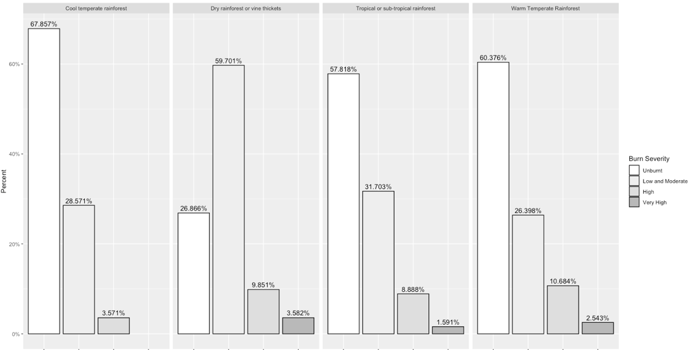
Figure B1. Rainforest Classification and burn severity within burn extent

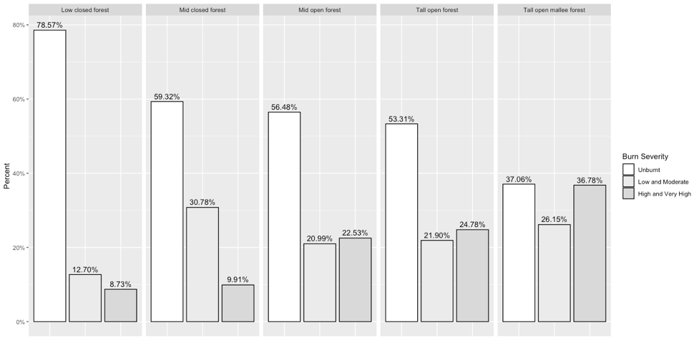
Figure B2. Forest Type and burn severity within burn extent (High and very high severity classes have been merged)

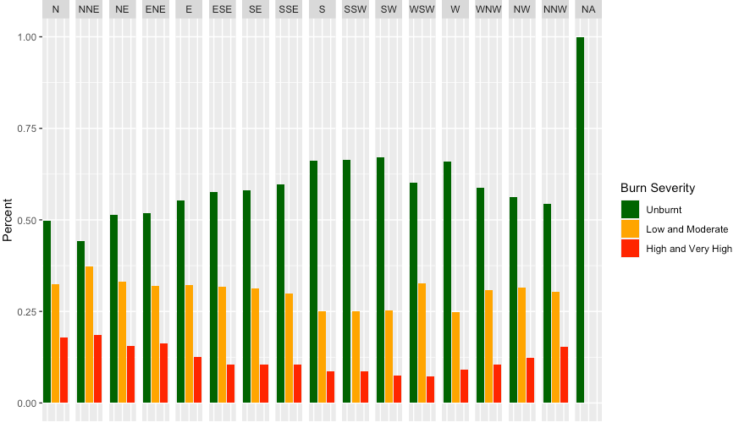
Figure B3. Detailed analysis of burn severity and aspect. High and very high burn severity classes have been merged. Coding adapted from Allistaire (2020).
(Allistaire. 2020. Conversion of wind direction (degrees) into factors, RStudio Community. https://community.rstudio.com/t/convert-wind-direction-degrees-into-factors-in-a-data-frame/14636. Accessed 01 September 2020).

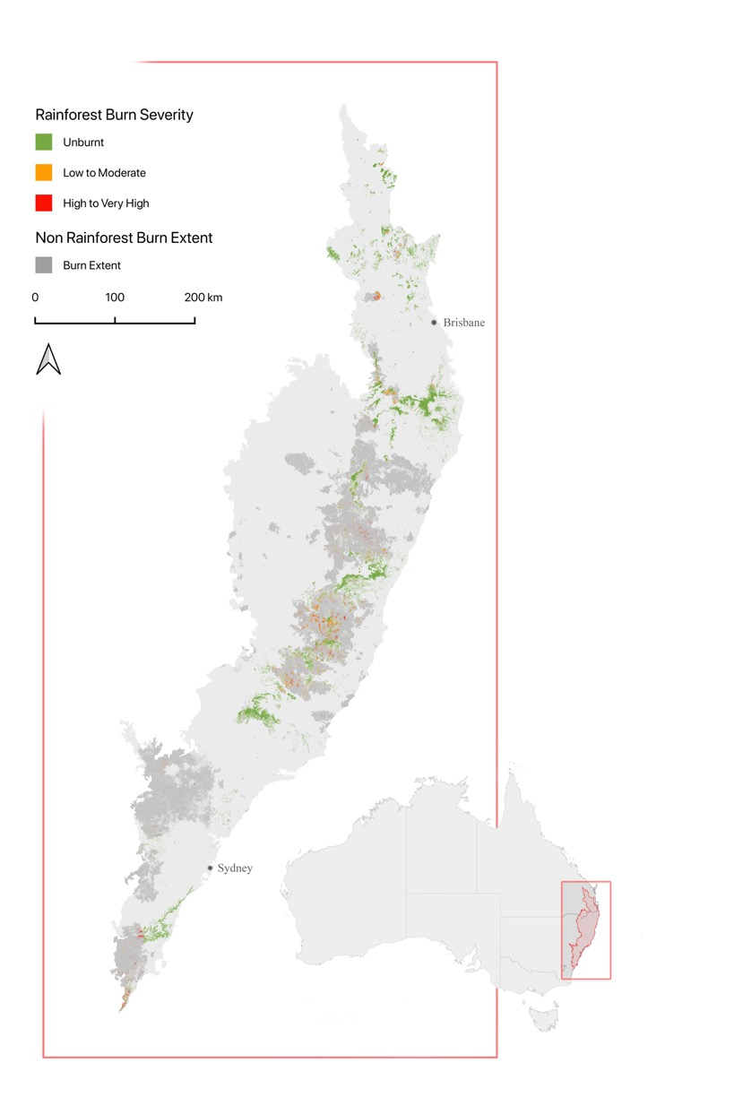
Figure B4. Burn severity mapping for all rainforests within the Eastern Australian Tropical and Sub-tropical Forests Conservation Zone. Higher resolution mapping included in supplementary documents and a shapefile can also be requested via email on myles.bennell@uqconnect.edu.au.

