Supplementary Information
Supplementary Table 1: Thermal manikin body segments and associated surface area and core temperature setting for comfort mode per the Advanced Berkeley Comfort model⁶³.
 | Body segment | Surface area (m²) | Core temperature (°C)
1 | Left foot | 0.05 | 35.1
2 | Right foot | 0.04 | 35.1
3 | Left lower leg | 0.09 | 35.6
4 | Right lower leg | 0.09 | 35.6
5 | Left thigh | 0.16 | 35.8
6 | Right thigh | 0.17 | 35.8
7 | Pelvis | 0.17 | 36.3
8 | Head | 0.11 | 36.9
9 | Left hand | 0.04 | 35.4
10 | Right hand | 0.04 | 35.4
11 | Left forearm | 0.05 | 35.5
12 | Right forearm | 0.05 | 35.5
13 | Left upper arm | 0.07 | 35.8
14 | Right upper arm | 0.08 | 35.8
15 | Chest | 0.14 | 36.5
16 | Back | 0.13 | 36.5
 | Total | 1.48 | 36.7

Supplementary Table 2: Dry-heat transfer coefficient of each body segment of the thermal manikin
 | 16°C |  | 28°C
Body segment | Log | Fetal | Log | Starfish
Back | 7.8 | 7.7 | 7.2 | 6.8
Chest | 7.8 | 6.9 | 6.9 | 6.0
Head | 5.1 | 5.3 | 4.6 | 4.5
Left foot | 8.5 | 8.3 | 7.0 | 7.9
Left forearm | 8.5 | 8.7 | 7.7 | 8.1
Left hand | 8.9 | 9.0 | 8.3 | 8.4
Left lower leg | 8.5 | 8.2 | 7.7 | 8.1
Left thigh | 7.6 | 7.4 | 7.3 | 7.6
Left upper arm | 7.9 | 8.0 | 7.5 | 7.9
Pelvis | 8.2 | 7.8 | 7.7 | 6.9
Right foot | 8.7 | 8.1 | 7.6 | 7.9
Right forearm | 9.1 | 8.0 | 8.1 | 7.9
Right hand | 9.2 | 8.5 | 8.4 | 8.1
Right lower leg | 8.7 | 8.2 | 7.9 | 8.1
Right thigh | 8.0 | 7.7 | 7.5 | 7.4
Right upper arm | 8.5 | 7.7 | 7.4 | 7.4

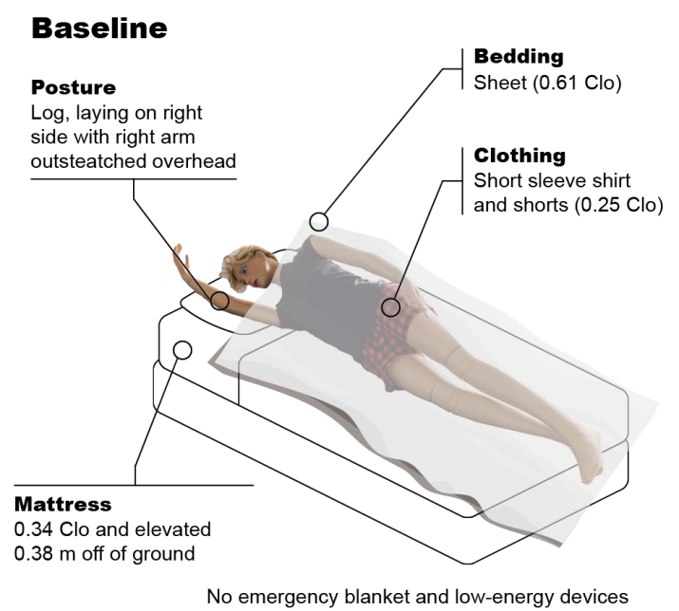
Supplementary Fig. 1: Baseline condition (thermal manikin posture and clothing, bedding, and mattress) is used to calculate the difference in manikin-based equivalent temperature as shown in (2).
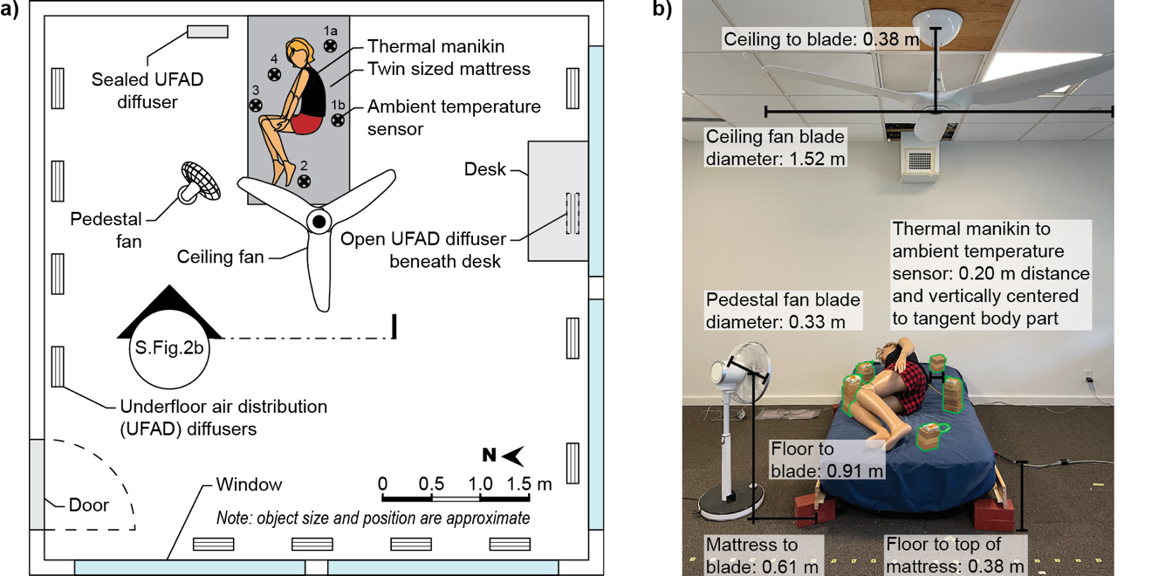
Supplementary Fig. 2: Plan view of controlled environmental chamber (CEC) and experimental setup; b) Section view of CEC setup prior to experiment with annotations. Ambient temperature sensors (green outline) were added for clarity. Ambient temperature sensors were present during experimental run.

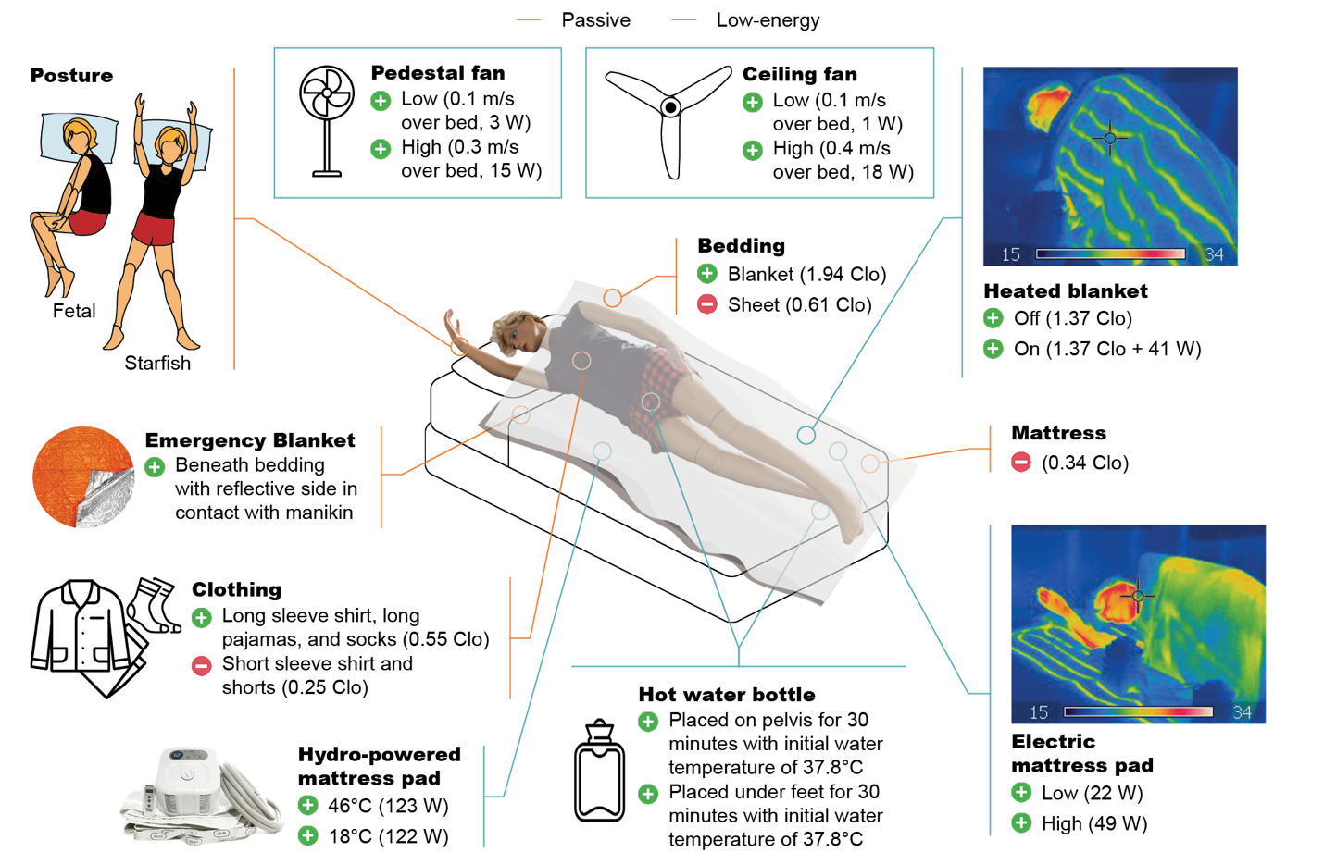
Supplementary Fig. 3: Illustration of experimental conditions representing a variety of passive and active heating and cooling strategies. Image created from a variety of licensed sources (author, Adobe Stock, FlatIcon by FreePik, Adventure Ready Brands, and Sleepme)
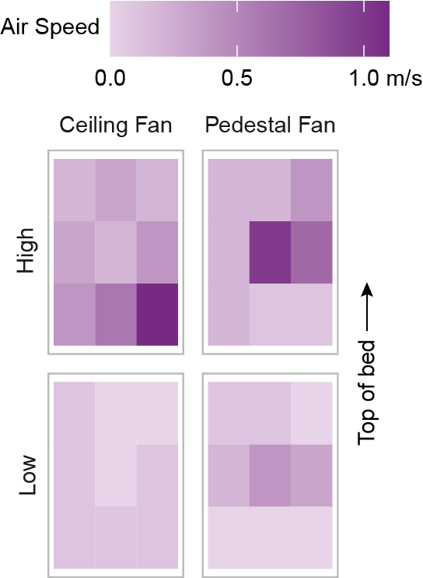
Supplementary Fig. 4: Spatial distribution of average air speed generated by the ceiling and pedestal fans across the bed as measured by a handheld anemometer 0.3 m above the mattress for the low- and high-speed settings.

