Supplementary Material
Title: Nucleoside Transporter-guided Cytarabine Conjugated Liposomes for Intracellular Methotrexate Delivery and Cooperative Choriocarcinoma Therapy
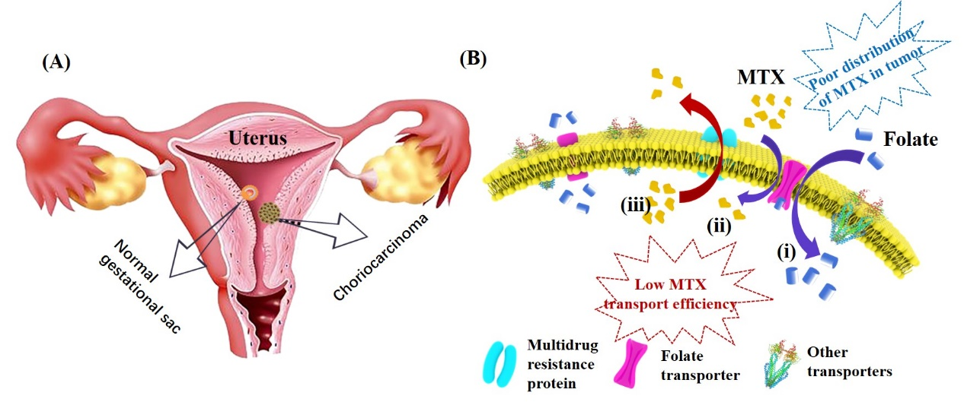
Fig. S1 Schematic diagram presenting the growth of choriocarcinoma (A). Schematic diagram presenting the transport of MTX across the cell membrane by membrane protein (B).

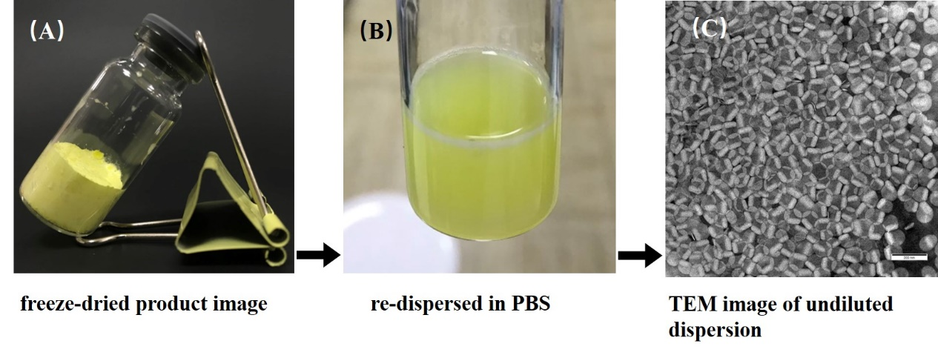
Fig. S2 The freeze-dried product image of Cy-Lipo@MTX (A). Redispersion of Cy-Lipo@MTX in PBS (B). TEM image of undiluted Cy-Lipo@MTX dispersion (C). Cy-Lipo@MTX are highly dispersed.

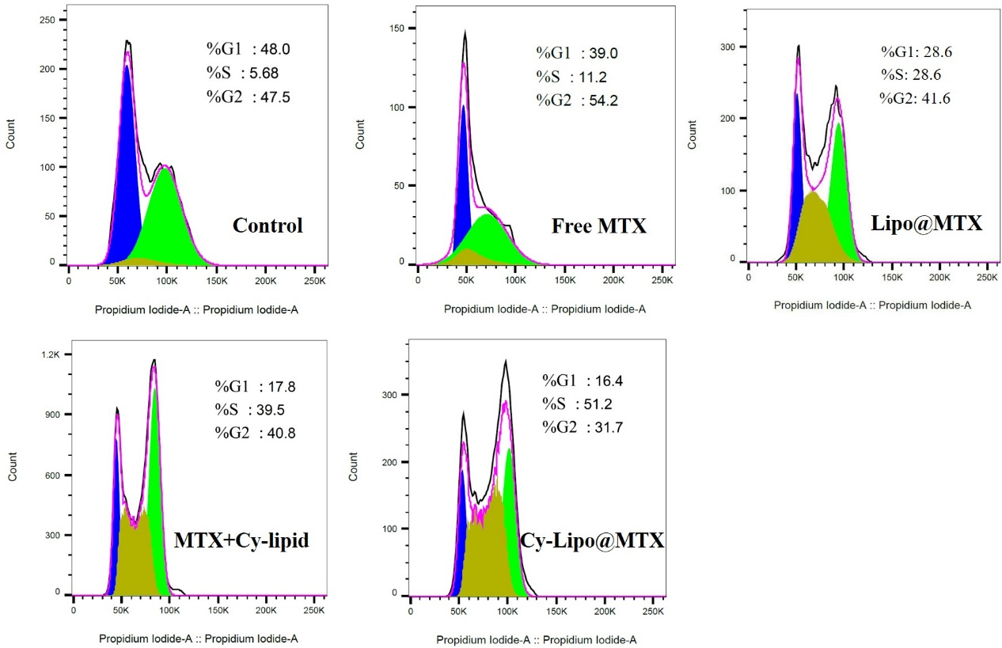
Fig. S3 JEG-3 cell cycle perturbations induced by culture medium or MTX formulations containing medium.

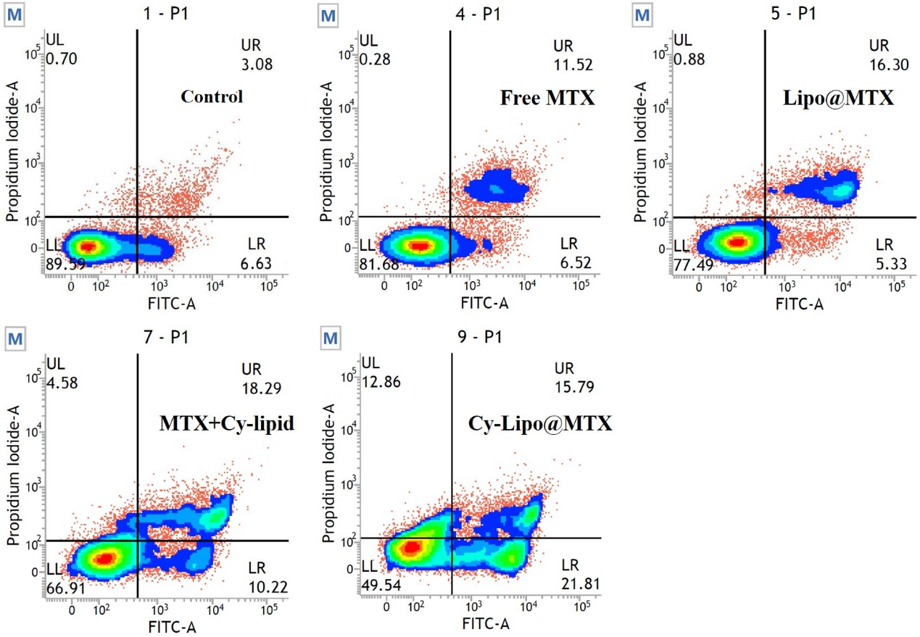
Fig. S4 Analysis of apoptosis after treating JEG cells with culture medium or MTX formulations containing medium.

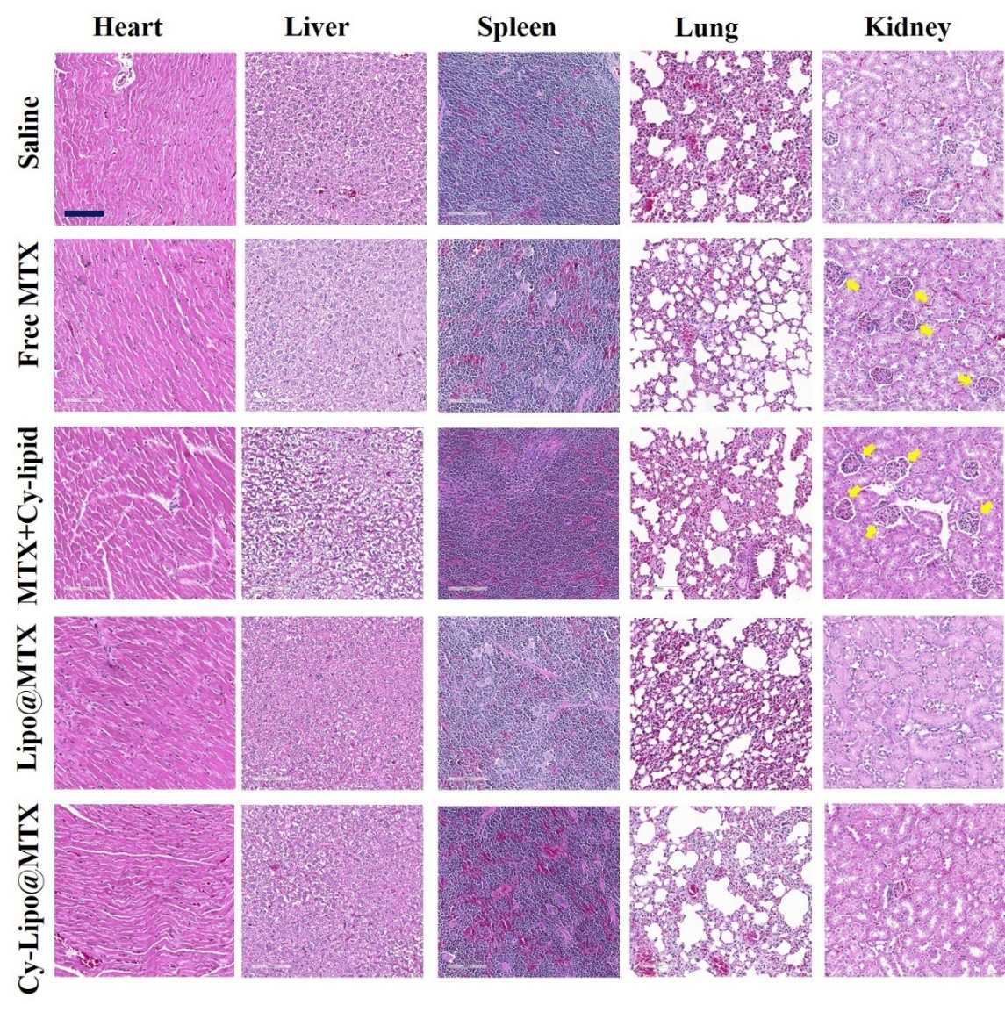
Fig. S5 In vivo toxicity evaluations of various formulations. H&E-stained slice images of major organs from different groups at the end of treatment, the scale bar is 100 μm. The yellow arrows represent the edematous glomeruli.

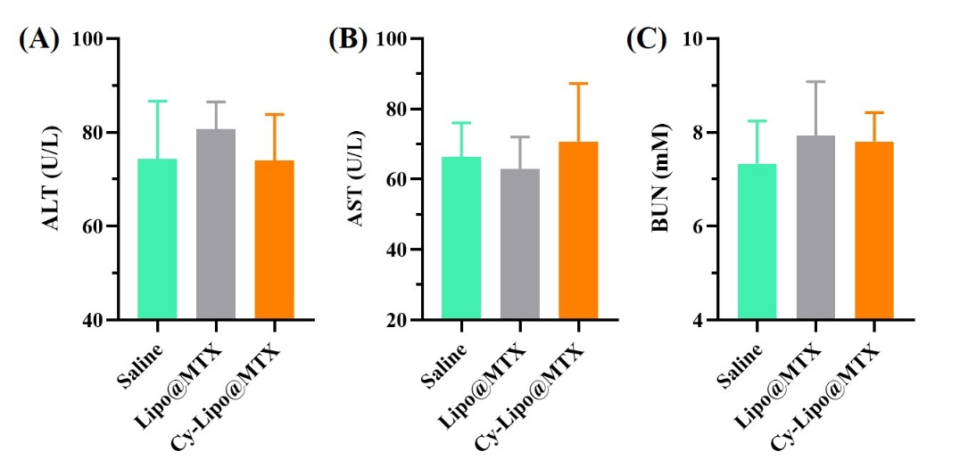
Fig. S6 Biochemical blood analysis of saline, Lipo@MTX, and Cy-Lipo@MTX treated mice at 24 d post-injection. The terms include alanine aminotransferase (ALT) (A), aspartate aminotransferase (AST) (B), and blood urine nitrogen (BUN) (C).

