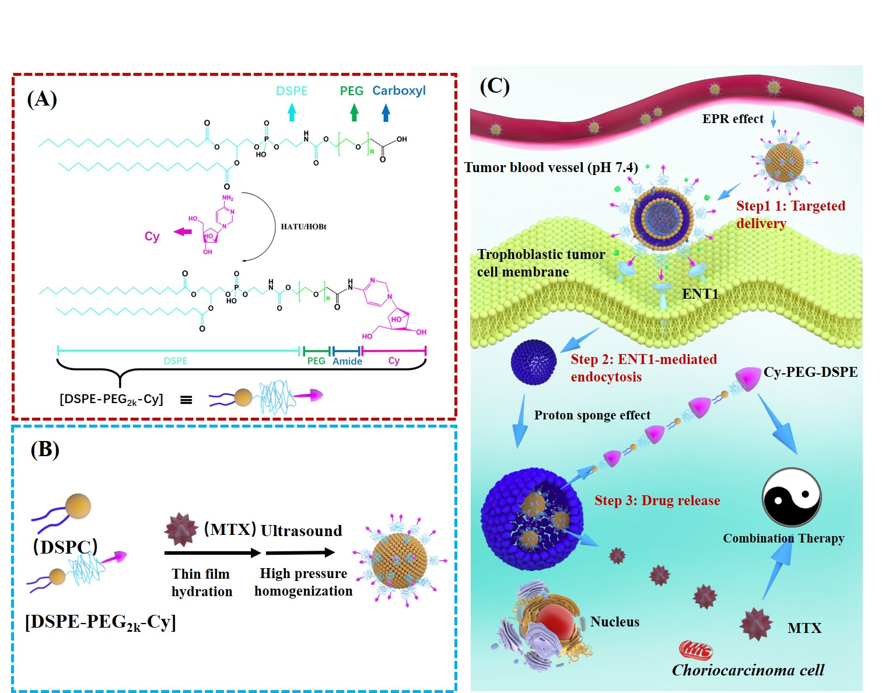
Schematic showing the preparation of Cy-Lipo@MTX and nucleoside transporter-guided intracellular methotrexate delivery and cooperative choriocarcinoma therapy

