Supplementary Results:

Supplementary Table 1: Composition of SARS-CoV-2 cases clusters in Hong Kong.
 | No. Cases | Case % | Mean | Range | No. Clusters | Cluster %
Local cluster | 225 | 21.7% | 3.5 | 2 – 106 | 23 | 17.0%
Imported cluster | 104 | 10.0% | 2 | 2 – 13 | 30 | 22.2%
Overseas cluster | 210 | 20.9% | 2 | 2 – 11 | 82 | 60.8%
Total cluster cases | 539 | 51.9% | 2 | 2 – 106 | 135 | 100.0%
Sporadic import | 449 | 43.3% | n/a | n/a | n/a | n/a
Sporadic local | 50 | 0.5% | n/a | n/a | n/a | n/a
Grand Total | 1,038 | 100.0% | n/a | n/a | n/a | n/a

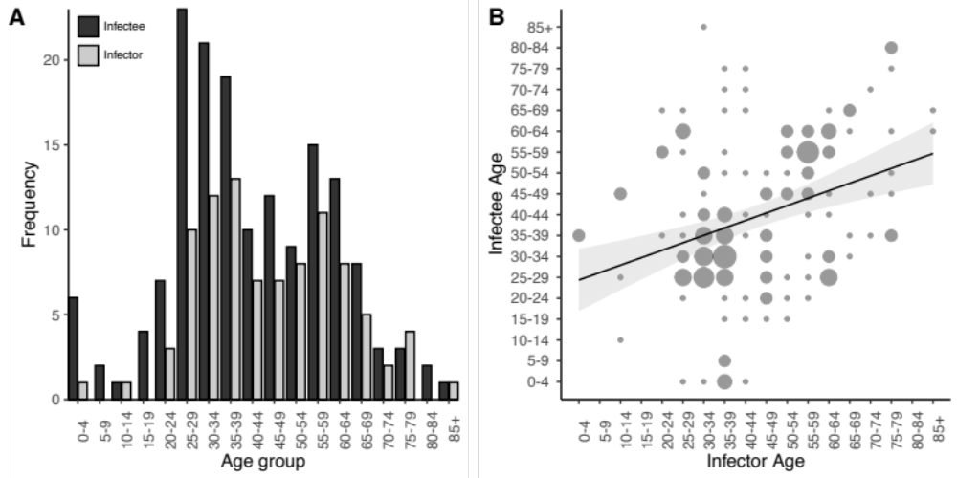

Supplementary Figure 1: A) Age distribution of SAS-CoV-2 infectors and infectees. Dependant on their intermediate position in the transmission chain, cases could be both an infector and infectee. B) Contact patterns by age among SAS-CoV-2 infections in Hong Kong. The size of each point indicates the relative number of pairs in each combination. Pairs were dependant only on the intermediate position in the transmission chain, so cases could be both an infector and infectee.

Supplementary Table 2: Estimated effective reproductive number, overdispersion parameter, coefficient of variation and proportion of infectious cases responsible for 80% of transmission in Wave 1 (Jan-Feb) and Wave 2 (Mar-Apr).
Epoch | R (95% CI) | k (95% CI) | Coefficient of  variation (95% CI) | Prop80%*  (95% CI)
Wave 1 | 0.60 (0.35 – 0.94) | 0.32 (0.17 – 0.87) | 2.9 (1.5 – 4.8) | 17% (10% – 28%)
Wave 2 | 0.56 (0.43 – 0.70) | 0.52 (0.33 – 0.98) | 2.3 (1.6 – 3.2) | 20% (16% – 27%)
*Prop80% is the proportion of cases responsible for 80% of transmission

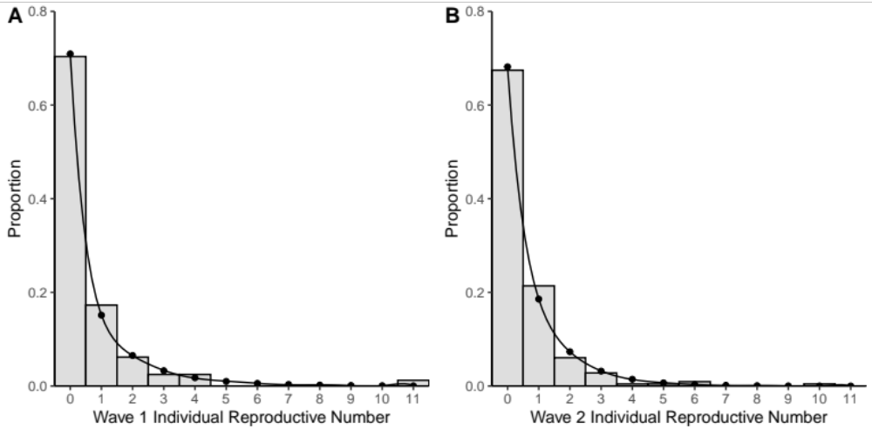
Supplementary Figure 2: Empirical offspring distribution of SARS-CoV-2 among local and imported COVID-19 cases in Hong Kong (overseas acquired clusters excluded) by epidemic wave. Wave One cases prior to March 1, 2020 (A: Left) and Wave Two cases after March 1, 2020. Corresponding fitted distribution parameters are shown in Supplementary Table 2.

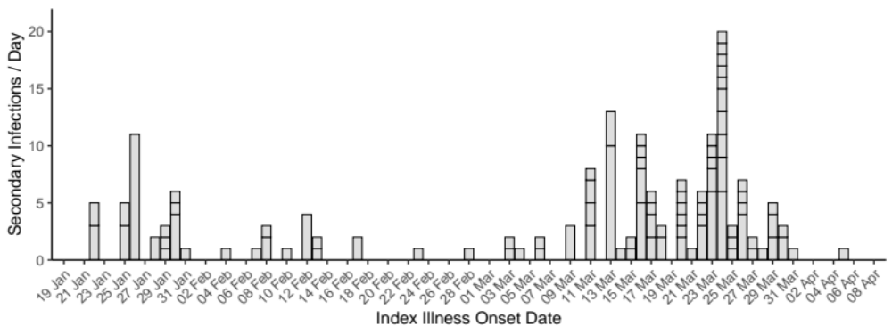
Supplementary Figure 3: Number of secondary SARS-CoV-2 infections within clusters per day in Hong Kong

Supplementary Table 3: Model comparison for COVID-19 serial intervals based 170 epidemiologically linked transmission pairs in Hong Kong.
Distribution | Mean/Shape | SD/Rate/Scale | AIC
Normal | 5.60 (4.93 - 6.29) | 4.30 (3.80 – 4.82) | 841.15
Log Normal | 1.55 (1.45 - 1.67) | 0.69 (0.61 - 0.77) | 717.23
Gamma | 2.33 (1.89 - 2.94) | 0.39 (0.31 - 0.50) | 721.85
Weibull | 1.53 (1.36 - 1.78) | 6.65 (5.98 – 7.41) | 730.07

Supplementary Table 4: Model comparison for COVID-19 empirical offspring distribution based on epidemiological linked transmission pairs in Hong Kong.
Distribution | Mu/Prob/Lambda | k | AIC
Negative Binomial | 0.58 (0.45 – 0.71) | 0.45 (0.30 – 0.72) | 601.58
Geometric | 0.63 (0.59 – 0.68) | NA | 620.27
Poisson | 0.58 (0.49 – 0.66) | NA | 711.39

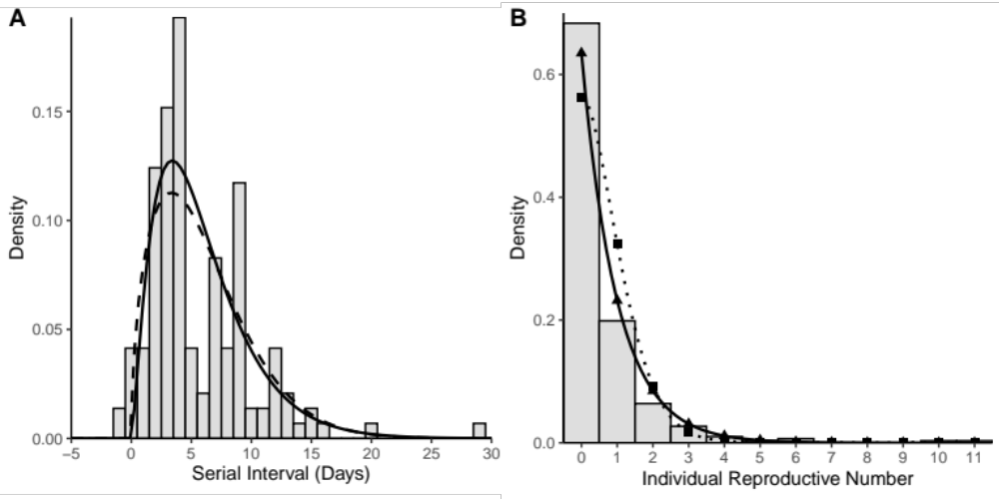
Supplementary Figure 4: (A) Empirical serial distribution of SARS-CoV-2 infections in Hong Kong among symptomatic infector-infectee pairs with fitted gamma (solid line) and Weibull (dotted) distributions. Both distributions were fitted excluding observations ≤0. (B) Empirical offspring distribution of SARS-CoV-2 among local and imported COVID-19 cases in Hong Kong (overseas acquired clusters excluded) and fitted geometric (solid – triangle) and Poisson (dotted – square). All distribution parameters are shown in Supplementary Table 3 & 4.

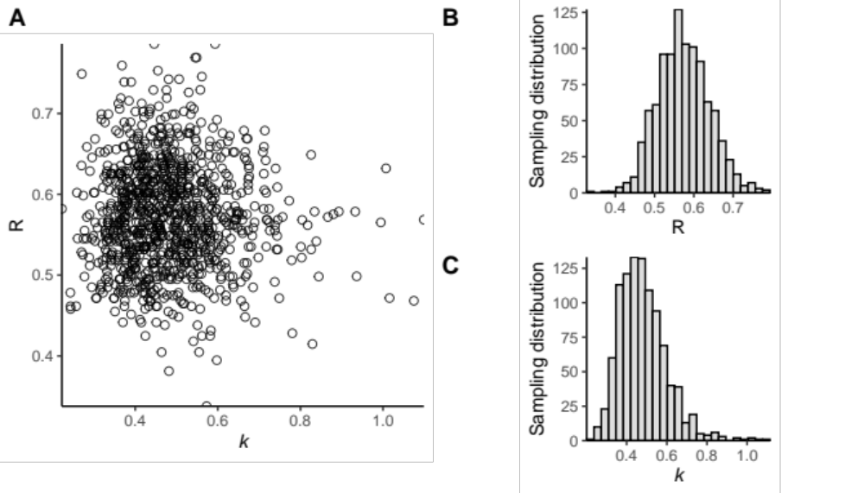
Supplementary Figure 5: (A) Joint estimate of the observed reproductive number (R) and the dispersion parameter (k) from 1000 bootstrapped replicates of the negative binomial fitted to the empirical offspring distribution. (B) Raw sampling distribution for bootstrapped replicates of R. (C) Raw sampling distribution for bootstrapped replicates of k.

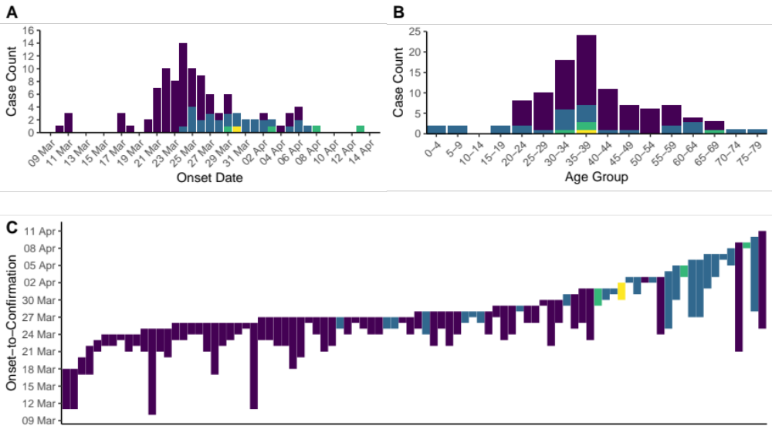
Supplementary Figure 6. A) Epidemic curve of 106 SARS-CoV-2 infections associated with a cluster of bars in Hong Kong by onset date and transmission generation. Asymptomatic cases are included by date of confirmation (Purple: Primary, Blue: Secondary, Green: Tertiary, Yellow: Quaternary). B) Age distribution of bar cluster cases by generation. C) Period of symptom onset-to-confirmation and isolation of cases associated with the bars. Asymptomatic cases are excluded.
Supplementary Table 5: Local cases of SARS-CoV-2 infection linked to quarantine and their position in the established chains of transmission.
 | Terminal Case | Intermediate Case | Total
Quarantined | 45 | 1 | 46*
Not Quarantined | 122 | 46 | 168
Total | 167 | 47 | 214
* A total of 51 local cases were quarantined, however five quarantined cases associated directly with the “bar and band” cluster whose position in the chain of transmission (terminal or intermediate) could not be determined and were excluded from this analysis.

