SUPPLEMENTARY MATERIAL

Improving the adsorption capacity of graphene oxide. Effect of Ca²⁺ on tetracycline retention

Florencia M. Onaga Medinaª, Marcelo J. Avena^{b}, María E. Paroloª
ªCentro de Investigaciones en Toxicología Ambiental y Agrobiotecnología del Comahue (CITAAC), Facultad de Ingeniería, CONICET-Universidad Nacional del Comahue. Buenos Aires 1400, 8300 Neuquén, Argentina.
^{b}Instituto de Química del Sur (INQUISUR), Departamento de Química, CONICET-Universidad Nacional del Sur. Av. Alem 1253, 8000 Bahía Blanca, Argentina.
* Corresponding author. E-mail address: maria.parolo@fain.uncoma.edu.ar

Structural and textural properties of graphite and graphene oxide

Table S.1. Textural properties of Gr and GO.
Material | Gr | GO
BET Surface area | 14 m² g⁻¹ | 30 m² g⁻¹
Pore Volume (BJH) | 0.04 cm³ g⁻¹ | 0.03 cm³ g⁻¹
Pore Size (BJH) | 10.1 nm | 5.6 nm
Slurry pH | 6.7 | 3.8

Table S.2. XRD parameters of Gr and GO
Material | FWHM | d₀₀₂ (nm) | Lc (nm) | Number of layers (Nc)
Gr | 0.38 | 0.34 | 21.49 | 65
GO | 0.66 | 0.95 | 12.06 | 13

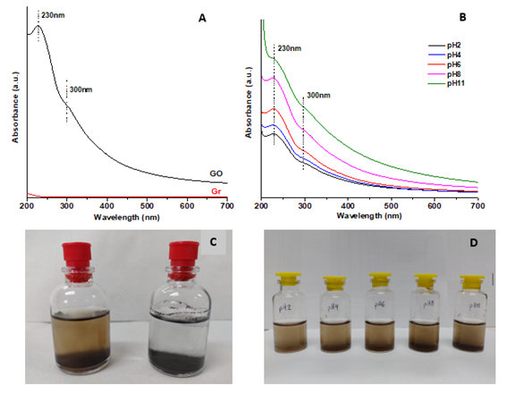
Fig. S1 UV-visible spectra: A) Gr and GO dispersions of 500 mg L⁻¹. B) GO dispersions of 500 mg L⁻¹ at pH 2-11. C) Photograph of GO (left) and Gr (right) dispersions. D) photograph of GO dispersions at different pH.

