[Supporting Information]
Hierarchical, Porous Hydrogels Demonstrating Structurally Dependent Mechanical Properties

Elisabeth C. Lloyd,ª Rami Alhasan,^{b} Sujata Dhakal,^{c} Svetlana Morozova,^{c} Douglas R. Tree,^{b} Robert J. Hickey^{a,d,}*

ªMaterials Science and Engineering, The Pennsylvania State University, University Park, PA 16802, USA
^{b}Chemical Engineering, Brigham Young University, Provo, UT 84602, USA
^{c}Macromolecular Science and Engineering, Case Western Reserve University, Cleveland, OH 44106, USA
^{d}Materials Research Institute, The Pennsylvania State University, University Park, PA 16802, USA
*Corresponding author: rjh64@psu.edu

Table of Contents
- Synthesis and Characterization of Block Copolymers
- Polymer Solution Viscosity Measurements
- Production of Hydrogels
  - Hierarchical Fibers from Injection
  - Hydrogels Prepared from Mold Immersion
  - Conventional Physical Hydrogels as a Control
- Hydrogel Swelling Ratios
- Small-Angle X-Ray Scattering (SAXS) Data
  - Data Collection
  - Fitting of SAXS Data
  - In Situ SAXS Under Extension
- Cryo-SEM Imaging and Microstructure Analysis
  - Sample Cross-Sections at Multiple Magnifications
  - Micrograph Analysis using ImageJ Software
  - Small Pore Area Fraction
  - Characterization of Core-Sheath Morphology
- Solvent Diffusion Coefficients Measured by Tracer Diffusion Experiments
- RPA Equations for Spinodals of Block Copolymer Solutions
  - Overview of Obtaining the Spinodals via the RPA
  - Formal Solution of the RPA Equations
- Solving RPA Equations to Estimate Spinodals of Block Copolymer Solutions
  - Ideal Chain Structure Factors
  - Numerical Method for Finding Spinodals
- Calculating and Selecting the Parameters Used to Estimate the Spinodals
  - Calculating the Degree of Polymerization
  - Selecting the Flory-Huggins Binary Interaction Parameters
- A Simple 1D Diffusion Model for the Solvent/Nonsolvent Exchange
  - Model Description
  - Initial Conditions and Parameters
  - Numerical Solutions for the Diffusion Experiments
  - Results of the 1D Simulations
- Critical Water Content Measurements
- Mechanical Properties
  - Measuring Cross-Sectional Area
  - Summary of Calculated Values
  - Raw Data for Uniaxial Extension Tests
- Oscillatory Shear Rheology on Hydrogels
- Small-Angle Light Scattering Experiments
- Property Comparison with Hydrogels in the Literature
- References
- Synthesis and Characterization of Block Copolymers
The triblock copolymer, poly(styrene)-poly(ethylene oxide)-poly(styrene) (SOS) used in this study was synthesized using a previously reported sequential living anionic polymerization.¹ Briefly, styrene (Sigma-Aldrich) monomer was first freeze-pump-thawed and then purified twice over di-n-butylmagnesium (Sigma-Aldrich, 1.0 M in heptane). Purified styrene monomer was then initiated using sec-butyllithium (Sigma-Aldrich, 1.4 M in cyclohexane), functionalized with ethylene oxide (Sigma-Aldrich, ≥ 99.5%) after 4 h, and finally terminated with methanol to produce the hydroxyl-terminated S homopolymer,² which was then precipitated in methanol and dried under vacuum. The purified S homopolymer was re-dissolved in tetrahydrofuran (THF) and re-initiated with potassium naphthalenide, which was prepared using a published procedure,³ then purified ethylene oxide monomer was added to the reactor to form the SO diblock. A 20 mL aliquot was taken from the reactor after 24 h and terminated in sparged methanol.
After removal of the aliquot, the SOS triblock was formed by coupling the SO diblock with α,α′-dibromo-p-xylene (Sigma-Aldrich, 97%).¹ 10 mL of a supersaturated, air-free solution of cesium iodide (Sigma-Aldrich, 99.9%) in THF, stirred overnight at 45 °C, was added prior to the coupling agent as a source of counterions to reduce aggregation. An air-free solution of the coupling agent was similarly prepared, and the molar equivalence of one-half the number of moles of S precursor was gradually added to the reactor over a period of 4 h using a syringe pump. After 24 h, any remaining diblock was terminated with sparged methanol and precipitated in a 1:3 mixture of isopropanol and hexane. The molecular weight values for the S precursor, the diblock copolymer, and the triblock polymer as well as the individual block molecular weights, PEO volume fraction (f_{O}), and dispersity are listed in Table S1. The molecular weight of all synthesized polymers (e.g., S-OH, SO, and SOS) were measured using a Tosoh GPC equipped with a Wyatt multi-angle light scattering detector and THF as the mobile phase. The increase in molecular weight with each successive step of the reaction is shown in the decrease in elution time in Figure S1. The difference in the molecular weight between the SO diblock and S homopolymer determined the PEO block length, which was doubled to obtain the length of the PEO mid-block in the SOS triblock. The average molecular weight obtained from the SEC of the final tri-block sample is also listed. To ensure the dn/dc used in the calculations was correct, the volume fraction of PEO in the diblock and triblock samples was determined using H¹ NMR in deuterated chloroform.
Figure S1. Size exclusion chromatography (SEC) traces for the synthesized polymers. There is an increase in polymer molecular weight as indicated in the decrease in elution time with successive living anionic polymerization steps: 1) S homopolymer (gray), 2) SO diblock copolymer (yellow), and 3) SOS triblock (magenta).

Table S1: Molecular characteristics of the polymers
Polymer | M_{n, total}ª (kg/mol) | M_{n,O}^{b} (kg/mol) | M_{n,S}^{b} (kg/mol) | f_{O}^{c} | Ð^{d}
S (13) | 13.1 | - | 13.1 | - | 1.04
SO (13-96) | 118.2 | 96.2 | 13.1 | 0.90 | 1.04
SO (13-192-13) | 182.4 | 192.4 | 13.1 | 0.90 | 1.05
ªNumber-average molecular weight (M_{n}) of synthesized polymers were determined using SEC. For the S homopolymer, previously reported dn/dc values were used.¹ For copolymers, the dn/dc values were calculated from polymer block weight fractions determined from ¹H NMR. ^{b}M_{n} values of polymer blocks were calculated from M_{n,total} and weight fraction of different blocks obtained from ¹H NMR. ^{c}The O block volume fraction (f_{O}) of the block copolymer was calculated using ¹H NMR data. The polymer block density values reported from Sigma-Aldrich, S is 1.04 g mL⁻¹ and O is 1.13 g mL⁻¹ at 25 °C, where used to calculate f_{O}. ^{d}Dispersity values (Ð = M_{w}/M_{n}) was determined from SEC.

- Polymer Solution Viscosity Measurements
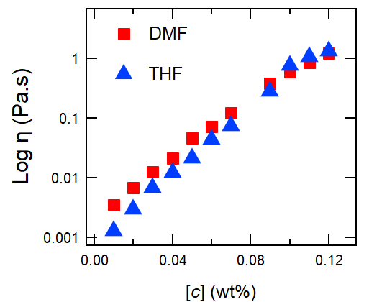
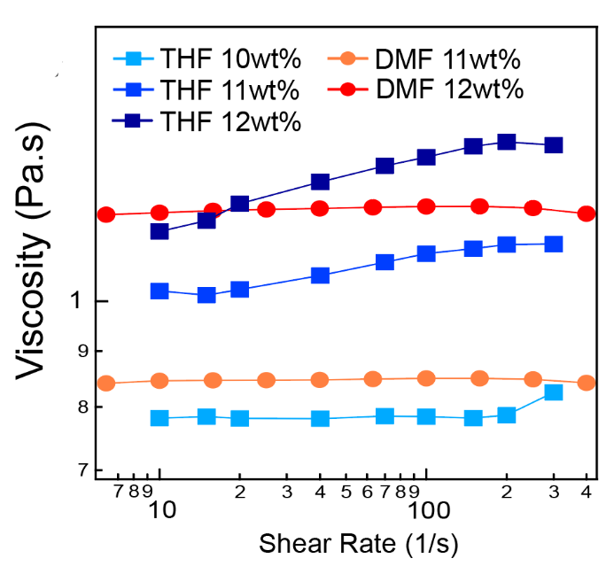
The viscosity of the initial polymer solutions in both THF and DMF were measured via flow sweep experiments in the 1 – 500 Hz range at room temperature using a Discovery HR-3 Hybrid Rheometer. Parallel plate geometries measuring 2 cm for entangled solutions and 6 cm for semi-dilute solutions were used to characterize viscosity (Figure S2a). A solvent trap, as well as 1 mL of the organic solvent at the top of the parallel plate geometry, was used to prevent the evaporation of the solvent, which was particularly important for THF samples at higher concentrations. Due to visible aggregates forming in the 11 and 12 wt% THF samples at high shear, stepwise steady shear measurements were also performed, with the average taken at each data point the overall average viscosity was then plotted with respect to concentration (Figure S2b).
b
a

Figure S2. Polymer solution viscosity (η) versus concentration (c) for polymer solutions prepared using THF (blue) and DMF (red). Viscosity measurements were performed by taking the average of a flow sweep in the 5 – 500 Hz range. In the entangled regime, the viscosity of the solutions prepared using DMF and THF are similar, allowing the viscosity to be matched between two samples (shaded region).
The average viscosity from the raw data at each concentration was fit with a trendline to calculate the concentration required to match the viscosity of two samples at 1.0 Pa.s: THF 11.0 wt% and DMF 11.5 wt%. The relatively close match between the DMF and THF solutions in this regime allowed a minimal difference in concentration when matching viscosity.

- Production of Hydrogels
  - Hierarchical Fibers from Injection
Initial solutions were prepared at concentrations of 11.0, 12.5, and 14.5 wt% in THF, and 9.5, 10.5, and 11.5 wt% in DMF. The solutions were stirred at 45 °C for a minimum of 3 h to ensure total dissolution before being injected into a syringe. To remove aggregates or bubbles that appeared as a result of the transfer from vial to syringe, the syringes were heated for several minutes under a stream of warm water, sealed in Parafilm© to prevent water from entering the syringe.
Solutions were injected using a 19-gauge needle with an inner diameter of 0.686 mm at a rate of 1.00 mL/min via a syringe pump. To prevent an appreciable reduction in the concentration gradient driving diffusion of the organic solvent, a minimum ratio of 1 L of water per 1 mL of injected solution was used in all cases. Due to the proximity to the surface and lower density of the organic solvents relative to water, tweezers were used to hold the end of the fibers below the surface for several seconds, at which point enough solvent had diffused out of the hydrogels to allow them to sink. Although the fibers formed immediately on injection into the water bath, they were left in the water bath for at minimum 1 h, at which point they were transferred to 20 mL scintillation vials for storage.
  - Hydrogels Prepared from Mold Immersion
The influence of shear on the formation of the hydrogel nanostructure was assessed by creating hydrogels in a mold and submerging them into a water bath. Hydrogels produced using a mold were thicker and less uniform as compared to the injected hydrogel fibers.

  - Conventional Physical Hydrogels as a Control
Conventional SOS triblock copolymer hydrogels were prepared using a modified procedure from Guo and Bailey⁴ to compare to hydrogels created using rapid injection processing. The SOS polymer was placed in an aluminum 4-inch dog bone mold and thermally pressed into shape at 100 psi at 150 °C. After pressing, the polymer still in the mold was transferred to a vacuum oven and annealed at 150 °C for 24 h and then cooled to room temperature. Once at room temperature, the sample was immersed in water for 3 d. The prepared sample was then characterized via SAXS and oscillatory shear rheology for comparison with the hierarchically ordered hydrogels. A small piece of dry annealed polymer was also retained for characterization.

- Hydrogel Swelling Ratio
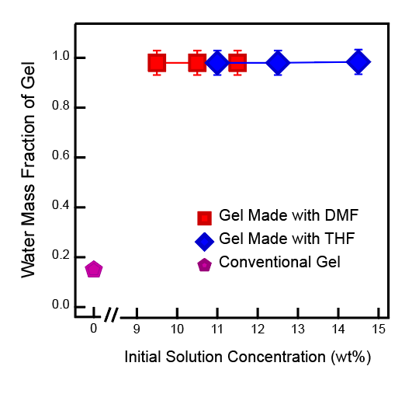
The fraction of polymer contributing to the mass of the hydrogel fibers was determined by weighing the hydrogels in the hydrated and dry states and dividing the former by the latter. The hierarchical hydrogel fibers exhibit exceptionally high-water weight fractions compared with hydrogels prepared via conventional methods.⁴ Furthermore, the hydrogel water weight fractions were surprisingly consistent with one another even with repetition, despite variations in the initial solution solvent and concentration, as well as hydrogel microstructure.

Figure S3. Measured water weight fractions of hierarchical hydrogels. Nearly all the DMF (red) and THF (blue) samples were 97.3% water by weight, with only the highest concentration of THF containing 97.7% water by weight. The water weight fraction of a SOS hydrogel prepared using conventional methods — as described in section 3a — is shown in pink.
- Small-Angle X-Ray Scattering Data

- Data collection
Due to the high-water content of the hydrogels, a synchrotron source was required to obtain scattering data. Small-angle X-ray scattering (SAXS) measurements were performed at Brookhaven National Laboratory, National Synchrotron Light Source – II (NSLS – II), beamline 11-BM Complex Materials Scattering (CMS). The natural adhesion of the hydrogel fibers allowed them to remain in the grooves of capillary holders during measurements. Hydrogel fibers were folded over themselves to achieve better signal where necessary. Samples were exposed for 3 s using a 13.5 keV beam with a wavelength of 0.9184 Å. A sample to detector distance of 10 m was used to access the q-range 0.0044-0.03 Å⁻¹. 2D scattering patterns were obtained using a Pilatus 2M detector. An empty beam was used to subtract the background from the hydrogel and converted to a 1D plot of intensity versus q. The background subtraction and conversion were performed for every sample measured at the beamline using the program SciAnalysis (https://github.com/CFN-softbio/SciAnalysis). The 1D scattering data and fits are shown for hydrogels of all concentrations for both solvents, prepared using injection (Figure S4a) and immersion (Figure 4b). Because the X-Ray scattering data shows no difference in the micelle nanostructures of the hydrogels, we infer that the formation of disordered sphere nanostructures is independent of solvent and shear-related conditions. See the next section for fitting details.
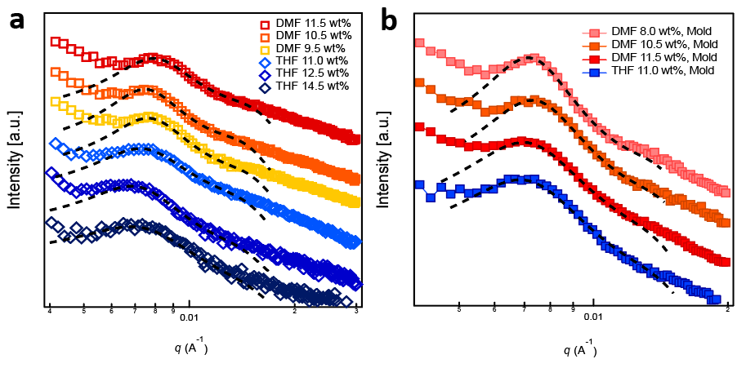Figure S4. 1D SAXS plots for hydrogel samples prepared using rapid injection processing and molds. a) SAXS data for fibers formed by injecting the initial solution—solvent and polymer concentration shown in the legends—directly into water at a rate of 1 mL/min. b) Raw SAXS data for hydrogels created by injecting the initial polymer solution into a silicone mold, then immersing the mold into a water bath. SAXS data vertically shifted for clarity.

- Fitting of SAXS Data
SAXS data was fit using Igor Pro with the IRENA package downloaded from Argonne National Lab.⁵ The data was loaded into IRENA and fit with a spheroid form factor and a hard sphere structure factor derived from the Percus-Yevick approximation. The micelle diameter and standard deviation, the domain spacing (micelle center-to-center distance), and volume fraction of scatterers were used as fitting parameters. The fitting region was confined to the primary peak and immediate surroundings, as the network effects and noise at low and high q, respectively, disrupt the fit results. The micelle diameter and standard deviation from the SAXS fits agree well with the values measured from TEM on the microgels (see Figure 2a in the main text), supporting the SAXS results.
The SAXS fitting parameters values indicate that the average domain spacing for all samples is 84 ± 3 nm. The micelle diameters calculated by the model — 20 ± 4 nm — show excellent agreement with the TEM results. Thus, the SAXS fitting results confirm there is essentially no change in micelle size, domain spacing, or volume fraction with respect to solvent or concentration. The fibers produced from the mold further corroborate these findings. Model results for domain spacing, micelle diameter, and volume fraction of scatterers are shown in Figure S5.
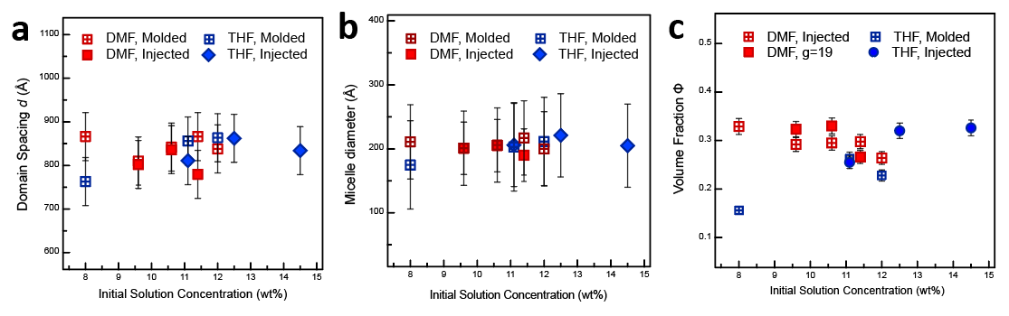
Figure S5. Modeling fit results for hydrogel fibers that were injected directly into the water bath (solid markers) or injected into a mold and then immersed into the water bath (window markers). Plotted a) micelle domain spacing, b) micelle diameter, and c) volume fraction of scatterers with respect to initial polymer concentration indicate that the nanoscale structural parameters are consistent across all samples.

The model was also applied to the SAXS data collected for the physically crosslinked hydrogel produced from the triblock copolymer from conventional methods (see section 3c). The domain spacing of the dry annealed sample was 43 nm, while the hydrated sample had a domain spacing of 104 nm due to swelling. Model fits show higher micelle diameter with a much larger standard deviation (28 ± 13 nm) in the conventional sample, compared with the hierarchical hydrogels. The volume fraction of scatterers calculated from the fitting parameters is similar for the conventional and hierarchical hydrogels.

- In Situ SAXS Under Extension
The effect of uniaxial extension on hydrogel nanostructure was explored using in situ SAXS measurements. Samples were placed in a Linkham Modular Force Stage with Kapton windows mounted in the beam path and strained at a rate of 3/min — the same as in all mechanical property characterizations — to 1x, 2x, 3x, and 4x their initial length, consecutively. At each extension, the sample was held in place and exposed for 3 s using a 13.5 keV beam with a wavelength of 0.9184 Å. Higher extensions could not be accessed due to the decreasing diameter of the gel fibers and the damage caused by the X-ray beam. A sample to detector distance of 10 m was used to access the q-range 0.0044-0.03 Å⁻¹. 2D scattering patterns were obtained using a Pilatus 2M detector. The 2D patterns for the hydrogel fiber with an initial solution concentration of 14.5 wt% in DMF are shown in Figure S6 below. No change in the domain spacing is evident (see Figure 5d of the manuscript), but there is a slight anisotropy evident in the samples between static and tensile configurations. The relative lack of anisotropy supports the hypothesis that the pores of these samples are deforming initially and control the mechanical properties at low extensions. At high strain, stress is gradually transferred to the polymer chains bridging the micelle cores, leading to eventual fracture. Up to moderate strain, as shown in Figure 5 of the main text and Figure S6 below, the nanostructure remains unchanged, with only a slight degree of anisotropy.
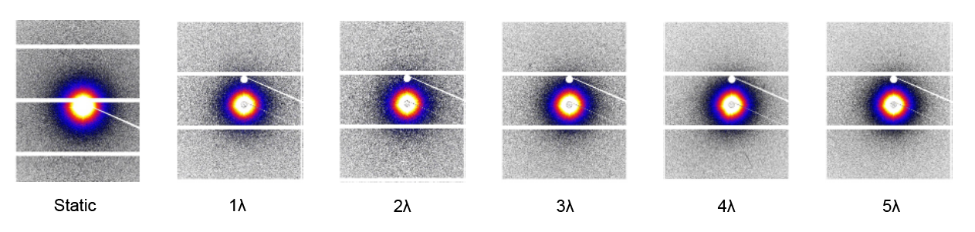
Figure S6. 2D scattering patterns of a THF 14.5 wt% hydrogel fiber at increasing extension. Minimal anisotropy occurring between static and tensile samples shows that the deformation of the gels up to moderate extension is dictated by the porous nanostructure rather than the micellar nanostructure.

- Cryo-SEM imaging and Microstructure Analysis

- Sample Cross-Sections at Multiple Magnifications
Imaging of the fiber cross-sections was achieved by cutting the hydrogel fibers perpendicular to their length to produce 2 mm thick hydrogel discs. The sections were placed on the head of a 5 mm wide aluminum pin and placed in a cryo-microtome chamber cooled to -165 °C. After the discs had vitrified, the pins were mounted into clamps within the chamber and microtomed repeatedly until the height of the sample had been reduced by at least a half millimeter to ensure an accurate cross-section. The pins with the mounted samples were stored under liquid nitrogen. Samples were then transferred to a supercooled stud under liquid nitrogen, which was then transferred into the Cryo-SEM antechamber at -90 °C. The samples were sputter coated with a gold-palladium alloy, then transferred into the primary chamber for imaging.

Images of the hydrogel fibers are shown in Figures S7-S12.
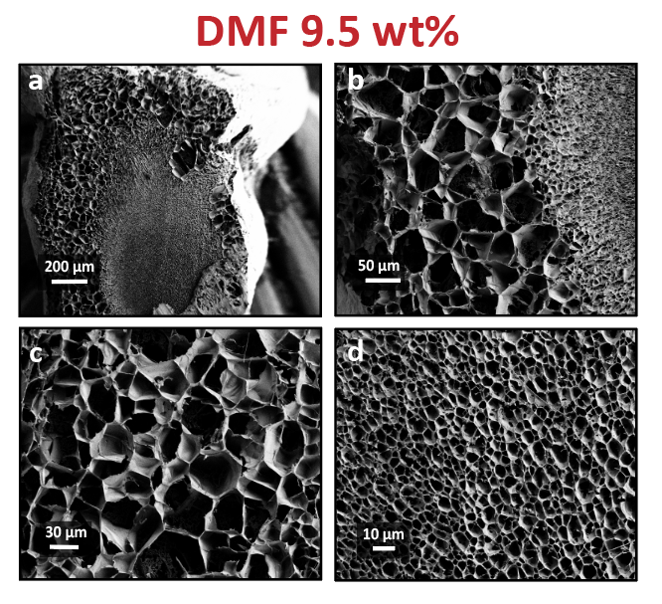
Figure S7. The cross-section of a vitrified hydrogel fiber, produced using a 9.5 wt% polymer solution in DMF, imaged using Cryo-SEM. a) The cross-section shows the coaxial structure with a high degree of variability in the thickness of the large pore outer sheath. b) Higher magnification of the fiber edge, showing the two distinct pore regions present in the fibers. c) High magnification of the large pore region. d) High magnification of the small pore region. Small pore region pores are much more uniform than large pore region pores.
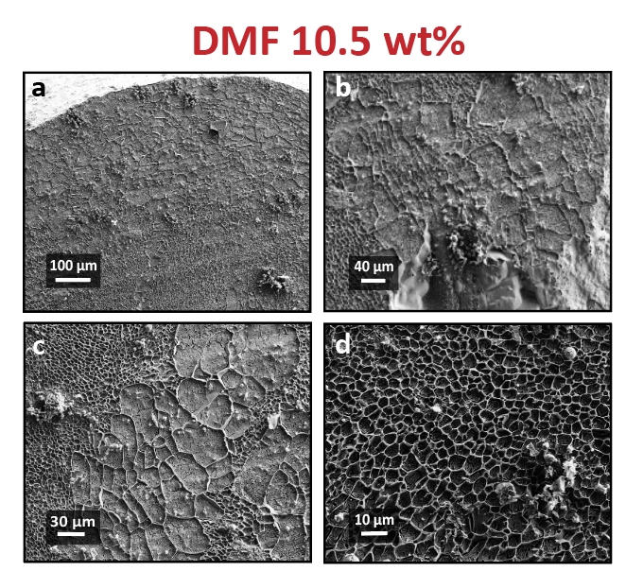
Fig S8. The cross-section of a vitrified hydrogel fiber, produced using a 10.5 wt% polymer solution in DMF, imaged using Cryo-SEM. Ice caps remained on large pores in the sample, reducing contrast. a) The cross-section shows the coaxial structure with less variability in the thickness of the large pore outer sheath. b) Higher magnification of the fiber edge, showing the two distinct pore regions present in the fibers. c) High magnification of the large pore outer region. d) High magnification of the small pore region.

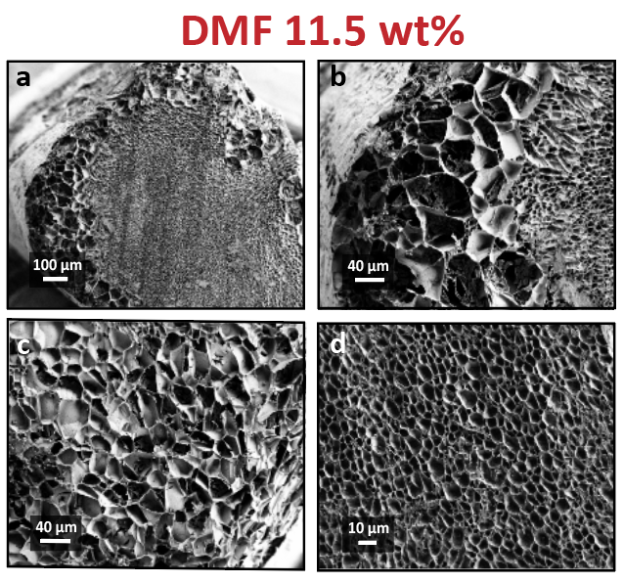
Fig S9. The cross-section of a vitrified hydrogel fiber, produced using a 11.5 wt% polymer solution in DMF, imaged using Cryo-SEM. a) The cross-section shows the coaxial structure is much more uniform, but the average value is well within standard deviation of the other two samples with this structure. b) Higher magnification of the fiber edge, showing the two distinct pore regions present in the fibers. c) High magnification of the large pore outer region. d) High magnification of the small pore region.

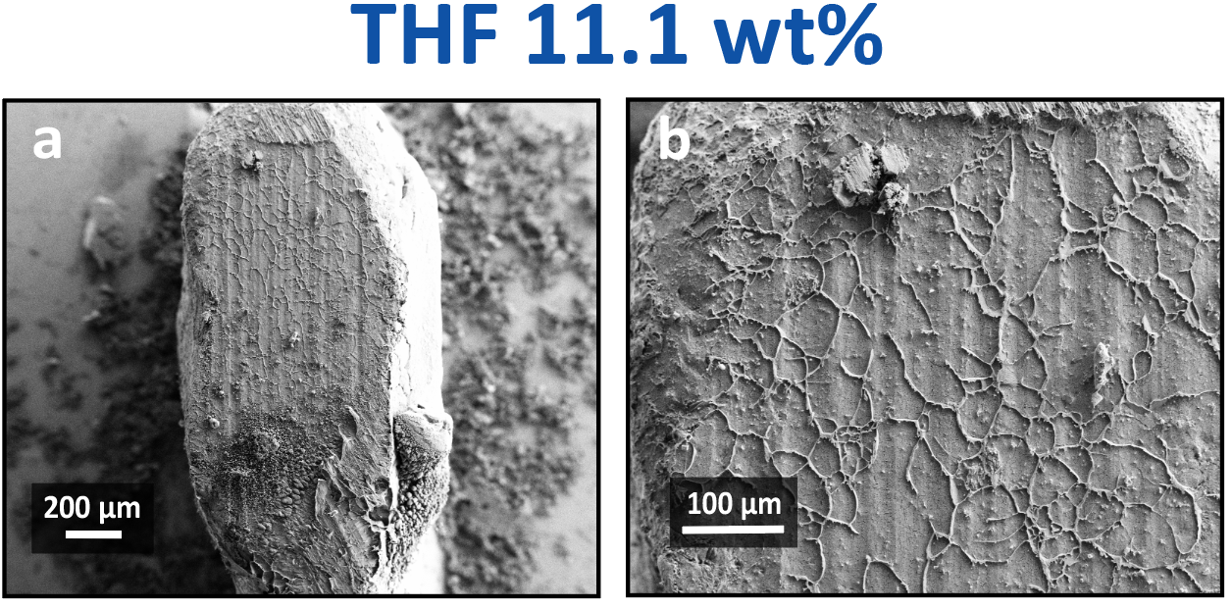
Fig S10. The cross-section of a vitrified hydrogel fiber, produced using a 11.1 wt% polymer solution in THF, imaged using Cryo-SEM. a) The fiber is primarily composed of a few large pores. b) Higher magnification image of the pores in this sample.

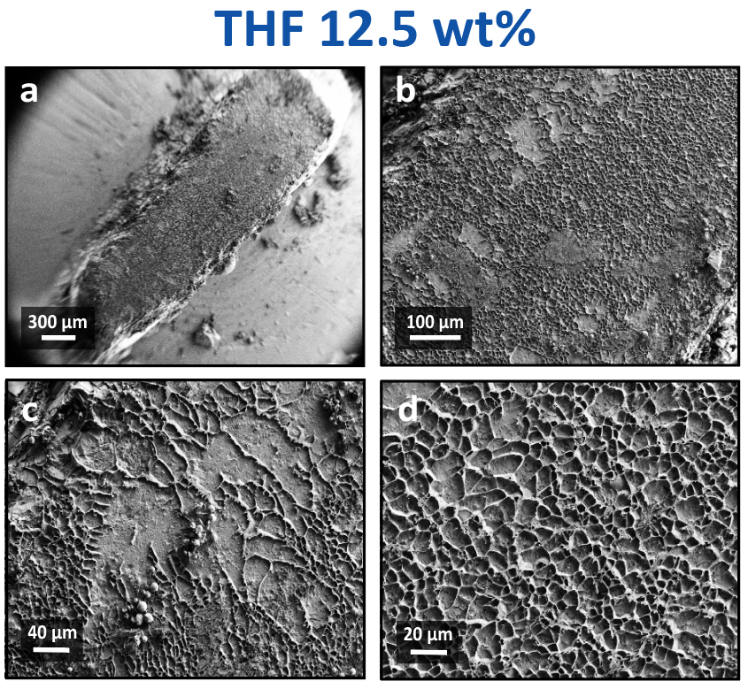
Fig S11. The cross-section of a vitrified hydrogel fiber, produced using a 12.5 wt% polymer solution in THF, imaged using Cryo-SEM. a) The fiber is primarily composed of a many small pores, with one lobe possessing an unusually high number of small pores. b) Large pores were also scattered sporadically throughout the sample, with c) clear boundaries between the two. d) The small pore region in this sample. All small pore regions imaged in this study showed a high degree of uniformity as well as a striking similarity in size distribution with one another.

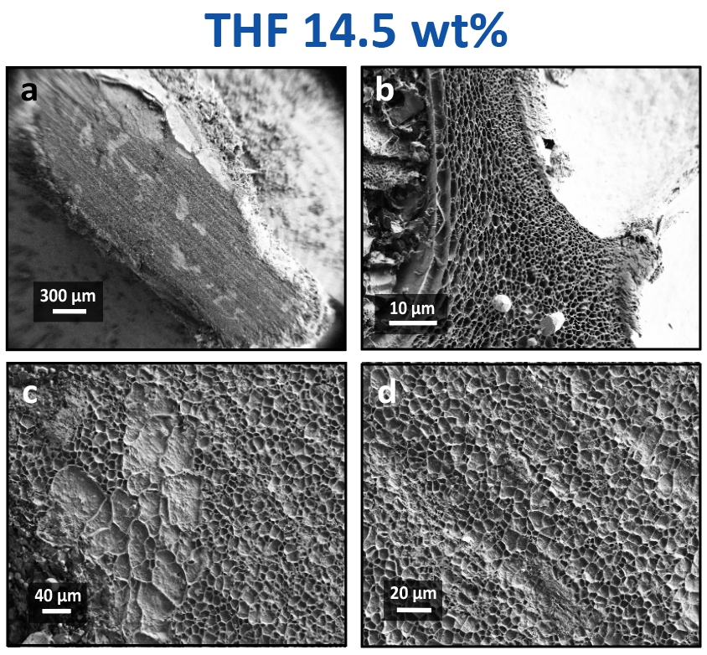
Fig S12. The cross-section of a vitrified hydrogel fiber, produced using a 14.5 wt% polymer solution in THF, imaged using Cryo-SEM. a) The fiber is almost entirely composed of a many small pores, with a few sporadic large pores. b) Edge of bubble inclusion withing the fibers, where the pores compressed between the bubbles appeared much stronger. This may indicate a role shear force plays in determining pore size. c) Clear boundaries between the large and d) small pores.

- Micrograph Analysis using ImageJ Software
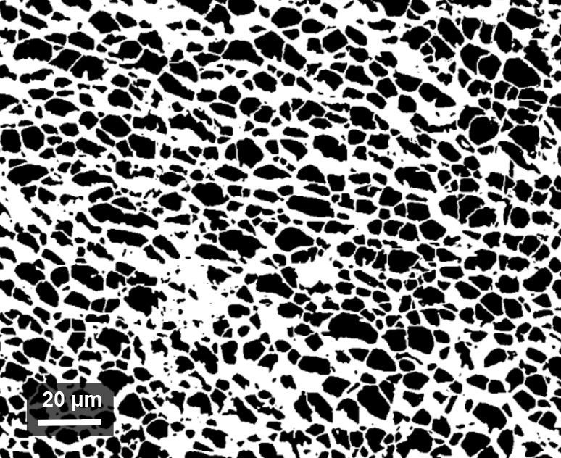
Pore sizes for the hydrogel samples were determined from cryo-SEM images that were analyzed via ImageJ software downloaded from nih.gov. First, cryo-SEM images were despeckled and converted to 8-bit binary. Then, the image threshold was set so that the pores were black regions bounded by white pore walls (Figure S13). Spot analysis with a minimum area of 1 μm² was used to eliminate static still caught within the threshold to produce measurements of the total area and Feret Diameters (the largest length between two pore walls) of each pore in the image. Some images exhibit poor contrast, and thus, the analysis was done by hand.

Figure S13. Pore image after being smoothed and converted to 8-bit binary via ImageJ software. A spot analysis with a minimum area of 1 μm² is used to calculate the average pore size.
Small Pore Area Fraction
A rough estimate of the fraction of the cross-section area comprised of small pores was obtained by dividing the total area of the hydrogel fiber cross-section, determined using ImageJ, by the area of the small pore regions, calculated by the method described in the previous section. These values were confirmed by measuring the large pore area and performing the same calculation.
Fig S14. The fraction of the fiber area comprised of small pores for samples produced using DMF (red) and THF (blue) as the initial organic solvents. The small pore area fraction remains relatively consistent for the DMF samples but increases dramatically for the THF samples. The bubble inclusions in the hydrogel fiber cross-sections were not included in the calculation for the sample produced using an initial polymer solution concentration of 14.5 wt% in THF (see Figures S11a and b).

Characterization of the Core-Sheath Morphology
The relative thickness of the outer “sheath” large-pore region in fibers possessing the coaxial morphology was measured perpendicular to the edge of the fiber at points equidistant along the perimeter of the fiber sample in Image J. As concentration increases, the diameter of the “sheath” region appears to decrease but is within error (Figure S15). It is possible that this indicates a trend, the existence of which is further supported by the increase in small pore area fraction seen in this morphology (see Figure S14). However, because variations are within error for the concentrations accessible in this study, no further conclusions may be drawn at this time.

Figure S15. A slight decrease in the thickness of the large pore “sheath” region is observed from the hydrogel cross-section micrographs. However, the variations are within error of one another, and the potential for other parameters to affect morphology effectively prevents any conclusions from being drawn from the data at this time.
- Solvent Diffusion Coefficients Measured by Tracer Diffusion Experiments
The polymer solution viscosity was held constant between two samples — THF 11.0 wt% and DMF 11.5 wt% — to isolate the effect of varying the solvent used to prepare the hydrogel. As seen in Figure S2b, the viscosity of the initial DMF and THF polymers solutions are in the same range, indicating that the polymer solution viscosity should have the same effect in both DMF and THF. Contrary to these expectations, the cryo-SEM images in Figure 3a-d show that the microstructures of the hydrogels are drastically different; THF and DMF exhibit either entirely large pores or the coaxial fiber structure, respectively.
To assess the impact of solvent diffusion, we incorporated 1 mg/mL of Eosin Y disodium salt into the initial solvents to trace the diffusion of the solvent out of solution. Briefly, 0.1 mL of the solvent/polymer/EY solutions were placed in the bottom of a quartz cuvette. At t = 0, 3 mL of water were added to the cuvette, and the increase in the maximum intensity of the EY peak was plotted with respect to time and fitted with Fick’s 2nd Law of Diffusion to determine the diffusion coefficient (Figure S16b). Interestingly, the values were highly consistent at 0.036 ± 0.075 cm²/min across solvent, polymer concentrations, and tracer concentrations, indicating that the diffusion of the solvent is determined by the gel rather than the solvent.
Tracer diffusion experiments using Eosin Y disodium salt (EY) were conducted to compare solvent diffusion coefficients between THF and DMF during hydrogel formation by tracking the increase in EY concentration during solvent exchange. Figure S16a shows that the EY absorption increases with time, as expected, and Figure S16b shows the plot of the normalized maximum absorption for solutions with respect to time. The experimental data was fitted with Fick’s Second Law of Diffusion to quantify the diffusion coefficient. Interestingly, the solvent exchange rate between THF and DMF are within error, indicating that the solvent exchange rates are the same between the two solvents. The calculated EY diffusion coefficient was constant at or around 0.036 ± 0.075 cm²/min for all initial polymer solution concentrations used in the study. Additionally, the diffusion coefficient does not show significant change when concentration of the tracer is increased, while keeping other parameters the same. Thus, solvent exchange rate is predicted to play a minimal role in dictating the hydrogel microstructure.

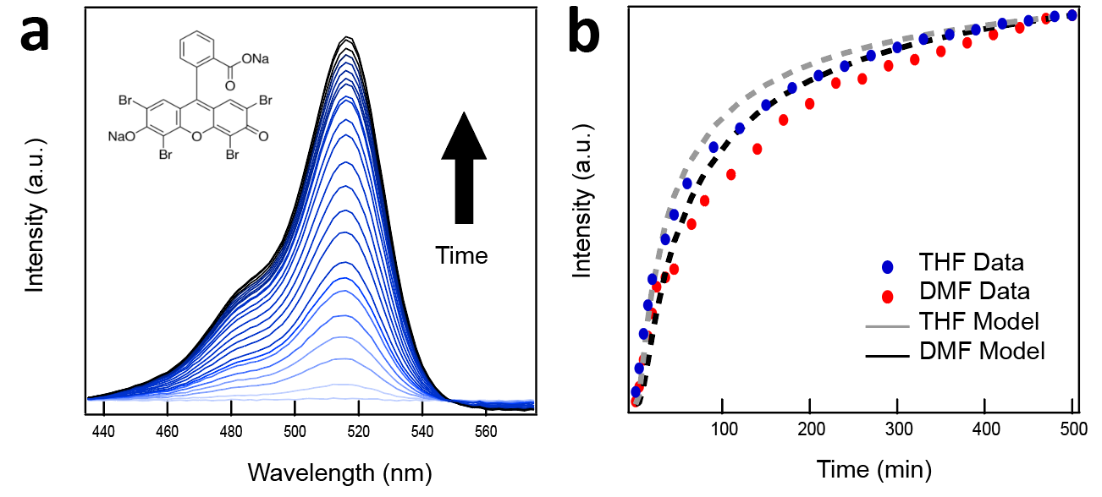
Figure S16. Measuring EY absorbance during solvent exchange. a) EY absorbance increases with time as EY diffuses out of the hydrogel. b) Plot of normalized intensity vs. time (min), where t = 0 is the point at which water was added to the cuvette containing the solution of EY, solvent, and polymer. The data was fit with Fick’s 2nd Law of diffusion to calculate the diffusion coefficient of the solvent as it diffuses from the gel.

- RPA Equations for Spinodals of Block Copolymer Solutions
In this section, we provide a description of the methods for obtaining spinodals via the random phase approximation (RPA) for the response functions relevant for triblock copolymer hydrogels. Our objective is to compute spinodals for both microphase and macrophase separation behavior for mixtures of a block polymer, a good solvent, and a poor solvent. In the first section, we employ the RPA to obtain structure factors that enable the computation of spinodal points for inhomogeneous mixtures of polymers (including block copolymers, blends, and solutions).⁶⁻¹⁰ [Morse2011]In the second section, we will describe a formal solution to the RPA equations for the system of interest: an incompressible solution of a block polymer, good solvent, and nonsolvent.

a. Overview of Obtaining Spinodals via the RPA
We first define φ_{i}(r) to be the volume fraction of the i^{th} species at point r where i = 1, 2, …, n_{b} are the blocks of the polymer, i = n_{b} + 1 is the good solvent, and i = n_{b} + 2 is the bad solvent. For convenience in summation formulas, we also define n_{s} = n_{b} + 2 as the total number of species. The average volume fraction of species i is given by,
 | $${\overline{φ}}_{i}=\frac{1}{V}\int{dr φ_{i}(r)}$$ | (S1)
and the variation of the volume fraction of the monomers about the average is given by,
 | $$ψ_{i}\left(r\right)=φ_{i}\left(r\right)-{\overline{φ}}_{i}.$$ | (S2)
A weak inhomogeneity expansion of a statistical field theory can be manipulated to give the free energy as a functional of the density variations of the species of the mixture,^{6,7,9} which can be expressed in Fourier space as,
 | $$F\left[φ_{i}(r)\right]=F\left[{\overline{φ}}_{i}\right]+\frac{k_{B}T}{2}\sum_{i}^{n_{s}}{\sum_{j}^{n_{s}}{\frac{1}{{\left(2π\right)}^{d}}\int{dq}}{\hat{Γ}}_{ij}\left(q\right){\hat{ψ}}_{i}\left(q\right){\hat{ψ}}_{j}\left(-q\right)+…}$$ | (S3)
where $k_{B}$ is Boltzmann's constant, $T$ is temperature, ${\hat{ψ}}_{i}$ is the forward Fourier transform of $ψ_{i}$, ${\hat{Γ}}_{ij}$ is forward Fourier transform of the so-called second vertex function, $d$ is the dimensionality, and $q$ is the wavevector. To economize on space and improve the clarity of equations, we have dropped the explicit dependence on $q$, but all variables should be considered in Fourier space unless otherwise indicated. The second vertex function is related to density fluctuations about the homogeneous state. Specifically, the second vertex function is given by,^{6,7}
 | $$\sum_{j=1}^{n_{s}}{{\hat{Γ}}_{ij} {\hat{S}}_{jk}}=δ_{ik}$$ | (S4)
where ${\hat{S}}_{jk}$ is the structure factor or density correlation function,^{6,7,9}
 | $${\hat{S}}_{jk}=〈{\hat{ψ}}_{j}{\hat{ψ}}_{k}〉.$$ | (S5)
An examination of Eq. S3 shows that the second vertex function is equal to the second functional derivative of the free energy. Consequently, thermodynamic stability (i.e., a spinodal point) is determined by finding the zeros of ${\hat{Γ}}_{ij}(q)$. Furthermore, the wavevector dependence of these zeros indicate the type of phase instability. If ${\hat{Γ}}_{ij}(0)$ is zero, then we have located the limit of stability of a bulk macrophase. If ${\hat{Γ}}_{ij}(q^{*})$ is zero at some finite wavevector $q^{*}$, then the limit of stability of a microphase separation occurs at the wavelength ${2π}/{q^{*}}$. Alternatively, the inverse relationship between ${\hat{Γ}}_{ij}$ and ${\hat{S}}_{jk}$ in Eq. S4 makes it possible to compute spinodals using the divergence of the structure factors rather than zeros of the second vertex function.
To obtain an explicit expression of the structure factors ${\hat{S}}_{ij}$, we again turn to a weak inhomogeneity expansion. This expansion gives a linear response relationship between the density variation ${\hat{ψ}}_{i}$ and a conjugate external field ${\hat{U}}_{j}$,⁶⁻¹⁰
 | $${\hat{ψ}}_{i}=-β\sum_{j=1}^{n_{s}}{{\hat{S}}_{ij}{\hat{U}}_{j}}$$ | (S6)
where $β=1/{k_{B}T}$. The RPA adds an additional assumption of mean-field behavior to Eq. S6 leading to the following combined “RPA equations” for a system of incompressible ideal chains and solvents,⁶⁻⁸
 | $${\hat{ψ}}_{i}=-\sum_{j=1}^{n_{s}}{{\hat{S}}_{ij}^{0}}\left[β{\hat{U}}_{j}+\sum_{k=1}^{n_{s}}{βV_{jk}{\hat{ψ}}_{k}+βW}\right]$$ | (S7)
where ${\hat{S}}_{ij}^{0}$ is the structure factor for a mixture of ideal (non-interacting) chains, $W$ is a Lagrange multiplier, and $V_{jk}$ is a mean-field interaction potential define as,
 | $$V_{jk}=\left\{\begin{aligned}0 j=k, \\ k_{B}Tχ_{jk} j≠k.\end{aligned}\right.$$ | (S8)
In the next section, we will provide a formal solution of Eq. S7 by eliminating the implicit dependence on ${\hat{ψ}}_{i}$, and manipulating the subsequent expressions to the form of the linear response function in Eq. S6.

b. Formal Solution to the RPA Equations
In this section, we formally solve the RPA equations given in Eq. S7 in order to obtain an expression for ${\hat{S}}_{ij}$. There are two steps to solving the RPA equations: (i) use incompressibility to solve for the Lagrange multiplier $W$, and then (ii) rearrange to isolate and solve for ${\hat{ψ}}_{i}$.
To find $W$, we substitute Eq. S7 into the incompressibility equation,
 | $$\sum_{i}{{\hat{ψ}}_{i}}=0$$ | (S9)
which yields,
 | $$W=\frac{-\sum_{i}{\sum_{j}{{\hat{S}}_{ij}^{0}\left[{\hat{U}}_{j}+\sum_{k}{V_{jk}{\hat{ψ}}_{k}}\right]}}}{\sum_{i}{\sum_{j}{{\hat{S}}_{ij}^{0}}}}$$ | (S10)
and by substituting the Lagrange multiplier into Eq. S7 with considerable rearrangements and mathematics gives RPA equations,
 | $${\hat{ψ}}_{i}=-\sum_{j=1}^{n_{s}}{{\hat{S}}_{ij}^{inc}}\left[β{\hat{U}}_{j}+\sum_{k=1}^{n_{s}}{βV_{jk}{\hat{ψ}}_{k}}\right]$$ | (S11)
that no longer contain $W$. In Eq. S11, we define “incompressible” ideal structure factors,
 | $${\hat{S}}_{ij}^{inc}={\hat{S}}_{ij}^{0}-\frac{\left(\sum_{l}{{\hat{S}}_{il}^{0}}\right)\left(\sum_{k}{{\hat{S}}_{kj}^{0}}\right)}{\sum_{k}{\sum_{l}{{\hat{S}}_{kl}^{0}}}}.$$ | (S12)
We can now formally solve Eq. S11 for ${\hat{ψ}}_{i}$ or ${\hat{ψ}}_{k}$. Expanding the right-hand side and mathematical manipulations with the left-hand side gives,
 | $${\hat{ψ}}_{k}=-\sum_{i=1}^{n_{s}}{{({\hat{A}}_{ik}^{-1})}_{ki}\sum_{j=1}^{n_{s}}{{\hat{S}}_{ij}^{inc}β{\hat{U}}_{j}}}$$ | (S13)
where ${\hat{A}}_{ij}$ is a new matrix defined as,
 | $${\hat{A}}_{ik}=δ_{ik}+\sum_{j=1}^{n_{s}}{{\hat{S}}_{ij}^{inc}βV_{jk}}.$$ | (S14)
Comparing Eq. S14 to Eq. S6, we can finally identify the nonideal structure factor predicted by the RPA,
 | $${\hat{S}}_{kj}=\sum_{i=1}^{n_{s}}{{({\hat{A}}_{ik}^{-1})}_{ki}{\hat{S}}_{ij}^{inc}}.$$ | (S15)
In the next section, we will introduce analytical expressions for the ideal chain structure factor ${\hat{S}}_{ij}^{0}$ and use them to compute a numerical solution for RPA equations.

- Solving RPA Equations to Estimate Spinodals of Block Copolymer Solutions
In this section, we report the modeling for an ideal chain needed to solve nonideal structure factors, and the numerical methods for estimating the spinodals for block copolymer solutions using Python. In the first section, we will show how the solution for the RPA equations derived in Section A is combined with analytical expressions for the ideal chain structure factors. In the second section, we will detail how to numerically solve these equations to compute spinodals.

a. Ideal Chain Structure Factors
In order to evaluate ${\hat{S}}_{kj}$ using Eqs. S12, S14, and S15, we need to specify a model and determine the ideal structure factors ${\hat{S}}_{ij}^{0}$. We assume that the block polymer is a standard Gaussian chain with Kuhn length $b$.^{7,9} The degree of polymerization of each block is $N_{pi}$ and $N_{p}=\sum_{i=1}^{n_{b}}{N_{pi}}$ is the total degree of polymerization of the polymer. It is also convenient to define polymer block fractions $f_{pi}={N_{pi}}/{N_{p}}$. Solvent and nonsolvent are modeled as Gaussian “chains” consisting of a single Kuhn monomer (i.e., $N_{s}=N_{n}=1$) of length $b$.
In this case, the ideal structure factor matrix has the form,^{7,8}
 | $${\hat{S}}_{ij}^{0}=\left[\begin{matrix}{\overline{φ}}_{p}{\hat{h}}_{ij}(ξ_{pi},ξ_{pj}) & 0 & 0 \\ 0 & {\overline{φ}}_{s}{\hat{g}}_{D}(ξ_{s}) & 0 \\ 0 & 0 & {\overline{φ}}_{n}{\hat{g}}_{D}(ξ_{n})\end{matrix}\right]$$ | (S16)
where the first row and column are also matrices whose rank is equal to the number of polymer blocks, $n_{b}$. Eq. S16 contains the polymer volume fraction ${\overline{φ}}_{p}=\sum_{i=1}^{n_{b}}{{\overline{φ}}_{i}}$, the solvent volume fraction ${\overline{φ}}_{s}=φ_{n_{b}+1}$, the nonsolvent volume fraction ${\overline{φ}}_{n}=φ_{n_{b}+2}$, the correlation function between polymer blocks ${\hat{h}}_{ij}$ where {i, j} $∈$ $[1, 2, …, n_{b}]$, and the Debye function ${\hat{g}}_{D}$. It also contains the block radius of gyration $ξ_{pi}=N_{p}f_{pi}{b^{2}q^{2}}/6$ where $q^{2}={\left|q\right|}^{2}$, and analogous quantities for the monomeric solvent and nonsolvent $ξ_{s}=ξ_{n}={b^{2}q^{2}}/6$. The Debye function is,
 | $${\hat{g}}_{D}\left(ξ\right)=\frac{2}{ξ}\left(e^{-ξ}+ξ-1\right),$$ | (S17)
and the correlation function for a block in a Gaussian chain is,
 | $${\hat{h}}_{ij}\left(ξ_{pi},ξ_{pj}\right)=\left\{\begin{aligned}N_{p}f_{pi}^{2}{\hat{g}}_{D}\left(ξ_{pi}\right) i=j, \\ \frac{N_{p}f_{pi}f_{pj}}{ξ_{pi}ξ_{pj}}\left(e^{-ξ_{pi}}-1\right)\left(e^{-ξ_{pj}}-1\right)e^{-\frac{M_{ij}b^{2}q^{2}}{6}} i≠j.\end{aligned}\right.$$ | (S18)
The quantity $M_{ij}$ is the shortest path (in monomer units) connecting the end of the $i^{th}$ polymer block to the start of the $j^{th}$block.

- Numerical Method for Finding Spinodals
In this section, we outline the numerical procedure by which we solve for the spinodals. There are three steps to obtaining spinodal curves:
- Specify the model parameters.
- Evaluate ${\hat{S}}_{kj}(q)$.
- Find the values of $q$ where ${\hat{S}}_{kj}(q)$ diverges as a function of the system parameters of interest (e.g., volume fractions $φ_{i}$ or Flory interaction parameters $χ_{ij}$).
We will briefly discuss the details of each step in turn.
The first step involves choosing parameters for a model solution of interest. In the main manuscript for example, we provide a table of parameters for a system consisting of a good solvent, a nonsolvent, and a linear ABA triblock polymer. The parameters that need to be specified are: $N_{p}, f_{A}, f_{B}, χ_{AB}, χ_{AS}, χ_{AN}, χ_{BS}, χ_{BN},$ and $χ_{SN}$.
Next, structure factors ${\hat{S}}_{kj}(q)$ are numerically calculated according to the formulas given in Sections II and III. First, the ideal structure factor matrix ${\hat{S}}_{ij}^{0}(q)$ is evaluated using Eq. S16, and “incompressible'” structure factors ${\hat{S}}_{ij}^{inc}(q)$ are then evaluated using Eq. S12. The incompressible structure factors are used to build ${\hat{A}}_{ik}\left(q\right)$ in Eq. S14 and then to solve for ${\hat{S}}_{kj}(q)$ using Eq. S15. These operations are implemented in standard Python 3.9.7 using the Anaconda distribution. Linear algebra is accomplished using the numpy standard library solve and lstsq functions.¹¹ We found the latter to be useful for solutions with ${\hat{A}}_{ik}$ matrices that are nearly singular.
Macrophase separations can be detected using structure factors calculated with this method. To determine macrophase spinodal points, we numerically solve for points where $1/{S_{11}(q_{zero})}$ (or another structure factor) crosses zero. We define $q_{zero}={10}^{-2}$ as a good trade-off between accurately capturing the $q→0$ behavior and numerical convenience. We find zeros using brentq, a bracketed nonlinear solver in the scipy.optimize Python package.¹²
Microphase separations are detected in a similar manner to macrophase separations, but the relevant point is now a finite wavenumber $q_{min}$ rather than $q_{zero}$. Accordingly, $q_{min}$ is first numerically determined using the minimize_scalar function in scipy.optimize.¹² A cubic spline is subsequently fit to the minima, and the zeros of spline are determined using methods previously described. These zeros are then identified as microphase spinodal points.
Phase diagrams are constructed using the above methods by sweeping two free parameters while holding the others constant. Two common types of phase diagrams are (i) those where all of the values of $f_{pi}$ and $χ_{ij}$ are held constant while sweeping ${\overline{φ}}_{p}$ and ${\overline{φ}}_{s}$, and (ii) those where one concentration (e.g., ${\overline{φ}}_{n}$) is held constant while another (e.g., ${\overline{φ}}_{p}$) is varied along with one of the values of $χ_{ij}$. One complication that can arise is the existence of multiple spinodal points in a given parameter sweep. This situation does not present a fundamental challenge but does require some extra care to capture all the relevant spinodal points.

- Calculating and Selecting the Parameters Used to Estimate the Spinodals

a. Calculating the Degree of Polymerization
To calculate the degree of polymerization of the block copolymer $N_{p}$, we pick poly(ethylene oxide), which has a higher block fraction $f_{O}=0.9$, to be the reference block of our polymer block-poly(styrene)-poly(ethylene oxide)-poly(styrene) or SOS described in the main manuscript. The molecular weight $M_{p}$ of this polymer is 192 kg/mol, and the densities of poly(ethylene oxide) $ρ_{O}$ and poly(styrene) $ρ_{S}$ are 1.27 g/mL and 1.05 g/mL, respectively. Using this information, one can estimate a block-fraction-averaged molar volume of the copolymer,
 | $${\tilde{V}}_{p}=\frac{M_{p}}{f_{O}ρ_{O}+(1-f_{O})ρ_{S}}≈153.85 \frac{L}{mol}.$$ | (S19)
Next, the molar volume of a repeat unit or a monomer of the reference polymer, which has a molecular weight $M_{O}=44.05$ g/mol, can be easily calculated using,
 | $${\tilde{V}}_{O}=\frac{M_{O}}{ρ_{O}}≈34.7 \frac{mL}{mol}.$$ | (S20)
Finally, we can approximate the degree of polymerization of this copolymer using a ratio of those two molar volumes in Equation S19 and S20 as follows,
 | $$N_{p}=\frac{{\tilde{V}}_{p}}{{\tilde{V}}_{O}}≈4436$$ | (S21)
b. Selecting the Flory–Huggins Binary Interaction Parameters
The Flory–Huggins binary interaction parameter “$χ$” is a measure of the miscibility between different components in the system. A lower $χ$ value indicates a higher miscibility between components. The $χ$ parameters between different components are needed to calculate the structure factors as indicated by Eq. S8. We obtain $χ$ values from the experimental estimations in the literature, or we resort to Hansen solubility parameters whenever experimental values are not available.¹³ Hansen solubility parameters provide reasonably accurate estimations of $χ$ values for polymeric solutions.^{13,14} The Hansen solubility parameters depend on three types of interactions: (a) atomic dispersion, (b) polar cohesion, and (c) electron exchange (hydrogen bonding).^{13,14} Table S2 contains the values of the $χ$ parameters used in the phase diagrams in the main text. Table S2 is similar to the one in the main manuscript, but it also provides the references used for each $χ$ value.
Table S2: The $χ$ parameters used in our calculations of the structure factor (the gray shading highlights the values that change by using THF vs. DMF as the solvent for the copolymer)
Parameter | THF (Solvent) | Reference | DMF (Solvent) | Reference
$$χ_{O-S}$$ | 1.17 | ¹⁵ | 1.17 | ¹⁵
$$χ_{O-Solvent}$$ | 0.50 | ¹⁶ | 0.05 | ¹⁷
$$χ_{O-H_{2}O}$$ | 0.17 | ¹⁸ | 0.17 | ¹⁸
$$χ_{S-Solvent}$$ | 0.47 | ¹³ | 0.80 | ¹³
$$χ_{S-H_{2}O}$$ | 8.24 | ¹³ | 8.24 | ¹³
$$χ_{Solvent-H_{2}O}$$ | 0.23 | ¹³ | 0.32 | ¹⁹
- A Simple 1D Diffusion Model for the Solvent/Nonsolvent Exchange
In here, we provide a description of the diffusion equations used to model a solvent/nonsolvent exchange system consisting of two parts: (a) a polymeric solution film, and (b) a bad solvent (nonsolvent) bath. The equations consider only one dimension, assume no convection, and account for how the substances distribute themselves within the system. The equations can be solved numerically using finite difference methods.

a. Model Description
We aim to track the diffusion and exchange of solvents using simple 1D diffusion equations for a ternary system of components without convection. Two phases in contact will be initially present in the system: (a) a solution of a polymer dissolved in a solvent (fiber phase “f”), and (b) a nonsolvent bath (bath phase “b”). In those phases, three components could be present: (1) a homopolymer “P”, (2) a solvent “S”, and (3) a nonsolvent “N”. For any phase, the diffusion flux $j_{i}$ in that phase is given by,
 | $$j_{i}=D_{iα}\frac{dρ_{i}}{dx}$$ | (S22)
where $D_{iα}$ is the ideal diffusivity of component $i$ in the specified phase “$α$” (independent of position), $ρ_{i}$ is the mass density of $i$, and $x$ is the position.²⁰ If we assume no convection, then the bulk velocity is very close to zero, and the mass flux $n_{i}$ will be approximately equal to the diffusion flux $j_{i}$. Only for dilute components in each phase, one can write the 1D diffusion equations without convection at constant $ρ$ and $D_{iα}$,
 | $$\frac{dw_{i}}{dt}=∇ . j_{i}=D_{iα}\frac{d^{2}w_{i}}{dx^{2}}$$ | (S23)
where $w_{i}$ is the mass fraction of component $i$ in the phase, and $t$ is the time. For incompressible systems, the mass fraction is equal to the volume fraction ${w_{i}=φ}_{i}$,²¹ and the diffusion equations become,
 | $$\frac{dφ_{i}}{dt}=D_{iα}\frac{d^{2}φ_{i}}{dx^{2}}.$$ | (S24)
We use Eq. S24 to calculate $φ_{P}$ and $φ_{N}$ in the fiber phase and $φ_{P}$ and $φ_{S}$ in the bath phase at every time step. The mass fraction for the component representing the bulk in each phase can be readily calculated using the fact that the sum of volume fractions must equal one ($\sum_{i}{φ_{i}}=1$).
In order to account for the change in the interface location due to solvent/nonsolvent exchange, we start from the mass flow across the interfacial surface,
 | $${\dot{m}}_{surface}=j . A$$ | (S25)
where $A$ is the cross-sectional area of the interface. We use Eq. S25 to find the change in mass of the polymeric solution phase,
 | $$\frac{dm_{s}}{dt}=\sum{{\dot{m}}_{in}}-\sum{{\dot{m}}_{out}}$$ | (S26)
where ${\dot{m}}_{in}$ is the mass flowrate into the phase and ${\dot{m}}_{out}$ is the mass flowrate leaving the phase. Substituting Eqs. S22 and S25 into Eq. S26 and using,
 | $$m_{s}= ρAL$$ | (S27)
where $ρ$ is the total density of the phase and $L$ is the thickness of the phase, one can change Eq. S26 at constant $ρ$ and $A$ into
 | $$ρA\frac{dL}{dt}=D_{Ns}\frac{dρ_{N}}{dx} . A-D_{Sn}\frac{dρ_{S}}{dx} . A-D_{Pn}\frac{dρ_{P}}{dx} . A.$$ | (S28)
Dividing Eq. S28 by $ρA$, we obtain the equation that account for the change of the interface in the system,
 | $$\frac{dL}{dt}=D_{Ns}\frac{dφ_{N}}{dx}-D_{Sn}\frac{dφ_{S}}{dx}-D_{Pn}\frac{dφ_{P}}{dx}$$ | (S29)

b. Initial Conditions and Parameters
The binary diffusion coefficients can be approximated based on a monomer diffusion coefficient, $D_{0}={k_{B}T}/{η_{r}b}$, where $k_{B}$ is Boltzmann’s constant, $T$ is the system temperature, $η_{r}$ is a reference viscosity, and $b$ is the Kuhn length of the polymer.²² We set the temperature to 293 K, the reference viscosity to 1 cP, and the Kuhn length to 1 nm. The diffusivity of the polymer $D_{P}$ in the bath phase is close to zero since we want $φ_{P}$ to be very low at all times in that phase. However, $D_{P}$ in the fiber phase is approximated to be $1/N_{p}$.²² The diffusivity of the solvent $D_{S}$ in the bath phase is $D_{0}$ as it can easily diffuse in that phase. The diffusivity of the nonsolvent $D_{N}$ in the fiber phase would be nearly zero at the beginning because $φ_{N}$ is zero initially, but $φ_{N}$ increases significantly with time. Thus, we pick the initial interfacial $φ_{N}/2$ as an approximate concentration in the phase, and we use a formula for $D_{N}$ that depends on $φ$ and $χ$ from our previous publication, which results in $D_{N}=0.1334 D_{0}$.²²

The following table shows the initial volume fractions and diffusivities used to solve for the 1D diffusion equations in each phase of the system described earlier.
Table S3: The initial conditions and parameters used for solving the diffusion equations.
Parameter | Bath phase | Fiber phase
$$φ_{P}$$ | 0.00 | 0.11
$$φ_{N}$$ | 1.00 | 0.00
$$φ_{S}$$ | 0.00 | 0.89
$$D_{P}/D_{0}$$ | 1.0e-8 | 1/4436
$$D_{N}/D_{0}$$ | - | 0.1334
$$D_{S}/D_{0}$$ | 1.0 | -

- Numerical Solution for the Diffusion Equations
To solve the diffusion equations in Eq. S24, we use a central finite difference for the second-order space derivative,
 | $$\frac{dφ_{i}}{dt}=\frac{D_{iα}}{∆x^{2}}\left[φ_{i-1}-2φ_{i}+φ_{i+1}\right],$$ | (S30 )
and we solve the equation using the “odeint” module in the Python package “scipy.integrate” at every time step. Next, we solve for the change in thickness of the polymeric solution described by Eq. S29 where we use a forward/backward finite difference for the first-order space derivatives,
 | $$\frac{dφ_{i}}{dx}=\frac{D_{iα}}{2∆x}\left[-3φ_{i}+4φ_{i-1}-φ_{i-2}\right],$$ | (S31 )
to calculate dL/dt and update the interface location.

- Results of the 1D Simulations
In this section, we present the findings from our 1D simulations, depicting the temporal evolution of component concentrations. Figure S17 displays the spatial distribution of polymer concentration at five distinct simulation points. Our chosen parameters resulted in relatively stable polymer concentration throughout the simulation, with no detectable diffusion into the nonsolvent bath.
In Figure S18, we observe a decrease in solvent concentration at early times, followed by a steady state once the desired interfacial separation is attained during fiber swelling. Conversely, in Figure S19, the nonsolvent concentration within the fiber phase increases initially, but stabilizes once the desired interfacial separation is reached. This behavior is attributed to solvent exchange across the moving interface, leading to a net influx of nonsolvent into the fiber, as evidenced by fiber swelling.
Figure S20 presents the average concentration of components within the fiber phase, as also depicted in the ternary phase diagrams in the main manuscript. Notably, the majority of concentration changes occur during the initial stages, prior to achieving the desired interfacial separation. Once this separation is achieved, the fiber phase exhibits relatively constant concentrations as it continues to swell over time.
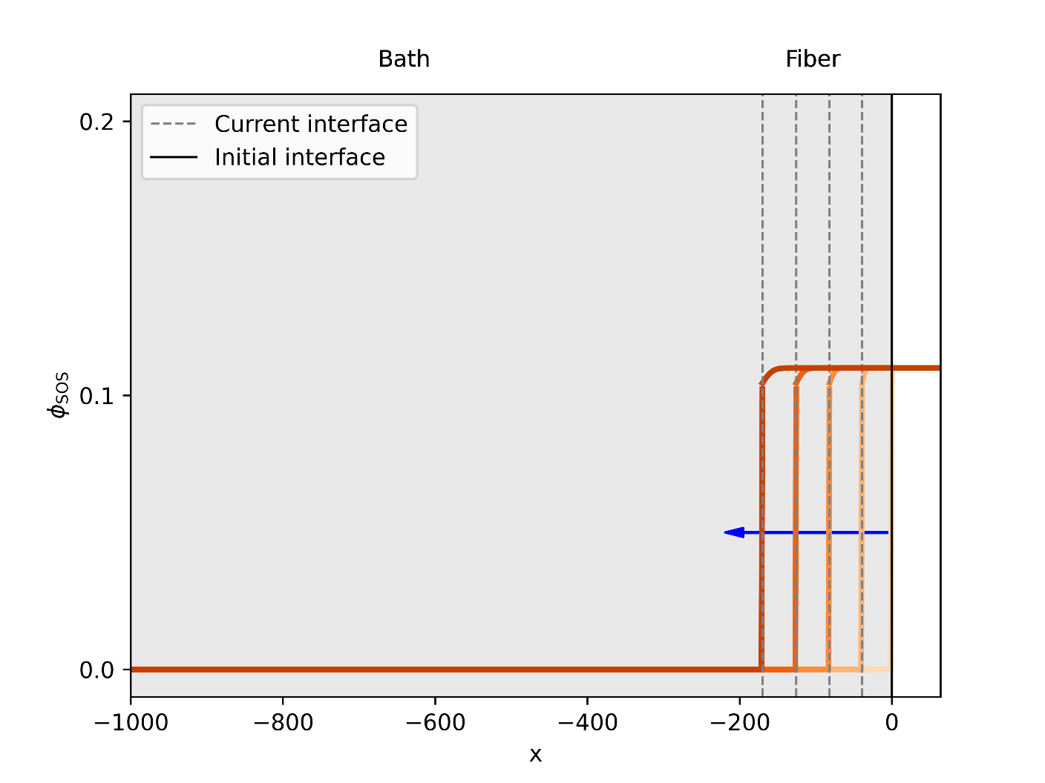
Figure S17. The time evolution of concentration of the polymer in a system consisting of the “fiber” and the “bath”. Initially, the fiber covers all the range where x > 0 while the bath covers all the range where x < 0. The time progresses from lighter to darker orange color. The blue arrow indicates the main direction of movement of the interface between the fiber and the bath during the simulations.

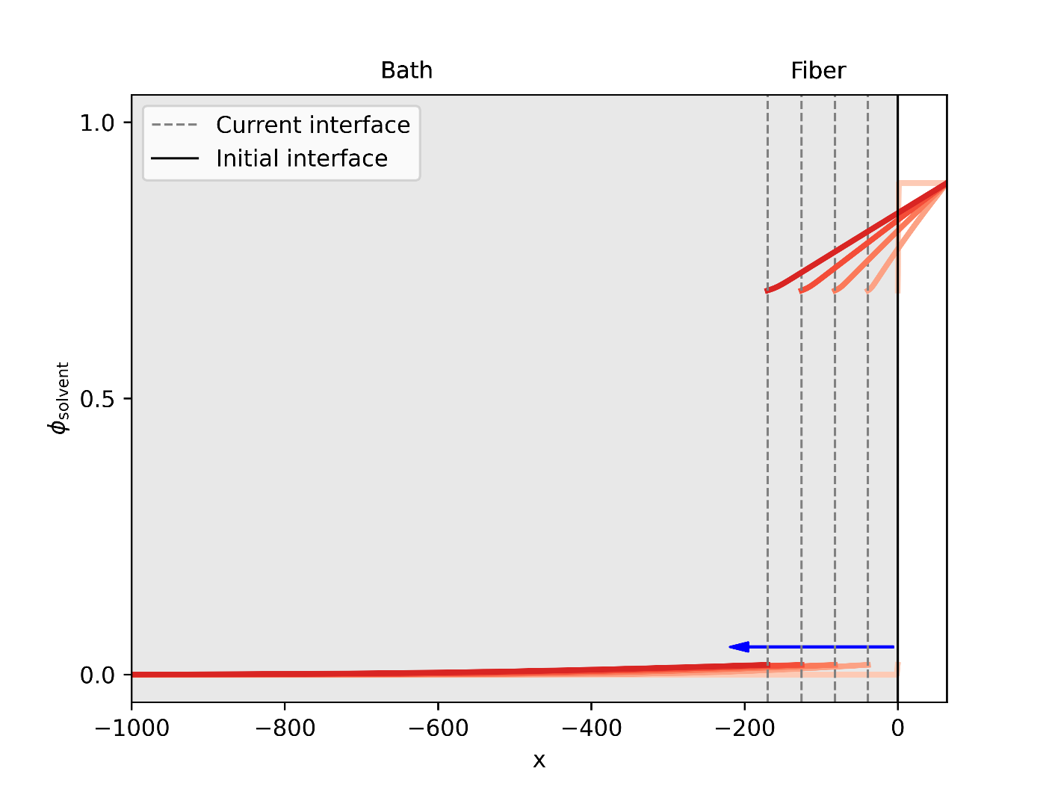
Figure S18. The time evolution of concentration of the solvent in a system consisting of the “fiber” and the “bath”. Initially, the fiber covers all the range where x > 0 while the bath covers all the range where x < 0. The time progresses from lighter to darker red color. The blue arrow indicates the main direction of movement of the interface between the fiber and the bath during the simulations.

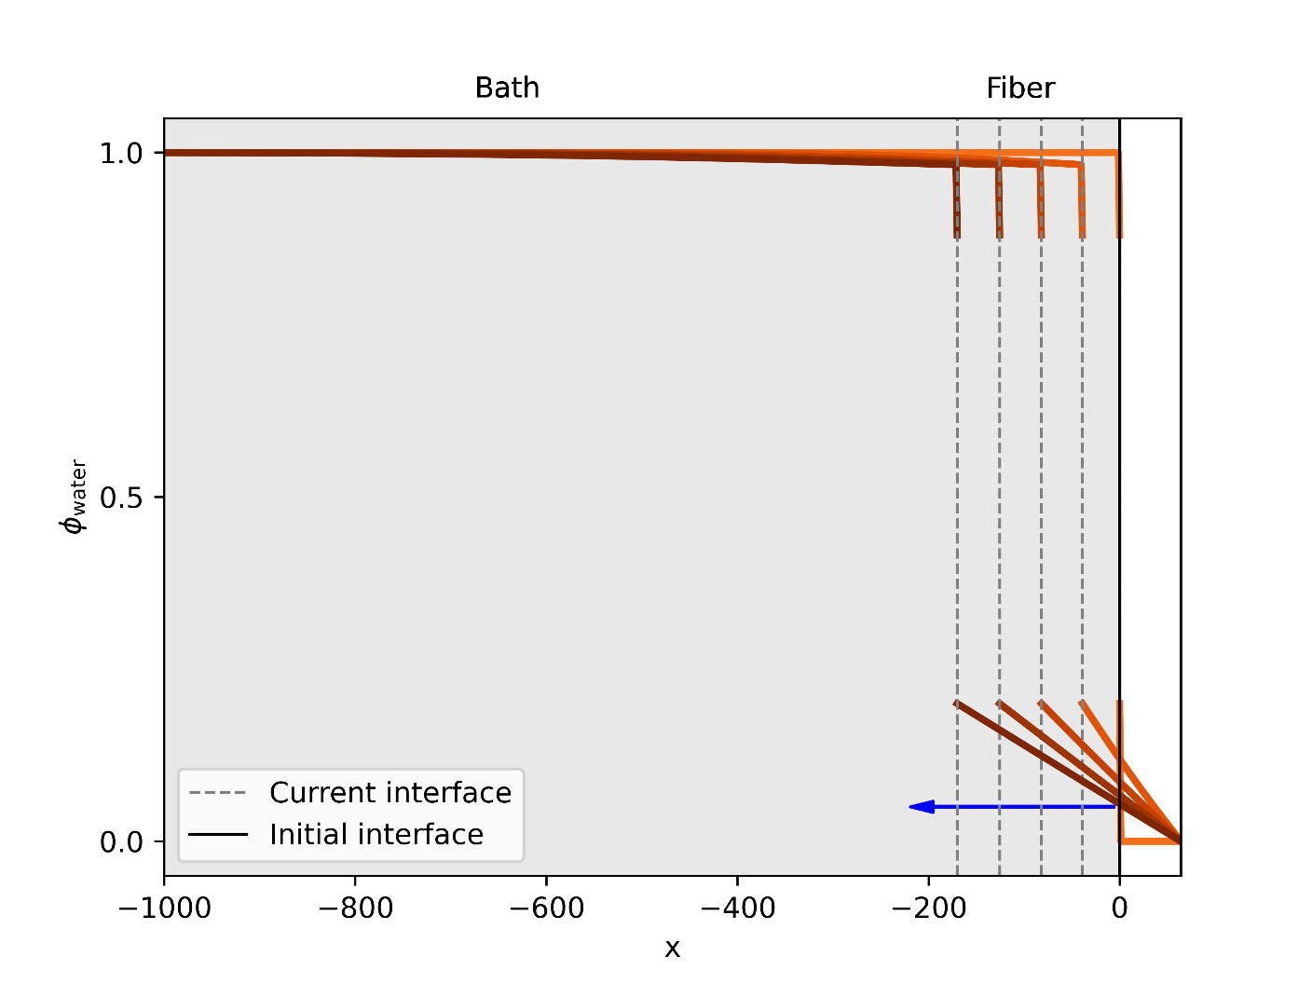
Figure S19. The time evolution of concentration of the nonsolvent in a system consisting of the “fiber” and the “bath”. Initially, the fiber covers all the range where x > 0 while the bath covers all the range where x < 0. The time progresses from lighter to darker brown color. The blue arrow indicates the main direction of movement of the interface between the fiber and the bath during the simulations.

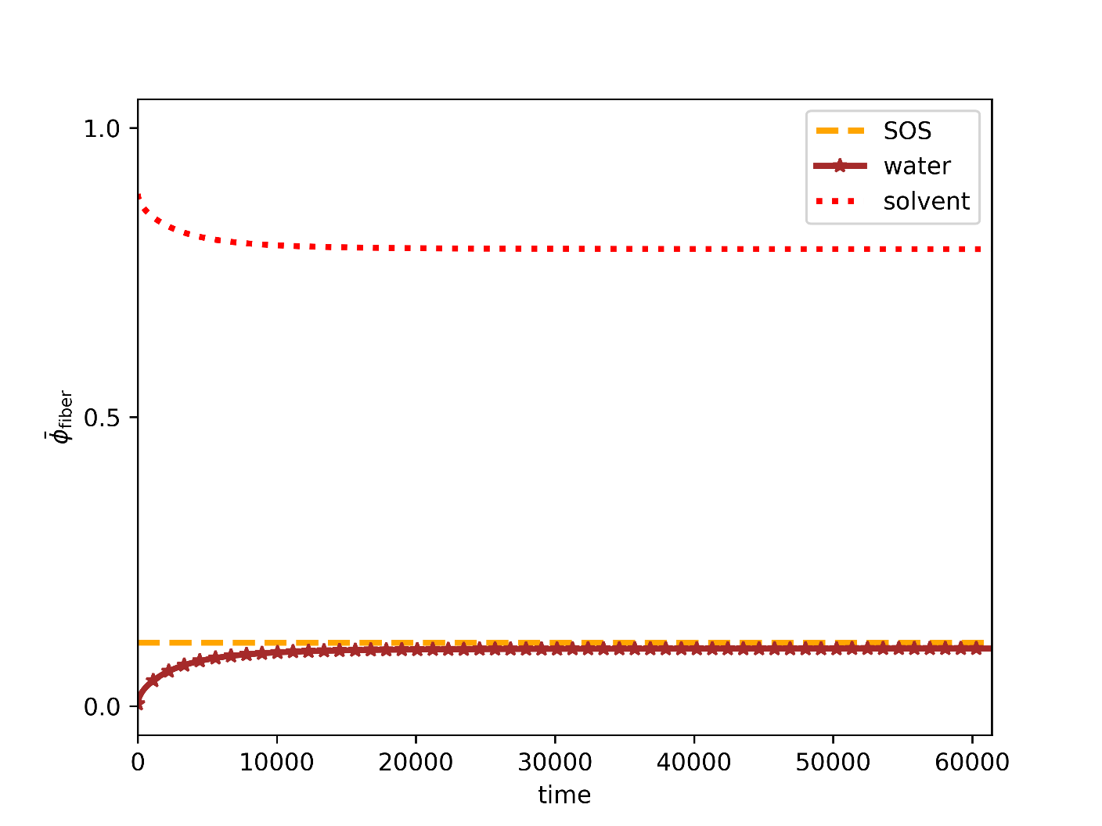
Figure S20. The time evolution of concentration of the average concentration of each of the three components (polymer, nonsolvent, and solvent) in the “fiber” phase.

- Critical Water Content Measurements
The critical water content (CWC) — i.e., the fraction of water that induces micellization in the block copolymers — was calculated by measuring the scattering intensity of filtered, dilute solutions of the triblock copolymers in THF and DMF as the weight fraction of water in solution increased. Measurements were conducted using a Brookhaven Instruments BI-200SM Research goniometer system with a 637 nm, 30 mW laser and a 100 μm aperture, and the solutions were filtered twice using a 0.45 μm Teflon filter. The concentration of the initial THF and DMF solutions was selected to be 4 and 2.5 mg/mL through trial and error as the lowest concentrations producing measurable scattering. As shown in Figure S21, the critical water content is identical for both THF and DMF solutions, where onset and completion of micellization occurs between 7-8% water by weight. This value was shown to be unaffected by concentration.
Figure S21. Critical water content measurements in a dilute triblock copolymer solution in THF and DMF.
Mechanical properties
              - Measuring fiber cross-sectional area
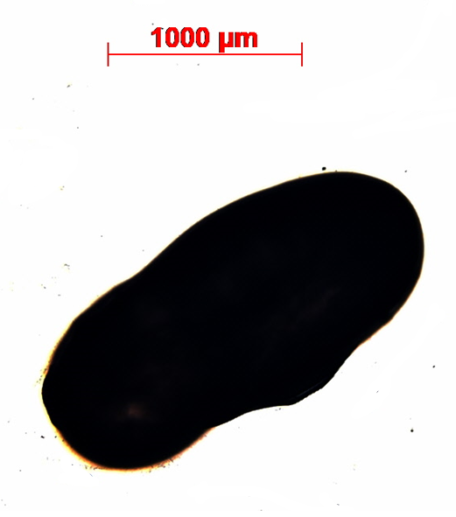
The low modulus and tensile strength of these hydrogels required a precise measurement of the cross-sectional area to accurately calculate the applied stress. Due to irregularities in the shape of the hydrogel fibers, the area was determined by taking cross-sectional slices of the hydrogel — similar to those mounted on aluminum pins for cryo-microtoming — and examining them under a bright field microscope at 2.5x magnification. Measurements were performed quickly, as the heat of the microscope began to evaporate the water withing the hydrogels. At least five representative slices were used for each cross-section, and the area of the cross-sections was calculated using Image J.
Figure S22. Example hydrogel slice used to calculate cross-sectional area for fiber samples. Images were obtained with a bright field microscope at 2.5x magnification.

              - Summary of calculated values
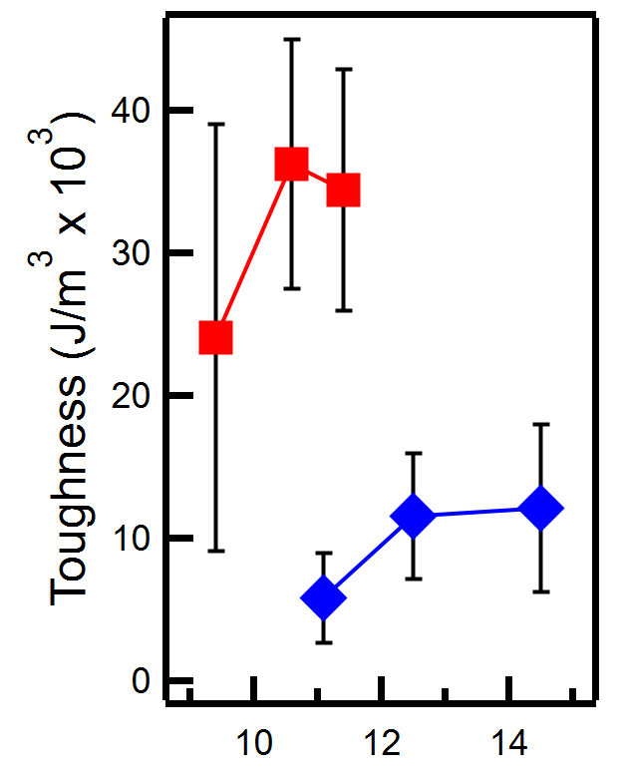
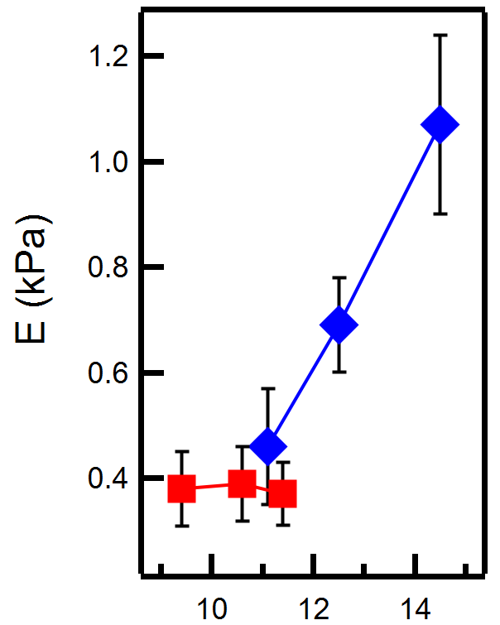
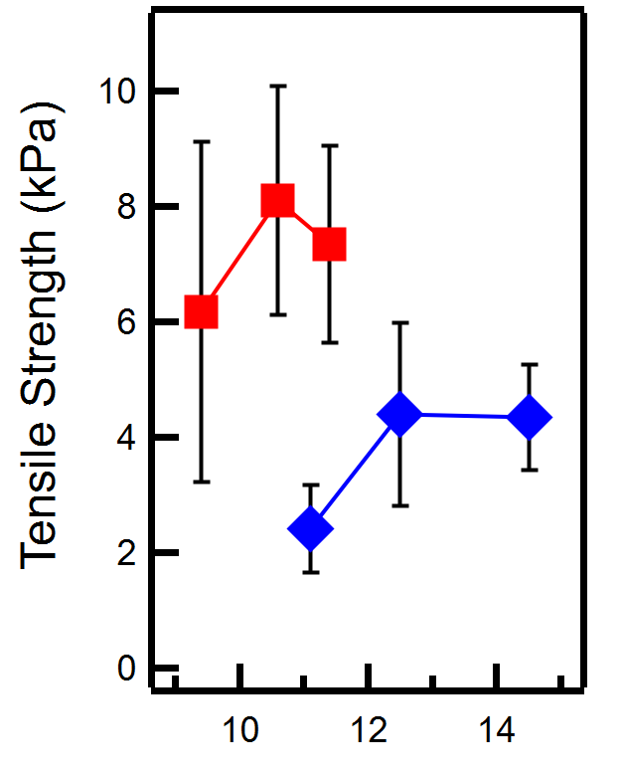
Due to the noise in the data, the Young’s Modulus (E) was calculated from a trendline fit to the first 100 points of data for every sample tested. The tensile strength corresponds with the maximum stress achieved by the samples. The toughness was calculated from the area under the stress-strain curve. Values are averaged for 5 to 7 samples per sample concentration. Average values and raw data are shown below.
Initial Solution Concentration (wt%)

Figure S23. Summary of measured mechanical properties. The Young’s Modulus for the DMF samples was highly consistent as the initial polymer solution increased, but the samples made with THF show a steady increase in E with concentration. The tensile strength of the samples produced with DMF were unchanging within error of one another, while the THF samples showed an increase. The variability in DMF sample tensile strength is reflected in the values calculated for toughness, but once again the values are all within error of each other. The THF samples show little variation in toughness due to the decrease in elongation with increasing initial solution concentration (see Figure 5a).

              - Raw data for uniaxial extension tests
Uniaxial extension tests were performed using spring-loaded steel grips and a 10 N load transducer on a Criterion Load frame from MTS. All samples were deformed at a rate of 3/min. In the graphs shown below, the sample data for a given initial solution condition is shown in gray, with the representative trace, which had the closest alignment to the average elongation ratio and ultimate tensile strength at break for each sample condition, highlighted in color. The color used corresponds with the samples shown in Figure 5a. The data for samples produced with DMF as the organic solvent shows a high degree of variability in the elongation at break at lower initial polymer solution concentrations, with some fibers failing earlier (6 times original length). Though the cause of this is unclear, it may potentially be attributed to slightly larger outer pore regions allowing cracks to propagate more easily. As initial polymer solution concentration increases for the samples produced using DMF, the elongation at break and ultimate tensile strength of the hydrogels becomes more consistent. Dips and drops in the data are attributed either to slight tearing of the fiber or to observed slippage of the hydrogel fiber from between the clamps.
THF samples showed distinct trends in mechanical properties with increasing concentration: as concentration increased, so did tensile strength and elastic modulus, consistent with results reported in previous publications where THF was used as the organic solvent. Conversely, the elongation at break decreased with increasing initial solution concentration.

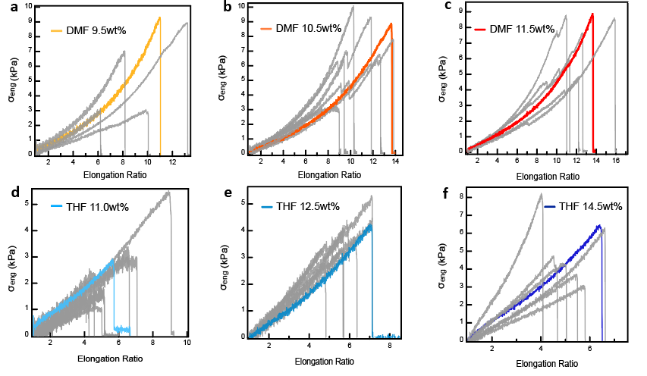
Figure S24. Stress-strain curves generated from uniaxial tensile tests for hydrogel fibers. Representative samples are shown in color for a) DMF 9.5 wt%, b) DMF 10.5 wt%, c) DMF 11.5 wt%, d) THF 11 wt%, e) THF 12.5 wt%, and f) THF 14.5 wt%. A minimum of four samples were tested for each sample condition. Though DMF samples showed greater variability in mechanical properties (ultimate tensile rate) at low initial solution conditions, the average values remained consistent. In contrast, samples prepared with THF increase in both average modulus and tensile strength with concentration, but elongation at break decreases with increasing concentration.

- Oscillatory shear rheology on hydrogels
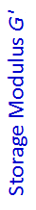
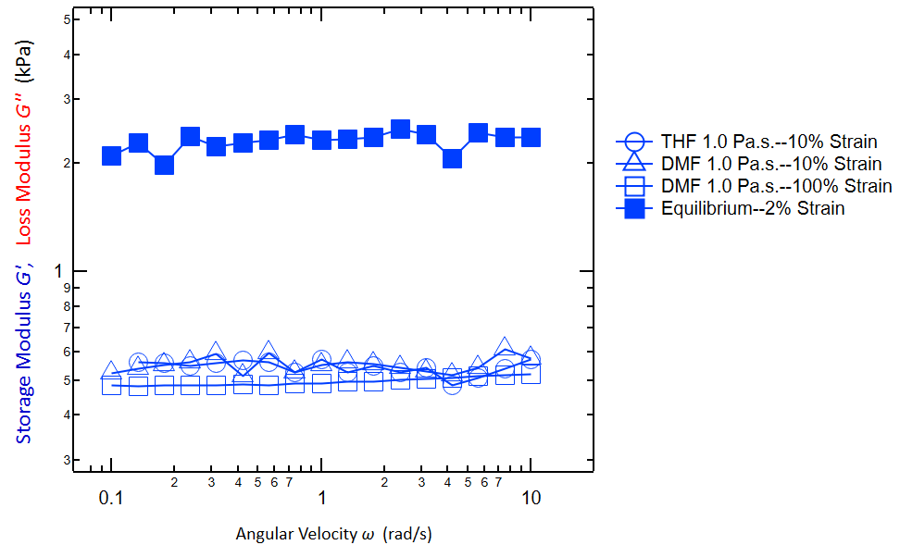
While the injected fiber samples were amenable to uniaxial extension tests, the hydrogels produced using conventional methods were brittle. The shear modulus of these hydrogels was measured via oscillatory shear rheology using a TA Ares-G2 rheometer, first with a dynamic strain sweep to determine the strain region appropriate for testing, and next with a dynamic frequency sweep from 0.1-10 rad/s. Interestingly, the hydrogel fibers showed no change in the storage modulus G’ with solvent or initial strain, as the storage modulus was approximately equal at both 10 and 100% strain. In contrast, the annealed “equilibrium” sample could only be tested at a strain of 2%. The lack of difference between samples is most likely due to the consistent swelling ratio for all samples.

Figure S25. Oscillatory shear rheology measurements for conventional samples and injected fiber hydrogel samples. Samples prepared through conventional methods were brittle and were thus tested at low strain. The shear modulus of the hydrogel samples was five times greater in the conventional samples than in the injected fiber samples, which is consistent with expectations. Interestingly, the injected fiber samples showed a consistent storage modulus, despite variations in both samples and strain.
- Small-Angle Light Scattering Experiments

              - Experimental Setup
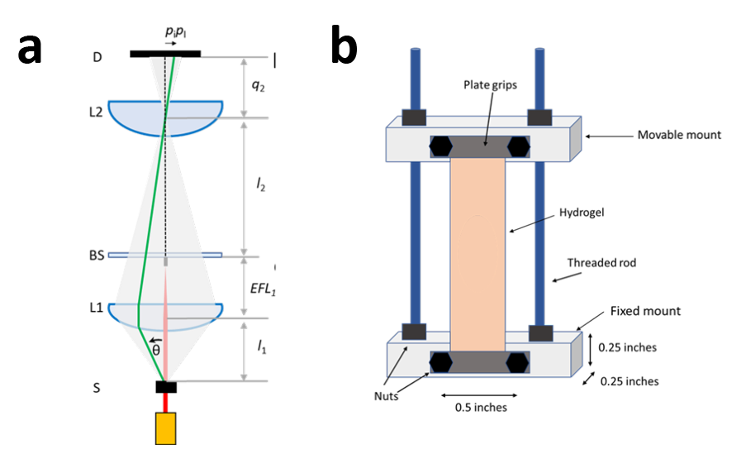
Figure S26. SALS experimental setup. a) Schematic diagram of the scattered light where S is the sample, θ is the scattering angle, focused by lens L1 through beamstop (BS) through lens L2 to a CMOS detector. b) Scheme of the stretching sample holder.

Figure S26a represents the small-angle light scattering (SALS) setup, which has been published previously.²³ The ray diagram shows the initial laser of 625 nm scattered from the sample at an angle θ through a convex lens L1 (Edmund Optics-NT67-245) with a numerical aperture, N.A. = 0.85 that captures up to 58° scattered light. The converging scattered light then passes through beam stop and is refocused through another convex lens L2 (Thorlabs-LA 1951A). The beam stop is at a focal length away from lens L1 and blocks all direct light from the laser. The l₁ and l₂ can be changed to optimize the q-range. The scattered light is then projected onto a CMOS detector, D (Basler acA800-510 um) which is a focal length away from L2.
A control image is taken using a diffraction grating with 100 lines per mm. This was later used to determine the pixel-to-q conversion for the scattering patterns. The hydrogel was then loaded to the sample setup. The l₁ was set to ~25 mm and l₂ to ~75 mm. The room lights were then turned off to avoid any background scattering. A scattering image was then taken for each sample.
Figure S26b shows a schematic diagram of the sample setup. The hydrogel is held in the setup using plate grips. These plate grips are 0.5 in wide, offering enough space to load the hydrogel. The nuts can be moved allowing the top mount (movable) to move in z-direction. The hydrogel can then be stretched to different lengths.

              - Results
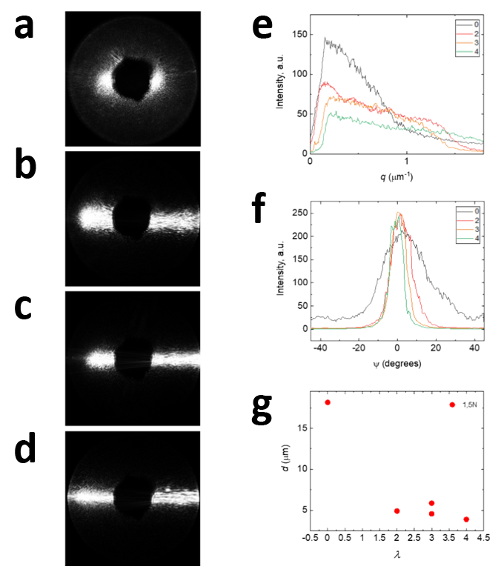
Figure S27. SALS data for a hydrogel prepared from a 12.5 wt% polymer solution in THF. 2D scattering plot for a) unstretched and stretched samples at elongation ratios of b) 2, c) 3, and d) 4. e) Intensity versus q plot at elongation ratios of 0, 2, 3, and 4. f) Intensity versus azimuthal angle, Ψ, plot at elongation ratios of 0, 2, 3, and 4. g) Pore domain spacing, d, .

The hydrogel pore domain spacing, d, and alignment were determined from the 2D scattering plots shown in Figures S27a – d. The domain spacing for the unstretched sample was calculated to be ~ 20 µm in size using the equation, d = 2π/q*, where q* is the primary scattering peak from Figure S27e. The asymmetric 2D scattering plots indicate that the hydrogel pores are oriented along the long axis of the gels. As the sample is stretched, the scattering band widens perpendicular to the direction of stretch and decreases in intensity. Simultaneously, the orientation of the pore domains, which is along the fiber, increases, as seen from the narrowing of the scattering band and in the intensity versus azimuthal angle, Ψ, plot in Figure S27f. Furthermore, as the hydrogel is stretched, the in-plane distance between pores decreases from ~ 20 µm to 2-2.5 µm (Figure S27g).

- Property Comparison with Hydrogels in the Literature
Table S3: Reported values from the literature for maximum tensile strength, Young’s Modulus, and elongation ratio at break for physical, single network, interpenetrating network, supramolecular, and porous gels. Values not reported are indicated by “NR,” and values with an asterisk were tested under compression. Reported values plotted with permission in Figure 5f of the manuscript.
Hydrogel Class | σ_{max} (MPa) | E (MPa) | λ_{b} |  | Reference in Manuscript
Physical Gel | 1.5-5 | 0.2-5 |  | 2.2-3.5 | 36
Physical Gel | 1-7.5 | 5 |  | 4.5-5.0 | 38
Physical Gel | 0.004-0.43 | NR |  | 1.4 | 22
Physical Gel | 20-200 | NR |  | 8.0 | 37
Single Network | 2.5-5 | 2-20 |  | 3.5-5 | 12
Single Network | 0.4-4 | 0.01-0.04 |  | 2.0-1.9 | 11
Single Network | 0.025-0.4 | 0.001-2 |  | 2.0-8.0 | 13
Single Network | 0.035-0.7 | 0.0184-0.072 |  | 5.0-8.0 | 4
Single Network | 1-9 | 0.114-10 |  | 2.0 | 14
Interpenetrating Network Gel | 50-250 | 0.008-0.374 |  | 1.25-5.0 | 46
Interpenetrating Network Gel | 2.1-3.1 | 0.5-6.5 |  | 4.0-9.0 | 47
Interpenetrating Network Gel | 0.1-17.2 | NR |  | 7.0 | 48
Hydrogel Class | σ_{max} (MPa) | E (MPa) |  | λ_{b} | Reference in Manuscript
Supramolecular | 0.5-6 | NR |  | 11-15 | 44
Supramolecular | 0.01-0.052 | NR |  | 15-33 | 39
Supramolecular | 0.75-2.5 | NR |  | 11-21 | 45
Porous | 0.014-0.21* | NR |  | 1.25-1.63* | 43
Porous | 0.005-0.014* | NR |  | 1.15* | 17
Porous | 0.025-0.15* | 0.96-5.8 |  | 1.6* | 40
Porous | 0.12* | 0.0073 |  | 1.95* | 41
Porous | 0.0025-0.015* | 0.0015-0.023 |  | 1.5* | 42

- References
1. Lang C, LaNasa JA, Utomo N, Xu Y, Nelson MJ, Song W, et al. Solvent-non-solvent rapid-injection for preparing nanostructured materials from micelles to hydrogels. Nat Commun 2019, 10: 3855.

2. Hillmyer MA, Bates FS. Synthesis and Characterization of Model Polyalkane−Poly(ethylene oxide) Block Copolymers. Macromolecules 1996, 29(22): 6994-7002.

3. Merrill BA. Potassium Naphthalenide. Encyclopedia of Reagents for Organic Synthesis. John Wiley & Sons, 2001.

4. Guo C, Bailey TS. Highly distensible nanostructured elastic hydrogels from AB diblock and ABA triblock copolymer melt blends. Soft Matter 2010, 6(19): 4807-4818.

5. Ilavskya J, Jemiana PR. Irena: tool suite for modeling and analysis of small-angle scattering. J Appl Crystallogr 2009, 42: 347-353.

6. Leibler L. Theory of Microphase Separation in Block Copolymers. Macromolecules 1980, 13(6): 1602-1617.

7. Uneyama T, Doi M. Density Functional Theory for Block Copolymer Melts and Blends. Macromolecules 2005, 38(1): 196-205.

8. Werner A, Fredrickson GH. Architectural effects on the stability limits of ABC block copolymers. J Polym Sci, Part B: Polym Phys 1997, 35(5): 849-864.

9. Fredrickson GH. The Equilibrium Theory of Inhomogeneous Polymers. Oxford University Press: New York, 2006.

10. Qin J, Grzywacz P, Morse DC. Renormalized one-loop theory of correlations in disordered diblock copolymers. J Chem Phys 2011, 135(8): 084902.

11. Harris CR, Millman KJ, van der Walt SJ, Gommers R, Virtanen P, Cournapeau D, et al. Array programming with NumPy. Nature 2020, 585(7825): 357-362.

12. Virtanen P, Gommers R, Oliphant TE, Haberland M, Reddy T, Cournapeau D, et al. SciPy 1.0: fundamental algorithms for scientific computing in Python. Nature Methods 2020, 17(3): 261-272.

13. Hansen CM. Hansen Solubility Parameters: A User's Handbook, 2nd edn. CRC Press: Bocoa Raton, FL, 2007.

14. Lodge TP, Hiemenz PC. Polymer Chemistry, 3rd edn. CRC Press: Boca Raton, FL, 2020.

15. Frielinghaus H, Hermsdorf N, Almdal K, Mortensen K, Messé L, Corvazier L, et al. Micro- vs. macro-phase separation in binary blends of poly(styrene)-poly(isoprene) and poly(isoprene)-poly(ethylene oxide) diblock copolymers. Europhys Lett 2001, 53(5): 680.

16. Özdemir C, Güner A. Solubility profiles of poly(ethylene glycol)/solvent systems, I: Qualitative comparison of solubility parameter approaches. Eur Polym J 2007, 43(7): 3068-3093.

17. Avaz S, Oguz O, Kurt H, Menceloglu YZ, Atilgan C. Soft segment length controls morphology of poly(ethylene oxide) based segmented poly(urethane-urea) copolymers in a binary solvent. Computational Materials Science 2017, 138: 58-69.

18. Dormidontova EE. Role of Competitive PEO−Water and Water−Water Hydrogen Bonding in Aqueous Solution PEO Behavior. Macromolecules 2002, 35(3): 987-1001.

19. Aryanti PTP, Ariono D, Hakim AN, Wenten IG. Flory-Huggins Based Model to Determine Thermodynamic Property of Polymeric Membrane Solution. Journal of Physics: Conference Series 2018, 1090(1): 012074.

20. Deen WM. Analysis of Transport Phenomena, 2nd edn. Oxford University Press: New York, 2011.

21. Alhasan R, Tree DR. Gibbs–Duhem Relation for Phase-Field Models of Polymeric Mixtures. Macromolecules 2022, 55(3): 759-765.

22. Tree DR, Delaney KT, Ceniceros HD, Iwama T, Fredrickson GH. A multi-fluid model for microstructure formation in polymer membranes. Soft Matter 2017, 13(16): 3013-3030.

23. Dhakal S, Chen Z, Estrin D, Morozova S. Spatially-Resolved Network Dynamics of Poly(vinyl alcohol) Gels Measured with Dynamic Small Angle Light Scattering. Gels 2022, 8(7): 394.

