Extended Data
Extended Data Table 1. Model coefficients and PSIS-LOO criterion values. Values in parentheses give 95% credible interval. All model ELPD_diff (difference in expected log-predictive density, ot goodness-of-fit) values are within 6*SE_diff, so no models are rejected.
 | year | year*climate | year*lifeform | year*climate + year*lifeform
Intercept | -32.134  (-32.848,-31.4) | -33.409  (-34.755,-32.036) | -36.242  (-40.584,-31.983) | -36.622  ( -41.128,-32.236)
year | 0.0165  (0.0161,0.0169) | 0.0172 (0.0164,0.0179) | 0.0184  (0.0161,0.0206) | 0.0186  (0.0163,0.0209)
climtropical | - | 2.192  (0.647,3.818) | - | 1.774  (0.043,3.465)
lifeformepiphyte | - | - | 6.437  (0.756,12.046) | 5.384  (-0.369,11.201)
lifeformherbaceousperennial | - | - | 4.447  (-0.194,9.017) | 4.326  (-0.312,9.034)
lifeformwoodyperennial | - | - | 4.3  (0.004,8.658) | 3.556  (-0.843,8.147)
year:climtropical | - | -0.0011  (-0.002,-0.0003) | - | -0.0009  (-0.0018,0)
year: lifeformepiphyte | - | - | -0.0029  (-0.0059,0) | -0.0024  (-0.0054,0.0006)
year: lifeformherbaceousperennial | - | - | -0.002  (-0.0044,0.0004) | -0.0019  (-0.0044,0.0005)
year: lifeformwoodyperennial | - | - | -0.002  -0.0042,0.0003) | -0.0016  (-0.004,0.0007)
ELPD_diff | -45.7 | -40.4 | -3.0 | 0
SE_diff | 10 | 9.3 | 3.2 | 0
ELPD_diff<6*SE_diff | Yes | Yes | Yes | Yes

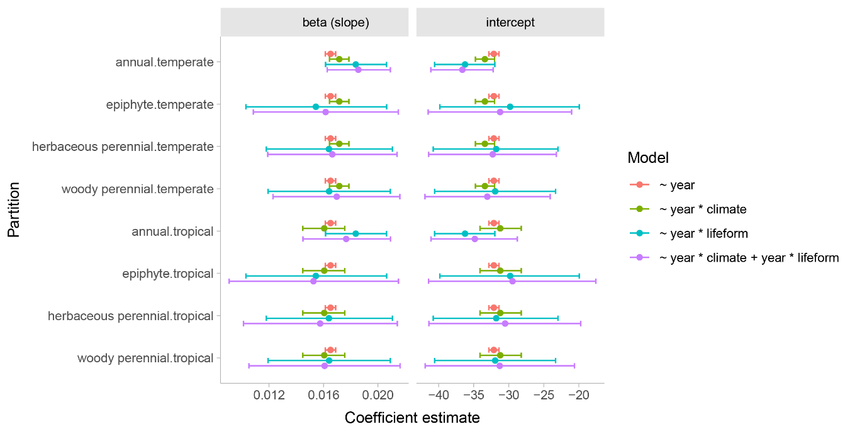

Extended Data Figure 1. Comparison of coefficients across partitioned data. To facilitate comparison, all coefficients were calculated for each group (e.g. intercept for epiphyte.tropical = Intercept + lifeformepiphyte + climtropical from Extended Data Table 1).

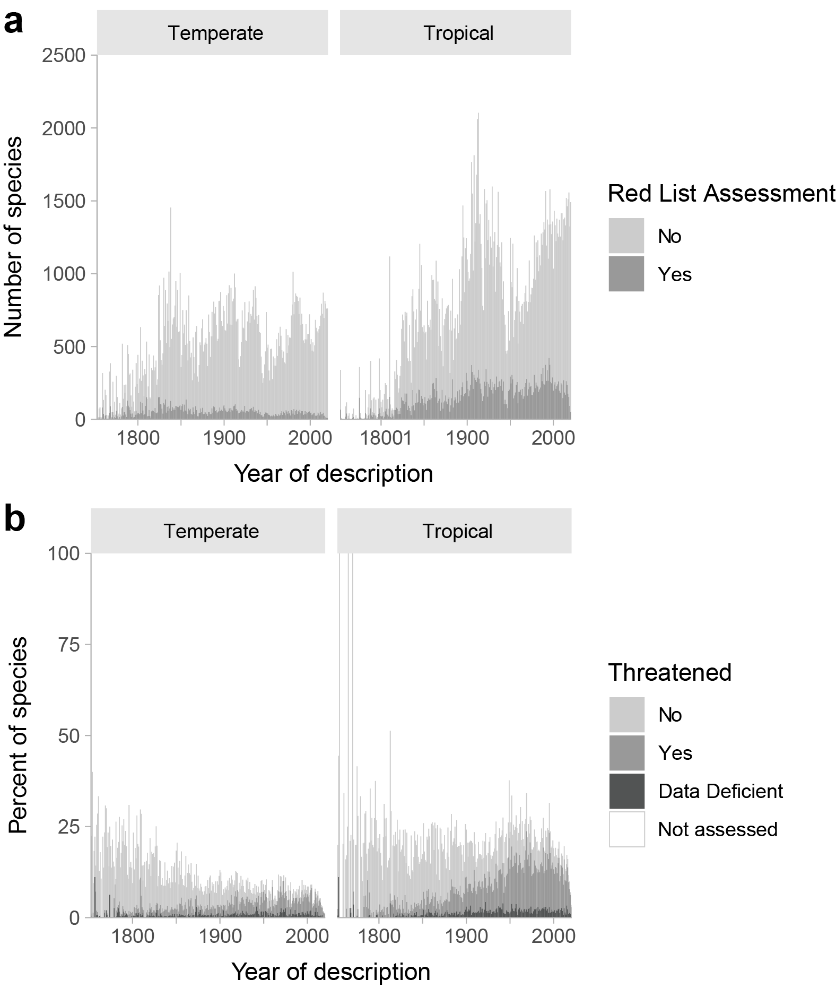
Extended Data Figure 2. The numbers (a) and proportions (b) of species described and assessed per year, partitioned by climate. Although temperate species are less likely to have a global Red List Assessment, the increase in the proportion of threatened species (mid-grey) is clear in both climatic zones, so our results are not driven by tropical species alone.

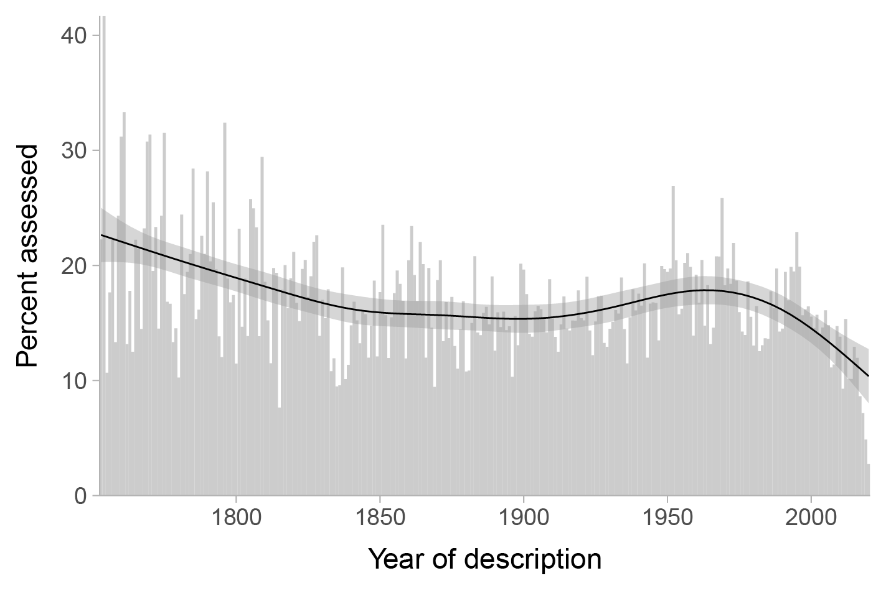

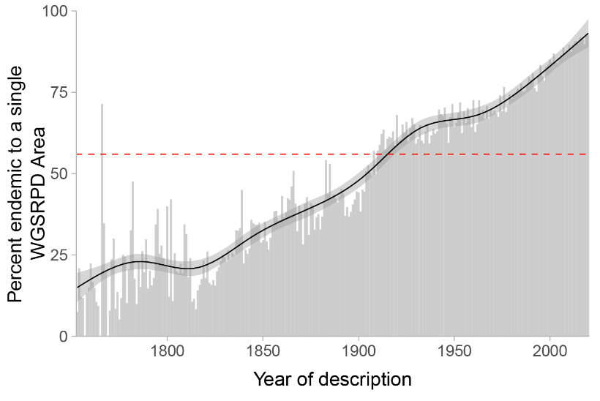
Extended Data Figure 3. Proportion of species that have been assessed by year of description as raw values (histogram) and smoothed trend (line shows generalised additive model fit, ribbon shows SE). Although there is a slight downwards trend (fewer recently described species have been assessed), there is no strong overall bias, and the drop-off after 2010 is likely due to the lag between description and assessment.

Extended Data Figure 4. Proportion of species that are endemic to a single botanical country (World Geographic Scheme for Recording Plant Distributions) by year of description as raw values (histogram) and smoothed trend (line shows generalised additive model fit, ribbon shows SE). Overall, 56% of species are endemic to a single botanical country (red dotted line), but this proportion is much higher for newly described (and undescribed) species.

