Appendix

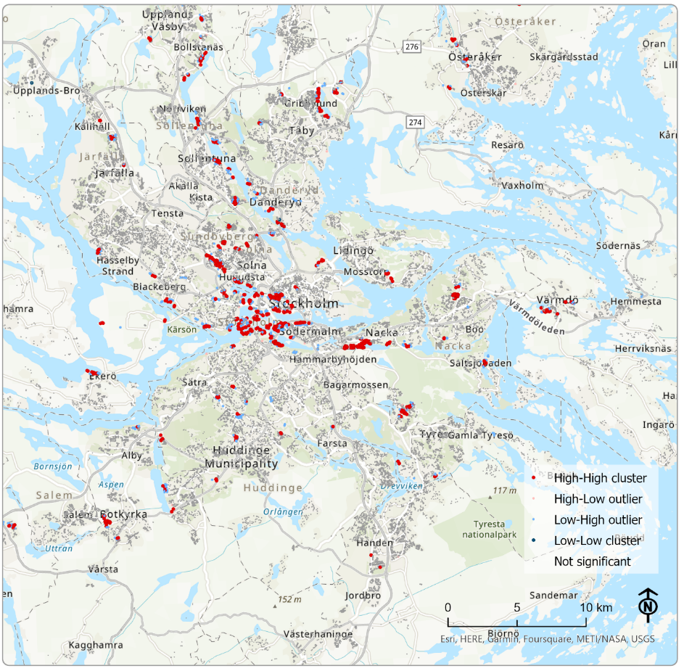
Figure A1: LISA for all amenities.

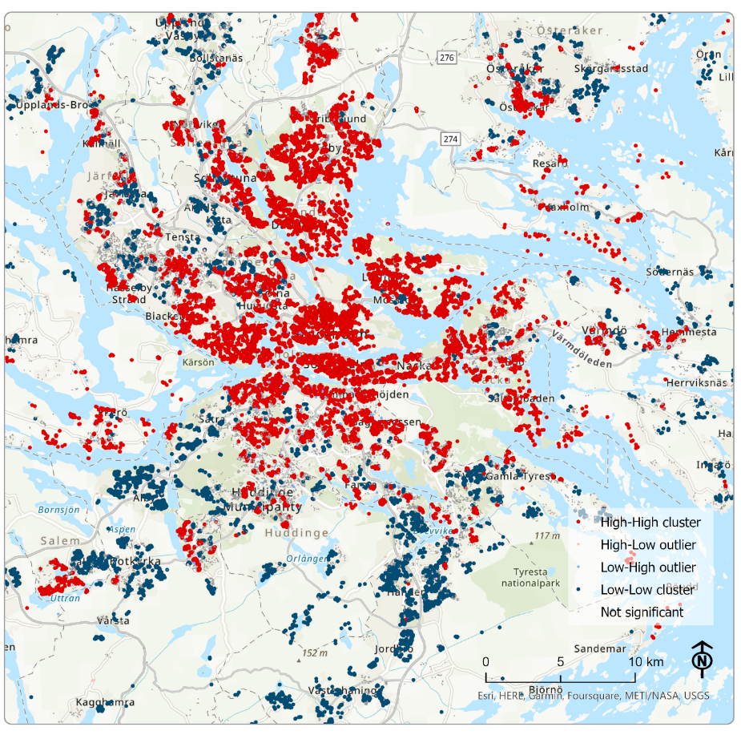
Figure A2: LISA for social amenities

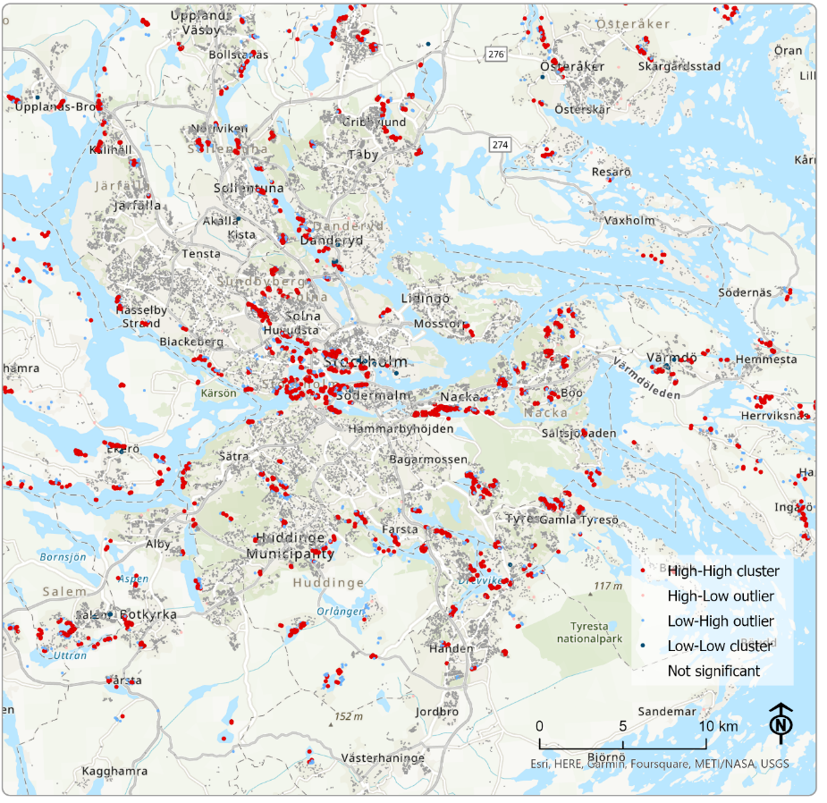
Figure A3: LISA for natural amenities

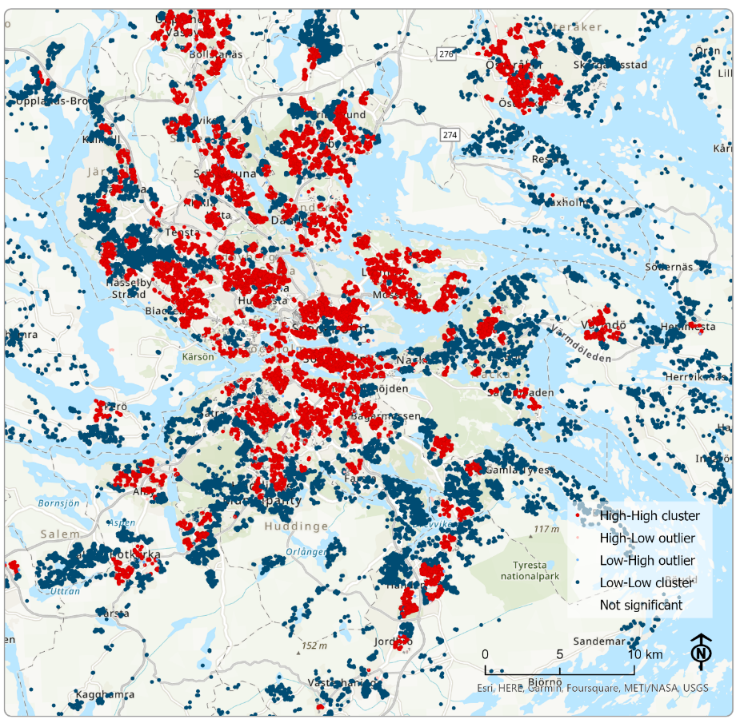
Figure A4: LISA for urban design related amenities.

