Supplementary Material

Supplementary Table 1. Distribution of death within a week or NEC stage III vs NSOFA scores and PACSOFAH scores

Supplementary Table 2. NEC stage III or death within a week: Predictive value of PACSOFAH and NSOFA scores and models.

Supplementary Table 3. Internal validation of the primary outcome: death within a week or NEC stage III

Supplementary Table 4. Factors associated with NEC stage III

Supplementary Table 5. Multivariate prediction models for death within a week

Supplementary Table 6. NEC totalis

Supplementary Table 7. Sensitivity analysis: multivariate prediction models for death or acute surgical abdomen within a week

Supplementary Table 8. Sensitivity analysis: multivariate prediction models among infants with definite or advanced NEC (stage ≥II)

Supplementary Figure 1. Selection of predictors used in the development of a multivariate prediction model of death within a week or NEC stage III among preterm infants at the time of initial evaluation for NEC

Supplementary Figure 2. Calibration plots of the 4 prediction models for necrotizing enterocolitis stage III or mortality within a week

Supplementary Figure 3. Comparison of area under the curve (AUC) of the 4 prediction models for necrotizing enterocolitis stage III or mortality within a week

Supplementary Figure 4. Box plots of serum potassium concentrations at initial evaluation

Supplementary Table 1. Distribution of NEC stage III or death within a week vs NSOFA scores and PACSOFAH scores

Supplementary Table 1.a. NSOFA score

NSOFA  Score​ | Number of infants who died or developed or NEC stage III/ Total number​ | %​
0 | 14/137​ | 10%​
1​ | 6/16​ | 38%​
2​ | 15/38​ | 40%​
3​ | 0/2​ | 0%​
4​ | 9/21​ | 43%​
5​ | 3/4​ | 75%​
6​ | 5/8​ | 63%​
7​ | 2/6​ | 33%​
8​ | 7/7​ | 100%​
9​ | 2/2​ | 100%​
10​ | 5/6​ | 83%​
11​ | 5/5​ | 100%​
12​ | 5/5 | 100%
13​ | 2/2​ | 100%​
14​ | 1/1​ | 100%​
Total | 81/260 | 31%

Supplementary Table 1.b. PACSOFAH score

PACSOFAH  Score​ | Number of infants who died or developed or NEC stage III/ Total number​ | %​
1 | 2/105 | 2%
2 | 4/26 | 15%
3 | 2/11 | 18%
4 | 6/23 | 26%
5 | 2/10 | 20%
6 | 2/4 | 50%
7 | 52/71 | 73%
8 | 13/13 | 100%
Total | 83/263 | 32%

Abbreviations: NEC, necrotizing enterocolitis; NSOFA, Neonatal sequential Organ failure Assessment; PACSOFAH, Pneumoperitoneum, Abdominal Compartment Syndrome, NSOFA, Acidemia, Hyperglycemia, Hyperkalemia

The risk of death/NEC stage III increased with PACSOFAH score (Cox and Snell pseudo r²=0.437) and with NSOFA score (r²=0.328), both P<0.001 (non-parametric regression analysis).
However, the distribution of the two scales was very different. Among infants who developed NEC stage III or died within a week, 38 had NSOFA score 0-3 but only 10 had a PACSOFAH score 1-3 at the time of initial assessment. Among infants who developed death/NEC stage III, 29/81 (36%) had NSOFA score in the upper half of the scale, whereas 65/83 (78%) had PACSOFAH scores of 7-8.
Supplementary Table 2. NEC stage III or death within a week: Predictive value of PACSOFAH and NSOFA scores and logistic models

Supplementary Table 2.a. Logistic regression models using either PACSOFAH or NSOFA only

Factors | OR (95%CI) | P-value
Model using NSOFA score: AUC=0.815 (95% CI 0.756, 0.875), n=260, NEC stage III n=81
NSOFA​ score | 1.543 (1.368, 1.740) | <0.001​
Model using PACSOFAH score: AUC=0.904 (95% CI 0.866, 0.943), n=263, NEC stage III n=83
PACSOFAH score | 2.110 (1.791, 2.485) | <0.001

The model using PACSOFAH had better accuracy than that using NSOFA (ROC contrast estimation = 0.09 (95%CI 0.04, 0.14, P=0.0004).

Supplementary Table 2.b. Comparison of 4 Different Models

Model | AUC | Cutoff* | PPV | NPV | Sensitivity | Specificity | LR+ | LR-
PACSOFAH score | 0.904 | $≥$2 | 51.3% | 98.1% | 97.6% | 57.2% | 2.28 | 0.04
NSOFA score | 0.815 | $≥$1 | 54.5% | 89.8% | 82.7% | 68.7% | 2.64 | 0.25
PACSOFAH, GA, inotropes | 0.918 | $≥$0.383 | 75.3% | 92.0% | 84.3% | 86.7% | 6.34 | 0.18
NSOFA, GA, inotropes | 0.849 | $≥$0.204 | 64.1% | 90.0% | 81.5% | 78.5% | 3.79 | 0.24

Abbreviations: PACSOFAH, Pneumoperitoneum, Abdominal Compartment Syndrome, NSOFA, Acidemia, Hyperglycemia, Hyperkalemia; NSOFA, Neonatal sequential Organ failure Assessment; AUC, area under the curve; PPV, positive predictive value; NPV, negative predictive value; LR+, likelihood ratio of a positive test; LR-, likelihood ratio of a negative test GA, gestational age; GA, gestational age
* Cutoff is either the value of PACSOFAH or NSOFA score, or the calculated probability of NEC stage III or death within a week using the multivariate prediction model.
Supplementary Table 3. Internal validation of the primary outcome: Death within a week or NEC stage III

Supplementary Table 3.a. PACSOFAH, GA, pressors within a week
Variable | B coefficient | Bias | Standard error | P-value | Bias-corrected 95% CI
PACSOFAH | 0.717 | 0.028 | 0.104 | <0.001 | 0.517, 1.085
Pressors within a week | 1.975 | 0.152 | 1.525 | <0.001 | 0.625, 20.958
GA (by week) | 0.145 | 0.002 | 0.089 | 0.087 | -0.028,+0.326
Constant | -7.350 | -0.143 | 2.854 | 0.007 | -13.221,-2.168

Supplementary Table 3.b. NSOFA, GA, pressors within a week

Variable | B coefficient | Bias | Standard error | P-value | Bias-corrected 95% CI
NSOFA | 0.440 | 0.019 | 0.080 | <0.001 | 0.308, 0.680
Pressors within a week | 2.374 | 0.104 | 0.919 | 0.002 | 1.139, 4.268
GA (by week) | 0.209 | 0.007 | 0.088 | 0.009 | 0.050, 0.412
Constant | -6.860 | -0.194 | 2.624 | 0.005 | -12.650, -2.429

Internal validation of the model for the primary outcome was done by bootstrapping to determine whether bias-corrected 95% confidence intervals of the b coefficients were different from zero, using 1000 bootstrap samples. This confirmed that PACSOFAH, NSOFA and pressors within a week are significantly associated with death within a week or NEC stage IIi and that GA is significant only for the NSOFA model.
Abbreviations: CI, confidence interval; PACSOFAH, Pneumoperitoneum, Abdominal Compartment Syndrome, NSOFA, Acidemia, Hyperglycemia, Hyperkalemia; NSOFA, Neonatal sequential Organ failure Assessment; GA, gestational age

Supplementary Table 4: Multivariate prediction models for NEC stage III

Factors | OR (95%CI) | P- value
Model using NSOFA score: AUC=0.811 (95% CI 0.771, 0.891), n=253, NEC stage III n=76
Gestational age (by week) ​ | 1.24 (1.07, 1.45) | 0.006
Pressors within a week​, n=41 | 7.28 (2.90, 18.26) | <0.001​
NSOFA​ score | 1.38 (1.22, 1.56) | <0.001​
Model using PACSOFAH score: AUC=0.901 (95% CI 0.857, 0.944), n=256, NEC stage III n=81
Gestational age (by week) | 1.25 (1.07, 1.47) | 0.006
Pressors within a week​, n=41 | 4.71 (1.77, 12.54) | 0.002
PACSOFAH score | 1.98 (1.65, 2.37) | <0.001

Abbreviations: NEC, necrotizing enterocolitis; NSOFA, Neonatal sequential Organ failure Assessment; PACSOFAH, Pneumoperitoneum, Abdominal Compartment Syndrome, NSOFA, Acidemia, Hyperglycemia, Hyperkalemia; AUC, area under the curve; CI, confidence interval; OR, odds ratio; CI; confidence interval

In forward stepwise logistic regression, variables entered into the model included gestational age, pressors and PACSOFAH score; NSOFA score was not significant once PACSOFAH score was entered into the model.
The model using PACSOFAH had better accuracy than that using NSOFA (ROC contrast estimation = 0.10 (95%CI 0.05, 0.16, P=0.0001).

Supplementary Table 5. Death within a week

Supplementary Table 5.a. Distribution of mortality by NSOFA score

NSOFA  Score​ | Number of infants who died /  Total number​ ​ | %​
0 | 2/137​ | 2%​
1​ | 0/16​ | 0%​
2​ | 6/38​ | 16%​
3​ | 0/2​ | 0%​
4​ | 6/21​ | 29%​
5​ | 1/4​ | 25%​
6​ | 3/8​ | 38%​
7​ | 2/6​ | 33%​
8​ | 5/7​ | 71%​
9​ | 1/2​ | 50%​
10​ | 3/6​ | 50%​
11​ | 4/5​ | 80%​
12​ | 3/5 | 60%
13​ | 2/2​ | 100%​
14​ | 1/1​ | 100%​
Total | 39/260 | 20%

Supplementary Table 5.b. Distribution of mortality by PACSOFAH score

PACSOFAH  Score​ | Number of infants who died /  Total number​ | %​
1 | 0/105 | 0%
2 | 0/26 | 0%
3 | 0/11 | 0%
4 | 0/23 | 0%
5 | 0/10 | 0%
6 | 1/4 | 25%
7 | 29/71 | 41%
8 | 10/13 | 77%
Total | 40/263 | 15%

Abbreviations: NEC, necrotizing enterocolitis; NSOFA, Neonatal sequential Organ failure Assessment; PACSOFAH, Pneumoperitoneum, Abdominal Compartment Syndrome, NSOFA, Acidemia, Hyperglycemia, Hyperkalemia

The distribution of the two scales was very different. Among those who died, 8 infants had NSOFA score 0-3 at the time of initial evaluation died, compared with none with PACSOFAH score <6. Half the infants (21/39) who died had NSOFA scores in the upper half of the scale, whereas all those who died had PACSOFAH score 6-8.

Supplementary Table 5.c. Multivariate prediction models for death within a week

Factors | OR (95%CI) | P- value
Model using NSOFA score: AUC=0.922 (95% CI 0.879, 0.965), n=253, death n=39

Gestational age (by week) ​ | ​1.251 (1.002, 1.561) | 0.048
Pressors within a week​, n=41 | 8.25 (3.12, 21.85)​ | <0.001​
NSOFA​ score | 1.51 (1.30, 1.75)​ | <0.001​
Model using PACSOFAH score: AUC=0.944 (95% CI 0.917, 0.971), n=256, death n=40
Gestational age (by week) | 1.10 (0.90, 1.35) | 0.35
Pressors within a week​, n=41 | 5.15 (1.95, 13.60) | <0.001
PACSOFAH score | 5.19 (1.94, 13.86) | 0.001

Abbreviations: NEC, necrotizing enterocolitis; NSOFA, Neonatal sequential Organ failure Assessment; PACSOFAH, Pneumoperitoneum, Abdominal Compartment Syndrome, NSOFA, Acidemia, Hyperglycemia, Hyperkalemia; AUC, area under the curve; OR, odds ratio; CI; confidence interval

Supplementary Table 6. NEC totalis

Supplementary Table 6.a. Distribution of NEC totalis vs NSOFA scores

NSOFA  Score​ | Number of infants with NEC totalis /  Total number​ | %​
0 | 0/137​ | 0%​
1​ | 0/16​ | 0%​
2​ | 2/38​ | 5%​
3​ | 0/2​ | 0%​
4​ | 2/21​ | 10%​
5​ | 1/4​ | 25%​
6​ | 1/8​ | 13%​
7​ | 1/6​ | 17%​
8​ | 0/7​ | 0%​
9​ | 1/2​ | 50%​
10​ | 2/5 | 40%​
11​ | 2/5​ | 40%​
12​ | 2/5 | 40%
13​ | 1/1​ | 100%​
14​ | 0/1​ | 0%​
Total | 15/258 | 6%

Supplementary Table 6.b. Distribution of NEC totalis vs PACSOFAH scores

PACSOFAH  Score​ | Number of infants with NEC totalis /  Total number​ | %​
1 | 0/105 | 0%
2 | 0/26 | 0%
3 | 0/11 | 0%
4 | 0/23 | 0%
5 | 0/10 | 0%
6 | 0/4 | 0%
7 | 10/70 | 14%
8 | 5/12 | 42%
Total | 15/261 | 6%

Abbreviations: NEC, necrotizing enterocolitis; NSOFA, Neonatal sequential Organ failure Assessment; PACSOFAH, Pneumoperitoneum, Abdominal Compartment Syndrome, NSOFA, Acidemia, Hyperglycemia, Hyperkalemia

Among the 15 infants who develop NEC totalis, 3 had a NSOFA score in 0-3, compared with none with PACSOFAH score < 7. Their median NSOFA score was 9 (IQR 4-11, minimum 2) versus 0 (IQR 0-2) in the other 243 infants (P<0.001) and the median PACSOFAH score was 7 (IQR 7-8, minimum 7) versus 2 (IQR 1,7) in the other 246 infants (P<0.001). Most infants who developed NEC totalis were already sick at the time of initial evaluation.

Supplement Table 6.c. Factors associated with NEC totalis:

Factors | OR (95% CI)​ | P​-value
Model using NSOFA score: AUC=0.911 (95% CI 0.855, 0.968), n=258, NEC totalis n=15
GA (per week)​ | 1.43 (1.05,1.94)​ | 0.02​
NSOFA​ score | 1.63 (1.35, 1.96​ | <0.001​
Model using PACSOFAH score: AUC=0.918 (95% CI 0.877, 0.960), n=261, NEC totalis n=15
GA (per week)​ | 1.22 (0.93, 1.60)​ | 0.15
PACSOFAH​ score | 7.14 (1.87, 27.32)​ | 0.004
Model using NSOFA score and serum potassium concentration: AUC 0.963 (95% CI 0.903, 1.00), n=209, NEC totalis n=10
GA (per week)​ | 1.74 (1.06,2.85)​ | 0.03​
NSOFA​ score | 1.73 (1.23, 2.43)​ | 0.001​
Serum potassium concentration (mmol/L)  <6​.0  6.01-6.99​  >7.0​ | ​  Ref​  35.4 (2.4, 518.9)​  72.4 (3.9, 1352.8)​ | 0.007​  -​  0.009​  0.004​
Model using PACSOFAH score and serum potassium concentration: AUC 0.974 (95% CI 0.941, 1.00), n=212, NEC totalis n=10
GA (per week)​ | 1.54 (0.98,2.40)​ | 0.06
PACSOFAH​ score | 17.9 (1.7, 185.3)​ | 0.02​
Serum potassium concentration (mmol/L)  <6​.0  6.01-6.99​  >7.0​ | ​  Ref​  8.8 (0.7, 111.6)​  54.3 (3.7, 796.0)​ | 0.01  -​  0.09​  0.004​

Logistic regression
Abbreviations: NEC, necrotizing enterocolitis; NSOFA, Neonatal sequential Organ failure Assessment; PACSOFAH, Pneumoperitoneum, Abdominal Compartment Syndrome, NSOFA, Acidemia, Hyperglycemia, Hyperkalemia; AUC, area under the curve; OR, odds ratio; CI; confidence interval

Both scales yield similar AUC, likely because most infants with NEC totalis were already sick at the time of initial evaluation.

Supplementary Table 7: Sensitivity Analysis: Death or acute surgical abdomen within a week
Supplementary Table 7a: Classification by NEC stage and surgical interventions
Classification | n
NEC stage I without surgery | 114
NEC stage I with acute surgical abdomen  Volvulus​  Intestinal obstruction due to meconium peritonitis​  Small bowel stenosis with serosal adhesion​  Penrose for ascites​ | 4
NEC stage I with later surgery  Spontaneous intestinal perforation with pneumoperitoneum  Drain for abdomen compartment syndrome  Silo for abdomen compartment syndrome; later closure  Penrose for esophageal perforation | 4
NEC stage II without surgery | 64
NEC stage II with later surgery for stenosis | 8
NEC stage III | 77
Abbreviation: NEC, necrotizing enterocolitis

Supplementary Table 7.b. Distribution of NSOFA scores among 6 groups by NEC stage and surgical interventions
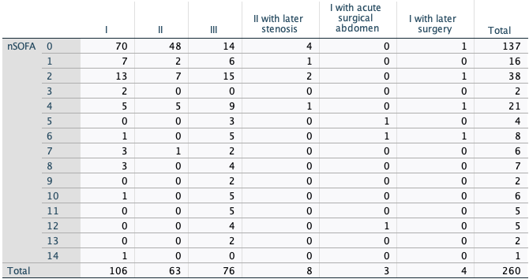
Supplementary Table 7.c. Distribution of PACSOFAH scores among 6 groups by NEC stage and surgical interventions
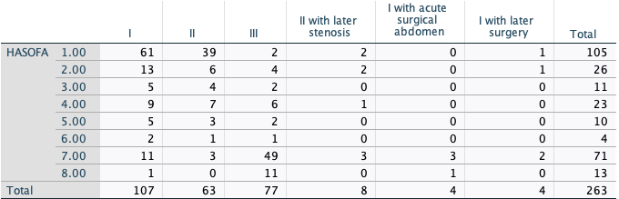
Abbreviations: NEC, necrotizing enterocolitis; NSOFA, Neonatal sequential Organ failure Assessment; PACSOFAH, Pneumoperitoneum, Abdominal Compartment Syndrome, NSOFA, Acidemia, Hyperglycemia, Hyperkalemia
Most infants with isolated stage I NEC or stage II NEC had low NSOFA and PACSOFAH scores, whereas most with stage III NEC had higher PACSOFAH scores.
All four infants with NEC stage I and acute surgical abdomen had an PACSOFAH score of 7-8. Three of them had a NSOFA score, their scores were 5, 6 and 12.
All 4 infants with NEC stage I (without acute surgical abdomen) who died within 48 hours, including 3 with sepsis and 1 with bleeding diathesis, had NSOFA score ≥8 and PACSOFAH score ≥6.
Supplementary Table 7.d. Multivariate prediction models for death or NEC stage III or acute surgical abdomen within a week:

Factors | OR (95%CI) | P- value
Model using NSOFA score: AUC=0.856 (95% CI 0.801, 0.912), n=253, death/NEC stage III/acute surgical abdomen n=88
Gestational age (by week) ​ | ​1.21 (1.03, 1.43) | 0.082
Pressors within a week​, n=41 | 13.14 (4.26, 40.52)​ | <0.001​
NSOFA​ score | 1.59 (1.35, 1.86)​ | <0.001​
Model using PACSOFAH score: AUC=0.925 (95%CI 0.890, 0.960), n=256, death/NEC stage III/acute surgical abdomen n=85
Gestational age (by week) | 1.13 (0.97, 1.33) | 0.13
Pressors within a week, n=41 | 9.06 (2.71, 30.34) | <0.001
PACSOFAH score | 2.09 (1.73, 2.52) | <0.001

Abbreviations: NEC, necrotizing enterocolitis; NSOFA, Neonatal sequential Organ failure Assessment; PACSOFAH, Pneumoperitoneum, Abdominal Compartment Syndrome, NSOFA, Acidemia, Hyperglycemia, Hyperkalemia; AUC, area under the curve; OR, odds ratio; CI; confidence interval

The model using PACSOFAH had better accuracy than that using NSOFA (ROC contrast estimation = 0.09 (95%CI 0.04, 0.14, P=0.0005).

Supplementary Table 8: Sensitivity Analysis among infants with NEC stage $≥$II

Supplementary Table 8.a. Death within 7 days
Factors | OR (95%CI) | P- value
Model using NSOFA score $≥$4: AUC=0.759 (95% CI 0.692, 0.878), n=147, death n=34
NSOFA​ score $≥$4 | 13.44 (5.36, 33.70)​ | <0.001​
Model using PACSOFAH score $≥6$: AUC=0.851 (95%CI 0.792, 0.910), n=148, death n=34
PACSOFAH score $≥6$ | 160 (9.6, 2660)* | <0.001
Multivariate model using NSOFA score: AUC=0.879 (95% CI 0.817, 0.942), n=140, death n=34
Gestational age (by week) ​ | ​1.21 (0.95, 1.53) | 0.12
Pressors within a week​, n=35 | 5.96 (2.12, 16.73) | <0.001​
NSOFA​ score | 1.39 (1.19, 1.61)​ | <0.001​
Multivariate model using PACSOFAH score: AUC=0.911 (95%CI 0.865, 0.957), n=141, death n=34
Gestational age (by week) | 1.13 (0.89, 1.43) | 0.32
Pressors within a week, n=35 | 4.10 (1.40, 11.99) | 0.01
PACSOFAH score | 5.20 (1.62, 16.75) | 0.006

Supplementary Table 8.b. Death or Surgery within 7 days
Factors | OR (95%CI) | P- value
Model using NSOFA score $≥$4: AUC=0.720 (95% CI 0.637, 0.804), n=147, death/surgery n=76
NSOFA​ score $≥$4 | 10.71 (4.35, 26.38)​ | <0.001​
Model using PACSOFAH score $≥2$: AUC=0.847 (95%CI 0.780, 0.914), n=148, death/surgery n=77
PACSOFAH score $≥2$ | 51.3 (11.7, 225.4) | <0.001
Multivariate model using NSOFA score: AUC=0.846 (95% CI 0.781, 0.910), n=140, death/surgery n=76
Gestational age (by week) ​ | ​1.09 (0.90, 1.31) | 0.39
Pressors within a week​, n=35 | 7.28 (1.86, 28.53)​ | 0.004​
NSOFA​ score | 1.62 (1.28, 2.04) | <0.001​
Multivariate model using PACSOFAH score: AUC=0.918 (95%CI 0.873, 0.963), n=141, death/surgery n=77
Gestational age (by week) | 0.98 (0.80, 1.19) | 0.80
Pressors within a week, n=41 | 3.90 (0.88, 17.41) | 0.07
PACSOFAH score | 1.95 (1.58, 2.41) | <0.001

Accuracy of the univariate prediction models for death using PACSOFAH and NSOFA were not significantly different.
The multivariate prediction model for death or surgery using PACSOFAH had better accuracy than that using NSOFA (ROC contrast estimation = 0.09 (95%CI 0.02, 0.15, P=0.01).

Abbreviations: NEC, necrotizing enterocolitis; NSOFA, Neonatal sequential Organ failure Assessment; PACSOFAH, Pneumoperitoneum, Abdominal Compartment Syndrome, NSOFA, Acidemia, Hyperglycemia, Hyperkalemia; AUC, area under the curve; OR, odds ratio; CI; confidence interval
* 0.5 added to one empty cell.

Supplementary Figure 1. Selection of predictors used in the development of a multivariate prediction model of death within a week or NEC stage III among preterm infants at the time of initial evaluation for NEC

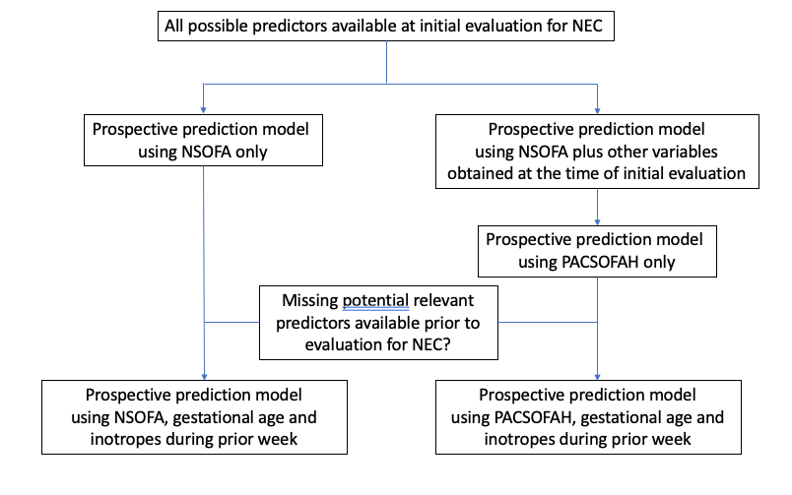

Supplementary Figure 2. Calibration Plots of the 4 predictor models for the primary outcome

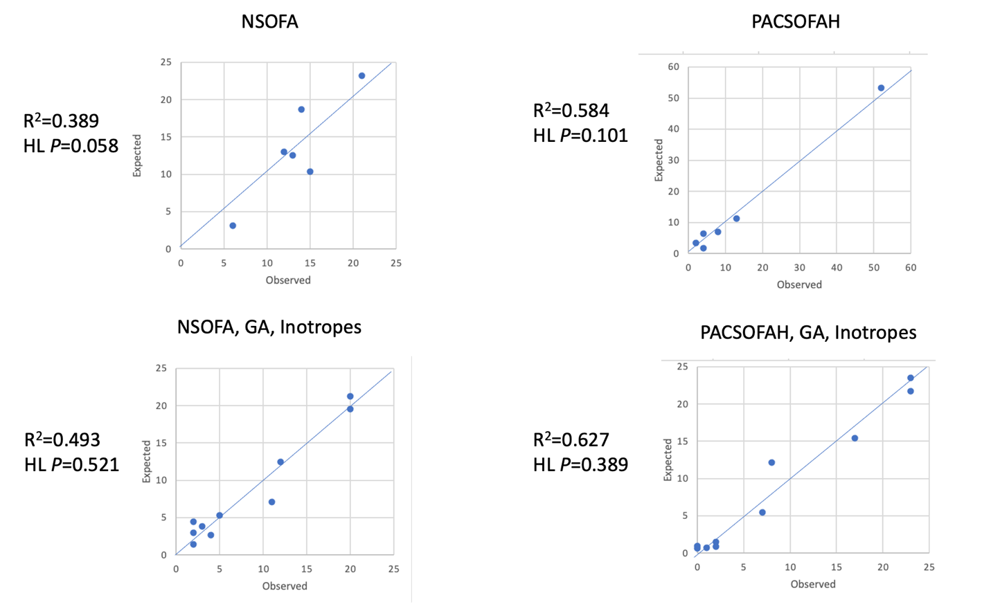
R², Nagelkerke r square; HL, Hosmer and Lemeshow chi-square test; GA, gestational age
Observed outcomes matched expected outcomes using all models (HL not significant); however Chi-square was lower after adding GA and inotropes to the models.
The best correlation between observed outcomes and expected outcomes was using PACSOFAH, GA and inotropes.
Supplementary Figure 3. Comparison of area under the curve (AUC) of the 4 predictor models for the primary outcome.

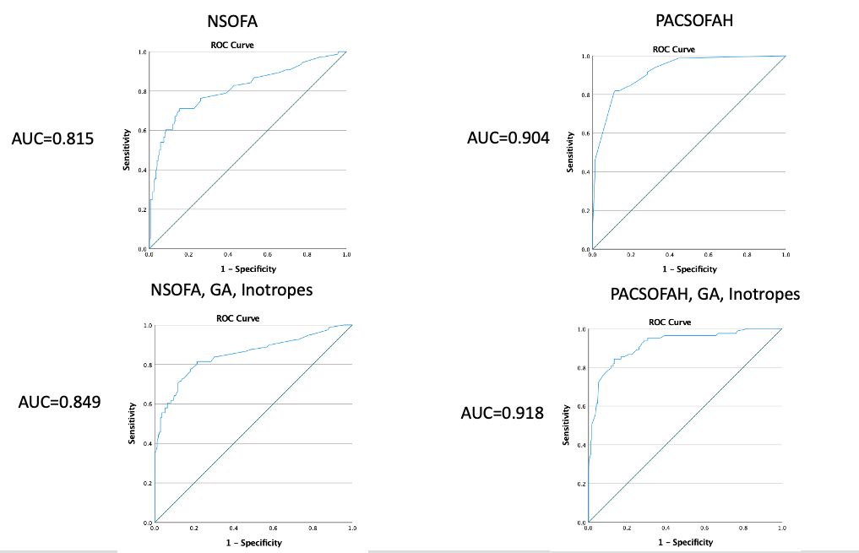

The highest AUC was obtained using PACSOFAH, GA and inotropes during the week preceding initial assessment for NEC.
Supplementary Figure 4. Box plots of serum potassium concentrations at initial evaluation

Supplementary Figure 4.a. Classification by NEC Stage and Surgery

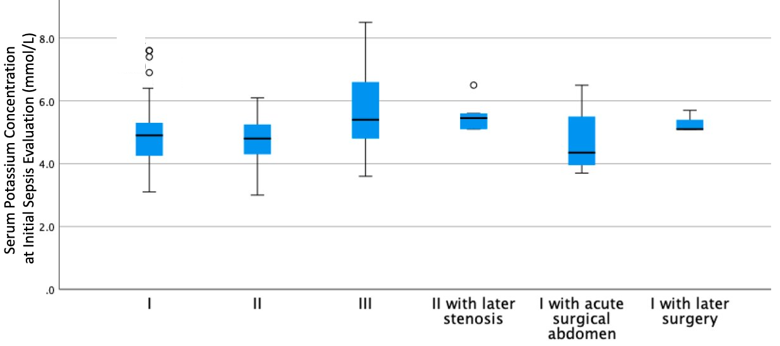
n= 83 55 69 6 4 3

Serum potassium concentration was significantly higher in infants with NEC stage III than in those with NEC stage I (P=0.002) or stage II (P<0.001) (Kruskal-Wallis test followed by pair-wise comparisons with Bonferroni correction).

Figure 4.b. NEC Totalis
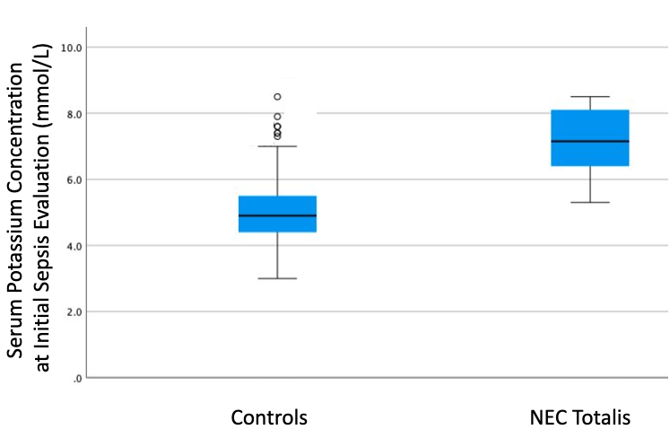
n=208 n=10

Serum potassium concentration was significantly higher in infants with NEC totalis than in controls (P<0.001, Mann-Whitney test).

