Persistent endothelial dysfunction in post-COVID-19 syndrome and its associations with symptom severity and chronic inflammation

Timon Kuchler¹; Roman Günthner¹; Andrea Ribeiro^{1,3}; Renate Hausinger¹; Lukas Streese²; Anna Wöhnl¹; Veronika Kesseler¹; Johanna Negele¹; Tarek Assali¹; Javier Carbajo-Lozoya¹; Maciej Lech³; Kristina Adorjan⁴; Hans Christian Stubbe⁵; Henner Hanssen⁶; Konstantin Kotilar⁷; Bernhard Haller⁸; Uwe Heemann¹; Christoph Schmaderer¹

Authors are affiliated with: ¹ “Technical University of Munich, School of Medicine, Klinikum rechts der Isar, Department of Nephrology, Ismaninger Str. 22, 81675 Munich, Germany; ² Faculty of Health Care, Niederrhein University of Applied Sciences, Krefeld, Germany. ³ LMU University Hospital Munich, Medizinische Klinik und Poliklinik IV, Ziemssenstraße 5, 80336 Munich, Germany“;⁴ „ LMU University Hospital Munich, Department of Psychiatry and Psychotherapy, Nußbaumstraße 7, 80336 Munich, Germany“;⁵„ LMU University Hospital Munich, Medizinische Klinik und Poliklinik II, Marchioninistraße 15, 81377 Munich, Germany“;⁶ „ University of Basel, Department of Sport, Exercise and Health, Preventive Sports Medicine and Systems Physiology, Switzerland; ⁷ Aachen University of Applied Sciences, Heinrich-Mussmann-Str. 1, 52428 Jülich, Germany “;⁸ “Technical University of Munich, School of Medicine, Klinikum rechts der Isar, Institute for AI and Informatics in Medicine, Ismaninger Str. 22, 81675 Munich, Germany”;

Online Data Supplement

Corresponding author

Correspondence to Christoph Schmaderer, MD, Department of Nephrology, Klinikum rechts der Isar, Ismaninger Straße 22, 81675 München, Germany. Email christoph.schmaderer@mri.tum.de

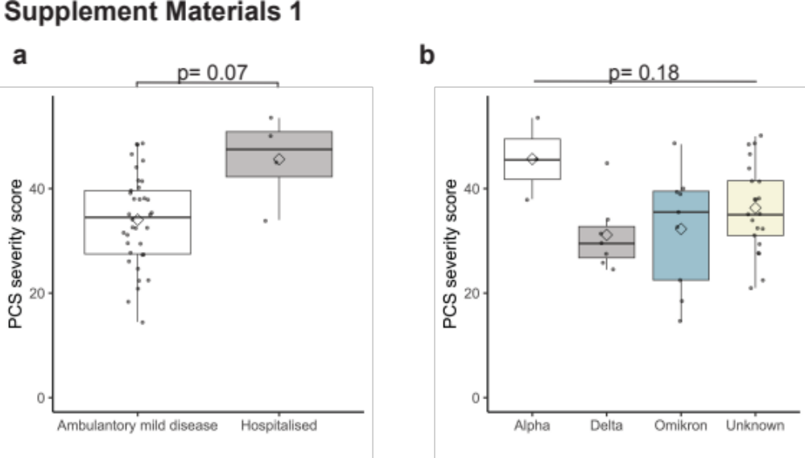
Boxplots show PCS severity score compared between patients with mild acute SARS-CoV-2 infection (white) and patients which were hospitalized (grey) (a) and PCS severity score between SARS-CoV-2 virus variants (b) Boxplots show values as mean (rectangle) and median (line). Wilcoxon rank sum test was used for nonparametric distributions and Welchs t test for parametric distributions.
Fig. E1: PCS severity score and severity of acute infection and virus variants
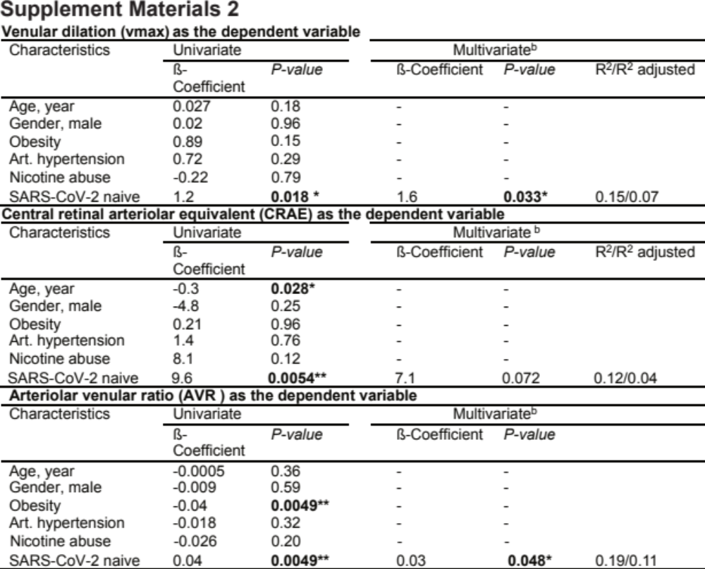
Regression model shows potential confounders of RVA and SARS-CoV-2 naïve cohort as a univariate mode for the dependent variables. The multivariate model^{b} was corrected for age, gender, obesity, arterial (Art.) hypertension and nicotine abuse for the dependent variables vmax, CRAE and AVR. The respective R² are shown for the multivariate model^{b} after correction. To fit a linear model, residuals were tested for normality.

Table E1

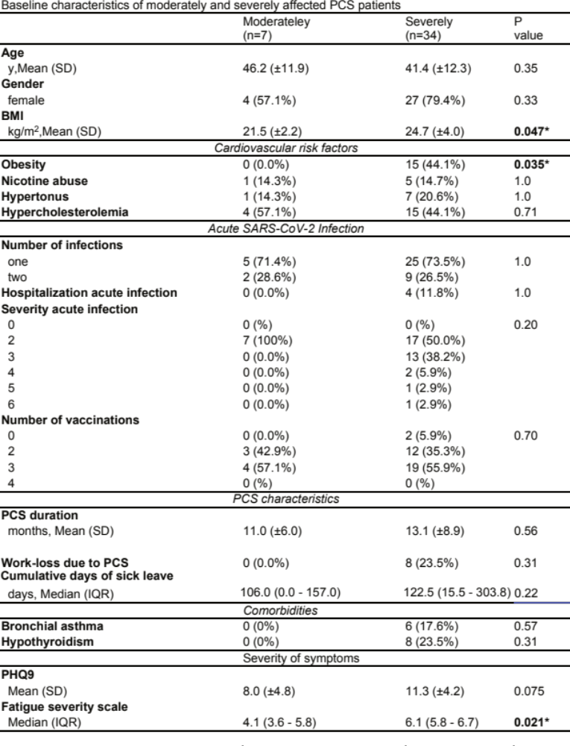
Table E2

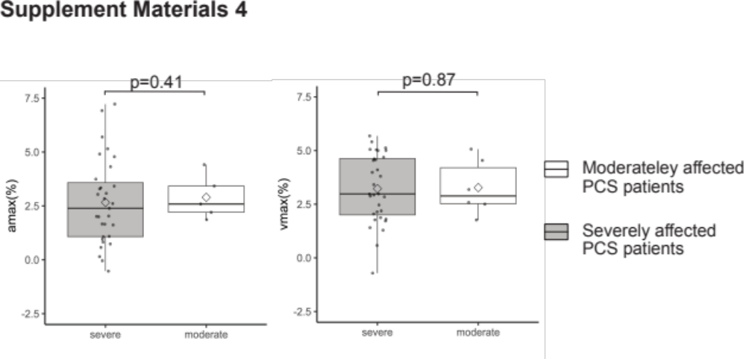
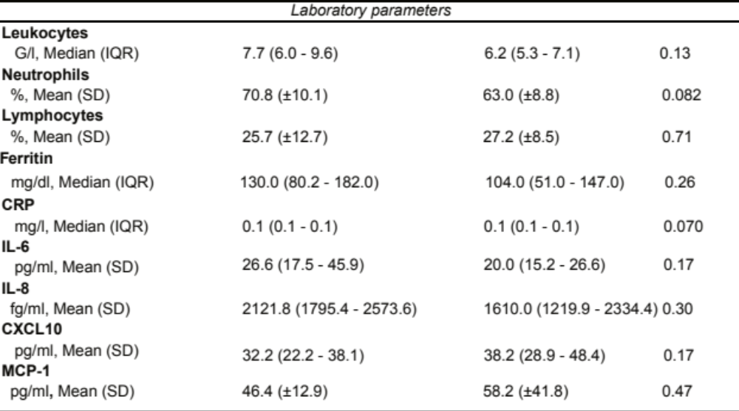
Parameters of retinal microvasculature in severely affected PCS patients. a Boxplot of DVA parameters amax and vmax in 7 moderately affected PCS patients (PCS severity score >10.75 and ≤26.25) (white) and 34 severely affected PCS patients (PCS severity score >26.25,) (grey). Boxplots show values as mean (rectangle) and median (line). To compare groups Wilcoxon rank sum test was used for skewed data and Welch´s t-test for normally distributed data.

P-values are shown for statistical tests comparing moderately (PCS severity score >10.75 and ≤26.25) and severely affected PCS patients (PCS severity score >26.25), t-test was used for normally distributed variables, the χ² test for categorical variables, the Wilcoxon rank sum test for variables with a skewed distribution and the Fisher exact test for binary variables. BMI, body mass indexobesity is defined as BMI > 25 kg/m²; hypercholesterolemia is defined as cholesterol > 200 mg/dl.

Fig. E2

Table E3

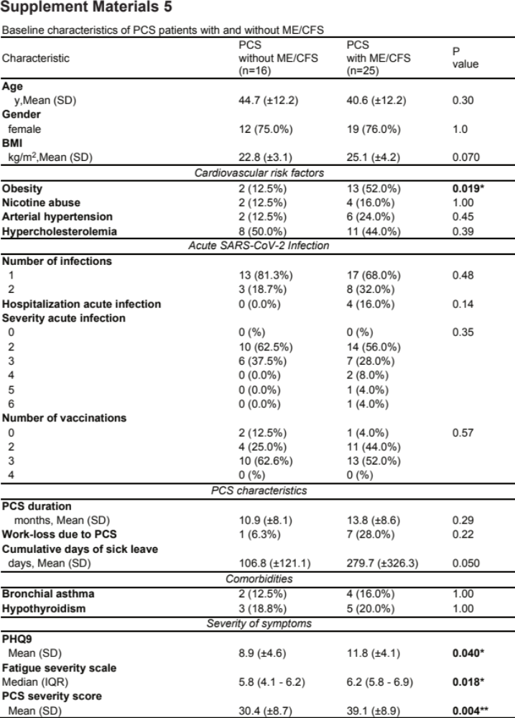

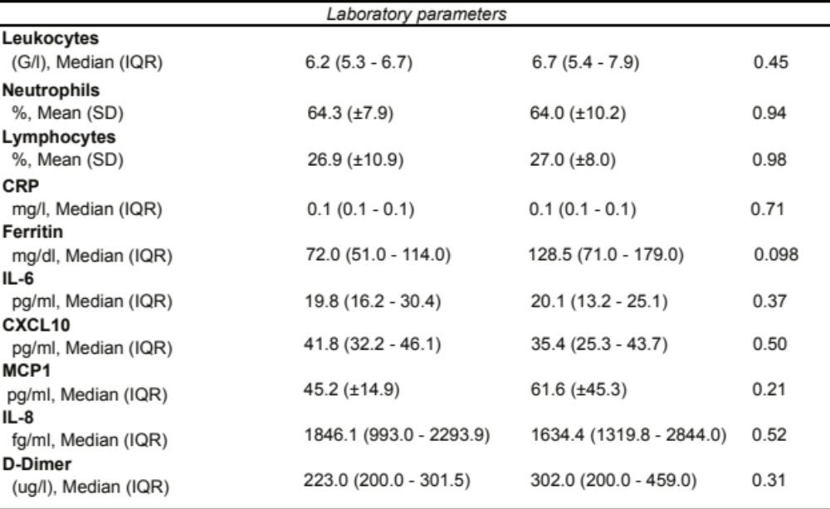
P-values are shown for statistical tests comparing PCS patients with ME/CFS with PCS patients without ME/CFS; t-test was used for normally distributed variables, the χ² test for categorical variables, the Wilcoxon rank sum test for variables with a skewed distribution and the Fisher exact test for binary variables. ME/CFS, myalgic encephalomyelitis/chronic fatigue syndrome; BMI, body mass index; obesity is defined as BMI > 25 kg/m2. Hypercholesterolemia was defined as cholesterol > 200 mg/dl.

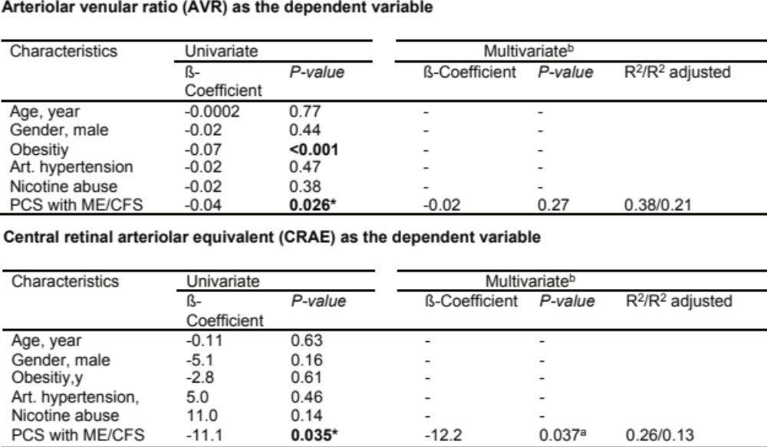
Regression model shows confounders of RVA, PCS with ME/CFS as a univariateª model. The multivariate model^{b} was corrected for age, gender, obesity, arterial (Art.) hypertension and nicotine abuse for the dependend variables AVR and CRAE. The respective R² are shown for the multivariate model^{b} after correction. To fit a linear model, residuals were tested for normality. For one modelª F-Statistic was not significant.

Fig. E3
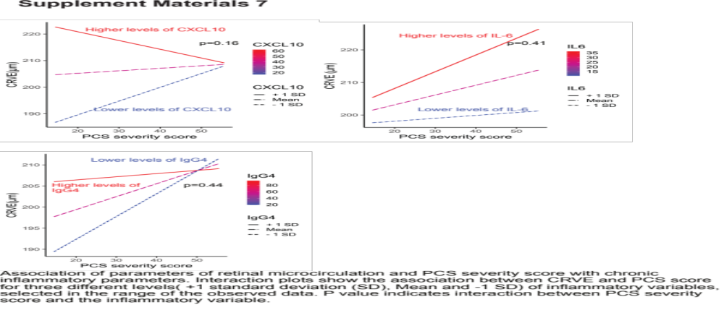
Table E4

eTable6
The multivariate linear regression model shows associations of laboratory parameters with the dependend variables AVR, CRAE, CRVE. D-Dimer was measured in n=36, thrombocytes and ferritin in n=37, TAG, CXCL10, IL8, IL-6, IgG4 and MCP-1 in n=38. The multivariate model^{b} was fitted for age, gender, obesity, arterial hypertension and nicotine abuse. F-statistic was significant for all shown significant models except modelª.

Association of parameters of retinal microcirculation and PCS severity score with inflammatory parameters. Interaction plots show the association between CRVE and PCS score for three different levels (+1 standard deviation (SD), Mean and -1 SD) of inflammatory variables CXCL10 and IL6, selected in the range of the observed data. P value indicates interaction between PCS severity score and the inflammatory variable and was computed using a multivariante linear model controlled for confounders age, gender, obesity, arterial hypertension and nicotine abuse.
<

