Colonic Microbiota Improves Fiber Digestion Ability and Enhances Absorption of SCFAs in Hainan Local Pigs
Pengxiang Xue¹, Yabiao Luo¹, Yanxia Song¹, Qiguo Tang¹, Feng Wang², Ruiping Sun², Zhe Chao², Meiying Fang¹,³#
¹ Department of Animal Genetics and Breeding, National Engineering Laboratory for Animal Breeding, MOA Laboratory of Animal Genetics and Breeding, College of Animal Science and Technology, China Agricultural University, Beijing, China.
² Institute of Animal Science and Veterinary Medicine, Hainan Academy of Agricultural Science, Haikou, China
³ Sanya Institute of China Agricultural University, Sanya, China.
#Address correspondence to Meiying Fang, meiying@cau.edu.cn

Table S1. Ingredients and nutrient level of the experimental diets (as-fed basis).
Item | Dietary fiber  5% |  | Dietary fiber  10%
Ingredients%
Corn | 49.4 |  | 32.7
Alfalfa | 2.7 |  | 16.9
Wheat bran | 13.1 |  | 13.1
Soybean meal | 18 |  | 18
Rice bran | 13 |  | 13
Soybean oil | 1 |  | 3.5
Limestone | 1.4 |  | 1.4
Sodium chloride | 0.3 |  | 0.3
L-Lysine | 0.1 |  | 0.1
Premix | 1 |  | 1
Total | 100 |  | 100
Nutrient level*
DE, MJ·kg⁻¹ | 13 |  | 12.89
CP % | 16.01 |  | 16.3
Lys % |  | 0.85 | 0.84
Met+Cys % |  | 0.44 |  | 0.43
Trp % |  | 0.14 |  | 0.14
Thr % |  | 0.54 |  | 0.53
Dietary fiber % |  | 5 |  | 10
Calcium % |  | 0.64 |  | 0.65
Phosphorus % |  | 0.55 |  | 0.54
*DE was calculated value, while other nutrient levels were measured values

Table S2. Primer sequences used for quantitative real-time PCR
Gene symbol | Primer sequence (5’ - 3’) | Product size (bp)
GAPDH | F: ACAGTCAAGGCGGAGAACG  R: CATTTGATGTTGGCGGGAT | 86
SLC16A1 | F: TCATCTCAGGCATCTATCT  R: GCTTCTCAGCAGCGTCTAT | 132
FFAR2 | F: ACTTGAACTCAACCCAGAAGG  R: CATGATCCACACAAAGCGCGAGT | 173
FFAR3 | F: GCTCCTGTTGCTCTTCCTG  R: ACGTGAGATAGACGGTGGTG | 122
PYY | F: GCCGCTACTACGCCTCCCT  R: AGCGTCTGGGCTGTCACGT | 80
GCG | F: ATTCATTGCTTGGCTGGTG  R: GTCTGCGGCGGAGTTCTTC | 83
β-actin | F: GGCACCACACCTTCTACAACGAG  R: TCATCTTCTCACGGTTGGCTTTGG | 102
IFNG | F: TCCAGCGCAAAGCCATCAGTG  R: ATGCTCTCTGGCCTTGGAACATAGT | 111
IL-8 | F: GAAGAGAACTGAGAAGCAACAACA  R: TTGTGTTGGCATCTTTACTGAGA | 99
TNF-α | F: CCACGCTCTTCTGCCTACTGC  R: GCTGTCCCTCGGCTTTGAC | 168
IL-18 | F: ACGATGAAGACCTGGAATCGG  R: AAACACGGCTTGATGTCCCT | 113
IL-26 | F: AGCGTGCAAGGAAACAGACT  R: CAGGAAATACAGCGGCTCA | 72
SLC16A1, monocarboxylate transporter 1; FFAR, free fatty acid receptor; PYY, peptide YY; GCG, pro-glucagon; IFNG, interferon gamma; IL-8, interleukin-8; TNF-α, tumor necrosis factor-α; IL-18, interleukin-18; IL-26, interleukin-26.

Table S3. Summary of metagenomic sequencing data
Sample | Total reads | Raw bases(GB) | Clean reads | Number of contigs | Total length(bp) | Average length(bp) | N50(bp)
DAH1 | 84,724,416 | 12.1199 | 83,383,214 | 496,697 | 684,325,088 | 1,378 | 1,692
DAH2 | 84,877,128 | 12.1418 | 80,192,868 | 307,103 | 480,480,021 | 1,565 | 2,226
DAH3 | 83,292,452 | 11.9151 | 81,224,658 | 363,783 | 521,596,497 | 1,434 | 1,860
DAL1 | 84,649,036 | 12.1091 | 83,293,264 | 376,012 | 553,863,710 | 1,473 | 1,977
DAL2 | 84,650,040 | 12.1093 | 82,848,320 | 358,808 | 532,381,185 | 1,484 | 2,003
DAL3 | 83,411,334 | 11.9321 | 82,769,460 | 353,461 | 569,599,294 | 1,612 | 2,395
DLYH1 | 84,840,014 | 12.1365 | 84,287,132 | 543,636 | 711,334,672 | 1,309 | 1,525
DLYH2 | 84,417,818 | 12.0761 | 83,951,394 | 509,084 | 654,767,202 | 1,286 | 1,489
DLYH3 | 86,126,816 | 12.3205 | 84,862,008 | 548,800 | 738,711,724 | 1,346 | 1,608
DLYL1 | 89,342,660 | 12.7806 | 87,833,792 | 452,588 | 650,373,702 | 1,437 | 1,852
DLYL2 | 87,891,832 | 12.573 | 84,197,566 | 405,816 | 541,643,585 | 1,335 | 1,582
DLYL3 | 84,446,924 | 12.0802 | 82,972,822 | 455,350 | 664,363,126 | 1,459 | 1,911
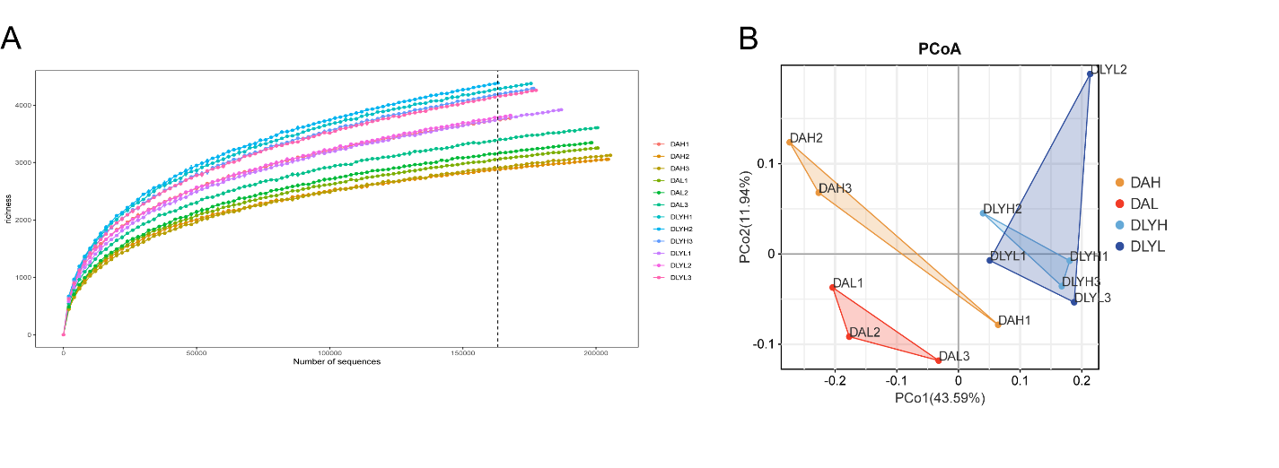
Fig S1. Rarefaction curves and β-diversity analysis. (A) a Rarefaction curves for richness in all samples. (B) Principal co-ordinates analysis (PCoA) based on Bray-Curtis distance.

Fig S2. Identification of the biomarker for each group by LEfSe at (A) genus level and (B) species level.

Fig S3. Differential species between (A) DAH group and DAL group, (B) DLYH group and DLYL group.

Fig S4. Orthogonal projection to latent structure-discriminant analysis (OPLS-DA) of metabolite composition in the four groups.

Fig S5. Expression of inflammatory factors in the colonic mucosa of (A) Ding’an pigs and (B) DLY pigs.

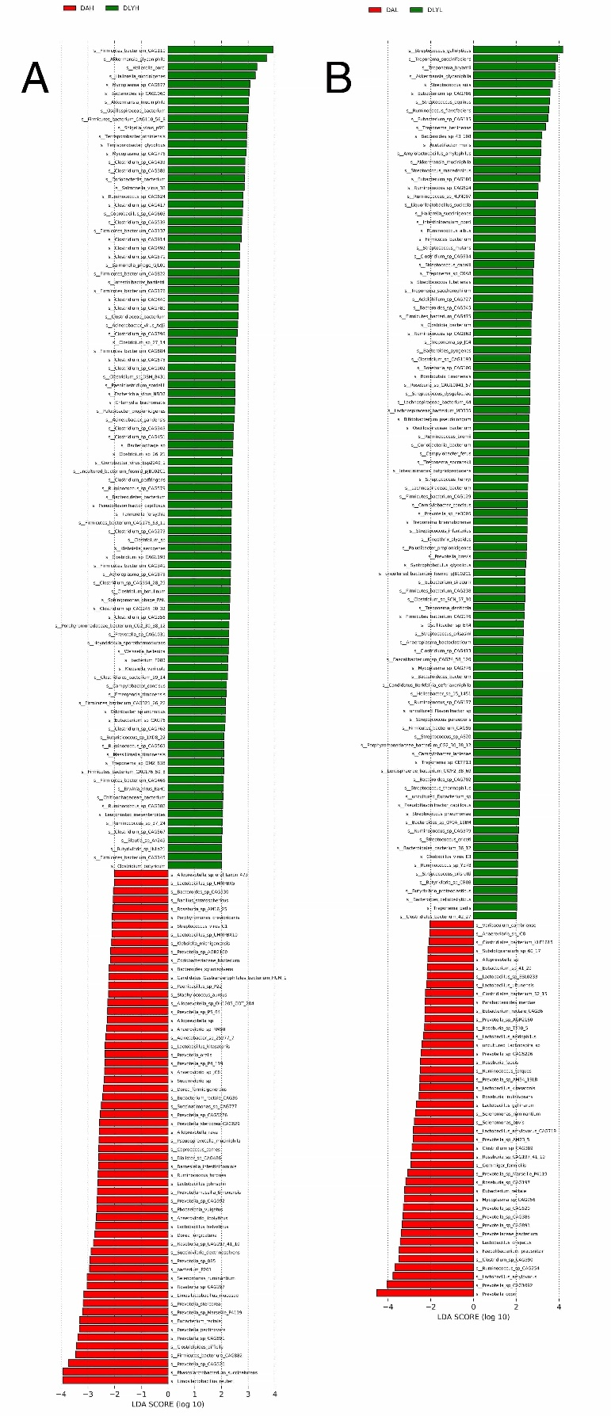
Fig S6. Differential species between (A) DAH group and DLYH group, (B) DAL group and DLYL group.

Fig S7. The relative abundance of propionate and butyrate-producing bacteria in the four groups.

