Supplementary material

DNA-hypomethylation in the TNF-alpha gene predicts rheumatoid arthritis classification in patients with early inflammatory symptoms.

R Pitaksalee ¹ ORCID 0000-0002-6488-2108
F Shuweihdi ² ORCID 0000-0003-1199-2992
R Parmar ¹ ORCID 0000-0002-8002-6440
P Emery ¹⁻³ ORCID 0000-0002-7429-8482
F Ponchel ¹ ORCID 0000-0002-3969-7701

Address
1. Leeds Institute of Rheumatic and Musculoskeletal Medicine, University of Leeds, Leeds, UK
2. Leeds Institute of Health Sciences. University of Leeds, School of Medicine.
3. NIHR Leeds Biomedical Research Centre, Leeds Teaching Hospitals NHS Trust, Leeds, UK

*Corresponding author: Frederique Ponchel
Leeds Institute of Rheumatic and Musculoskeletal Medicine,
St James Hospital, CSB, room 5.25
University of Leeds,
Leeds, UK., Leeds LS9 7TF,
UK.
+447577431861.
F.Ponchel@leeds.ac.uk.

SUP Table 1 : datasets used for the selection of CpG candidates
Dataset ID | Cells type | samples | technology
GSE121192 | - Naïve CD4 T-cells  - Memory CD4+Tcells  - Monocytes | 6 HC,  10 early RA | 450K bead array
GSE71841 | CD4+T-cell | 12 HC | 450K bead array
GSE35069 | CD4+T-cells,  CD8+T-cells,  NK cells,  B-cells,  Monocytes,  Neutrophil,  Eosinophil,  Granolocytes | 6 HC | 450K bead array
GSE71841 | CD4+T-cell | 12 HC,  12 RA | 450K bead array
GSE 111942 | PBMC | 18 HC,  25 RA | 450K bead array
GSE 87095 | B-cells | 73 HC,  49 RA | 450K bead array
GSE 117929 | PBMC | 19 HC, | 450K bead array
GSE 82218 | PBMC | 25 HC, | 450K bead array
GSE 88824 | WB | 14 HC, | 450K bead array
Personal communication | Naïve CD4+T-cells  Monocytes,  B-cells | 31 HC,  63 RA | 450K bead array

SUP Table 2 : Top ranking of CpG candidate
Selection strategy 1
Selection of candidate CpG |  | Naïve CD4+T-cells$ |  |  |  | Other lymphocytes  Median β-value * |  |  |  | Other Whole blood cell types  Median β-value (%)*
CpG | Gene | Medianβ-value  HC$ | Medianβ-value RA$ | Δβ-value $ | p-value$ | CD4+T-  in HC | CD8+T-  in HC | B-cells  in HC | NK-cells  in HC | Mono  in HC$ | Mono  in RA$ | Neutrophil  in HC | Eosinophil  in HC | Granolocytes  in HC
cg17741993 | TNF | 0.53 | 0.30 | -0.22 | 0.0005 | 0.27 | 0.34 | 0.43 | 0.17 | 0.87 | 0.90 | 0.86 | 0.90 | 0.84
cg16379091 | IFITM1 | 0.57 | 0.37 | -0.20 | 0.0002 | 0.60 | 0.46 | 0.88 | 0.44 | 0.90 | 0.89 | 0.89 | 0.90 | 0.87
cg13681468 | GPRIN3 | 0.49 | 0.17 | -0.32 | 0.0005 | 0.44 | 0.35 | 0.84 | 0.33 | 0.90 | 0.92 | 0.90 | 0.91 | 0.88
cg03718883 | INS-IGF2 | 0.59 | 0.35 | -0.24 | 0.0004 | 0.59 | 0.59 | 0.79 | 0.70 | 0.82 | 0.83 | 0.84 | 0.85 | 0.84
cg05246522 | KSR1 | 0.39 | 0.17 | -0.22 | 0.0002 | 0.38 | 0.32 | 0.45 | 0.27 | 0.84 | 0.82 | 0.72 | 0.50 | 0.80
cg20105257 | HLA-E | 0.45 | 0.25 | -0.20 | 0.0002 | 0.42 | 0.30 | 0.89 | 0.64 | 0.98 | 0.98 | 0.96 | 0.97 | 0.94
cg00759807 | LOC100287036 | 0.57 | 0.37 | -0.19 | 0.0003 | 0.37 | 0.42 | 0.53 | 0.39 | 0.94 | 0.93 | 0.93 | 0.94 | 0.89
cg27183791 | ANKRD11 | 0.50 | 0.32 | -0.18 | 0.0000 | 0.25 | 0.14 | 0.69 | 0.07 | 0.82 | 0.77 | 0.76 | 0.77 | 0.79
cg05784862 | KSR1 | 0.36 | 0.18 | -0.18 | 0.0006 | 0.37 | 0.33 | 0.46 | 0.30 | 0.80 | 0.77 | 0.71 | 0.57 | 0.74
cg02231590 | ITM2C | 0.54 | 0.37 | -0.18 | 0.0001 | 0.51 | 0.42 | 0.06 | 0.46 | 0.84 | 0.82 | 0.81 | 0.83 | 0.82
cg00576086 | TERT | 0.55 | 0.38 | -0.17 | 0.0001 | 0.66 | 0.35 | 0.81 | 0.57 | 0.84 | 0.83 | 0.86 | 0.86 | 0.83
cg25256924 | PTPRCAP | 0.39 | 0.24 | -0.15 | 0.0009 | 0.31 | 0.33 | 0.55 | 0.44 | 0.88 | 0.88 | 0.77 | 0.74 | 0.80
cg17851795 | PBX2 | 0.59 | 0.45 | -0.15 | 0.0005 | 0.66 | 0.59 | 0.76 | 0.71 | 0.83 | 0.82 | 0.80 | 0.80 | 0.79
cg12669088 | KRAS | 0.39 | 0.24 | -0.14 | 0.0008 | 0.43 | 0.39 | 0.61 | 0.40 | 0.86 | 0.85 | 0.74 | 0.39 | 0.81
cg05299836 | BCKDK | 0.46 | 0.32 | -0.14 | 0.0005 | 0.54 | 0.47 | 0.52 | 0.49 | 0.83 | 0.82 | 0.81 | 0.80 | 0.78
cg01260502 | GIMAP7 | 0.32 | 0.18 | -0.14 | 0.0007 | 0.55 | 0.44 | 0.84 | 0.69 | 0.91 | 0.90 | 0.91 | 0.91 | 0.90
cg03050965 | S1PR1 | 0.57 | 0.44 | -0.13 | 0.0002 | 0.69 | 0.52 | 0.78 | 0.49 | 0.84 | 0.83 | 0.80 | 0.82 | 0.79
cg23660197 | MICB | 0.49 | 0.37 | -0.12 | 0.0003 | 0.53 | 0.39 | 0.75 | 0.46 | 0.81 | 0.78 | 0.75 | 0.73 | 0.77
cg04618171 | HPCAL1 | 0.35 | 0.23 | -0.12 | 0.0001 | 0.66 | 0.71 | 0.93 | 0.87 | 0.92 | 0.92 | 0.92 | 0.92 | 0.92
cg20703928 | NCK2 | 0.24 | 0.12 | -0.12 | 0.0006 | 0.44 | 0.36 | 0.83 | 0.67 | 0.93 | 0.93 | 0.89 | 0.92 | 0.89
cg06813419 | TRAF5 | 0.54 | 0.43 | -0.10 | 0.0007 | 0.64 | 0.55 | 0.61 | 0.76 | 0.93 | 0.93 | 0.93 | 0.94 | 0.92
cg23149454 | PDE2A | 0.56 | 0.47 | -0.10 | 0.0002 | 0.57 | 0.44 | 0.76 | 0.55 | 0.88 | 0.88 | 0.86 | 0.89 | 0.84
cg14885762 | SEPT9 | 0.25 | 0.16 | -0.09 | 0.0006 | 0.46 | 0.41 | 0.12 | 0.64 | 0.83 | 0.82 | 0.84 | 0.81 | 0.83
cg15350899 | BCL9L | 0.28 | 0.21 | -0.07 | 0.0006 | 0.50 | 0.36 | 0.81 | 0.54 | 0.81 | 0.79 | 0.79 | 0.81 | 0.77
cg14665366 | GPRIN3 | 0.14 | 0.08 | -0.07 | 0.0007 | 0.28 | 0.18 | 0.86 | 0.29 | 0.94 | 0.92 | 0.90 | 0.90 | 0.88
cg01105418 | ZBTB18 | 0.40 | 0.59 | 0.19 | 0.0002 | 0.80 | 0.73 | 0.58 | 0.87 | 0.83 | 0.81 | 0.82 | 0.71 | 0.83

Selection strategy 2
Selection of candidate CpG |  | Naïve CD4+T-cells$ |  |  |  |  | Other lymphocytes  Median β-value * |  |  |  |  |  | Other Whole blood cell types  Median β-value (%)*
CpG | Gene | Medianβ-value HC$ |  | Medianβ-value RA$ | Δβ-value $ | p-value$ | CD4+T-  in HC | CD8+T-  in HC | B-cells  in HC |  | NK-cells  in HC |  | Mono  in HC$ |  | Mono  in RA$ | Neutrophil  in HC | Eosinophil  in HC | Granolocytes  in HC
cg15058210 | HDAC4 |  | 0.53 | 0.35 | -0.19 | 0.0001 | 0.43 | 0.32 |  | 0.64 |  | 0.26 |  | 0.10 | 0.09 | 0.06 | 0.05 | 0.06
cg15978561 |  |  | 0.25 | 0.12 | -0.14 | 0.0005 | 0.24 | 0.20 |  | 0.59 |  | 0.19 |  | 0.04 | 0.04 | 0.05 | 0.05 | NA
cg05903736 |  |  | 0.33 | 0.21 | -0.12 | 0.0004 | 0.33 | 0.29 |  | 0.59 |  | 0.27 |  | 0.12 | 0.11 | 0.07 | 0.06 | 0.06
cg12054453 | MIR21 |  | 0.22 | 0.11 | -0.11 | 0.0019 | 0.23 | 0.19 |  | 0.47 |  | 0.10 |  | 0.20 | 0.17 | 0.38 | 0.32 | 0.39
cg24174557 |  |  | 0.32 | 0.21 | -0.11 | 0.0004 | 0.33 | 0.32 |  | 0.17 |  | 0.28 |  | 0.30 | 0.27 | 0.32 | 0.39 | 0.29
cg16936953 |  |  | 0.40 | 0.20 | -0.20 | 0.0013 | 0.33 | 0.36 |  | 0.55 |  | 0.25 |  | 0.37 | 0.36 | 0.61 | 0.62 | 0.64
cg02835823 | IRF8 |  | 0.28 | 0.42 | 0.14 | 0.0007 | 0.60 | 0.45 |  | 0.07 |  | 0.41 |  | 0.63 | 0.65 | 0.80 | 0.84 | 0.79
cg16853860 | PSMB9 |  | 0.72 | 0.51 | -0.21 | 0.0071 | 0.58 | 0.38 |  | 0.55 |  | 0.37 |  | 0.74 | 0.68 | 0.70 | 0.63 | 0.71
cg26427498 | NAMPT |  | 0.38 | 0.20 | -0.19 | 0.0035 | 0.32 | 0.24 |  | 0.67 |  | 0.23 |  | 0.05 | 0.04 | 0.05 | 0.04 | 0.04
cg08752433 | PPTC7 |  | 0.74 | 0.56 | -0.18 | 0.0021 | 0.58 | 0.49 |  | 0.68 |  | 0.47 |  | 0.62 | 0.66 | 0.41 | 0.27 | 0.39
cg01106881 | DNPEP |  | 0.49 | 0.32 | -0.17 | 0.0011 | 0.34 | 0.23 |  | 0.24 |  | 0.11 |  | 0.06 | 0.05 | 0.09 | 0.10 | 0.06
cg22077313 | S100P |  | 0.61 | 0.44 | -0.17 | 0.0001 | 0.47 | 0.29 |  | 0.72 |  | 0.19 |  | 0.37 | 0.35 | 0.20 | 0.21 | 0.18
cg13064571 | C8orf44 |  | 0.54 | 0.39 | -0.15 | 0.0012 | 0.48 | 0.50 |  | 0.70 |  | 0.23 |  | 0.18 | 0.20 | 0.10 | 0.06 | 0.07
cg00004667 | ZBTB17 |  | 0.26 | 0.11 | -0.15 | 0.0002 | 0.25 | 0.18 |  | 0.03 |  | 0.14 |  | 0.05 | 0.05 | 0.06 | 0.07 | 0.04
ch.2.207814544R | KLF7 |  | 0.31 | 0.16 | -0.14 | 0.0001 | 0.25 | 0.25 |  | 0.02 |  | 0.04 |  | 0.04 | 0.04 | 0.04 | 0.03 | 0.04
ch.2.105901354F | NCK2 |  | 0.34 | 0.21 | -0.13 | 0.0013 | 0.30 | 0.30 |  | 0.02 |  | 0.04 |  | 0.02 | 0.02 | 0.04 | 0.03 | 0.03
cg20388732 | STAT5A |  | 0.27 | 0.14 | -0.13 | 0.0075 | 0.31 | 0.11 |  | 0.26 |  | 0.09 |  | 0.05 | 0.05 | 0.06 | 0.05 | 0.06
cg03206537 | NEURL2 |  | 0.43 | 0.31 | -0.12 | 0.0005 | 0.39 | 0.30 |  | 0.40 |  | 0.24 |  | 0.28 | 0.27 | 0.16 | 0.08 | 0.17
ch.13.39564907R | LINC00332 |  | 0.26 | 0.16 | -0.10 | 0.0003 | 0.25 | 0.25 |  | 0.04 |  | 0.05 |  | 0.04 | 0.04 | 0.06 | 0.05 | 0.05
cg17002328 | CCDC88C |  | 0.71 | 0.82 | 0.10 | 0.0091 | 0.85 | 0.76 |  | 0.20 |  | 0.71 |  | 0.85 | 0.84 | 0.83 | 0.79 | 0.85
cg23458168 | ZNF536 |  | 0.46 | 0.58 | 0.12 | 0.0072 | 0.69 | 0.59 |  | 0.56 |  | 0.49 |  | 0.43 | 0.52 | 0.45 | 0.44 | 0.48
cg20793665 | PTMA |  | 0.34 | 0.47 | 0.13 | 0.0057 | 0.56 | 0.50 |  | 0.33 |  | 0.80 |  | 0.88 | 0.83 | 0.84 | 0.87 | 0.86

$ our dataset published (1) CpG in bold are those taken forward for qMSP assay development.

SUP figure 1 : Structure of the DNA region surrounding the candidate CpG in the TNF gene. a) from our dataset comparing naïve and memory CD4+T-cell and monocyte in HC and RA, and b) in various blood cell types in health.
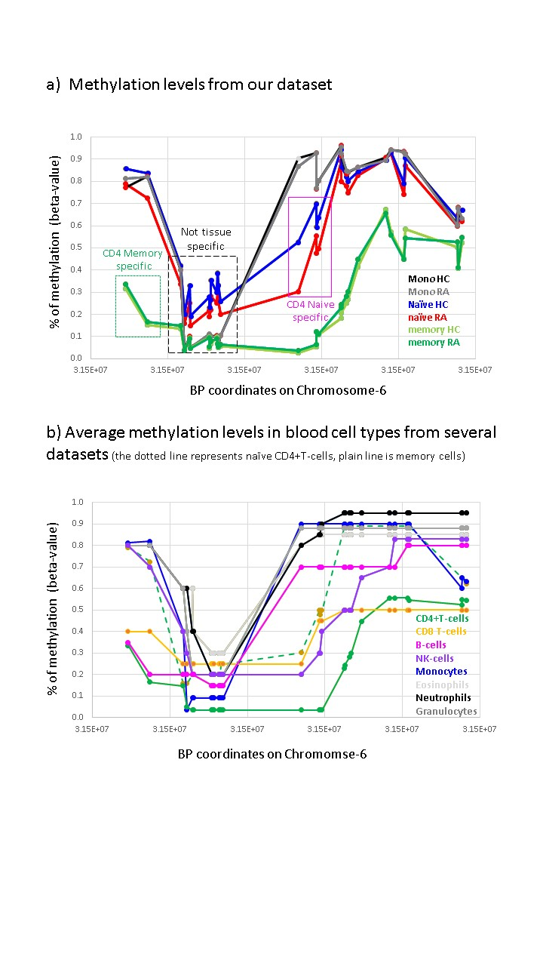

Detailed of DNA preparation
Genomic DNA was extracted using a silica-membrane-based DNA purification kit (QIAamp DNA Blood Mini Kit), according to the manufacturer’s protocol. Briefly, cell pellets were re-suspended in 200 uL PBS and 20 uL of Proteinase K were added, followed by 200 uL of lysis buffer (Buffer AL) and incubated at 56ºC for 10 min. DNA was precipitated by adding 200 uL of pure ethanol. The sample was transferred to a QIAamp Mini spin column and centrifuged to separate the supernatant at 15000g for 1 min (used for all centrifugations). The DNA, adsorbed on the QIAamp silica membrane in the column was washed twice (wash Buffer AW1 and Buffer AW2), to remove any residual contaminants. Purified DNA was then eluted (Buffer AE) for 10 min before and centrifuged out of the QIAamp Mini spin column. DNA quality and concentration were asserted using a spectrophotometer (ND1000). An absorbance ratio (OD280/OD260) at 1.8 – 2 was accepted as pure DNA.
Detailed Bisulfite conversion of genomic DNA
To differentiate between methylated and un-methylated cytosine by PCR, bisulfite conversion of the DNA is necessary to differentiate unmethylated-cytosine turned into Uracil while keeping methylated-cytosine untouched. Bisulfite conversion was performed using the EZ DNA Methylation-Gold Kit (Zymo Research) following the manufacturer’s protocol. Briefly, 500 ng of genomic DNA ( adjusted to 20 uL) and 130 uL of the CT conversion reagent were mixed in PCR tubes and placed into a Thermal Cycler (Techne™ TC-512 Gradient Thermal Cycler, Bibby Scientific) programmed at 98 ºC for 10 min and then at 64ºC for 2.5 h. Samples were then transferred to the Zymo-Spin™ IC Column containing 600 uL of binding buffer and centrifuge (10000 g for 30 sec) before desulphonation and clean-up by adding 200 uL of desulphonation buffer followed by several washing and centrifugation steps. Pure Bisulfite-converted DNA was eluted from the column matrix with 20 uL of Elution Buffer and used for methylation analysis. The quantity of DNA after bisulfite converted was measured again by nanodrop.

Detailed Primer design for qMSP
Designing the qPCR assay then relies on the same principles as other fluorescent-probe based assay, using primers to ensure specificity of the PCR product and a probe to quantify it. TaqMan® MGB Probe and primer set were designed using Primer Express Software v2.0. Two types of reactions are needed for a qMSP quantitative assay, one for the methylation-dependent CpG of interest and one for a methylation-independent CpG for a control gene used for normalization.
For the gene of interest, primers were designed to amplify a region next to the candidate CpG site to be tested, according to qPCR primer design guidelines (2-5). Both the sense or antisense DNA strands could be used for designing primers/probes. First, the genomic DNA sequence of candidate regions was obtained from UCSC or NCBI database (using Human Genome Assembly GRCh37.p13). The sequence was then bisulfite converted in silico, using the sequence manipulating function in the online platform, MethPrimer 2.0.
For the candidate CpG, the primer sequences were manually edited to obtain the best Tm (59-60 ºC), positioning the candidate CpG site at 3’ end of a primer (either F or R), for a length of the PCR product of ~100 pb, avoiding self-dimers/hairpins or primer-dimers. A probe was also designed to encompass CpG sites where possible. The PCR product was checked in silico to ensure the specificity to the gene of interest (absence of homology with other sequences after bisulfite-conversion of genomic DNA), using the blasting function of the Bisearch primer-design and search tool.
For the internal control, the qMSP primers should amplify bisulfite modified DNA independently of its methylation status. Primers/probes were therefore designed to avoid CpG sites.
All primers were synthesised by Thermo Fisher Scientific, reconstituted to a concentration of 100 uM in sterile water. TagMan custom probe-MGBNFQ were synthesised by Applied Biosystems reconstituted to a concentration of 2.5 uM in sterile water. Primers and probe were aliquoted stored at -20ºC. The details of each design are described in the results sections.

Detailed qMSP assay optimisation
The development of qMSP assays starts with reactions optimisation which was done using both 100% methylated and 100% unmethylated control-DNA. qPCR conditions were optimised using a standard PCR mixture as recommend by manufacturer’s instructions for TaqMan™ Universal Master Mix-II, varying the concentration of F and R primers. The reaction were performed in the Applied Biosystems™ QuantStudio™ 5 Real-Time PCR System. In order to ensure the specificity (methylated/unmethylated DNA) and efficiency (equivalent yield for each PCR product), each assay was optimised varying primer concentrations from 50-900 nM, Primers being the main factor affecting the efficiency of the qPCR reaction. For this, reactions were set up varying primer concentrations and directly compared using Cts between assays. A dilution series of the template DNA (0.2 to 50 ng) was then used to compare efficiencies of the different assays. The Optimized assay was then used to quantify methylation of the target locus in genomic DNA from patient samples.

Detailed assay discussion
qMSP assay permits the use of blood (or other mixed tissue) as biological template, but this imposed a number of conditions on the suitability of the candidate CpG. The ideal situation would require the methylation status of the candidate CpG in the target cells (here demethylated in CD4+T-cells) to be different from the status in all other cell types (ie fully methylated in all non-CD4+T-cells). This restricts considerably the number of candidates which also need to be differentially methylated in samples between the outcome of interest and its alternative. The dataset to search for candidate CpG sites was generated in naïve CD4+T-cells identified > 3000? differentially methylated CpGs (1). The TNF candidate gene appeared highly relevant to RA and we previously confirmed lower methylation in early RA using sequencing (1). The CpG chosen was in a wider region that is demethylated in T-cells (naïve and memory), while not in monocytes and with mixed pattern in other cell types. The dilution of signal comparing purified CD4+T-cells to PBMC and WB suggests that the higher % of methylation observed results from loss of signal due to methylation in non-CD4+T-cells, while the Δβ-value is still sufficiently sensitive in PBMC over purified cells, while no longer in WB. IRF8 and IFIMT1 were selected due to their potential role of IFN-related signalling in pre-RA at the gene expression levels (6, 7)and MIR21 for its differential expression in pre-RA (8) and the abundant literature associating it with RA (9-13), however, designing assays was not successful for the specific CpG chosen for MIR21 and unsatisfactory for IRF8. For the HDAC4 qMSP, observations during optimisation suggest that the type of DNA template impacted the quantification and the limited Δβ -value between HC and RA in PBMC, suggests that this may also be modulated in other cells types, explaining the loss of signal. This is biologically relevant considering the role of the HDAC4 gene in epigenetic remodelling, while it prevent this candidate to be a biomarker. Altogether, our data demonstrate that analysing the DNA region around the candidate CpG is critical to the design of the assays, while considering various blood cell-types methylation patterns will define the type of material that can be used.

SUP Table 3 : qMSP assay primer and probe details

Gene | Position | F/R/Probe | sequence | Product size
TNF | Chr 6:  31,543,091-31,543,211 | F 5' to 3' | TTTCGGAATCGGAGTAGGGAG | 121
TNF | Chr 6:  31,543,091-31,543,211 | R 5' to 3' | ACCCTACACCTTCTATCTCGATTTCTT
TNF | Chr 6:  31,543,091-31,543,211 | Probe | TCGTTTTCGCGATGGAG
HDAC4 | Chr 2:  240,196,872-240,196,954 | F 5' to 3' | TGGGTCGAAGTTATTTTAGGTTTTTAGT | 83
HDAC4 | Chr 2:  240,196,872-240,196,954 | R 5' to 3' | AACGACTTACCAAAAACAACCTCAA
HDAC4 | Chr 2:  240,196,872-240,196,954 | Probe | TAGATTATTAGGTCGCGTAGGTT
IRF8 (V.1) | Chr 16:  85,979,046-85,979,116 | F 5' to 3' | TGAAGTAGTAGTTTCGGTATTGGGTTT | 71
IRF8 (V.1) | Chr 16:  85,979,046-85,979,116 | R 5' to 3' | ACCAACCCACGCCAAAAA
IRF8 (V.1) | Chr 16:  85,979,046-85,979,116 | Probe | TAGTGGAGATCGGGAATGA
IRF8 (V.2) | Chr 16:  85,979,046-85,979,126 | F 5' to 3' | TGAAGTAGTAGTTTCGGTATTGGGTTT | 81
IRF8 (V.2) | Chr 16:  85,979,046-85,979,126 | R 5' to 3' | CTACGTCCTTACCAACCCACG
IRF8 (V.2) | Chr 16:  85,979,046-85,979,126 | Probe | TAGTGGAGATCGGGAATGA
GAPDH | Chr 12:  6,645,449-6,645,570 | F 5' to 3' | TTGGGTAGTTTTGGAGTTTTTAGTTG | 122
GAPDH | Chr 12:  6,645,449-6,645,570 | R 5' to 3' | AATACAACATCTCCTTACCCCCAA
GAPDH | Chr 12:  6,645,449-6,645,570 | Probe | AGTTAGGTTAGTTTGGTAGGGAA

SUP Table 4 : qMSP final condition

Final Taq-man qMSP reaction composition and cycling conditions.

SUP data : qMSP calibration
The relative level of methylation in the target gene was measured using Ct value of each reactions (target and internal control). It is presented as a percentage of methylation (%). A calibrator is included one ach PCR plate to ensure reproducibility between all experiments due to the large number of samples analyzed over time. The formula to calculate this is as followed.

Percentage of methylation (%) = Relative level of methylation x 100
= 2 ^{-ΔΔCt} x 100
where
ΔCt sample = Ct _{sample} target gene - Ct _{sample} internal control
ΔCt calibrator = Ct _{calibrator} target gene - Ct _{calibrator} internal control
ΔΔCt = ΔCt sample - ΔCt calibrator

Sample DNA template from an individual patient after bisulfite converted.
Calibrator Control DNA template 100% methylated and bisulfite converted
Target gene is the gene of interest for the assay (for example the TNF gene) at the CpG chose for the assay development with expected change in methylation status
Internal control is the GAPDH gene used for normalization from a region independent of any methylation change

SUP Figure 2 : % of methylation for the HDAC4 qMSP in CD4+T-cells and PBMC.
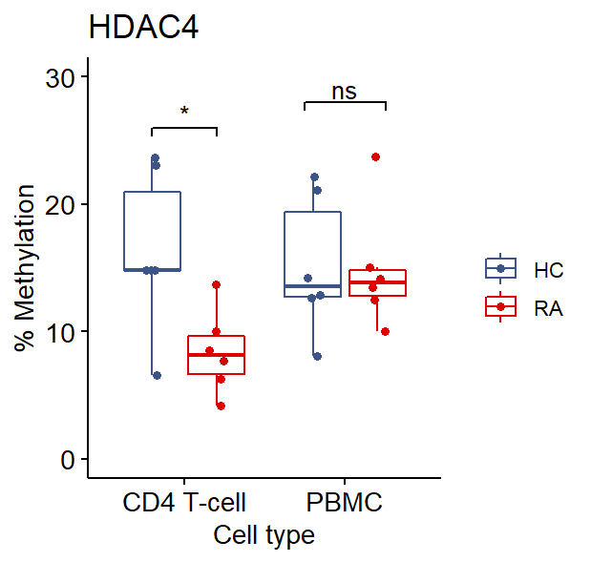
Boxplot of the % of methylation of the HDAC4 qMSP in CD4+T-cells or PBMC in early RA (red, n=6) and healthy control (blue, n=6). * p<0.05. NS not significant.

SUP Figure 3 : HDAC4-qMSP data

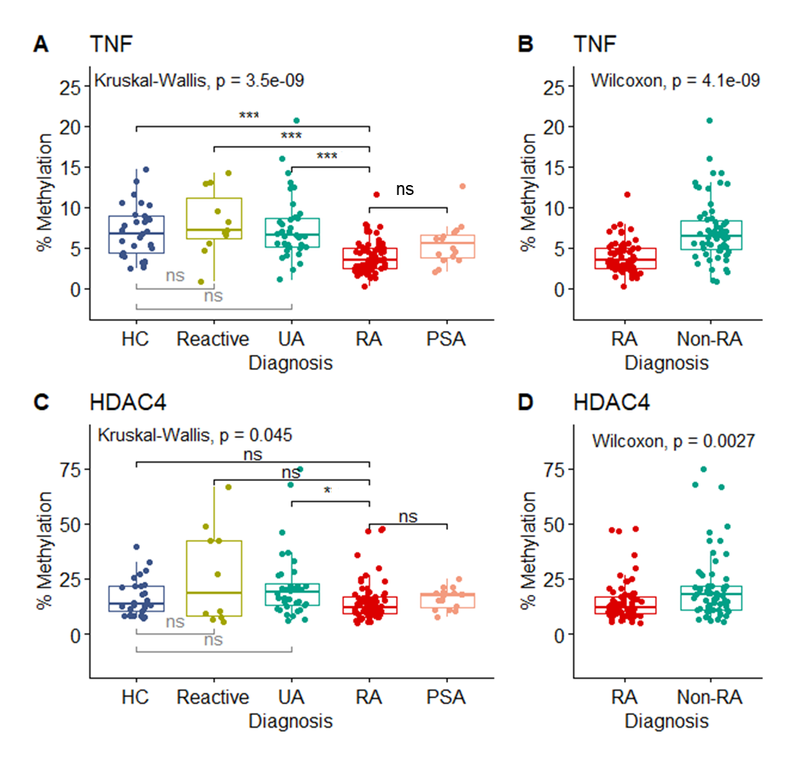

Boxplot of the % of methylation observed using the HDAC4 qMSP in PBMC from IACON patients (n=127). *p<0.05, NS not significant. Comparing RA to non-RA, % methylation were lower in RA (p=0.0027).
SUP Table 5 : Patient characteristics in the combined dataset IACON + RADAR (top section) and in ACPA-negative patients (bottom section).
All patients (n=284) | RA  (n=190) | Non-RA  (n=94) | MWT  or chi2  p-value | OR  p-value | AUC  (95%CI)
TNF methylation levels* | 3.26 [2.48;4.37] | 6.16 [4.77;7.92] | 1.96 x 10⁻¹⁹ | 0.54 [0.46; 0.64]  p = 5.57 x 10⁻¹³ | 0.171  (0.115-0.227)
TNF high risk  n (%) | 150 (78.9%) | 18 (19.1%) | <2.2 x 10⁻²² | 15.8 [8.51;29.5]  p = 1.0 x 10⁻¹⁶ | 0.799  (0.750 - 0.848)
Age (years)* | 58.5 [49.0;70.0] | 45.0 [34.0;52.0] | 8.93 x 10⁻¹² | 1.06 [1.04;1.08]  p = 3.88 x 10⁻¹⁰ | 0.749  (0. 689,0.808)
Female fender  n (%) | 137 (72.1%) | 65 (69.1%) | 0.7053 | 1.15 [0.67;1.98]  p = 0.6052 | 0.515  (0.458,0.572)
Symptoms duration (months)* | 5.73 [3.21;11.9] | 6.00 [3.00;11.9] | 0.8103 | 0.99 [0.97;1.01]  p = 0.2780 | 0.507  (0.434,0.579)
Smokers  n (%) | 115 (62.5%) | 42 (47.7%) | 0.0295 | 2.17 [1.31;3.59]  p = 2.55 x 10⁻³ | 0.595  (0.534,0. 656)
RF positive  n (%) | 99 (52.7%) | 10 (10.9%) | 3.95 x 10⁻¹¹ | 9.53 [4.66;19.5]  p = 4.20 x 10⁻¹³ | 0.713  (0.665 - 0.76)
ACPA positive n (%) | 108 (58.4%) | 8 (8.60%) | 5.6 x 10⁻¹⁵ | 14.5 [6.64;31.5]  p = 1.0 x 10⁻¹⁶ | 0.744  (0.699 - 0.789)
Tender joint count* | 9.50 [3.25;15.8] | 3.00 [1.00;7.00] | 3.55 x 10⁻⁷ | 1.11 [1.06;1.15]  p = 2.06 x 10⁻⁶ | 0.703  (0. 637 - 0.768)
Swollen joint count* | 4.50 [2.00;9.00] | 1.00 [0.00;4.00] | 4.79 x 10⁻⁸ | 1.22 [1.13;1.32]  p = 1.05 x 10⁻⁶ | 0.7122  (0.52 - 0.772)
CRP (mg/L)* | 11.3 [0.00;24.0] | 2.50 [0.00;11.7] | 0.0002 | 1.03 [1.01;1.05]  p =7.82 x 10⁻⁴ | 0.647  (0.583 - 0.712)
DAS28* | 4.57 [3.51;5.49] | 3.30 [2.37;4.10] | 5.62 x 10⁻⁹ | 2.01 [1.62;2.51]  p = 4.20 x 10⁻¹⁰ | 0.751  (0. 692 - 0.809)
ACPA negative patients (n=167) | RA  (n=81) | Non-RA  (n=86) | MWT  or chi2  p-value | OR  p-value | AUC  (95%CI)
TNF methylation levels* | 3.02 [2.27;3.85] | 6.10 [4.72;7.92] | 9.8x10⁻¹⁶ | 0.45 [0.34;0.58]  p = 1.15 x 10⁻⁹ | 0.140  (0.079 - 0.201)
TNF high risk  n (%) | 70 (86.4%) | 18 (20.9%) | 1 x 10⁻¹⁶ | 24.0 [10.6;54.6]  p = 2.2x10⁻²² | 0.827  (0.770 - 0.885)
Age (years)* | 64.0 [52.0;73.0] | 45.0 [34.0;52.0] | 7.68 x 10⁻¹³ | 1.10 [1.06;1.13]  p = 6.14 x 10⁻¹⁰ | 0.821  (0.758 - 0.884)
Female fender  n (%) | 64 (79.0%) | 60 (69.8%) | 0.2346 | 1.63 [0.81;3.30]  p = 0.1782 | 0.546  (0.480 - 0.124)
Symptoms duration (months)* | 5.05 [2.75;9.63] | 6.00 [3.00;11.4] | 0.3234 | 0.99 [0.96;1.01]  p = 0.3355 | 0.544  (0.456 - 0. 632)
Smokers  n (%) | 48 (59.3%) | 38 (44.2%) | 0.0729 | 1.84 [0.99;3.40]  p = 0.0539 | 0.575  (0.5 - 0. 651)
RF positive  n (%) | 28 (34.6%) | 6 (6.98%) | 2.30 x 10⁻⁵ | 7.04 [2.73;18.2]  p = 7.95 x 10⁻⁶ | 0. 638  (0.579 - 0. 696)
Tender joint count* | 11.0 [4.00;16.0] | 3.00 [2.00;6.75] | 5.01 x 10⁻⁷ | 1.12 [1.07;1.17]  p = 4.25 x 10⁻⁶ | 0.725  (0. 645 - 0.804)
Swollen joint count* | 5.50 [2.00;11.0] | 1.00 [0.00;4.00] | 2.78 x 10⁻⁶ | 1.20 [1.10;1.30]  p = 1.84 x 10⁻⁵ | 0.708  (0. 627 - 0.789)
CRP (mg/L)* | 9.80 [0.00;21.0] | 2.50 [0.00;10.7] | 0.0017 | 1.03 [1.01;1.05]  p = 0.0047 | 0.636  (0.554 - 0.717)
DAS28* | 4.91 [3.48;5.64] | 3.12 [2.46;3.97] | 8.43 x 10⁻⁹ | 2.06 [1.57;2.69]  p = 1.46 x 10⁻⁷ | 0.758  (0.83 - 0.833)

Data are described using n (% of patients), * median (IQR). RF rheumatoid factor, ACPA anti-citrullinated peptide antibodies, TJC tender joints count, SJC swollen joints count, CRP C-reactive protein, DAS28 disease activity score 28 joints.
References
1. Pitaksalee R, Burska AN, Ajaib S, Rogers J, Parmar R, Mydlova K, et al. Differential CpG DNA methylation in peripheral naive CD4(+) T-cells in early rheumatoid arthritis patients. Clinical epigenetics. 2020;12(1):54.
2. Rodriguez A, Rodriguez M, Cordoba JJ, Andrade MJ. Design of primers and probes for quantitative real-time PCR methods. Methods Mol Biol. 2015;1275:31-56.
3. Davidović R, Božović A, Mandušić V, Krajnović M. Methylation-specific PCR: four steps in primer design. Open Life Sciences. 2014;9(12):1127-39.
4. AppliedBiosystems. Real-time PCR handbook2014. Available from: https://www.thermofisher.com/content/dam/LifeTech/global/Forms/PDF/real-time-pcr-handbook.pdf.
5. AppliedBiosystem. Designing TaqMan® MGB Probe and Primer Sets for Allelic Discrimination Assays Using Primer Express®Software 2015. Available from: https://www.thermofisher.com/document-connect/document-connect.html?url=https://assets.thermofisher.com/TFS-Assets%2FLSG%2Fmanuals%2Fcms_041902.pdf.
6. Ouyang X, Zhang R, Yang J, Li Q, Qin L, Zhu C, et al. Transcription factor IRF8 directs a silencing programme for TH17 cell differentiation. Nat Commun. 2011;2:314.
7. Yu H, Lu C, Tan MT, Moudgil KD. The gene expression profile of preclinical autoimmune arthritis and its modulation by a tolerogenic disease-protective antigenic challenge. Arthritis Res Ther. 2011;13(5):R143.
8. Ouboussad L, Hunt L, Hensor EMA, Nam JL, Barnes NA, Emery P, et al. Profiling microRNAs in individuals at risk of progression to rheumatoid arthritis. Arthritis Res Ther. 2017;19(1):288.
9. Dong L, Wang X, Tan J, Li H, Qian W, Chen J, et al. Decreased expression of microRNA-21 correlates with the imbalance of Th17 and Treg cells in patients with rheumatoid arthritis. J Cell Mol Med. 2014;18(11):2213-24.
10. Huang Z, Xing S, Liu M, Deng W, Wang Y, Huang Z, et al. MiR-26a-5p enhances cells proliferation, invasion, and apoptosis resistance of fibroblast-like synoviocytes in rheumatoid arthritis by regulating PTEN/PI3K/AKT pathway. Biosci Rep. 2019;39(7).
11. Shengwei J, Huaijun C, Yongsheng L, Hao Z, Weiwei S, Jianmin W, et al. Maresin 1 improves the Treg/Th17 imbalance in rheumatoid arthritis through miR-21. Annals of the Rheumatic Diseases. 2018;77(11):1644.
12. Deng Y, Zhou Y, Liang Q, Ge C, Yang J, Shan B, et al. Inflammation-Instructed Hierarchical Delivery of IL-4/miR-21 Orchestrates Osteoimmune Microenvironment toward the Treatment of Rheumatoid Arthritis. Advanced Functional Materials. 2021;31(33):2101033.
13. Churov AV, Oleinik EK, Knip M. MicroRNAs in rheumatoid arthritis: Altered expression and diagnostic potential. Autoimmunity Reviews. 2015;14(11):1029-37.

