Supplemental Information
Table S1. Demographic data of the study cohort
Table S2. Statistics of the whole-exome sequencing data
Table S3. Genes selected for customized panel sequencing
Table S4. Statistics of the targeted gene sequencing data
Table S5. Statistics for variants identified by targeted gene sequencing
Table S6. Mutations identified in known ALS genes
Table S7. Rare coding variants identified in PCDHA9
Table S8. Clinical features of patients with the homozygous PCDHA9 L700P mutation
Table S9. The raw electromyogram (EMG) data of the mutant and wild type mice
Table S10. Quality control of snRNA-seq
Table S11. DEGs in neuron cluster in snRNA-seq
Table S12. DARs in neuron cluster in snATAC-seq
Table S13. GRN analysis in WT and Mut mice
Table S14. Malat1 related miRNA and mRNA
Table S15. CellphoneDB analysis in WT and Mut mice

Movie 1. Unilateral paralyzed Mut mouse. The left hind limb is stiff without voluntary movement, 14-month-old.
Movie 2. Abnormal claw contractions in 10-month-old Mut mouse.

Fig. S1. Generation of Pcdha9 L729P (Mut) and M723fs (Del) mice.
Fig. S2. Neurogenic skeletal muscular atrophy in Pcdha9 Mut mice.
Fig. S3. Pcdha9 heterozygous Mut mice exhibit late-onset motor function deficits.
Fig. S4. Abnormal neuromuscular junctions (NMJs) in both Pcdha9 Mut and Del mice.
Fig. S5. Myelination is not affected significantly in the spinal cord and sciatic nerve in Mut mice.
Fig. S6. Tandem mass tag (TMT)- labeled quantitative proteomic analysis of the ventral horn spinal cord in Mut and littermate controls mice.
Fig. S7. Mutation of PCDHA9 leads to its instability and the hyper-phosphorylation of PYK2.
Fig. S8. The protein levels of NKA-β1 and NKA-α3 in the spinal cord of 12-month-old WT and Mut mice were not affected.
Fig. S9. Quality control and integration efficiency of snRNA-seq and snATAC-seq.
Fig. S10. Analysis of snRNA-seq and snATAC-seq.
Fig. S11. Feature plot of marker genes in snRNA-seq.
Fig. S12. Feature plot of marker genes in snATAC-seq.

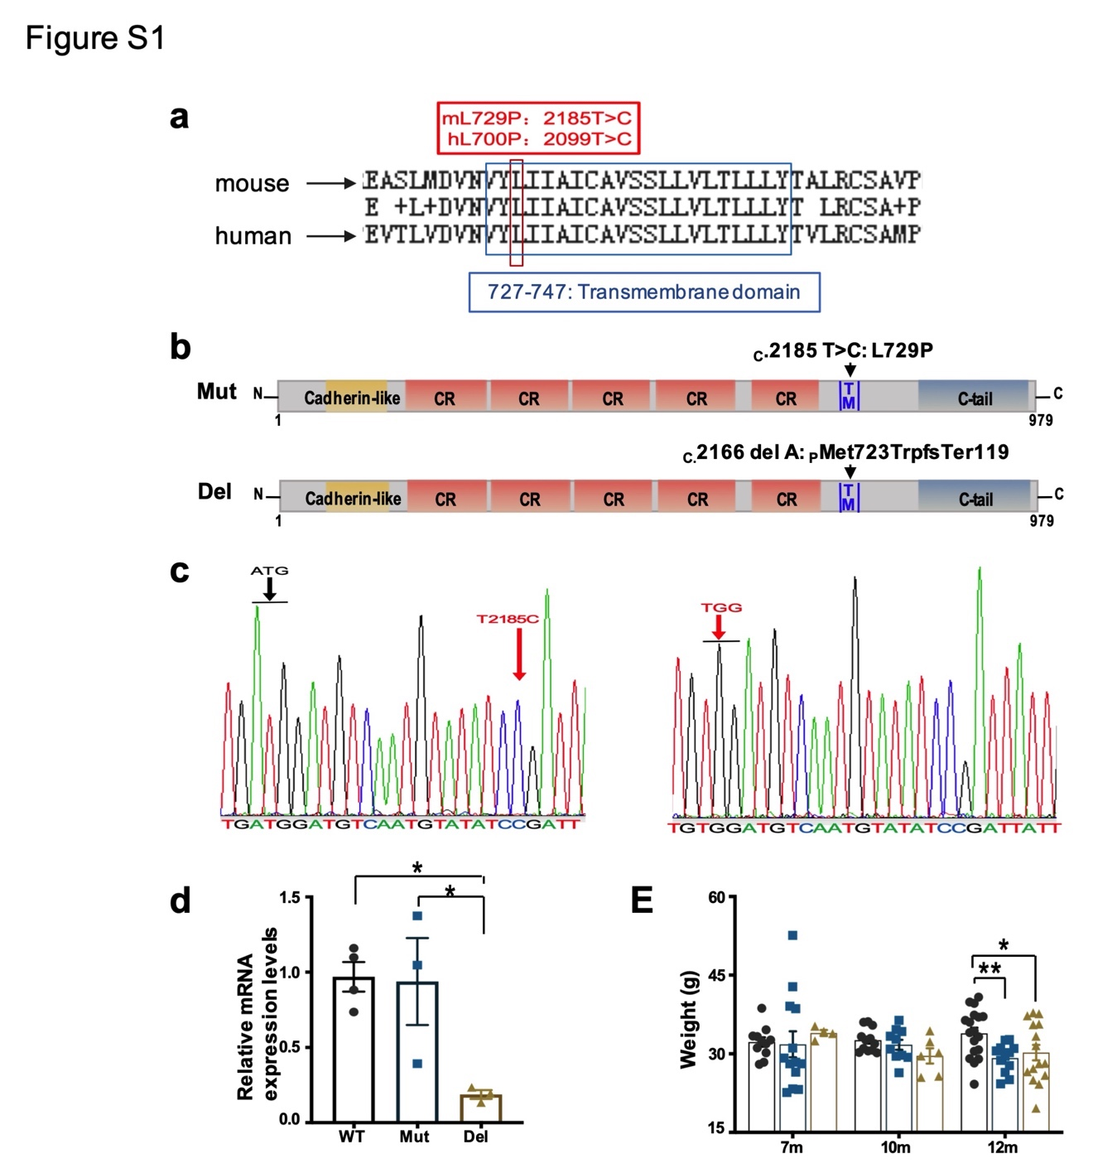

Supplementary Figure 1. Generation of Pcdha9 L729P (Mut) and M723fs (Del) mice.
(a) Conservation between mouse and human in the transmembrane domain of PCDHA9. (b) Schematic of genomes for Mut and Del mice. (c) Sequencing confirmation of T2185C (left panel) and deletion of 2166A (right panel) in mice. (d) Relative mRNA levels of Pcdha9 in the spinal cord of 6-month old female WT, Mut and Del mice by quantitative real time PCR (n=3). (e) Body weight of mice at different age. Mut and Del mice exhibited body weight loss at 12-month old (7-month old: wt, n=11; mut, n=13; del, n=4. 10-month old: wt, n=12; mut, n=10; del, n=6. 12-month old: wt, n=18; mut, n=12; del, n=15). All data represent mean ± SEM.*P < 0.05, **P < 0.01, one-way ANOVA.
(Related to Figure 2)

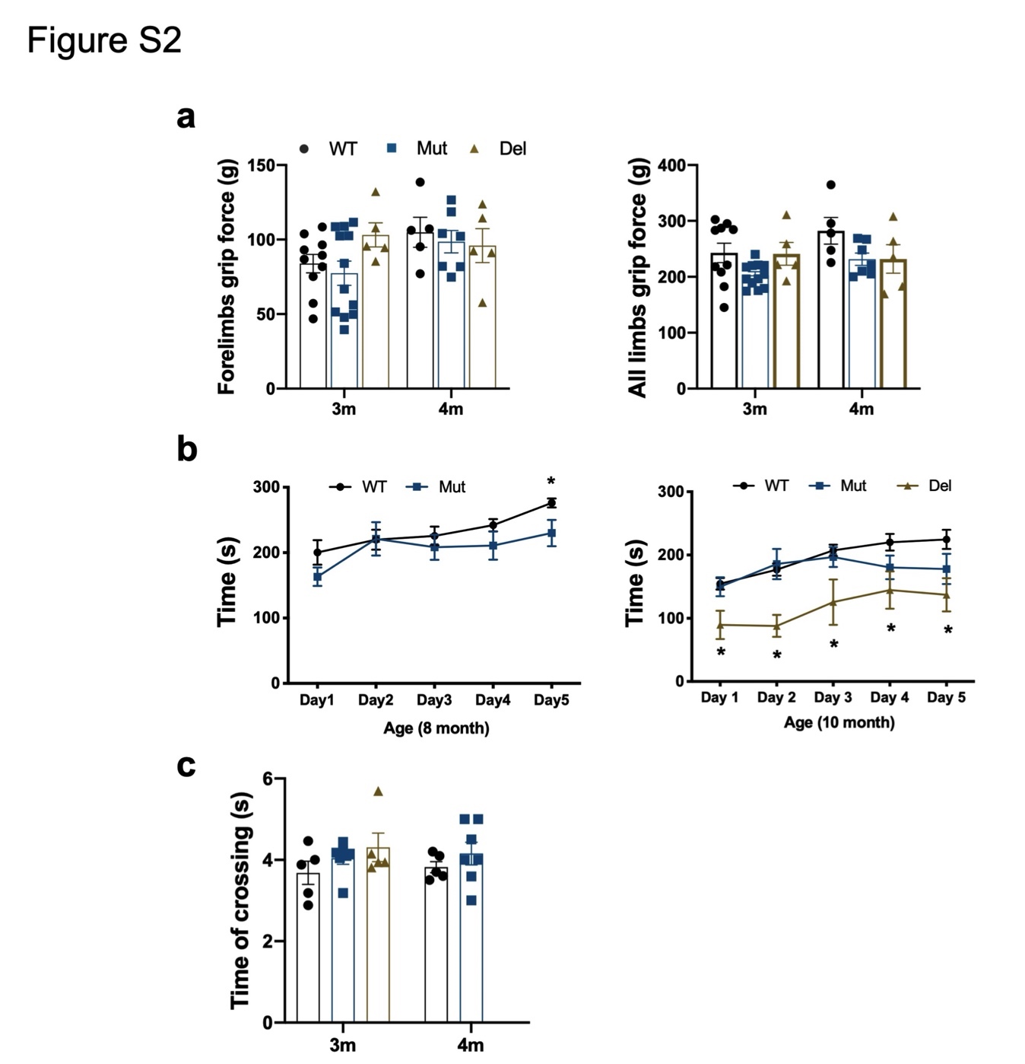

Supplementary Figure 2. Both Pcdha9 Mut and Del mice exhibit largely normal motor behaviors before 8 months old. (a) Grip force (gram) for limbs of mice at 3- and 4-month old. (b) Rota rod test performed in five consecutive days, 8 and 10 month old mice. Time until falling was analyzed. (c) Time crossing the swimming tank during the swimming test, 3 and 4 month old mice. All data represent mean ± SEM. *P < 0.05, one-way ANOVA was used in 3 groups analysis, while t-test was used in 2 group analysis.
(related to Figure 2)

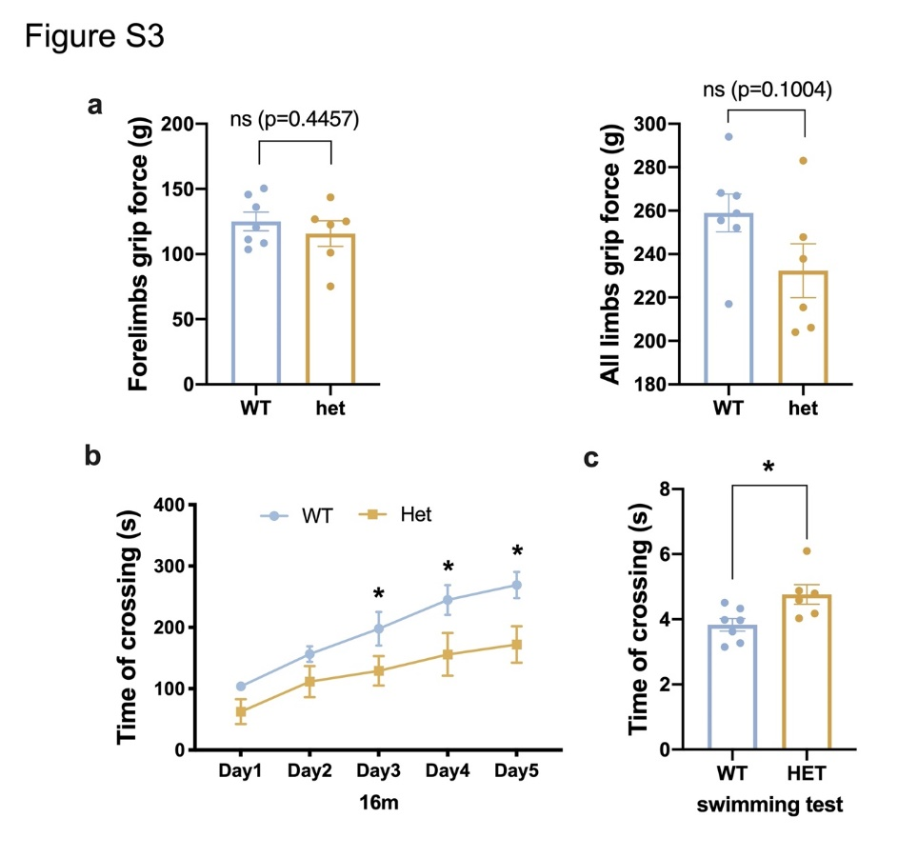
Supplementary Figure 3. Pcdha9 Mut heterozygous mice exhibit late-onset motor function deficits. (a) Grip force (gram) for limbs of mice at 16-month old. (b) Rota rod test performed in five consecutive days, 16 month old mice. Time until falling was analyzed. (c) Time crossing the swimming tank during the swimming test, 16 month old mice. All data represent mean ± SEM. *P < 0.05, t-test. WT: n=7; HET: n=6.
(related to Figure 2)

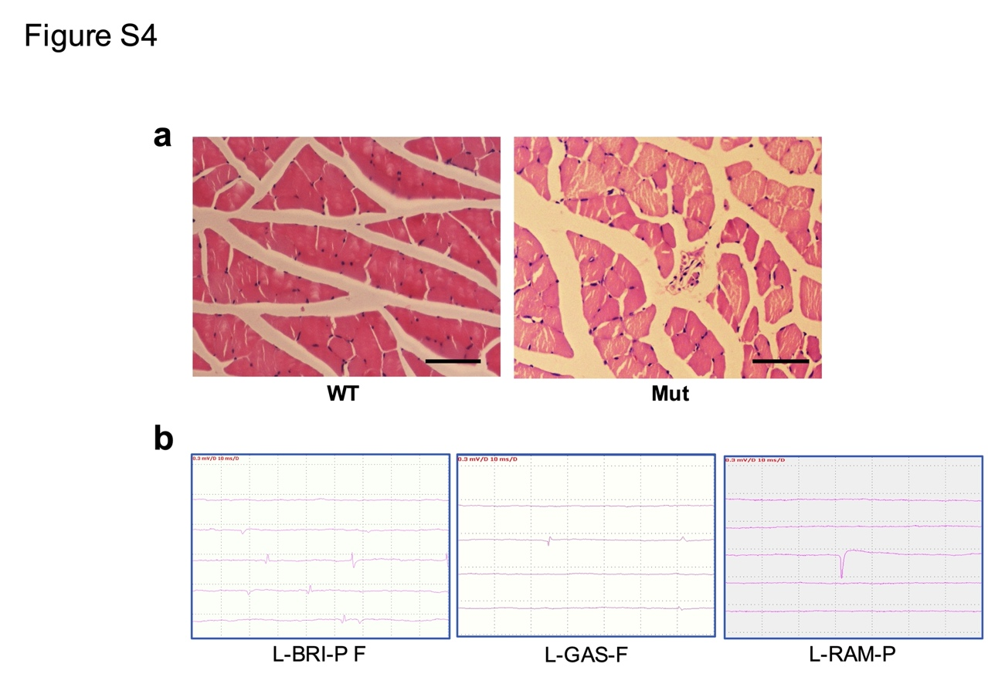
Supplementary Figure 4. Neurogenic skeletal muscular atrophy in Pcdha9 Mut mice. (a) H&E staining of gastrocnemius muscles from 12-month old WT and Mut mice. Scale bar = 50 μm. (b) EMG data for the wild type mice. The EMG in wild type mice usually displayed as resting or non-spontaneous potentials, while positive sharp wave and fibrillation potentials were occasionally identified in one side of the muscles. L-BRI-P F: a positive sharp wave and fibrillation detected in the left biceps brachii muscle; L-GAS-F: a fibrillation potential identified in the left gastrocnemius muscle; L-RAM-P: a positive sharp wave detected in the left rectus abdominisa muscle.
(related to Figure 3)

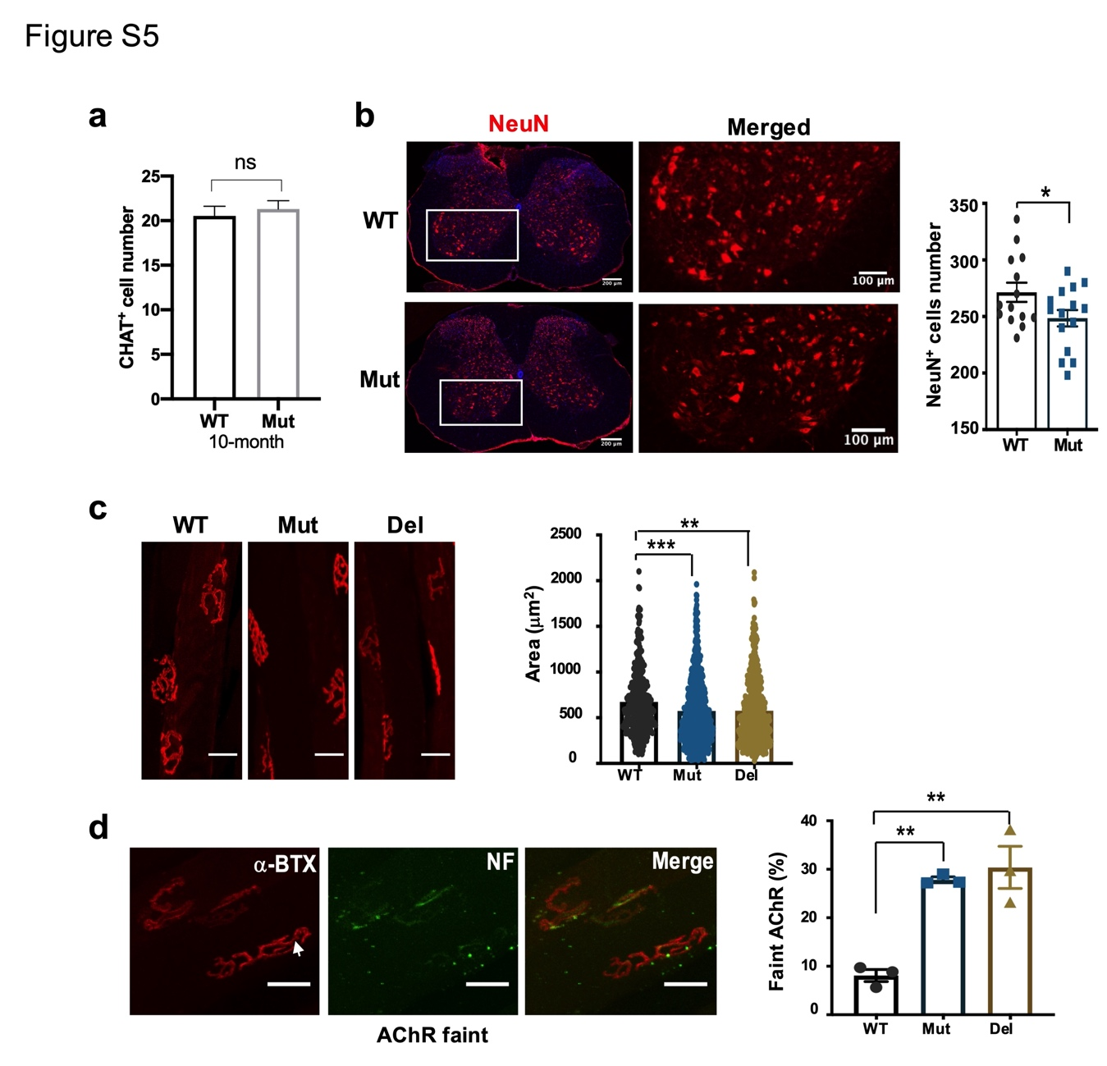
Supplementary Figure 5. Abnormal neuromuscular junctions (NMJs) in both Pcdha9 Mut and Del mice. (a) Statistic analysis of CHAT+ motor neurons in 10 month old mice spinal cord. N=3 mice. t test. Error bars represent ± SEM. (b) Confocal images of NeuN-positive neurons in the ventral horn of lumbar spinal cord from 12-month old WT and Mut mice (related to Figure 4A. Right panel: Statistical analyses of NeurN positive cells (N=3 mice; n=15 slice. *p<0.05, ***p<0.001, t test. Error bars represent ± SEM). (c) The area analysis of single NMJs. Scale bar = 30 μm. N=3 mice. **p<0.01, ***p<0.001, one-way ANOVA. Error bars represent ± SEM. (d) Confocal images of AChR in NMJs from wild type mouse and analyses of AChR-faint-innervated NMJs (realated to Figure 4d). NMJs were double stained with α-BTX (red) and anti-neurofilament (NF, presynaptic, green). The white arrow indicated faintly labeled NF-200 and AChRs (with decreased intensity of α-BTX staining). Scale bar = 30 μm. (3 mice for each group. NMJs: n=452 in WT, n=736 in Mut, n=620 in Del mice). (related to Figure 4)
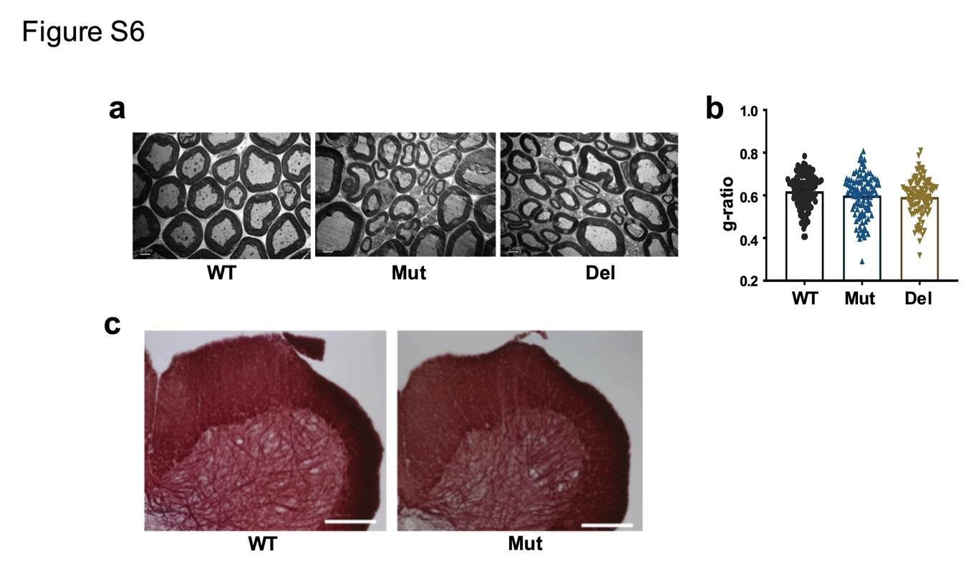
Supplementary Figure 6. Myelination is not affected significantly in the spinal cord and sciatic nerve in Mut mice. (a) Transmission electron microscopy of sciatic nerve from 13-month old mice. (b) Statistic analysis of the g-ratio in sciatic nerve from (A). N=3 mice. one-way ANOVA. Error bars represent ± SEM. (c) Black gold II staining of the spinal cord from 12-month old mice.
(related to Figure 4)

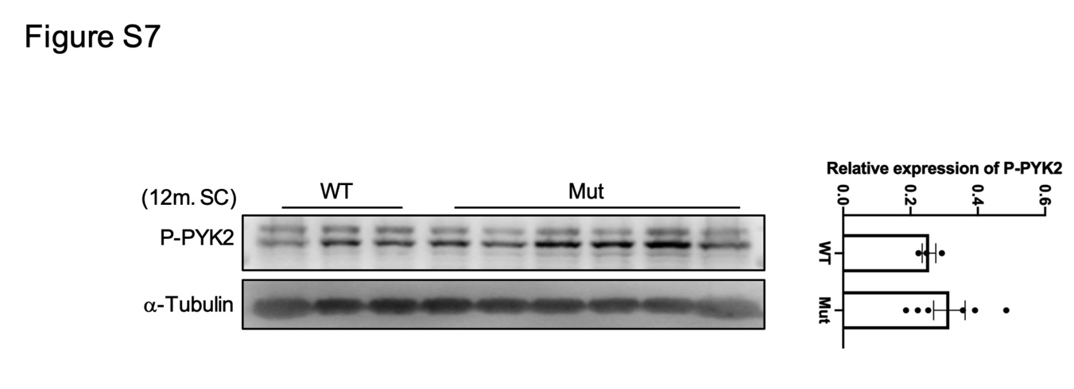
Supplementary Figure 7. The phosphorylation levels of PYK2 in the spinal cords of 12-month old WT and Mut mice detected by Western blot. Statistic analysis the expression levels were normalized by α-Tubulin, unpaired t-test. The data represent mean ± SEM. Increased by not significant.
(related to Figure 6)

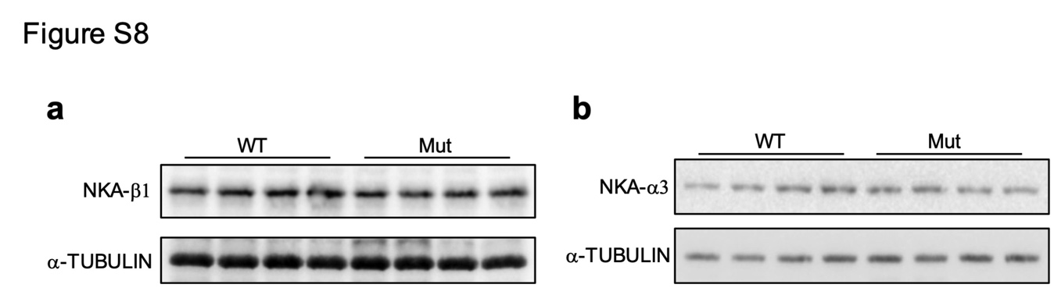

Supplementary Figure 8. The protein levels of NKA-β1 and NKA-α3 in the spinal cord of 12-month-old WT and Mut mice were not affected. (a) Western blot of NKA-β1. (b) Western blot of NKA-α3. N=4 mice for each group.
(related to Figure 7)

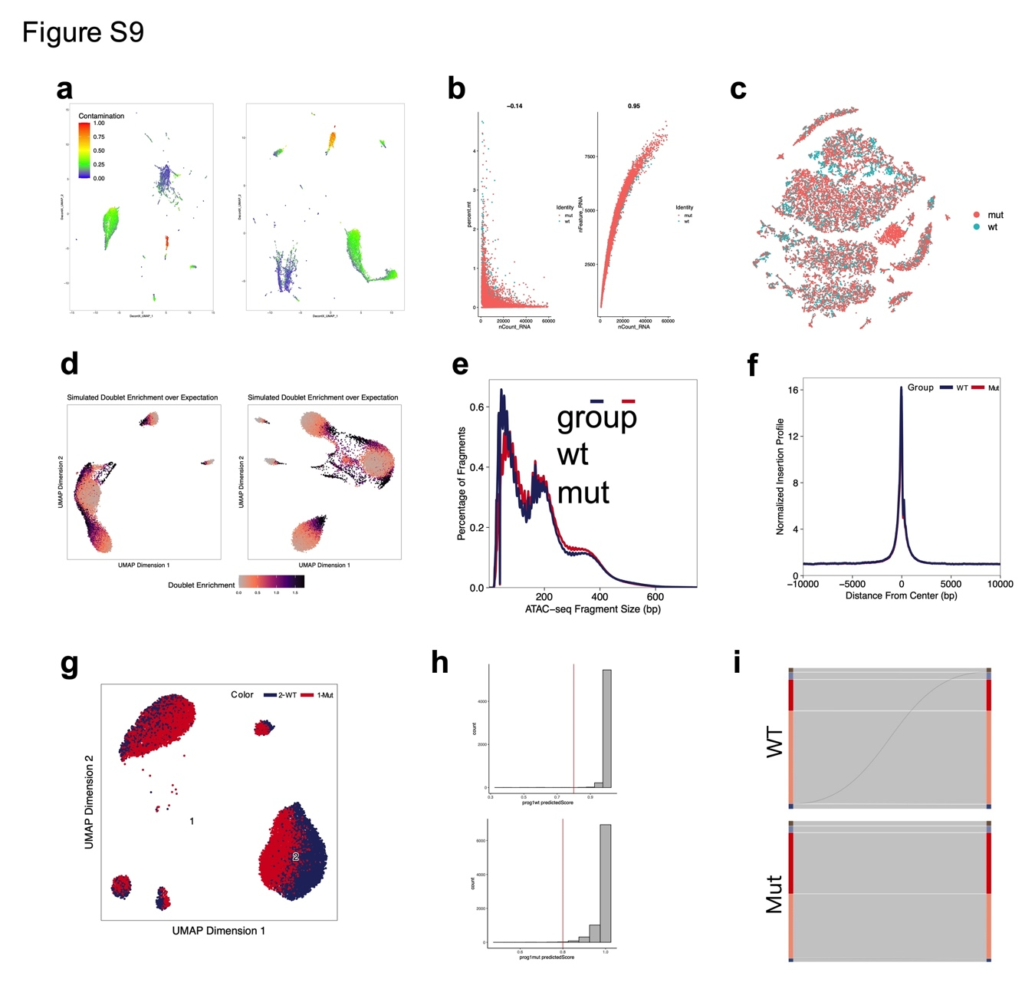
Supplementary Figure 9. Quality control and integration efficiency of snRNA-seq and snATAC-seq. (a) UMAP plot of the percentage of contamination in both WT and Mut snRNA-seq data. (b) The relationships of the features of cells from spinal cord snRNA-seq, such as the number of UMI detected, percentage of cell counts mapping to mitochondrial genes and the number of genes detected. (c) Visualization of cells in WT and Mut snRNA-seq data in tSNE plots and no obvious distribution differences were found between the two datasets. (d) The simulated doublet enrichments of snATAC-seq data from WT and Mut mice in UMAP plots. (e) Fragment size distributions for the cells in snATAC-seq. (f) Aggregate TSS insertion profiles centered at all TSS regions in snATAC-seq. (g) UMAP plot of integrated snATAC-seq dataset from WT and Mut mice. (h) Visualization of cells predicted scores that represent the similarity of snATAC-seq and snRNA-seq data. Vertical red line marked the predicted scores 0.8. (i) Sankey plots illustrating the efficiency of integration between snATAC-seq and snRNA-seq data from WT and Mut mouse spinal cord.
(related to Figure 8)

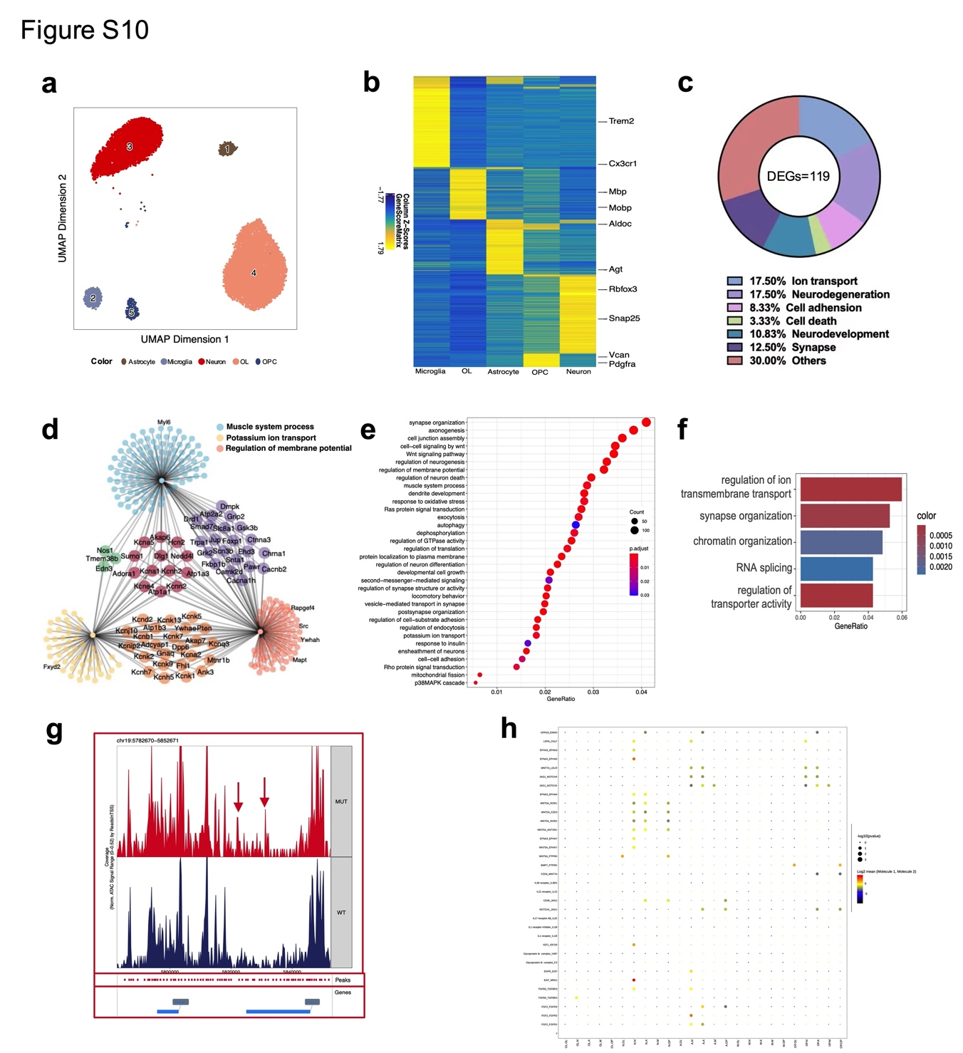
Supplementary Figure 10. Analysis of snRNA-seq and snATAC-seq. (a) Unsupervised cell clusters visualized by UMAP in integrated WT and Mut snATAC-seq data, and major cell types was identified by known markers. (b) Heatmap for conserved gene expression enriched in different cell types based on gene score. (c) Pie chart comparing proportion of gene function in DEGs. (d) The depictions of the linkages of genes and biological concepts of interested. (e) GO analysis was performed to illuminate biological functions of genes associated with significant DARs in neuron cluster. (f) GO analysis of the downstream genes of Rxra according to Mut mouse GRN. (g) In neuron cluster, the specific cis-regulatory interactions of Malat1 in Mut mouse and WT mouse. According to the GRN, these peaks were predicted to be the binding sites of Rxra. (h) Overview of specific ligand-receptor interactions using CellPhoneDB on Mut mouse compared with WT mouse snRNA-seq. (related to Figure 8)

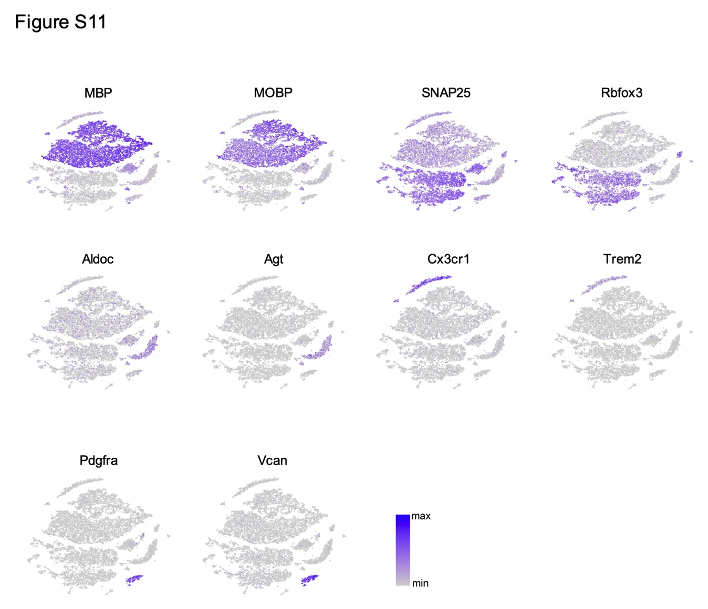
Supplementary Figure 11. Feature plot of marker genes in snRNA-seq. Mbp and Mobp for oligodendrocytes, Snap25 and Rbfox3 for neurons, Aldoc and Agt for astrocytes, Cx3cr1 and Trem2 for microglias, Pdgfra and Vcan for OPCs.
(related to Figure 8)

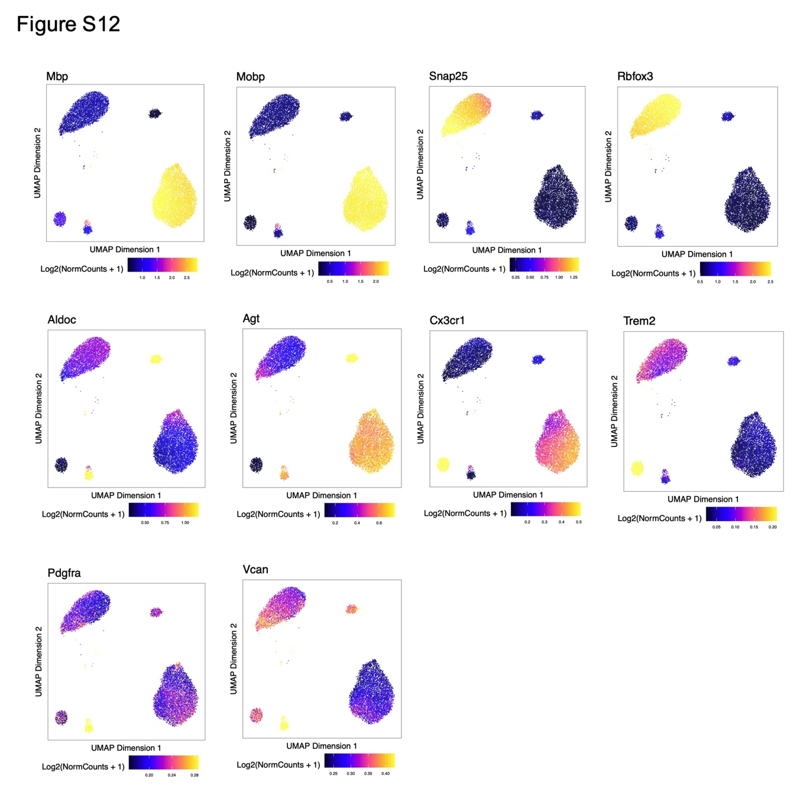
Supplementary Figure 12. Feature plot of marker genes in snATAC-seq. Mbp and Mobp for oligodendrocytes, Snap25 and Rbfox3 for neurons, Aldoc and Agt for astrocytes, Cx3cr1 and Trem2 for microglias, Pdgfra and Vcan for OPCs.
(related to Figure 8)

