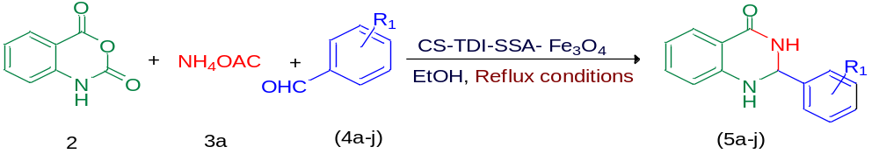Table 1 Optimization of the ternary reaction of isatoic anhydride (2) with ammonium acetate (3a) and 4-chlorobenzaldehyde (4a) under different conditionsª

Entry | Catalyst (mg) | Solvent | T (°C) | Time (min) | Yield^{b}(%)
1 | - | EtOH | 70 | 1440 | 20
2 | 20 | EtOH | Reflux | 20 | 91
3 | 7 | EtOH | 70 | 35 | 78
4 | 3 | EtOH | 70 | 45 | 55
5 | 20 | Solvent-Free | Reflux | 130 | 71
6 | 20 | H₂O | Reflux | 60 | 87
7 | 20 | MeOH | Reflux | 30 | 75
8 | 20 | CH₂Cl₂ | Reflux | 35 | 54
9 | 20 | C₆H₅CH₃ | Reflux | 50 | 45
10 | 20 | THF | Reflux | 100 | 40
11 | 20 | CH₃CN | Reflux | 40 | 55
12 | 20 | EtOH | Room temperature | 70 | 53
13 | 20 | EtOH | 50 | 55 | 78
14 | 20 | EtOH | 60 | 45 | 82
ªReaction conditions: isatoic anhydride (2, 0.5 mmol), ammonium acetate (3a, 1.0 mmol), 4-chlorobenzalaldehyde (4a, 0.5 mmol), CS-TDI-SSA-Fe₃O₄ (1) and solvent (2.0 mL). ^{b}Isolated yields.

Table 2 Synthesis of DHQ derivatives (5a–j) through the three-component condensation of aldehyde derivatives (4a–j) isatoic anhydride (2), and ammonium acetate (3a) in the presence of CS-TDI-SSA-Fe₃O₄ organocatalyst (1).
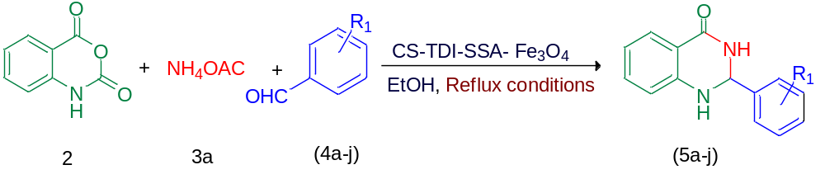
Entry | Aldehyde | Product | Time (min) | Yield (%) | M.P. (°C) Observed | M.P. (°C) (Reported)
1 | 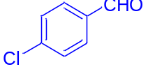  4a | 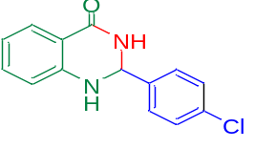  5a | 20 | 91 | 196-197 | 196-197^{110,111}
2 | 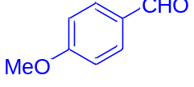  4b | 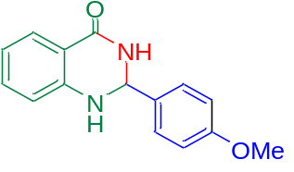  5b | 25 | 88 | 190-193 | 192-193¹¹²
3 | 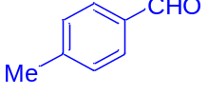  4c | 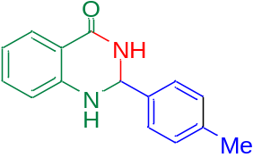  5c | 20 | 86 | 227-228 | 227-228⁹⁷
4 | 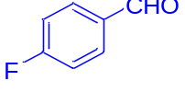  4d | 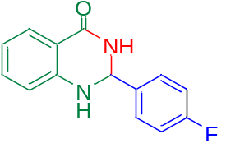  5d | 20 | 90 | 198-200 | 199-200¹¹³
5 | 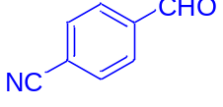  4e | 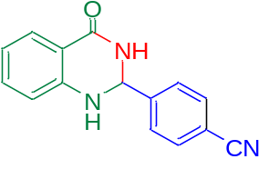  5e | 18 | 88 | 349-351 | 350-351¹¹⁴
6 | 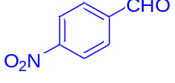  4f | 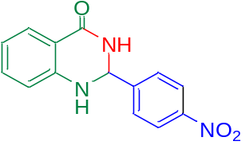  5f | 20 | 86 | 214-216 | 213-215¹¹⁵
7 | 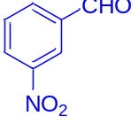  4g | 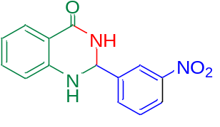  5g | 25 | 84 | 216-218 | 216-217⁹⁶
8 | 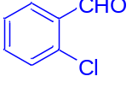  4h | 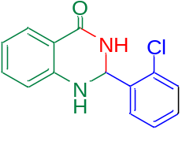  5h | 20 | 90 | 201-204 | 202-204¹¹⁶
9 | 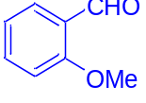  4i | 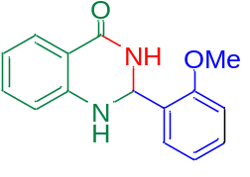  5i | 30 | 86 | 165-168 | 165-167¹¹⁷
10 | 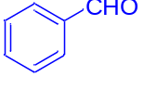  4j | 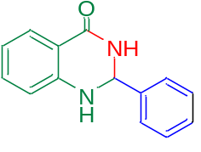  5j | 20 | 88 | 215-217 | 216-218¹¹⁸

Table 4 Calculation of GC metrics for compound 5a.
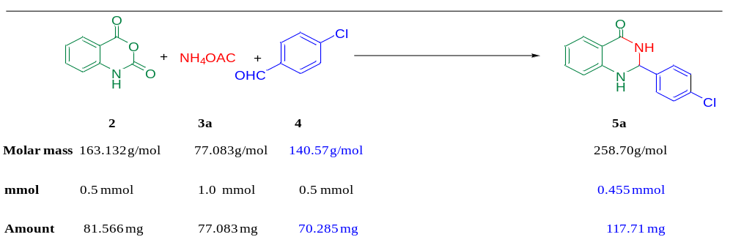
 | Parameters | Characteristics | Formula | Ideal  Value | Calculated value for  compound 5a
1 | Environmental  (E) factor | E-factor signifies the total amount of  waste generated in a chemical reaction. | [Total mass of raw  materials - the total  mass of product]/  mass of product | 0 | [(81.566 + 77.083 +70.285)-117.71]/ 117.71 = 0.945
2 | Atom  Economy (AE%) | Atom economy signifies the  percentage of atoms wasted in chemical  reaction. Higher the value of AE, greener  is the reaction.  Maximum value of atom economy is  100% which indicates that all the  atoms present in reactants lies in the  product. | [MW of product] ÷  Σ(MW of  stoichiometric  reactants) × 100 | 100% | [(117.71)/ (81.566 + 77.083 +70.285)] ×100  = 51.42%
3 | Carbon  Efficiency (CE%) | CE signifies the percentage of  carbons in the reactants that is left  in the product. | [Amount of carbon  in product/ Total  carbon present in  reactants] x 100 | 100% | [0.455 x 14 / (1.0 x2+ 0.5x 7  + 0.5 x 8)]x 100  = [ 6.37 / (2 + 3.5 +4)] x 100  = 67.05%
4 | Process mass  intensity (PMI) | PMI takes into account reaction  efficiency, stoichiometry,  amount of solvent and all reagent  used in the chemical reaction. | Σ (mass of  stoichiometric  reactants)/[mass of  stoichiometry product] | 1 | (81.566 + 77.083 +70.285)/  117.71  = 1.945
5 | Reaction mass  efficiency  (RME %) | RME accounts into atom economy,  chemical yield and stoichiometry. | [mass of product/Σ  (mass of  stoichiometric  reactants)] × 100 | 100% | [117.71/  (81.566 + 77.083 +70.285)] × 100 = 51.42%

