Electronic Supporting Information

Hyperbranched 5-sulfosalicylic acid-TDI-chitosan decorated by Fe₃O₄ nanoparticles: a highly efficient solid acid organocatalyst for the synthesis of quinazoline derivatives under green conditions
Reyhaneh Peyvasteh sourkouhi, Mohammad G. Dekamin*, Ehsan Valiey, Najmeh Hassanzadeh, Mohammad Dohendou
Pharmaceutical and Biologically-Active Compounds Research Laboratory, Department of Chemistry, Iran University of Science and Technology, Tehran 16846-13114, Iran
Tel: +98-21-77240640-50; fax: +98-21-73021584; e-mail: mdekamin@iust.ac.ir

Page | Content
S1 | Title page
S2 | Synthesis of 2,3-dihydroquinazolin-4(1H)-one derivatives catalyzed by CS-TDI-SSA-Fe₃O₄ (1)
S3 | Fig S1. FTIR spectra of the commercial Chitosan (a), (CS-TDI-SSA- Fe₃O₄ 1, b)
S3 | Fig S2. The EDX spectrum of the CS-TDI-SSA-Fe₃O₄ (1)
S4 | Fig S3. FESEM images of the CS-TDI-SSA-Fe₃O₄ (1)
S5 | Fig S4. XRD patterns of the CS-TDI-SSA-Fe₃O₄ (1)
S5 | Fig S5. VSM pattern of CS-TDI-SSA-Fe₃O₄ (1)
S6 | Fig S6. TGA curve of the CS-TDI-SSA-Fe₃O₄ (1)
S6 | Fig S7. Reusability of the CS-TDI-SSA-Fe₃O₄ organocatalyst (1) in the model reaction to afford 5a
S7 | Table S1 Optimization of the ternary reaction of isatoic anhydride (2) with ammonium acetate (3a) and 4-chlorobenzaldehyde (4a) under different conditions.ª
S8 | Table S2 Calculation of GC metrics for compound 5a.
S9 | Table S3 Comparative synthesis of compound 5a using the reported heterogeneous catalysts versus the present method.
S10 | Scheme 2 The proposed mechanism for the synthesis of 2,3-dihydroquinazoline derivatives 5 catalyzed by the biobased multifunctional CS-TDI-SSA-Fe₃O₄ solid acid nanocomposite (1).
S11 | Fig S8. FTIR spectrum of 2‑(4‑Chlorophenyl)-2,3‑dihydroquinazolin‑4(1H)-one (5a)
S11 | Fig S9. ¹H-NMR spectrum of 2‑(4‑Chlorophenyl)‑2,3‑dihydroquinazolin‑4(1H)‑one (5a)
S12 | Fig S10. FTIR spectrum of 2‑(4‑Methylphenyl)-2,3‑dihydroquinazolin‑4(1H)-one (5c)
S12 | Fig S11. ¹H-NMR spectrum of 2‑(4‑Methylphenyl)-2,3‑dihydroquinazolin‑4(1H)-one (5c)
S13 | Fig S12. FTIR spectrum of 2‑phenyl‑2,3‑dihydroquinazolin‑4(1H)-one (5j)
S13 | Fig S13. ¹H-NMR spectrum of 2‑phenyl‑2,3‑dihydroquinazolin‑4(1H)-one (5j)

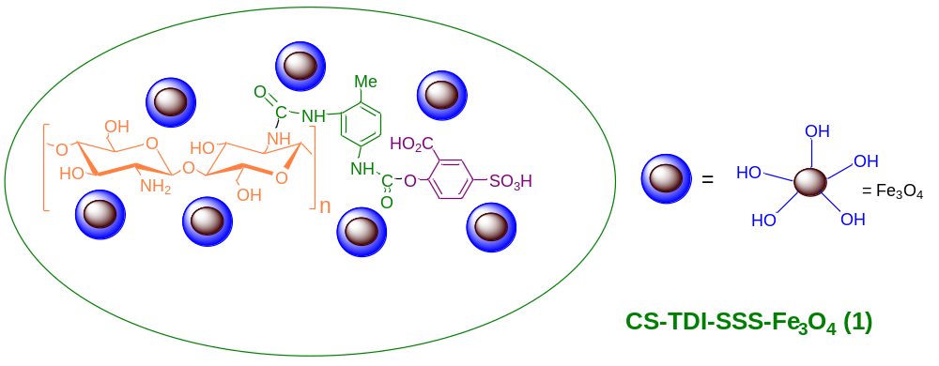
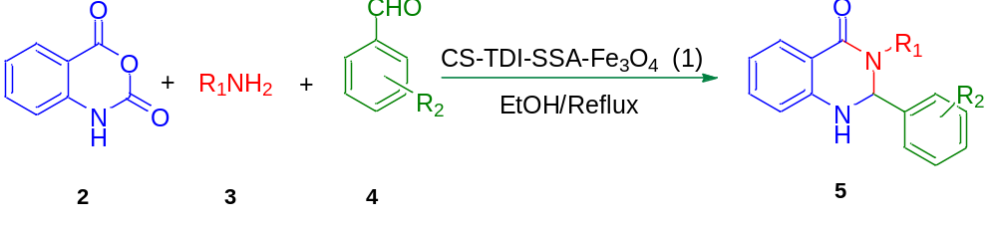

Scheme S1. Synthesis of 2,3-dihydroquinazolin-4(1H)-one derivatives catalyzed by CS-TDI-SSA-Fe₃O₄ (1)

Characterization of the CS-TDI-SSA-Fe₃O₄ (1)
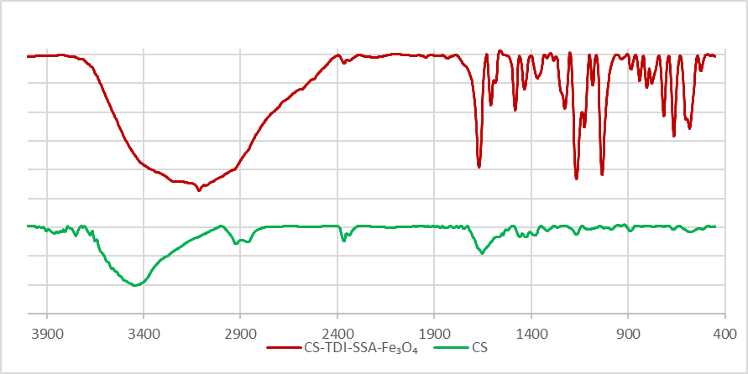
(b)
(a)
Fig S1. FTIR spectra of the commercial Chitosan (a), (CS-TDI-SSA- Fe₃O₄ 1, b).
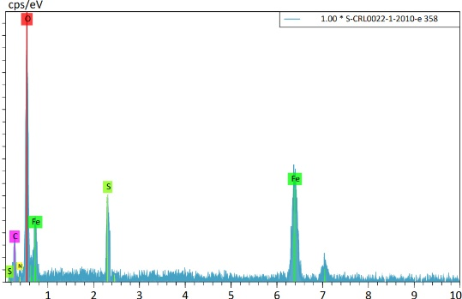
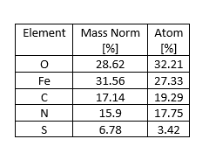
Fig S2. The EDX spectrum of the CS-TDI-SSA-Fe₃O₄ (1).
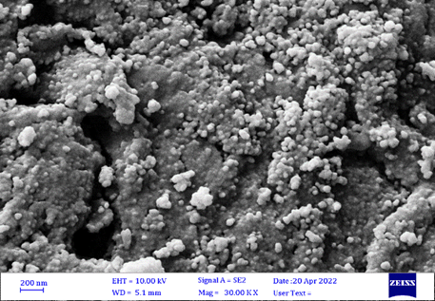
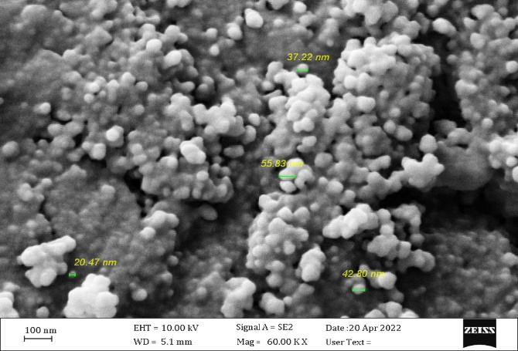
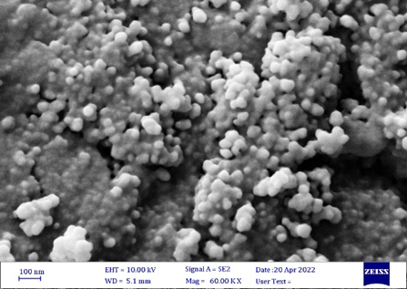

Fig S3. FESEM images of the CS-TDI-SSA-Fe₃O₄ (1)

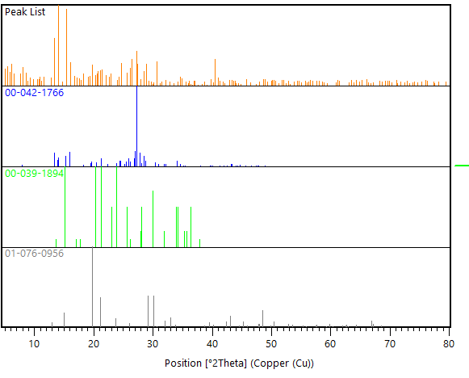
Fe₃O₄
chitosan
5-Sulfosalicylic acid
Fig S4. XRD patterns of the CS-TDI-SSA-Fe₃O₄ (1).

Fig S5. VSM pattern of CS-TDI-SSA-Fe₃O₄ (1).
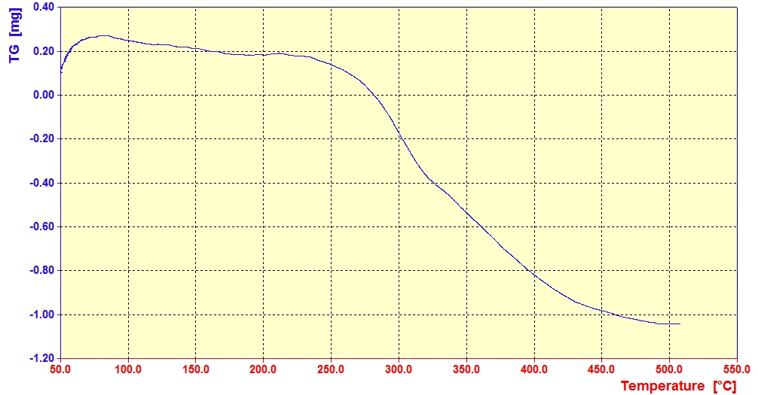
Fig S6. TGA curve of the CS-TDI-SSA-Fe₃O₄ (1)

Fig S7. Reusability of the CS-TDI-SSA-Fe₃O₄ organocatalyst (1) in the model reaction to afford 5a.

Table S1 Optimization of the ternary reaction of isatoic anhydride (2) with ammonium acetate (3a) and 4-chlorobenzaldehyde (4a) under different conditions.ª
Entry | Catalyst (g) | Solvent | T (°C) | Time(min) | Yield (%)
1 | - | EtOH | 70 | 1440 | 20
2 | 0.02 | EtOH | Reflux | 20 | 91
3 | 0.007 | EtOH | 70 | 35 | 78
4 | 0.003 | EtOH | 70 | 45 | 55
5 | 0.02 | Solvent-Free | Reflux | 130 | 71
6 | 0.02 | H₂O | Reflux | 60 | 87
7 | 0.02 | MeOH | Reflux | 30 | 75
8 | 0.02 | CH₂Cl₂ | Reflux | 35 | 54
9 | 0.02 | C₆H₅CH₃ | Reflux | 50 | 45
10 | 0.02 | THF | Reflux | 100 | 40
11 | 0.02 | CH₃CN | Reflux | 40 | 55
12 | 0.02 | EtOH | Room temperature | 70 | 53
13 | 0.02 | EtOH | 50 | 55 | 78
14 | 0.02 | EtOH | 60 | 45 | 82

ªReaction conditions: isatoic anhydride (2, 0.5 mmol), ammonium acetate (3a, 1mmol), 4-chlorobenzalaldehyde (4a, 0.5 mmol), CS-TDI-SSA-Fe₃O₄ (1) and solvent (2.0 mL). isolated yields.

Table S2 Calculation of GC metrics for compound 5a.
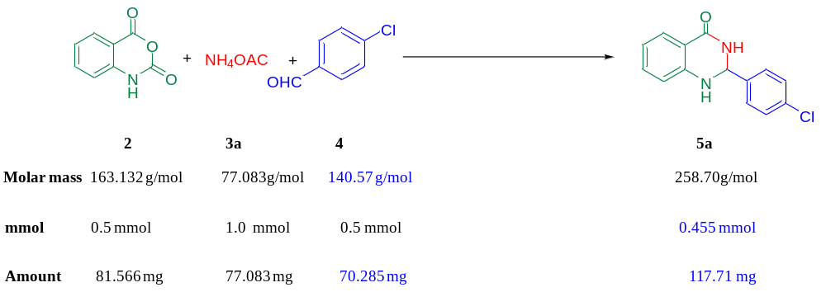
 | Parameters | Characteristics | Formula | Ideal  Value | Calculated value for  compound 5a
1 | Environmental  (E) factor | E-factor signifies the total amount of  waste generated in a chemical reaction. | [Total mass of raw  materials - the total  mass of product]/  mass of product | 0 | [(81.566 + 77.083 +70.285)-117.71]/ 117.71 = 0.945
2 | Atom  economy (AE%) | Atom economy signifies the  percentage of atoms wasted in chemical  reaction. Higher the value of AE, greener  is the reaction.  Maximum value of atom economy is  100% which indicates that all the  atoms present in reactants lies in the  product. | [MW of product] ÷  Σ(MW of  stoichiometric  reactants) × 100 | 100% | [(117.71)/ (81.566 + 77.083 +70.285)] ×100  = 51.42%
3 | Carbon  efficiency (CE%) | CE signifies the percentage of  carbons in the reactants that is left  in the product. | [Amount of carbon  in product/ Total  carbon present in  reactants] x 100 | 100% | [0.455 x 14 / (1.0 x2+ 0.5x 7  + 0.5 x 8)]x 100  = [ 6.37 / (2 + 3.5 +4)] x 100  = 67.05%
4 | Process mass  intensity (PMI) | PMI takes into account reaction  efficiency, stoichiometry,  amount of solvent and all reagent  used in the chemical reaction. | Σ (mass of  stoichiometric  reactants)/[mass of  stoichiometry product] | 1 | (81.566 + 77.083 +70.285)/  117.71  = 1.945
5 | Reaction mass  efficiency  (RME %) | RME accounts into atom economy,  chemical yield and stoichiometry. | [mass of product/Σ  (mass of  stoichiometric  reactants)] × 100 | 100% | [117.71/  (81.566 + 77.083 +70.285)] × 100 = 51.42%

Table S3 Comparative synthesis of compound 5a using the reported heterogeneous catalysts versus the present method.
Entry | Catalyst | Catalyst  Loading | Condition reaction | Time(min) | Yield  (%) | Ref.
1 | Silica sulfuric acid | 20 mol% | Solvent –free | 300 | 80 | (ref. [28])
3 | Sulfamic acid | 10 mol% | H₂O | 35 | 89 | (ref. [29])
4 | Cobalt aluminat  (CoAl₂O ₄) | 0.02 gr | EtOH | 130 | 82 | (ref. [39])
6 | CS-TDI-SSA-Fe₃O₄ | 0.02 gr | EtOH | 20 | 91 | This work

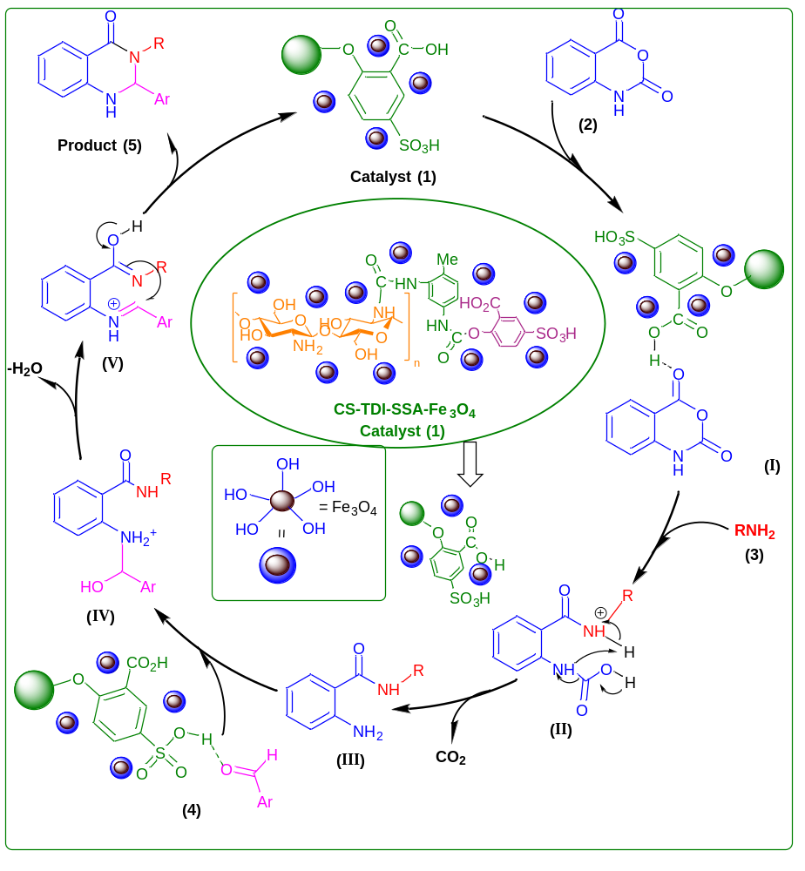
Scheme S2 The proposed mechanism for the synthesis of 2,3-dihydroquinazoline derivatives 5 catalyzed by the biobased multifunctional CS-TDI-SSA-Fe₃O₄ solid acid nanocomposite (1).

Selected spectral data
2‑(4‑Chlorophenyl)‑2,3‑dihydroquinazolin‑4 (1 H)‑one (5a):
White solid, melting point: 196-197 °C. ¹HNMR (500MHz, CDCl₃): δ(ppm) 7.95 (dt, J = 7.8, 1.4 Hz, 1H), 7.58-750 (m, 3H), 7.43 (dd, J = 8.4, 1.3 Hz, 2H), 7.0-732 (m, 1H), 6.92 (t, J = 7.6 Hz, 1H), 6.68 (d, J = 8.1 Hz, 1H), 5.90 (s, 1H), 5.85 (s, 1H); FTIR (KBr) ν (cm⁻¹): 3447, 3306, 3187, 1656, 1509.

Fig S8 FTIR spectrum of 2‑(4‑Chlorophenyl)-2,3‑dihydroquinazolin‑4(1H)-one (5a).

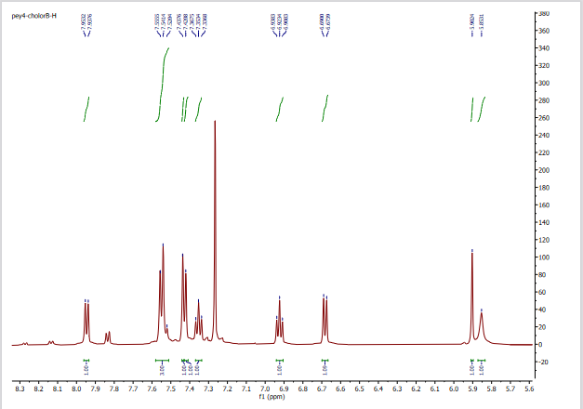
Fig S9 ¹H NMR spectrum of 2‑(4‑Chlorophenyl)‑2,3‑dihydroquinazolin‑4(1H)‑one (5a)

2‑(4‑Methylphenyl)‑2,3‑dihydroquinazolin‑4 (1 H)‑one (5c):
White solid, melting point: 227– 228 °C. ¹HNMR (500 MHz, CDCl₃):
δ(ppm) 7.95 (d, J = 7.8 Hz, 1H), 7.48 (d, J = 7.6 Hz, 2H), 7.34 (t, J = 7.6 Hz, 1H), 7.27 (s, 3H), 6.91 (t, J = 7.6 Hz, 1H), 6.67 (d, J = 8.1 Hz, 1H), 5.87 (s, 1H), 5.79 (s, 1H), 2.4 (s,3H); FTIR (KBr) ν (cm⁻¹): 3450, 3312,3192, 2924, 1658, 1510, 1295.

Fig S10 FTIR spectrum of 2‑(4‑Methylphenyl)-2,3‑dihydroquinazolin‑4(1H)-one (5c).
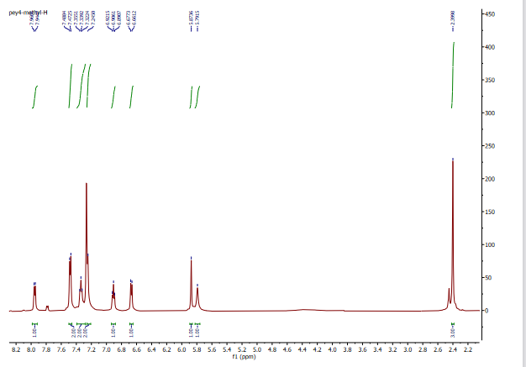

Fig S11 ¹H NMR spectrum of 2‑(4‑Methylphenyl)-2,3‑dihydroquinazolin‑4(1H)-one (5c).
2‑phenyl‑2,3‑dihydroquinazolin‑4 (1 H)‑one (5j):
White solid, melting point: 215-217 °C. ¹HNMR (500MHz, CDCl₃): δ(ppm) 8.00 – 7.94 (m, 1H), 7.62 (dd, J = 6.7, 3.0 Hz, 2H), 7.50 – 7.44 (m, 3H), 7.41 – 7.32 (m, 1H), 6.93 (t, J = 7.6 Hz, 1H), 6.70 (d, J = 8.1 Hz, 1H), 5.92 (d, J = 10.0 Hz, 2H), 4.43 (s, 1H). FTIR (KBr, cm⁻¹) ν =3300, 3184, 2928, 1656, 1512

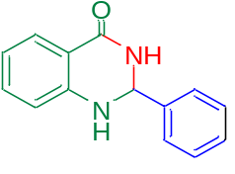

Fig S12 FTIR spectrum of 2‑phenyl‑2,3‑dihydroquinazolin‑4(1H)-one (5j).
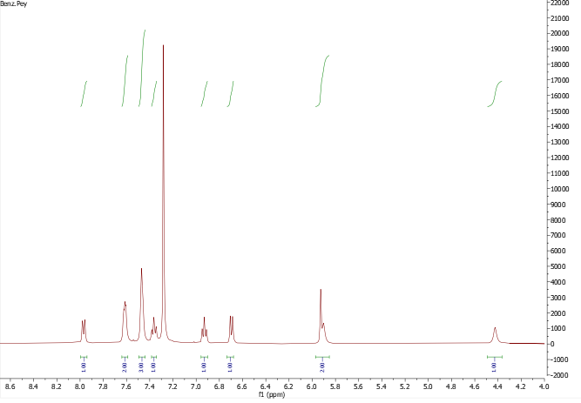

Fig S13 ¹H NMR spectrum of 2‑phenyl‑2,3‑dihydroquinazolin‑4(1H)-one (5j).
.

