Table 1.
Docked complex structure of PDGFRA with the hit compounds, 2’hydroxy-5’-methylchalcone, linoleic acid and annonacin and its interactions in 3D complex and 2D structures
Hit compounds | 3D complex structure with target protein, PDGFRA | 2D interaction representation with the target protein, PDGFRA
2’ hydroxy-5’- methyl chalcone | 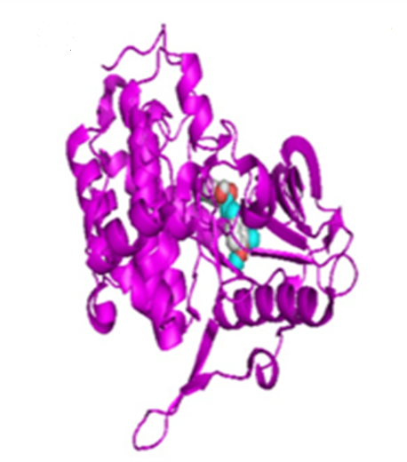 | 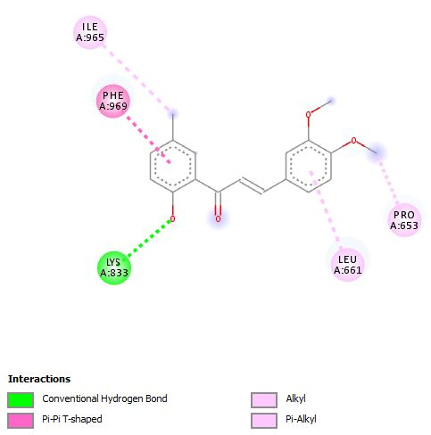
Linoleic acid | 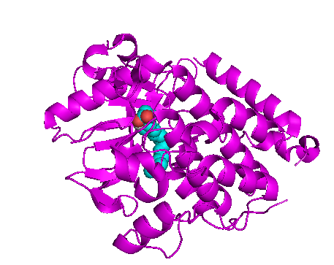 | 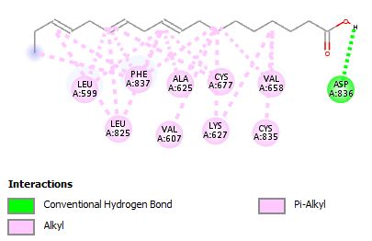
Annonacin | 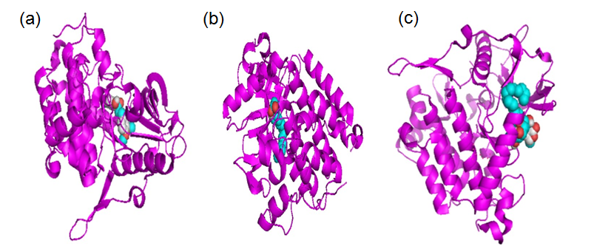 | 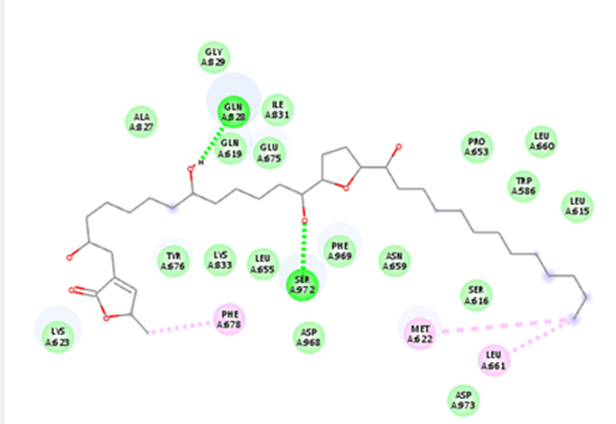

* Protein structure has been depicted with secondary structure model (coloured in magenta) with space fill model (Oxygen in red; Nitrogen in blue; and Hydrogen in white)

