Tab. S1
Gene ID | Gene Function
Solyc04g071070.2 | PREDICTED: LOW QUALITY PROTEIN: extensin-3 [Solanum lycopersicum]
Solyc04g150161.1 | PREDICTED: extensin-2-like [Solanum tuberosum]
Solyc11g066820.2 | PREDICTED: glucomannan 4-beta-mannosyltransferase 2 [Solanum lycopersicum]
Solyc11g005150.3 | PREDICTED: leucine-rich repeat extensin-like protein 6 [Solanum lycopersicum]
Solyc03g123630.4 | pectinesterase/pectinesterase inhibitor U1 precursor [Solanum lycopersicum]
Solyc02g088100.3 | expansin precursor [Solanum lycopersicum]
Solyc02g084990.3 | PREDICTED: mannan endo-1,4-beta-mannosidase 7 [Solanum lycopersicum]
Solyc03g093080.3 | PREDICTED: probable xyloglucan endotransglucosylase/hydrolase protein 23 [Solanum lycopersicum]
Solyc06g051800.3 | expansin precursor [Solanum lycopersicum]
Solyc03g111690.4 | PREDICTED: probable pectate lyase 18 [Solanum lycopersicum]
Solyc08g082190.3 | PREDICTED: glycine-rich cell wall structural protein 2-like [Capsicum annuum]
Solyc07g064180.4 | pectinesterase 2.1 [Solanum lycopersicum]
Solyc09g089580.4 | 1-aminocyclopropane-1-carboxylate oxidase homolog isoform 1 [Solanum lycopersicum]
Solyc08g080630.4 | ethylene-responsive proteinase inhibitor 1 precursor [Solanum lycopersicum]
Solyc02g077880.3 | auxin repressed/dormancy associated protein [Solanum lycopersicum]
Solyc07g049530.3 | 1-aminocyclopropane-1-carboxylate oxidase 1 [Solanum lycopersicum]
Solyc04g071580.3 | abscisic stress-ripening protein 2 [Solanum lycopersicum]
Solyc12g089300.2 | PREDICTED: gibberellin-regulated protein 1-like [Solanum lycopersicum]
Solyc07g056670.3 | gibberellin 2-oxidase 2 [Solanum lycopersicum]
Solyc03g113910.3 | PREDICTED: gibberellin-regulated protein 10 [Solanum lycopersicum]
Solyc01g088400.4 | PREDICTED: protein ECERIFERUM 1-like [Solanum lycopersicum]
Solyc07g006890.1 | PREDICTED: cytochrome P450 94A1-like [Solanum lycopersicum]
Solyc12g100270.2 | PREDICTED: protein ECERIFERUM 1 [Solanum lycopersicum]
Solyc03g065250.4 | PREDICTED: protein ECERIFERUM 1-like [Solanum lycopersicum]
Solyc10g006660.3 | PREDICTED: calcium-binding protein PBP1-like [Solanum lycopersicum]
Solyc04g009800.3 | calcium dependent protein kinase [Solanum lycopersicum]
Solyc10g079420.1 | PREDICTED: probable calcium-binding protein CML36 [Solanum lycopersicum]
Solyc03g118810.1 | PREDICTED: calcium-binding allergen Ole e 8-like [Solanum lycopersicum]
Solyc01g057770.3 | PREDICTED: boron transporter 1 isoform X2 [Solanum lycopersicum]
Solyc03g096290.3 | PREDICTED: aquaporin PIP1-1 [Solanum pennellii]
Solyc10g083880.2 | PREDICTED: aquaporin TIP1-1 [Solanum lycopersicum]
Solyc08g081190.3 | plasma membrane intrinsic protein 1.5 [Solanum lycopersicum]
Solyc05g015850.4 | PREDICTED: probable WRKY transcription factor 75 [Solanum pennellii]
Solyc01g079260.4 | PREDICTED: probable WRKY transcription factor 23 [Solanum lycopersicum]
Solyc08g014120.3 | transcription factor bHLH113 [Solanum lycopersicum]
Solyc03g095770.3 | PREDICTED: probable WRKY transcription factor 70 [Solanum lycopersicum]
Solyc04g078550.3 | PREDICTED: probable WRKY transcription factor 7 [Solanum lycopersicum]
Solyc09g015770.3 | WRKY transcription factor 81 [Solanum lycopersicum]
Solyc10g006130.1 | PREDICTED: ethylene-responsive transcription factor 3-like [Solanum lycopersicum]
Solyc05g052040.1 | ethylene-responsive transcription factor 5 [Solanum lycopersicum]
Solyc08g078190.2 | ethylene-responsive transcription factor [Solanum lycopersicum]
Solyc02g088340.4 | WRKY transcription factor 3 [Solanum lycopersicum]

Fig. S1
(a)
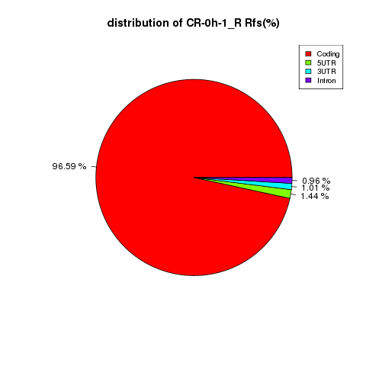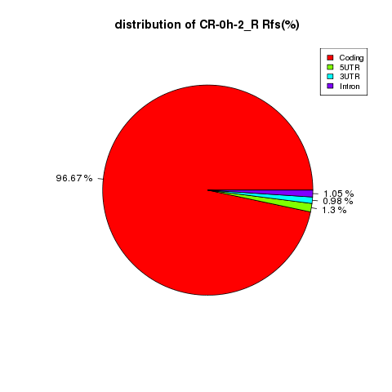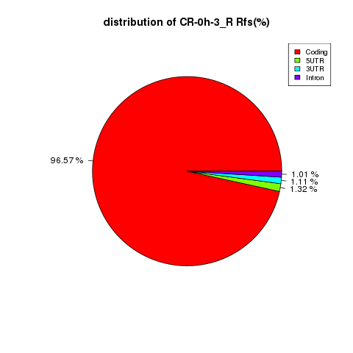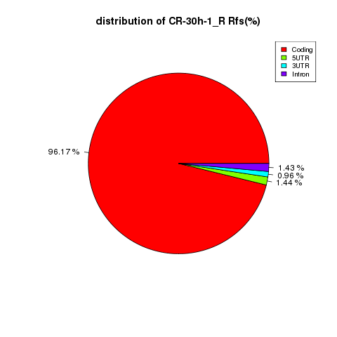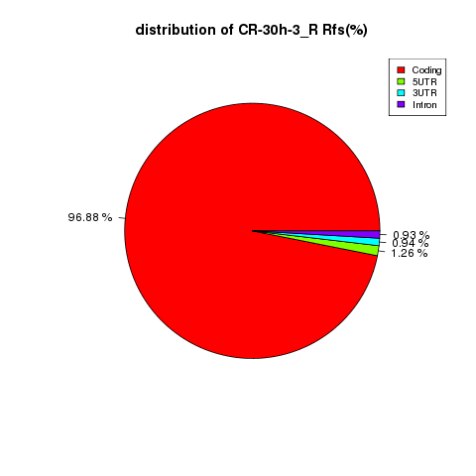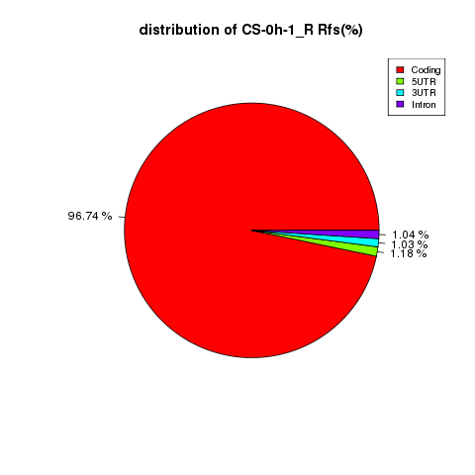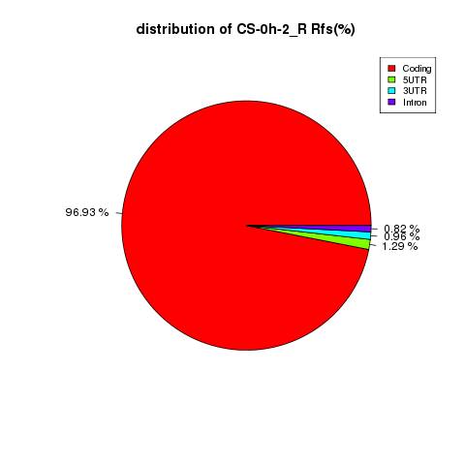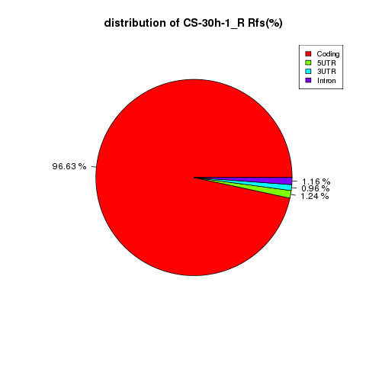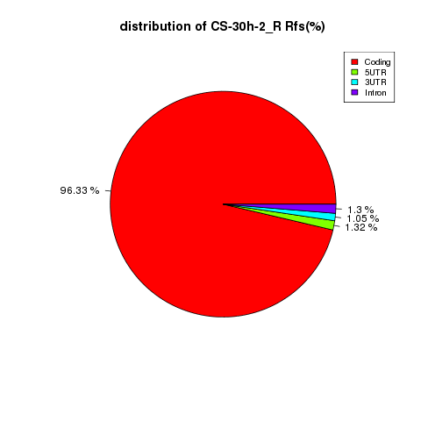
(b)
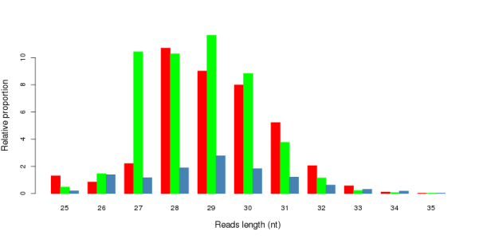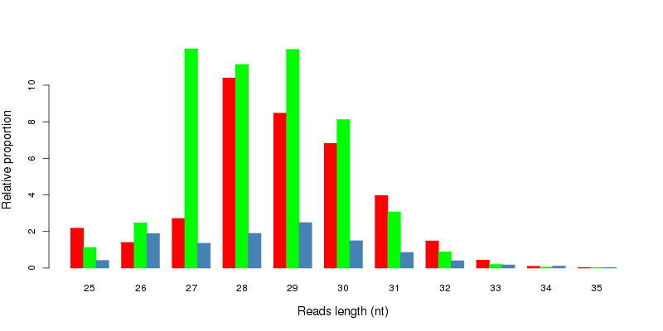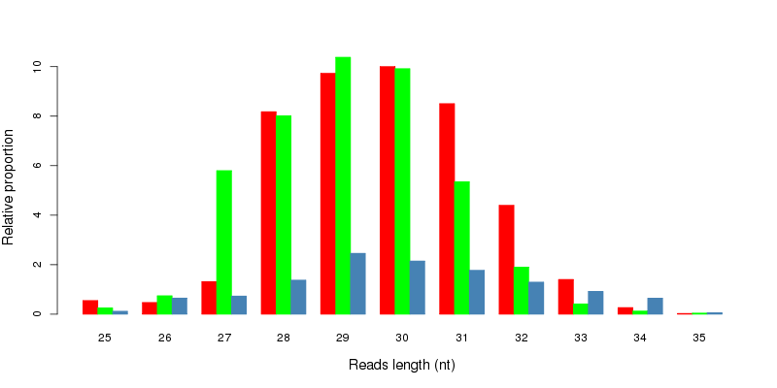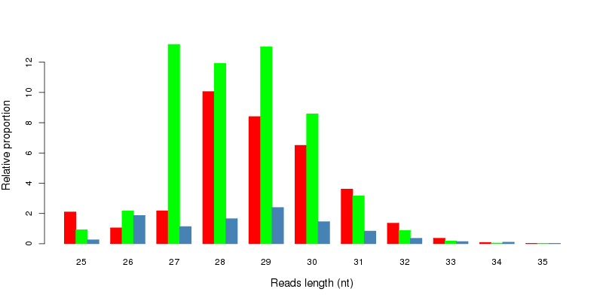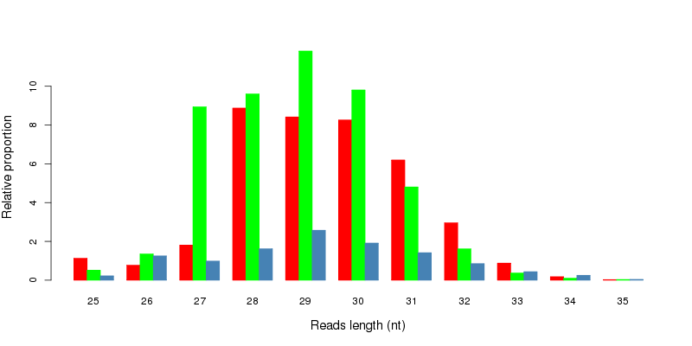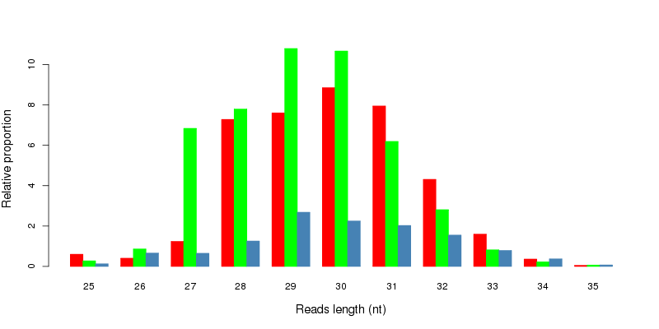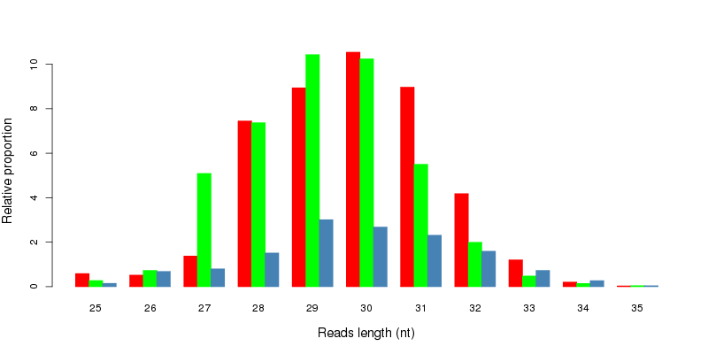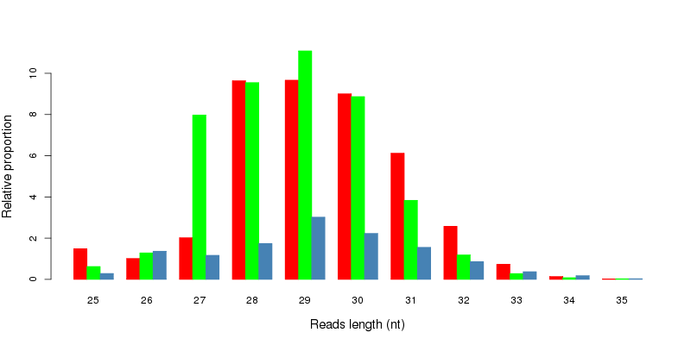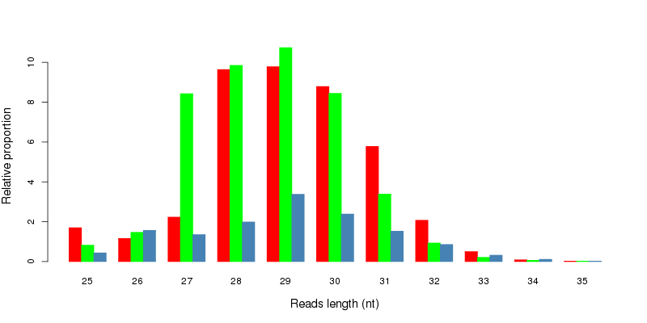
(c)
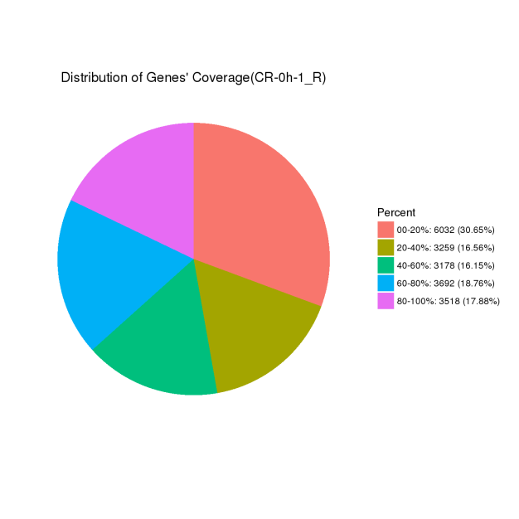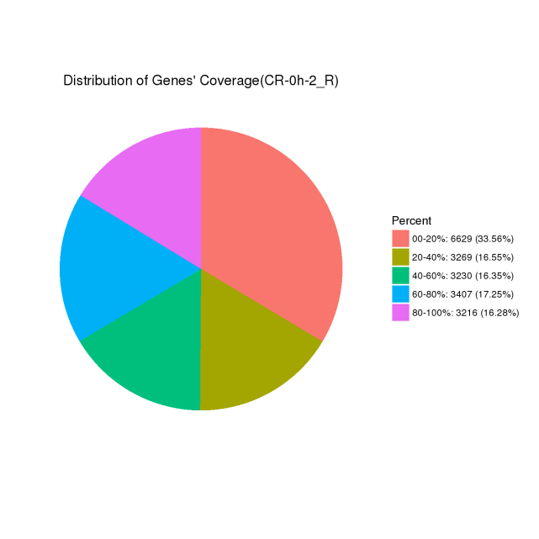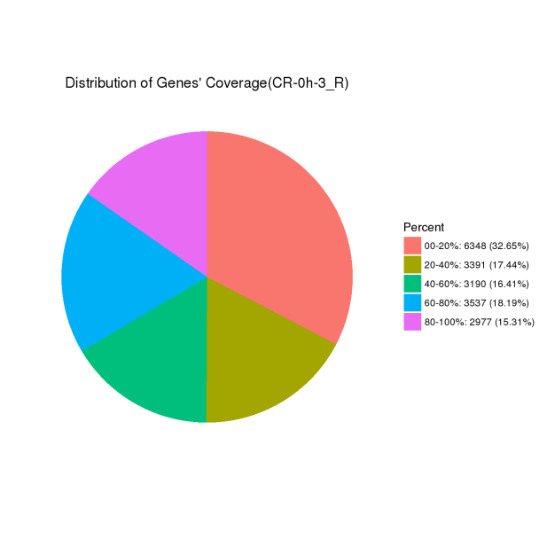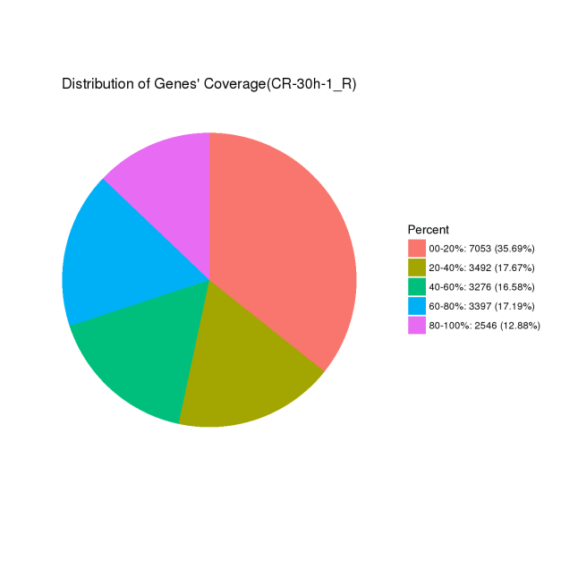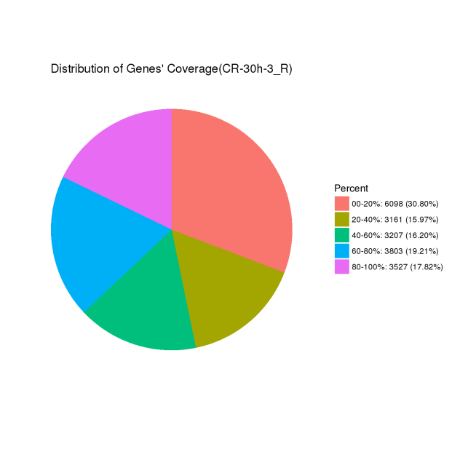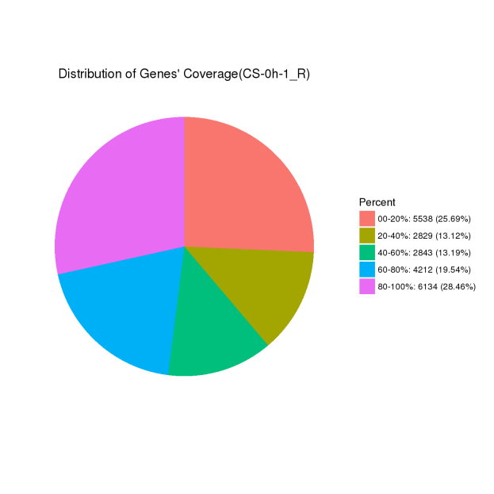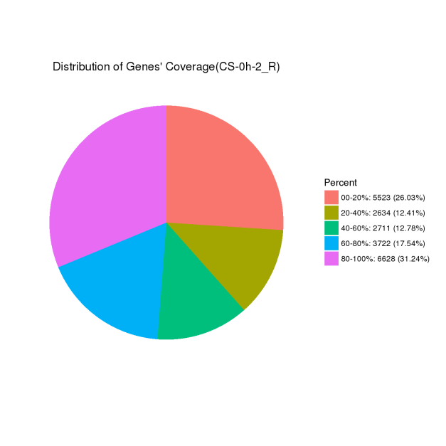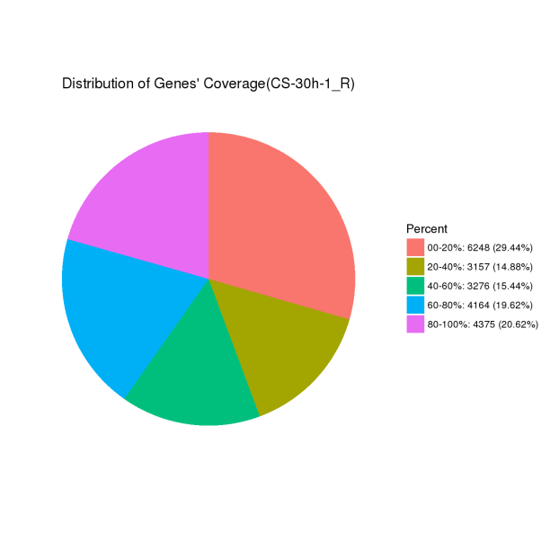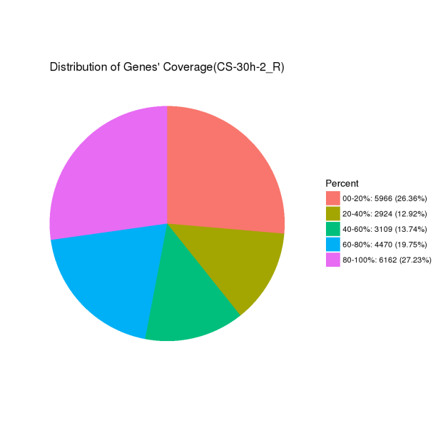
(d) 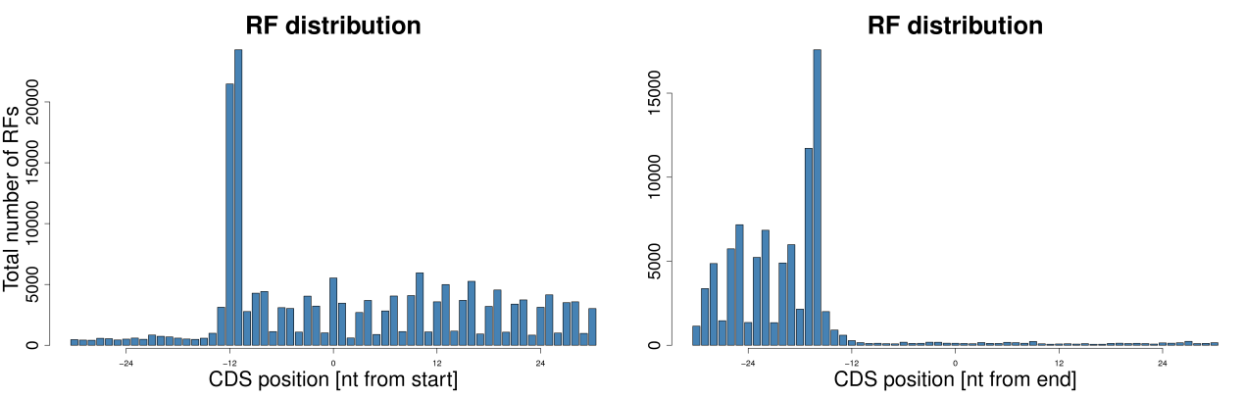
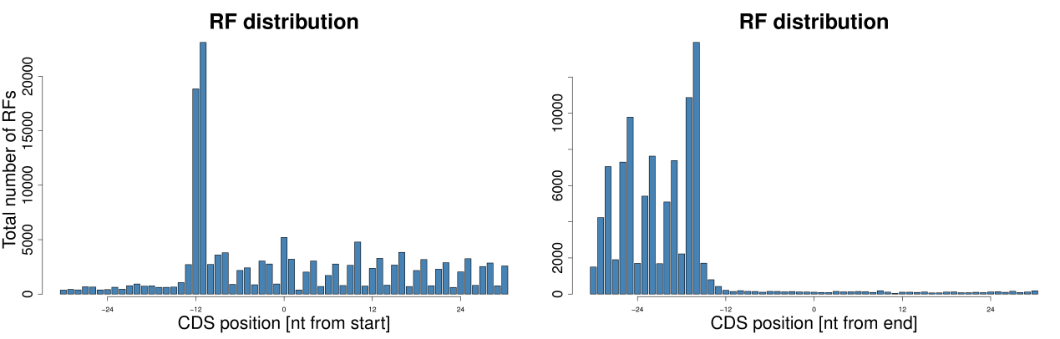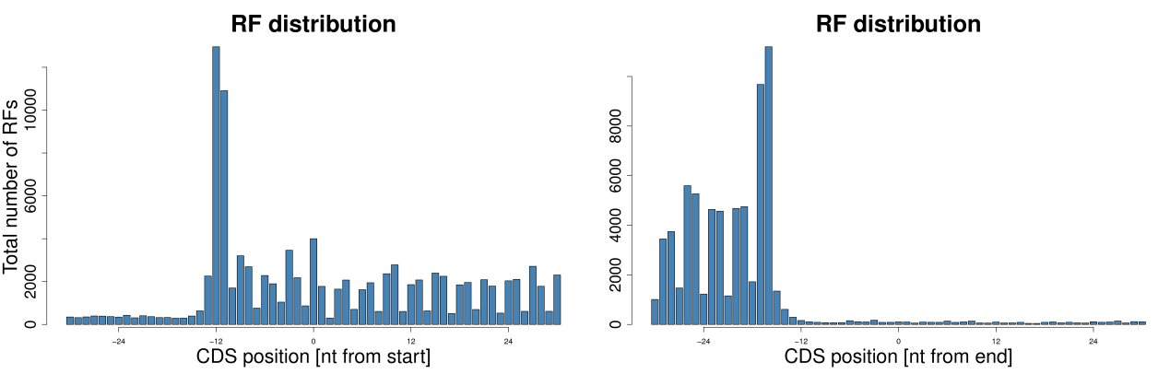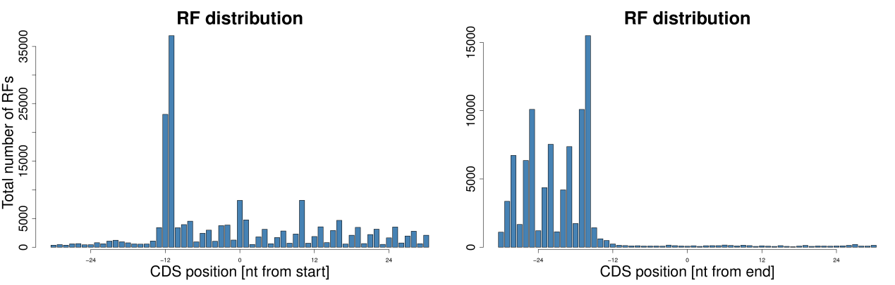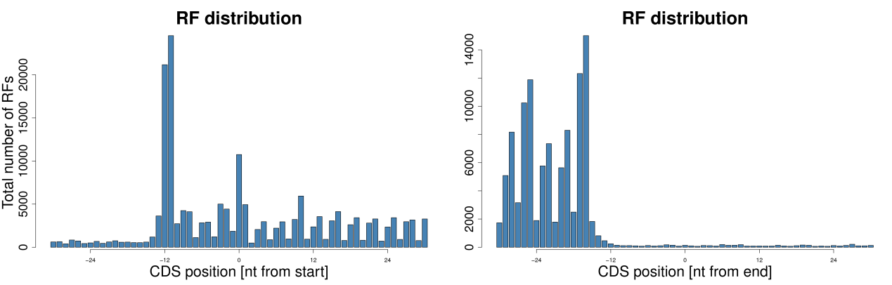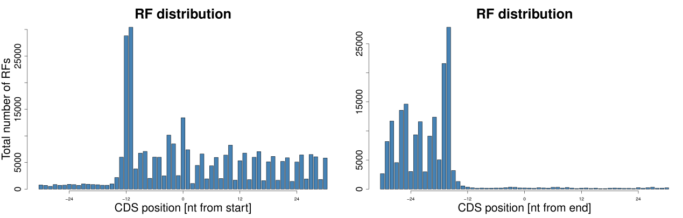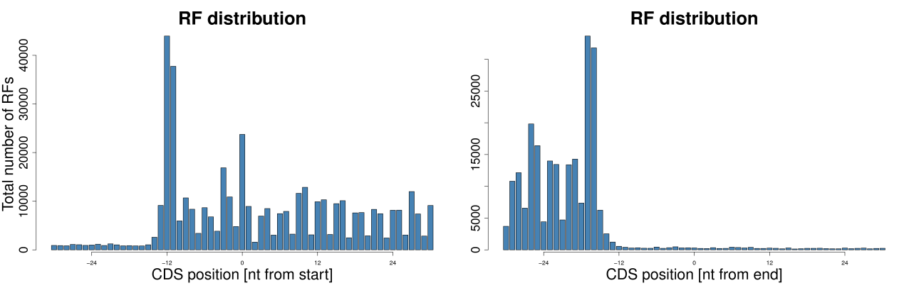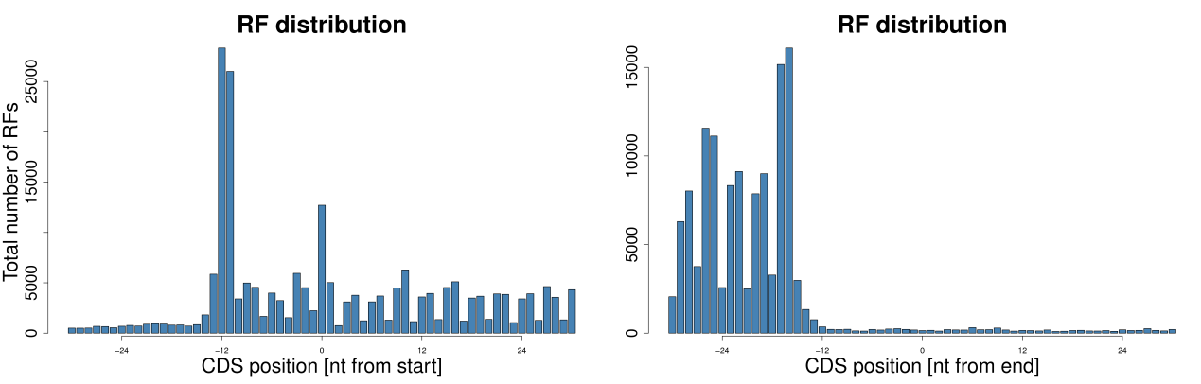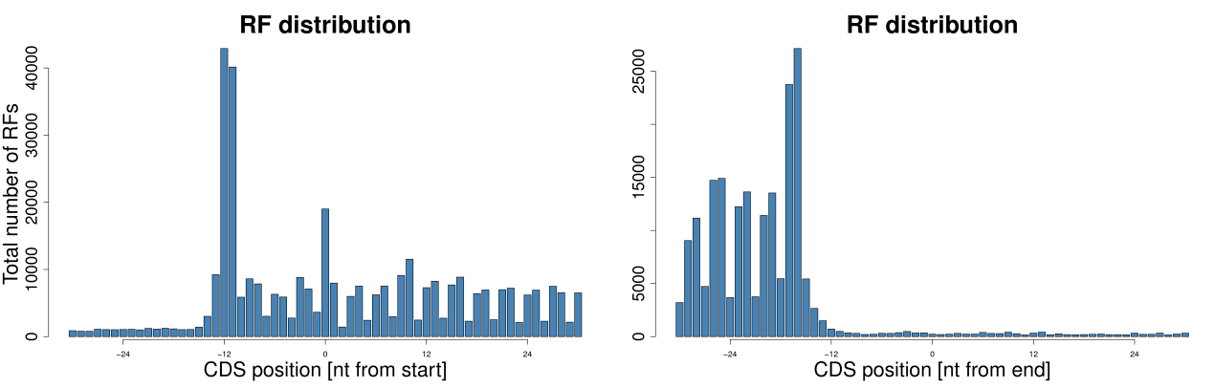
Fig. S1 The Data of Ribo-seq feature(The sequence of pictures is CR-0h-1,CR-0h-2,CR-0h-3,CR-30h-1,CR-30h-3,CS-0h-1,CS-0h-2,CS-30h-1,CS-30h-2,CS-30h-3);（a）Distribution of RFs in coding genes；（b）Gene coverage statistics；（c）Distribution of RFs aroundcodons；（d）RFs alignment codon positions.

Fig. S2
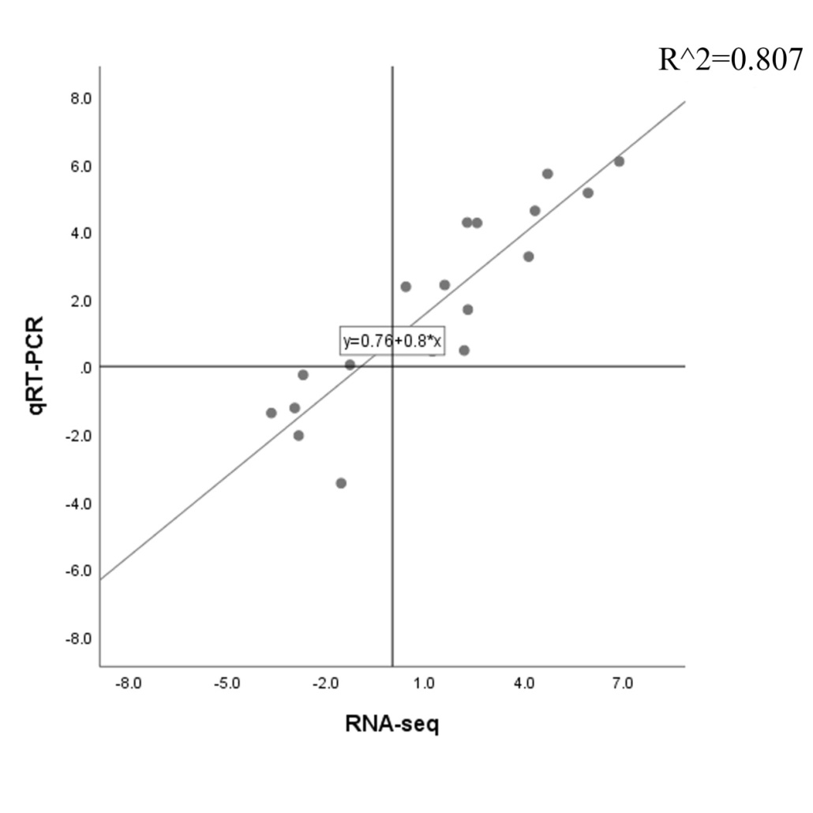
Fig. S2 Correlation analysis of qRT-PCR and RNA-seq

Fig. S3
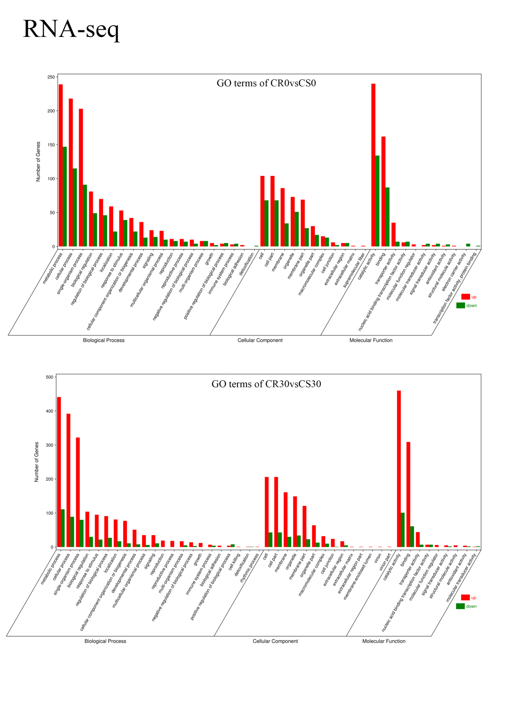
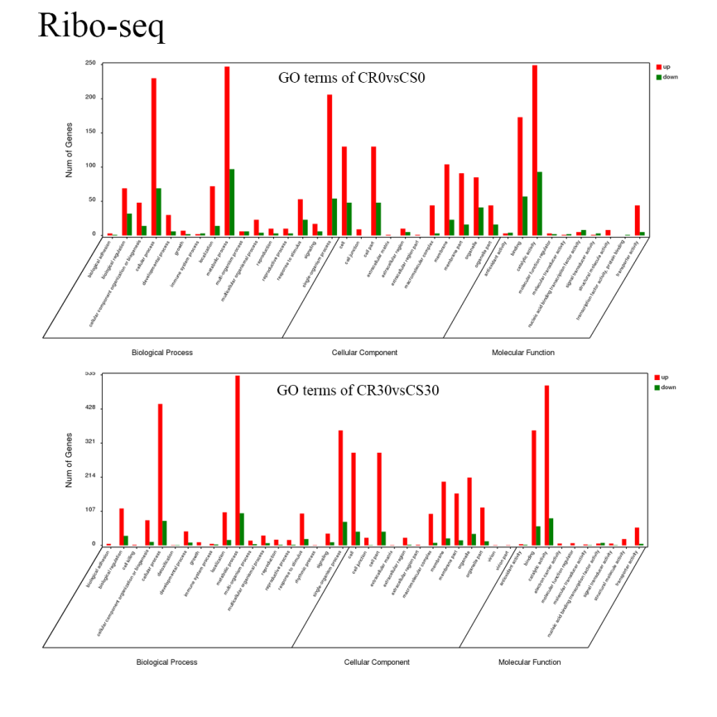Fig. S3 GO classification of transcripts of DEGs. The x-axis indicates number of the GO term, and the y-axis indicates DEGs.

Fig. S4
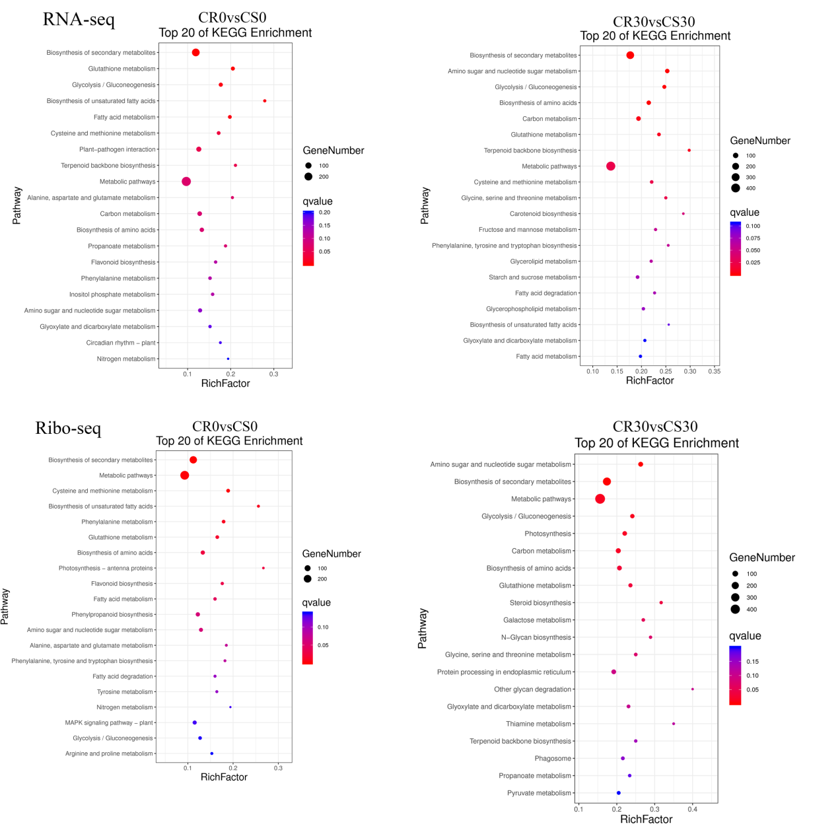
Fig. S4 The top 20 KEGG pathways enriched by DEGs. The x-axis indicates the richfactor, and the y-axis indicates the pathway names.

Fig. S5

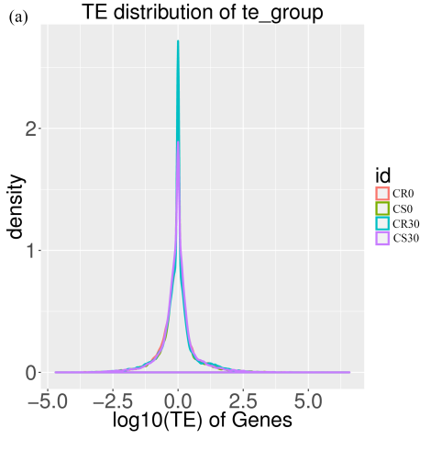
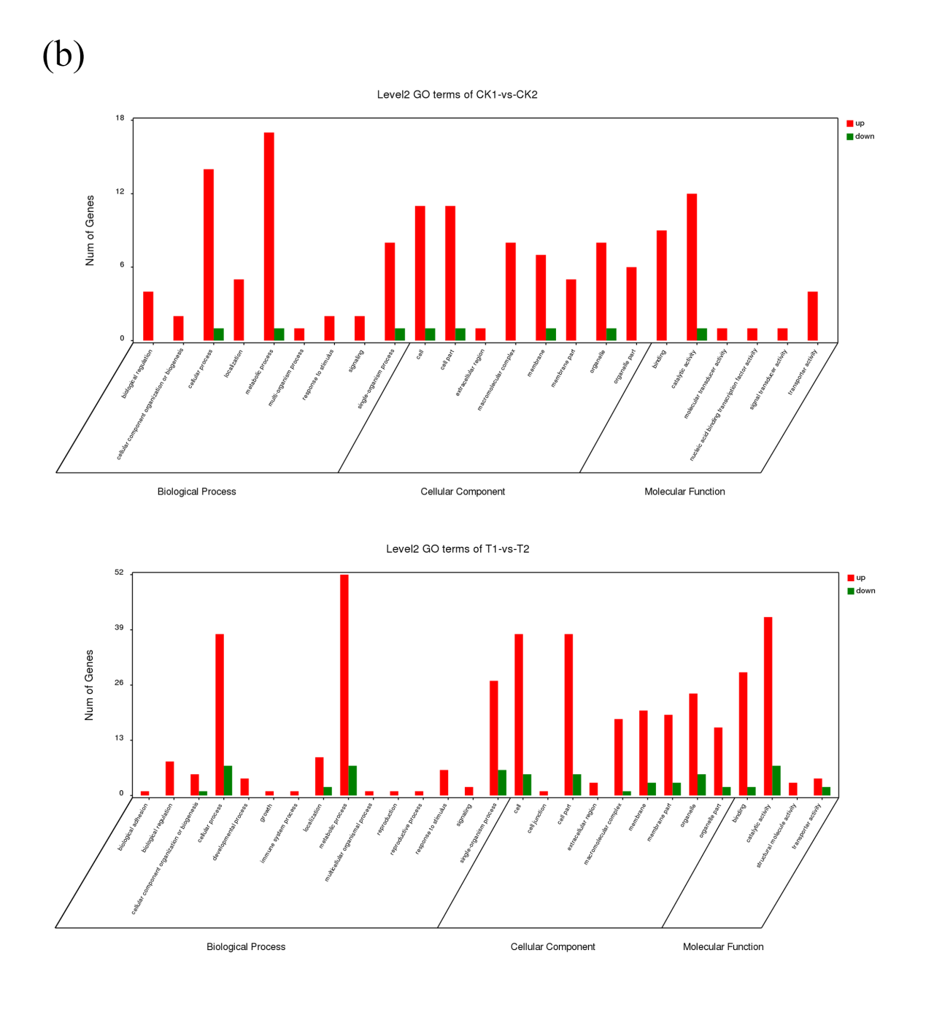
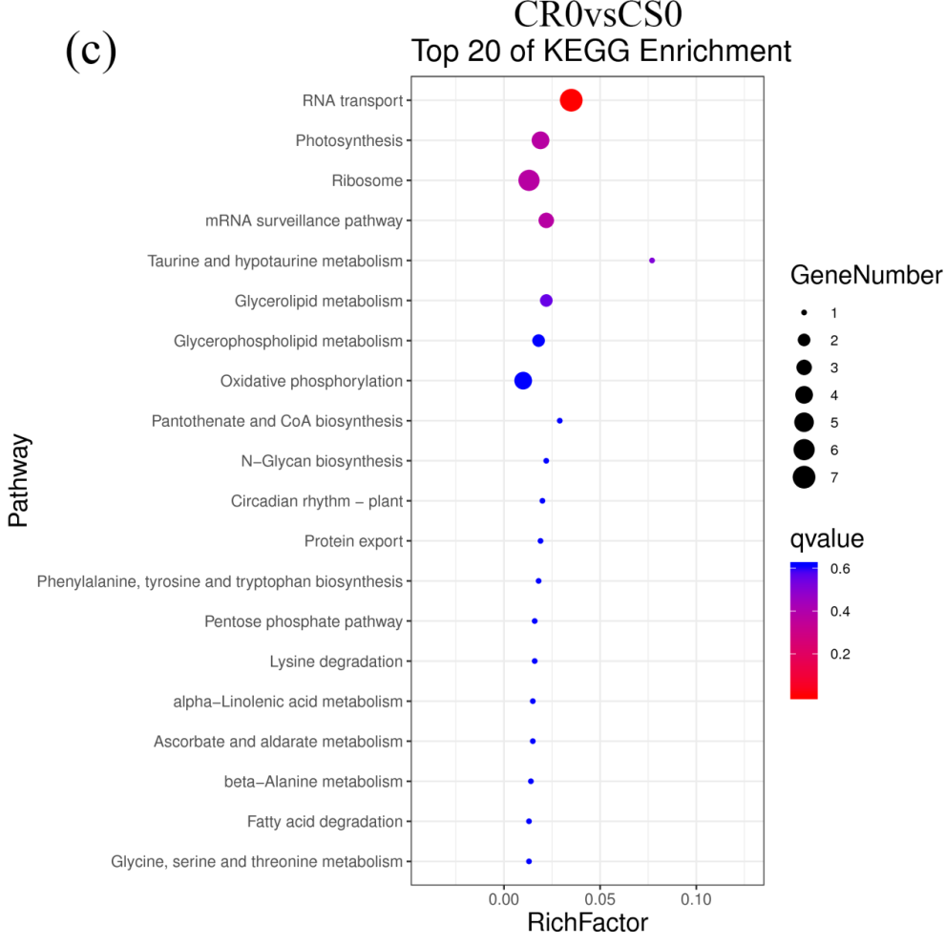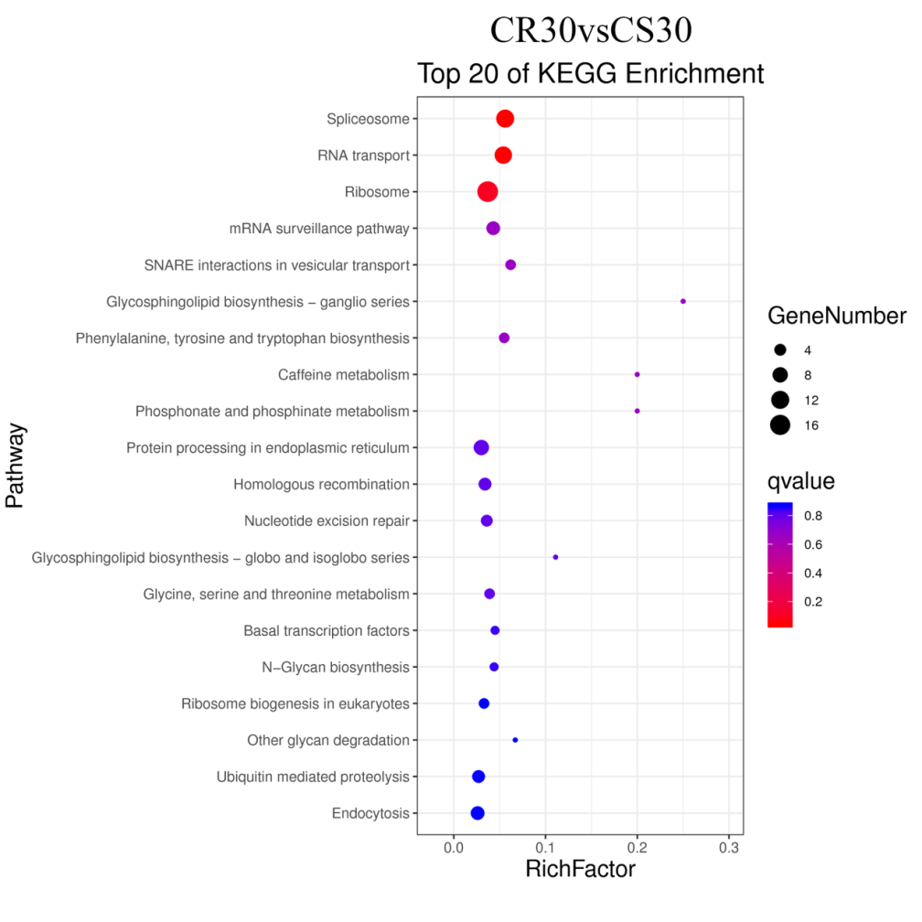
Fig. S5 (a) Translation efficiency calculation; (b) GO classification of transcripts of DTEGs. The x-axis indicates number of the GO term, and the y-axis indicates DTEGs; (c) The top 20 KEGG pathways enriched by DTEGs. The x-axis indicates the richfactor, and the y-axis indicates the pathway names.

