Additional file 1

Genes Encoding Vascular Cambium Activity of Eucalyptus Urophylla × E. Grandis Revealed by Transcriptomic Analyses
Guo Liu^{1,2}, Zhihua Wu², Jianzhong Luo^{1,2}, Chubiao Wang², Xiuhua Shang², Guowu Zhang^{2*}

1 State Key Laboratory of Tree Genetics and Breeding aboratory, Chinese Academy of Forestry, Beijing, China;
2 Research Institute of Fast-growing Trees, Chinese Academy of Forestry, Zhanjiang, China;
* corresponding author: fyzgwu@163.com
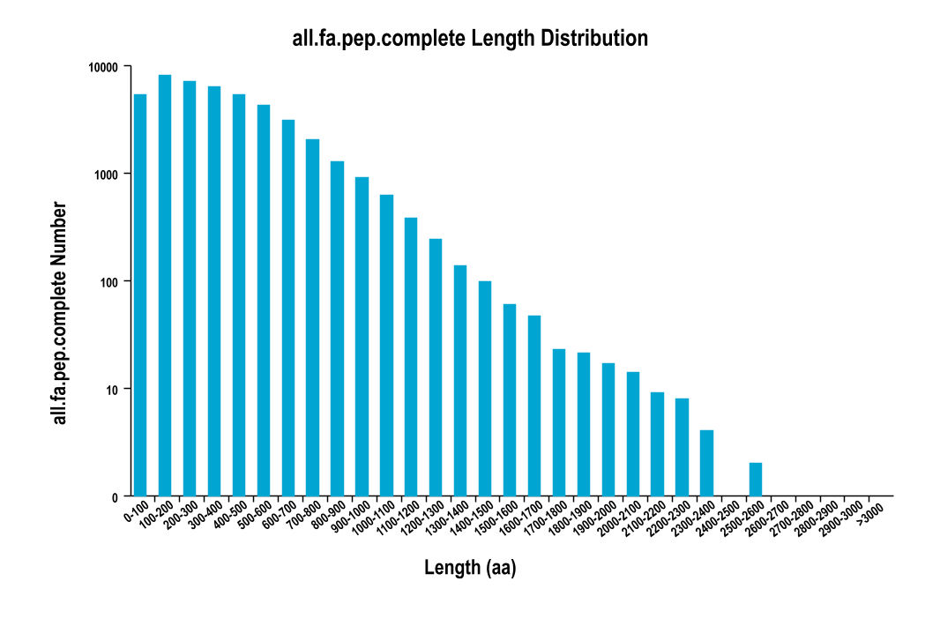
Figure S1. The predicted length distribution of the complete-CDS-encoded protein.
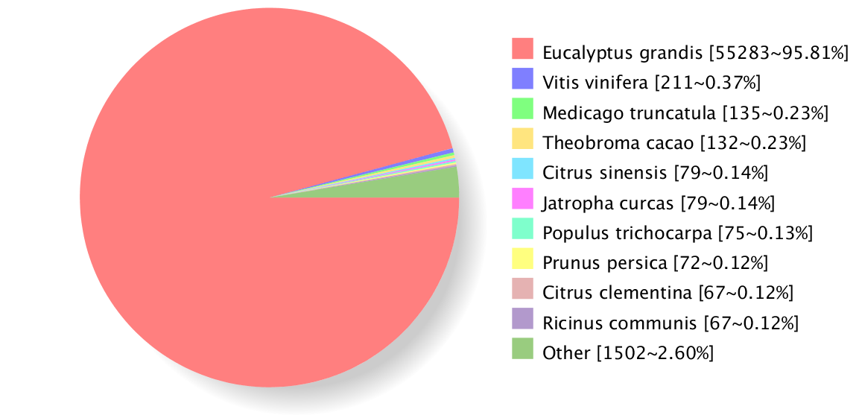
Figure S2. The Nr annotated species taxonomic statistical map of all transcripts.
Note: Different colors represent different species.
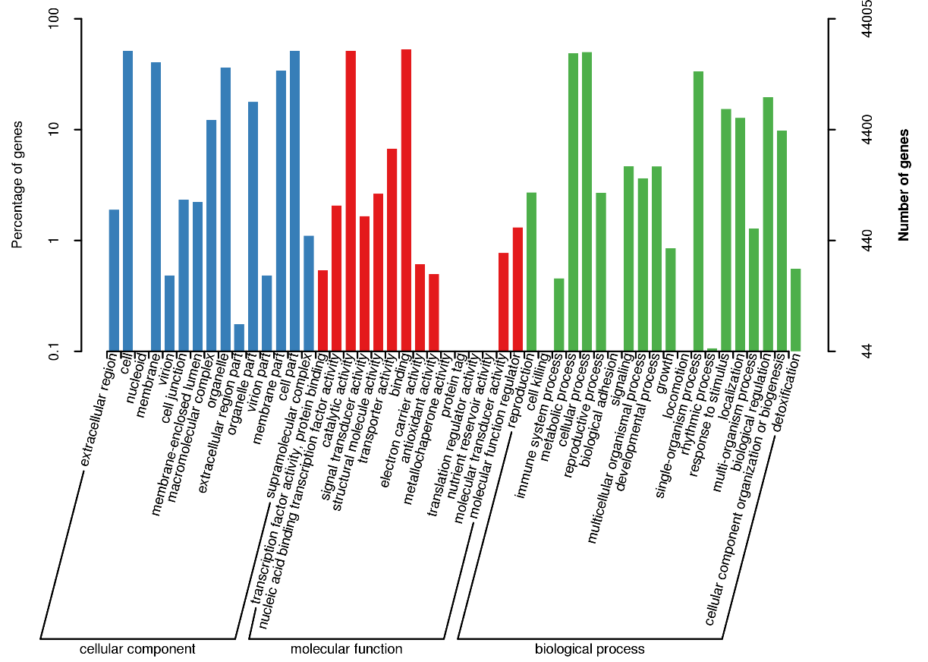
Figure S3. GO categories for all transcripts in the transcriptome.
The right y-axis represents the number of transcripts in a category and the left y-aixs represents the percentage of transcripts in a category.
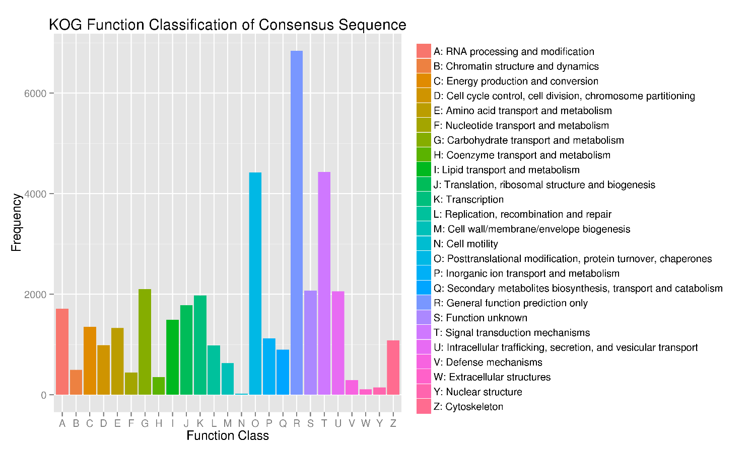
Figure S4. KOG functional classification for the transcriptome sequences.

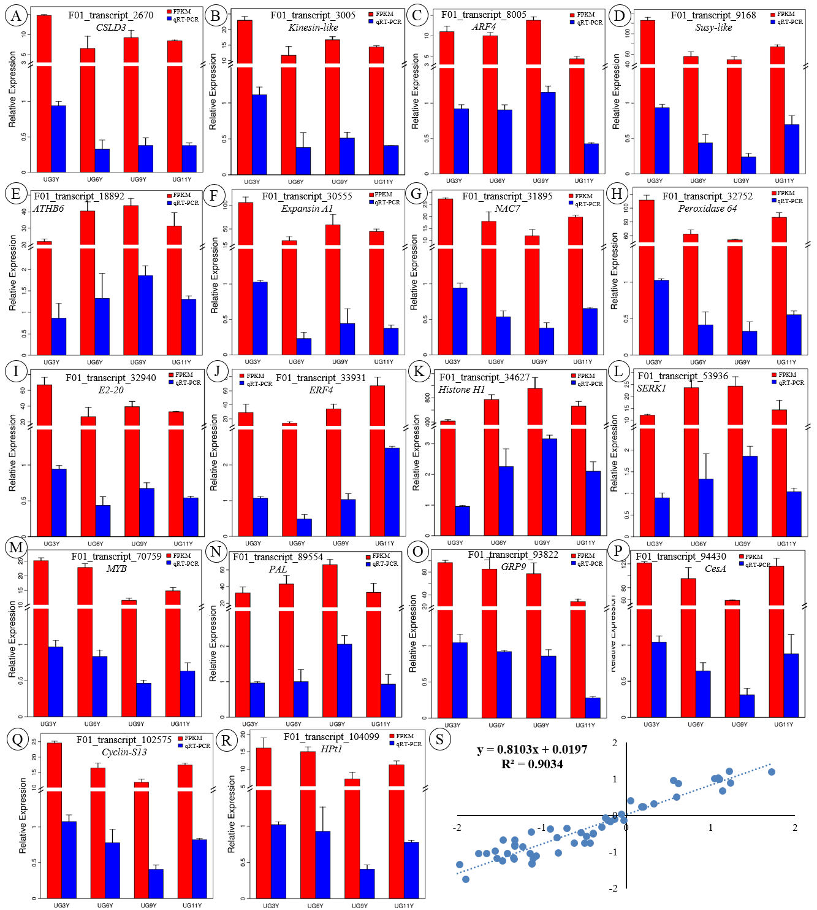
Figure S5. (A-R) The expression profles (FPKM) in the transcriptome and RT-qPCR results of 18 candidate genes. (S) The correlation between qRT-PCR and the transcriptome data, as shown by values of log₂(RPKM ratios) obtained by RNA-seq (x-axis), plotted against the values of log₂(relative expression ratios) obtained by RT-qPCR (y-axis) for the 18 candidate genes. Each sample was analyzed in three biological replicates (significant differences at p <0.05).

