Supporting information

Supplementary Table 1. Primer sequences used in pyrosequencing
Assay name | Forward primer (1st step PCR) | Reverse primer (1st step PCR) | Forward primer (2nd step PCR) | Reverse primer (2nd step PCR) | Sequencing primer
 | sequence | sequence | sequence | sequence | sequence
DPYS | TTAGTTTTTTAGGGGGGAGGAGT | ACCCCCCAACTCTACCTCAAAC | TTAGTTTTTTAGGGGGGAGGAGT | U-ACCCCCCAACTCTACCTCAAAC | GTAGTATATGAGGTTAGGTTATAAAT
N33 | GYGYGTGGAGGAGATATTGTTT | CATTCTACCTCCTTTTTCTTCTAT | GYGYGTGGAGGAGATATTGTTT | U-CATTCTACCTCCTTTTTCTTCTAT | GTTTTTTTAAGTAGTAGGTAAG
SLC16A12 | TAGAGGGAGAGGTGGTTTAGGTGAT | CACCCAAATTAAAATCCCAAACTC | TAGAGGGAGAGGTGGTTTAGGTGAT | U-CACCCAAATTAAAATCCCAAACTC | AAGGGTATTTTTTAAGGAAG
miR124a1 | AAAGGTGAAAGAAAGGAAGAGG | TCTCCCACTTCCACCCACA | GGGTGGGTAGAAGATGGAATAA | U-CCACCAAAAAAATACTATAATCCC | AATTAGGAAAAAGAAATAAA
miR34bc | ATAGTTTAATTGTATTTGGAGAAA | ACCTTCCAAAAAAAATACCTAA | ATAGTTTAATTGTATTTGGAGAAA | U-ACCTTCCAAAAAAAATACCTAA | GGGTAGGTTGAGTAGGAT
U =biotin labeled universal primer tag: 5'-biotin-GGGACACCGCTGATCGTTTA

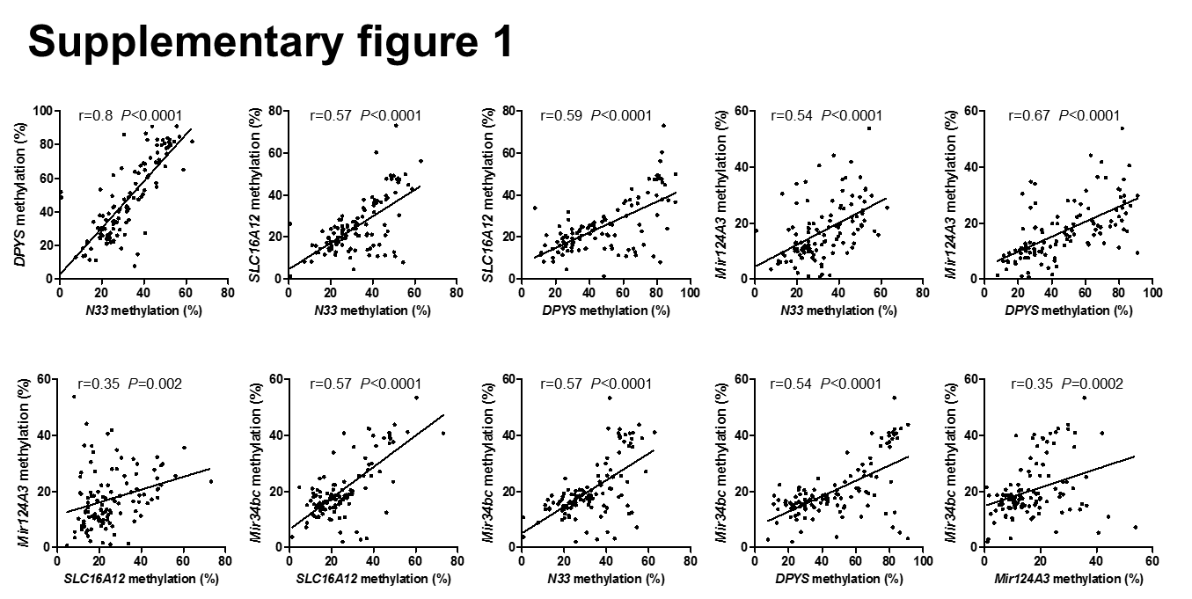

Supplementary figure 1. Correlations of methylation status of five gene promoters (DPYS, N33, SLC16A12, miR124a3 and miR34bc). Statistical analysis was performed using the Spearman correlation analysis.

