SUPPORTING INFORMATION for

Effect of organic matter addition on cadmium solubility in alkaline paddy soils

Zhaoyang Sun1,2, Wenjun Zhang2, Hongwen Sun2, Jiaping Wang3, Qiusheng Chen4, Chaolei Yuan1,2*

1 School of Agriculture, Sun Yat-sen University, Shenzhen, 518107, China
2 MOE Key Laboratory of Pollution Processes and Environmental Criteria, College of Environmental Science and Engineering, Nankai University, Tianjin 300350, China
3 College of Agriculture, Shihezi University, Shihezi 832000, China
4 Institute of Agro-product Safety and Nutrition, Tianjin Academy of Agricultural Sciences, Tianjin 300381, China

*Corresponding author: yuanchlei@mail.sysu.edu.cn (C. Yuan)

Table S1. Information for paddy soils used ª
 | Sandy loam paddy soil | Silt loam paddy soil | Silty clay paddy soil
Coordinates of sampling site | 29°56'39"N  112°36'13"E | 29°56'27"N  112°35'48"E | 29°55'54"N  112°35'25"E
pH (1:5 soil: water) | 8.17 | 7.87 | 7.92
Total organic carbon (g kg⁻¹) | 3.8 | 10.4 | 13.2
Total inorganic carbon (g kg⁻¹) | 11.0 | 9.7 | 8.9
Total nitrogen (g kg⁻¹) | 0.61 | 1.54 | 1.59
Total sulfur (g kg⁻¹) | 0.04 | 0.21 | 0.16
Total cadmium (mg kg⁻¹) | 0.24 | 0.57 | 0.89
Total arsenic (mg kg⁻¹) | 10.5 | 14.7 | 18.5
Total manganese (mg kg⁻¹) | 523.8 | 577.8 | 849.9
Total iron (g kg⁻¹) | 42.3 | 44.5 | 63.3
Sand (%) | 54.1 | 35.8 | 11.4
Silt (%) | 43.8 | 51.2 | 47.4
Clay (%) | 2.1 | 13.0 | 41.2
ª For the measurement of soil pH, 10 mL Milli-Q water was added to 2 g air-dried soil. After shaking for 30 min at 120 rpm, the soil suspension stood for 30 min at room temperature, and the pH of the supernatant was then read by a pH electrode (Model IJ44A, Ionode, Australia). Total organic carbon was determined using the Walkley-Black method Nelson and Sommers (1996), and total inorganic carbon was determined using the modified pressure-calcimeter method (Sherrod et al., 2002). Total soil nitrogen was determined using an elemental analyzer (EA3000, EuroVector, Italy). Total soil sulfur was measured according to Butters and Chenery (1959). To determine total soil cadmium, arsenic, manganese, and iron, 0.1 g of soil was digested with 7 mL of concentrated nitric acid and 3 mL of hydrofluoric acid in a microwave oven, and then analyzed with an inductively coupled plasma-mass spectrometry (ICP-MS) (Elan DRC-e, PerkinElmer, USA). Soil particle size was measured using the hydrometer method (Gee and Bauder, 1986); the size range is 2.00-0.05 mm for sand, 0.05-0.002 mm for silt, and < 0.002 mm for clay.

Table S2. Selected properties of plant residues used ª
 | Rice straw | Alfalfa
pH (1:5) | 6.53 | 5.44
Total carbon (g kg⁻¹) | 397.9 | 405.0
Total nitrogen (g kg⁻¹) | 7.93 | 37.75
C/N ratio | 50 | 11
Total sulfur (g kg⁻¹) | 0.38 | 0.33
Total cadmium (mg kg⁻¹) | 0.78 | 0.05
Total arsenic (mg kg⁻¹) | 0.38 | 0.08
Dissolved organic carbon (g kg⁻¹) | 49.0 | 174.8
ª The pH measurement method was the same as that for soil. Total carbon and nitrogen of plant residues were determined with an elemental analyzer (EA3000, EuroVector, Italy). Total sulfur of plant residues was measured according to Tabatabai and Bremner (1970). The determination of total plant cadmium and arsenic was described previously by Qiao et al. (2018). To determine dissolved organic carbon, 2 g of plant residue was shaken with 10 mL of Milli-Q water at 220 rpm and 25 ℃ for 24 h. After centrifugation, the supernatant was filtered using a 0.45 μm filter membrane and then analyzed with a TOC analyzer (Multi N/C 3100, Analytic Jena, Germany) (Hu et al., 2022).

Table S3. Soil DOC (dissolved organic carbon) extracted by H₂O and 0.01 M CaCl₂ from 9 soil treatments. There was no significant difference between DOC concentrations obtained by the two extraction reagents. ª
Soil | OM added | H₂O extractable DOC  (mg kg⁻¹) | 0.01 M CaCl₂ extractable DOC  (mg kg⁻¹)
Sandy loam | 0 | 59.7±1.2 | 58.1±0.7
Sandy loam | 2% rice straw | 657.2±11.3 | 668.0±6.9
Sandy loam | 2% alfalfa | 3271.7±203.6 | 3232.6±14.2
Silt loam | 0 | 67.6±2.2 | 68.4±5.7
Silt loam | 2% rice straw | 491.6±6.3 | 497.4±7.4
Silt loam | 2% alfalfa | 2507.8±48.6 | 2493.1±47.3
Silty clay | 0 | 68.6±3.4 | 67.6±5.1
Silty clay | 2% rice straw | 525.1±16.9 | 534.0±34.4
Silty clay | 2% alfalfa | 2179.5±106.0 | 2093.0±119.7
ª To check whether there is interference between Ca²⁺ and DOC when using 0.01 M CaCl₂ extraction for determining DOC concentration, we compared DOC concentrations extracted by water and 0.01 M CaCl₂ from 9 soil treatments with or without rice straw or alfalfa at 2% addition rate. H₂O extractable DOC was determined in the same way as 0.01 M CaCl₂ extractable DOC described in the main text. Namely, 1 g of soil was weighed into a 50 mL centrifuge tube, and 20 mL of Milli-Q water was added. Then, the tubes were closed tightly and shaken end-over-end at 50 rpm and room temperature for 1 h. After centrifugation at 7800 rpm for 2 min, the supernatants were passed through 0.22 µm membrane filters. The extracts were acidified by adding 0.2 mL of 1 M HCl to 20 mL of the filtered supernatant and then analyzed with a TOC analyzer (Multi N/C 3100, Analytic Jena, Germany).
Table S4. Correlation matrix of soil factors at week 4 (after 4 weeks of flooding). (Pearson; n = 9 (only data for the unamended control soils were shown because in all soils with added OM the dissolved Cd concentration was under detection limit); only R values with adjusted P < 0.05 were shown) ª
 | Cd²⁺ | pH | Eh | Fe²⁺ | DOC | NO₃⁻-N | NH₄⁺-N | DON | TOC | TIC
Cd²⁺ | 1
pH |  | 1
Eh |  |  | 1
Fe²⁺ |  |  | 0.924 | 1
DOC |  |  | -0.857 | -0.917 | 1
NO₃⁻-N |  |  |  |  |  | 1
NH₄⁺-N |  | 0.942 |  |  | 0.845 |  | 1
DON |  | 0.915 |  |  |  |  | 0.812 | 1
TOC | -0.821 |  | -0.977 | -0.857 |  |  |  |  | 1
TIC |  |  |  |  |  |  |  |  |  | 1
ª Cd²⁺, dissolved soil Cd; Fe²⁺, dissolved soil Fe²⁺; DOC, dissolved organic carbon; DIC, dissolved inorganic carbon; NO₃⁻-N, nitrate-nitrogen; NH₄⁺-N, ammonium-nitrogen; DON, dissolved organic nitrogen; TOC, total organic carbon; TIC, total inorganic carbon.
Table S5. Correlation matrix of soil factors at week 8 (after 4 weeks of drying). (Pearson; n = 90; only R values with adjusted P < 0.05 were shown) ª | Cd²⁺ | pH | Eh | DOC | NO₃⁻-N | NH₄⁺-N | DON | TOC
Cd²⁺ | 1
pH | 0.836 | 1
Eh | -0.542 | -0.657 | 1
DOC | -0.397 | -0.257 |  | 1
NO₃⁻-N |  |  | 0.436 |  | 1
NH₄⁺-N | -0.461 |  |  |  |  | 1
DON |  |  | 0.306 |  | 0.667 |  | 1
TOC | -0.932 | -0.850 | 0.655 | 0.356 | 0.286 | 0.377 |  | 1
ª For abbreviations of soil properties, see Table S4. Dissolved Fe²⁺ concentration was not included because it was below the detection limit in all treatments at week 8.

Table S6. Effects of OM addition on Cd adsorption by soil. Data are dissolved Cd concentrations (μg L⁻¹) after 0.4 g of soil from each treatment was shaken with 25 mL of CdCl₂ solution containing 1000 μg L⁻¹ Cd²⁺ for 24 h. Control, no OM added; Mix, 1:1 mixture of rice straw and alfalfa.
Soil | Control |  | Rice straw |  |  |  | Alfalfa |  |  |  | Mix
Soil | Control |  | 0.5% | 1% | 2% |  | 0.5% | 1% | 2% |  | 0.5% | 1% | 2%
Sandy loam | 45.82 |  | 43.59 | 41.30 | 38.06 |  | 44.21 | 40.86 | 37.58 |  | 43.26 | 40.81 | 37.82
Silt loam | 29.93 |  | 28.59 | 26.41 | 24.96 |  | 28.36 | 26.65 | 24.33 |  | 29.09 | 27.35 | 25.16
Silty clay | 19.41 |  | 18.89 | 18.29 | 17.41 |  | 18.83 | 18.41 | 17.36 |  | 18.80 | 18.53 | 17.29

Table S7. Correlation matrix of soil factors (including TIC) at week 8 (after 4 weeks of drying). (Pearson; n = 77 ª; only R values for adjusted P < 0.05 were shown) ^{b}
 | Cd²⁺ | pH | Eh | DOC | NO₃⁻-N | NH₄⁺-N | DON | TOC | TIC
Cd²⁺ | 1
pH | 0.821 | 1
Eh | -0.448 | -0.588 | 1
DOC | -0.363 |  |  | 1
NO₃⁻-N |  |  | 0.362 |  | 1
NH₄⁺-N | -0.468 |  | -0.271 |  |  | 1
DON |  |  | 0.291 |  | 0.663 |  | 1
TOC | -0.940 | -0.830 | 0.540 | 0.345 |  | 0.384 |  | 1
TIC | 0.701 | 0.660 | -0.505 | -0.369 | -0.271 |  |  | -0.705 | 1
ª For 13 out of the 90 samples at week 8, there was not enough soil left for TIC (total inorganic carbon) determination. ^{b} For abbreviations of soil properties, see Table S4. Dissolved Fe²⁺ concentration was not included because it was below the detection limit in all treatments at week 8.

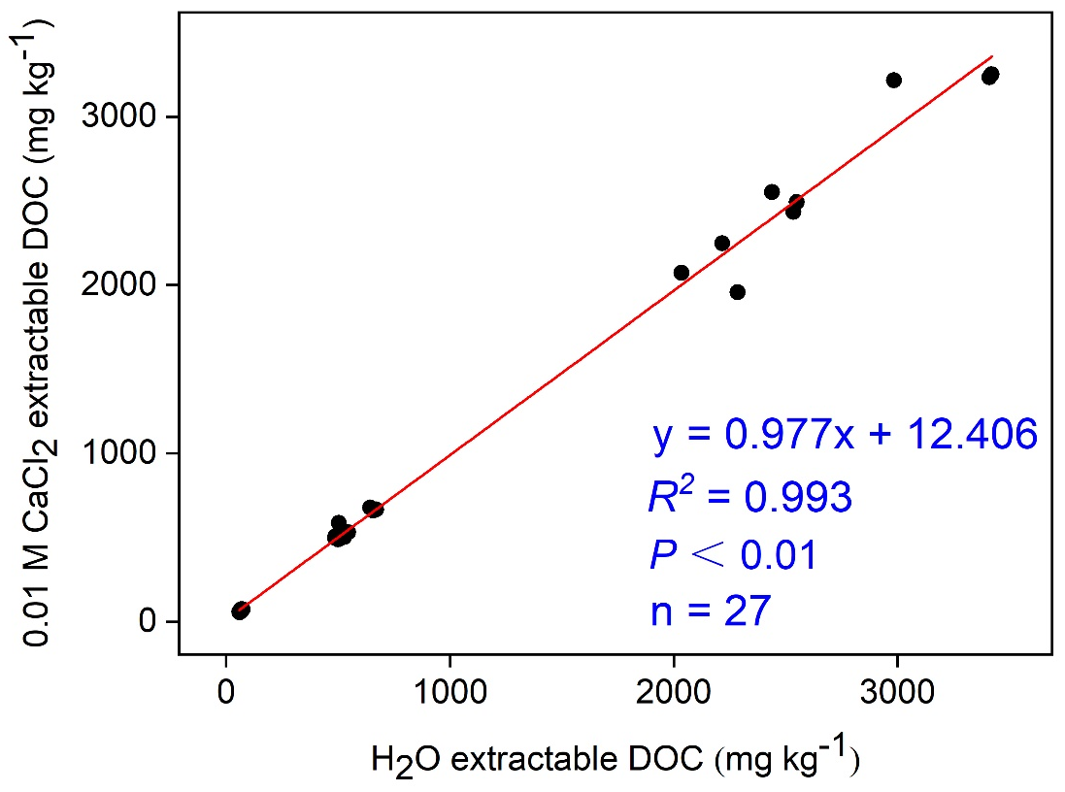
Fig. S1. Correlation between concentrations of soil DOC extracted by H₂O and 0.01 M CaCl₂. For details, see Table S3.

Fig. S2. Eh in three alkaline paddy soils with different textures after 4 weeks of flooding and subsequent 4 weeks of drying. Mix is a 1:1 mixture of rice straw and alfalfa.

Fig. S3. pH in three alkaline paddy soils with different textures after 4 weeks of flooding and subsequent 4 weeks of drying. Mix is a 1:1 mixture of rice straw and alfalfa.

Fig. S4. TOC (total organic carbon) concentration in three alkaline paddy soils with different textures after 4 weeks of flooding and subsequent 4 weeks of drying. Mix is a 1:1 mixture of rice straw and alfalfa.
Fig. S5. DOC (dissolved organic carbon) concentration in three alkaline paddy soils with different textures after 4 weeks of flooding and subsequent 4 weeks of drying. Mix is a 1:1 mixture of rice straw and alfalfa.

Fig. S6. DON (dissolved organic nitrogen) concentration in three alkaline paddy soils with different textures after 4 weeks of flooding and subsequent 4 weeks of drying. Mix is a 1:1 mixture of rice straw and alfalfa.

Fig. S7. NO₃⁻-N concentration in three alkaline paddy soils with different textures after 4 weeks of flooding and subsequent 4 weeks of drying. Mix is a 1:1 mixture of rice straw and alfalfa.

Fig. S8. NH₄⁺-N concentration in three alkaline paddy soils with different textures after 4 weeks of flooding and subsequent 4 weeks of drying. Mix is a 1:1 mixture of rice straw and alfalfa.

Fig. S9. Dissolved Fe²⁺ concentration in three alkaline paddy soils with different textures after 4 weeks of flooding and subsequent 4 weeks of drying. Mix is a 1:1 mixture of rice straw and alfalfa. At weeks 0 and 8, dissolved Fe²⁺ concentration was below the detection limit in all treatments.

Fig. S10. Significant soil predictors (including TIC) of dissolved soil Cd at week 8 (after 4 weeks of drying) identified by random forest regression. At week 4, because the concentration of dissolved Cd in all soils with added OM was below the detection limit, random forest regression was not conducted. Dissolved Fe²⁺ concentration was not included because it was below the detection limit in all treatments at week 8. For 13 out of the 90 samples at week 8, there was not enough soil left for TIC (total inorganic carbon) determination, sample numbers were 77. MSE indicates mean squared error. Significance levels: *, P < 0.05; **, P < 0.01. For abbreviations of soil predictors, see Table S4.

References
Butters, B., Chenery, E.M., 1959. A rapid method for the determination of total sulphur in soils and plants. Analyst 84, 239-245.
Gee, G.W., Bauder, J.W., 1986. Particle-size analysis, in: Klute, A. (Ed.), Methods of Soil Analysis: Part 1—Physical and Mineralogical Methods. Soil Science Society of America and American Society of Agronomy, Madison, pp. 383-411.
Hu, X., Qu, C., Han, Y., Chen, W., Huang, Q., 2022. Elevated temperature altered the binding sequence of Cd with DOM in arable soils. Chemosphere 288, 132572.
Nelson, D.W., Sommers, L.E., 1996. Total carbon, organic carbon, and organic matter. In: Sparks, D.L., Page, A.L., Helmke, P.A., Loeppert, R.H., Soltanpour, P.N., Tabatabai, M.A., Johnston, C.T., Sumner, M.E. (Eds.), Methods of Soil Analysis Part 3—Chemical Methods. Soil Science Society of America and American Society of Agronomy, Madison, pp. 961-1010.
Sherrod, L.A., Dunn, G., Peterson, G.A., Kolberg, R.L., 2002. Inorganic carbon analysis by modified pressure-calcimeter method. Soil Science Society of America Journal 66, 299-305.
Tabatabai, M.A., Bremner, J.M., 1970. A simple turbidimetric method of determining total sulfur in plant materials1. Agronomy Journal 62, 805-806.

