Supplementary material
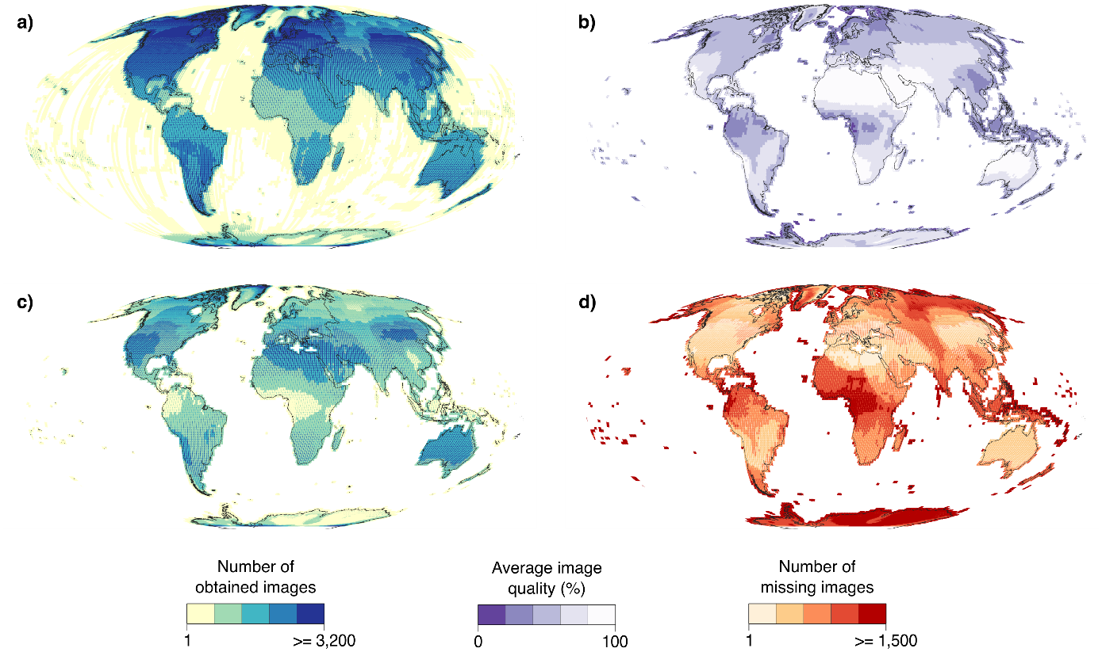
Extended data figure 1. Availability and quality of available Landsat images. a) Number of images collected between 1982 and 2022. Note that the clear linear boundaries of areas of high data availability visible in North America, Europe, the Middle East, and Eastern Asia reflect the visibility areas of receiving stations established in the early stages of the Landsat program that remained active during most of the program’s lifespan (compare Extended Data Fig. 2). b) Average quality of each available image, reflecting the effectiveness of pre-processing and the visibility of the land surface, given cloud cover. c) Number of collected images, weighted by the quality of each image. d) Number of images that were lost due to complete cloud cover or lack of image collection/storage.
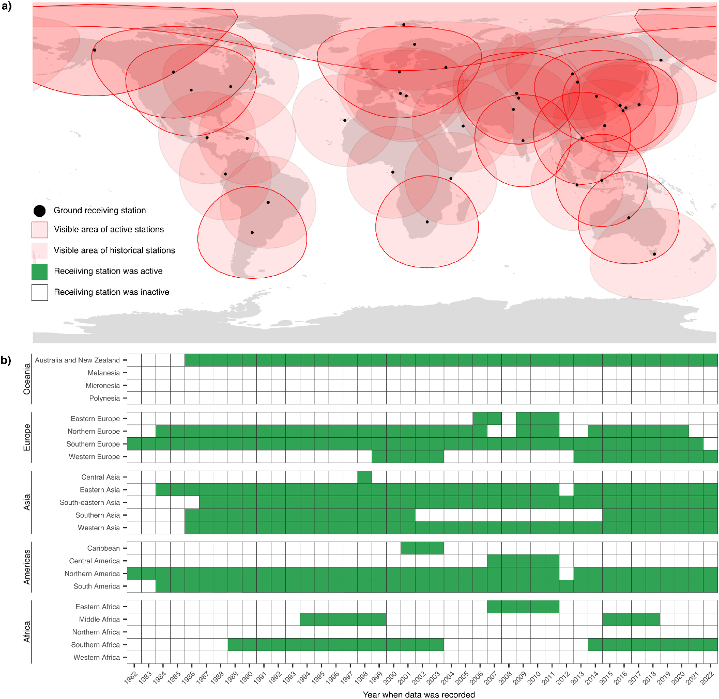
Extended data figure 2. Spatial and temporal coverage of Landsat data receiving stations. a) Each of the 39 original Landsat receiving stations (black markers) had a visibility circle of ~2,700 km (shown in pink) from within which data was received from overpassing satellites and stored. Only 14 stations are still active as pf 2022 (pink with red outlines), covering most of North America, continental Europe, and Oceania, and portions of South America, South Africa, and Russia. Meanwhile, Central, Western, and Eastern Africa, as well as Central America and the northern edges of South America, are now no longer covered by any receiving stations, thus relying fully on the satellites’ on-board storage. b) Temporal variation in data receiving capabilities within different geographical regions. In Asia and North America, most regions have a near complete coverage between 1982 and 2022, the period during which Landsat TM, ETM, and OLI missions were active. Still, some sub-regions are covered poorly (between 1-5 years), such as Central Asia, the Caribbean, and Central America. In Oceania, small island territories in Melanesia, Micronesia and Polynesia lack receiving capabilities. In the same continent, while Australia and New Zealand compose one region, only Australia actively collected data.
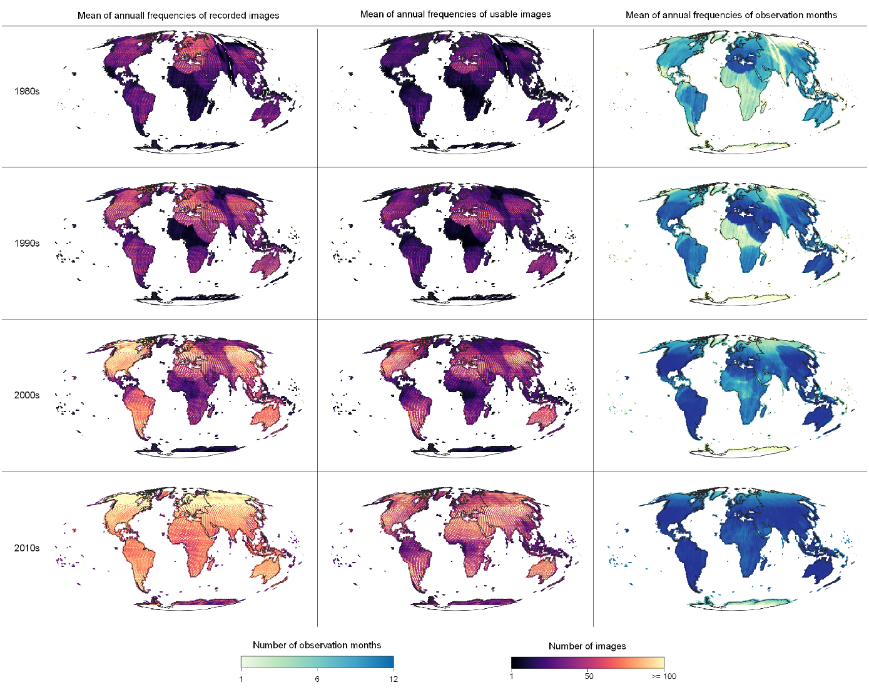
Extended Data Figure 3. Decadal changes in Landsat data coverage and quality. Historical variation in the within-year quality of daytime Landsat images for three quality metrics across four decades. Left column: average number of images available for downstream applications. Middle column: the same quantity, weighted by the quality of individual images. Right column: number of months with usable images.
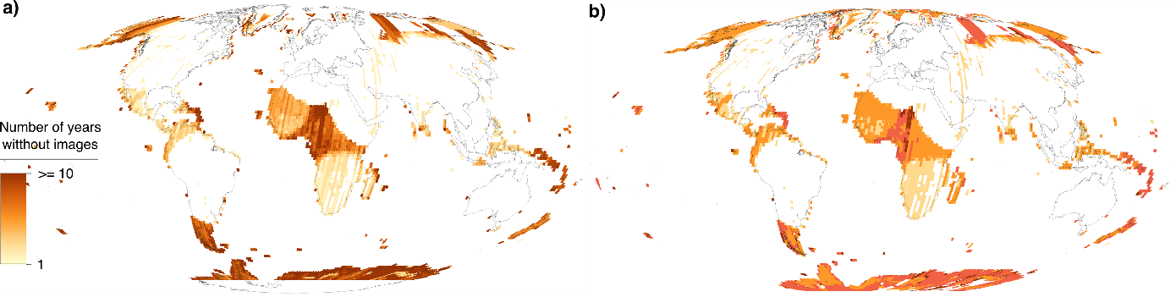
Extended data figure 4. Extended interruptions in temporal Landsat data coverage. a) Total number of years lacking any usable Landsat images, showing interruptions in year-to-year continuity of the Landsat archive. Only data gaps registered after the first imaging year are considered. b) Largest number of consecutive years without any data (after first imaging year).

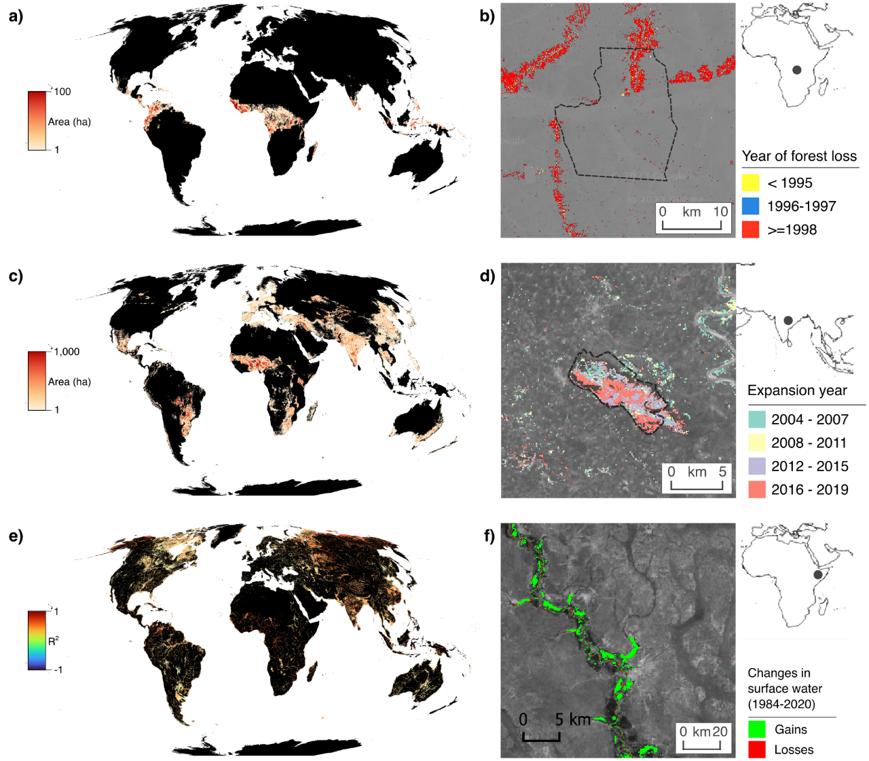
Extended Data Figure 5. Land change areas in doubt, due to associated changes in Landsat data coverage and quality. Panels a), c), and e) map areas of doubtful changes (compare Fig. 3) at a 10-km resolution. Panels b), d), and f) showcase local examples where Landsat data limitations affect perceived land changes, as inferred from Landsat-based time-series products. a) Doubtful areas of deforestation mapped into years directly following ≥1-year periods without data, casting doubt on true timing of deforestation events. b) Forest losses mapped by the TMF inside/surrounding the Luo Scientific Reserve, DRC (delineated by dashed black line) during the 1990s, showing that deforestation is mostly mapped into period after the end of the first Congo war (1996-1997), when Landsat data were again available, even though in-situ evidence largely attributes this deforestation to human displacement during the war. c) Doubtful arable-land gains mapped by the GLAD product in countries/periods for which FAO statistics report losses, which simultaneously, the quality-weighted frequency of Landsat images improved, thus likely representing overestimations by the Landsat-based GLAD product. d) Arable-land gains mapped by the GLAD product inside the Bakhira Wildlife Sanctuary (a protected Ramsar wetland and Important Bird Area in Northern India). Nearly the entire wetland area is re-classified into arable-land by the GLAD mapping algorithm over the two mapping epochs following the 2013 launch of Landsat 8, which massively increased coverage and quality of images, which moreover have impaired interoperability with images from earlier Landsat missions. By inspecting historical time-series of high-resolution imagery (using Google Earth Pro), we found these changes to be entirely artefactual. e) Doubtful increases in global, seasonal surface-water extents that may reflect increasing Landsat data coverage and quality. Colors indicate directions and strengths of (nearly exclusively positive) statistical associations of multi-annual trends between i) proportions of 10-km pixels that are perceived by the GSW product as being covered by seasonal surface water, and ii) annual numbers of months with usable Landsat observations. f) Seasonal surface-water gains mapped by the GSW regionally misrepresent true surface-water losses, such as those along the drying Jubba river (Somalia), caused by droughts within the Horn of Africa.
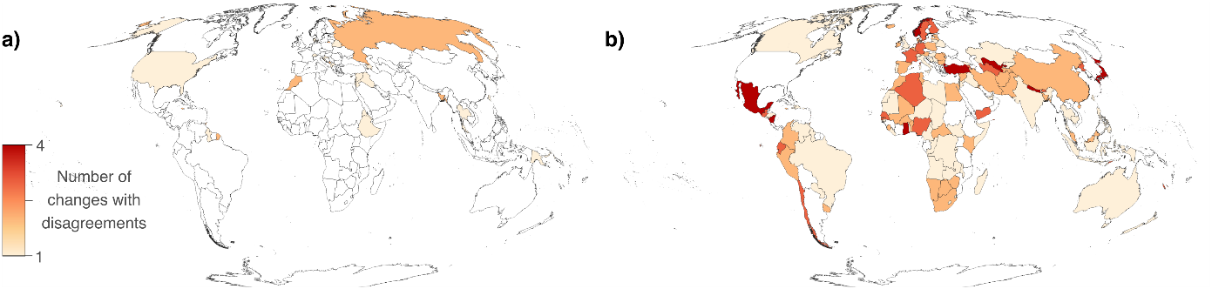
Extended Data Figure 6. Disagreeing reports of arable-land extents. Both maps show frequencies of changes in the GLAD product that disagree in change direction with changes reported in national FAO statistics on arable-land areas. a) Instances where GLAD maps losses whereas statistics indicates gains. b) Instances where GLAD maps gains whereas statistics map losses. Comparing a) and b) shows that whereas cases where GLAD potentially mischaracterizes true arable-land gains as losses are rare, those cases where GLAD potentially mischaracterizes true losses as gains are common and occur globally.
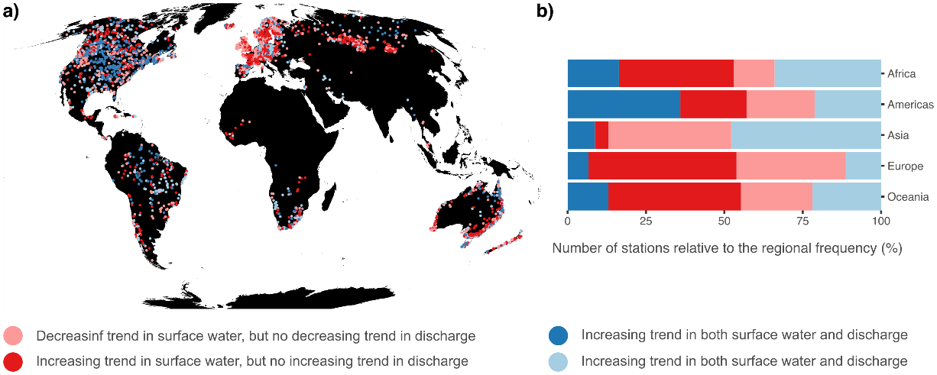
Extended Data Figure 7 – Comparison of trends in seasonal surface water between GSW and gauge station data. a) Locations of gauge-station records of water-discharge changes that were compared against changes in the percentages of upstream hydrological (sub-)basins that are covered by seasonal surface water according to the Landsat-based GSW product. Colours indicate qualitative agreement/disagreement on significant directional trends (p<0.05, based on Mann-Kendall tests) between discharge measurements (gauge stations) and seasonal surface-water data (GSW). Bright red: perceived increasing trends in surface-water cover are not supported by increasing discharge trends; pale red: perceived decreasing trends in surface-water cover not supported by decreasing discharge trends; bright blue: perceived decreasing trends in surface-water cover supported by decreasing discharge trends; pale blue: perceived increasing trends in surface-water cover supported by increasing discharge trends. b) Percentages of hydrological (sub-)basins per continent showing each type of agreement/disagreement between recorded water-discharge (gauge stations) and perceived seasonal surface-water trends.

