Supplementary Material to the paper Assessment of the superior photocatalytic properties of Sn²⁺-containing SnO₂ microrods on the photodegradation of methyl orange

Alexandre de Oliveira Jorgetto¹*, Maria Valnice Boldrin Zanoni², Marcelo Ornaghi Orlandi¹

¹ Department of Engineering, Physics and Mathematics, São Paulo State University (UNESP), Araraquara, SP 14800-060, Brazil.
² Unesp, National Institute for Alternative Technologies of Detection, Toxicological Evaluation and Removal of Micropollutants and Radioactives (INCT-DATREM), Institute of Chemistry, São Paulo State University (UNESP), P.O. Box 355, Araraquara, SP 14800-900, Brazil.
* corresponding author: alexandre.jorgetto@unesp.br
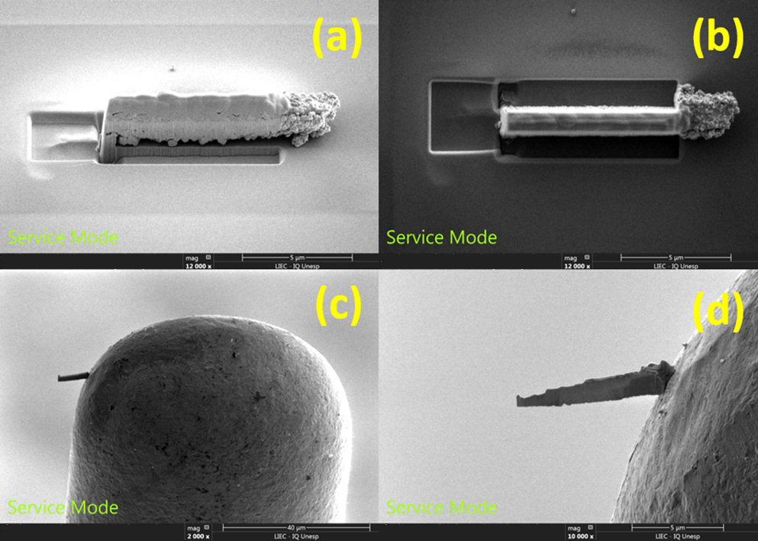
Figure S1. Lateral (a) and top (b) perspectives of the SnO₂/Sn²⁺ microrod being thinned out in the FIB microscope. It is possible to notice the protective layer of carbon and platinum at the surface of the microrod. Image (c) shows the section of the microrod welded on a FIB lift-out sample holder, which was further thinned out with the ion beam (d) prior to the HR-TEM analysis.
Figure S2. Histograms exhibiting the percent distribution of particles in terms of their length (a) and width (b) of the microrods.

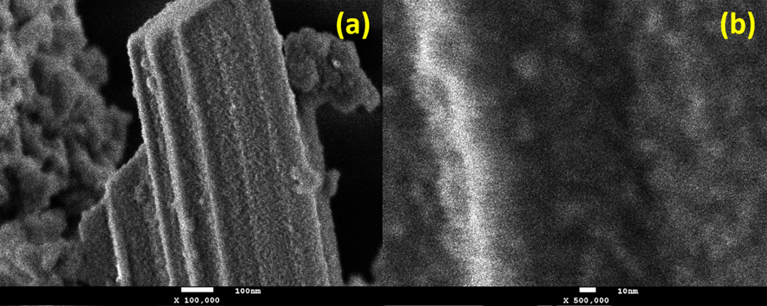
Figure S3. SEM images of a “smooth” SnO₂/Sn²⁺ microrod amplified 100 k× (a) and 500 k× (b).
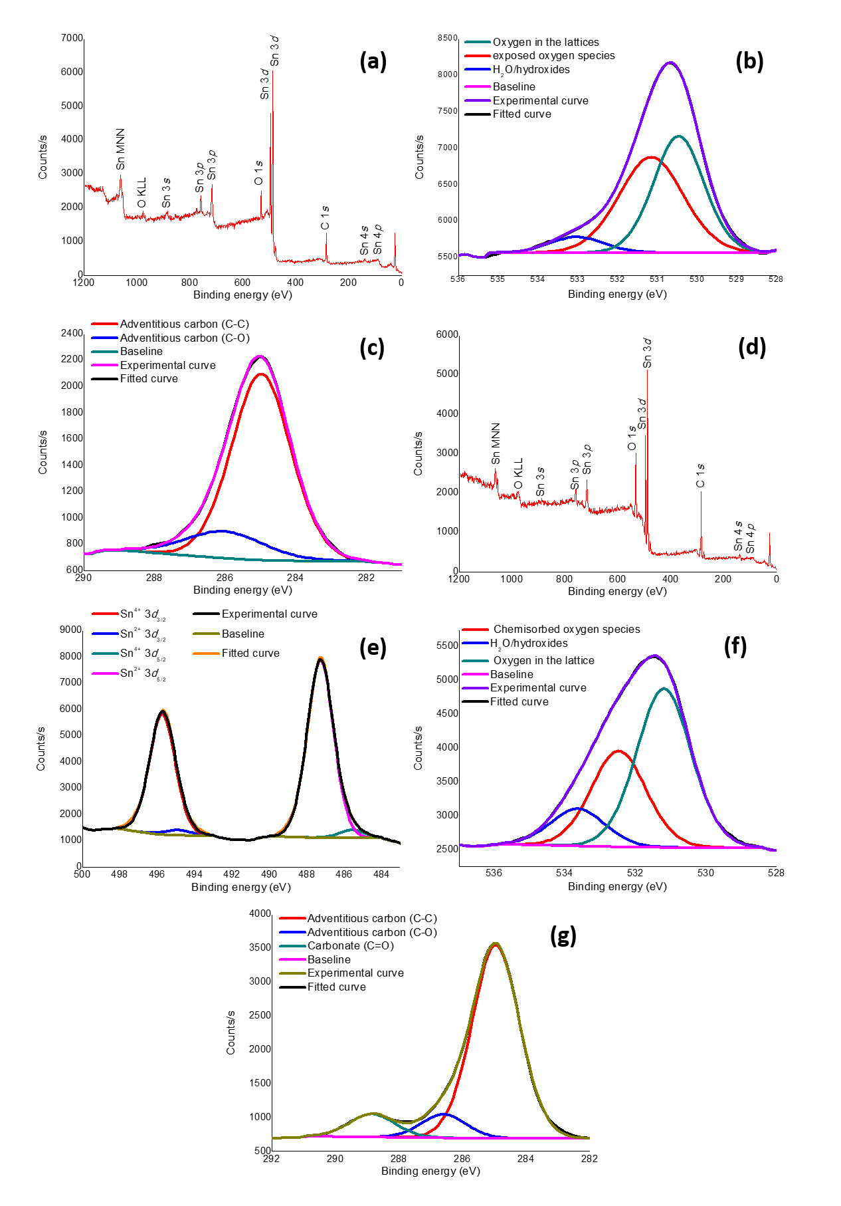
Figure S4. Results of the XPS analysis exhibiting the survey (a) and high-resolution spectra of the peaks of O 1s (b) and C 1s (c) of the sputtered SnO₂/Sn²⁺ material, and the survey (d) and high-resolution spectra of the peaks of Sn 3d (e), O 1s (f) and C 1s (g) of the sputtered SnO₂/Sn²⁺ material.
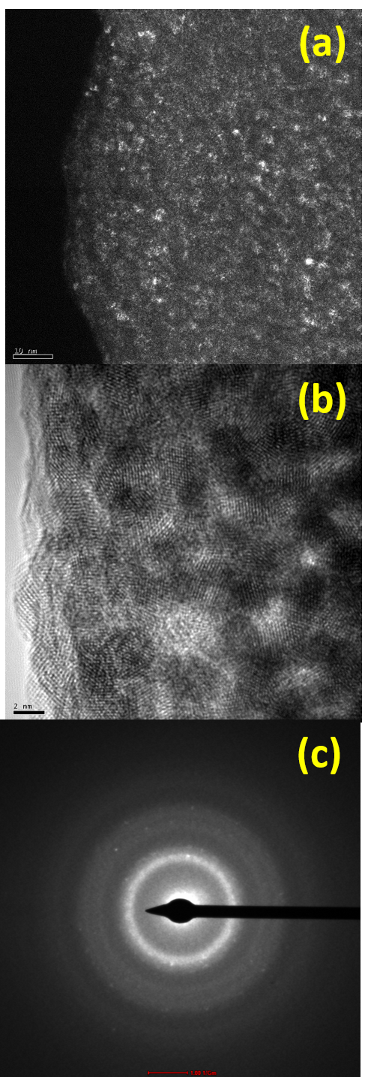
Figure S5. Dark field TEM (a) and HR-TEM (b) images along with the SAED analysis (c) of the internal structure of a SnO₂/Sn²⁺ microrod collected at its subsurface.


Figure S6. SAED analysis of a single nanosphere attached to the surface of a SnO₂/Sn²⁺ microrod

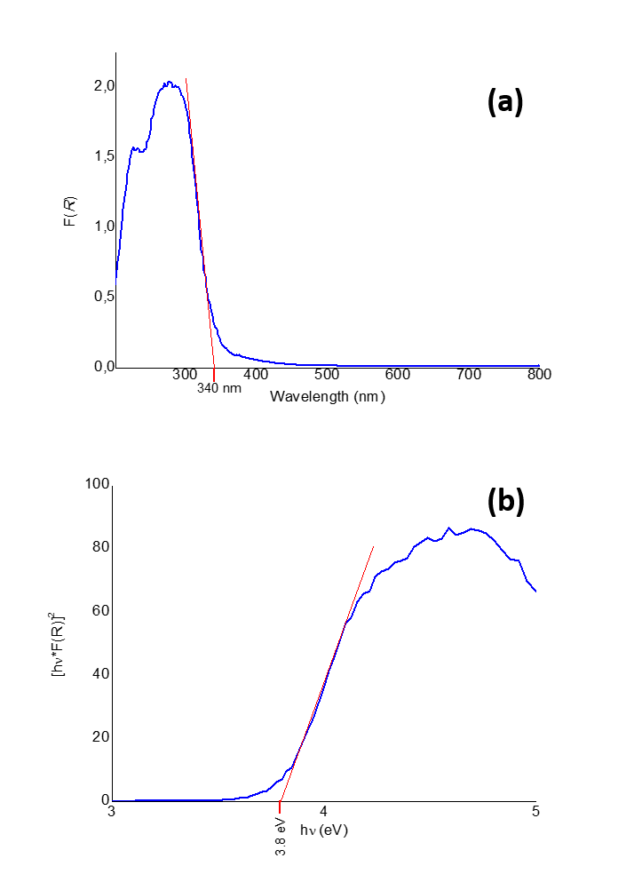
Figure S7. Results of the UV-Vis DRS analysis carried out for SnO₂ annealed at 1000 °C in air for 2 h, exhibiting its Kubelka-Munk (a) and Tauc (b) plots.
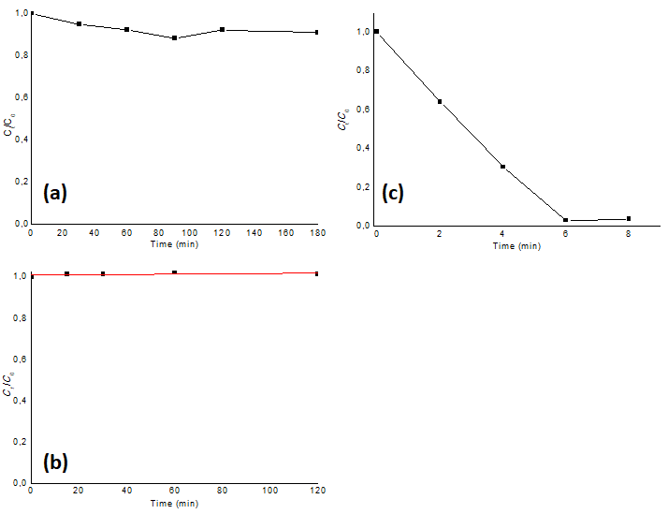
Figure S8. Adsorption test (dark regime) (a), photolysis test without material (b) and photodegradation of MO at a photocatalyst dose of 5.33 g L⁻¹ (c).

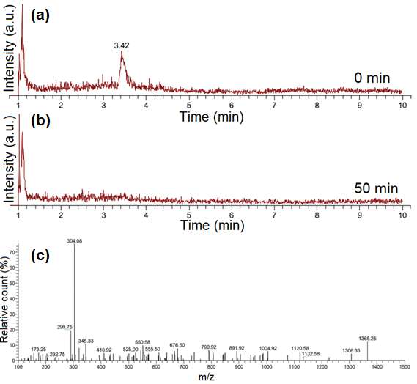
Figure S9. Chromatograms of samples collected at time 0 min (a) and after 50 min (b) of photodegradation with the material SnO₂/Sn²⁺. The peak at 3.42 min in the first chromatogram correspond to the fragment m/z = 304.08 (c), relative to the anionic structure of the MO.

In the chromatogram of Fig. S9 (a), it is possible to notice a peak at retention time of 3.42 min. The mass spectrum of this peak is expressed in Fig. S9 (c), which demonstrated that the main contributor to this peak is the fragment of m/z = 304.08, associated to the molecular ion peak of the methyl orange anion (excluding the sodium mass). As can be noted from Fig. S9 (b), the peak associated to MO disappeared completely for the sample illuminated for 50 min, and no other peak appeared, indicating that no by-products were generated after the photodegradation process using the material SnO₂/Sn²⁺ as photocatalyst.

