Supplementary Information

Light-Stimulated Micromotor Swarms in an Electric Field with Versatile Spatial, Temporal, and Mode Control

Zexi Liang¹, Hyungmok Joh¹, Bin Lian¹, and Donglei Emma Fan^{1, 2}
¹Materials Science and Engineering Program, Texas Materials Institute
²Department of Mechanical Engineering, The University of Texas at Austin

Figure S1. Histogram of the length of Si nanowires (measured from ~100 wires. The average is 6.7 µm).

Figure S2. Simulation results of Im(p), (p), and $\left|\frac{Im\left(α\right)}{α}\right|$ for (a-c) 5 µm and (d-f) 10 µm wires.
Figure S3. Multi-cluster formation under a large circular light pattern, e.g. 250 µm in diameter. The ten small clusters eventually merge into three large stable clusters.

Figure S4. Single cluster formation when the light pattern is reduced to a size of 50 µm in diameter.

Figure S5. Dynamic chaining and long-range interaction of micromotor chains. (a) Schematic and (b) experimental snapshots of three nanorods interacting and chaining at 200 kHz rotating E-field every 0.25 s. Scale bar: 20$μm$. (c) Simulation of chaining and dynamic rotation from 10 nanorods. (d) Average electric potential energy of all orientation configurations between two nanorods versus inter-distance.

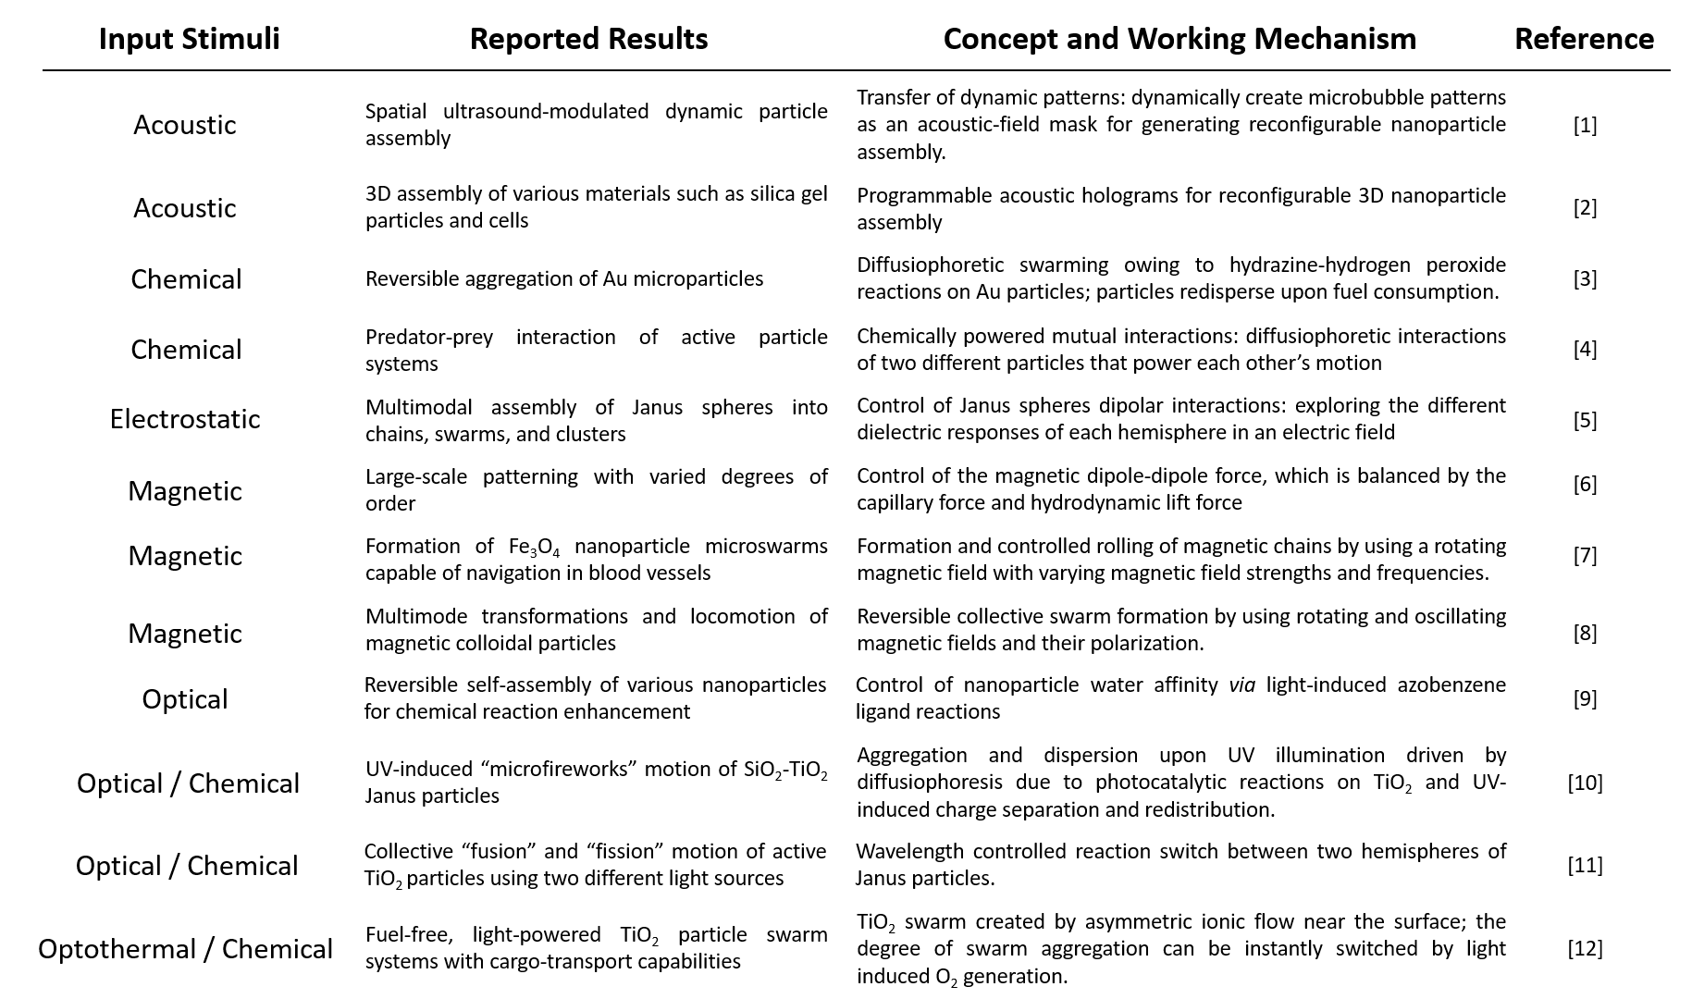
Table S1. The input stimuli, results, concept, and driving mechanism of various micromotor swarms.

Note 1: Theoretical analysis of electric polarizability of a nanorod in a rotating electric field
Consider the x-axis along a nanorod’s longitudinal direction, the field vector can be expressed as $E=E_{0}(\hat{x}-i\hat{y})exp\left(iωt\right)$, rotating counterclockwise at angular frequency of $ω$. Assuming all the nanorods in the solution have identical geometry and electrical properties, the calculated polarizability ($α$) would be also the same. As a nanorod has a large aspect ratio, its electric polarizability along the transverse direction can be considered as negligible in the tested frequencies, and $α$ can be approximated as the electric polarizability along the long direction of the nanorod. In an AC electric field, due to the Maxwell-Wagner polarization and electrical-double-layer effect,¹³ the polarizability $α$ is a function of frequency and also a complex quantity containing a phase lag to the applied external field. The induced dipole from an individual nanorod is $p=αE_{∥}.$ Since the field is constantly rotating, the phase of the field is the angle of the field vector. A uniform electric field always exerts a zero dielectrophoretic force on the induced dipole, but still applies a torque when the dipole moment has lagging angle to the phase of $E_{∥}$. The averaged torque over one cycle can be expressed by$τ_{e}=\frac{1}{2}Re\left[\underline{p}\left(t\right)×{\underline{E}}^{*}\left(t\right)\right]=-\frac{1}{2}E_{0}^{2}Im\left[α\right]\hat{z}.$

Note 2: Method for the calculation of electrostatic interactions of two identical nanorods in a rotating electric field
The orientation of the nanorod is defined in the interval of $(-π/2,π/2]$. The component of the electric field $E(t)$ that is in parallel with nanorods 1 and 2 are $E_{∥1}=E_{0}\exp{(iωt-{iθ}_{1})}{\hat{s}}_{i}$ and $E_{∥2}=E_{0}\exp{(iωt-{iθ}_{2})}{\hat{s}}_{j}$, respectively, with correspondingly induced dipoles of $p_{1}=αE_{∥1}$ and $p_{2}=αE_{∥2}$. Since there is a phase lag of ($θ_{2}-θ_{1}$) between $E_{∥1}$and $E_{∥2},$the same phase lag will pass to the induced dipole $p_{1}$ and $p_{2}$. The dipole on nanorod 1 is then represented by two point-charges $q_{1}^{+}=\frac{{|p}_{1}| }{l}$ and $q_{1}^{-}=-q_{1}^{+}$ located at $r_{1}^{+}=r_{1}+\frac{l}{2}{\hat{s}}_{1}$ and $r_{1}^{-}=r_{1}-\frac{l}{2}{\hat{s}}_{1}$. The dipole-dipole interaction between the nanorods 1 and 2 is then calculated from the Coulomb forces between the four point-charges $q_{1}^{+}, q_{2}^{+},q_{1}^{-} and q_{2}^{-}$. Since the nanorods are identical,${|q}_{1}^{+}|=\left|q_{2}^{+}\right|=\left|q_{1}^{-}\right|=\left|q_{2}^{-}\right|$ , when they are at the same condition. The induced charges are directly proportional to the dipole moment, and thus the same phase lag between $p_{1}$ and $p_{2}$ will be inherited by the charges of $q_{1}^{±}=±q_{0}\exp\left(iωt-iθ_{1}\right)and q_{2}^{±}=±q_{0}\exp\left(iωt-iθ_{2}\right)$, respectively, where $q_{0}=\frac{αE_{0}}{l}$ when a rod aligns with the external field (E). As a result, the Coulomb’s force between $q_{1}^{±}$ and $q_{2}^{±}$ in average over one period is given by Equation (1):

$F_{12}=\frac{ω}{2π}\int_{0}^{\frac{2π}{ω}}{\frac{1}{4πε_{m}}\frac{Re\left(q_{1}^{±}\right)Re\left(q_{2}^{±}\right)}{{\left|r_{1}^{±}-r_{2}^{±}\right|}^{2}}dt}=\frac{\cos{{(θ}_{2}-θ_{1})}}{2}\frac{1}{4πε_{m}}\frac{q_{0}^{2}}{{\left|r_{1}^{±}-r_{2}^{±}\right|}^{2}}$, (1)

where $ε_{m}$ is the permittivity of the suspension medium. The equation shows that all the involved point-charge interaction becomes zero in a rotating electric field when two nanorods are oriented orthogonally, corresponding to $\left|θ_{1}-θ_{2}\right|=0$.

Note3: Discussion about long-range interaction and transition between networks and clusters
The two types of swarm behaviors, network formation and clustering, only arise when the induced dipole-dipole interaction is significant, i.e., under laser exposure and when the frequency is between 10 kHz to 200 kHz. But how does the transition between these two modes occur and what makes the difference, e.g., how can the network form without further collapsing into clusters? We investigate the underlying principle by modeling the dynamic assembling process of a micromotor chain. As shown in Fig. S5a, when three nanorods assemble into a chain, the rod in the middle (in yellow) cannot receive an effective rotational torque exerted by the external electric field due to the attachment of the two neighboring nanorods at its two tips, where the opposite charges at the junctions nullify electric torques from the external field. For the two micromotors separated at the two ends the chain, however, has one end fixed to the rod in the middle, with the other end free to rotate. As a result, the two nanorods on the ends of the chain (in blue and red) rotate around the fixed tips of the nanorod in the center. When they are approximately $90°$ to the adjacent rod (in yellow), the dipole-dipole interaction becomes much lower, often causing them to disassemble from the chain (Fig. S5b). This experimental result is well replicated in the simulation (Fig. S5c and Movie S17), where two micromotors rotate around the tips of a close-by nanorod assembled in the center, frequently disassemble when aligned to the orthogonal direction, and re-assemble at the tips during the rotation.

The simulation of the above multi-nanorod chain system sheds light to the two aforediscussed swarm modes. When many nanorods are dispersed in a suspension, the high density and near-field interaction result in their rapid assembly with neighboring rods, forming into a network in an electric field. For the nanorods assembled inside the network, the rotational torques are largely cancelled, similar to those in the center of the chain system studied in the simulation (Fig. S5c). Here, although long-range attraction forces among the rods can exist at frequencies of 10 kHz to 200 kHz, such electrostatic interactions are insufficient to overcome the energy barrier needed to break the assembled nanorod chain for the clusters observed at 10 kHz. On the other hand, at 10 kHz, the electrorotation torque is much more substantial compared to that of ~200 kHz, which greatly suppresses chaining or assembly, while the electrostatic interaction is strong enough that can aggregate the rotating nanorods into clusters. To unveil the electrostatic attraction effect that could account for cluster formation, we calculate the electrostatic potential between two polarized nanorods placed in a rotating electric field in Fig. S5d. As aforediscussed in Equation (2), the dipole-dipole electric interaction between two neighboring rods can be either attractive or repulsive depending on their relative orientations. When rotating the two rods, it is reasonable to assume that their relative orientation is uniformly distributed in the range of $(-π/2,π/2]$. With this assumption, we can calculate the average electrical potential between two randomly oriented rods under the rotating electric field as a function of the center-to-center distance, as shown in Fig. S5e, which indicates the averaged electrostatic force between two rotating nanorods in an electric field is attractive.

References:
(1) Ma, Z. et al. Spatial ultrasound modulation by digitally controlling microbubble arrays. Nat. Commun. 11, 4537 (2020).
(2) Melde, K. et al. Compact holographic sound fields enable rapid one-step assembly of matter in 3D. Sci. Adv. 9, eadf6182 (2023).
(3) Kagan, D., Balasubramanian, S. & Wang, J. Chemically Triggered Swarming of Gold Microparticles. Angew. Chemie 123, 523–526 (2011).
(4) Mou, F. et al. Active Micromotor Systems Built from Passive Particles with Biomimetic Predator-Prey Interactions. ACS Nano 14, 406–414 (2020).
(5) Yan, J. et al. Reconfiguring active particles by electrostatic imbalance. Nat. Mater. 15, 1095–1099 (2016).
(6) Wang, W. et al. Order and information in the patterns of spinning magnetic micro-disks at the air-water interface. Sci. Adv. 8, eabk0685 (2022).
(7) Wang, Q. et al. Ultrasound Doppler-guided real-time navigation of a magnetic microswarm for active endovascular delivery. Sci. Adv. 7, eabe5914 (2021).
(8) Xie, H. et al. Reconfigurable magnetic microrobot swarm : Multimode transformation, locomotion, and manipulation. Sci. Robot. 4, eaav8006 (2019).
(9) Zhao, H. et al. Reversible trapping and reaction acceleration within dynamically self-assembling nanoflasks. Nat. Nanotechnol. 11, 82–88 (2016).
(10) Hong, B. Y., Diaz, M., Co, U. M. & Sen, A. Light-Driven Titanium-Dioxide-Based Reversible Microfireworks and Micromotor / Micropump Systems. Adv. Funct. Mater. 20, 1568–1576 (2010).
(11) Vutukuri, H. R., Lisicki, M., Lauga, E. & Vermant, J. Light-switchable propulsion of active particles with reversible interactions. Nat. Commun. 11, 2628 (2020).
(12) Zhang, J. et al. Light-Powered, Fuel-Free Oscillation, Migration, and Reversible Manipulation of Multiple Cargo Types by Micromotor Swarms. ACS Nano 17, 251-262 (2022).
(13) Liang, Z. & Fan, D. Visible light-gated reconfigurable rotary actuation of electric nanomotors. Sci. Adv. 4, eaau0981 (2018).

