Lim et. al. Supplementary Document

Supplementary Table 1: RAD51C rare missense variants detected in the BEACCON study of 5,734 familial breast cancer cases and 14,382 population controls, and their characteristics.

Supplementary Figure 1: Mutational signatures from combined RAD51C MS samples using DeconstructSig (A) VUS (samples 10 to 19 and 21), (B) VUS-TN group (samples 10, 14, 16 and 19), and (C) VUS-ER+ group (samples 12, 15, 17, 18 and 21), (D) p.Gly264Ser variant (samples 1 to 9), (E) p.Gly264Ser-TN group (samples 1 to 5), (F) p.Gly264Ser-ER+ group (samples 7 to 9), (G) ovarian tumour with LOH in a VUS variant (sample 20) and (H) combined tumours with LOH in a LoF variant as reference†. Variant criteria: Consequence_rank<=6; GnomAD_AF_NFE<0.0001; AlleleFreq>0.1, ReadDepth>20. VUS: Variants of unknown significance; TN: triple-negative; ER+: ER-positive.

Supplementary Figure 2: Pedigree analyses of families of (A) subjects 4 and 6, (B) subject 9, (C) subject 12, (D) subject 22, (E) subject 23, (F) subject 24, and (G) subject 25. Tumour hormone receptor status, lobular breast cancer and age of diagnosis are specified where available.

Supplementary Table 1: RAD51C rare missense variants detected in the BEACCON study of 5,734 familial breast cancer cases and 14,382 population controls, and their characteristics.
 | Frequency |  | MAF | In silico prediction |  |  |  |  | ClinVar | Interaction domain | Pathology or family phenotype |  |  | Literature reported
HGVSp | case (homozygous) (%) | Control (homozygous) (%) | MAF | REVEL | CADD | Condel | PolyPhen | SIFT |  |  | TN (available) | Index OC | FHx OC | Literature reported
p.Thr5Met | 1 | 1 | 4.00E-05 | 0.04 | 10 | neu | neu | del | VUS | 0
p.Gln11Arg | 0 | 1 | 1.00E-05 | 0.19 | 26 | del | del | del | VUS | 0
p.Lys26Glu | 0 | 1 | <1.00E-05 | 0.24 | 28 | del | del | del | . | 0
p.Lys26Arg | 1 | 0 | <1.00E-05 | 0.06 | 23 | neu | neu | neu | . | 0 | 0 (1)
p.Ser29Phe | 1 | 0 | <1.00E-06 | 0.11 | 24 | neu | neu | del | VUS | 0 | 0 (1)
p.Ala30Val | 0 | 1 | <1.00E-05 | 0.21 | 26 | del | del | del | VUS | 0
p.Gln33Arg | 0 | 1 (1) | <1.00E-07 | 0.04 | 23 | neu | neu | neu | . | 0
p.Ile52Leu | 0 | 1 | <1.00E-08 | 0.04 | 22 | neu | neu | neu | VUS | 0
p.Thr78Ile | 1 | 1 | <1.00E-09 | 0.06 | 21 | neu | neu | neu | VUS | 0 | 0 (1)
p.Lys84Asn | 1 | 0 | 1.00E-05 | 0.08 | 19 | neu | neu | neu | VUS | 1 | 0 (1)
p.Thr96Ser | 1 | 0 | 2.00E-05 | 0.11 | 18 | neu | neu | neu | VUS | 1
p.Ala126Thr† | 68 (1.19%) | 133 (0.90%) | 0.0054 | 0.1 | 22 | neu | neu | neu | B | 1 | 11 (33) | 1 | 2 | Successful correction of (MMC) hypersensitivity [3]; Benign [2]; no changes in protein interaction [7]
p.Cys135Tyr | 1 | 1 | 1.00E-05 | 0.75 | 27 | del | del | del | LP | 1 |  |  |  | Partially deleterious[1]
p.Met136Ile | 1 | 0 | 2.00E-05 | 0.05 | 17 | neu | neu | neu | VUS | 1 | 1 (1)
p.Gln137Arg | 1 | 0 | <1.00E-05 | 0.63 | 26 | del | del | del | . | 0 | 0 (1)
p.Gln143Arg | 4 (0.07%) | 3 (0.02%) | 8.00E-05 | 0.69 | 26 | del | del | del | VUS | 0 | 1 (3) |  | 2 | Partially deleterious[1] Pathogenic[2]
p.Ile144Thr | 2 | 1 | 8.00E-05 | 0.31 | 26 | del | del | del | VUS | 0 | 1 (2)
p.Ser163Gly | 1 | 2 | <1.00E-05 | 0.26 | 23 | neu | neu | neu | VUS | 0
p.Val166Ala | 1 | 0 | 2.00E-05 | 0.06 | 23 | neu | neu | neu | VUS | 0
p.Val169Ala | 2 (0.03%) | 12 (0.08%) | 0.0003 | 0.08 | 22 | neu | neu | neu | VUS | 0 | 0 (1) |  |  | Successful correction of (MMC) hypersensitivity [3]
p.Ala175Thr | 1 | 1 | 4.00E-05 | 0.44 | 26 | del | del | del | VUS | 0
p.Cys176Arg | 0 | 1 | <1.00E-05 | 0.33 | 26 | del | del | del | . | 0 |  |  |  | Excess in case[3]
p.Gln178Pro | 1 | 0 | <1.00E-05 | 0.21 | 24 | neu | neu | del | . | 0 |  |  | 1
p.His187Asp | 0 | 1 | <1.00E-05 | 0.04 | 15 | neu | neu | neu | . | 0
p.Arg193Gln | 0 | 1 | 3.00E-05 | 0.07 | 13 | neu | neu | neu | VUS | 0
p.Ile208Val | 1 | 1 | 3.00E-05 | 0.13 | 24 | neu | neu | neu | VUS | 0
p.Arg212His | 2 | 0 | 2.00E-05 | 0.64 | 28 | del | del | del | VUS | 0 | 0 (2) |  |  | Benign[4]
p.Arg214His | 0 | 2 | <1.00E-05 | 0.17 | 14 | neu | neu | neu | VUS | 0
p.Ser231Thr | 0 | 1 | <1.00E-06 | 0.11 | 23 | neu | neu | neu | . | 0
p.Glu232Asp | 1 | 0 | <1.00E-07 | 0.15 | 18 | neu | neu | neu | VUS | 0
p.Ile240Leu | 0 | 1 | 1.00E-05 | 0.25 | 23 | neu | neu | del | VUS | 0
p.Val241Met | 1 | 1 | 3.00E-05 | 0.52 | 25 | del | del | del | VUS | 0 | 0 (1)
p.Asp242Asn | 1 | 0 | <1.00E-05 | 0.81 | 32 | del | del | del | VUS | 0 | 0 (1)
p.Ile244Val | 1 | 1 | 4.00E-05 | 0.16 | 20 | neu | neu | neu | VUS | 0 | 1 (1)
p.Arg249Cys | 0 | 1 | 1.00E-05 | 0.44 | 30 | del | del | del | VUS | 0
p.Arg249His | 0 | 1 | <1.00E-05 | 0.44 | 30 | del | del | del | VUS | 0
p.His250Tyr | 0 | 1 | 3.00E-05 | 0.13 | 24 | neu | neu | del | VUS | 0
p.Asp253Gly | 0 | 1 | 1.00E-05 | 0.21 | 27 | del | neu | del | VUS | 0
p.Arg258Cys | 1 | 1 | 6.00E-05 | 0.53 | 28 | del | del | del | VUS | 0 | 0 (1)
p.Arg258His | 2 (0.03%) | 4 (0.03%) | 4.00E-05 | 0.5 | 32 | del | del | del |  | 0 | 0 (2) | 1 |  | Deleterious via functional[5] Pathogenic[2], Hypomorphic[6]
p.Arg260Trp | 0 | 1 | <1.00E-05 | 0.6 | 29 | del | del | del | VUS | 0
p.Leu262Val | 1 | 1 | 0.0001 | 0.32 | 22 | del | del | del | VUS | 0 | 0 (1) |  | 1
p.Gly264Ser | 30 (1) (0.52%) | 78 (0.53%) | 0.0034 | 0.2 | 23 | neu | neu | neu |  | 0 | 10 (14) |  | 1 | Pathogenic in small sample size[3, 8, 9]; reduced cell survival [3], Hypomorphic[6]
p.Met286Thr | 0 | 1 | <1.0E-05 | 0.42 | 26 | del | del | del | . | 0
p.Met286Val | 0 | 1 | <1.00E-05 | 0.14 | 20 | neu | neu | neu | VUS | 0
p.Arg312Gln | 0 | 1 | 3.00E-05 | 0.47 | 32 | del | del | del | VUS | 0
p.Thr336Pro | 1 | 1 | 2.00E-05 | 0.21 | 23 | neu | neu | del | VUS | 0
p.Val350Ile | 1 | 1 | <1.00E-05 | 0.02 | 16 | neu | neu | neu | . | 0 | 0 (1)
p.Ala354Val | 0 | 1 | 2.00E-05 | 0.04 | 12 | neu | neu | neu | VUS | 0
p.Gln358Glu | 0 | 1 | <1.00E-05 | 0.06 | 0 | neu | neu | neu | . | 0
p.Ser364Gly | 1 | 0 | 2.00E-05 | 0.03 | 15 | neu | neu | del | VUS | 0
p.Arg370Gln | 0 | 1 | 2.00E-05 | 0.15 | 23 | neu | neu | del | VUS | 0

Variants of interest that fulfil one or more of following criteria are in bold: (1) >=4 in-silico tools, (2) specific tumour or family phenotype, (3) excess of cases, (4) interaction domain or (5) previously reported as pathogenic. Cut-offs of CADD>25 and Revel>0.5 are used. GnomAD_AF_NFE: GnomAD Database Allele Frequency Non-Finnish European; del: deleterious; neu: neutral; LP: likely pathogenic; VUS: variant of unknown significance; LB: likely benign; OC: ovarian cancer; FHx: 1-2 deg family history. ClinVar database was accessed in March 2020. Four likely TN cases (ER-/PR-/HER2nr) are included in this table.
†p.Ala126Thr is a known benign variant included as a reference

Supplementary Figure 1: Mutational signatures from combined RAD51C MS samples using DeconstructSig (A) VUS (samples 10 to 19 and 21), (B) VUS-TN group (samples 10, 14, 16 and 19), and (C) VUS-ER+ group (samples 12, 15, 17, 18 and 21), (D) p.Gly264Ser variant (samples 1 to 9), (E) p.Gly264Ser-TN group (samples 1 to 5), (F) p.Gly264Ser-ER+ group (samples 7 to 9), (G) ovarian tumour with LOH in a VUS variant (sample 20) and (H) combined tumours with LOH in a LoF variant as reference†. Variant criteria: Consequence_rank<=6; GnomAD_AF_NFE<0.0001; AlleleFreq>0.1, ReadDepth>20. VUS: Variants of unknown significance; TN: triple-negative; ER+: ER-positive.

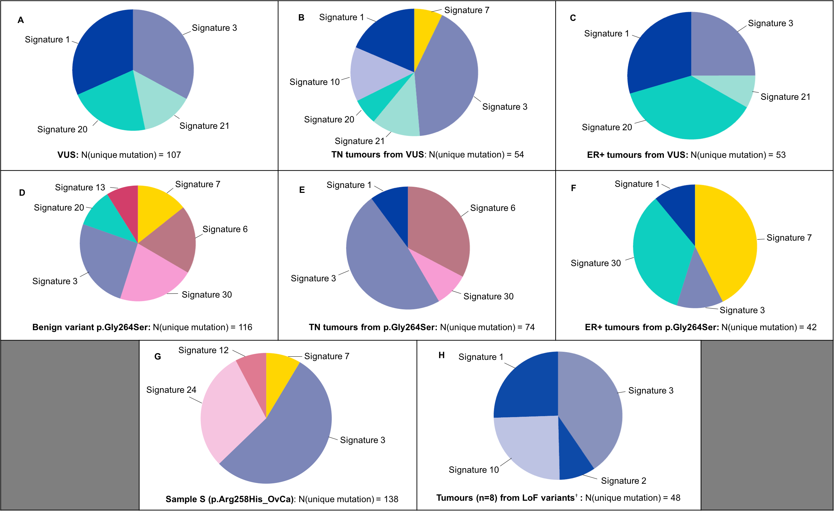
†Previously published(1)
Supplementary Figure 2: Pedigree analyses of families of (A) subjects 4 and 6, (B) subject 9, (C) subject 12, (D) subject 22, (E) subject 23, (F) subject 24, and (G) subject 25. Tumour hormone receptor status, lobular breast cancer and age of diagnosis are specified where available.

(A)
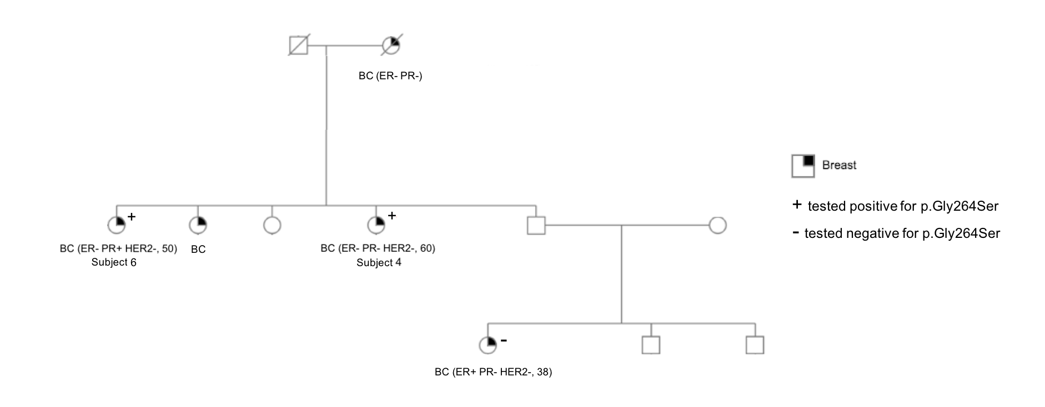

(B)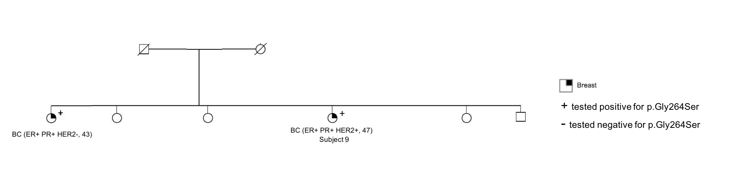

(C)
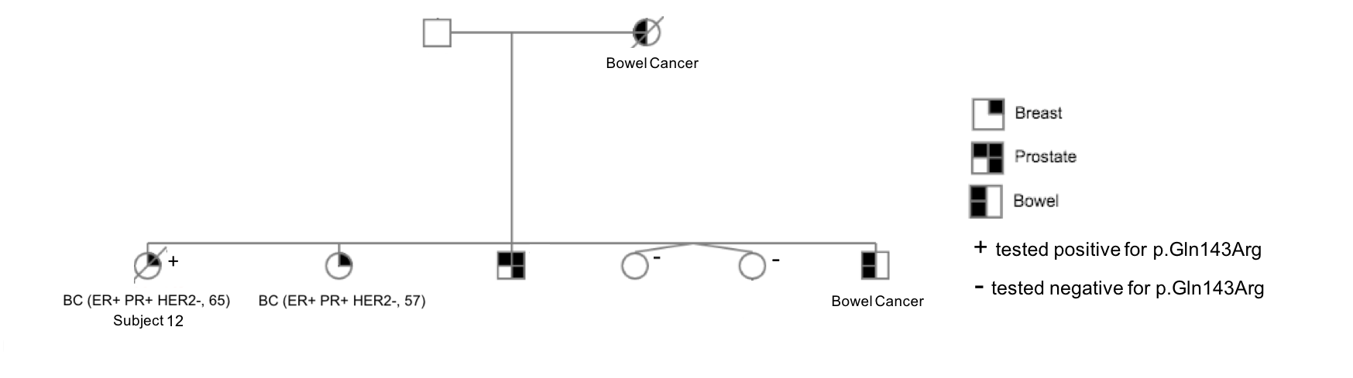
(D)
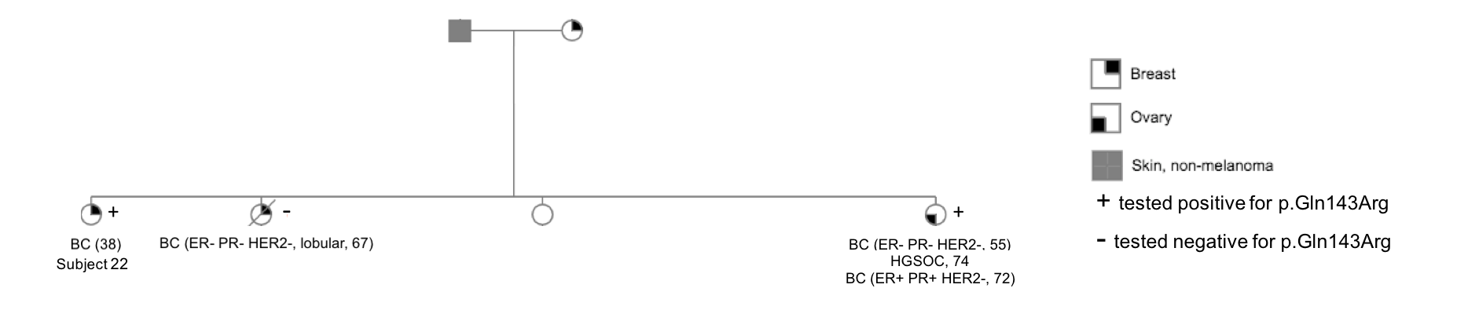

(E)
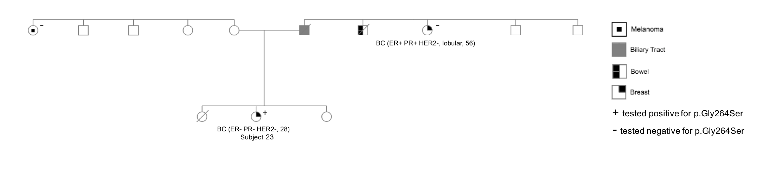

(F)
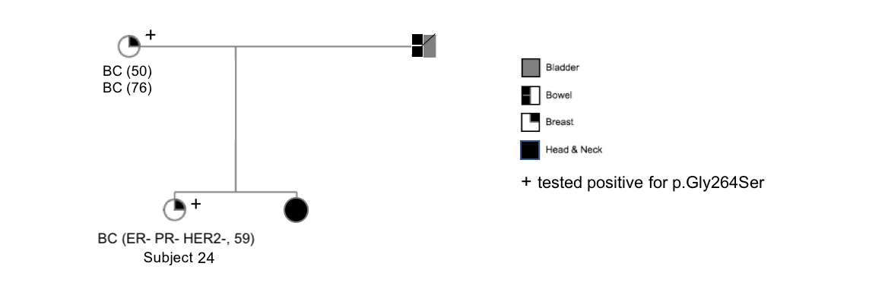

(G)
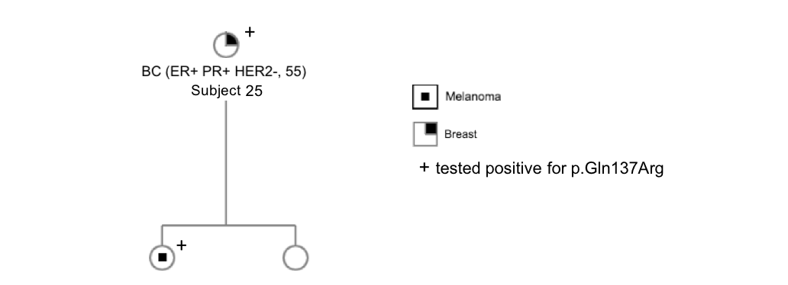

References

1. Li N, McInerny S, Zethoven M, Cheasley D, Lim BWX, Rowley SM, et al. Combined tumor sequencing and case/control analyses of RAD51C in breast cancer. Journal of the National Cancer Institute. 2019.

