Invasions and symbioses: multidimensional variability of the microbiome of an introduced ascidian species

Supplementary figures

Carles Galià-Camps^{1,2,*,†}, Elena Baños^{1,3,*}, Marta Pascual^{1,2,x}, Carlos Carreras^{1,2,x}, Xavier Turon^{3,x}
¹ Departament de Genètica, Microbiologia i Estadística, Universitat de Barcelona (UB), Avinguda Diagonal 643, 08028 Barcelona, Spain
² Institut de Recerca de la Biodiversitat (IRBio), Universitat de Barcelona (UB), Barcelona, Spain
³ Department of Marine Ecology, Centre d’Estudis Avançats de Blanes (CEAB-CSIC), Accés Cala Sant Francesc 14, 17300 Blanes, SPAIN
* These authors contributed equally to the manuscript
x These authors jointly supervised this work
† Corresponding author: cgaliacamps@gmail.com
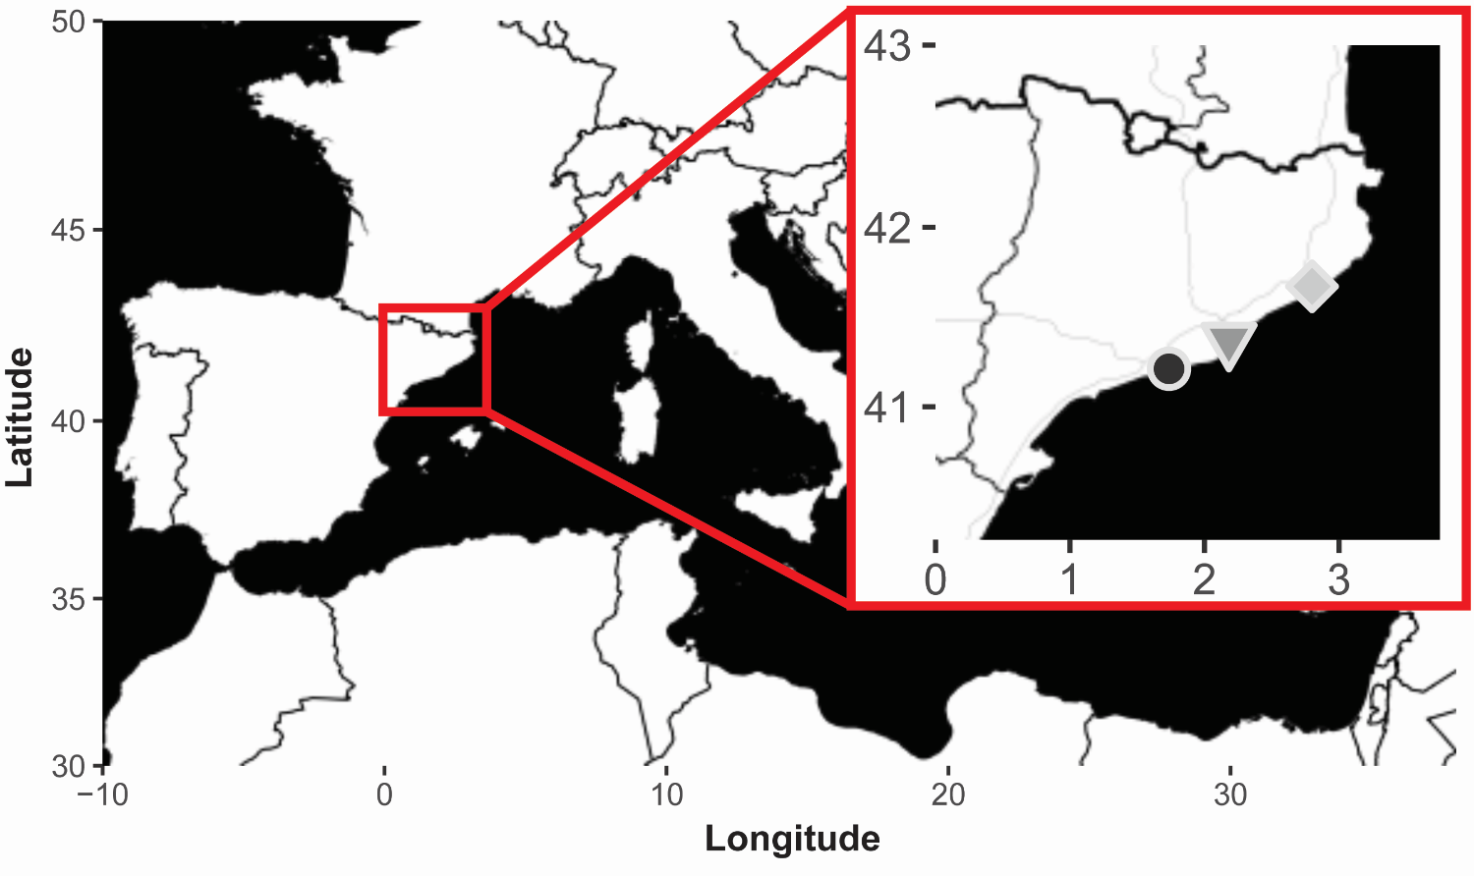
Figure S1. Map of the sample locations in the NW Mediterranean. The dark gray circle corresponds to Vilanova i la Geltrú, the gray triangle corresponds to Barcelona, and the light gray diamond corresponds to Blanes. Maps were obtained with the R package “ggmap”.

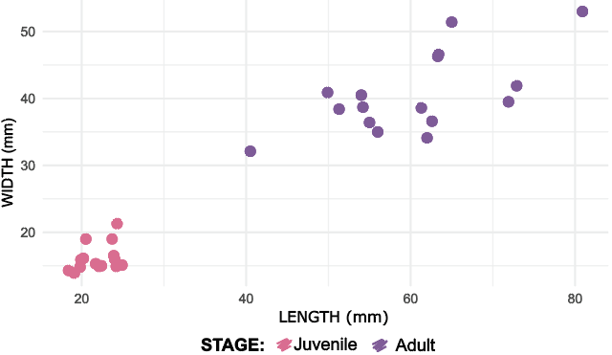
Figure S2. Size distribution of the samples used in the present study.

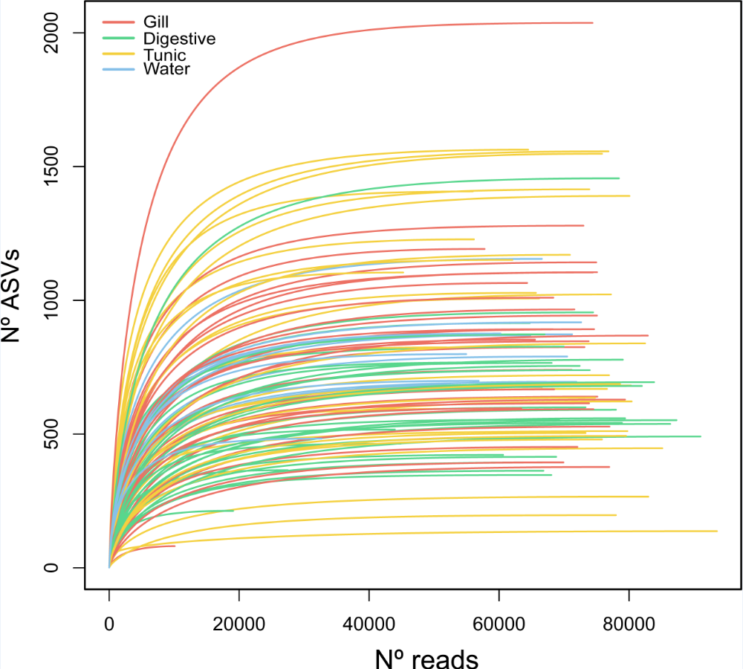
Figure S3. Rarefaction curves of the number of ASV recovered as a function of the number of reads of the samples used in the present study. Note that all samples reach their asymptotic values.

