Supplementary Figure 1. Progression-free survival (PFS) and overall survival (OS) analyses by the Kaplan–Meier method in the entire cohort. A: PFS; B: OS.
A、
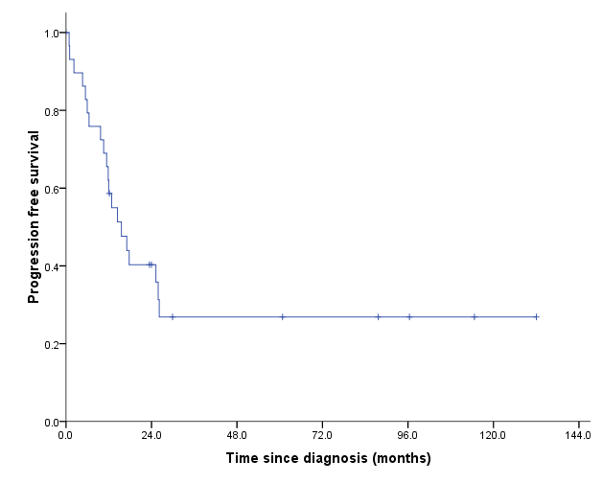

B
