Supplementary material

3D modeling of in vivo MRI guided nano-photothermal therapy mediated by magneto-plasmonic nanohybrids

Zahed Tavangari^{1,2}, Mohammadreza Asadi¹, Rasoul Irajirad¹, Abolfazl Sarikhani^{1,2},
Zahra Alamzadeh¹, Habib Ghaznavi^{3,*}, Samideh Khoei^{1,2,*}

¹Finetech in Medicine Research Center, Iran University of Medical Sciences, Tehran, Iran
²Medical Physics Department, Iran University of Medical Sciences, Tehran, Iran
³Pharmacology Research Center, Zahedan University of Medical Sciences, Zahedan, Iran

(*) Corresponding authors:
H. Ghaznavi: dr.ghaznavi@zaums.ac.ir
Pharmacology Research Center, Zahedan University of Medical Sciences, Zahedan, Iran
S. Khoei: khoei.s@iums.ac.ir
Finetech in Medicine Research Center, Iran University of Medical Sciences, Tehran, Iran

Calculation of the photothermal conversion efficiency
A home-built setup was employed to irradiate the nanohybrids with laser and measure the photothermal conversion efficiency. The setup consisted of a cuvette with a 1 cm path length, containing 1 mL of the nanohybrid solution (500 μg/mL Au), an infrared (IR) thermal imaging camera (Testo 875−1i, Germany), and an 808 nm continuous semiconductor diode laser. The photothermal conversion efficiency of the magneto-plasmonic nanohybrids was determined using the formula [1]:
$η=\frac{hs(T_{max}-T_{surr})-Q_{dis}}{I(1-{10}^{-A_{808nm}})}$ (1)
Here, h, s, T_{max}, T_{sur}, I, A₈₀₈, and Q_{dis} represent the heat transfer coefficient, the surface area of the container, the maximum equilibrium temperature, the surrounding temperature, the laser power, the absorbance nanohybrids at 808 nm, and Q_{dis} is heat dissipation due to light absorbance of the solvent, which can be calculated according to Equation 2:
$Q_{dis}=\frac{mC∆T}{t}$ (2)
The variables m, C, ΔT, and t represent, respectively, the mass of water in grams (g), the specific heat capacity of water (J g⁻¹ K⁻¹), the temperature rise (K), and the duration of laser irradiation in seconds (s). hs can be calculated according to Equation 3:
$hs=\frac{ \sum{m_{i}c_{p,i}}}{τ_{s}}$ (3)
The symbols τ_{s} and i are used to denote the time constant of the sample and the individual components of the system, which include the nanohybrids suspension and cuvette. τ_{s} can be calculated according to Equation 4:
$\left\{\begin{aligned}τ_{s}=\frac{t}{-ln\left(θ\right)} \\ θ=\frac{\left(T-T_{surr}\right)}{\left(T_{max}-T_{surr}\right)}\end{aligned}\right.$ (4)
In this study, the temperature variation of the nanohybrid solution was monitored during the heating stage using laser irradiation, followed by subsequent cooling without the use of laser irradiation (see Fig. S1a). After 11 minutes of irradiation, the maximum temperature of the nanohybrid solution increased by 28.6 °C, which can be attributed to the thermal equilibrium between the heat input and output. The time constant for heat transfer, τ_{s}, was determined by linear fitting of the cooling time t versus the natural logarithm of the temperature decrease (-lnθ) and was found to be 5.43 minutes (Fig. S1b). According to the given information, Q_{dis} was calculated to be 0.53 mW using Equation (2). The photothermal conversion efficiency (η) of the nanohybrids was approximately 30%.

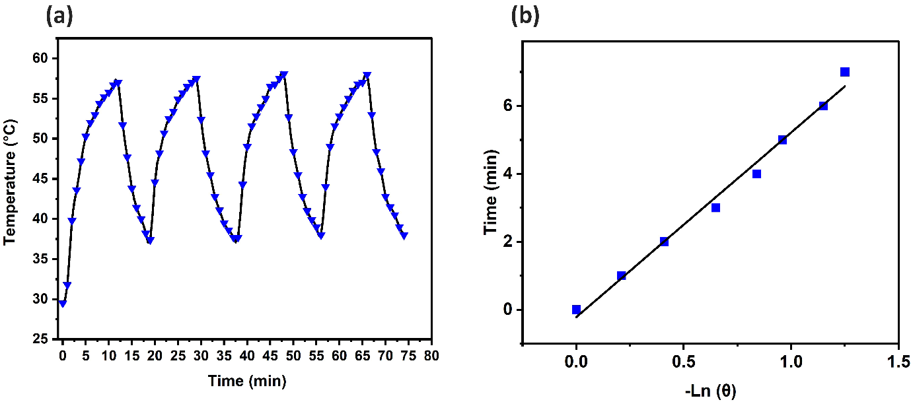

Fig. S1: (a) Plot of the temperature vs. time for the nanohybrids (500 μg/mL Au, A₈₀₈ = 3.2) during laser irradiation (808 nm, 1.4 W/cm²) and cooling (laser off) stages. (b) Plot of the cooling time vs. -Lnθ.

In vitro study of NPTT
We assessed the cytotoxicity of the nanohybrids using the methyl thiazolyl tetrazolium (MTT) assay. Briefly, we seeded a suspension of CT26 cells at a concentration of 5 × 10⁴ cells/mL in complete RPMI medium into a 96-well plate and allowed them to adhere for 24 hours. We then replaced the medium with a fresh one containing nanohybrids with varying gold concentrations. After incubation for 4, 12, and 24 hours at 37°C, we added 50 μL of MTT solution (1.0 mg/mL in PBS) to each well. Following an additional 4 hours of incubation, we removed the medium and added 100 μL of dimethyl sulfoxide (DMSO) to each well to dissolve the formazan crystals. We measured the absorbance of the formazan crystals at 570 nm using a Bio-Rad ELISA reader. Fig. S2a shows the viability of CT26 cells treated with nanohybrids at varying gold concentrations over 4, 12, and 24 hours. Based on MTT assay results, CT26 cancer cells were incubated with nanohybrid at the concentration of 20 μg/mL for 12h and then irradiated by the 808 nm laser at different laser power densities for 5 min. An MTT assay was also performed to quantitatively measure the cell viabilities after NPTT under different laser powers (Fig. S2b).
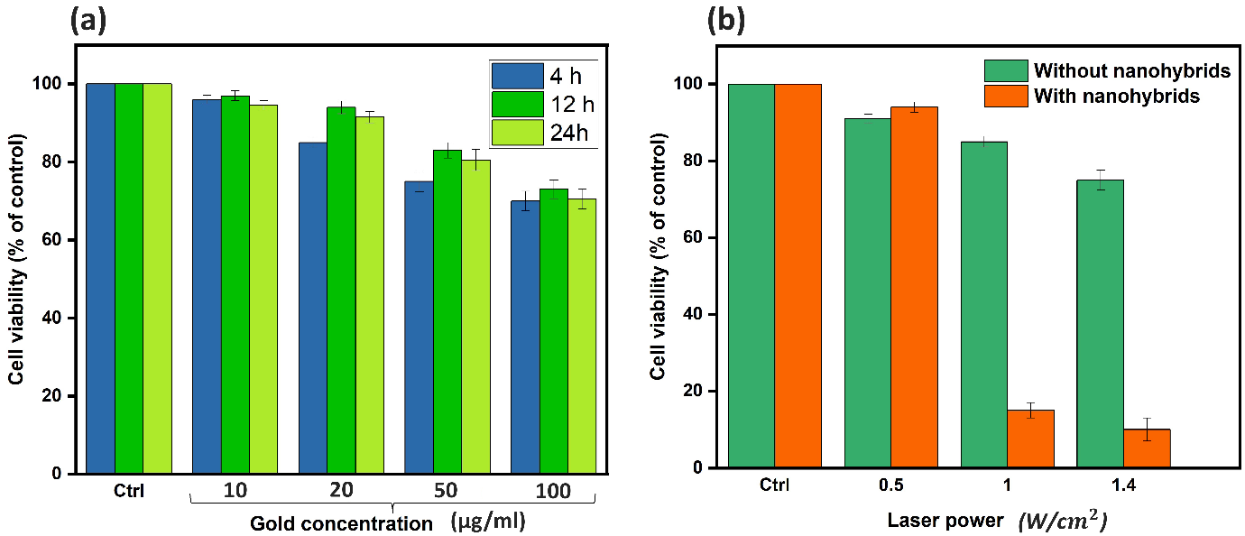

Fig. S2: In vitro cell experiments. (a) This chart shows the viability of CT26 cells treated with nanohybrids at varying gold concentrations over 4, 12, and 24 hours. (b) Viabilities of CT26 cells after NPTT at different laser power densities. Error bars were based on the standard deviations of three parallel samples.

References
1. Tian Q, Jiang F, Zou R, Liu Q, Chen Z, Zhu M, Yang S, Wang J, Wang J, Hu J: Hydrophilic Cu9S5 nanocrystals: a photothermal agent with a 25.7% heat conversion efficiency for photothermal ablation of cancer cells in vivo. ACS nano 2011, 5(12):9761-9771.

