Supplementary Information for the Submission by Contel et al. “Characteristics and Service Utilization by Users of Home Care Services in Catalonia: A Retrospective Cohort-Based Study of a Social Program for Dependent Individuals”.

Supplementary Tables
Table S1. Prevalence of home care services dependency recipients according to sex and income level (year 2019), rate per 1000 individuals
Income level, €/year | Men | Women | Total
High (>100 000) | 0.6 | 1.2 | 0.8
Intermediate (18 000–100 000) | 1.9 | 3.1 | 2.4
Low (<18 000) | 4.8 | 11.0 | 8.2
Very low (on welfare support) | 7.2 | 15.3 | 11.8

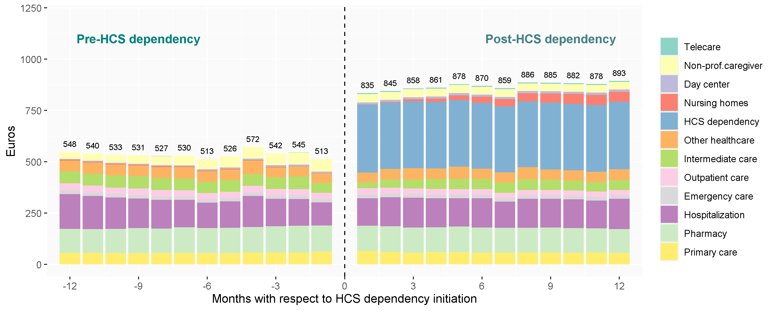
Supplementary Figures

Figure S1. Expenditure associated with healthcare and social services utilization by home care services (HCS) dependency recipients before and after its initiation during 2018–2019. Bars represent mean total monthly services (€) and each service is represented by a different color.

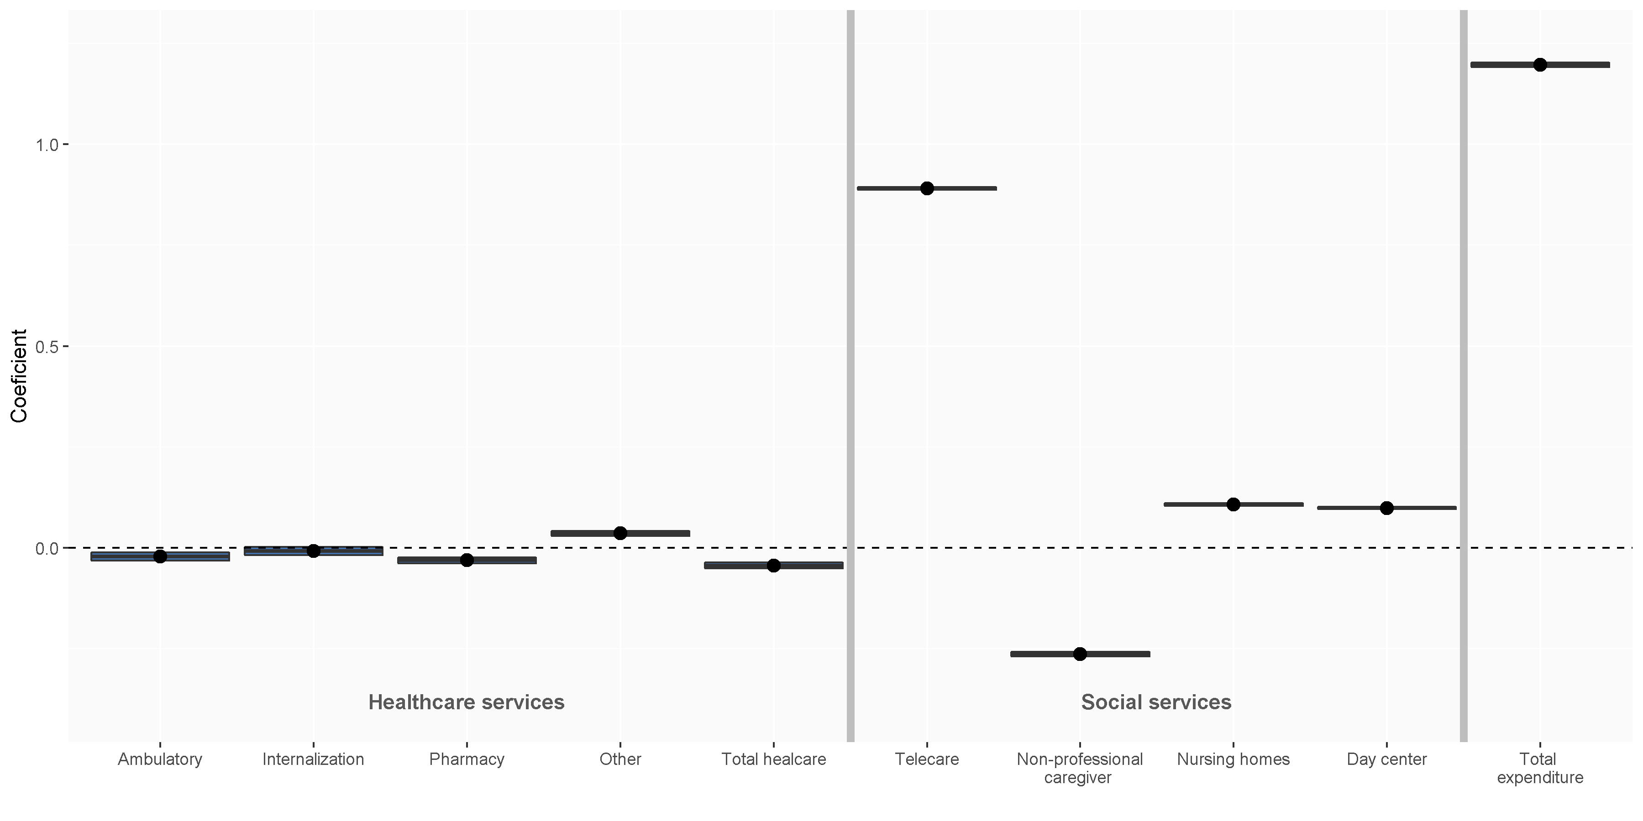
Figure S2. Comparison between healthcare and social monthly expenditure in a year before and after home care services (HCS) dependency initiation (2018–2019 period). Linear regression models were used to quantify changes in expenditure. The lines in each category represent the coefficient between expenditure before and after HCS dependency and the blue boxes represent the 95% confidence interval. The dashed line at 0.0 indicates no change and the blue boxes above and below the line indicate significantly increased and decreased utilization, respectively.

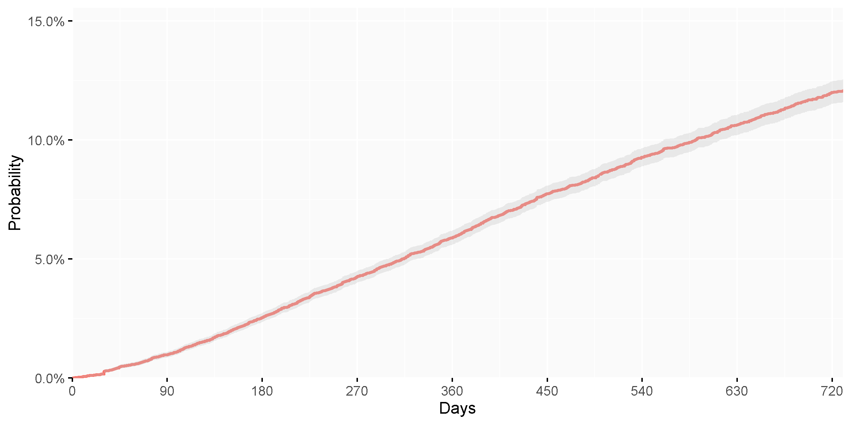
Figure S3. Probability of nursing home admission up to 2 years for individuals who initiated home care services (HCS) dependency in 2018–2019. The Kaplan-Meier approach was used to calculate the probability. The red line and the shadowed grey area represent the probability of nursing home admission over time and the 95% confidence interval, respectively.
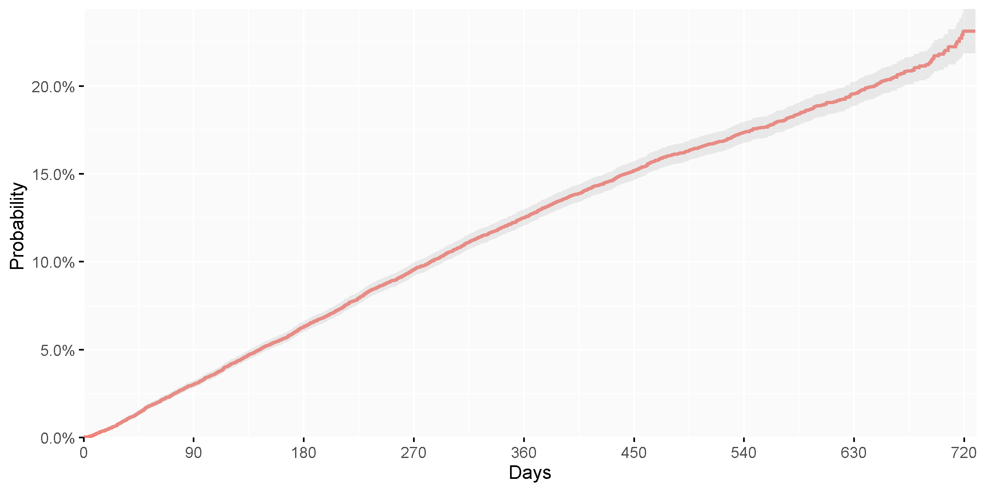
Figure S4. Probability of death up to 2 years for individuals who initiated home care services (HCS) dependency in 2018–2019. The Kaplan-Meier approach was used to calculate the probability. The red line and the shadowed grey area represent the probability of death over time the 95% confidence interval, respectively.

