Additional File 1
Figure 1: Map of the studied city by districts (Porto Alegre, Rio Grande do Sul, Brazil).
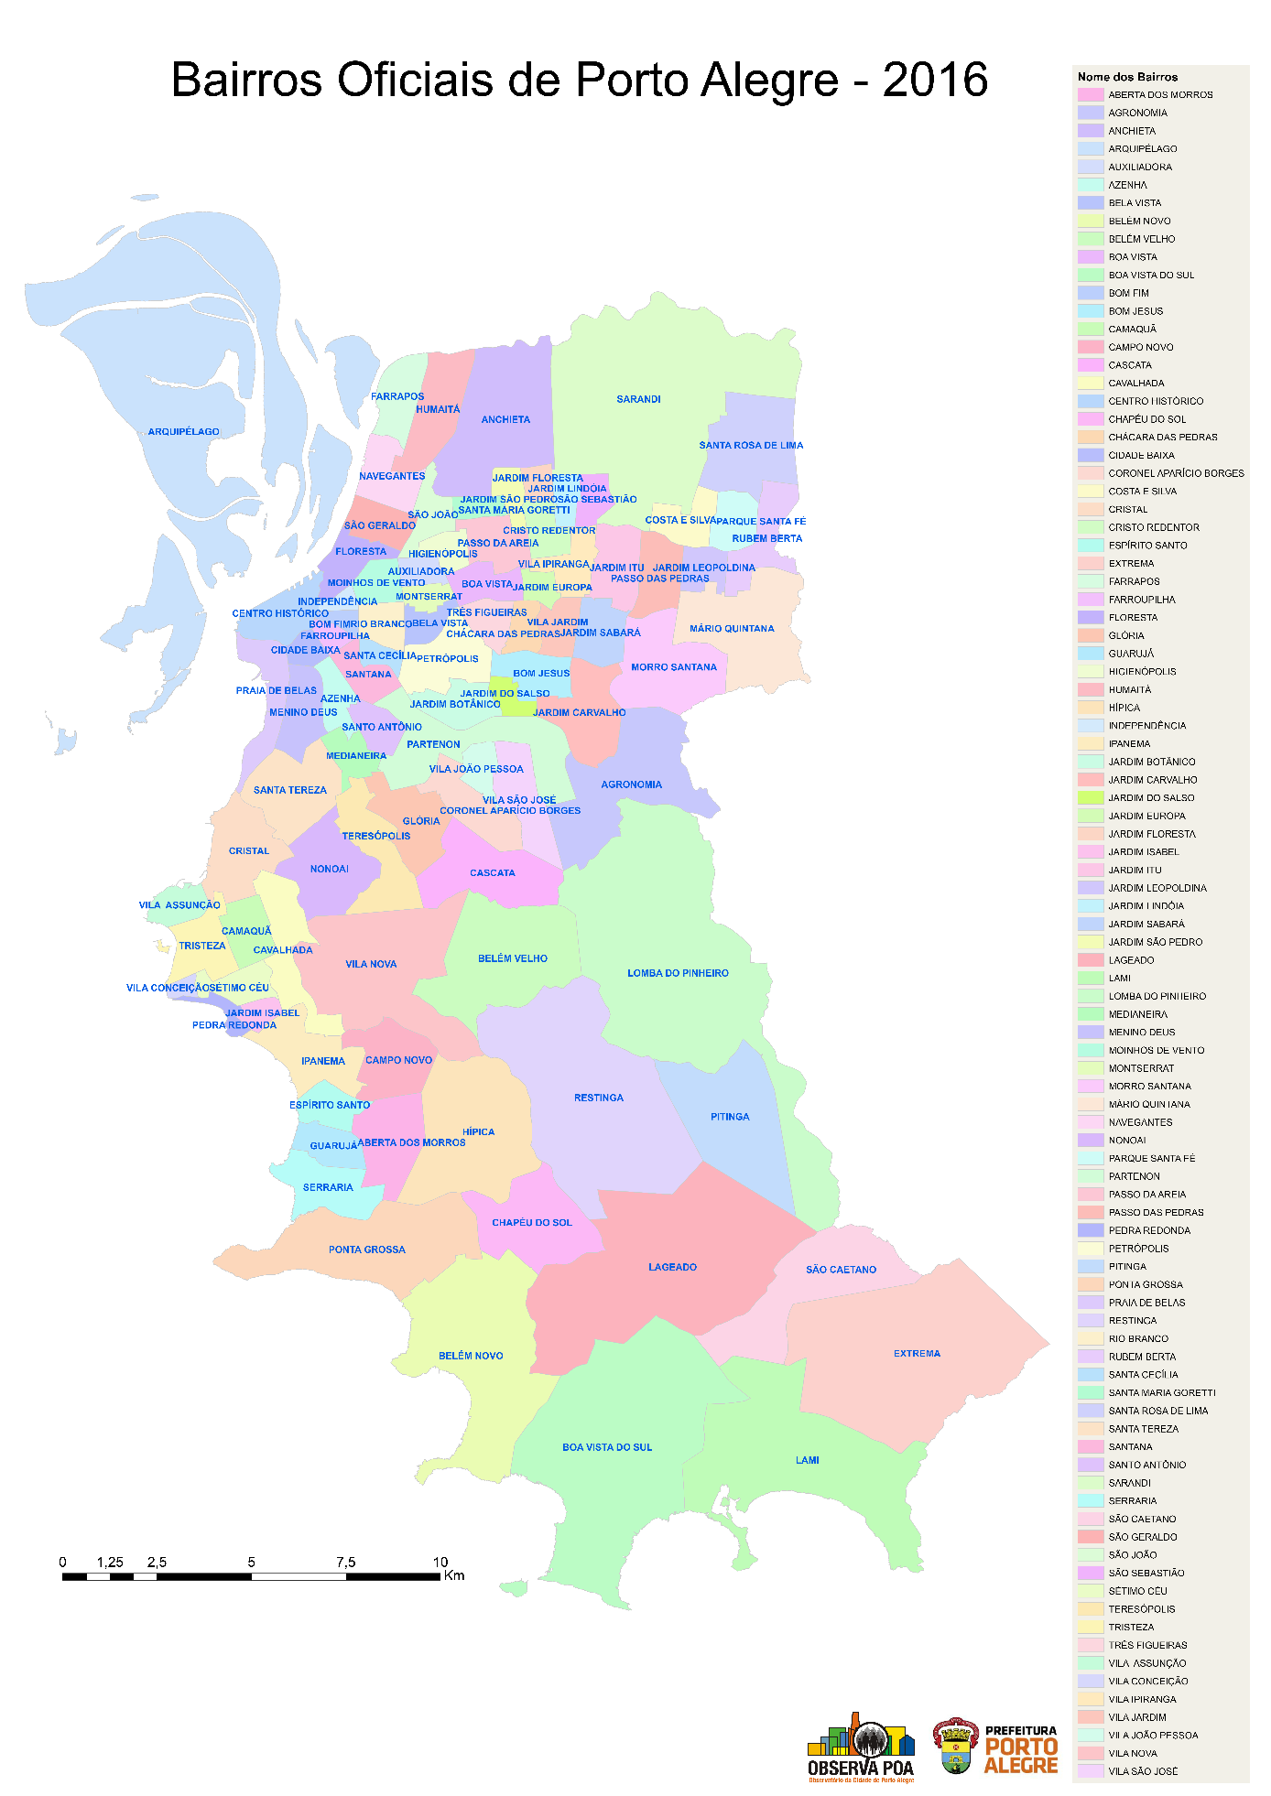
Name of Districts
Official Districts of Porto Alegre - 2016

Source: OBSERVAPOA and PROCEMPA, 2016. Public domain.
http://observapoa.com.br/default.php?reg=259&p_secao=46

