Additional File 2
Figure 2: Map of the studied city by Participatory budgeting Regions - macro-regions (Porto Alegre, Rio Grande do Sul, Brazil).
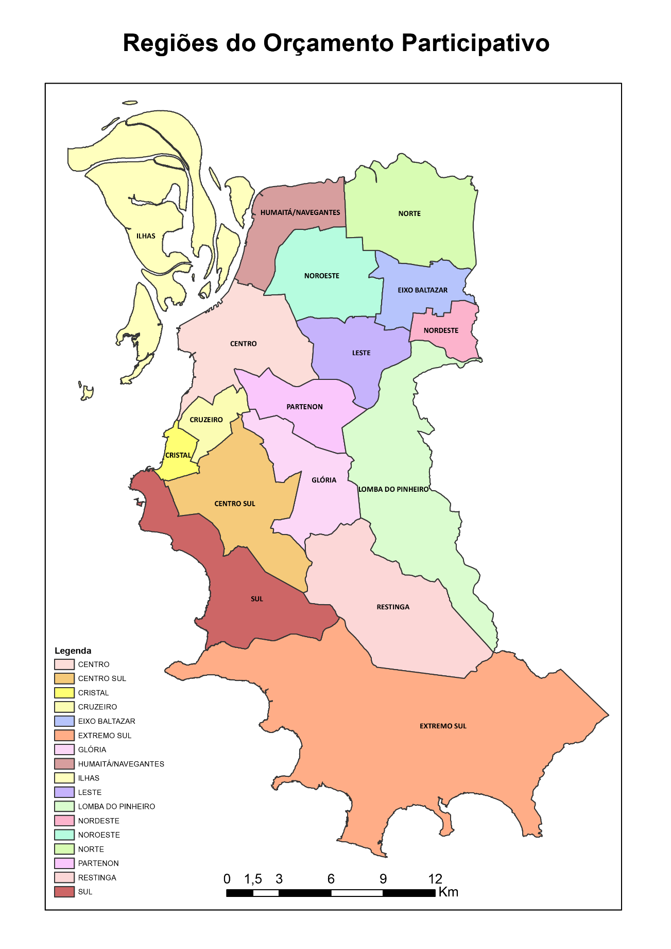
Participatory Budgeting Regions

Source: OBSERVAPOA and PROCEMPA, 2016. Public domain.
http://lproweb.procempa.com.br/pmpa/prefpoa/observatorio/usu_doc/sem_grids.pdf

