Additional File 2
Figure 2: Map of the studied city by Participatory budgeting Regions - macro-regions (Porto Alegre, RS, Brazil).
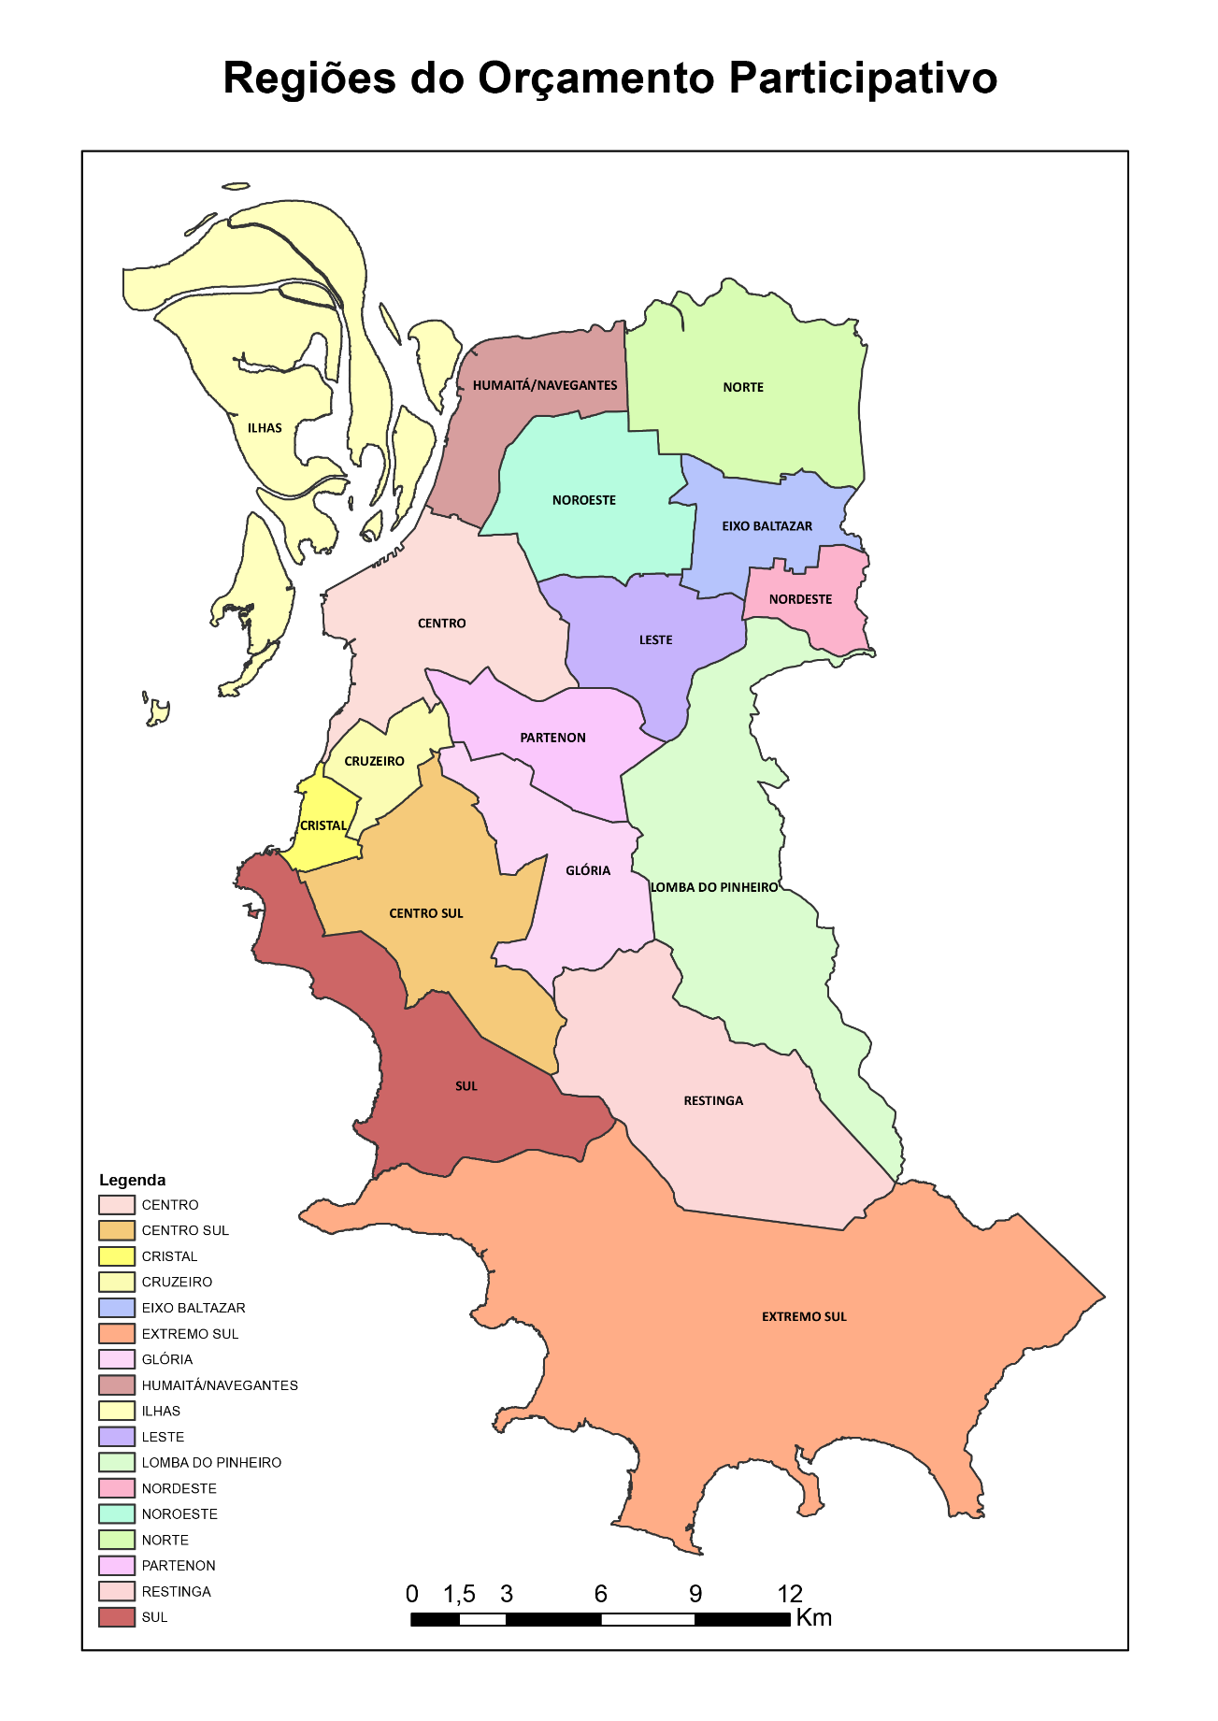
Participatory Budgeting Regions

RS: Rio Grande do Sul.
Source: OBSERVAPOA and PROCEMPA, 2016.

