Additional File 1
Figure 1: Map of the studied city by districts (Porto Alegre, RS, Brazil).
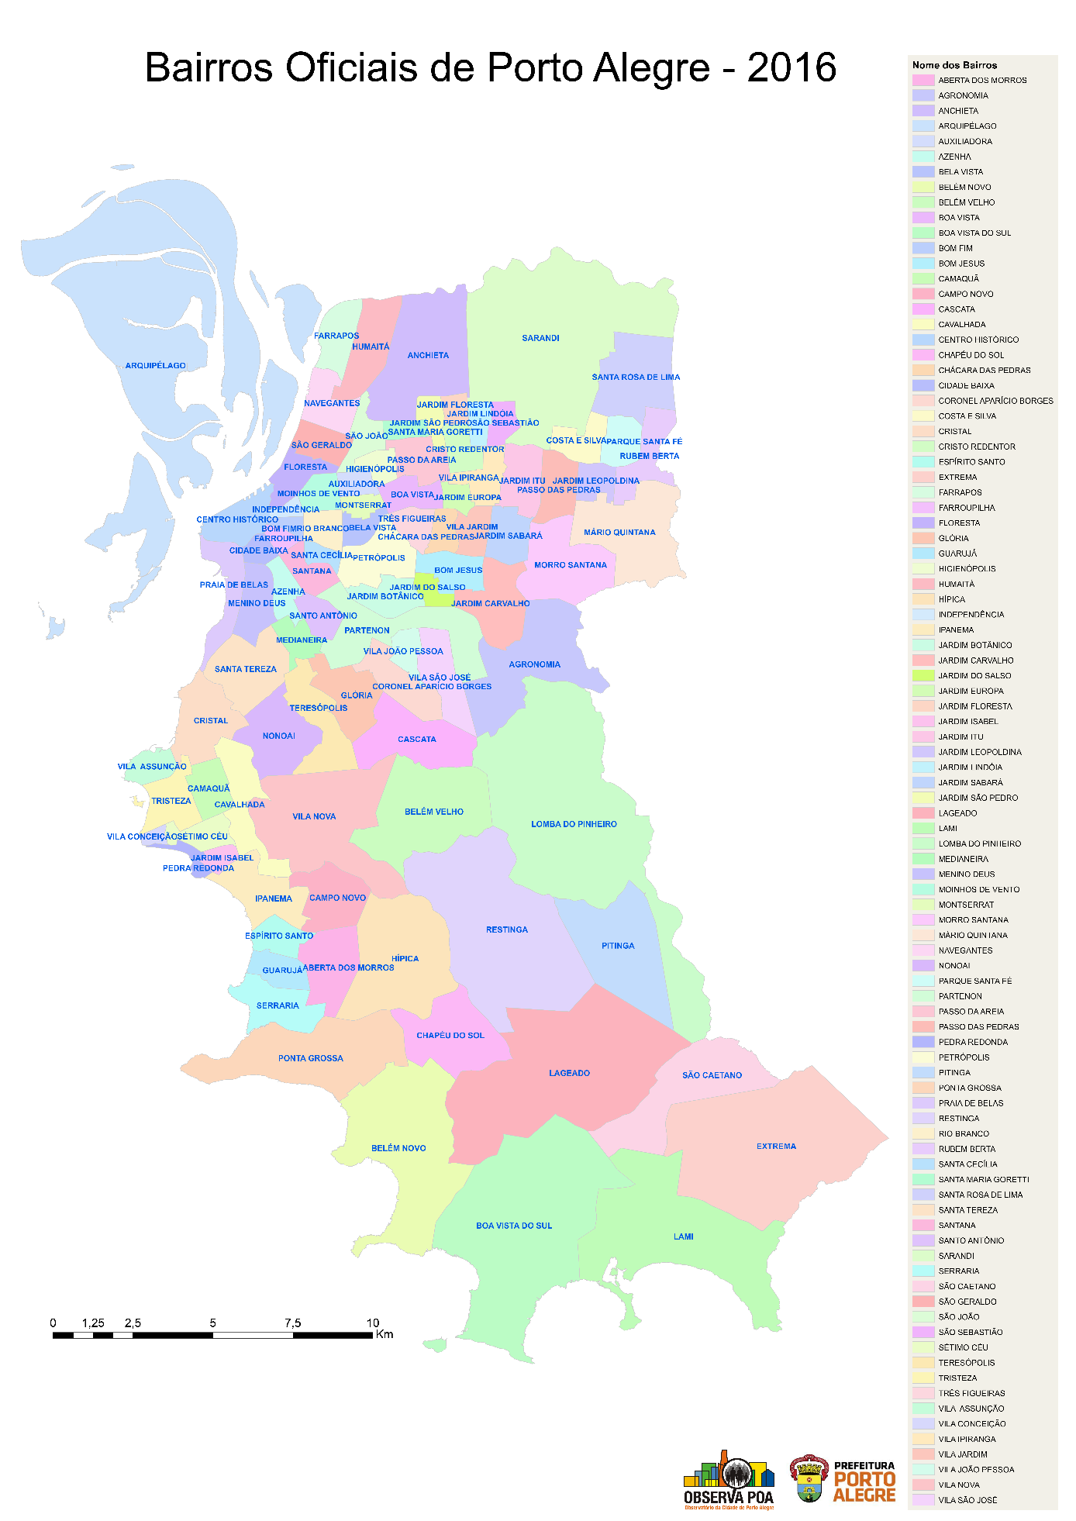
Name of Districts
Official Districts of Porto Alegre - 2016

RS: Rio Grande do Sul.
Source: OBSERVAPOA and PROCEMPA, 2016.

