Supplementary Material

An Application of Slow Feature Analysis to the Genetic Sequences of
Coronaviruses and Influenza viruses

Anastasios A. Tsonis^{1,2,}* Geli Wang³, Lvyi Zhang³, Wenxu Lu³, Aristotle Kayafas⁴, and Katia Del Rio-Tsonis⁴*

1 Department of Mathematical Sciences, Atmospheric Sciences Group, University of Wisconsin-Milwaukee, Milwaukee, WI 53201, USA
2 Hydrologic Research Center, San Diego, CA 92127, USA
³ Key Laboratory of Middle Atmosphere and Global Environment Observation (LAGEO), Institute of Atmospheric Physics, Chinese Academy of Sciences, Beijing 100029, China
⁴Department of Biology and Center for Visual Sciences at Miami University, Oxford, OH 45056, USA
* Corresponding authors

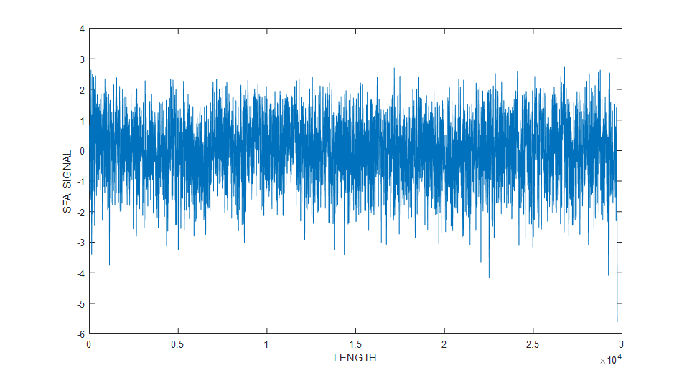

Figure S1: Same as Figure 1 but for SARS-CoV-1

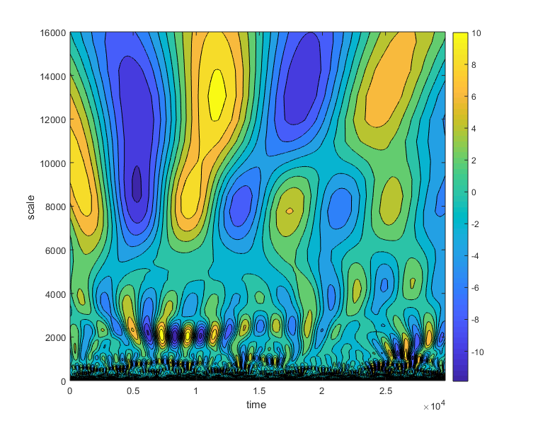

Figure S2: Same as Figure 2 but for SARS-CoV-1

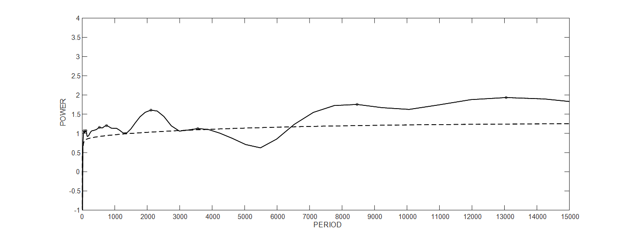

Figure S3: Same as Figure 3 but for SARS-CoV-1

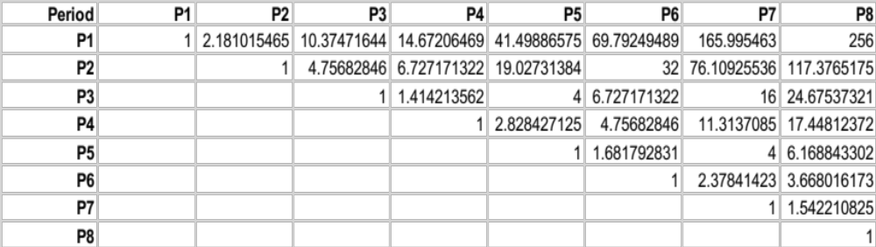

Table ST1: Same as Table 1 but for SARS-CoV-1

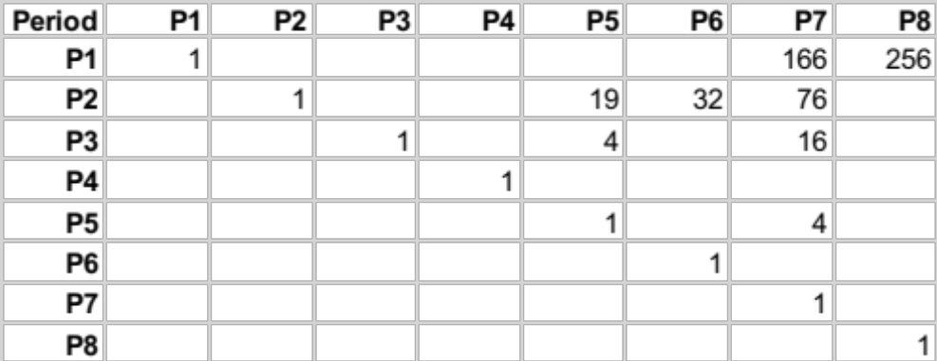

Table ST2: Same as Table 2 but for SARS-CoV-1
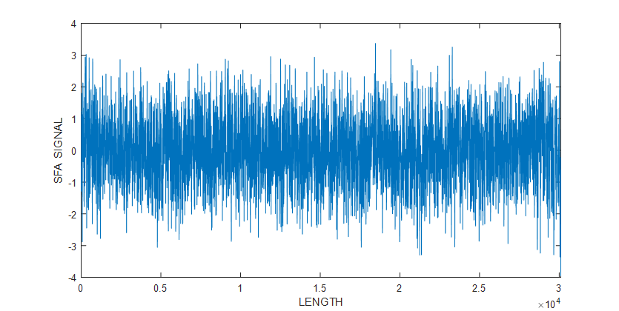

Figure S4: Same as Figure 1 but for MERS

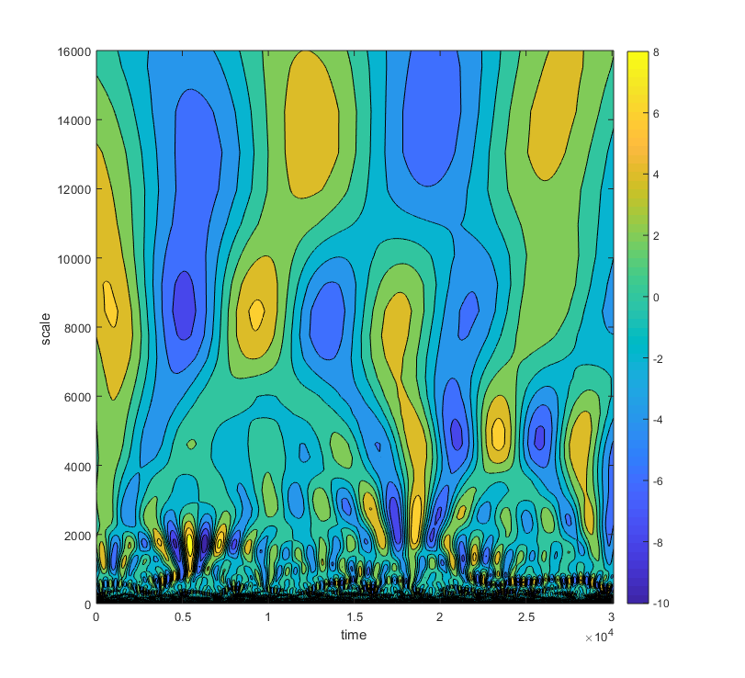

Figure S5: Same as Figure 2 but for MERS

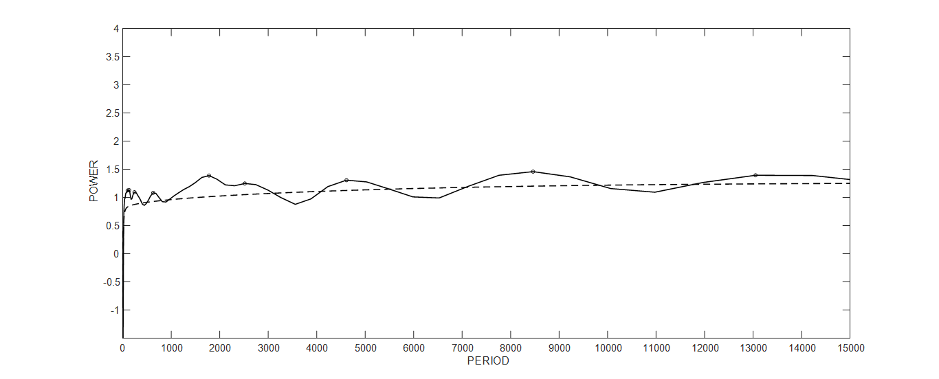

Figure S6: Same as Figure 3 but for MERS

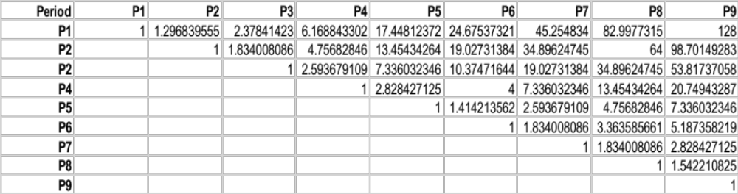

Table ST3: Same as Table 1 but for MERS

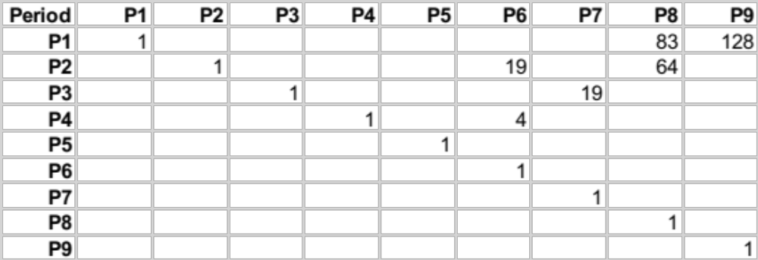

Table ST4: Same as Table 2 but for MERS
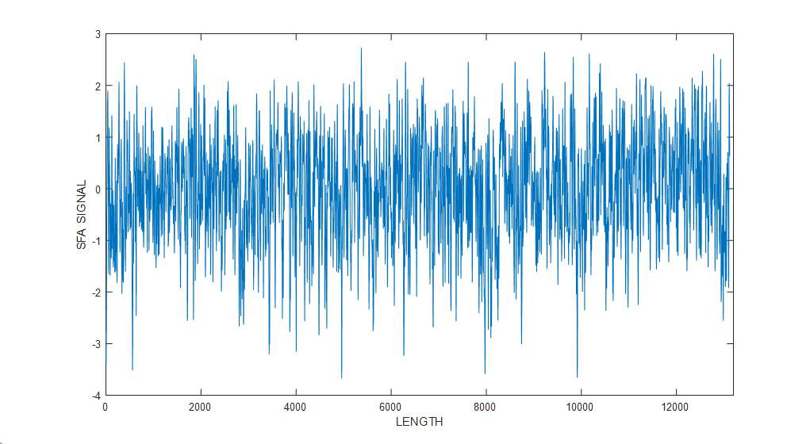
Figure S7: Same as Figure 1 but for H1N1-1918

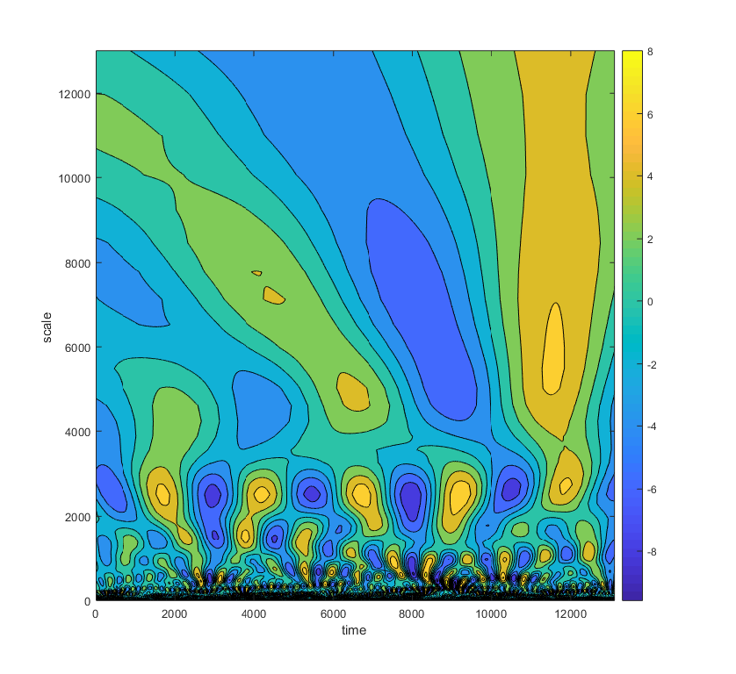

Figure S8: Same as Figure 2 but for H1N1-1918

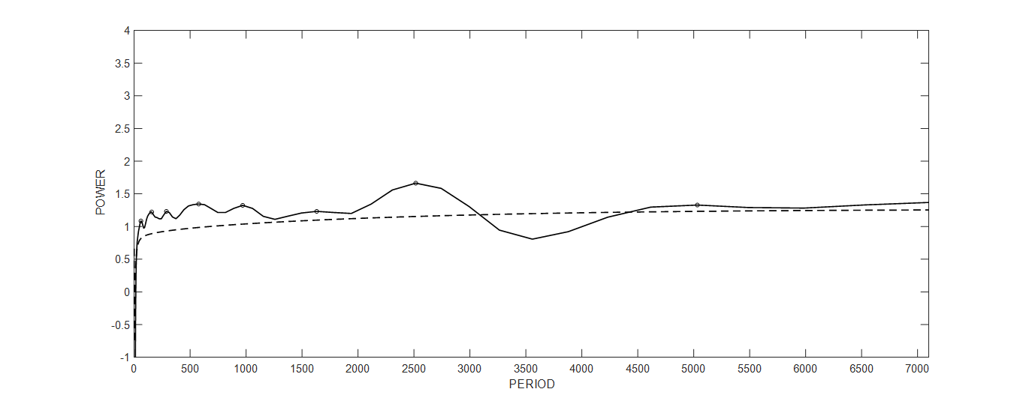

Figure S9: Same as Figure 3 but for H1N1-1918

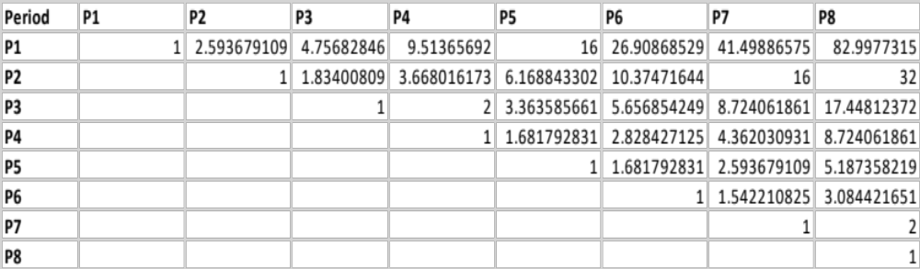

Table ST5: Same as Table 1 but for H1N1-1918

Period | P1 | P2 | P3 | P4 | P5 | P6 | P7 | P8
P1 | 1 |  |  |  | 16 |  |  | 83
P2 |  | 1 |  |  |  |  | 16 | 32
P3 |  |  | 1 | 2
P4 |  |  |  | 1
P5 |  |  |  |  | 1
P6 |  |  |  |  |  | 1
P7 |  |  |  |  |  |  | 1 | 2
P8 |  |  |  |  |  |  |  | 1

Table ST6: Same as Table 2 but for H1N1-1918

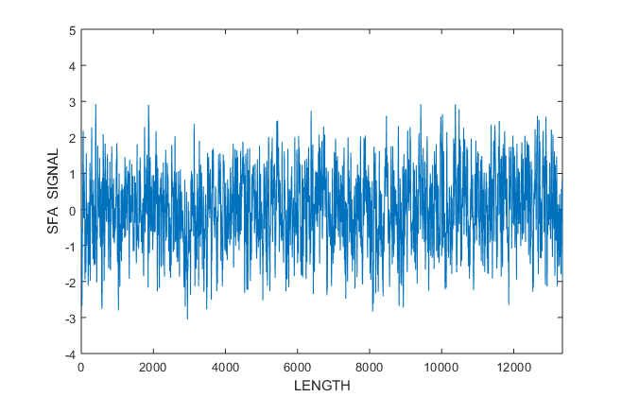

Figure S10: Same as Figure 1 but for H1N1-2009

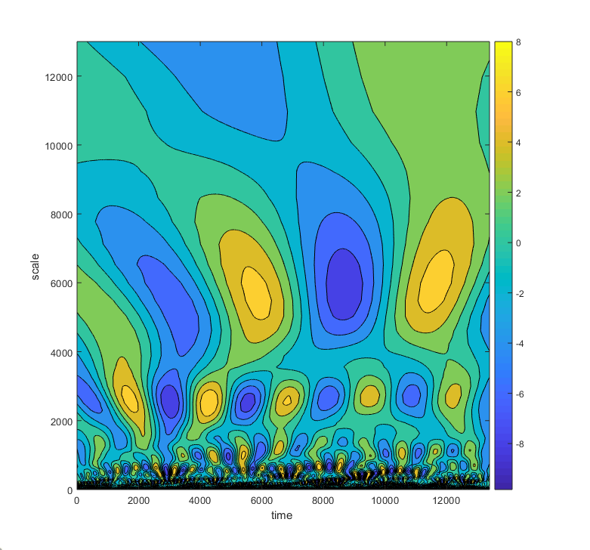

Figure S11: Same as Figure 2 but for H1N1-2009
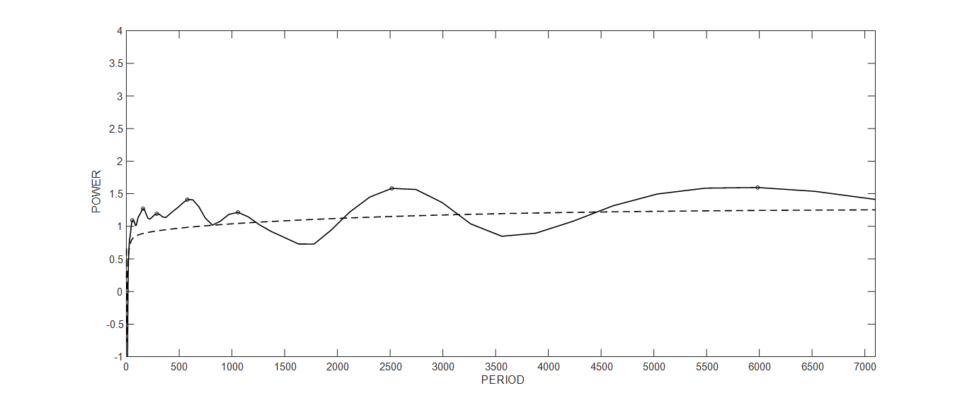

Figure S12: Same as Figure 3 but for H1N1-2009

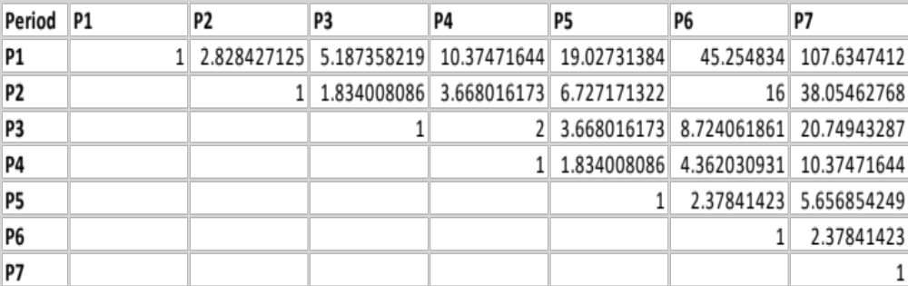

Table ST7: Same as Table 1 but for H1N1-2009

Period | P1 | P2 | P3 | P4 | P5 | P6 | P7
P1 | 1 |  |  |  | 19
P2 |  | 1 |  |  |  | 16 | 38
P3 |  |  | 1 | 2
P4 |  |  |  | 1
P5 |  |  |  |  | 1
P6 |  |  |  |  |  | 1
P7 |  |  |  |  |  |  | 1

Table ST8: Same as Table 2 but for H1N1-2009

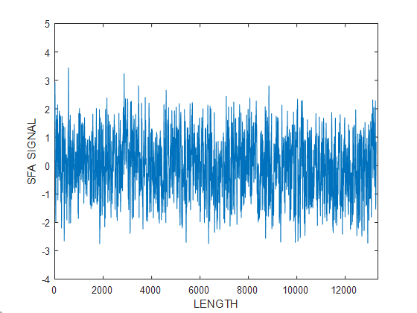

Figure S13: Same as Figure 1 but for H2N2-1957

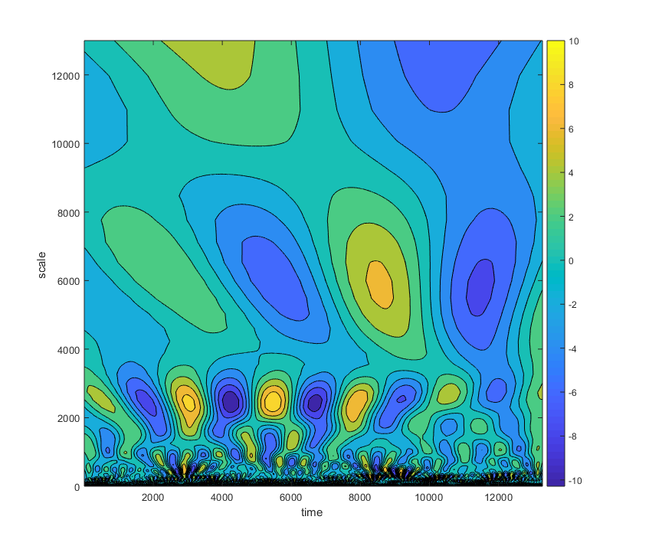

Figure S14: Same as Figure 2 but for H2N2-1957

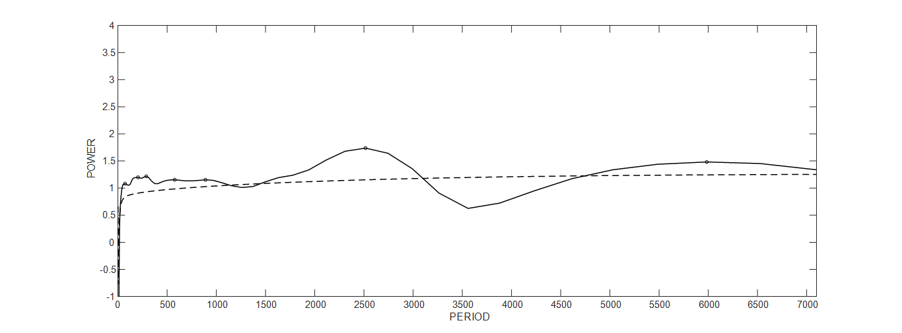

Figure S15: Same as Figure 3 but for H2N2-1957

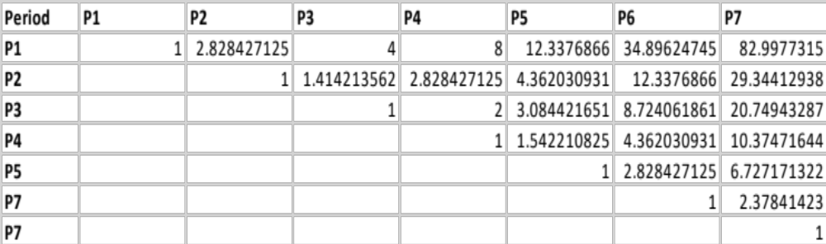

Table ST9: Same as Table 1 but for H2N2-1957

Period | P1 | P2 | P3 | P4 | P5 | P6 | P7
P1 | 1 |  | 4 | 8 |  |  | 83
P2 |  | 1
P3 |  |  | 1 | 2
P4 |  |  |  | 1
P5 |  |  |  |  | 1
P6 |  |  |  |  |  | 1
P7 |  |  |  |  |  |  | 1

Table ST10: Same as Table 2 but for H2N2-1957

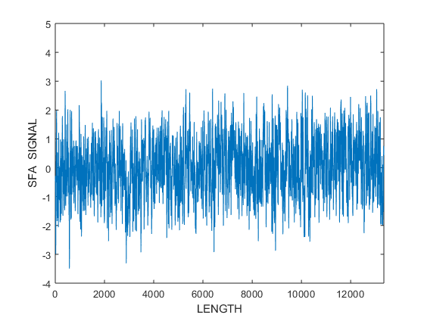

Figure S16: Same as Figure 1 but for H3N2-1968

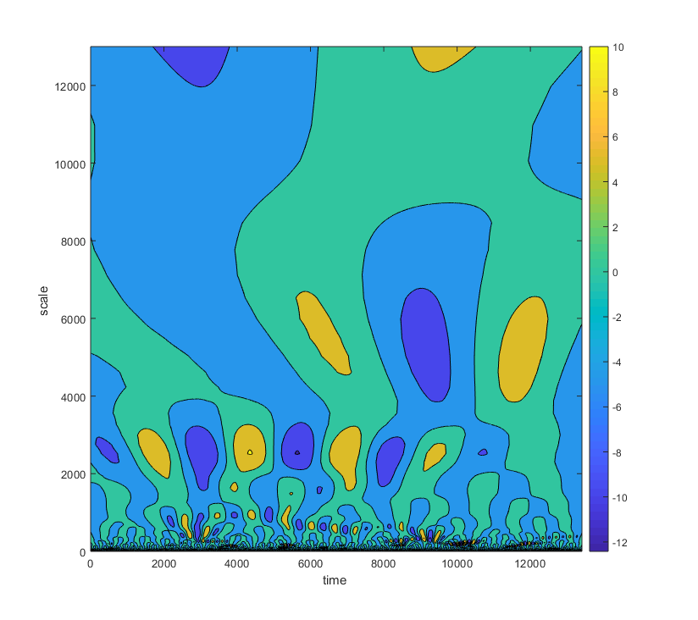

Figure S17: Same as Figure 2 but for H3N2-1968

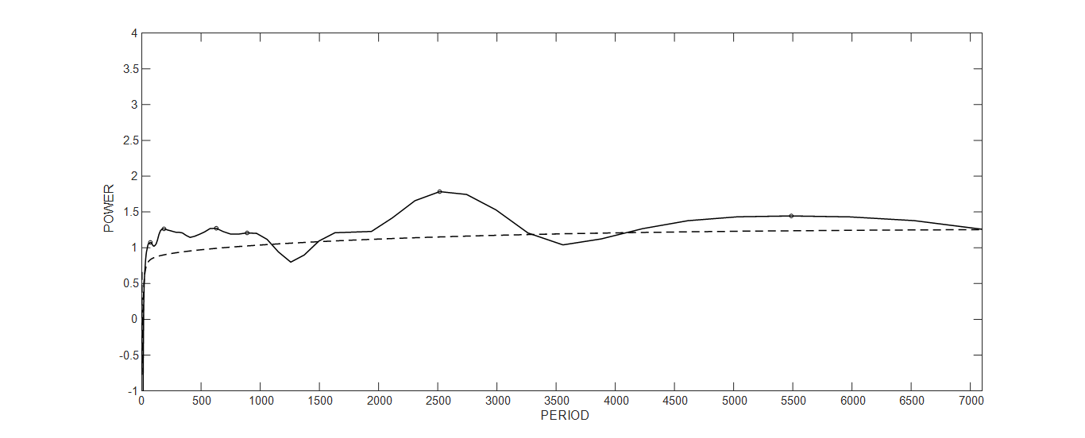

Figure S18: Same as Figure 3 but for H3N2-1968

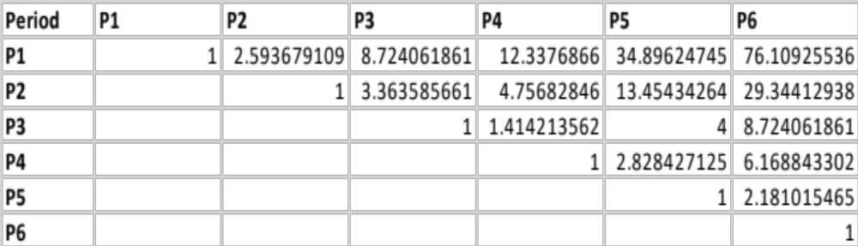

Table ST11: Same as Table 1 but for H3N2-1968

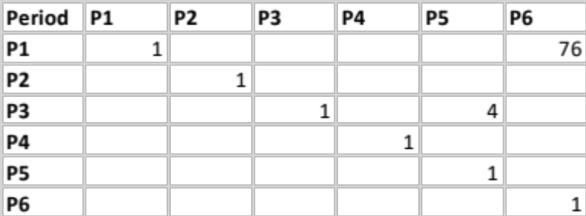

Table ST12: Same as Table 2 but for H3N2-1968

