Supplementary Materials
Methods
Stimuli: To ensure the applicability of the stimuli (faces and houses) for Chinese participants, we assessed the stimuli by inviting another 35 participants to judge the age (either young or old) of the houses and faces before our formal experiment. The assessment showed that the accuracy of the age judgment of the face pictures was 0.99 (SD = 0.02) and the accuracy of the house pictures was 0.91 (SD = 0.10). To reduce individual differences in age judgment on the task stimuli, the participants participated in two training sessions before the MRI scanning.
Behavioral data analysis: We recorded the response time and response accuracy as the measure of behavioral performance during the task-fMRI scanning. To test whether the participants showed different behavioral performances for different outcomes (face/house), we compared the response time and response accuracy between the face trials (the current category was face) and the house trials (the current category was house). Paired t-tests were applied to determine the significance of the difference in behavioral performance (two-tailed; Fig. S1).

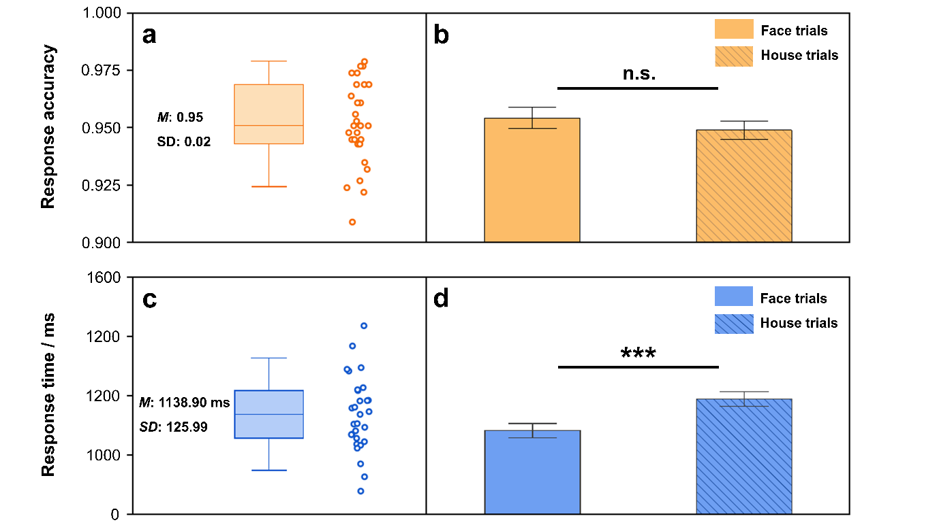Fig. S1 Behavioral performance during the task-fMRI scanning. (a) Response accuracy for the whole task across all participants. (b) Response accuracy for both the face trials and house trials. No significant difference in the response accuracy was found between the face trials (the current category was face) and the house trials (the current category was house; face M = 0.954 vs. house M = 0.949; paired t₂₈ = 1.06, p = .30). (c) Response time of the whole task across all participants. (c) Response time for both the face trials and house trials. The response time was significantly shorter in the face trials than in the house trials (face M = 1083.57 ms vs. house M = 1190.30 ms; paired t₂₈ = -9.21, p < .001). Whisker plots indicate the distribution of the response accuracy or response time, and the whiskers represent ±2 standard deviations (SD) outside the upper and the lower quartiles. The dots indicate the raw data of the participants. Error bar was 1 standard error of the mean (SEM); n.s., non-significant; ***, p < .001.
Table S1 The coordinates and size of each of the orbitofrontal cortex (OFC) subregions, which were determined according to the Brainnetome Atlas.
Hemisphere | OFC  subregions | Coordinates in  MNI space  (x, y, z) |  |  | Size of subregions
Hemisphere | OFC  subregions |  |  |  | (#voxels) | (mm³)
Left
 | mOFC₁ | -7 | 54 | -7 | 517 | 4,136
 | mOFC₂ | -6 | 52 | -19 | 616 | 4,928
 | lOFC₁ | -23 | 38 | -18 | 918 | 7,344
 | lOFC₂ | -36 | 33 | -16 | 500 | 4,000
 | lOFC₃ | -41 | 32 | -9 | 549 | 4,392
Right
 | mOFC₁ | 6 | 47 | -7 | 630 | 5,040
 | mOFC₂ | 6 | 57 | -16 | 698 | 5,584
 | lOFC₁ | 23 | 36 | -18 | 1,201 | 9,608
 | lOFC₂ | 40 | 39 | -14 | 456 | 3,648
 | lOFC₃ | 42 | 31 | -9 | 483 | 3,864
Abbreviations: m, medial; l, lateral.

Table S2 Classification accuracy obtained from the multi-voxel pattern analysis (MVPA) for classifying each of the pieces of decision-related information on the unilateral orbitofrontal cortex (OFC) subregions.
Decision-related information | Unilateral OFC  subregions |  |  | Classification accuracy  (Mean ± SD) | t₂₈ | p-value
Previous category
 |  | mOFC₁.L |  | 0.522 ± 0.030 | 3.89 | .001*
 |  | mOFC₂.L |  | 0.515 ± 0.024 | 3.43 | .002*
 |  | lOFC₁.L |  | 0.514 ± 0.020 | 3.65 | .001*
 |  | lOFC₂.L |  | 0.527 ± 0.025 | 5.71 | < .001*
 |  | lOFC₃.L |  | 0.526 ± 0.026 | 4.52 | < .001*
Previous age
 |  | mOFC₁.L |  | 0.527 ± 0.032 | 4.44 | < .001*
 |  | mOFC₂.L |  | 0.505 ± 0.031 | 0.91 | .370
 |  | lOFC₁.L |  | 0.510 ± 0.024 | 2.23 | .034
 |  | lOFC₂.L |  | 0.518 ± 0.032 | 2.98 | .006*
 |  | lOFC₃.L |  | 0.516 ± 0.030 | 2.92 | .007*
Current category
 |  | mOFC₁.L |  | 0.545 ± 0.027 | 8.80 | < .001*
 |  | mOFC₂.L |  | 0.525 ± 0.028 | 4.66 | < .001*
 |  | lOFC₁.L |  | 0.515 ± 0.031 | 2.52 | .018
 |  | lOFC₂.L |  | 0.526 ± 0.028 | 4.76 | < .001*
 |  | lOFC₃.L |  | 0.526 ± 0.031 | 4.50 | < .001*
Current age
 |  | mOFC₁.L |  | 0.517 ± 0.034 | 2.70 | .012
 |  | mOFC₂.L |  | 0.511 ± 0.031 | 1.89 | .069
 |  | lOFC₁.L |  | 0.504 ± 0.033 | 0.67 | .507
 |  | lOFC₂.L |  | 0.525 ± 0.029 | 4.61 | < .001*
 |  | lOFC₃.L |  | 0.518 ± 0.029 | 3.23 | .003*
Previous category
 |  | mOFC₁.R |  | 0.520 ± 0.025 | 4.24 | < .001*
 |  | mOFC₂.R |  | 0.511 ± 0.027 | 2.27 | .031
 |  | lOFC₁.R |  | 0.514 ± 0.024 | 3.20 | .003*
 |  | lOFC₂.R |  | 0.516 ± 0.022 | 3.66 | .001*
 |  | lOFC₃.R |  | 0.526 ± 0.020 | 6.73 | < .001*
Previous age
 |  | mOFC₁.R | 0.523 ± 0.034 |  | 3.61 | .001*
 |  | mOFC₂.R | 0.518 ± 0.031 |  | 2.99 | .006*
 |  | lOFC₁.R | 0.507 ± 0.032 |  | 1.10 | .282
 |  | lOFC₂.R | 0.515 ± 0.026 |  | 2.95 | .006*
 |  | lOFC₃.R | 0.530 ± 0.027 |  | 5.91 | < .001*
Current category
 |  | mOFC₁.R | 0.546 ± 0.023 |  | 10.60 | < .001*
 |  | mOFC₂.R | 0.520 ± 0.022 |  | 4.87 | < .001*
 |  | lOFC₁.R | 0.526 ± 0.035 |  | 3.93 | .001*
 |  | lOFC₂.R | 0.535 ± 0.029 |  | 6.46 | < .001*
 |  | lOFC₃.R | 0.536 ± 0.027 |  | 7.17 | < .001*
Current age
 |  | mOFC₁.R | 0.514 ± 0.039 |  | 1.87 | .071
 |  | mOFC₂.R | 0.502 ± 0.032 |  | 0.25 | .803
 |  | lOFC₁.R | 0.503 ± 0.039 |  | 0.39 | .698
 |  | lOFC₂.R | 0.518 ± 0.029 |  | 3.40 | .002*
 |  | lOFC₃.R | 0.511 ± 0.033 |  | 1.72 | .097
Abbreviations: m/l, medial/lateral; L/R, left/right hemisphere; *, p < .05/5 = .01 (Bonferroni correction).

Table S4 Significant clusters obtained from the psychophysiological interaction (PPI) analyses (GLM2 and GLM3) for the seeds in the mOFC₁ and lOFC₃. The threshold of the analysis was set at voxel level p < .025 and the GRF correction at the cluster level Z > 3.09.
Seed regions | Anatomical location | Peak coordinates in MNI space  (x, y, z) |  |  | Cluster size |  |  | Z |  | p-value
Seed regions | Anatomical location |  |  |  | (#voxels) |  | (mm³)
mOFC₁
 | M1.L | -22 | -30 | 76 |  | 201 | 1,608 | 4.90 | < .001
 | M1.R | 28 | -34 | 72 |  | 168 | 1,344 | 4.92 | < .001
 | V1/V3.R | 10 | -86 | 16 |  | 103 | 824 | 4.26 | .002
 | V3.R | 4 | -78 | 38 |  | 79 | 632 | 4.32 | .008
lOFC₃
 | SMG.L | -58 | -36 | 42 |  | 200 | 1,600 | 4.64 | < .001
 | ACC.L | -4 | 20 | 40 |  | 135 | 1,080 | 4.42 | < .001
 | SMG.R | 48 | -42 | 56 |  | 123 | 984 | 4.42 | < .001
 | FPC.R | 28 | 62 | -4 |  | 109 | 872 | 3.91 | < .001
 | SMA.R | 28 | 12 | 60 |  | 107 | 856 | 4.95 | < .001
 | SMA.L | -16 | 8 | 66 |  | 101 | 808 | 4.14 | < .001
 | dlPFC.L | -26 | 56 | 14 |  | 90 | 720 | 3.76 | .002
 | SMG.L | -42 | -52 | 52 |  | 67 | 536 | 3.93 | .011
 | V3.L | -10 | -78 | 34 |  | 66 | 528 | 4.05 | .012
 | OPC.R | 58 | 22 | 24 |  | 65 | 520 | 3.87 | .013
 | PMC | 0 | 16 | 62 |  | 60 | 480 | 4.10 | .020
Abbreviations: FPC, frontal polar cortex; dlPFC, dorsal lateral prefrontal cortex; OPC, opercular cortex; SMA, supplementary motor area; PMC, premotor cortex; M1, primary motor cortex; ACC, dorsal anterior cingulate cortex; SMG, supramarginal gyrus; MTG, middle temporal gyrus; V1, primary visual cortex; V3, the third visual cortex. L (R), left (right) hemisphere.

