Extended Data

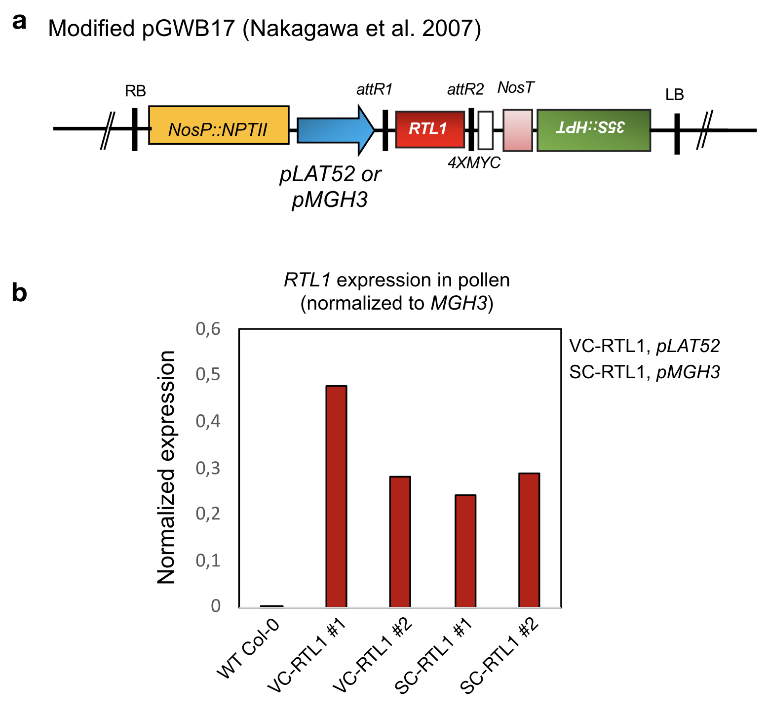
Extended Data Fig. 1 - Ectopic expression of RTL1 in pollen. a, A modified version of the pGWB17 plasmid containing the genomic sequence of RTL1 (AT4G15417) was generated by replacing the 35S promoter by the LAT52 or MGH3 promoters. b, Stable RTL1 expression in pollen was confirmed by RT-qPCR in two independent lines that were selected as homozygous for each transgene in the T₃ generation. RTL1 expression was normalized to the levels of the endogenous MGH3 gene that is specifically expressed in pollen.

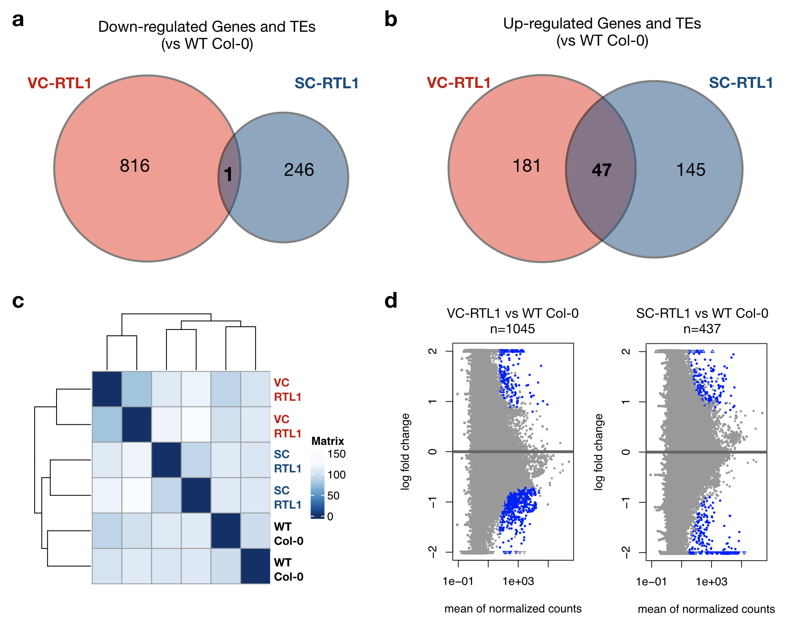
Extended Data Fig. 2 - Small RNA sequencing of VC-RTL1 and SC-RTL1 transgenic pollen. a, Venn diagram shows little overlap between genes and transposable elements (TEs) with significantly reduced siRNA levels in VC-RTL1 and SC-RTL1 pollen, as compared to wild-type control (WT Col-0). b, Venn diagram shows partial overlap between genes and TEs with up-regulated siRNA levels in VC-RTL1 and SC-RTL1 pollen (vs. WT Col-0). c, Transformed small RNA datasets were used for sample clustering to visualize sample-to-sample distances, which are represented by the scale gradient. The heatmap of this distance matrix shows an overview of similarities and dissimilarities between all datasets. d, MA plots highlight the number of genes and TEs differentially expressed in VC-RTL1 and SC-RTL1 pollen as calculated by DESeq2 (P <0.05), which are marked as blue dots.

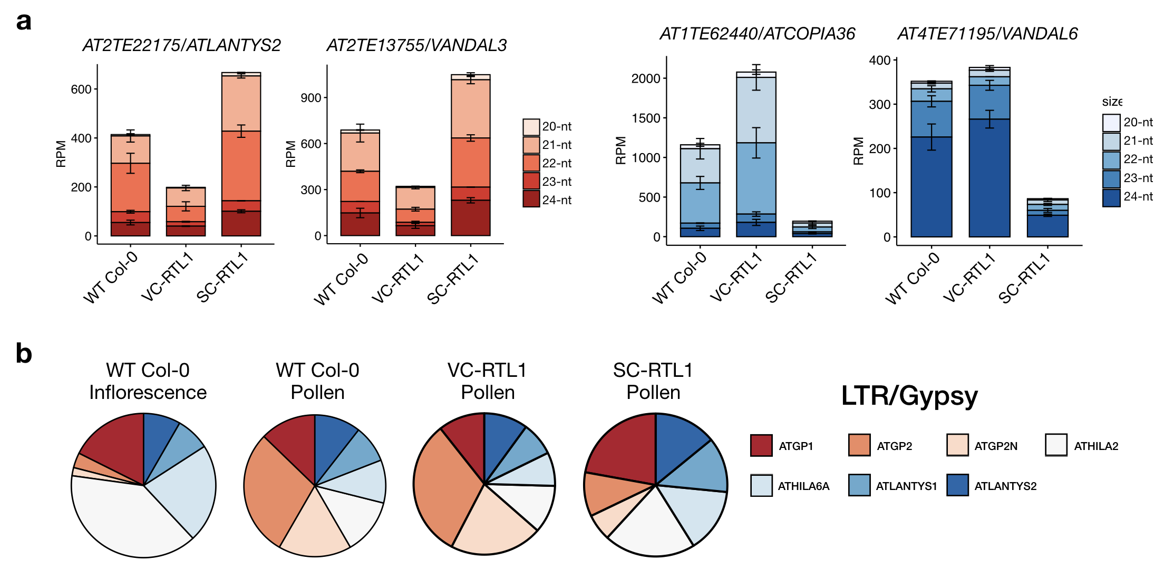
Extended Data Fig. 3 - Ectopic expression of RTL1 in pollen suppresses siRNA biogenesis from TEs. a, Examples of individual TEs producing siRNA in WT Col-0 pollen, but showing significantly reduced levels in either VC-RTL1 or SC-RTL1 pollen. Error bars represent the standard error, and RPM is reads per million. c, Pie charts represent the LTR/Gypsy families showing the highest siRNA levels in WT Col-0 pollen, to illustrate that siRNAs matching to ATGP2 and ATGP2N are enriched in pollen as compared to inflorescence tissue, and depleted specifically in SC-RTL1 pollen.

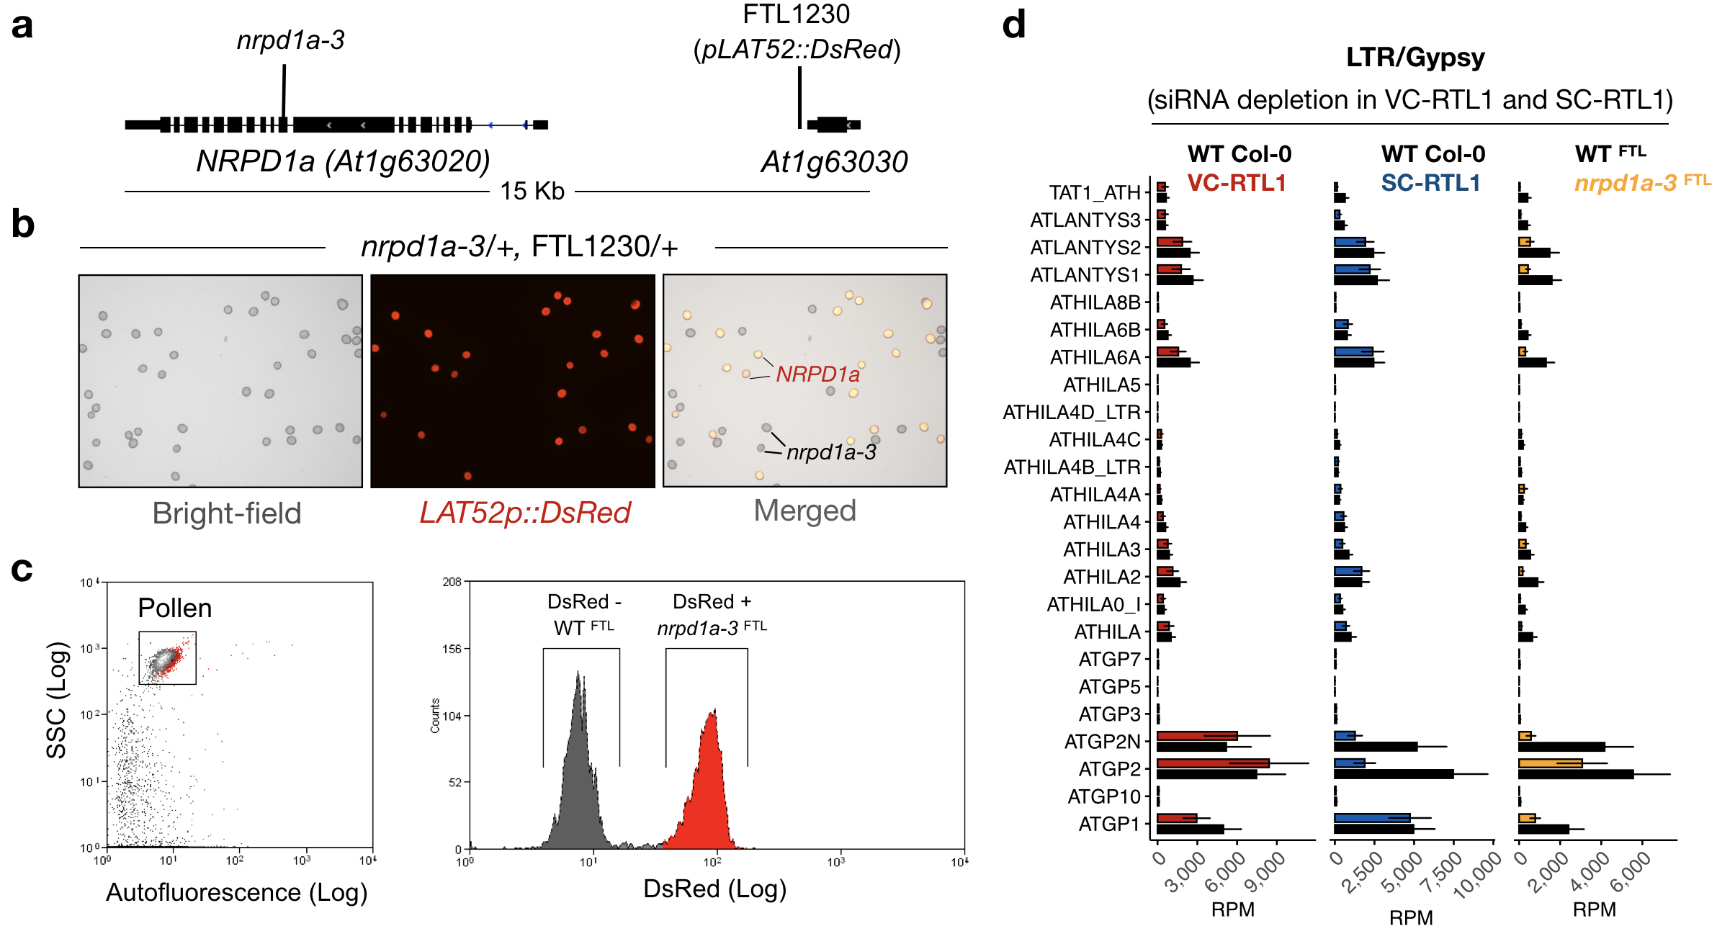
Extended Data Fig. 4 - FACS-based purification of nrpd1a pollen. a, A fluorescence-tagged line (FTL1230) was identified carrying the FTL transgene in close proximity to the NRPD1a (AT1G63020) gene that encodes the largest subunit of RNA Polymerase IV (Pol IV). The schematic depicts the localization of the FTL1230 transgene and the nrpd1a-3 T-DNA mutant allele. b, A cross was performed between FTL1230 and nrpd1a-3 mutant to obtain double heterozygous FTL1230/+, nrpd1a-3/+ F₁ plants showing approximately 50% of DsRed positive (DsRed +) pollen representing the WT allele of NRPD1a (WT^{FTL}), and approximately 50% of DsRed negative (DsRed -) pollen representing the mutant nrpd1a-3 allele (nrpd1a-3^{FTL}). c, The two populations were purified by fluorescence-activated cell sorting based on the differences in DsRed signal. d, Normalized small RNA reads mapping to differentially expressed TEs in VC-RTL1 and SC-RTL1 pollen show variable expression levels in wild-type Col-0 pollen, and dependency of Pol IV activity for their biogenesis. This is shown by the reduced levels in nrpd1a-3^{FTL} mutant pollen, showing that these siRNAs are produced specifically during pollen development.

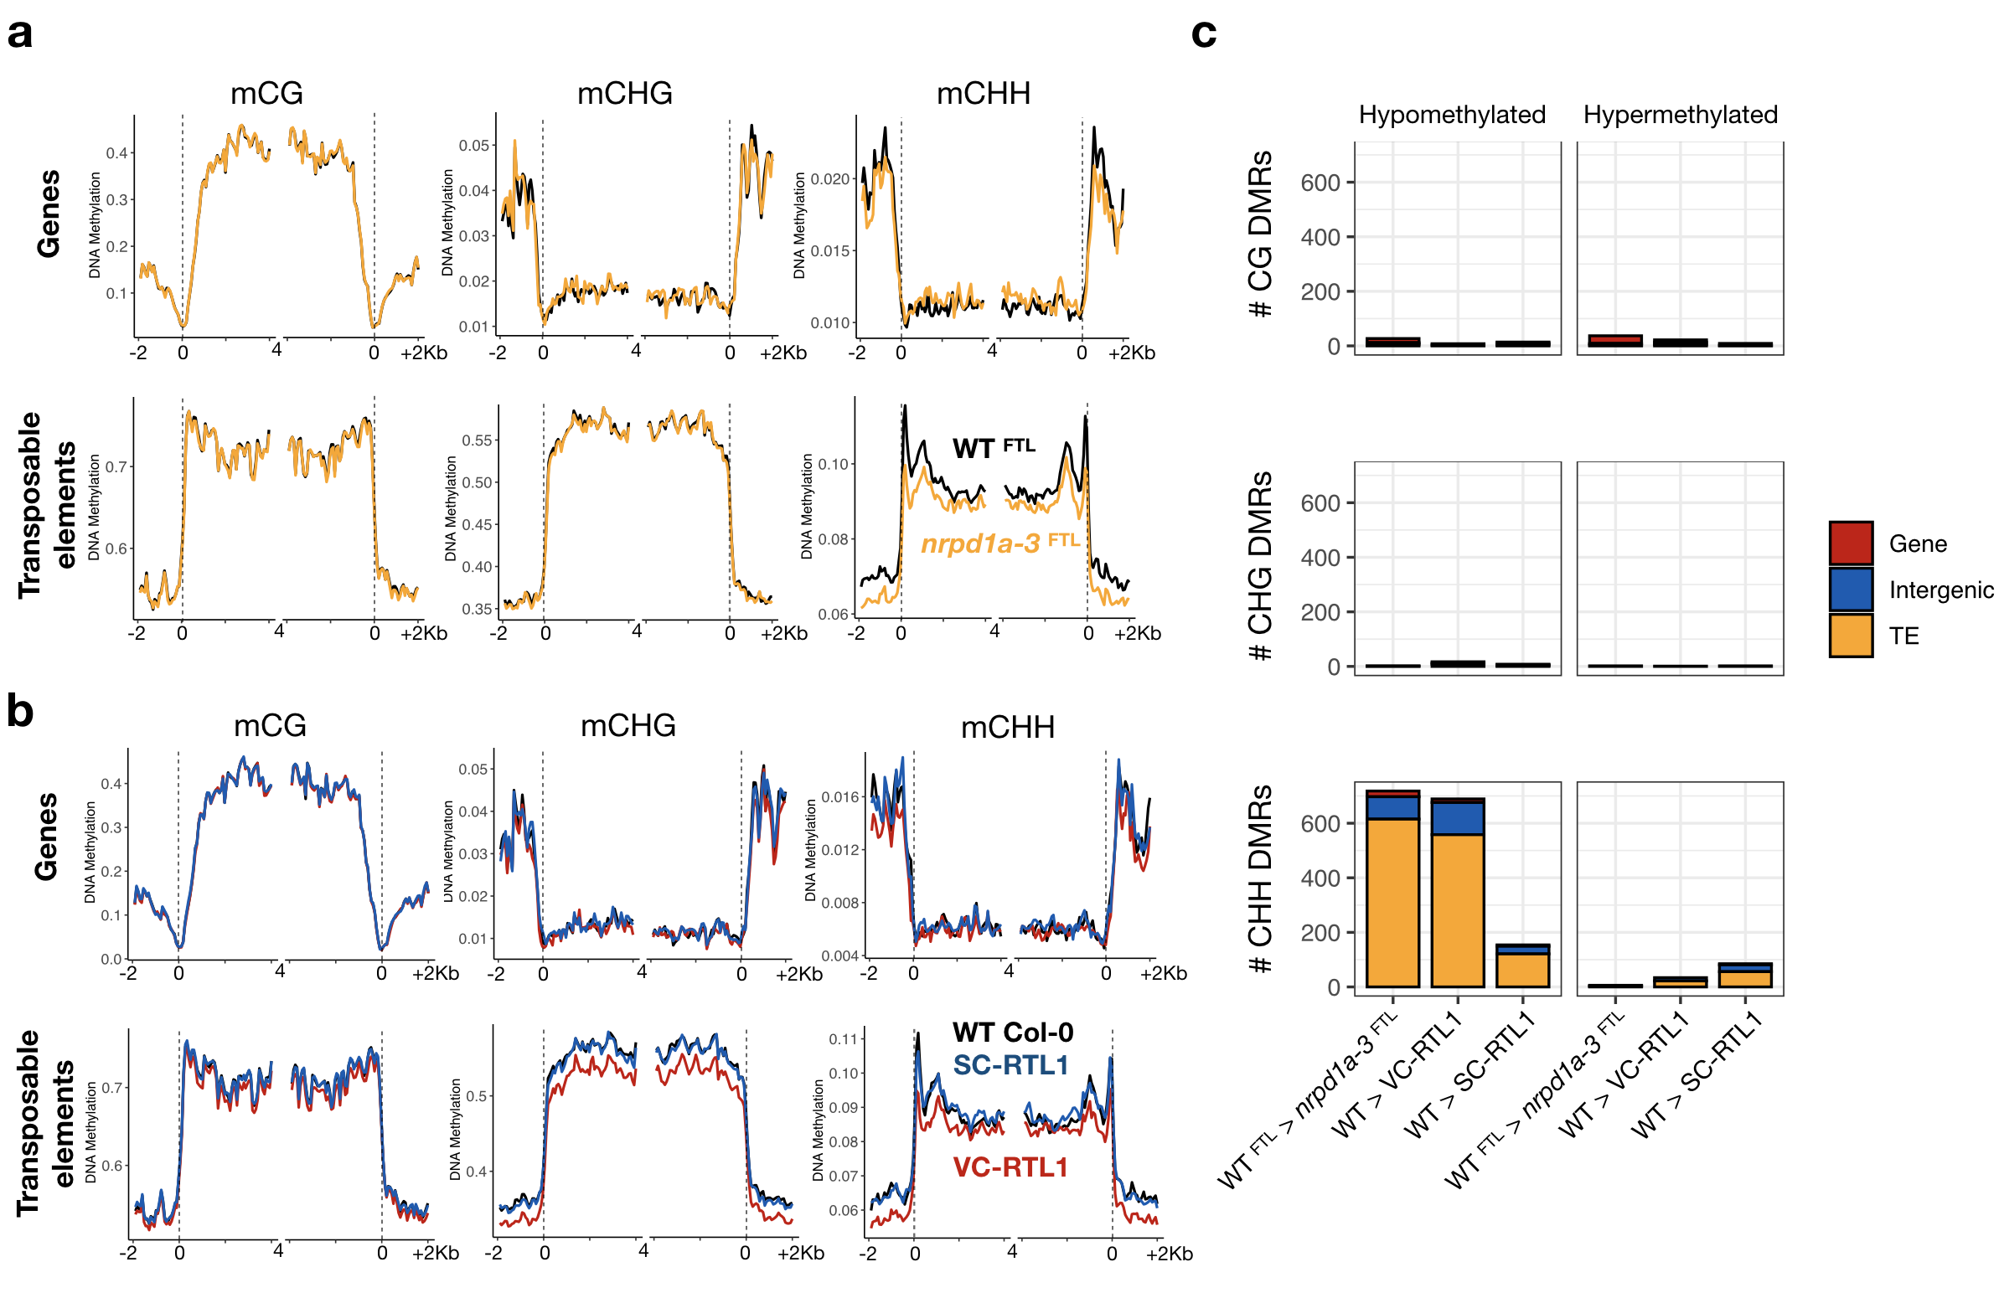
Extended Data Fig. 5 - Differentially methylated regions in VC-RTL1 and SC-RTL1 pollen. a, Average CG, CHG, and CHH methylation levels in WT^{FTL} and nrpd1a-3^{FTL} pollen are plotted as 100-bp bins overlapping protein-coding genes or transposable elements annotated in the Arabidopsis TAIR10 reference genome, and aligned at the 5’ and 3’ ends (dashed lines). b, Average CG, CHG and CHH methylation levels at genes and TEs are also plotted for WT Col-0, VC-RTL1 and SC-RTL1 pollen, showing a reduction in non-CG methylation in VC-RTL1. c, Differentially methylated regions (DMRs) in VC-RTL1 and SC-RTL1 pollen (as compared to WT Col-0) are mainly hypomethylated in the CHH context and overlap with TEs. The number of DMRs detected for VC-RTL1 is similar to what is observed in nrpd1a-3^{FTL} pollen.

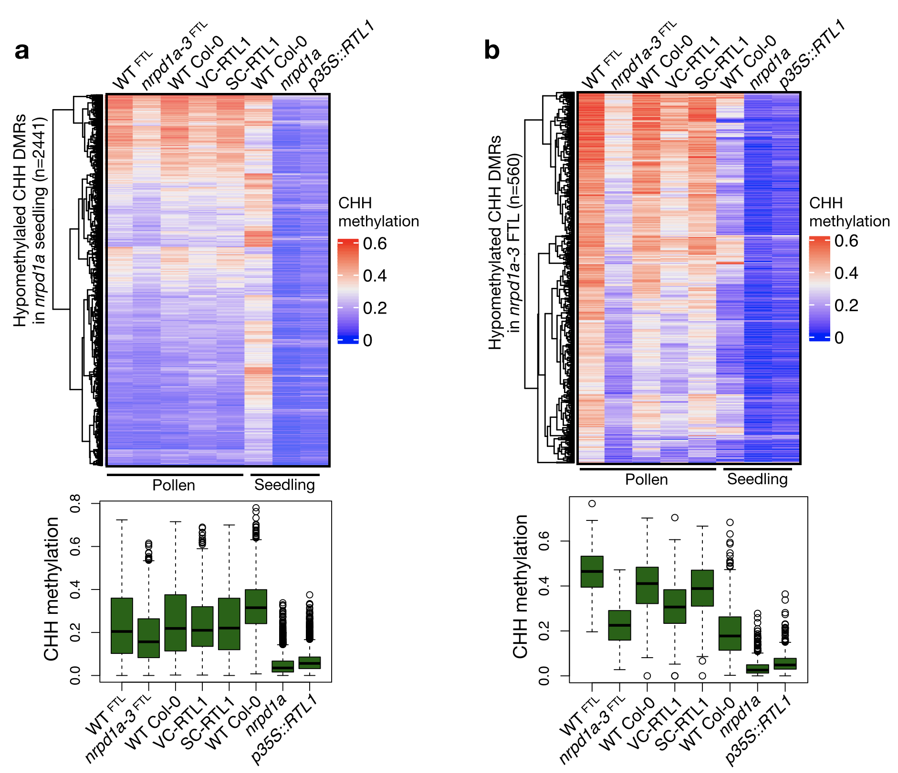
Extended Data Fig. 6 - Loss of CHH methylation in nrpd1a-3 pollen. a, Heatmap and boxplot representation of differentially methylation regions (DMRs) in the CHH context between WT Col-0 seedlings and nrpd1a homozygous mutant shows strong loss of CHH methylation in the mutant, which is comparable to what is observed when RTL1 is ectopically expressed by the 35S promoter (p35S::RTL1). b, Loss of Pol IV activity specifically during gametophytic development (nrpd1a-3^{FTL}) leads to a partial loss of CHH methylation, which is also found in VC-RTL1 pollen.

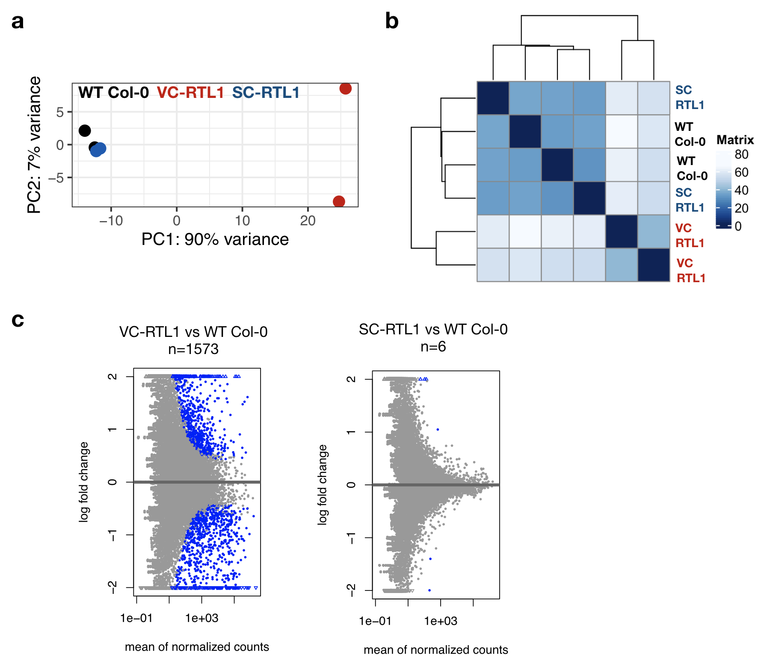
Extended Data Fig. 7 - RNA sequencing of VC-RTL1 and SC-RTL1 transgenic pollen. a, Principal component analysis shows the reproducibility of RNA sequencing experiments for two independent transgenic lines of each construct and wild-type Col-0 control. This also highlights differences between VC-RTL1 and SC-RTL1 datasets, as VC-RTL1 separates from WT Col-0 and SC-RTL1 along PC1. b, Transformed datasets were used for sample clustering to visualize sample-to-sample distances, which are represented by the scale gradient. The heatmap of this distance matrix shows an overview of similarities and dissimilarities between all datasets. c, MA plots highlight the number of genes and TEs differentially expressed in VC-RTL1 and SC-RTL1 pollen as calculated by DESeq2 (P <0.05), which are marked as blue dots.

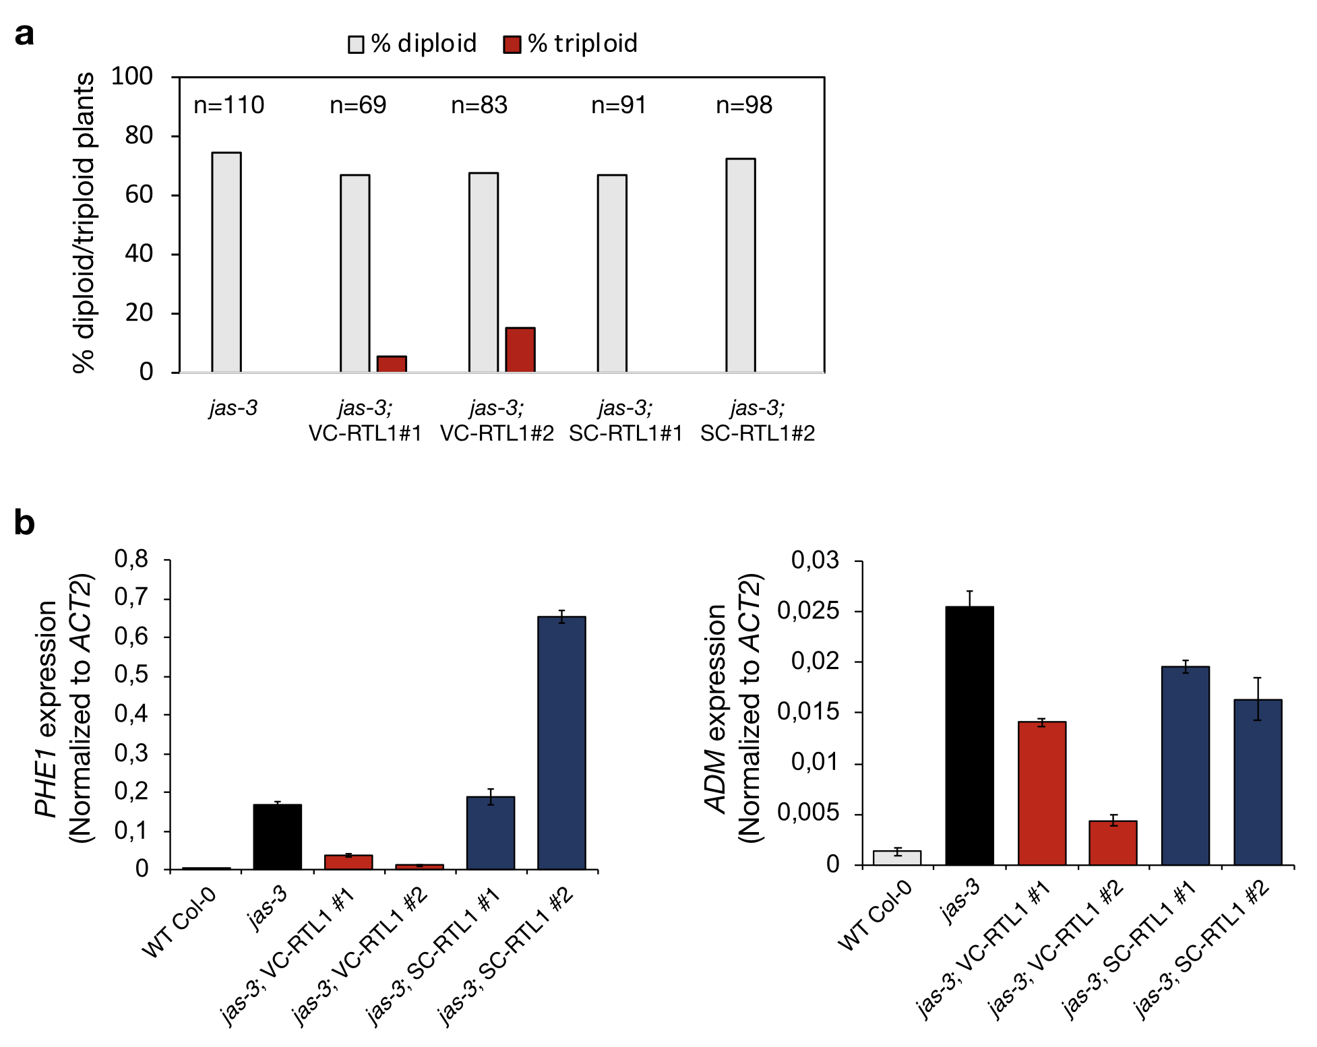
Extended Data Fig. 8 - Loss of siRNA biogenesis in the vegetative nucleus impacts triploid seed viability and genomic imprinting. a, The presence of viable triploid seeds in jas-3;VC-RTL1 lines was quantified by inspecting the presence of triploid plants in the selfed progeny, based on their fertility defects. b, Expression of the paternally expressed imprinted genes PHE1 and ADM is up-regulated in jas-3 mutant siliques 7 days after pollination, as compared to wild-type Col-0. This response is reduced in siliques of jas-3;VC-RTL1 lines, particularly for PHE1 that was found down-regulated in two independent transgenic lines showing lower levels of seed collapse.

Extended Data Table 1 - Primers used in this study.
Name | Sequence (5’ - 3’)
Cloning  pLAT52_HindIII_F  pLAT52_XbaI_R  pMGH3_HindIII_F pMGH3_XbaI_R | aatAAGCTTGACATACTCGACTCAGAAGGTA  aatTCTAGATTTTTTTTTGGTGTGTGTACTT  aatAAGCTTTACTTCTCCGACCAAAAACTT  aatTCTAGAGTGCGATTTCTTCGAGAGAAC
RT-qPCR  RTL1_F  RTL1_R  MGH3_F  MGH3_R  ACT2_F  ACT2_R  ADM_F  ADM_R  PHE1_F  PHE1_R | ATGGACTGCAACTCCACC GTTCTGTCATTGGATGGCTC  TGTCCAAGGACATTCAGTTGGC CACGGAAGGGTTTTATCAGAG  GAGAGATTCAGATGCCCAGAAGTC  TGGATTCCAGCAGCTTCCA  TTGAAAGAGTTTGCGGATGTG  AGGACCAACATTATGGTCATACC  TTGGTGTAGCTCCTACTGTTGT  AGCCTGGTATTGGAATTGAACC
Genotyping  LBb1.3  nrpd1a-3_F  nrpd1a-3_R  LB_T-DNA_FTL  FTL1230_F  FTL1230_R  LB3  jas-3_SAIL_F  jas-3_SAIL_R | ATTTTGCCGATTTCGGAAC  GATCTGTTCAGCTTGCTCGTC  TGCTTATGATGGCACTGTGAG  GGCATGCAAGCTGATAATTC  GAATTCTCCAACACAGCTCAGG  AGATCCGCGTGTTTGAATTTCT  TAGCATCTGAATTTCATAACCAATCTCGATACAC  CACTTCAAATGGTGTTGCATG  TCTTCCCATTTTCACTCATGG

Supplementary Information

Supplementary Data 1 - Differentially expressed small RNAs from genes and TEs. Read counts were normalized using the R package DESeq2. Genes and TEs were considered differentially expressed if displaying an FDR adjusted p-value < 0.05.

Supplementary Data 2 - Differentially Methylated Regions (DMRs). DMRs were defined as 100-bp bins containing at least 4, 5 or 6 differentially methylated CGs, CHGs or CHH, and with an absolute methylation difference of 0.40, 0.35 and 0.25, respectively. DMRs localizing within 200 bp of each other were merged and mapped to annotated features in the Arabidopsis TAIR10 genome.

Supplementary Data 3 - Hypomethylated CHH DMRs in nrpd1a mutant. mCHH levels mapping to hypomethylated CHH DMRs between WT^{FTL} and nrpd1a-3^{FTL} pollen, and between WT Col-0 and nrpd1a seedlings.

Supplementary Data 4 - Differentially expressed genes and TEs. Read counts were normalized using the R package DESeq2. Genes and TEs were considered differentially expressed if displaying an FDR adjusted p-value < 0.05.

Supplementary Data 5 - Summary of RNA sequencing and whole-genome bisulfite sequencing (WGBS). For small RNA analysis, trimmed and collapsed reads (18-30 nucleotides) were mapped to TAIR10 genome using bowtie (-v 1 --all). For WGBS libraries, mean genomic coverage and methylation percentages for CG, CHG and CHH context is presented. Cytosines covered by 3 or more reads were used to calculate methylation percentages. For RNA-seq analysis, high quality raw reads were aligned to the TAIR10 genome using STAR.

