Supplementary information

Azobenzene-Containing Liquid Crystalline Composites for Robust Ultraviolet Detectors Based on Conversion of Illuminance-Mechanical Stress-Electric Signals

Xiaoxiong Zheng, Yining Jia & Aihua Chen*

School of Materials Science and Engineering, Beihang University
No. 37 Xueyuan Road, Haidian District, Beijing 100191, P. R. China
Beijing Advanced Innovation Centre for Biomedical Engineering, Beihang University
No. 37 Xueyuan Road, Haidian District, Beijing 100191, P. R. China

Correspondence to A. Chen (E-mail: chenaihua@buaa.edu.cn)

Content
Section 1: Synthesis of block copolymers
Section 2: Supplementary figures and tables
Section 3: Calculation of ultraviolet protection factor (UPF)
Section 4: Supplementary movies
References

Section 1: Synthesis of block copolymers
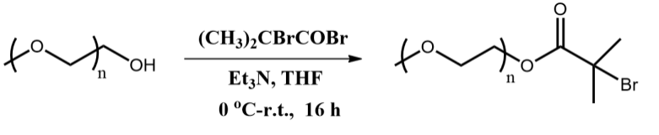
Scheme 1. Preparation of the PEO macroinitiators.
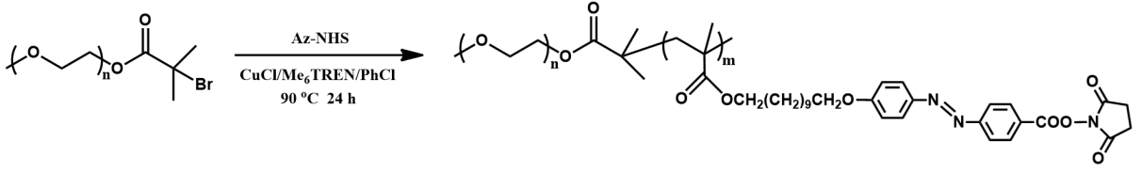
Scheme 2. Preparation of the block copolymers

Preparation of PEO macroinitiators. The synthesis of the macroinitiators is shown in Scheme 1, similar to the previous study.^{[1]} A solution of 0.276 g (1.2 mmol) of α-bromoisobutyryl bromide in 5 mL of dry tetrahydrofuran (THF) was added to a mixture of 0.152 g (1.5 mmol) of triethylamine and 2 g (1.0 mmol) of PEO-OH with an M_{n} of 2000 in 20 mL of THF at 0 °C, and then the mixture was stirred for 16h at ambient temperature. After the mixture was filtered, half of the solvent was evaporated, and the PEO macroinitiator (PEO-Br) was precipitated into cold ether. After dissolution in ethanol, the solution was stored in a refrigerator to recrystallize the product. Yield: 1.75 g (80%). M_{n}(GPC)=2200, M_{w}/M_{n} =1.04.
Preparation of the block copolymers. The synthesis of the block copolymers is shown in Scheme 2. 13.4 mg (0.136 mmol) of Cu(I)Cl, 300 mg (0.136 mmol) of PEO macroinitiators, and 1940 mg (3.356 mmol) of the reactive azobenzene-containing monomer^{[2]} were mixed in a 50 mL Schleck flask, degassed and filled with nitrogen. A 109.0 μL (94 mg, 0.409 mmol) of Me₆TREN in 4 mL of chlorobenzene was added through a syringe. The mixture was degassed three times using the freeze-pump-thaw procedure and sealed under vacuum. After 30 min stirring at room temperature, the Schleck flask was placed in the preheated 90℃ oil bath for 24h. The solution was passed through an acidic Al₂O₃ column with THF as eluent to remove the catalyst. The yellow filtrate was concentrated under reduced pressure and reprecipitated into ether and ethanol. The yellow polymer was collected by filtration and dried under vacuum. Yield: 1860 mg (75%). M_{n}(NMR)=18156, M_{n}(GPC)=13572, M_{w}/M_{n} =1.13, as shown in Figure S1.

Section 2: Supplementary figures and tables
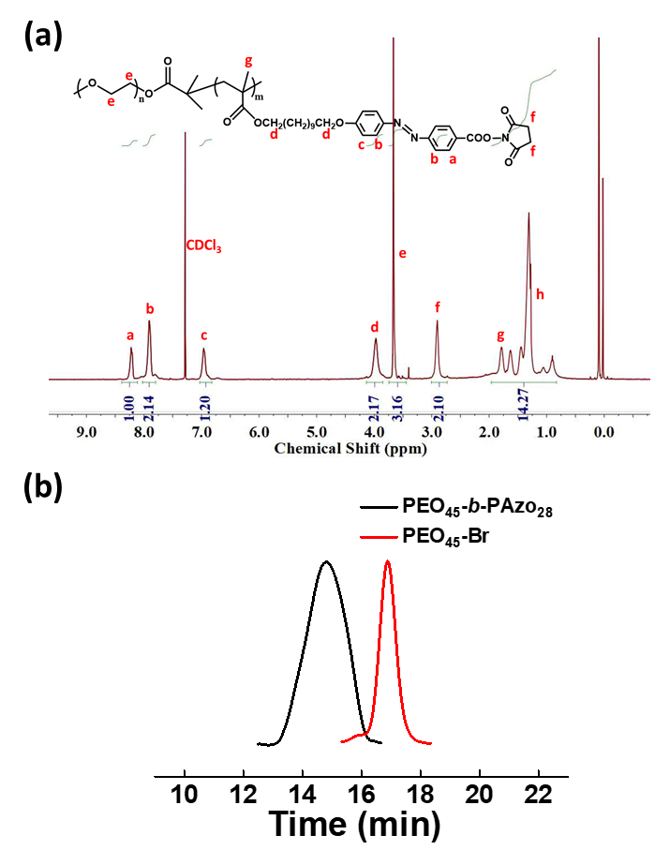
Figure S1. (a) The typical ¹H NMR spectrum of BCPs, using CDCl₃ as the solvent. (b) GPC traces of BCPs and macroinitiators (THF, polystyrene standards).

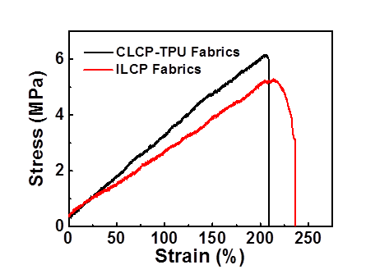
Figure S2. The stress-strain curves of the CLCP-TPU and ILCP fabrics.

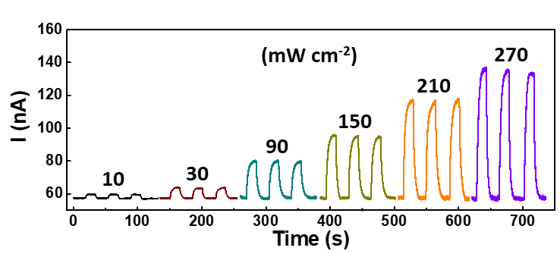
Figure S3. Initial data of current changes in accordance with UV power density from 10 to 270 mW cm⁻².

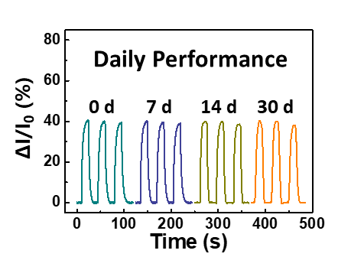
Figure S4. The daily performance (0~30 days) of ILCP-based device at room temperature. The relative current changes were recorded upon 90 mW cm⁻² UV light.

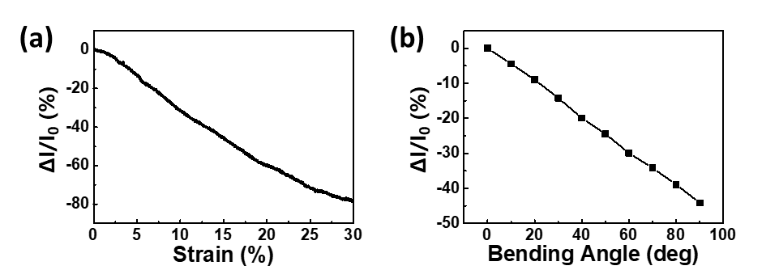
Figure S5. Relative current changes under (a) uniaxial 0~30% strain stretching and (b) 0~90º bending.

Table S1. The flexibility comparison of wearable photodetectors.
Active materials |  | Substrate | Flexibility | Response time | Ref.
Photoelectric materials | ZnO nanorod array | Ni textile | 120º bending | 6 s | [3]
Photoelectric materials | p-CuZnS/n-TiO₂ | Ti microfiber | 60º bending | < 0.2 s | [4]
Photoelectric materials | Reduced graphene oxide-ZnO | Mica | 180º bending | 17.9 s | [5]
Photoelectric materials | P3HT:PCBM | PET | 180º bending | < 1 s | [6]
Photoelectric materials | Porphyrin-SWNT | PET | 50% strain | ~ 150 s | [7]
Functional polymers | Azobenzene/α-cyclodextrin | Hydrogel | 90% strain | ~ 20 s | [8]
Functional polymers | Azobenzene | PNIPAm IL gels | - | ~ 6 min | [9]
Functional polymers | Diarylethene-containing ILs | PEO | - | ~ 15 min | [10]
Functional polymers | Azo-CLCPs | Azo-CLCPs/TPU | 240% strain/90º bending | 5 s | This work

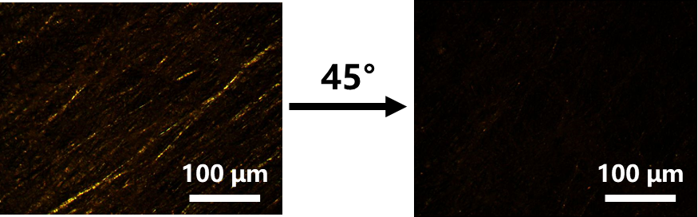
Figure S6. POM images of the texture of the ILCP fibers before and after rotating the sample 45º with respect to the polarizer at room temperature.

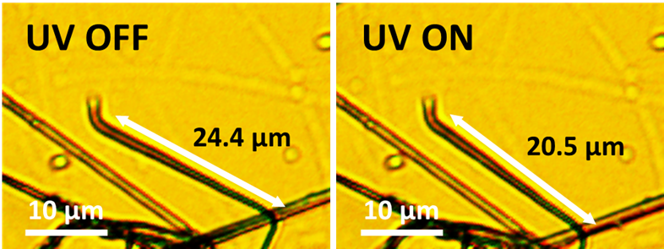
Figure S7. OM images of the single ILCP fiber before and after UV irradiation.

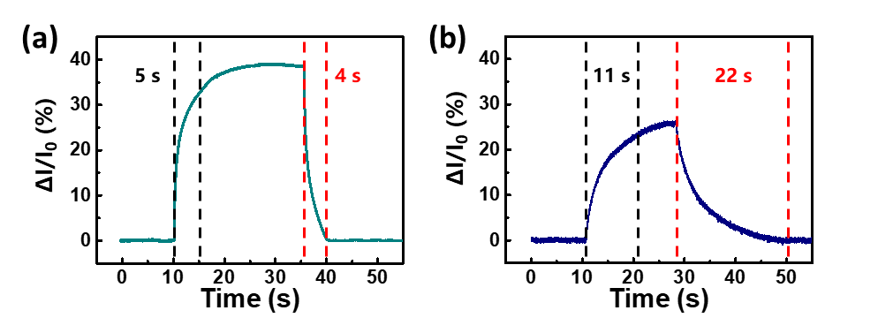
Figure S8. The response and recovery time of (a) TPU-based ILCPs and (b) PAN-based ILCPs, upon 90 mW cm⁻² UV light.

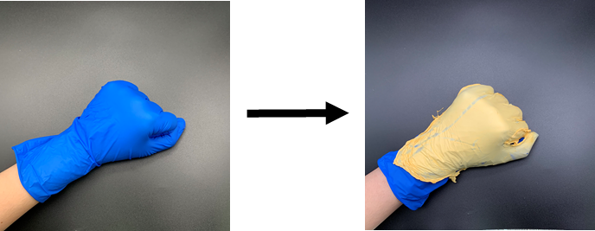
Figure S9. Photographs of the conformal and recyclable UV shielding LCP-TPU fabrics.

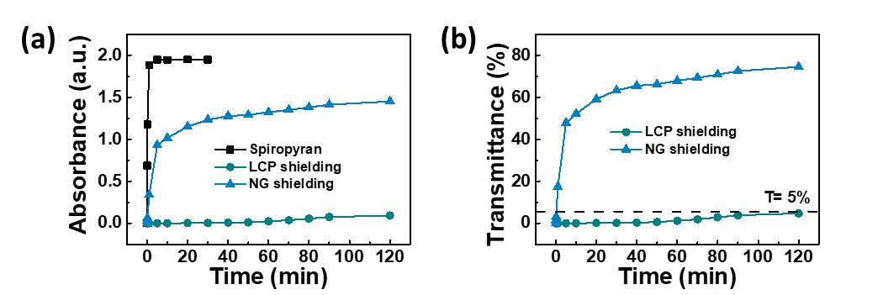
Figure S10. UV shielding property evaluation upon 20 mW cm⁻² UV light by photochromic spiropyran indicator (10⁻⁵ mol/L, ethanol solution). (a) Plots of absorption spectra of spiropyran at 540 nm versus UV irradiation time. (b) Plots of the actual transmittance versus UV irradiation time. Define the actual transmittance as T = A/A_{max}, where A_{max} denote the max absorbance of spiropyran and A denote the absorbance of LCP shielding and NG shielding samples.

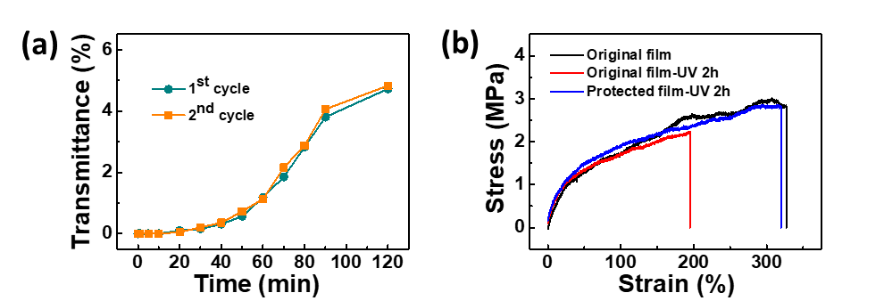
Figure S11. (a) Plots of the actual transmittance versus UV irradiation time of the 1st and 2nd cycles of LCP-TPU shielding samples. The LCP-TPU fabrics can be reused after irradiation with 520 nm visible light (200 mW cm⁻²) for 10 min. (b) The stress-strain curves of the original nitrile film, the original nitrile film after 2 h UV irradiation, and the protected nitrile film after 2 h UV irradiation, respectively. The LCP-TPU fabrics can be applied to prevent the UV aging of nitrile gloves.

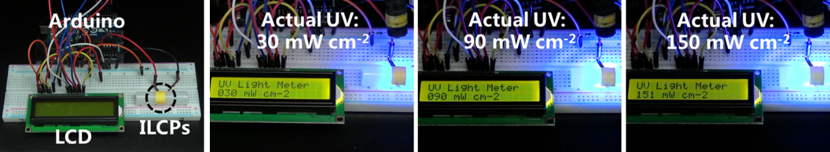
Figure S12. The physical connection diagram and practical working process of the LCD UV monitor.

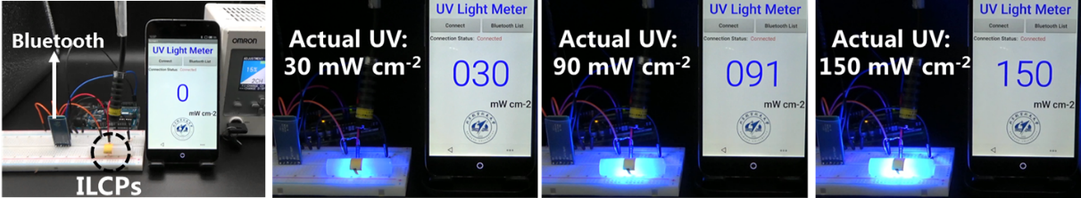
Figure S13. The physical connection diagram and practical working process of the remote Bluetooth UV monitor.

Section 3: Calculation of ultraviolet protection factor (UPF)
The calculation of UPF was based on the GB/T 18830-2009 evaluation method, which used the following equation:
$$UPF=\frac{\sum_{λ=290}^{λ=400}{E(λ)×ε(λ)×∆λ}}{\sum_{λ=290}^{λ=400}{E(λ)×T(λ)×ε(λ)×∆λ}}$$
Where λ is the wavelength, E(λ) is solar UV spectral irradiance, ε(λ) is the relative erythemal effectiveness, T(λ) is the spectral transmittance of the sample, and ∆λ is the wavelength increment.
When UPF > 50 and UV-A light transmittance < 5%, the sample can be evaluated as UV protective textiles. To exclude the effect of film thickness, we defined the normalized UPF as the ratio of UPF over the film thickness.

Table S2. The calculated UPF of LCP-TPU fabrics (20 μm).
λ | E(λ) | ε(λ) | T(λ)
λ | E(λ) | ε(λ) | Original film | 100% Strain | Washing
290 | 3.090E-06 | 1.000E+00 | 0.004 | 0.007 | 0.004
295 | 7.860E-04 | 1.000E+00 | 0.005 | 0.009 | 0.005
300 | 8.640E-03 | 6.490E-01 | 0.005 | 0.009 | 0.005
305 | 5.770E-02 | 2.200E-01 | 0.005 | 0.008 | 0.005
310 | 1.340E-01 | 7.450E-02 | 0.004 | 0.008 | 0.004
315 | 2.280E-01 | 2.520E-02 | 0.003 | 0.007 | 0.003
320 | 3.140E-01 | 8.550E-03 | 0.003 | 0.006 | 0.003
325 | 4.030E-01 | 2.900E-03 | 0.002 | 0.005 | 0.002
330 | 5.320E-01 | 1.360E-03 | 0.002 | 0.005 | 0.003
335 | 5.135E-01 | 1.150E-03 | 0.003 | 0.004 | 0.003
340 | 5.390E-01 | 9.660E-04 | 0.002 | 0.004 | 0.002
345 | 5.345E-01 | 8.100E-04 | 0.002 | 0.004 | 0.002
350 | 5.590E-01 | 6.840E-04 | 0.002 | 0.004 | 0.002
355 | 6.080E-01 | 5.750E-04 | 0.002 | 0.004 | 0.002
360 | 5.640E-01 | 4.840E-04 | 0.002 | 0.004 | 0.002
365 | 6.830E-01 | 4.070E-04 | 0.002 | 0.004 | 0.002
370 | 7.660E-01 | 3.430E-04 | 0.002 | 0.004 | 0.002
375 | 6.635E-01 | 2.880E-04 | 0.002 | 0.004 | 0.003
380 | 7.540E-01 | 2.430E-04 | 0.002 | 0.004 | 0.003
385 | 6.055E-01 | 2.040E-04 | 0.002 | 0.004 | 0.002
390 | 7.570E-01 | 1.720E-04 | 0.003 | 0.004 | 0.003
395 | 6.680E-01 | 1.450E-04 | 0.002 | 0.005 | 0.003
400 | 1.010E+00 | 1.220E-04 | 0.002 | 0.005 | 0.002
UPF |  |  | 25040 | 13851 | 24869
Normalized UPF |  |  | 1250 | 693 | 1243

Table S3. The calculated UPF of commercial UV protection clothing (90 μm).
λ | E(λ) | ε(λ) | T(λ)
λ | E(λ) | ε(λ) | Original film | 100% Strain | Washing
290 | 3.090E-06 | 1.000E+00 | 0.059 | 0.289 | 0.141
295 | 7.860E-04 | 1.000E+00 | 0.068 | 0.299 | 0.145
300 | 8.640E-03 | 6.490E-01 | 0.079 | 0.306 | 0.148
305 | 5.770E-02 | 2.200E-01 | 0.087 | 0.313 | 0.152
310 | 1.340E-01 | 7.450E-02 | 0.093 | 0.327 | 0.158
315 | 2.280E-01 | 2.520E-02 | 0.100 | 0.337 | 0.162
320 | 3.140E-01 | 8.550E-03 | 0.104 | 0.347 | 0.168
325 | 4.030E-01 | 2.900E-03 | 0.111 | 0.351 | 0.170
330 | 5.320E-01 | 1.360E-03 | 0.118 | 0.355 | 0.172
335 | 5.135E-01 | 1.150E-03 | 0.124 | 0.358 | 0.173
340 | 5.390E-01 | 9.660E-04 | 0.129 | 0.360 | 0.174
345 | 5.345E-01 | 8.100E-04 | 0.134 | 0.362 | 0.176
350 | 5.590E-01 | 6.840E-04 | 0.137 | 0.365 | 0.177
355 | 6.080E-01 | 5.750E-04 | 0.141 | 0.366 | 0.177
360 | 5.640E-01 | 4.840E-04 | 0.143 | 0.369 | 0.179
365 | 6.830E-01 | 4.070E-04 | 0.145 | 0.375 | 0.181
370 | 7.660E-01 | 3.430E-04 | 0.148 | 0.377 | 0.183
375 | 6.635E-01 | 2.880E-04 | 0.154 | 0.385 | 0.186
380 | 7.540E-01 | 2.430E-04 | 0.157 | 0.387 | 0.187
385 | 6.055E-01 | 2.040E-04 | 0.159 | 0.388 | 0.190
390 | 7.570E-01 | 1.720E-04 | 0.161 | 0.390 | 0.193
395 | 6.680E-01 | 1.450E-04 | 0.164 | 0.392 | 0.192
400 | 1.010E+00 | 1.220E-04 | 0.168 | 0.395 | 0.193
UPF |  |  | 1044 | 306 | 631
Normalized UPF |  |  | 12 | 3.4 | 7.0

Table S4. The calculated UPF of nitrile gloves (80 μm).
λ | E(λ) | ε(λ) | T(λ)
λ | E(λ) | ε(λ) | Original film | 100% Strain | Washing
290 | 3.090E-06 | 1.000E+00 | 0 | 0 | 0
295 | 7.860E-04 | 1.000E+00 | 0.001 | 0.001 | 0.001
300 | 8.640E-03 | 6.490E-01 | 0.002 | 0.003 | 0.002
305 | 5.770E-02 | 2.200E-01 | 0.002 | 0.004 | 0.002
310 | 1.340E-01 | 7.450E-02 | 0.002 | 0.003 | 0.002
315 | 2.280E-01 | 2.520E-02 | 0.002 | 0.004 | 0.002
320 | 3.140E-01 | 8.550E-03 | 0.003 | 0.004 | 0.003
325 | 4.030E-01 | 2.900E-03 | 0.003 | 0.006 | 0.003
330 | 5.320E-01 | 1.360E-03 | 0.003 | 0.007 | 0.003
335 | 5.135E-01 | 1.150E-03 | 0.005 | 0.009 | 0.006
340 | 5.390E-01 | 9.660E-04 | 0.006 | 0.012 | 0.007
345 | 5.345E-01 | 8.100E-04 | 0.008 | 0.015 | 0.009
350 | 5.590E-01 | 6.840E-04 | 0.009 | 0.019 | 0.010
355 | 6.080E-01 | 5.750E-04 | 0.011 | 0.023 | 0.013
360 | 5.640E-01 | 4.840E-04 | 0.015 | 0.029 | 0.017
365 | 6.830E-01 | 4.070E-04 | 0.019 | 0.038 | 0.022
370 | 7.660E-01 | 3.430E-04 | 0.026 | 0.052 | 0.030
375 | 6.635E-01 | 2.880E-04 | 0.038 | 0.074 | 0.044
380 | 7.540E-01 | 2.430E-04 | 0.052 | 0.099 | 0.060
385 | 6.055E-01 | 2.040E-04 | 0.067 | 0.125 | 0.078
390 | 7.570E-01 | 1.720E-04 | 0.086 | 0.155 | 0.100
395 | 6.680E-01 | 1.450E-04 | 0.109 | 0.189 | 0.127
400 | 1.010E+00 | 1.220E-04 | 0.132 | 0.222 | 0.153
UPF |  |  | 24250 | 13407 | 22351
Normalized UPF |  |  | 303 | 168 | 279

Section 4: Supplementary movies
Movie S1. Adhesion ability of ILCP fabrics to skins.
Movie S2. OM images of the deformation of ILCP fibers upon UV light.
Movie S3. The practical working process of the UV monitors through LCD screen and remote Bluetooth.
Movie S4. The practical working process of UV security unlock.
Movie S5. The practical working process of UV security input.

References
- Tian, Y. Q., Watanabe, K., Kong, X. X., Abe, J., Iyoda, T., Macromolecules 2002, 35, 3739.
- Lv, J., Wang, W., Wu, W., Yu, Y., J. Mater. Chem. C 2015, 3, 6621.
- Z. Zhu, Y. Gu, S. Wang, Y. Zou, H. Zeng, Adv. Electron. Mater. 2017, 3, 1700281.
- X. J. Xu, J. Chen, S. Cai, Z. Long, Y. Zhang, L. Su, S. He, C. Tang, P. Liu, H. Peng, X. S. Fang, Adv. Mater. 2018, 30, 1803165.
- J. An, T. S. D. Le, C. H. J. Lim, V. T. Tran, Z. Zhan, Y. Gao, L. Zheng, G. Sun, Y. J. Kim, Adv. Sci. 2018, 5, 1800496.
- S. H. Park, R. Su, J. Jeong, S. Z. Guo, K. Qiu, D. Joung, F. Meng, M. C. McAlpine, Adv. Mater. 2018, 30, 1803980.
- S. Pyo, W. Kim, H. Il Jung, J. Choi, J. Kim, Small 2017, 13, 1700918.
- H. Wang, C. N. Zhu, H. Zeng, X. Ji, T. Xie, X. Yan, Z. L. Wu, F. Huang, Adv. Mater. 2019, 31, 1807328
- C. Wang, W. Dong, P. Li, Y. Wang, H. Tu, S. Tan, Y. Wu, M. Watanabe, ACS Appl. Mater. Interfaces 2020, 12, 42202.
- H. Nie, N. S. Schauser, N. D. Dolinski, J. Hu, C. J. Hawker, R. A. Segalman, J. Read de Alaniz, Angew. Chem. Int. Ed. 2020, 59, 5123.

