Supplementary Information
Hybrid light-matter chiral polariton state and the electromagnetic enantiomers

Rahul Kumar*¹, Ben Trodden¹, Anastasiia Klimash¹, Manon Bousquet¹, Nicola J. Fairbairn¹, Affar Karimullah¹, Nikolaj Gadegaard², Peter Skabara¹, Artur Movsesyan^{3,4}, Alexander O. Govorov* ³, Shun Hashiyada^{5,6} Gordon J. Hedley¹ and Malcolm Kadodwala¹*
¹ School of Chemistry, Joseph Black Building, University of Glasgow, Glasgow, G12 8QQ, UK
² School of Engineering, Rankine Building, University of Glasgow, Glasgow G12 8LT, U.K
³Department of Physics and Astronomy and Nano scale and Quantum Phenomena Institute, Ohio University, Athens, OH 45701, USA
⁴Institute of Fundamental and Frontier Sciences, University of Electronic Science and Technology of China, Chengdu, China.
⁵Innovative Photon Manipulation Research Team, RIKEN Center for Advanced Photonics, 2-1 Hirosawa, Wako, Saitama 351-0198, Japan
⁶Department of Electrical, Electronic, and Communication Engineering, Chuo University, 1-13-27 Kasuga, Bunkyo-Ku, Tokyo 112-8551, Japan.

Methods
MHeB14 synthesis & Characterization:
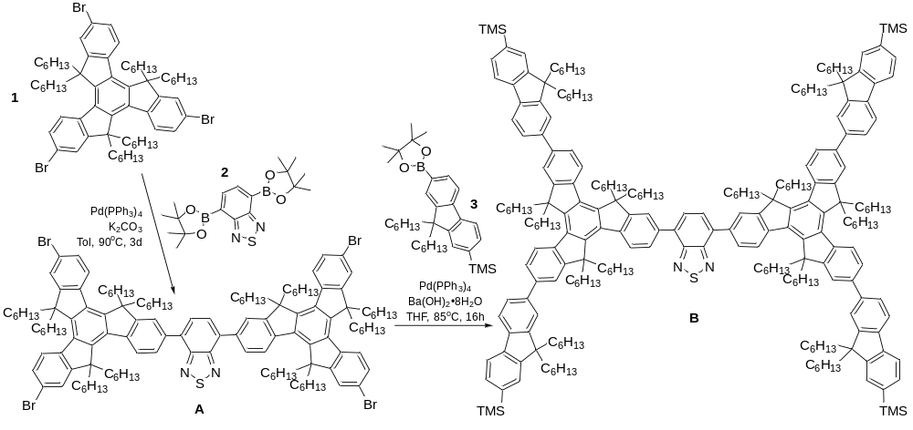
Supplementary Scheme 1. Synthesis of the MHeB14 (represented as B)
Compound A was synthesised via Suzuki-Miyaura coupling between bromide 1 and 2,1,3-benzothiadiazole-4,7-bis(boronic acid pinacol ester) 2 (Scheme 1). Truxene derivative 1 was used in large excess (7:1 ratio) in order to minimise side polymerisation reactions and achieve higher selectivity. However, the best yield for the reaction is still as low as 18 % due to the selectivity issues. The target compound B was similarly synthesised via Suzuki-Miyaura coupling of A with 9,9-dihexyl-2-trimethylsilane-7-boronic ester-9H-fluorene 3, giving the product in 63% yield.
Experimental details:
Materials: Unless stated otherwise, all reagents were purchased from Sigma Aldrich, TCI, Alfa Aesar or Fluorochem and used without further purification. Compound 1 was prepared according to the previously reported procedure. [1]
Instrumentation and Analytical Techniques: Melting points were determined using a Stuart Scientific SMP1 Melting Point Apparatus or Stuart SMP50 Automatic Melting Point Apparatus. ¹H and ¹³C NMR spectra were recorded on a Bruker AVIII 400 apparatus at 400 MHz and 100 MHz, respectively, or a Bruker AV500 at 500 MHz and 125 MHz, respectively. NMR data are presented in the following order: chemical shifts (δ) in ppm; multiplicity as singlet (s), doublet (d), triplet (t), quartet (q), multiplet (m); coupling constants (J) in Hz. Multiplets are reported over the range they appeared (in ppm). MS MALDI-TOF analyses were run on a Shimadzu Axima-CFR spectrometer (mass range 20-150000Da); Thermogravimetric analyses (TGA) were performed on a Perkin-Elmer Thermogravimetric Analyser TGA7 or on a NETZSCH TG 209 F3 - Tarsus thermogravimeter under a constant flow of Argon or Nitrogen (20 mL/min). The temperature was increased at a rate of 10 °C/min from 40 °C to 500 °C. Differential scanning calorimetry (DSC) was carried out on a TA Instruments Q1000 with a RC-90 refrigerated cooling unit attached or on a NETZSCH DSC 214 – Polyma differential scanning calorimeter.
Synthesis:
Compound A: 4,7-Bis(7,12-dibromo-5,5,10,10,15,15-hexahexyl-10,15-dihydro-5H-diindeno[1,2-a:1',2'-c]fluoren-2-yl)benzo[c][1,2,5]thiadiazole
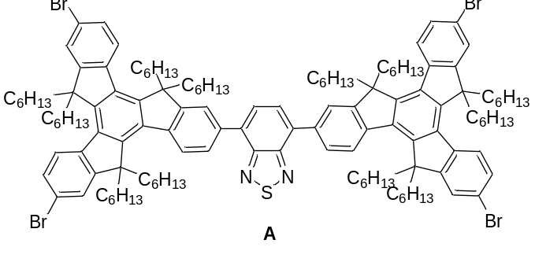
Supplementary Scheme 2: Molecular Structure of compound A
A mixture of tribromohexahexyltruxene 1 (13 g, 12 mmol, 7 eq.), tetrakis(triphenylphosphine)palladium (0) (0.8 g, 0.68 mmol, 0.4 eq.) and 2,1,3-benzothiadiazole-4,7-bis(boronic acid pinacol ester) 2 (0.665 g, 1.7 mmol, 1 eq.) was dried under reduced pressure for 30 min, then dissolved in dry degassed toluene. An aqueous degassed solution of K₂CO₃ (2M, 4.28 mL) was added and the mixture was stirred at 100°C for 3 days. The mixture was washed with water (200 mL), the toluene layer was separated, and aqueous phase was extracted with dichloromethane (2×200 mL). The organic phases were combined, dried over MgSO₄ and concentrated under reduced pressure. The crude mixture was purified by column chromatography on silica gel. The starting material was first eluted with hexane, then the product was eluted with a hexane : toluene (5:1) mixture. Pure compound A was obtained as a yellow-green powder (660 mg, 0.3 mmol, 18%): mp 124-126 °C; MS (MALDI-TOF) calculated for C₁₃₂H₁₇₆Br₄N₂S 2137.03, found 2141.97 [M⁺]; ¹H NMR (400 MHz, CDCl₃) δ 8.53 (d, J = 8.9 Hz, 2H), 8.29 (d, J = 8.6 Hz, 2H), 8.23 (d, J = 8.6 Hz, 2H), 8.20 – 8.18 (m, 4H), 8.05 (s, 2H), 7.63 (dd, J = 7.7, 1.9 Hz, 4H), 7.57 (ddd, J = 8.3, 5.0, 1.9 Hz, 4H), 3.10 – 3.03 (m, 4H), 2.97 – 2.87 (m, 8H), 2.33 – 2.21 (m, 4H), 2.14 – 2.04 (m, 8H), 1.13 – 0.79 (m, 72H), 0.78 – 0.61 (m, 36H), 0.55 (dt, J = 20.3, 6.3 Hz, 24H). ¹³C NMR (CDCl₃) δ 155.54, 155.43, 153.90, 153.48, 145.39, 144.70, 144.25, 139.60, 138.64, 138.56, 137.75, 137.21, 137.04, 135.18, 132.64, 128.83, 127.54, 126.90, 125.48, 125.39, 125.06, 125.01, 124.24, 122.62, 120.43, 55.63, 55.50, 55.37, 36.49, 36.40, 31.04, 30.97, 29.01, 28.96, 28.91, 23.50, 23.42, 21.80, 21.77, 13.40. Elemental Analysis: Found: C, 73.80, H, 8.34, N, 1.30, Expected: C, 74.00, H, 8.28, N, 1.31.
Compound B: 4,7-bis(7,12-bis(9,9-dihexyl-7-(trimethylsilyl)-9H-fluoren-2-yl)-5,5,10,10,15,15-hexahexyl-10,15-dihydro-5H-diindeno[1,2-a:1',2'-c]fluoren-2-yl)benzo[c][1,2,5]thiadiazole
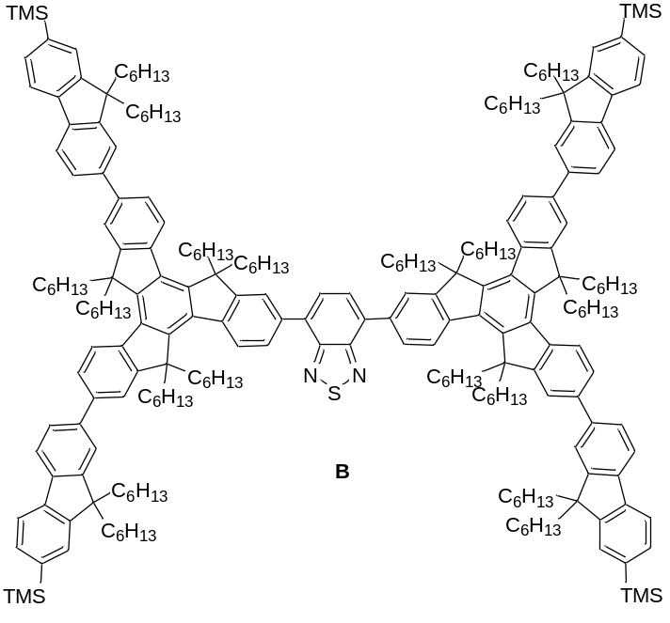
Supplementary Scheme 3: Molecular Structure of compound B
The mixture of A (202mg, 0.098mmol, 1eq), and (9,9-dihexyl-7-(4,4,5,5-tetramethyl-1,3,2-dioxaborolan-2-yl)-9H-fluoren-2-yl)trimethylsilane 3 (781mg, 1.462mmol, 15eq), with tetrakis(triphenylphosphine)palladium(0) (56mg, 0.049mmol, 0.5eq) and Ba(OH)₂∙8H₂O (769mg, 2.437mmol, 25eq) was dried under vacuum during 30 min and then dissolved in dry degassed THF (15mL). Degassed water was added (1.61mL) and the mixture was heated at 85 °C overnight. The crude mixture was washed with water and the aqueous layer was extracted with toluene, organic layers were combined, dried with MgSO₄ and evaporated under vacuum. The product was purified by column chromatography (silica gel, hexane, then 10:1 hexane/toluene) to afford a bright yellow powder (231 mg, 68 %) mp 114-128 °C; MS (MALDI-TOF) calculated for C₂₄₄H₃₄₀N₂SSi₄ 3442.55, found 3363.79 [M+(– C₆H₁₃)]; ¹H NMR (400 MHz, CDCl3) δ 8.60 (d, J = 8.0 Hz, 2H), 8.51 (d, J = 8.1 Hz, 4H), 8.25 – 8.16 (m, 4H), 8.06 (s, 2H), 7.84 (d, J = 7.8 Hz, 4H), 7.80 (s, 6H), 7.77 – 7.74 (m, 14H), 7.57 – 7.48 (m, 8H), 3.15 – 3.04 (m, 12H), 2.38 – 2.16 (m, 12H), 2.07 (t, J = 8.1 Hz, 16H), 1.22 – 1.07 (m, 48H), 1.07 – 0.85 (m, 72H), 0.85 – 0.54 (m, 100H), 0.36 – 0.31 (m, 39H). ¹³C NMR (CDCl3) δ 151.54, 151.29, 148.88, 147.31, 142.62, 142.54, 139.88, 138.61, 137.80, 137.53, 137.37, 136.68, 136.13, 135.34, 135.29, 135.19, 128.99, 125.19, 124.77, 124.44, 123.36, 123.09, 122.39, 122.07, 118.45, 117.66, 117.61, 117.20, 116.14, 53.03, 52.28, 50.53, 37.36, 34.29, 28.71, 28.51, 26.83, 26.74, 21.25, 20.87, 19.78, 19.64, 19.51, 19.47, 11.24, 11.13, 11.07, 11.05, -1.86, -3.72.

NMR characterization of compound A and B are shown in supplementary figure (SF) 1-4.
Chiral Nanocavity Fabrication:
The 1000/ 1500 nm nanocavity were realised using and an injection moulding machine (ENGEL), following the technique explained by Gadegaard et al. [2]. The master shim for this was made using e-beam lithography. In nutshell, 100 nm of PMMA was spin coated onto a Si wafer, baked for an hour at 180 ˚C and patterned using a VB6 UHR EWF lithography tool (Vistec). The exposed resist was developed in IPA and Methyl Isobutyl Ketone, MIBK (3:1 ratio) for 60 secs followed by electroplating Ni onto the surface. The patterned Ni was removed from the wafer to provide the shim that was then used as the master in a tool placed in the injection moulder.
The polycarbonate pellets are thermally heated and pushed into the tool to create small plastic slides with the nanostructures indented on the surface. These slides are then coated with 100 nm of Au in an e-beam evaporator at a rate of ≈ 0.3 nm s⁻¹. When gold is evaporated onto the surface, it takes the shape of the indentation and forms a hybrid plasmonic structure constituting an inverse structure at the top and a solid one at the bottom.
Thin film preparation:
200 mg of PMMA was weighed in a vial in regular atmosphere before being inserted into the glovebox (MBraun). Once in the glovebox, 4ml of toluene was pipetted into the vial of PMMA was then left to dissolve on a hotplate for an hour at 50°C. In the meantime, a high concentration stock solution of MHeB14 was made up in the glovebox using toluene by pipetting 2 ml toluene into a vial followed by some scrapings of the yellow MHeB14 crystals. The resultant mixture was shaken vigorously and left for around half an hour to ensure it was well and truly dissolved in the toluene to give a vivid yellow solution.
Once the PMMA was fully dissolved, the MHeB14 and PMMA solutions were then used to make up respective ratios to give the 1%, 10%, 50% MHeB14 solution for spinning. Once these 3 solutions were ready, the 3 respective metafilms were placed onto the chuck and spin for 60 seconds at a rate of 2000 RPM. In these 60 seconds, a pipette was used to uptake 100 µl of the respective solution from the vial and thus deposited onto the substrate whilst spinning.
Refractive Index measurement:
The M-2000XI (JA Wollam) was used for measuring RI of the films. The amplitude psi (Ψ) and phase delta (Δ) were collected at incident angle from 45^{ο} to 75º at a difference of 5º. The obtained data was fitted using CompleteEase software. The dye doped PMMA was modelled as B-spline with general oscillator as starting material. The real and imaginary part of refractive index for various dye concentration are shown in SF 5
Optical Measurement
The PL and reflectance measurements were carried out using a home-built 30 mm cage-rod setup. For PL experiment, CW diode laser ($λ$_{max}= 404 nm; L404P400M; Thor labs) operating at constant current of 180 mA was collimated using a lens and redirected into the pair of polarizers with the help of left turning mirror, as shown in SF 6(a). The two polarisers were used to control the power and polarization of the incident beam. The linearly polarized beam was then directed towards the sample using a 50:50 beam splitter and focused onto the sample by a 10× objective (NA=0.3) to a spot size of 350 µm. The input power at sample was $\sim$ 70µW. The reflected light was collected using same objective and passed through the combination of quarter wave plate and analyser. The circularly polarised emission was detected with ±45^{ο} of the analyser position while the Quarter Wave plate was kept at 0º. The 90:10 beam splitter was used sent 10% and 90% of the emitted light to Camera and Spectrograph (SR-303i-B, Andor Technology) respectively. The collimating lens was used to focus the light to optical fibre connected to the spectrometer and the long pass filter (cut-off wavelength $\sim$ 450 nm) was used to stop the laser beam from reaching and saturating the detector. The EMCCD camera (DU970P-BVF, Andor Technology) was used to acquire the signal with the acquisition time of 0.1 second and 500 spectrum was added for each measurement. External light source was used to locate the 1000 /1500 nm metafilm with the help of the camera.
For Broadband experiment, same setup was used except replacing diode laser with broadband light (HL-2000-FHA; Ocean Optics) source and removing left turning prism, shown in SF 6(b)
Simulation:
The EM simulation was carried out using COMSOL 6.0. We have conducted a series of numerical simulations of Maxwell’s equations by using finite element approach with COMSOL V6 Multiphysics software with the Wave optics module. The Shuriken’s dimensions were obtained from SEM image - and 200 nm thick PMMA was used on the top. The excitation port was placed 850 nm above the top gold surface. Floquet periodic boundary conditions were applied on the side walls and 200 nm perfectly matched layer was used outside excitation and receiving ports absorb all the wave coming out of the simulated domain. The Refractive index values used for Au, PMMA and PMMA doped with dye were extracted from ellipsometry and values of Zhang et al. -given in COMSOL library- were used for polycarbonate. Meshing was done using Physics controlled mesh. The incident light is linearly polarised along the y axis. The model used in simulation is shown in SF 7

NMR spectra
Compound A:
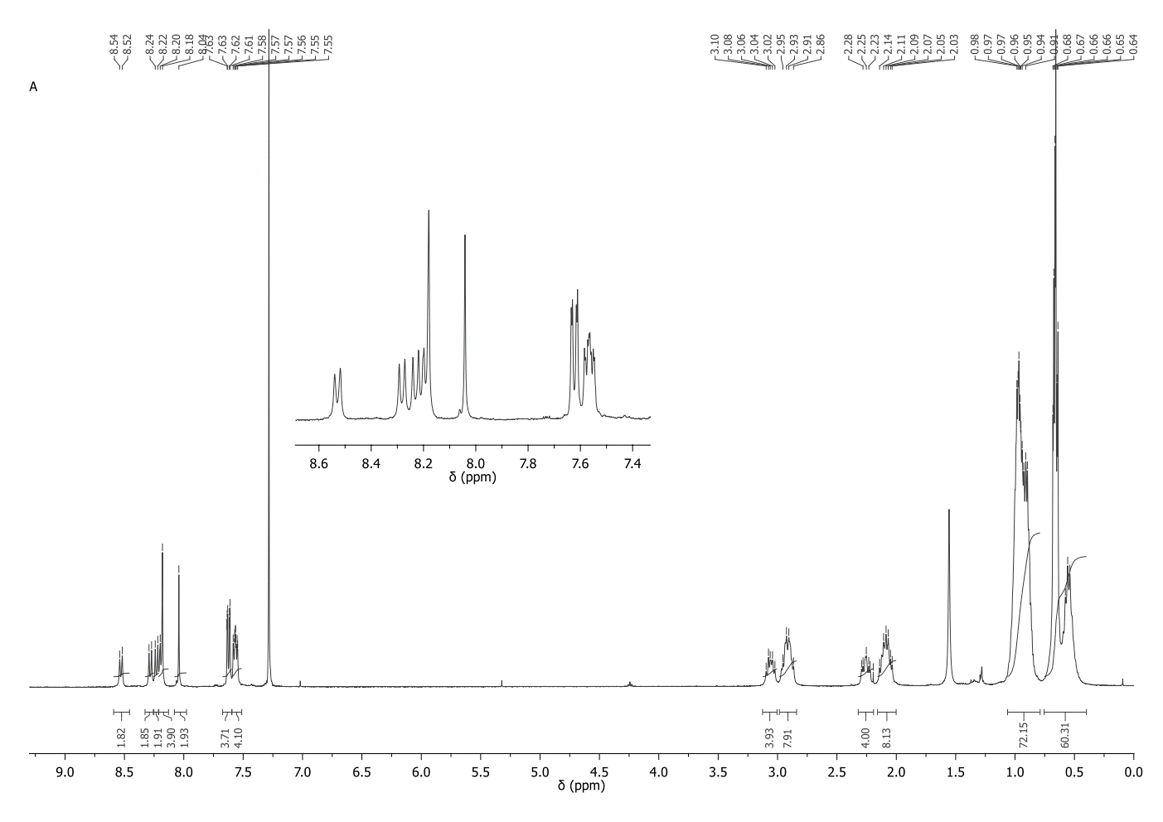
Supplementary Figure 1 ¹H NMR spectrum of compound A in CDCl₃, 400MHz, 293 K.
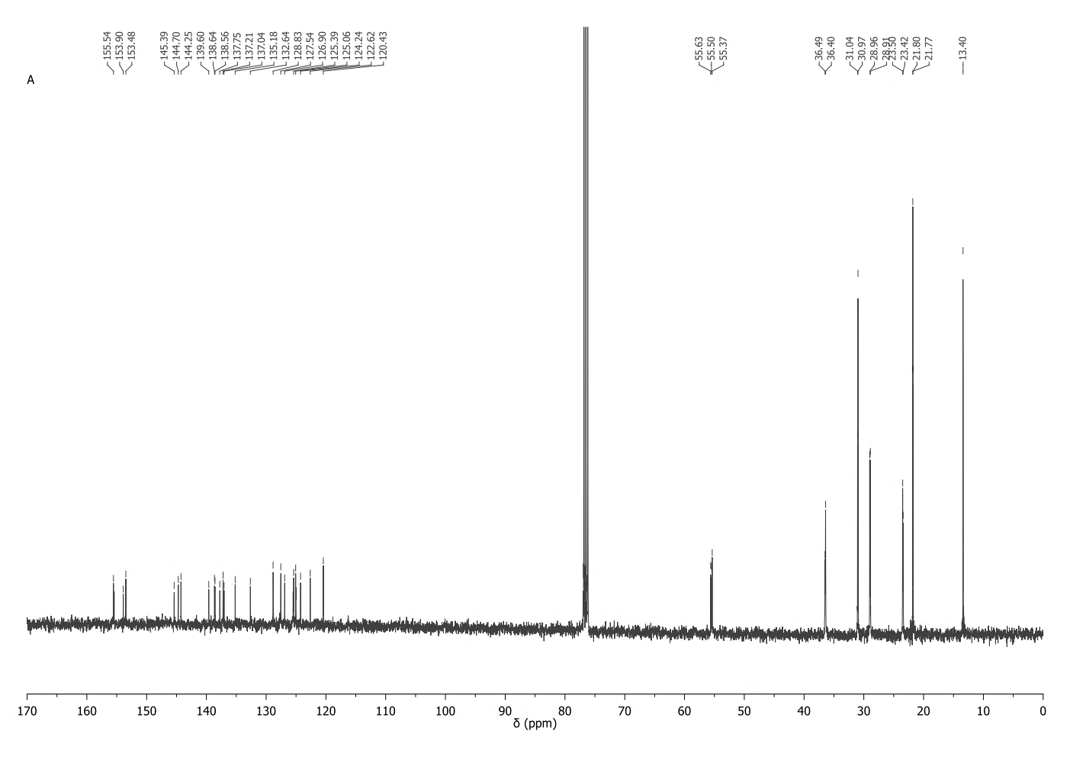
Supplementary Figure 2 ¹³C NMR of compound A in CDCl₃, 400MHz, 293 K.

Compound B:
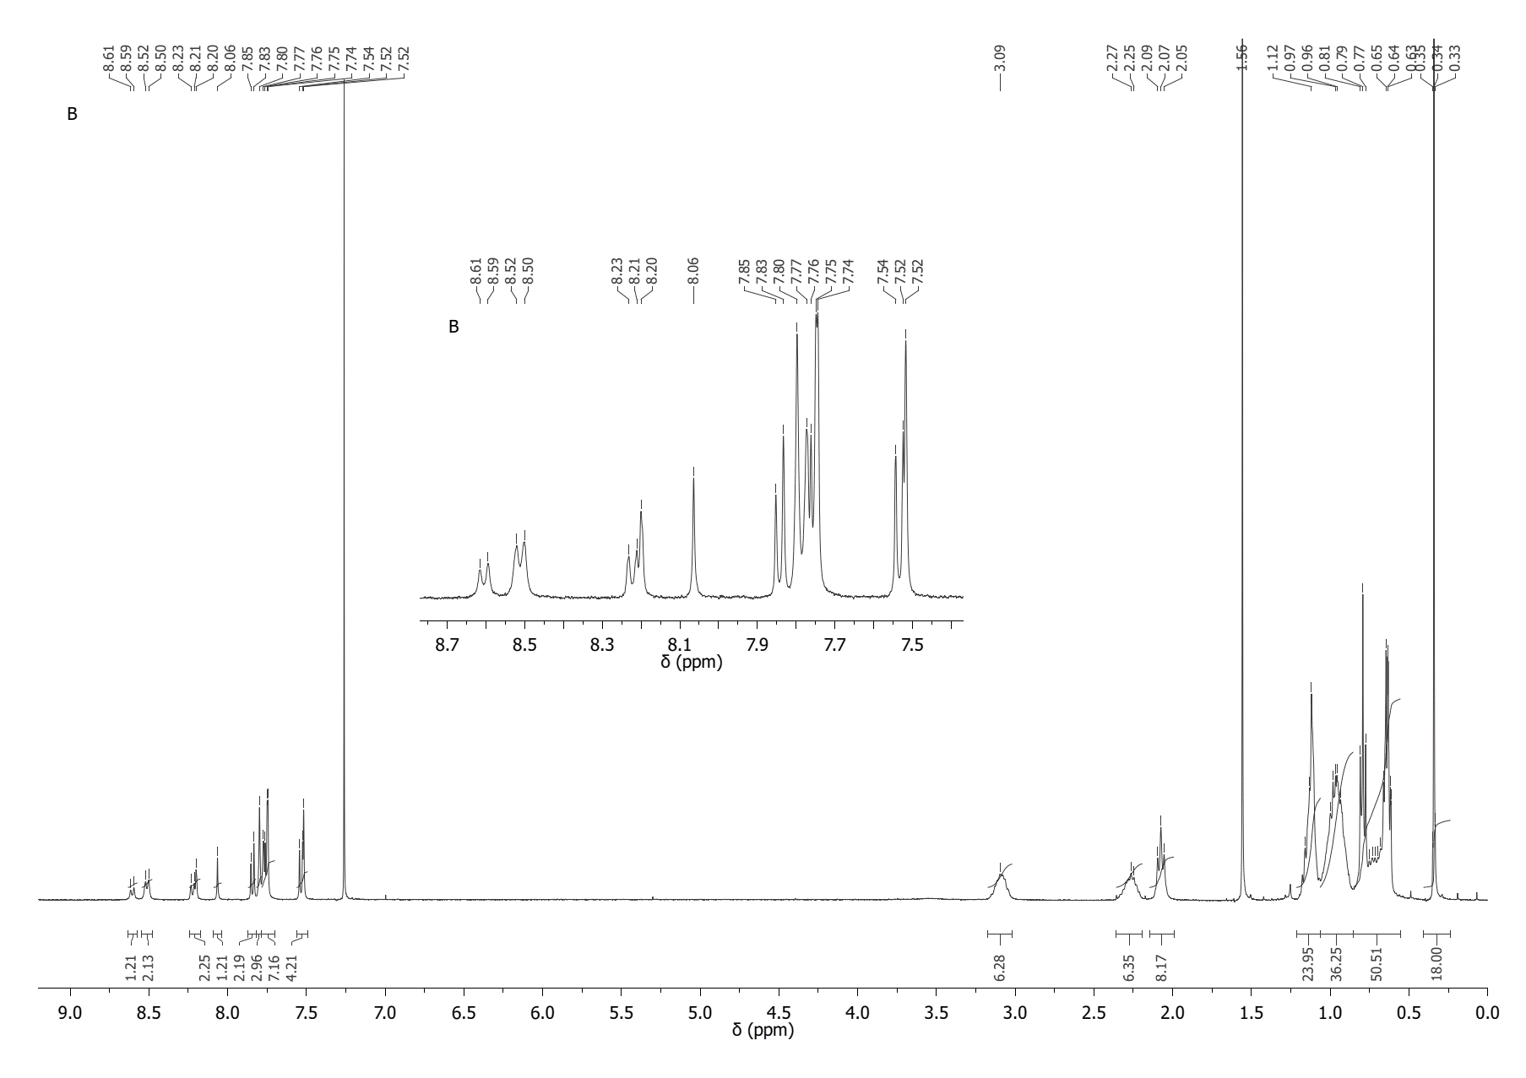
Supplementary Figure 3 ¹H NMR spectrum of compound B in CDCl₃, 400MHz, 293 K.
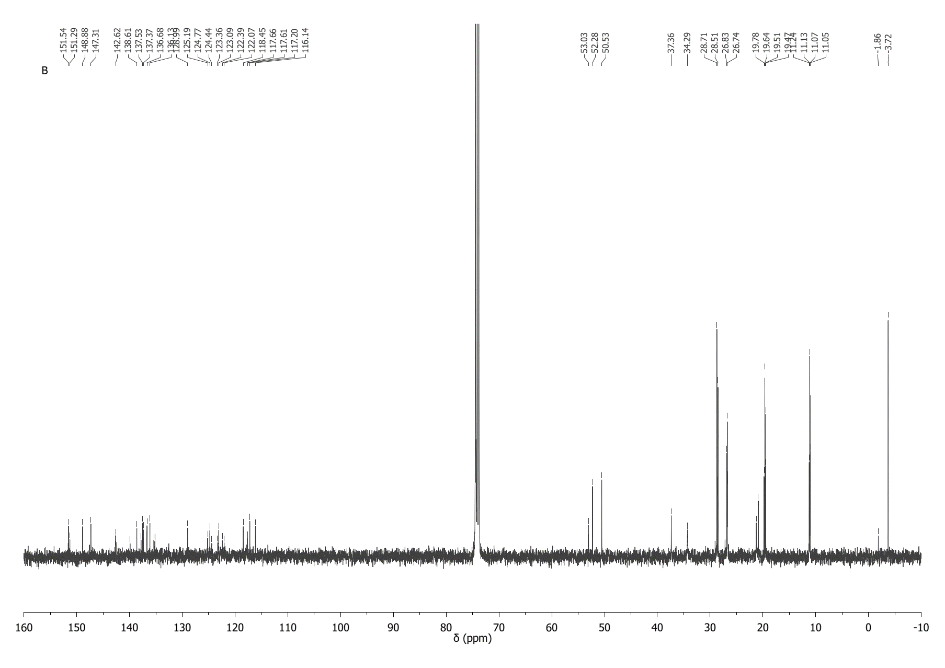
Supplementary Figure 4 ¹³C NMR of compound B in CDCl₃, 400MHz, 293 K.

Supplementary Figure 5: RI of the films calculated from ellipsometry (a) Real part (b) Imaginary part

Supplementary Figure 6 Schematic showing characterization setup (a) PL (b) Broadband
Supplementary Figure 7 COMSOL model used for simulation.
Supplementary Figure 8 Linearly polarized Relative reflectivity -with respect to that of flat gold- of the undoped and doped 1000 nm (black) and 1500 nm (red) metafilms. The concentration of dye is shown on the top of each panel. L ($λ \sim$563 nm) & X ($λ\sim$620 nm) shows position of two interband transitions peaks of flat gold layer.

Supplementary Figure 9 The circularly polarised PL spectrum LH (left; red) and RH (right, blue) for (a) 1000 nm (b) 1500 nm metafilm for various dye doping concentrations i.e., PMMA (0%), 1%, 10% and 50% doped films. The dashed line and solid line respectively show LCP and RCP PL emission from the structures. The spectra which are solid filled in red and blue show LCP and RCP PL emission of MHeB14 when present on the flat gold. All spectra have been self-normalised to value at λ=533 nm. The concentration of dye for the given row is shown in on the right side. L (λ ~563 nm) & X (λ~620 nm) shows position of two gold interband transitions peaks. The dotted line in first row spectra (0%) shows PL from flat gold.

Supplementary Figure 10 The circularly polarised relative reflectivity LH (left; red) and RH (right, blue) for (a) 1000 nm (b) 1500 nm metafilm for various dye doping concentrations i.e., PMMA (0%), 1%, 10% and 50% doped films. The dashed line and solid line respectively show LCP and RCP reflectance from the structures. The concentration of dye for the given row is shown in on the right bottom of the panel. L (λ ~563 nm) & X (λ~620 nm) shows two interband transitions peaks of the gold. All spectra are relative to corresponding spectrum obtained from flat gold.

Supplementary Figure 11 The calculated relative electric-field intensity in 200 nm thick volume for 50% concentration dye (top) and normalised -PL (bottom) for (a) 1000 nm (b) 1500 nm metafilms. The dashed line and solid line respectively show the electric LCP and RCP PL emission from the structures. The spectra which are solid filled in red and blue show LCP and RCP PL emission of MHeB14 when present on the flat gold. All spectra have been self-normalised to value at $λ=$533 nm. E_{ref} is the electric field in 200 nm thick volume of 50% concentration dye on the top of flat gold. In simulation, the dashed and solid line respectively shows relative electric-field intensity when the incident E-field is left and right circularly polarized.
.
Supplementary Figure 12 The calculated relative electric-field intensity in 200 nm thick volume for 10% concentration dye (top) and normalised -PL (bottom) for (a) 1000 nm (b) 1500 nm metafilms. The dashed line and solid line respectively show the electric LCP and RCP PL emission from the structures. The spectra which are solid filled in red and blue show LCP and RCP PL emission of MHeB14 when present on the flat gold. All spectra have been self-normalised to value at $λ=$533 nm. In simulation, the dashed and solid line respectively shows relative electric-field intensity when the incident E-field is left and right circularly polarized. E_{ref} is the electric field in 200 nm thick volume of 10% concentration dye on the top of flat gold.
Supplementary Figure 13 The calculated relative electric-field intensity in 200 nm thick volume for 1% concentration dye (top) and normalised -PL (bottom) for (a) 1000 nm (b) 1500 nm metafilms. E_{ref} is the electric field in 200 nm thick volume of 1% concentration dye on the top of flat gold. The dashed line and solid line respectively show the electric LCP and RCP PL emission from the structures. The spectra which are solid filled in red and blue show LCP and RCP PL emission of MHeB14 when present on the flat gold. All spectra have been self-normalised to value at $λ=$533 nm. In simulation, the dashed and solid line respectively shows relative electric-field intensity when the incident E-field is left and right circularly polarized.

Supplementary Figure 14 CD (gCD) and CPL (gCPL) spectra for Rhodamine 6G. The concentration in (wt%) PMMA is given on the top.

Reference
[1] Kanibolotsky, A. L.; Berridge, R.; Skabara, P. J.; Perepichka, I. F.; Bradley, D. D. C.; Koeberg, M. Synthesis and Properties of Monodisperse Oligofluorene-Functionalized Truxenes: Highly Fluorescent Star-Shaped Architectures. J. Am. Chem. Soc. 2004, 126 (42), 13695–13702. https://doi.org/10.1021/ja039228n.
[2] Gadegaard, N., Mosler, S. & Larsen, N. B. Biomimetic Polymer Nanostructures by Injection Molding. Macromol. Mater. Eng. 2003, 288, 76–83.

